Synapsis
Last updated: April 20, 2019

Types 1
Location 2
Synaptic Development 3
Ultrastructure 3
Postsynaptic Electrical Events 5
Inhibition & Facilitation At Synapses 7
Chemical Transmission 8
Synaptic Plasticity & Learning 9

Synapsis - functional contact between cells.

Types

electrical synapsis
- low-resistance pathway between neurons (nėra cheminio transmiterio).
- passive electrotonic spread of current
- much shorter latency!
- can spread in both directions!
- nepaplitę žinduolių nervų sistemose; in human CNS:
  - retina
  - olfactory bulb
  - some neurons in lateral vestibular nucleus
- also exist in non-nerve tissues (e.g. širdies laidžioji sistema, miokardas, smooth muscle) – coordination of electrical activity between cells (syncytium) → coordinated muscle contraction.

Morphologically - gap junction dar žr. 2940-2942 p. (skin)
- 1.5-2 nm aqueous channel formed from six molecules of integral membrane protein connexin.
- channel in one cell aligns and merges with channel in another cell.
- membranes of cells are separated by only 2 nm.
- enables passing of small molecules and ions (cytoplasmic continuity)
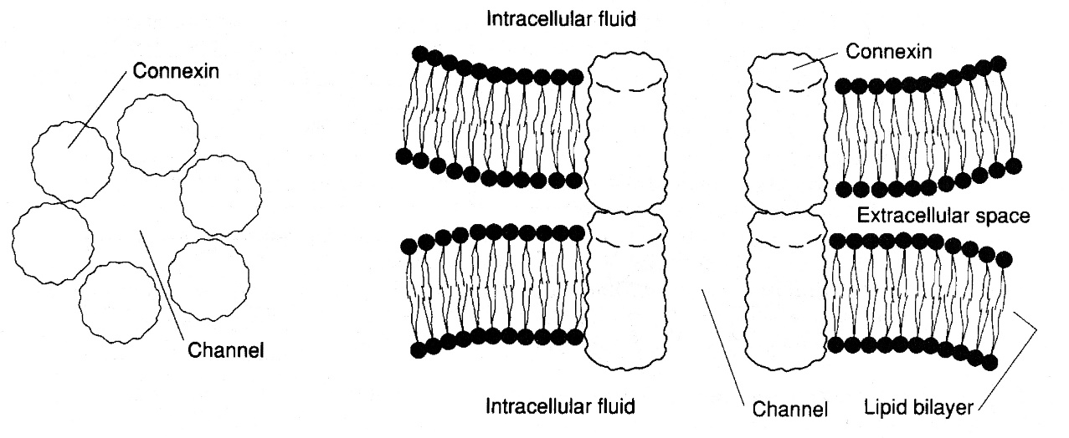

conjoint synapses – combined electrical and chemical transmission.

chemical synapsis
- perduoda signalą cheminio neurotransmiterio pagalba.

Location
Sinapsės būna tarp bet kurių dviejų neuronų dalių (labiausiai paplitę – axodendritic ir axosomatic):
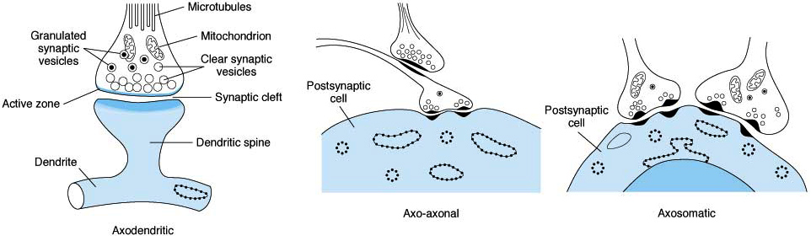
Note clear and granulated synaptic vesicles in endings and clustering of clear vesicles at active zones, shown longitudinally in A and in cross section in B and C.
- sometimes axon terminal branches form basket / net around soma of postsynaptic cell ("basket cells" of cerebellum and autonomic ganglia).
- sometimes axon terminal branches intertwine with dendrites of postsynaptic cell (climbing fibers of cerebellum).

dendritic spines  - axodendritic endings are commonly located on dendritic spines (small knobs projecting from dendrites), but some also end directly on shafts of dendrites;  spines on apical dendrites of large pyramidal neurons in cerebral cortex; numbers of spines increase rapidly from birth to 8 months of age (in Down's syndrome, spines are thin and small):  - many spines have narrower necks than heads, ratio (head to neck) affects electrical properties. | 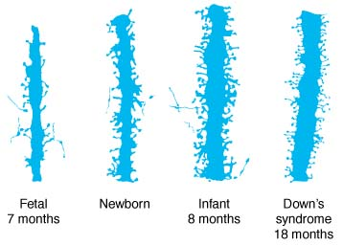
- spines are labile structures - their numbers can be increased (e.g. by exposure to complex environment in vivo); changes in spine morphology can be observed on time of seconds (depend on actin and myosin).

- each neuron divides to form > 2000 synaptic endings.
- single spinal motor neuron has ≈ 10,000 synapses (2000 on cell body, 8000 on dendrites) – synapses cover ≈ 40% of soma membrane and ≈ 75% of dendritic membrane.
- in cortical neurons, 98% synapses are on dendrites and only 2% are on cell bodies.
- Convergence - many presynaptic neurons converge on any single postsynaptic neuron.
Divergence - most axons divide into many branches that diverge to end on many postsynaptic neurons.

Ephapse (“artificial synapse”) - place where two or more nerve cell processes (axons, dendrites) touch without forming typical synaptic contact; some form of neural transmission may occur at such contact sites (esp. important in neuropathic pain genesis).

Synaptic Development
How, during development, neurons find "right" targets and make "right" synaptic connections?
- growing axons have growth cones at their tips which migrate through tissues.
- cones are guided by attractants and repellents in tissues.
- semiphorins - proteins that repel / attract growth cones (depends on concentration of second messengers in growth cone).
- receptors for semiphorins are called neurophilins.
- neurons make many synaptic connections and then "inappropriate" connections disappear.
- many neurons die by apoptosis; only most active neurons and synaptic junctions persist.
- competition between neurons for synaptic sites (e.g. adjacent neurons grow into brain area that has been denervated).

Ultrastructure
neuromuscular junction - see p. 1113-1115, 1119 (6) (musculoskeletal)

- sinapsės matomos šviesos mikroskopu (stained by Golgi method) tik kaip button-like swellings (synaptic boutons) su uodegėlėmis:  - aksono gale – bouton terminaux (s. axon terminal, synaptic ending, end-feet, neuropodia).  - aksono šonuose (i.e. consecutive synapses along axon course) – bouton en passant. |  | 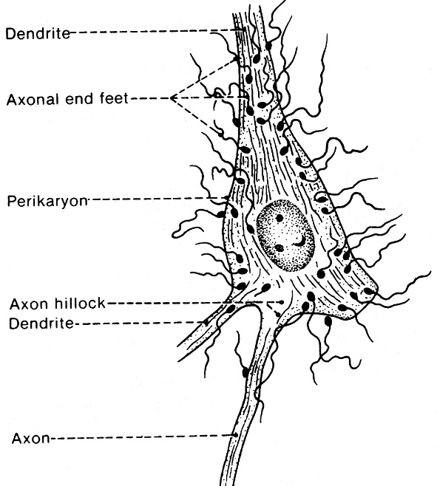
Synaptic knob (S) ending on dendrite (D); P, postsynaptic thickening; M, mitochondrion.
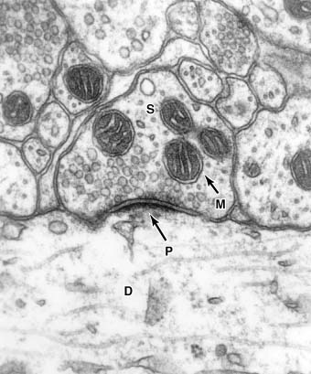 | 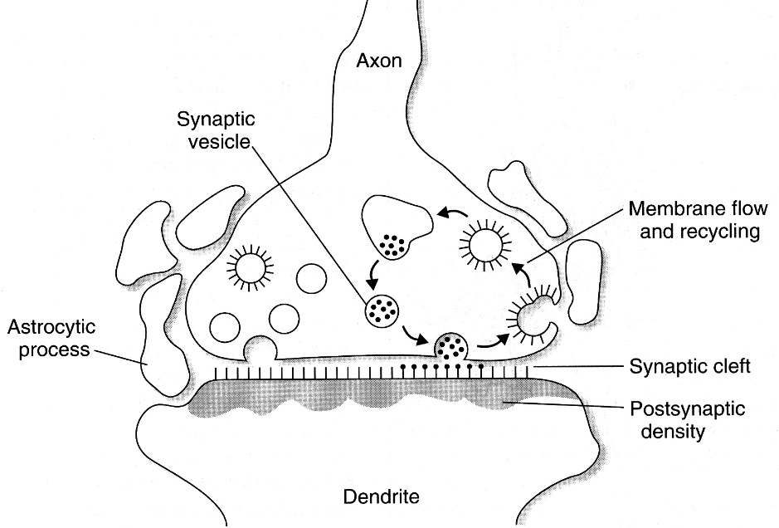

Presynaptic component (transmitter region) has many mitochondria and synaptic vesicles.
- ląsteles skiria siauras (20-60 nm) synaptic cleft.
Postsynaptic component (receptor region)
- forma ir plotu atitinka presinaptinę dalį.
- nusagstyta receptoriais (iš citoplazmos pusės receptor molecules are anchored in postsynaptic thickening – dense material of variable thickness).

Synaptic vesicles – membrane bounded spheroidal structures that contain neurotransmitter.
one vesicle = one quantum of neurotransmitter
- release their content by exocytosis into synaptic cleft.
- vesicle membrana įsilieja į presinaptinės dalies membraną – susidaręs membranos perteklius juda į sinapsės periferiją (membrane flow) → recycled by endocytosis (įsilieja į sER ir dalyvauja naujų vesicles sudaryme).
- three kinds of synaptic vesicles:
  - small clear vesicles - contain acetylcholine, glycine, GABA, glutamate.
  - small vesicles with dense core - contain catecholamines.
  - large vesicles with dense core - contain neuropeptides.
- vesicles & their wall proteins are synthesized in Golgi apparatus → migrate to axon endings by fast axoplasmic transport.
- large vesicles are located throughout presynaptic terminals and release their neuropeptide by exocytosis from all parts of terminal;
vs. small vesicles are located near synaptic cleft and discharge their contents very rapidly into cleft at areas of membrane thickening called active zones (contain rows of Ca²⁺ channels).
- neuropeptides in large vesicles are produced in cell body;
vs. small vesicles recycle in ending (exocytosis → retrieved by clathrin endocytosis → enter endosomes → bud off endosome → refill with transmitter → docking → priming → exocytosis).
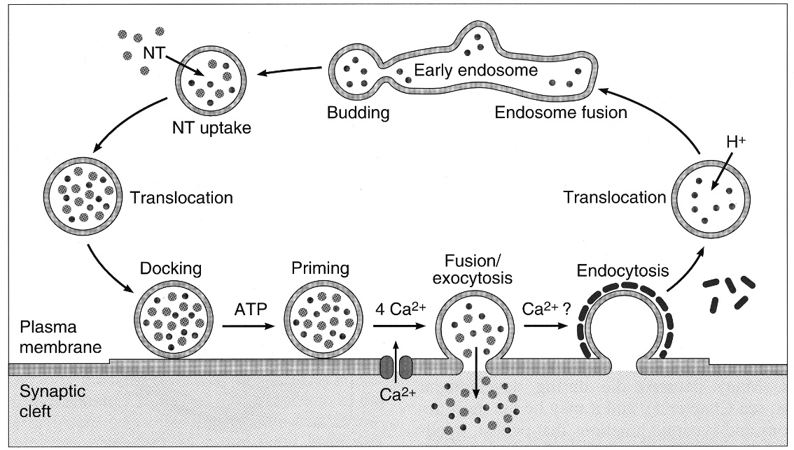
- docking process: v-snare protein synaptobrevin* (in vesicle membrane) locking with t-snare protein syntaxin** (in cell membrane).
*target of tetanus toxin (in CNS) and botulinum toxins B, D, F, G (in PNS)
**target of botulinum toxin C (in PNS)
Ca²⁺ is key to synaptic vesicle fusion & discharge:
- action potential (reaching presynaptic terminal) opens voltage-gated Ca²⁺ channels → Ca²⁺ influx → vesicle exocytosis.
- Ca²⁺ content is restored by rapid removal from cell (primarily by Ca²⁺-Na⁺ antiport).
In Lambert-Eaton myasthenic syndrome, antibodies to Ca²⁺ channels inhibit Ca²⁺ entry into nerve terminal and reduce neurotransmitter release.
Aminoglycoside antibiotics also impair Ca²⁺ channel function → similar syndrome.

Postsynaptic Electrical Events
- postsinaptinė membrana neturi voltage-gated ion channels; tačiau jie yra ląstelės membranoje immediately adjacent to postsynaptic membrane; postsinaptinių ligand-gated ion channels sukelta depoliarizacija aktyvuoja voltage-gated ion channels ir efektorinės ląstelės membrana nuvilnija action potential.
- single stimulus applied to presynaptic neuron does not lead to action potential in postsynaptic neuron; instead, stimulation produces transient postsynaptic membrane potential change:
- Excitatory synapses – postsinaptinė membrana depoliarizuojama (excitatory postsynaptic potential).
- Inhibitory synapses – postsinaptinė membrana hiperpoliarizuojama (inhibitory postsynaptic potential).
- postsynaptic potential decays with time constant (time to decay to 1/e, or 1/2.718 of maximum) ≈ 3 ms; it is due to membrane capacitance.
- sinapsių efektai sumuojasi (algebraic summation) ir postsinaptinis neuronas arba generuoja impulsą, arba impulso generacija inhibuojama – all or none law.
- minimum time for transmission across one synapse is 0.5 ms (synaptic delay) - time it takes for mediator to be released and to act on postsynaptic membrane.
- conduction along chain of neurons is slower if there are more synapses in chain.

Excitatory Postsynaptic Potential (epsp)
- excitatory transmitter opens Na⁺ or Ca²⁺ channels in postsynaptic membrane → depolarization of postsynaptic membrane (EPSP).
- depolarized area is immediately under presynaptic ending - so small that it does not drain off enough positive charges to depolarize whole membrane.
- during EPSP, neuron excitability is increased – several EPSPs summate and may produce action potential;
- spatial summation - activity in > 1 synapse at the same time (A → C vis didinamas aktyvių sinapsių skaičius ir C išgaunamas action potential)  - temporal summation - repeated afferent stimuli cause new EPSPs before previous EPSPs have decayed (D → F vis mažinamas atstumas tarp dviejų stimulų ir F išgaunamas action potential) | 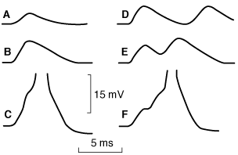
- jei ant neurono esti aktyvuotos tik kelios sinapsės, neuronas negeneruoja action potential, bet jo excitability esti ↑ (t.y. neuronas esti in subliminal fringe).
- jei ant neurono aktyvuota daug sinapsių, neuronas generuoja action potential (t.y. neuronas esti in discharge zone).
- jei sužadinsime B neuroną, tai susižadins 2 neuronai (X ir Y); analogiškai ir su C neuronu; bet jei sužadinsime B ir C neuronus kartu, bus iš viso sužadinti tik 3 neuronai (X, Y ir Z) – šis fenomenas vadinamas occlusion (decrease in expected response, due to presynaptic fibers sharing postsynaptic neuron): | 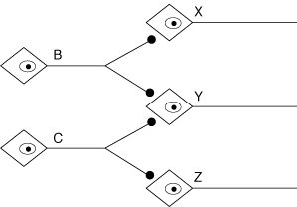

Inhibitory Postsynaptic Potential (Ipsp)
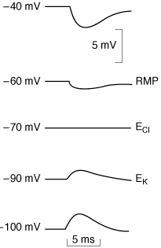 | - inhibitory transmitter opens Cl⁻ channels in postsynaptic membrane → hyperpolarization of postsynaptic membrane (IPSP).  jei membranos potencialas dirbtinai padaromas tokio dydžio kaip E_{Cl} (equilibrium potential for Cl⁻ ≈ -70 mV), tai dingsta varomasis suminis gradientas Cl⁻ jonams ir IPSP nebeįmanoma išgauti; jei membranos potencialas dirbtinai padaromas dar neigiamesnis negu E_{Cl}, tai pro atsidariusius Cl⁻ channels, Cl⁻ juda laukan ir depoliarizuoja membraną.  - during IPSP, neuron excitability is decreased (postsynaptic or direct inhibition) – several IPSPs summate (temporally, spatially).
- alternative methods to produce IPSP:
- opening of K⁺ channels
- closure of Na⁺ or Ca²⁺ channels.

Slow Postsynaptic Potentials
- in addition to classic EPSPs and IPSPs, slow EPSPs and IPSPs have been described (in autonomic ganglia, cardiac and smooth muscle, cortical neurons);
- have latency 100-500 ms;
- last several seconds;
- due to decreases / increases in K⁺ conductance;
- sympathetic ganglia also have late slow EPSP (latency 1-5 seconds; last 10-30 minutes; also due, at least in part, to decreased K⁺ conductance).

Action Potential Generation in Postsynaptic Neuron
- constant interplay of EPSPs and IPSPs on postsynaptic neuron → fluctuating membrane potential (algebraic sum of hyperpolarizing and depolarizing activity).
- if 10-15 mV depolarization (firing level) is attained, propagated spike results.
- in motor neurons, cell portion with lowest threshold is initial segment (axon portion at and just beyond axon hillock) - it is first part of neuron to fire (t.y. suminiai membranos potencialai iki jo turi ateiti pasyviai – elektrotoniškai); discharge is propagated in two directions:
  - down axon (antegrade)
  - back into soma (retrograde) - "wiping slate clean" for renewal of interplay of excitatory and inhibitory activity on cell.
N.B. at neuromuscular junction (after single stimulus) amount of Acch released is 10-fold greater than necessary to produce action potential (i.e. striated myocytes are always activated and does not depend on summation phenomena!).
- role of dendrites:
- for many years, standard view has been that dendrites are simply extensions of soma that expand area available for integration.
- recent data indicate that propagated action potentials can be recorded in some dendrites; Ca²⁺ pools can be formed in vicinity of individual dendritic spines (local changes in synaptic strength related to learning & memory?).

Inhibition & Facilitation At Synapses
  - indirect inhibition - due to effects of previous postsynaptic neuron discharge;
examples - refractory period, after-hyperpolarization.
- direct inhibition - not consequence of previous discharges of postsynaptic neuron;  examples - postsynaptic inhibition (due to IPSP), presynaptic inhibition. | 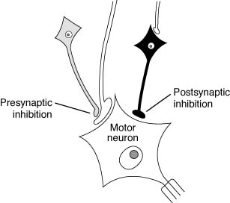
Neuromodulation (strictly in neurobiologic terms) - nonsynaptic action on neurons when substance alters sensitivity to synaptic stimulation / inhibition.
- frequently produced by neuropeptides and steroids (circulating and produced in CNS).

Presynaptic inhibition
- mediated by neurons that end on excitatory endings (forming axo-axonal synapses), not necessary very close to synaptic knobs (as commonly shown in illustrations).
- three mechanisms:
- increasing Cl⁻ conductance → ↓size of action potential (that passes near and reaches presynaptic membrane) → reduced Ca²⁺ entry in presynaptic membrane → ↓amount of excitatory transmitter released:  - opening voltage-gated K⁺ channels → ↓size of action potential …  - direct inhibition of transmitter release (independent of Ca²⁺ influx). | 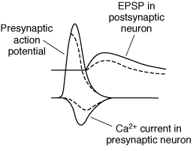
- GABA - first transmitter to be shown to produce presynaptic inhibition.
- GABA_{A} receptors directly increase Cl⁻ conductance.
- GABA_{B} receptors (via G protein) increase K⁺ conductance (baclofen - GABA_{B} agonist, effective in spasticity treatment) or directly block Ca²⁺ channels.
- example of presynaptic inhibition - "gating" of pain transmission.

Presynaptic Facilitation
Serotonin increases intraneuronal cAMP levels → phosphorylation of K⁺ channels closes K⁺ channels → slowed repolarization → ↑duration of action potential → Ca²⁺ channels open for longer period. | 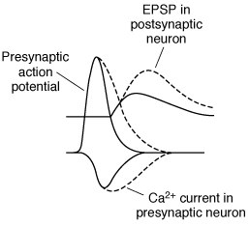
Organization of Inhibitory Systems
- "Afferent inhibition" - inhibitory systems converge on given postsynaptic neuron.  - "Negative feedback inhibition" - neurons inhibit themselves; e.g. each spinal motor neuron regularly gives off recurrent collateral that synapses with inhibitory interneuron (Renshaw cell) which terminates on this and other spinal motoneurons:  - "Feed-forward inhibition" (seen in cerebellum) - basket cells and Purkinje cells are excited by the same parallel-fiber excitatory input; stimulation of basket cells produces IPSPs in Purkinje cells (limits duration of excitation produced by any given afferent volley). | 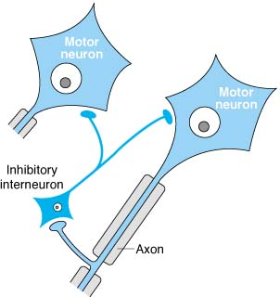

Chemical Transmission
- chemical transmitter is inactivated in one of three ways:
- presynaptic neurons reuptake (from synaptic cleft) most and possibly all amine and amino acid neurotransmitters.
- transmitter diffuses out of synaptic cleft.
- active enzymatic degradation in synaptic cleft (only Acch).

Receptors
- For each ligand there are many subtypes of receptors.
- There are receptors on presynaptic as well as postsynaptic elements for many secreted transmitters.
  - presynaptic receptors (s. autoreceptors) often inhibit further ligand secretion (feedback control); autoreceptors can also facilitate neurotransmitter release.
- Receptors group in large families:
- majority - receptors coupled to G proteins
- receptors as ligand-gated ion channels:
      - GABA_{A} receptors
      - glycine receptors
      - ionotropic glutamate receptors (NMDA, AMPA, kainate)
      - nicotinic Acch receptors
- Receptors are concentrated (due to specific binding proteins) in postsynaptic structures close to endings of neurons that secrete neurotransmitters specific for them.
- Prolonged exposure to ligands causes most receptors to become unresponsive (desensitization):
- homologous desensitization - loss of responsiveness only to particular ligand.
- heterologous desensitization - cell becomes unresponsive to other ligands as well.
  - desensitization mechanisms:
    - phosphorylation of receptor molecules
    - internalization of receptor molecules
    - destruction or ↓synthesis of receptor molecules (down-regulation).
  - desensitization results in substance tolerance & physical dependence; withdrawal is rebound phenomenon.
- Chronic receptor deprivation of its ligand → hypersensitization (important in organ or tissue transplants, which are deprived of physiologic neurotransmitter by denervation).

Synaptic Plasticity & Learning
- long-term changes in synaptic function can occur as result of history of synapse discharge; i.e. synaptic conduction can be strengthened / weakened on basis of past experience.
- can be presynaptic or postsynaptic in location.
- represent forms of learning & memory.

Posttetanic Potentiation
Brief (tetanizing) train of stimuli → Ca²⁺ accumulation in presynaptic neuron → transmitter release↑ → enhanced postsynaptic potentials (enhancement lasts up to 60 seconds).

Habituation (see S5. Memory & Learning)
Stimulus repeated over and over → gradual inactivation of Ca²⁺ channels → decreased intracellular Ca²⁺ → neurotransmitter release↓ → response to stimulus gradually disappears (habituation).
- can be short-term, or prolonged (if exposure is repeated many times).

Sensitization (see S5. Memory & Learning)
Repeated stimulus produces greater postsynaptic response if it is coupled (one or more times) with unpleasant / pleasant stimulus.
- due to presynaptic facilitation (discharge of serotonergic neurons that end on presynaptic endings).
- may occur as:
    - short-term memory - due to Ca²⁺-mediated change in adenylyl cyclase (→ cAMP production↑).
    - long-term memory - also involves protein synthesis, growth of presynaptic & postsynaptic neurons and their connections.

Long-term potentiation
Brief period of rapidly repeated stimulation - rapidly developing persistent enhancement of postsynaptic potential response;
- resembles posttetanic potentiation but is much more prolonged (can last for days) and is initiated by Ca²⁺ increase in postsynaptic neuron (vs. presynaptic in posttetanic potentiation).  - example at Schaffer collateral synapses on dendrites of pyramidal cells in CA1 region (hippocampus):  - released glutamate (Glu) binds to AMPA and NMDA receptors in dendritic spine.  - depolarization triggered by activation of AMPA receptors relieves Mg²⁺ block in NMDA receptor channel, and Ca²⁺ enters neuron with Na⁺.  - increase in cytoplasmic Ca²⁺ activates calmodulin (CaM), which in turn activates Ca²⁺/calmodulin kinase II (CaM kII).  - CaM kII phosphorylates AMPA receptor (P), increasing its conductance + moves more AMPA receptors into synaptic cell membrane.  - in addition, retrograde chemical signal (PS) (arachidonate or NO) may pass to presynaptic neuron, producing long-term increase in quantal release of glutamate. | 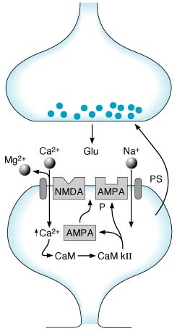

Long-term depression
- opposite of LTP (i.e. results in synaptic strength↓).
- produced by slower stimulation of presynaptic neurons and is associated with smaller rise in intracellular Ca²⁺ (than occurs in LTP).
- mechanism - dephosphorylation of AMPA receptors (decreasing their conductance) + facilitating their movement away from synaptic plasma membrane.

Bibliography for ch. “Neuron, Synapsis, Neurochemistry” → follow this link >>
NMS Neuroanatomy 1998, Histology 1997
Cotran “Robbins Pathologic Basis of Disease”, 6th ed., 1999 (1293-1297 p.)
Ganong “Review of Medical Physiology”, 2002

Viktor’s Notes℠ for the Neurosurgery Resident
Please visit website at www.NeurosurgeryResident.net

