Neurochemistry
Last updated: April 20, 2019
Classification of neurotransmitters 2
Catecholamines 3
Noradrenaline (s. Norepinephrine, Levarterenol) 4
Epinephrine 6
Dopamine 6
Serotonin (s. 5-hydroxytryptamine, 5-HT) 8
Histamine 10
Acetylcholine 11
Amino acids 13
Glutamate, Aspartate 13
γ-aminobutyric acid (GABA) 15
Glycine 16
Neuropeptides 16
Opioids 17
Substance P & other tachykinins 18
Cannabinoids 19
Gases 20
NO 20
CO 20
Transmitters of Motor System 20
Transmitters of Autonomic Nervous System – see p. A34

Neurotransmitter – endogenous chemical agent that relays information from one neuron to another through synapse; released by presynaptic cell (upon excitation), crosses synapse to stimulate or inhibit* postsynaptic cell by binding to receptor.
*final result (hyperpolarization or depolarization) is dependent on both transmitter and its receptor.
- to qualify as neurotransmitter, five classic criteria must be demonstrated:
  - presence within neurons
  - synthetic pathways with identified enzymes
  - release mechanisms from neuron into synapse
  - metabolic pathways to effect removal from synapse
  - mimicry of neuronal activity by iatrogenic application of neurochemical.
N.B. few neurotransmitters actually fulfill all criteria within CNS.

- original Dale-Feldberg law: single neuron makes use of the same transmitter at all of its synapses (i.e. each neuron releases one and only one neurotransmitter).
- reformulated Dale-Feldberg law: single neuron makes use of the same combination of chemical messengers at all of its synapses.
More than one neurotransmitter may be released at any given synapse!
- one transmitter may predominate (others – cotransmitters, comodulators) – classification of neuronal systems.
- tobulėjant tyrimo metodikoms, atrandami vis nauji transmiteriai ir specifiniai traktai.
pvz. dauguma katecholaminerginių traktų (labai ploni, nemielinizuoti) atrasta tik naudojant fluorescence microscopy).

Classification of neurotransmitters
- Monoaminergic – modulating action in CNS (cell bodies in relatively few locations with multiple branched axons projecting to almost all parts of CNS):
  - Catecholaminergic:
      - dopamine
      - noradrenaline
      - adrenaline
  - Serotonergic – serotonin
  - Histaminergic – histamine
- Cholinergic – acetylcholine – major transmitter in PNS (except postganglionic sympathetic neurons)
- Amino acids – major transmitters in CNS:
    - Excitatory – glutamate, aspartate, cysteic acid, homocysteic acid.
    - Inhibitory – γ-aminobutyric acid (GABA), glycine, taurine, β-alanine.
- Peptidergic – žinomi 28 peptidai (substance P & other tachykinins, ADH, oxytocin, CRH, TRH, GnRH, GRH, somatostatin, opioids, CKK, VIP, neurotensin, gastrin, glucagon, motilin, secretin, calcitonin gene-related peptide, neuropeptide Y, activins, inhibins, angiotensin II, galanin, ANP, brain natriuretic peptide, etc.)
- peptidinių transmiterių gausa pasižymi hypothalamus.
- Purines:
- adenosine (general CNS depressant, coronarodilator; stimulatory effects of caffeine and theophylline are due to adenosine receptors blockade).
- ATP
- Lipids: anandamide.
- Gases – small gaseous molecules: NO, CO.

Neurochemical pathways that bypass thalamus on their way to cerebral cortex:
- neurotransmitter – nucleus of origin:
  - acetylcholine – nucleus basalis of Meynert, hypothalamus
  - GABA, neuropeptides, histamine – hypothalamus
  - dopamine – substantia nigra, ventral midbrain tegmental nuclei
  - serotonin – raphe nuclei (midbrain)
  - noradrenaline – locus ceruleus
- features:
    - tai discrete nuclei (basal forebrain, hypothalamus, midbrain tegmentum).
    - direct, diffuse, profuse projections to entire cortex – modulatory action.
    - most ending form true synapses; some endings are not true synapses (noradrenerginės ir serotonerginės skaidulos).

- neurotransmiterių balansas limbinėje sistemoje nulemia mūsų nuotaikas, drives, instinctual behaviors; todėl reikia klausti ne “How are you?”, bet “Which neurochemical system predominates today – serotonergic, dopaminergic, cholinergic, or peptidergic?”.
- gausiausiai įvairių transmiterių randama in circuits of basal motor nuclei:
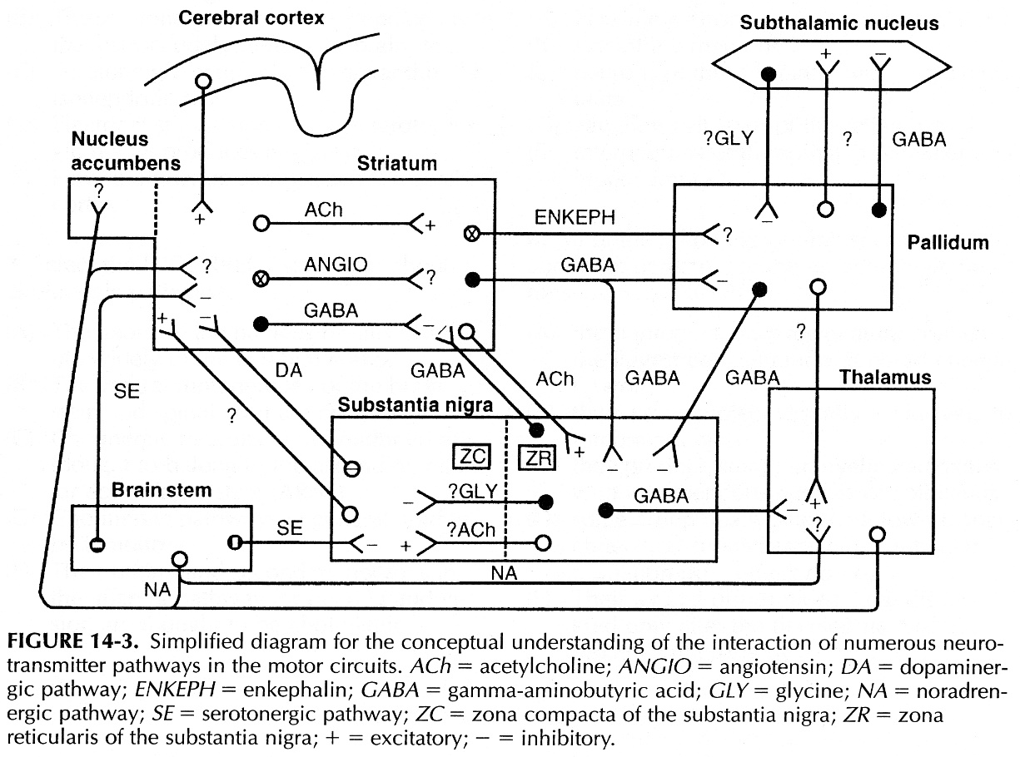

Catecholamines
biosynthesis & catabolism
see 812 p. (biochemistry), 2723 p. (endocrine system)
- sintezuojami iš Tyrosine.
- NA ir A katabolizuojami į VMA (vanillylmandelic acid); dopamine katabolizuojamas į homovanillic acid.
N.B. neuronuose katabolizmą vykdo monoamine oxidase (MAO)! ekstraceliulinius katecholaminus ardo catechol-O-methyltransferase (COMT)

Monoamine oxidase is predominantly intraneuronal enzyme (located in outer membrane of mitochondria).
- in human brain, at least two forms of MAO have been identified:
type A (specifically inhibited by clorgyline)
type B (specifically inhibited by deprenyl)

location
CNS
- katecholaminerginių neuronų taisyklė:
dopaminerginiai – in midbrain
noradrenerginiai – in pons
adrenerginiai – in medulla
- catecholaminergic projections (except dopaminergic) are diffuse, having less distinct body topography – modulate or gate many general functions (e.g. mood, attention).

Noradrenaline (s. Norepinephrine, Levarterenol)
- stored in characteristic small vesicles with dense core (granulated vesicles); transport into vesicles is blocked by reserpine, tetrabenazine.
- release into synapse is blocked by guanethidine, bretylium.
- reuptake is major mechanism of NA removal from synaptic cleft;
- noradrenergic neuron damage → no reuptake → more NA from other sources is available to stimulate receptors (denervation hypersensitivity).
- reuptake is blocked by tricyclic antidepressants, cocaine.
- reuptaken NA is oxidized by monoamine oxidase (MAO); deaminated derivatives (3,4-dihydroxy-mandellic acid, 3,4-dihydroxy-phenylglycol) enter circulation and are O-methylated in liver by catechol-O-methyltransferase (COMT).
- secreted extracellular NA is O-methylated by COMT, then normetanephrine is oxidized by MAO in liver.
- end product of catabolism (by either way) is vanillylmandelic acid (VMA) – secreted into urine.

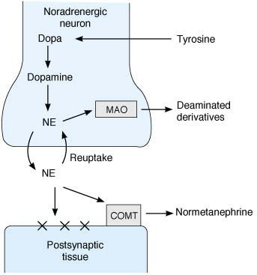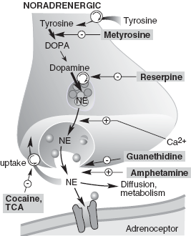
X, receptor

Release of NE is modulated by NE itself (acting on presynaptic α2-autoreceptors), and by ACh, angiotensin II:
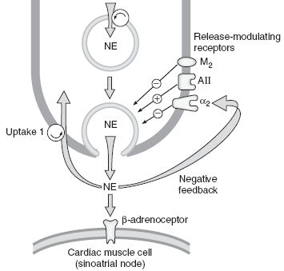

Noradrenerginiai neuronai in CNS tęsiasi nuo medulla iki basal forebrain, but most concentrate in pons:
- nucleus locus ceruleus:
- pagrindinės aferentės – dorsal raphe nucleus of midbrain (serotonerginis); šiaip aferentės labai plačios.
- eferentės į visas CNS struktūras (branduolys su plačiausiomis projekcijomis!) – aksonai šakojasi tūkstančius kartų.
- normal function of locus ceruleus system remains mystery (may be related to behavioral vigilance – orientation to unexpected external sensory stimuli).
- degeneruoja sergant parkinsonizmu (šalia substantia nigra degeneracijos).
- other tegmental pontine nuclei (of RF) – projekcijos ne tokios plačios.

- noradrenerginės skaidulos keliauja:
  - periventricular pathway (dorsal longitudinal fasciculus of Schütz, etc.)
  - central tegmental tract
  - ventral tegmental-medial forebrain bundle tract
- žievėje noradrenerginės skaidulos nesudaro aiškių sinapsių.
- noradrenergic axons have tendency to regenerate! (at least in lower animals)
- noradrenergic system↓ may cause depression, and ↑ may cause mania (now this catecholaminergic theory of mood disorders is questioned).

In PNS - most postganglionic sympathetic endings.
N.B. epinephrine is not mediator at postganglionic sympathetic endings!

Receptors
- serpentine receptors coupled via G_{s/i/q} proteins to adenylyl cyclase, K⁺ channels, phospholipase C.
Receptor Type | Second Messenger | Net Channel Effects
α_{1A}, α_{1B}, α_{1D} | ↑ IP₃ & DAG | ↓ K⁺
α_{2A}, α_{2B}, α_{2C} | ↓ cAMP | ↑ K⁺, ↓ Ca²⁺
β₁ | ↑ cAMP
β₂ | ↑ cAMP
β₃ | ↑ cAMP

Receptor | Agonist activity | - NA has greater affinity to α receptors; A – to β receptors.  - α receptors are sensitive to both NA and A; β receptors are sensitive to A but relatively insensitive to NA.  - isoproterenol is strongest β receptor agonist.  N.B. epinephrine is single most active endogenous amine on both α and β receptors!
α₁ | NA > A > isoproterenol
α₂ | A > NA > isoproterenol
β₁ | isoproterenol > A = NA
β₂ | isoproterenol > A >> NA
also see A34, A35 p.

Epinephrine
- cell bodies in medulla; project to hypothalamus (function is uncertain), thalamus, periaqueductal gray, and spinal cord.

Dopamine
pharmacology – see A35 p.
catabolism
≈ as in NA (i.e. reuptake, MAO, COMT); end product – homovanillic acid (HVA).

location
- small intensely fluorescent (SIF) cells in autonomic ganglia
- CNS
- adrenomedullary cells

Regions of CNS lacking dopaminergic perikarya:
  - Spinal cord
  - Nuclei of cranial nerves
  - Thalamus
  - Cerebral cortex & cerebellar cortex

Location of dopaminergic perikarya and axonal distribution
I. Telencephalon:
- Olfactory bulb (periglomerular cells) – have no axons at all (amacrine interneurons)*
- Septal area
II. Diencephalon:
- Retina – have no axons at all (amacrine interneurons)*
- Zona incerta – have short axons
- Hypothalamus (arcuate and periventricular nuclei) – have short axons - tuberoinfundibular tract (secretes dopamine into portal hypophysial vessels to inhibit prolactin secretion).
*inhibit lateral transfer of excitatory activity (signal-to-noise ratio↑)
III. Midbrain tegmentum:
- Substantia nigra (pars compacta – pigmented dorsal part) – axons of medium length run rostrally to:
  - corpus striatum (nigrostriatal tract) – main projection!; highly organized according to body topography!
  - thalamic motor nuclei, nucleus subthalamicus, hypothalamus (nigrodiencephalic fibers).
  - motor cortex (nigrocortical fibers).
N.B. in normal humans there is steady loss of dopamine receptors in basal ganglia with age (men > women)
- Ventral tegmental nuclei – send long axons – ryšiai platesni negu substantia nigra:
    - kaudaliai (!) pasiekia spinal cord.
    - rostraliai projektuojasi į:
entire cortex (mesocortical tract);
limbic structures (mesolimbic tract) - role in addiction to drugs, schizophrenia.

Receptors
Receptor Type | Second Messenger | Net Channel Effects
D₁, D₅ | ↑ cAMP
D₂ | ↓ cAMP | ↑ K⁺, ↓ Ca²⁺
D₃, D₄ | ↓ cAMP

- serpentine receptors coupled to G proteins.
- D₁, D₂ receptors are present in striatum - control extrapyramidal system; D₁ also relaxes renal vascular smooth muscle.
- D₃, D₄, D₅ receptors are present in limbic system.
- D₃ and D₄ play role in thought control (limit negative symptoms of schizophrenic processes); D₄ receptors have greater affinity for "atypical" antipsychotic drug clozapine - effective in schizophrenia (number of D₄ receptors is increased sixfold in schizophrenia).

Modulation of Dopamine activity
Dopamine activity can be increased by four mechanisms: see Mov10 p. for pharmacology
- increased synthesis - by giving levodopa, s. l-dopa - it is product beyond rate-limiting enzyme (tyrosine hydroxylase) + there is abundant amount of next enzyme (aromatic amino acid decarboxylase) in CNS;
- if dopa is combined with peripherally active DOPA decarboxylase inhibitor carbidopa, more dopa is delivered across BBB.
- levodopa + carbidopa action is enhanced by COMT inhibitor tolcapone. see Mov10 p.
- increased release – by drugs forcing release of presynaptic catecholamines (amphetamine, cocaine, methylphenidate).
- prolongation of activity:
  - by blocking re-uptake (amantadine – also stimulates dopamine release).
  - by blocking catabolism - with MAO B inhibitors (deprenyl, s. selegiline)
- receptor stimulation - by direct agonists at receptor level (bromocriptine, pergolide, pramipexole, ropinirole).
N.B. orally administered dopamine cannot cross blood-brain barrier!

Dopamine function can be antagonized by three mechanisms:
- decreased synthesis - α-methyl para-tyrosine inhibits tyrosine hydroxylase.
- decreased release (dopamine depleters) - reserpine and tetrabenazine (block vesicular packaging of dopamine).
- D receptor blockade - neuroleptics.

Clinical Effects:
dopamine↓ → extrapyramidal movement disorders (dopamine D₂ receptor blockade).
dopamine↑ → psychomotor activation, aggravation of psychoses.

Dysfunction of dopaminergic systems priklauso nuo:
- dopamine kiekio
- receptorių jautrumo
jei ↑ - involuntary movements
jei ↓ - bradykinesia, akinesia (parkinsonism)

Schizophrenia – overactive limbic dopaminergic system;
- dopamine antagonists pagerina būklę, tačiau sukelia parkinsonizmą;
- ilgai gydant dopamine antagonists, padidėja dopamino receptorių jautrumas → hyperkinesias (tardive dyskinesia).

Serotonin (s. 5-hydroxytryptamine, 5-HT)

- sintezuojamas iš Tryptophan :  - rate-limiting step (regulated by availability of substrate and cofactors; not influenced by 5-HT concentration!) - hydroxylation by tryptophan hydroxylase to form 5-hydroxytryptophan (5-HTP).  - decarboxylation by amino acid decarboxylase to serotonin.  - transportą į sinaptines pūsleles blokuoja reserpine, tetrabenazine.  - katabolizuojamas (after reuptake) su MAO (primarily MAO-A) į 5-hydroxyindoleacetic acid (5-HIAA)  see 813 p. (biochemistry)  - urinary 5-HIAA is index of serotonin metabolism rate.  - melatonin is N-acetylated derivative of serotonin;  N-methylated and N-formylated derivatives are also formed in brain (may be related to psychosis). | 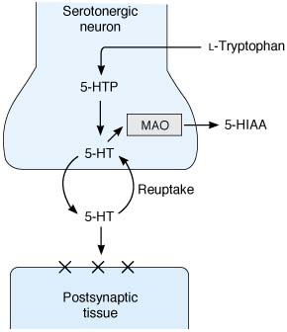

Highest 5-HT concentrations are in platelets and GI tract (90% of body’s serotonin; enterochromaffin cells, myenteric plexus).
- carcinoid tumors synthesize large quantities of serotonin.

In CNS esti tik 2% viso organizmo serotonino - serotonerginiai neuronai susitelkę in (para)median plane of brain stem tegmentum – raphe nuclei (nucl. raphes dorsalis, nucl. raphes medianus, nucl. raphes magnus, nucl. raphes pallidus, etc.).
- raphe nuclei degeneruoja (→ brain dysfunction) in Alzheimer disease (nucleus raphe dorsalis), chronic alcoholism.
- serotonerginiai neuronai turi primitive, large, relatively unbranched dendrites (isodendritic).
- dendritai sudaro persipinančius pluoštelius, kurie artimai kontaktuoja su blood vessels ir ventricular surfaces – chemical sampling of blood and CSF.
- serotonerginės projekcijos (kaip ir noradrenerginės) į visas CNS struktūras – augmenting and modulating role.
  - largest and most dense innervation to cerebral cortex (of known neurochemical systems) – diffusely and profusely!
  - neaišku, kiek serotonerginių skaidulų sudaro tikras sinapses žievėje – serotonergic terminals form baskets around cortical neurons.

Serotonin – inhibitory neurotransmitter
  - inhibicinės sinapsės ant preganglinių simpatinių neuronų nugaros smegenyse (cardiovascular control).
  - inhibicinės sinapsės in substantia gelatinosa (increase pain threshold); stimulation of periaqueductal gray matter → skausmas↓.
  - trūkstant serotonino (iš serotonino sintezuojamas melatoninas!) – insomnia, depresija.
  - serotonino perteklius – mania (serotonin may be involved in pathogenesis of obsessive-compulsive disorder), insomnia, GI & orgasmic disturbances.
  - tricyclic antidepressants, cocaine block reuptake → nuotaika↑; naujausi antidepresantai – selective serotonin reuptake inhibitors (SSRI); ecstasy causes serotonin release (euphoria) → serotonin depletion (depression).
  - hyperserotonemia gali sąlygoti autizmą.
  - discharge in serotonergic neurons in dorsal raphe nucleus causes migraine.
  - certain methylated serotonin derivatives (formed in brain as errors in metabolism) may cause psychosis.

Serotonino funkcijos nepilnai ištirtos; įtakoja:
- homeostasis (water balance, appetite, blood circulation*, temperature control, respiration, etc.)
*directly serotonin constricts splanchnic and renal vessels, and dilates skeletal muscle vessels; positive chronotropic & inotropic effects
- behavior:
  - activity level, aggression.
  - sexual
  - self-stimulation.
- pain responses.
- regulation of circadian rhythms (prominent serotonergic innervation of suprachiasmatic nuclei of hypothalamus)
- sleep (serotonergic neurons discharge rapidly in awake state, slowly during drowsiness, more slowly with bursts during sleep, and not at all during REM sleep).

Receptors
Receptor Type | Second Messenger | Net Channel Effects | Agonists | Antagonists
5HT_{1A}  (raphe nuclei, hippocampus) | ↓ cAMP | ↑ K⁺ | buspirone, ergots (ergotamine, dihydroergotamine,  methysergide)
5HT_{1B}  (striatum) | ↓ cAMP |  | -triptans
5HT_{1C}
(choroid plexus)
5HT_{1D} – similar to 5HT_{1B} | ↓ cAMP | ↓ K⁺ | -triptans
5HT_{2A} (neocortex, hippocampus, platelets) | ↑ IP₃ & DAG | ↓ K⁺ | hallucinogens (LSD, psilocin, mescaline, DOM, DMT) | methysergide,  cyproheptadine, ketanserin, hypnotics (eplivanserin, pimavanserin, pruvanserin, volinanserin)
5HT_{2C} | ↑ IP₃ & DAG
5HT₃ | - | ↑ Na⁺ |  | -setrons
5HT₄ | ↑ cAMP
5HT_{5A}, 5HT_{5B}
5HT₆
5HT₇

- serpentine receptors coupled via G proteins to adenylyl cyclase, phospholipase C.
- 5HT_{2A} mediate behavioral effects of serotonin.
- 5HT₃ are ligand-gated ion channels; 5HT₃ receptors are present in GI tract and area postrema - related to vomiting.
- 5HT₆ receptors have high affinity for antidepressant drugs.

Histamine
synthesis & catabolism
- formed by decarboxylation of Histidine.
- catabolized:
- to methylhistamine → methylimidazoleacetic acid by MAO.
- to imidazoleacetic acid (less important in humans) by diamine oxidase (histaminase).

Location & function
- posterior hypothalamus (tuberomammillary nucleus).
- axons project to all CNS parts.
- function is uncertain, but histamine has been related to arousal, sexual behavior, regulation of some anterior pituitary hormones secretion, blood pressure, drinking, pain thresholds.

Receptors
Receptor Type | Second Messenger | Effects
H₁ | ↑ IP₃ & DAG | allergy mediator (nasal and bronchial mucus production, contraction of bronchioles, pruritus, pain)
H₂ | ↑ cAMP | gastric acid secretion↑
H₃ (presynaptic)

- all three receptor types are found in peripheral tissues and brain.

Acetylcholine
Biosynthesis & catabolism
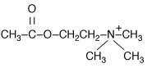 | choline + acetyl-CoA  ↓ choline acetyltransferase (CAT)  acetylcholine (acetyl ester of choline; quaternary ammonium)  ↓ acetylcholinesterase  choline + acetate
↓
active choline uptake into presynaptic neuron

- choline is not synthesized in CNS; it is transported into brain.
- choline transport (cotransport with Na⁺) into neuron can be blocked by hemicholinium.

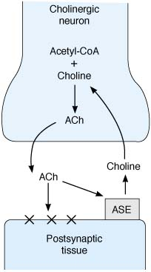  ASE, acetylcholinesterase;  X, receptor | Acch transport into vesicles (refill of recycled membrane vesicles):  - vesicle membrane has H⁺-ATPase;  - energy contained in H⁺ gradient is used to pump Acch into vesicle (secondary active transport).  - each vesicle contains 5000-10000 Acch molecules (Acch quantum).  Cholinesterases  - Acch rapidly dissociates from receptor and must be rapidly removed if repolarization is to occur.  - removal occurs by hydrolysis by acetylcholinesterase (s. true or specific cholinesterase);  - clustered in postsynaptic membrane and in synaptic cleft; some is found in glia.  - greatest affinity for Acch, but also hydrolyzes other choline esters.  - pseudocholinesterase (s. nonspecific cholinesterase) - found in plasma (synthesized in liver); also capable of hydrolyzing Acch.

N.B. cholinergic synapse is unique – transmitter is inactivated by enzymatic destruction (vs. in other synapses – by transmitter diffusion / active reuptake from synaptic cleft).

function & location
Acetylcholine – excitatory neurotransmitter.
Most significant functions of Acch – movement and memory-cognition.

Major transmitter of PNS:
- myoneural junction
- preganglionic autonomic endings
- postganglionic autonomic endings:
    - parasympathetic
    - sympathetic to sweat gland, and muscle vasodilator

In CNS cholinerginius neuronus galima lokalizuoti tik netiesiogiai – aptinkant choline acetyltransferase arba acetylcholinesterase:
- Striatum – intrinsic neurons.
- Basal forebrain – nucleus basalis of Meynert in gigantocellular complex of basal forebrain (projects diffusely to hippocampus and entire cortex - involved in motivation, perception, and cognition); degenerates in Alzheimer disease.
- RF (nucleus pedunculopontinus, nucleus laterodorsalis) – project strongly to intralaminar nuclei (dalis ARAS sistemos); ponto-geniculo-occipital spike system responsible for REM sleep is cholinergic.
- Some amacrine cells in retina.
  - distribution of cholinergic neurons resembles that of monoaminergic systems (cholinergic neurons project diffusely to much of brain) but differs in that there are also cholinergic interneurons and short cholinergic systems throughout CNS.

Receptors
Nicotinic (N) cholinergic receptors
- located in:
  - neuromuscular junctions (muscle type N receptors)
  - autonomic ganglia (neuronal type N receptors) also see A34, A35 p.
  - CNS (some N receptors are located presynaptically on glutamine-secreting axon terminals - facilitate glutamate release)
palengvinimas – N receptoriai esti pirmosiose sinapsėse už CNS ribų
- ligand-gated ion channels - activated receptor permits passage of Na⁺ (and other cations*) through central channel in receptor molecule.
* neuronal type N receptors have high permeability to Ca²⁺
(role in synaptic facilitation and learning);
muscular type N receptors also permit K⁺ efflux, but Na⁺ influx is much greater
(due to greater electrochemical gradient) → depolarization.
- receptor is made of 5 subunits (α, α, β, δ, γ); both α subunits must bind 1 Acch molecule each to activate whole receptor (i.e. open ion channel).

Muscarinic (M) cholinergic receptors
- located in:
- parasympathetic postaganglionic synapses (smooth muscle, heart, glands). see A34, A35 p.
- CNS (e.g. in striatum).
- serpentine receptors coupled via G proteins to adenylyl cyclase, K⁺ channels, phospholipase C.

Receptor Type | Second Messenger | Net Channel Effects | Agonists | Antagonists
N₁ (neuronal type + adrenal medulla) | – | ↑ Na⁺, Ca²⁺ | nicotine (initialy stimulates but then blocks) | hexamethonium
N₂ (muscle type) |  | ↑ Na⁺, K⁺ |  | α-bungarotoxin (snake venom), curare
M₁ (brain, gastric parietal cells) | ↑ IP₃ & DAG | ↑ Ca²⁺ | muscarine (alkaloid in toadstools, Amanita muscaria) | atropine, scopolamine,  selective M₃ antagonists (tolterodine, darifenacin, solifenacin)
M₂ (cardiac cells, smooth muscle) | ↓ cAMP | ↑ K⁺ (hyperpolarization)
M₃ (salivary glands, smooth muscle*, iris) | ↓ cAMP
M₄ (glands, smooth muscle) | ↑ IP₃ & DAG
M₅ | ↑ IP₃ & DAG
*GI, urinary bladder

M receptors affinities: muscarine > Acch > nicotine
N receptors affinities: nicotine > Acch > muscarine

Disorders
Acetylcholine↓:
- botulinum toxins – Acch sekrecijos inhibicija mioneuralinėje sinapsėje;
- Lambert-Eaton myasthenic syndrome – Acch sekrecijos inhibicija mioneuralinėje sinapsėje (antibodies to presynaptic Ca²⁺ channels);
- aminoglycosides – Acch sekrecijos inhibicija mioneuralinėje sinapsėje (inhibited presynaptic Ca²⁺ channels);
- myasthenia gravis – Acch receptorių autoimuninė inaktyvacija;
- α-bungarotoxin, curare – Acch receptorių blokada mioneuralinėje sinapsėje.
Acetylcholine↑:
- black widow spider venom – masyvi Acch sekrecija.
- organophosphates, carbamates, Amanita muscaria – acetilcholinesterazės inhibitoriai.
- Inocybe, Clitocybe mushrooms (toadstools) – contain muscarine (stimulation of M receptors).

Amino acids
Glutamate, Aspartate
synthesis & catabolism
- glutamate is formed by reductive amination of Krebs cycle intermediate α-ketoglutarate.
- aspartate is formed by transamination of Krebs cycle intermediate oxaloacetate.
- both reactions are reversible, and catabolism occurs via Krebs cycle.

location & functions
Principal excitatory transmitters of CNS! (as acetylcholine in PNS).
- depolarize many different mammalian neurons when delivered directly on their cell membranes.
- glutamate is responsible for 75% excitatory transmission in brain.
- aspartate is transmitter in pyramidal cells, spiny stellate cells in visual cortex.
- glutamate is excitotoxin - can kill cells by overstimulating them (huge Ca²⁺ influx);
  - glutamate reuptake (into neurons and glia) is important to prevent this.
  - during ischemia, anoxia, trauma, glutamate reuptake is inhibited → cascade of events that leads to cell death

Receptors
Glutamate Receptor Type | Second Messenger | Net Channel Effects
Metabotropic (11 subtypes) | ↓ cAMP or ↑ IP₃ & DAG | Ca²⁺↑
Ionotropic:
AMPA, kainate |  | ↑ Na⁺
NMDA |  | ↑ Na⁺, Ca²⁺
Metabotropic receptors are serpentine G protein-coupled receptors → activate phospholipase C;
- widely distributed in brain.
- involved in synaptic plasticity (particularly in hippocampus and cerebellum) – slow prolonged changes of cellular excitability.
Ionotropic receptors are ligand-gated ion channels.
- serve for fast neurotransmission.
- three general types, each named for glutamate congeners to which they respond in maximum fashion:
- kainate receptors (kainate is acid isolated from seaweed)
- AMPA receptors (for α-amino-3-hydroxy-5-methyl-4-isoxazoleproprionate)
- NMDA receptors (for N-methyl-D-aspartate).

NMDA receptors:
  - permits passage of relatively large amounts of Ca²⁺.
  - glycine binds to it and is essential for its normal response to glutamate.
  - at normal membrane potentials, channel is blocked by Mg²⁺; block is removed only when neuron is partially depolarized by activation of AMPA or other channels.
  - glutamate increases NO synthesis.
  - high concentration in hippocampus (receptor blockade prevents long-term potentiation) - NMDA receptors are generally assumed to be associated with learning and memory.
  - NMDA receptoriai gausiausi srityse, jautriausiose hipoksijai (cortex, striatum, hippocampus, cerebellum); insulto, hipoksijos, epilepsijos gydymui bandoma taikyti NMDA receptor antagonists, Ca²⁺ channel blockers, glycine.
  - manoma, kad inhaliaciniai anestetikai veikia per NMDA receptorius.
  - NMDA antagonists phencyclidine and ketamine (which produce amnesia and feeling of dissociation from environment) bind to site inside channel.
  - NMDA antagonist memantine – FDA approved for advanced Alzheimer disease.
  - NMDA antagonist are investigated as neuroprotective agents in ischemic stroke. see Vas5 p.

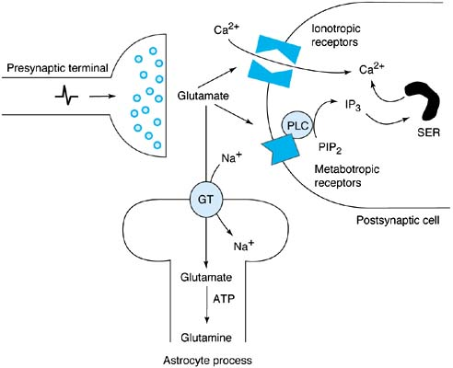
Synaptic actions of glutamate are terminated mainly by uptake through Na⁺-dependent glutamate transporters (GT) on glia.
  - 60% ALS (amyotrophic lateral sclerosis) patients have large decrease in glutamate transport activity.
  - riluzole (glutamate antagonist) – FDA approved for ALS.
  - acamprosate (glutamate antagonist) – alcoholism treatment.
- in astrocyte, glutamate is converted into glutamine (by glutamine synthetase).
- glutamine can be shuttled back to neurons for reconversion into glutamate.

γ-aminobutyric acid (GABA)
synthesis & catabolism
- formed by decarboxylation of glutamate by glutamate decarboxylase (GAD)*.
- catabolized (by transamination) to succinic semialdehyde by GABA transaminase (GABA-t)* → succinate → citric acid cycle.
*reikalingas kofaktorius vit.B₆
- there is in addition active GABA reuptake.

localization & functions
- localization of GABAergic systems is based on concentrations of:
  - GABA
  - GAD – preferred, nes:
    - glial cells also take up GABA;
    - glutamate (GABA precursor) itself acts as transmitter;
    - GABA often coexists with other transmitters.

GABAerginiai neuronai esti tik CNS
- GABA – principal inhibitory transmitter of CNS!
GABA vyrauja galvos smegenyse, vykdo presynaptic inhibition. see A4 p.
glycine vyrauja nugaros smegenyse, vykdo postsynaptic inhibition.
- GABA agonistai naudojami epilepsijai gydyti;
- GABA activity↓ → anxiety.
- GABA is present in 20-60% CNS synapses.
- GABA is 200-1000 times more abundant than dopamine or NE.
- žievėje GABAerginiai neuronai pasiskirstę tolygiai, bet negausiai (only 30% cortical interneurons use GABA as primary transmitter).
- GABAerginiai neuronai (Golgi II type) pagrinde sudaro short interneuronal circuits of entire CNS!
- some intermediate length GABAergic tracts:
  - most intrinsic neurons of cerebellum (esp. Purkinje cells)
  - substantia nigra (pars reticulata) striatum interneurons

substantia nigra pallidum
Huntington disease – loss of small striatum interneurons (→ GABA↓ in striatum) → hyperkinesias (dėl dopamine overactivity), tačiau GABAmimetic drugs are ineffective!
Autoantibodies to GAD (→ GABA deficiency) causes stiff-man syndrome (SMS).
Receptors & pharmacology
Receptor Type | Second Messenger | Net Channel Effects
GABA_{A} |  | ↑ Cl⁻
GABA_{B} | ↑ IP₃ & DAG | ↑ K⁺, ↓ Ca²⁺
GABA_{C} (only in retina) |  | ↑ Cl⁻
- GABA_{A} & GABA_{C} are ligand-gated ion channels; GABA_{B} is G protein-coupled.
- GABA_{A} is coupled to Cl⁻ channels (increases Cl⁻ conductance).
- GABA_{B} is coupled (via G protein) to K⁺ channels (increases K⁺ conductance).
- GABA_{A} is located postsynaptically (induction of IPSP), whereas GABA_{B} is located presynaptically (inhibits release of excitatory neurotransmitter).

GABA_{A} agonists:
  - benzodiazepines - increase frequency of openings of Cl⁻ channels
  - barbiturates - increase duration of openings of Cl⁻ channels
  - newer anticonvulsants (e.g. lamotrigine, topiramate).
  - alcohol, progesterone & deoxycorticosterone metabolites, muscimol (poison of Amanita muscaria).

GABA_{B} agonist - baclofen (spasticity treatment).

GABA receptor blockers:
      - tetanus toxin
      - picrotoxin, bicuculline (convulsant).

Glycine
Functions & receptors
- excitatory effect (by action on NMDA receptors).
- postsynaptic inhibition (primarily in brain stem & spinal cord)
  - glycine receptor is ligand-gated Cl⁻ channel.
  - action is antagonized by strychnine (→ convulsions and muscular hyperactivity).
  - glycine receptor mutation (glycine-gated channel defect) → hyperactive startle reflexes (startle disease, s. hyperexplexia); H: valproate, clonazepam.
  - tetanus toxin (tetanospasmin) blocks glycine receptors.
Three kinds of neurons responsible for direct inhibition in spinal cord:
    - neurons that secrete glycine
    - neurons that secrete GABA
    - neurons that secrete both (glycine and GABA in the same vesicles).

Neuropeptides
- peptidai, gausiai randami nervų sistemoje (išsk. cerebellum!!!); taip pat randama ir kitur (e.g. VIP).
- gaminami ribosomose ant mRNA matricos (in perikarya, dendrites, but not in axons!); proteolytic enzymes cleave neuropeptides from precursor proteins.
- supakuoti į vesicles, keliauja į axon terminal.
- CNS ir PNS kotransmiteriai (excitatory, inhibitory) – modify action of primary transmitters!
- traktai, kurie naudoja tą patį primary transmitter, gali naudoti skirtingus neuropeptides, i.e. pathways are neuropeptide-coded (“neuropeptide signature”).
- manoma, kad ontogenezėje neuronai gali keisti savo neuropeptidinę transmisiją – neuronų plastiškumo mechanizmas? (sąlyginiai refleksai, learning, memory)

Neuropeptidų klasifikacija
A. Hormones (neurohypophyseal neuropeptides) – oxytocin, ADH.
B. Releasing and inhibitory factors for hormones (adenohypophyseal releasing neuropeptides) – produced in hypothalamus.
C. Neurotransmitters (neuromodulators)*:
1. Opioid (e.g. endorphins, enkephalins).
2. Nonopioid (e.g. substance P, VIP, kai kurie adenohipofizės hormonai ir releasing-faktoriai).
*N.B. it seems that all of neuropeptides may function as neurotransmitters!

Opioids
function & pharmacology - see S20, S21 p.
pro-opiomelanocortin (POMC) – common precursor for:
ACTH, β-LPH, MSH, β-endorphin, Met-enkephalin
- skirtinguose neuronuose, veikiant skirtingiems skaldantiems enzimams, gaunami skirtingi POMC produktai.
- POMC gausiai randamas hipofizėje, hypothalamus ir kitose CNS dalyse, o taip pat plaučiuose, GI trakte, placentoje.

Opioid peptides (substances that bind to opioid receptors):
  - Enkephalins (Leu-enkephalin, Met-enkephalin)
  - β-Endorphin
  - Dynorphins
  - Neoendorphins (α and β)
  - Endomorphins (1 and 2)
- opioid peptides have number of different precursors; each has prepro form and pro form from which signal peptide has been cleaved.

opioid receptors
μ₁₋₂ receptor (site of morphine action): supraspinal analgesia (μ₁), euphoria (physical dependence), sedation, respiratory depression (μ₂), GI motility↓, miosis, GH and prolactin secretion↑.  κ₁₋₃ receptor: spinal analgesia, dysphoria, sedation, diuresis, miosis.  δ₁₋₂ receptor: analgesia. | 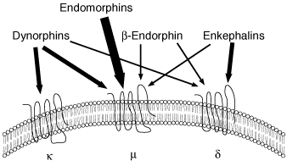
- all three are serpentine receptors coupled to G_{q} protein (↓ cAMP).
μ receptors increase K⁺ conductance (→ hyperpolarization).
κ and δ receptors close Ca²⁺ channels (→ transmitter release↓).

σ receptor: dysphoria, psychotomimetic effects (hallucinations), pupil dilation, respiratory & vasomotor stimulation.
- less specific – also binds nonopioids (e.g. phencyclidine).
ε receptor: catatonia.

Receptor distribution:
- CNS (μ receptors in brain, κ receptors in spinal cord):
limbic system (esp. amygdala): emotional behavior;
hypothalamus: neuroendocrine secretion;
medial thalamus: deep pain (poorly localized, emotionally influenced);
brain stem: respiration, cough, nausea & vomiting (without unpleasant sensation), BP maintenance, pupillary diameter, stomach secretion control;
substantia gelatinosa: attenuation of afferent painful stimuli.
- PNS (δ receptors): attenuation of painful stimuli.
- GI tract: motility↓
- Immune cells

Endogenous opioids
endorphins (“endogenous morphins”)
- neuropeptides that bind to same receptors that bind exogenous opiates.
- found in many parts of body.

enkephalins – pentapeptide endorphins.
- found in many parts of brain and GI tract.
- bind to pain-related receptors (nonaddicting analgesics) – presynaptically inhibit pain transmission by substance P.
- pagal amino rūgštį 5-oje pozicijoje:
- Leu-enkephalin
- Met-enkephalin

dynorphins - group of seven peptides with similar amino acid sequences.
- geographically coexist with enkephalins.

Substance P & other tachykinins
Tachykinins (differ at amino terminal end but have in common carboxyl terminal sequence of Phe-X-Gly-Leu-Met-NH₂, where X is Val, His, Lys, or Phe):
Gene | Polypeptide tachykinin | Receptors
SP/NKA (substance P/neurokinin A) | Substance P  Neurokinin A  Neuropeptide K  Neuropeptide α  Neurokinin A (3-10) | Substance P (NK-1)  Neuropeptide K (NK-2)
NKB (neurokinin B) | Neurokinin B | Neurokinin B (NK-3)

Substance P
- substance P receptor is G protein-coupled (↑ IP₃ and DAG).
- substance P is primary transmitter for pain in dorsal roots (i.e. first synapse in pathway for slow pain):
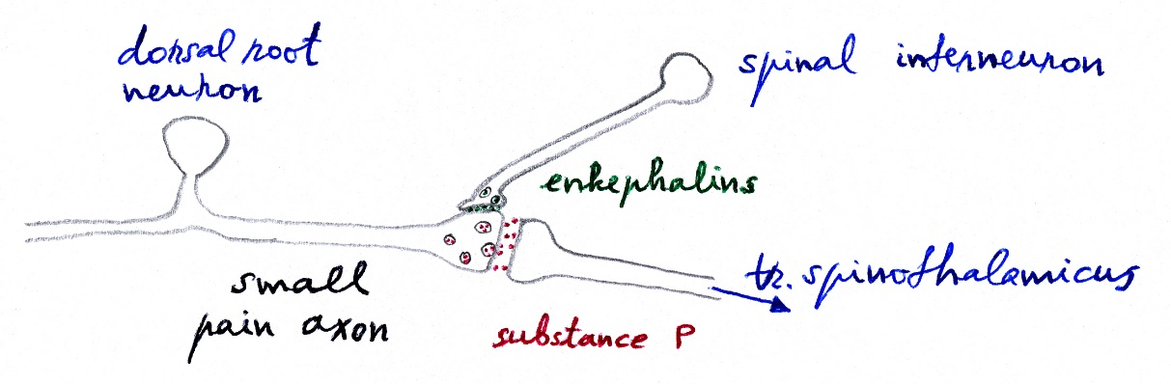
- enkephalins vykdo presinaptinę inhibiciją – blokuoja substance P išsiskyrimą ir skausmo perdavimą.
- kaip veikia serotonerginiai bulbospinaliniai skausmą slopinantys aksonai nežinoma (inhibicinės sinapsės in substantia gelatinosa?).
- substance P randama ir žarnyne bei uždegimo židiniuose – viena iš stipriausiai lygiuosius raumenis veikiančių medžiagų (dilation of blood vessels, contraction of intestine).
- substance P is probable mediator of local axon reflex (upon injection into skin, it causes redness and swelling) – neurogenic inflammation.

fosaprepitant (Emend®) – when administered IV is rapidly converted to aprepitant - selective high-affinity antagonist of human substance P/neurokinin 1 (NK₁) receptors – strong antiemetic.
- crosses BBB (effective in central emesis).
- augments antiemetic activity of ondansetron and dexamethasone.
- indicated in combination with other antiemetic agents for prevention of acute and delayed nausea and vomiting associated with initial and repeat courses of highly emetogenic cancer chemotherapy (incl. high-dose cisplatin).

Cannabinoids
- two receptors (CB₁, CB₂) have high affinity for exogenous Δ⁹-tetrahydrocannabinol (THC, dronabinol) - psychoactive ingredient in marijuana (derived from hemp plant, Cannabis sativa).
- hashish is made from plant resin - contains more psychoactive cannabinoids.
- THC accumulates in body fat, metabolized in liver.
- mild tolerance and mild psychologic dependence occur with continued frequent use. see Psy23 p.

CB₁ receptor
- endogenous ligand for receptor is anandamide (derivative of arachidonic acid):
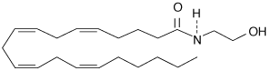

CB₂ receptor
- endogenous ligand palmitoylethanolamide (PEA); physiologic role of this compound is unsettled (acts peripherally to augment analgesic effects of anandamide).

Marijuana effects (immediately after smoking; maximal effects take about 20 minutes; effects largely disappear by 3 hours):
  - euphoria, relaxation (high) → drowsiness, calmness, sexual arousal↑, dream states, analgesia.
  - enhancement of sensory activity, distortion of time and space.
  - decreased muscle strength, impaired short-term memory, mental activity, coordination and highly skilled motor activity (such as driving car).
  - appetite↑, xerostomia, reddening of conjunctiva! (no change in pupils!)
  - tachycardia, postural hypotension.
  - high doses → toxic psychosis with hallucinations, delusions (e.g. schizophrenia exacerbation).
N.B. seizures do not occur!!!
- some report increased suspiciousness, paranoia, and aggressiveness; others become quite withdrawn socially.
- fatal overdose has not been documented!
- treatment of intoxication: reassurance in quiet setting (!!!), diazepam; for acute psychotic state – haloperidol.

Medical use: severe emesis caused by chemotherapy, appetite enhancement in AIDS patients.

Gases
- act by diffusion (rather than being secreted in packets at synapses and binding to receptor sites on membranes).
- relax smooth muscles.
- involved in memory.

NO
Not to be confused with "laughing gas" nitrous oxide (N₂O)!!!
- sintezuojamas iš Arg by NO synthase, type 1. see 1317 p. (cardiovascular)
- not stored – i.e. synthesized when needed.
- retrograde neurotransmitter – released from postsynaptic cells, activates presynaptic potentials.
- crosses cell membranes with ease and binds directly to guanylyl cyclase → cGMP↑.
- very short-lived: NO → nitrite → nitrate → urine.
- NO is strong smooth muscle relaxant (e.g. in enteric NS, pulmonary vasculature).
- klinikinis pritaikymas: nėščiųjų toksikozės gydymas, plautinės hipertenzijos gydymas.

CO
- susidaro hemo katabolizmo metu. see 822 p. (biochemistry)
- like NO, activates guanylyl cyclase.

Transmitters of Motor System
- LMN (lower motor neuron) in spinal cord uses acetylcholine.
- internuncial pool of inhibitory neurons in spinal cord use GABA and glycine (Renshaw cell).
- UMN (upper motor neurons) of cerebral cortex use glutamate (this includes all motor outputs from cerebral cortex – corticospinal, corticobulbar tracts, inputs to rubrospinal and tectospinal systems, etc).
- output neurons in basal ganglia and cerebellum use GABA.
basal ganglia transmitters – see A102 (2) p.

Bibliography for ch. “Neuron, Synapsis, Neurochemistry” → follow this link >>
NMS Neuroanatomy 1998,
Ganong “Review of Medical Physiology”, 2002
Lippincott’s Pharmacology Review, 2nd ed., 2000
“The Merck Manual”, 17th ed., 1999
“Stedman’s Medical Dictionary”, 27th ed., 2000
Goetz “Textbook of Clinical Neurology”, 1st ed., 1999 (241-243 p.)

Viktor’s Notes℠ for the Neurosurgery Resident
Please visit website at www.NeurosurgeryResident.net

