Basal Ganglia
Last updated: April 20, 2019

Basal Ganglia Physiology & Connections 1
Subthalamic Nucleus (corpus Luysi) 2
Topography 2
Neurotransmitters 2
Connections 3
Inactivation 3
Overexcitation 3
Nucleus Accumbens (NAcc) 3

Basal Ganglia Physiology & Connections
Normally, there is balance between systems:
Cholinergic (excitatory) – intrastriatal.
- there are two types of cholinergic receptors in basal ganglial structures - nicotinic and muscarinic (interneurons within striatum are primarily muscarinic, but nicotinic receptors also populate striatum as well as other basal nuclei).
Glutamatergic (excitatory) – everywhere excitation is needed, except intrastriatal.
Dopaminergic (inhibitory via D₂ receptors; excitatory via D₁ receptors) – nigrostriatal.
GABAergic (inhibitory) – everywhere inhibition is needed (e.g. striatonigral, striatopallidal), except nigrostriatal.
Striatum inhibits pallidum!

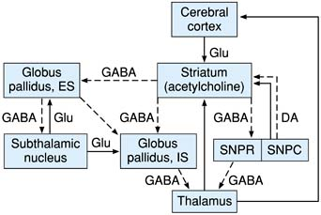 | solid lines – excitatory pathways; dashed lines – inhibitory pathways;  subthalamic nucleus projection to substantia nigra (pars compacta) is omitted for clarity  thalamocortical projections probably use glutamate  cerebral cortex = motor, supplementary, and premotor cortices

black arrows – excitation;  speckled arrows - inhibition.  GP_{i} = globus pallidus internal segment;  GP_{e} = globus pallidus external segment;  STN = subthalamic nucleus;  SNr = pars reticularis of substantia nigra;  SNc = pars compacta of substantia nigra;  thal = thalamus. | 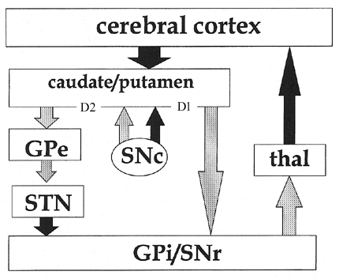
Note two primary pathways from striatum to internal pallidus + subst. nigra reticulata:
"direct" pathway (inhibitory) - flows monosynaptically to GP_{i}
"indirect" pathway (in sum excitatory) - has intermediate synapses in GP_{e} and subthalamic nucleus.
N.B. subthalamic nucleus regulates output of basal ganglia to thalamus!
- direct and indirect pathways balance one another physiologically.
- tonic dopaminergic input (from subst. nigra compacta on striatum) activates direct pathway neurons that express D₁ receptors and inhibits indirect pathway neurons that express D₂ receptors.

Afferents to basal nuclei:
- cortical afferents to caudate/putamen are somatotopically organized and excitatory (glutamate).
limbic system provides major input to striosomes, whereas neocortical areas primarily project to matrix of striatum.
- brain stem input is primarily inhibitory from pars compacta substantia nigra (dopamine).

Efferents from basal nuclei:
- emanate primarily from GP_{i} and pars reticulata substantia nigra.
- tonic inhibitory influence passes to thalamic nuclei (i.e. various influences on GP_{i} provide phasic modulation of tonic inhibition on thalamus).
- final part - excitatory thalamocortical projections.

Subthalamic Nucleus (corpus Luysi)
Topography
see p. A110 (1) >>
- oval shaped.
- lies on inner surface of peduncular portion of internal capsule.
- caudally, medial part of nucleus overlies rostral portion of substantia nigra.

Neurotransmitters
- dominant neurotransmitter - glutamate - powerful excitatory effects on target structures (STN has been suggested to be major driving force and central feature of basal ganglia circuitry)
N.B. classically STN was thought be GABAergic and inhibitory!

Connections
- primary motor cortex - major input to STN; arises from layer V; primarily collaterals of axons terminating elsewhere (STN is pivotal nucleus through which cortex influences output of basal ganglia*); STN has no efferent projections to cortex.
*cortex is thought to drive basal ganglia circuitry, not only through its classic input to striatum but also through STN!
- globus pallidus pars externa (GPe) – heavy inhibitory afferents to STN; STN projects excitatory input to all parts of greater pallidal complex
- substantia nigra pars reticulata (SNr) – receives excitatory input from STN.
- pedunculopontine tegmental nucleus (PPN) - reciprocal excitatory projections.

Inactivation
Hemiballismus (series of violent chorea-like movements) – see p. Mov1 >>

Overexcitation
PD symptoms (akinesia, rigidity, and tremor).
- in PD patients DBS of STN alleviates parkinsonian symptoms

Nucleus Accumbens (NAcc)
- topography: region in the basal forebrain rostral to the preoptic area of the hypothalamus.
- NAcc + olfactory tubercle = ventral striatum

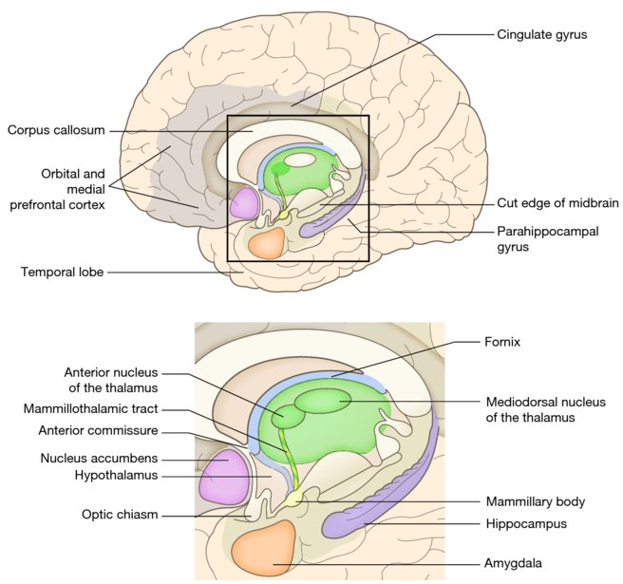

- afferents: mesolimbic pathway (dopaminergic neurons) → ventral striatum (GABAergic medium spiny neurons)
- NAcc can be subdivided:
- NAcc core
- NAcc shell.
- NAcc role:
- cognitive processing of aversion, motivation, reward (i.e., incentive salience, pleasure, and positive reinforcement) - significant role in addiction;
- reinforcement of learning
- lesser role in processing fear (a form of aversion), impulsivity, and the placebo effect.
- encoding of new motor programs

Bibliography for ch. “Basal Nuclei” → follow this link >>

Viktor’s Notes℠ for the Neurosurgery Resident
Please visit website at www.NeurosurgeryResident.net

