PNS
Last updated: April 20, 2019
Anatomy 1
Histology 2
Physiology 3
Axoplasmic Transport 3

Anatomy
- Blood vessels

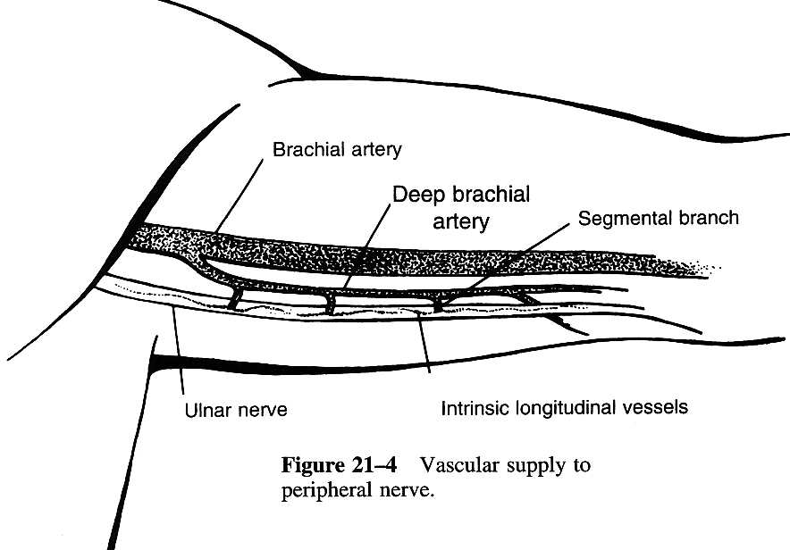

- Three levels of connective tissue (within which fibers and vessels lie)
  - Epineurium
      - external epineurium – tough, surrounds periphery of nerve.
      - internal epineurium – loose, occupies space between fascicles.
    - represents up to 50% of cross-sectional area of nerve trunk.
    - thicker where nerve crosses joint.
    - well-developed vascular plexus runs within epineurium.

  - Perineurium – surrounds each fascicle.
    - thin, dense, multilayered connective tissue.
    - blood-nerve barrier: tight basement membranes within perineurium protect endoneurial space.
    - tensile strength of perineurium maintains intrafascicular pressures.
    - vascular structures traverse perineurium obliquely to enter endoneurial space.

  - Endoneurium – surrounds individual myelinated nerve fiber or group of unmyelinated nerve fibers.
    - delicate collagenous matrix with fibroblasts, mast cells, and capillary network

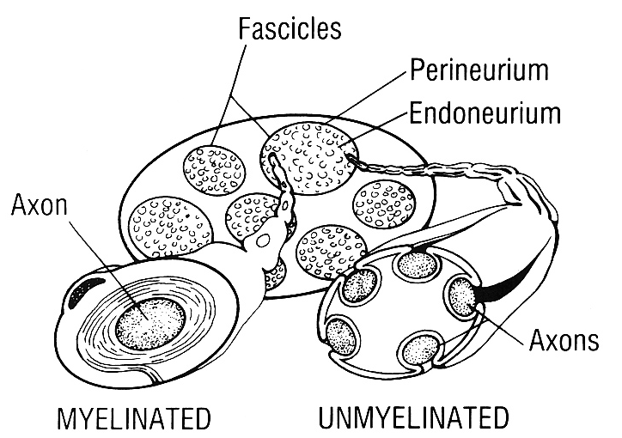

- Nerve fibers
    - all axons are bundled together into fascicles:
- fascicles are located within internal epineurium.
- bounded by perineurium.
    - fascicles are often grouped together into grouped fascicles.
- can be easily divided along internal epineurial planes.
- major peripheral nerves contain many grouped fascicles.
- there is constant redistribution of fascicular organization along peripheral nerve (interfascicular plexuses allow for interconnections).
    - fascicles are more numerous and smaller where nerve crosses joint.
- smaller fascicles and more internal epineurium between them allows for increased protection of nerve fibers.

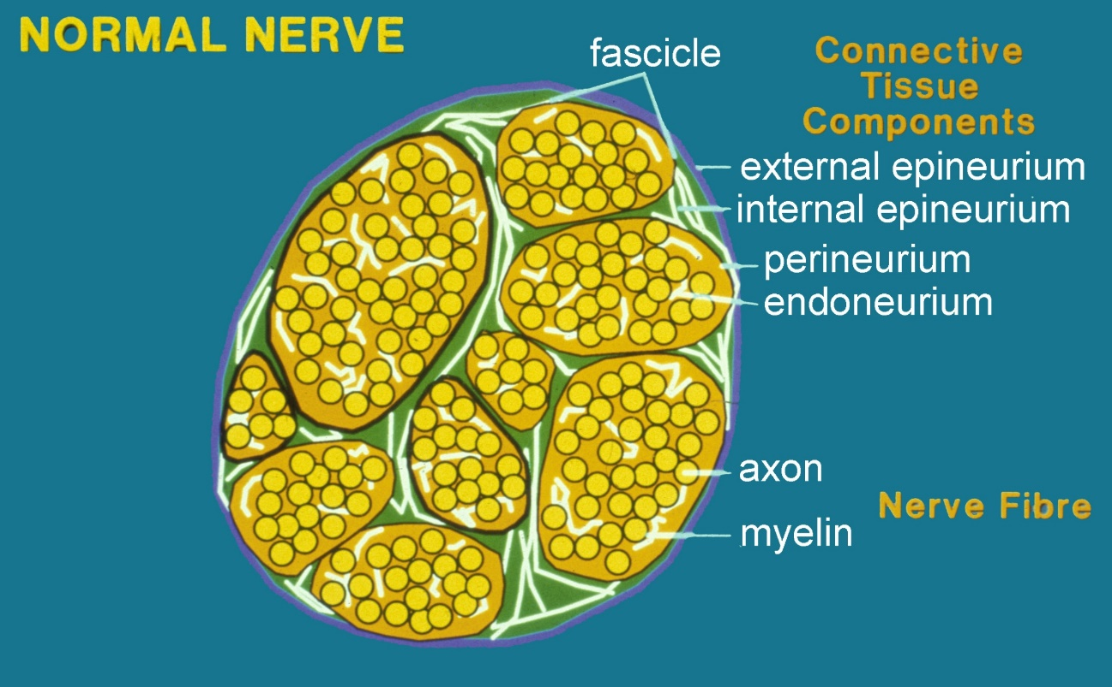

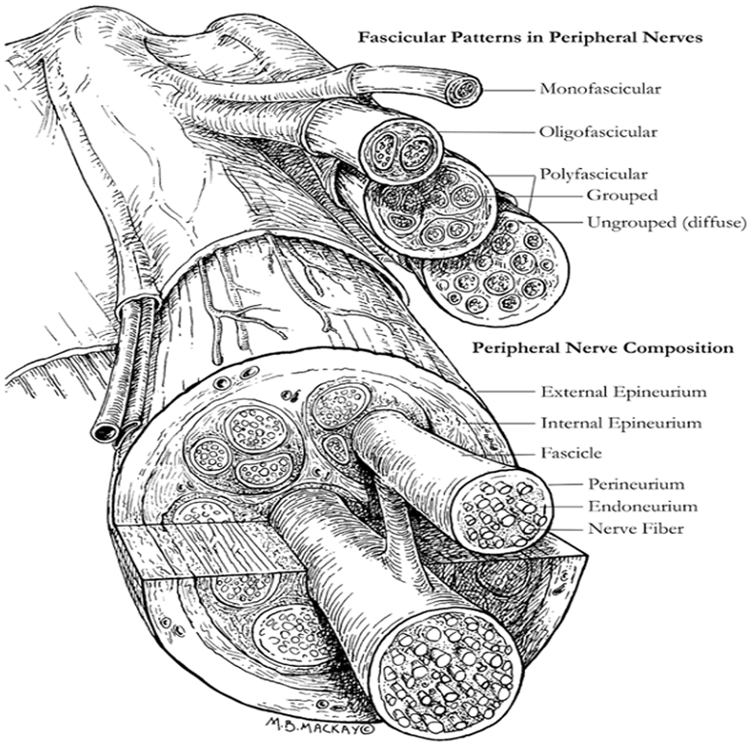

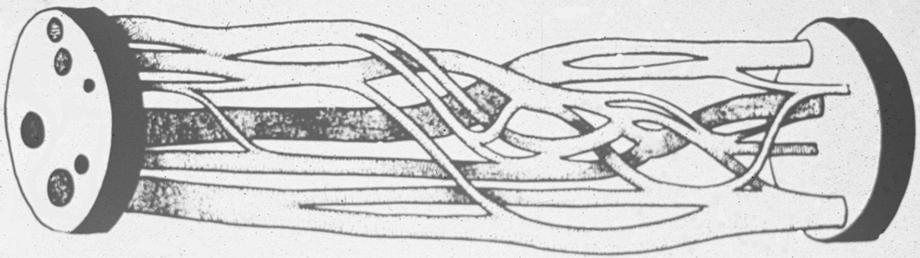

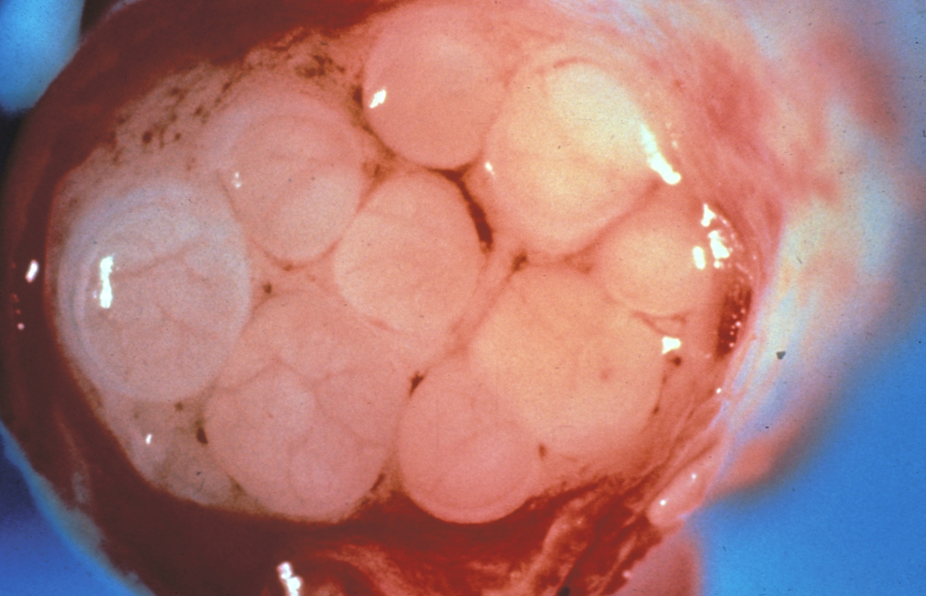

Histology
- up to 500 Schwann cells may myelinate single axon.
- peripheral nerves contain both myelinated and unmyelinated fibers (in average 4:1) traveling within each fascicle.

Myelination process:
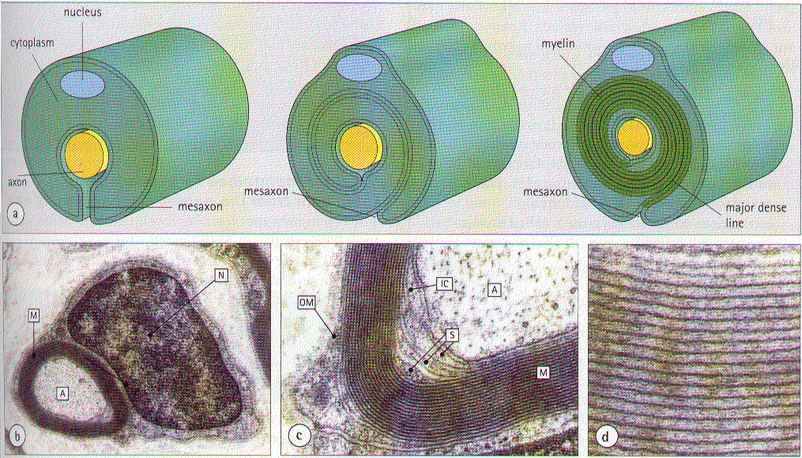

Unmyelinated fibers:
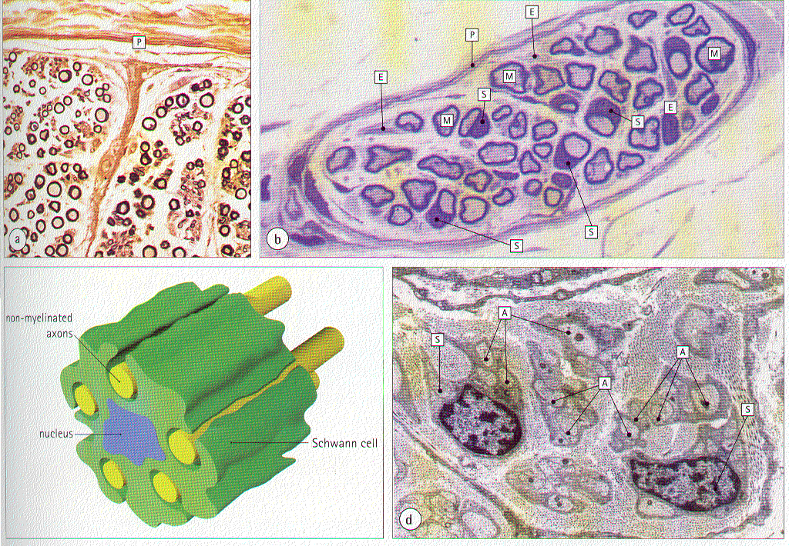

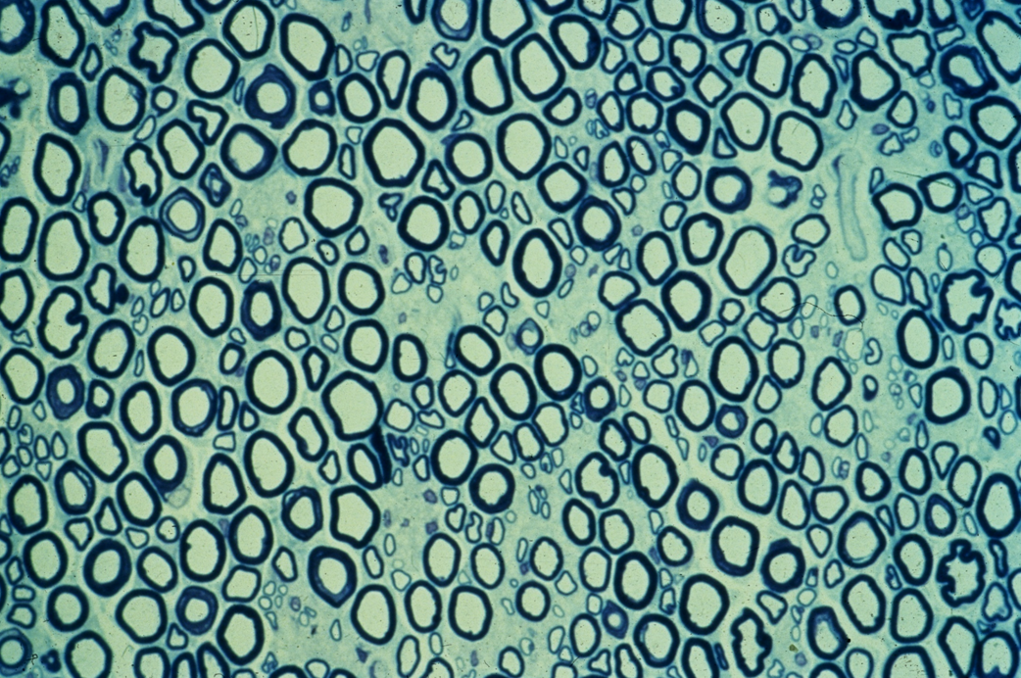

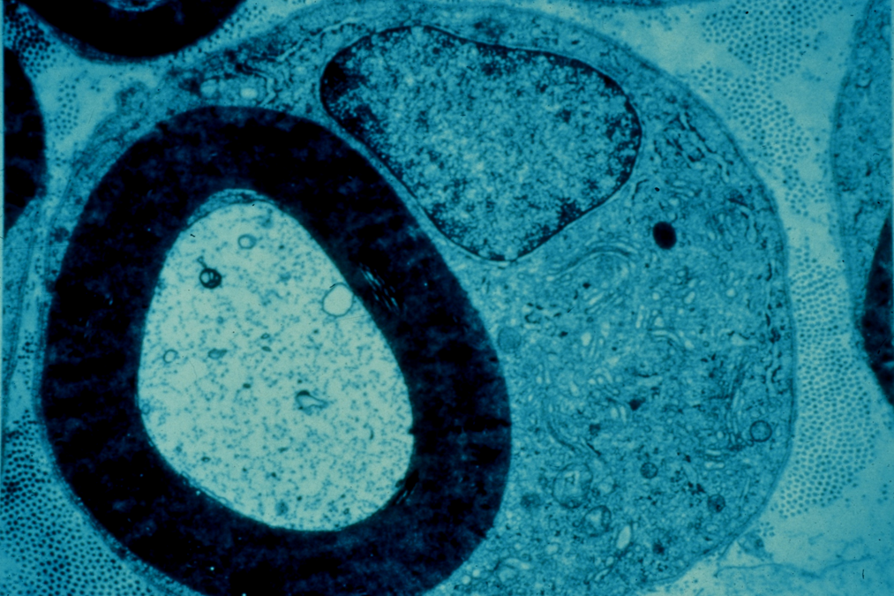

Physiology
Axoplasmic Transport
- multiple transport mechanisms:
  - Anterograde transport:
    - fast
    - slow – speed is high but frequent prolonged stops (average speed is slow)
- all cellular proteins and neurotransmitters are produced in cell body; cell body may be at significant distance from terminal axon.

  - Retrograde fast transport (removes breakdown products from distal axon back to cell body).

Bibliography for ch. “PNS” → follow this link >>

Viktor’s Notes℠ for the Neurosurgery Resident
Please visit website at www.NeurosurgeryResident.net

