Reflex
Last updated: April 20, 2019
Monosynaptic reflexes: stretch reflex 1
Polysynaptic reflexes: withdrawal reflex 7

Reflex - simplest form of coordinated movement - rapid, stereotyped, involuntary (automatic), neurally* mediated response to sensory stimulus (that requires quick reaction at involuntary level).
*by relatively simple neuronal network

Monosynaptic reflex arc – sensory neuron synapses directly on motoneuron:
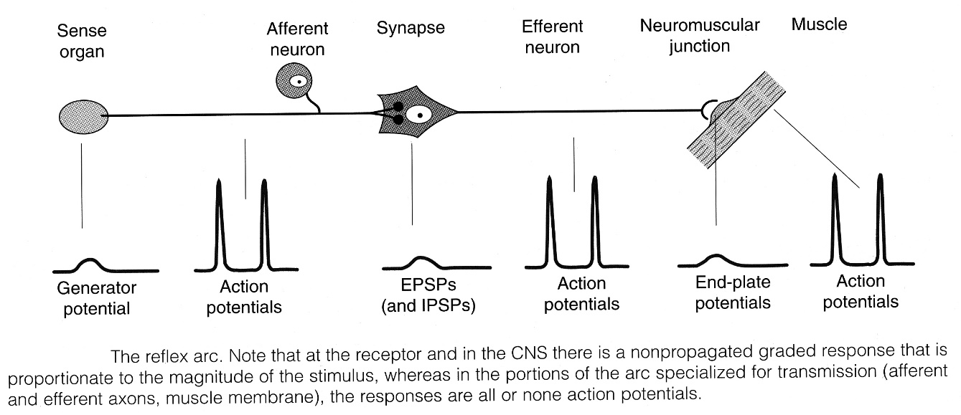

Polysynaptic reflex arc – įsiterpia interneuronai (excitatory or inhibitory) – refleksas gali apimti visą kūną!

Some reflexes (esp. spinal and brain stem reflexes) are normally elicited only in developing nervous system.
- as higher motor centers mature, these reflexes are suppressed.
- these reflexes reemerge if damage to higher motor centers occurs (unmasking of such reflexes is good example of hierarchical organization of motor system).

Monosynaptic reflexes: stretch reflex
stretch reflex - when skeletal muscle is stretched*, it contracts (short phasic contraction - reflex is also termed phasic stretch reflex) to oppose lengthening.
* by tapping tendon with reflex hammer
- harder muscle is stretched, stronger is reflex contraction.
- sense organ is muscular spindle.
- muscles involved in precise movements contain large numbers of spindles (vs. muscles involved in posture maintenance).
- neurotransmitter at central synapse is glutamate.

Reaction time - time between stimulus and response.
- reaction time in knee jerk is 19-24 ms.
- central delay - time taken to traverse spinal cord (for knee jerk it is 0.6-0.9 ms; since minimal synaptic delay is 0.5 ms, only one synapse could have been traversed).

Muscular spindles
– fusiform end organ: 3-10 much smaller skeletal muscle fibers (intrafusal fibers) enclosed by capsule:
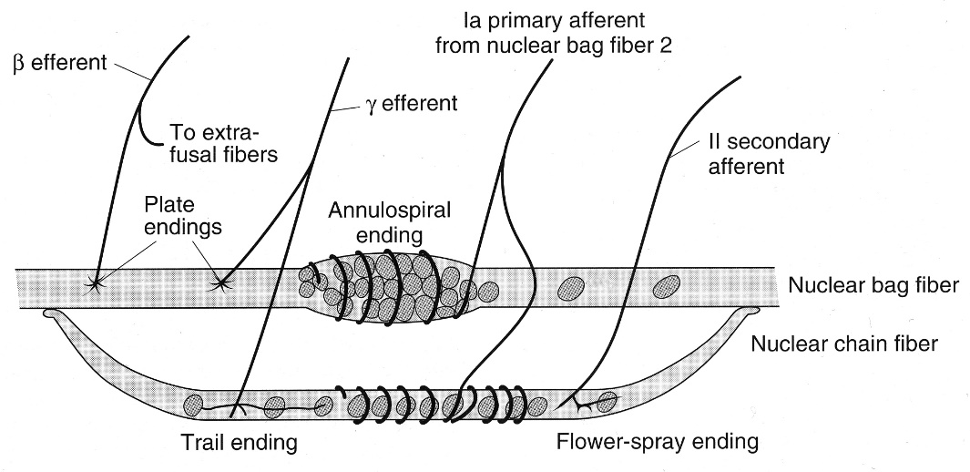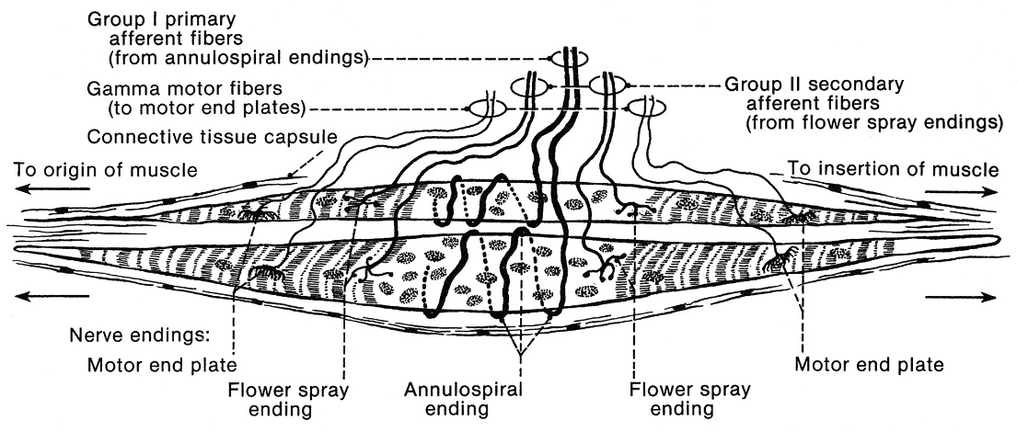
intrafusal fibers:
- more embryonal in character, have less distinct striations.
- in parallel with extrafusal muscle fibers (main function - to sense length of extrafusal muscle fibers).
- ends of intrafusal fibers are contractile, whereas central portions probably are not.
- types of intrafusal fibers:
- nuclear bag fibers (typically 2 per spindle - fiber 1 with low myosin ATPase activity + fiber 2 with high myosin ATPase activity) - contain many nuclei in dilated central area (bag).
- nuclear chain fibers (typically ≥ 4 per spindle) - thinner and shorter, lack definite bag; ends connect to sides of nuclear bag fibers.

Sensory innervation of intrafusal fibers:
- primary (annulospiral) endings - terminations of single rapidly conducting (group Ia) afferent fiber; wrap around center of all intrafusal fibers; make monosynaptic pathway to α-motoneuron.
- secondary (flower-spray) endings - terminations of group II sensory fibers; located nearer ends of nuclear chain fibers; make polysynaptic pathways to α-motoneuron.

Motor innervation of intrafusal fibers – γ-motoneurons (their Aγ axons constitute 30% of fibers in ventral roots! - small motor nerve system); their endings are of two histologic types:
- motor endplates (plate endings) on nuclear bag fibers – concerned with dynamic aspects.
- extensive networks (trail endings) primarily on nuclear chain fibers – concerned with static aspects.
- in addition, larger β-motoneurons innervate both intrafusal and extrafusal fibers.

Function of Spindles
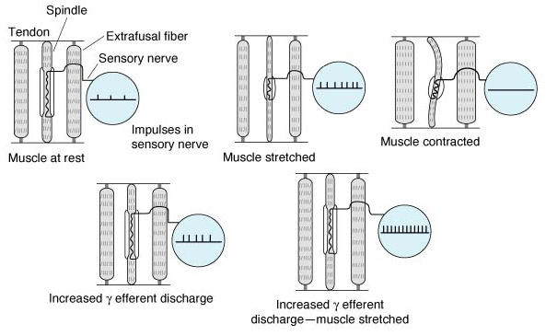
- when muscle is passively stretched, spindle is stretched, its sensory endings are distorted → receptor potentials generated → train of action potentials (frequency proportionate to stretching degree).
- primary endings on nuclear bag fibers show dynamic response (discharge most rapidly while muscle is being stretched and less rapidly during sustained stretch) – i.e. feel rate of stretch*.  - primary endings on nuclear chain fibers show static response (discharge at increased rate throughout stretch period) – i.e. feel length of stretch. | 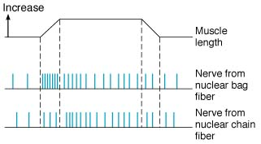
*helps to dampen oscillations caused by conduction delays in feedback loop regulating muscle length (normally small oscillation in this feedback loop occurs - physiologic tremor ≈ 10 Hz).
- when muscle actively contracts, spindle stops firing (muscle shortens while spindle does not) – unloading ← it is undesirable because CNS stops receiving information about muscle shortening.
- γ-motoneuron stimulation (prevents unloading) → shortening of contractile ends of intrafusal fibers → stretching nuclear bag portion → deforming annulospiral endings → initiating impulses in Ia fibers → reflex muscle contraction.
N.B. CNS can contract muscle:
directly (used practically) – via stimulation of α-motoneurons
indirectly (only theoretically) – via stimulation of γ-motoneurons (via stretch reflex).
- if muscle is stretched during discharge of γ-motoneuron, additional action potentials are generated by additional stretch of nuclear bag region (i.e. ↑rate of discharge in Ia fibers).
N.B. γ-motoneuron discharge increases spindle sensitivity (i.e. spindle sensitivity varies with rate of γ efferent discharge).
accuracy of movement depends on sensory feedback; γ-motoneuron provides way for motor system to ensure accuracy of sensory information it is receiving.
- γ-motoneuron discharge increases during discharge of α-motoneurons ("α-γ linkage") → spindle shortens with muscle → spindle discharge continues throughout contraction (i.e. spindle remains capable of responding to stretch and reflexly adjusting α-motoneuron discharge throughout contraction).
spindles provide α-motoneuron with excitatory input in addition to that coming from higher CNS centers
Control of γ-motoneuron discharge
- γ-motoneurons are regulated to large degree by descending tracts from number of areas in brain - sensitivity of muscle spindles is adjusted to meet needs of postural control.
- anxiety increases γ discharge → hyperactive tendon reflexes in anxious patients.
- unexpected movement → increased γ discharge.
- skin stimulation (esp. by noxious agents) → increased γ discharge to ipsilateral flexor muscle spindles while decreased to extensors (+ opposite pattern in contralateral limbs); e.g. Jendrassik's maneuver.

Spindles participate in control of motor performance; example:
- task – lift weight.
- CNS activates simultaneously α and γ motoneurons (alpha-gamma co-activation);
- in correct performance, intrafusal and extrafusal fibers contract at equal rate, so Ia firing remains constant.
- if CNS initially underestimated weight to be lifted and activated insufficient numbers of α motoneurons → extrafusal fibers do not shorten; intrafusal fibers still shorten and so become stretched → Ia firing↑ → CNS increases stimulation of α motoneurons.

Size principle:
small α-motoneuron → small motor unit (i.e. small number of myocytes) → small myocytes (less strong, fatigue-resistant)
- in any motor task, small motor units (small motoneurons are more excitable) are recruited before larger ones.
- motor cortex does not need to specify which motoneurons to activate, it just sends signal (so number of cortex neurons can be greatly reduced!):
    - for minimal signal, only small motor units (with type I red muscle fibers) are activated and small force is generated;
    - if more force is required, cortex sends strong signal and larger (stronger) motor units (with type II white muscle fibers) are also activated (recruitment)
- small motor units thus participate in all motor tasks – they develop fatigue resistance (remember: small type I red muscle fibers are fatigue resistant).
- other method of increasing force is to increase firing frequency of α-motoneurons already recruited (maximum muscle contraction at maximum firing frequency is known as fused tetanus).

Reciprocal inhibition  - afferent Ia fibers from spindles pass directly to spinal α-motoneurons supplying the same muscle.  - at the same time, collaterals of afferent Ia fibers end on Golgi bottle neurons (inhibitory interneurons) that secrete glycine → IPSPs (postsynaptic inhibition) in α-motoneurons supplying antagonistic muscles.  N.B. antagonist muscle inhibition reflex is disynaptic! | 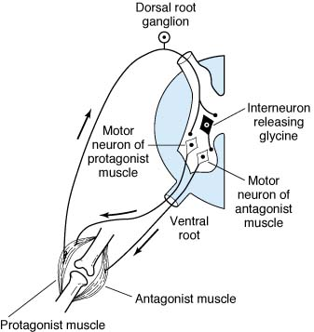

Inverse Stretch Reflex (s. autogenic inhibition)
- when muscle is stretched great enough, reflex contraction suddenly ceases and muscle relaxes.
- receptor for this reflex is Golgi tendon organ (s. neurotendinous spindle) – net-like collection of knobby nerve endings among tendon fibers (near musculotendinous junction):
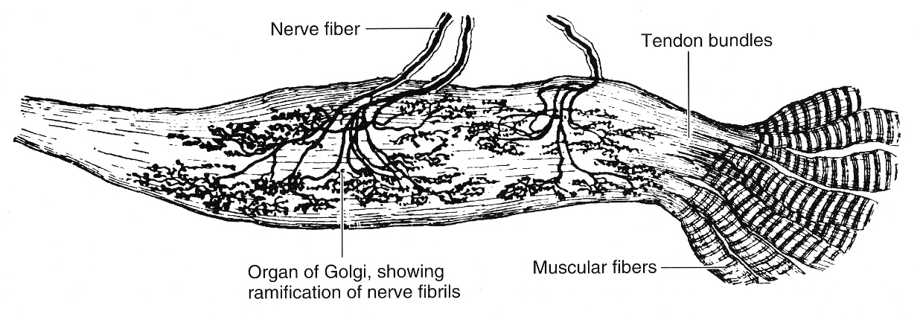
- Golgi tendon organs do not have efferent innervation.
- Golgi tendon organs make myelinated, rapidly conducting (Ib group) sensory nerve fibers.
- Ib fibers end on spinal inhibitory interneurons (glycine-ergic) that, in turn, terminate directly on α-motoneurons supplying the same muscle + Ib fibers make excitatory connections on α-motoneurons supplying antagonists to muscle.  N.B. Golgi tendon organs are in series with muscle fibers - are stimulated by both passive muscle stretch and active muscle contraction – sense muscle tension (vs. muscular spindles – are in parallel - sense muscle length; active muscle contraction inhibits spindle activity).  - stimulation by passive stretch is not great - more elastic muscle fibers take up much of stretch (this is why it takes strong stretch to produce relaxation).  - discharge is regularly produced by active muscle contraction - Golgi tendon organ functions as transducer in feedback circuit that regulates muscle force & tension (analogous to muscular spindle feedback - regulates muscle length & velocity). | 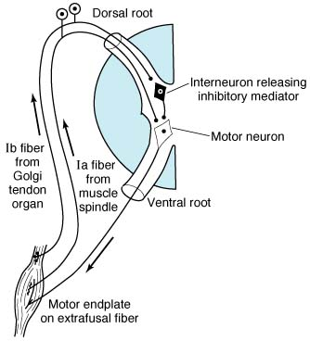
- importance of spindles & Golgi tendon organs: section of afferent nerves to limb causes limb to hang loosely in semiparalyzed state.
N.B. inverse stretch reflex is disynaptic!

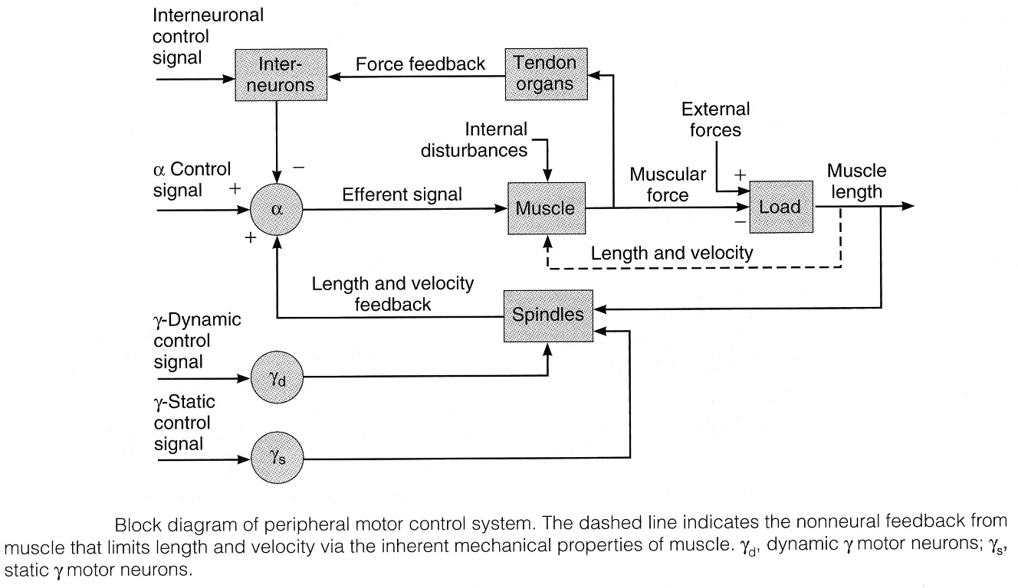

Internuncial Inhibitory Pool
- complex reflexes use many inhibitory GABA-ergic interneurons.  - one of these inhibitory interneurons is Renshaw cell - receives recurrent collateral from α-motoneuron axon (before it leaves ventral horn).  - Renshaw cell axon releases glycine → contacts (postsynaptic inhibition):  - the same alpha motor neuron  - other alpha motor neurons that innervate agonists.  - inhibitory interneuron mediating reciprocal inhibition.  - Renshaw cell shortens reflex (i.e. α-motoneurons can inhibit their own activity).  - Renshaw cell (and other internuncial neurons) also receives input from higher motor centers, which can modulate activity of these neurons (fine-tune reflex movements). | white cells and synapses are excitatory; black cells are inhibitory. 1 and 2 are anterior horn cells; 3 is Renshaw cell; 4, 5, 6 are interneurons. Note spinal and supraspinal inputs to inhibitory interneurons. Note also recurrent collateral from α-motoneuron contacting Renshaw cell, which in turn makes contact with anterior horn cell and sends recurrent collateral to inhibit inhibitory interneuron mediating reciprocal inhibition.
 | 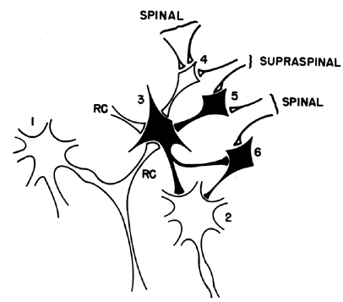

Muscle Tone (tonus)
- muscle resistance to passive stretch.
- rate of γ discharge:
low → hypotonic muscles
high → hypertonic muscles.
hypertonic (spastic) muscle - resistance to stretch is high because of hyperactive stretch reflexes.

Lengthening reaction (clasp-knife effect)
In hypertonic muscles, sequence of moderate stretch → muscle contraction, strong stretch → muscle relaxation is clearly seen.
e.g. passive elbow flexion meets immediate resistance (stretch reflex in triceps muscle); further stretch activates inverse stretch reflex → resistance to flexion suddenly collapses.

Clonus
- regular, rhythmic contractions of muscle subjected to sudden, maintained stretch.
- mechanism - burst of impulses from hyperactive spindles discharges all motoneurons supplying muscle at once (synchronized motoneuron discharge) → muscle contraction stops spindle discharge → muscle relaxes; however, stretch has been maintained, and spindles are stimulated again.

Polysynaptic reflexes: withdrawal reflex
- sensory neuron activates pathway A with three interneurons, pathway B with four interneurons, and pathway C with four interneurons; one interneuron in pathway C connects to neuron that doubles back to other interneurons (reverberating circuits).  - some pathways convey information to higher CNS centers.  - because of synaptic delay, activity in branches with fewer synapses reaches motoneurons first, followed by activity in longer pathways → prolonged motoneuron bombardment from single stimulus. | 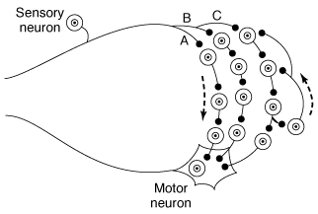

withdrawal (s. flexor, pain) reflex (typical polysynaptic reflex): noxious (usually painful*) stimulation of skin → flexor** muscle contraction & inhibition of extensor muscles → stimulated part is withdrawn from stimulus.
N.B. sense organ for this reflex is nociceptor!
* in normal individual only painful stimulus elicits reflex; when descending motor pathways are damaged, lighter, nonpainful stimulus may elicit reflex (e.g. Babinski reflex).
**flexor in physiologic (not anatomic) sense.
e.g. plaštakos pirštų ekstenzoriai laikomi fiziologiniais fleksoriais (pvz. netyčia paėmus karštą daiktą į ranką)
- if stimulus is applied to limb, response includes extension of opposite limb (crossed extensor reflex).
- strong stimuli generate activity in interneuron pool which spreads to all four extremities; this is easily demonstrated in spinal animal (modulating effects of brain impulses abolished by section of spinal cord);
e.g. if hind limb of spinal cat is pinched, stimulated limb is withdrawn, opposite hind limb extended, ipsilateral forelimb extended, and contralateral forelimb flexed.
  - spread of excitatory impulses up and down spinal cord is called irradiation of stimulus; increase in number of active motor units is called recruitment of motor units.
  - irradiation of stimulus is generally transient; spinal cord also shows prolonged changes in excitability (due to activity in reverberating circuits, prolonged effects of synaptic mediators) - central excitatory state and central inhibitory state; when central excitatory state is marked, excitatory impulses may irradiate also to autonomic areas.
e.g. in chronic paraplegics, mild noxious stimulus may cause, in addition to prolonged withdrawal-extension patterns in all 4 limbs, urination, defecation, sweating, and blood pressure fluctuations (mass reflex).
- important features of withdrawal reflex:
  - flexion of stimulated limb gets it away from irritation source, and extension of other limb supports body.
  - pattern assumed by all four extremities puts animal in position to run away from offending stimulus.
  - withdrawal reflexes are prepotent (i.e. preempt spinal pathways from any other reflex activity taking place at the moment).
- as strength of noxious stimulus is increased:
  - flexion becomes greater (stimulus irradiates & recruits more and more motoneurons).
  - response becomes more prolonged - due to prolonged, repeated firing of motoneurons (called after-discharge – continuous firing after sensory impulsation have ceased) - due to continued bombardment by impulses arriving by complicated (parallel) and circuitous (reverberating) polysynaptic* paths.
N.B. response outlasts stimulus! – while keeping limb away from stimulus, brain decides where to place it next.
*in monosynaptic reflexes afterdischarge is not possible
  - reaction time is shortened (stronger stimuli produce more action potentials → more branches become active → spatial and temporal summation of EPSPs occurs more rapidly).
N.B. in general, withdrawal reflex has long latency (polysynaptic + uses slow conducting afferent fibers [Aδ, C] from nociceptors).

Local Sign - exact flexor pattern of withdrawal reflex depends on limb part that is stimulated.
e.g. if medial limb surface is stimulated, response will include some abduction, whereas stimulation of lateral surface will produce some adduction with flexion.
N.B. fact that reflex responses are stereotyped does not exclude possibility of their being modified by experience (e.g. habituation, sensitization).

Fractionation:
- supramaximal stimulation of any of sensory nerves from limb never produces as strong contraction as that elicited by direct electrical stimulation of muscles themselves (i.e. each input goes to only part of motoneuron pool for extremity flexors).

Occlusion
- if all sensory inputs are stimulated one after the other, sum of tension developed by stimulation of each is greater than that produced by direct electrical stimulation of muscle or stimulation of all inputs at once (i.e. various afferent inputs share some of motor neurons).

Bibliography for ch. “Cranial Neuropathies” → follow this link >>
NMS Neuroanatomy 1998, Physiology 2001
Ganong “Review of Medical Physiology”, 2002

Viktor’s Notes℠ for the Neurosurgery Resident
Please visit website at www.NeurosurgeryResident.net

