Cortical Sensory Physiology
Last updated: April 21, 2019

N.B. cortex is not necessary for conscious perception of basic senses, but necessary for discriminative senses!

Cortical Plasticity
- extensive neuronal connections in sensory areas can be changed relatively rapidly to reflect use of represented area.
- cortical connections of sensory units have extensive convergence / divergence - connections can become weak with disuse and strong with use.
- these plastic processes occur during development and in adulthood.
- these plastic processes occur in all types of sensory cortices (cutaneous sensations, auditory, visual).
- plasticity also occurs in motor cortex.
Examples:
- if digit is amputated, cortical representation of neighboring digits spreads into cortical area that was formerly occupied by amputated digit.
- if cortical area representing digit is removed, somatosensory map of digit moves to surrounding cortex.
- extensive, long-term deafferentation of limbs (or amputations) → dramatic shifts in somatosensory representation in cortex (e.g. limb cortical area responds to touching face, i.e. face touching causes sensations projected to missing limb).
- if monkey is trained to make fine discriminations with one digit, cortical representation of digit expands.
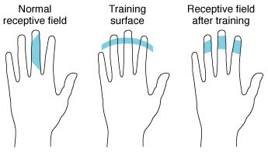 | - receptive fields of single neurons in finger part in sensory cortex are on single digit; if monkey is trained to carry out task that involves contact with only distal portions of I-III digits, single neurons acquire receptive fields on all three digits:  Left: Normal receptive field of single cortical neuron on side of II finger.  Middle: Training monkey to do task involving stimulation of distal portions of I-III fingers.  Right: Resulting receptive field in cortical neuron.

- during development, experimentally routing visual input to auditory cortex creates visual receptive fields in auditory system.
- tactile and auditory stimuli increase metabolic activity in visual cortex in blind individuals.
- deaf individuals respond faster and more accurately to moving stimuli in visual periphery.

The same type of plasticity is observed in motor cortex!

Bibliography for ch. “Cerebrum” → follow this link >>

Viktor’s Notes℠ for the Neurosurgery Resident
Please visit website at www.NeurosurgeryResident.net

