Blood Supply of Spinal Cord
Last updated: October 6, 2023

Longitudinal Arteries 1
Anterior spinal artery 1
Posterior spinal arteries 3
Segmental Arteries 4
Great segmental medullary artery (s. artery of Adamkiewicz, arteria radicularis magna, artery of lumbar enlargement) 7
Upper thoracic anterior segmental medullary artery (s. artery of Albrecht von Haller) 12
Regional Vascularization 12
Venous drainage 14

Longitudinal Arteries
Anterior spinal artery
- main artery of spinal cord!
- origin (at level of foramen magnum) – from confluence of bilateral VA (V4) branches.
- courses along fissura mediana ant. (from olivary nucleus to conus medullaris).
  - duplication of ASA is frequent in cervical region.
  - due to its long course, ASA requires additional* arterial supply via anterior radiculomedullary arteries in order to maintain adequate blood flow to entire cord.
*because of opposing flow from adjacent ascending and descending radicular branches that supply ASA, watershed areas exist at border of each region (esp. upper thoracic region).
- diameter 0.2-0.8 mm - thinnest in thoracic cord and thickest in conus region.
- (para)median branches (sulcal arteries) → central (sulcocommissural) arteries feed the bulk of gray matter (except dorsal horns)
Poorest in midthoracic region – there it can be discontinuous!
- circumferential branches (circumferential arteries) feed ventrolateral columns of white matter and anastomose with aa. spinales post.

A. spinalis ant. territory – anterior 2/3 of spinal cord:  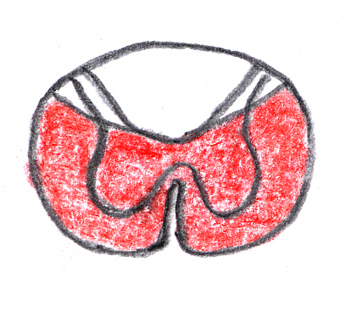 | 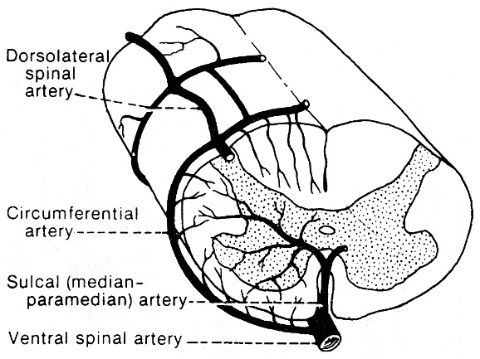
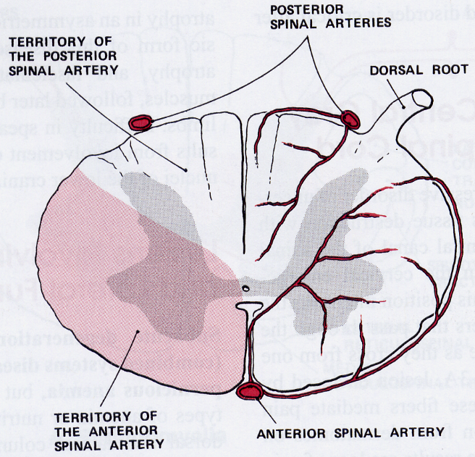

Left vertebral artery DSA (frontal view): anterior spinal artery (arrowheads) originating from left vertebral artery (arrow):
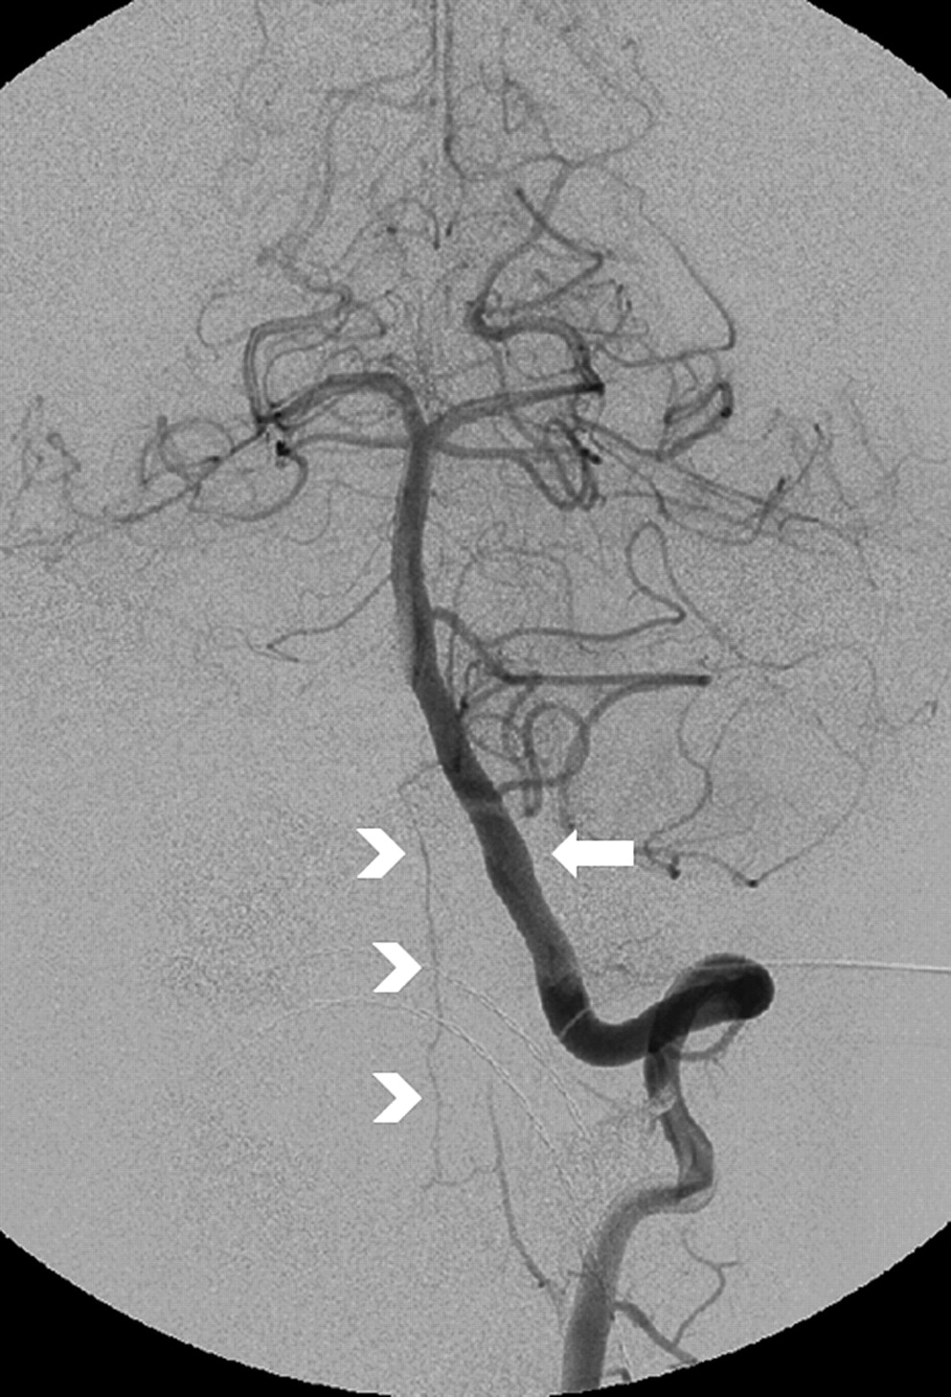

Posterior spinal arteries
- smaller (diameter < 0.5 mm) paired arteries lying just medial to dorsal roots.
- originate at the level of the foramen magnum by branches of VA or PICA.
  - additional supply from posterior radiculomedullary arteries.
- form rete of communicating vessels - very resistant to interruption of its blood supply.
- feeds dorsal columns and posterior dorsal horns.

(1) Posterior spinal arteries; (2) anterior spinal artery; (3) spinal branch; (4) anterior radiculomedullary artery; (5) posterior radiculomedullary artery; (6) central (sulcal) arteries; (7) vasocorona.
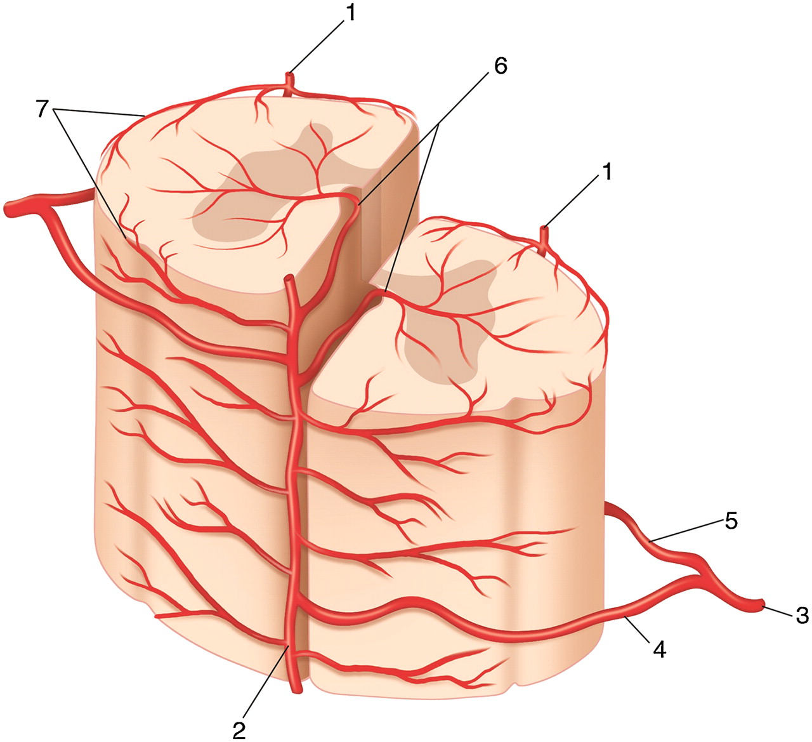

Segmental Arteries
Segmental arteries (catheterized during DSA):
- branches of vertebral arteries, deep and ascending cervical arteries and to a lesser degree from the ascending pharyngeal and occipital arteries – for cervical cord
- superior intercostal artery (branch of costocervical trunk) – for T1-2
- posterior intercostal arteries (9 pairs) – for T3-11
- subcostal arteries (1 pair)
- lumbar arteries (4 pairs)
- branches of internal iliac artery (mainly the iliolumbar and lateral sacral arteries) and median sacral artery (branch of the aorta at the level of the bifurcation*) – for L5 and sacrum.
*aorta bifurcates at lower level of L4

(1) basilar artery; (2) vertebral artery; (3) anterior spinal artery; (4) posterior spinal arteries; (5) anterior radiculomedullary artery; (6) ascending cervical artery; (7) deep cervical artery; (8) subclavian artery; (9) posterior radiculomedullary artery; (10) segmental arteries (posterior intercostal arteries); (11) great anterior radiculomedullary artery of Adamkiewicz; (12) segmental arteries (lumbar arteries); (13) rami cruciantes (continuations of ASA that surround conus and provide robust anastomoses with posterior spinal arteries)
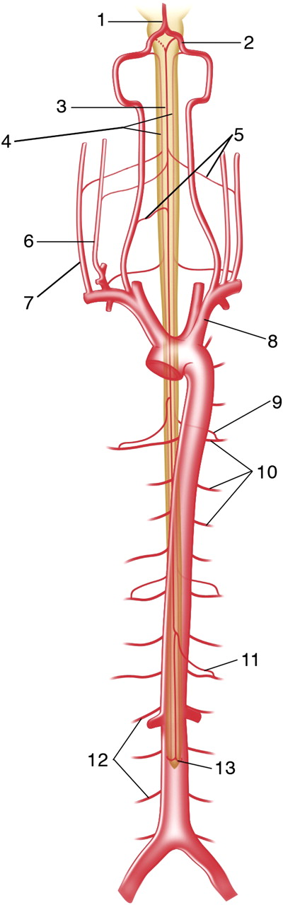

- segmental arteries travel posteriorly (on the left) or posterolaterally (on the right) along the surface of the vertebral bodies, providing short branches to supply the anterior and lateral vertebral bodies.
- segmental arteries divide into three major trunks:
- lateral or ventral (posterior intercostal or lumbar artery)
- middle or dorsal (muscular and cutaneous branches)
- spinal

(1) Posterior spinal arteries; (2) anterior spinal artery; (3) great anterior radiculomedullary artery or artery of Adamkiewicz; (4) medial musculocutaneous branch; (5) lateral musculocutaneous branch; (6) posterior radiculomedullary artery; (7) retrocorporeal arteries; (8) spinal branch; (9) posterior (dorsal) branch; (10) anterior (ventral) branch; (11) left segmental artery (posterior intercostal artery); (12) right segmental artery (posterior intercostal artery); (13) aorta.
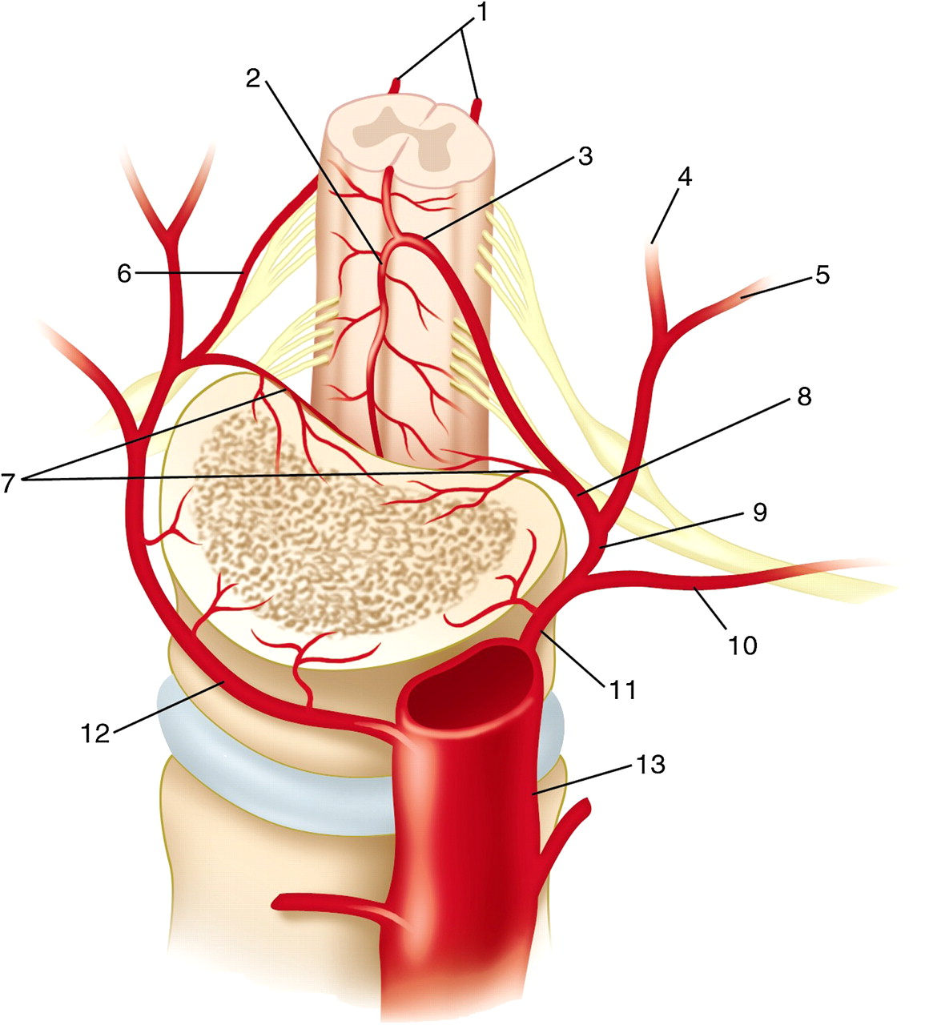

Visos somitinių arterijų spinal arteries duoda radicular arteries* - maitina šakneles;
- ties nugaros smegenų sustorėjimais radicular arteries labai stambios ir pasiekia aa. spinales ant. et post. – tokios radicular arteries vadinamos segmental medullary arteries (s. radiculomedullary arteries):
anterior segmental medullary arteries (viso labo tik 4-9 neporinės arterijos) – anastomozuoja su a. spinalis ant.
posterior segmental medullary arteries (enter at every level from both sides) – anastomozuoja su aa. spinales post.

*pagal Terminologia Anatomica aa. intervertebrales neišskiriamos

N.B. aa. spinales post. receive numerous segmental feeders along their length; vs. a. spinalis ant. - supplied by only limited number.
Infarctions in a. spinalis ant. territory are much more common than in aa. spinales post. territory!

Great segmental medullary artery (s. artery of Adamkiewicz, arteria radicularis magna, artery of lumbar enlargement)
- neporinė, stambiausia ir pastoviausia iš aa. medullares segmentales.
- atsišakoja nuo apatinių aa. intercostales post. arba viršutinių aa. lumbales (i.e. T₈-L₂); džn. L₂ iš kairės pusės.
- contrast enhanced MRA has a67-100% success rate for the detection of Adamkiewicz (DSA has 100% success rate).
- typical angiographic appearance – loops up then down (“shepherd’s hook”):

DSA (A, B) on the left; MRA on the right
Artery of Adamkiewicz (arrow) which supplies anterior spinal artery (arrowheads); hemivertebral blush is noted in (A), confirming midline position of the anterior spinal artery:
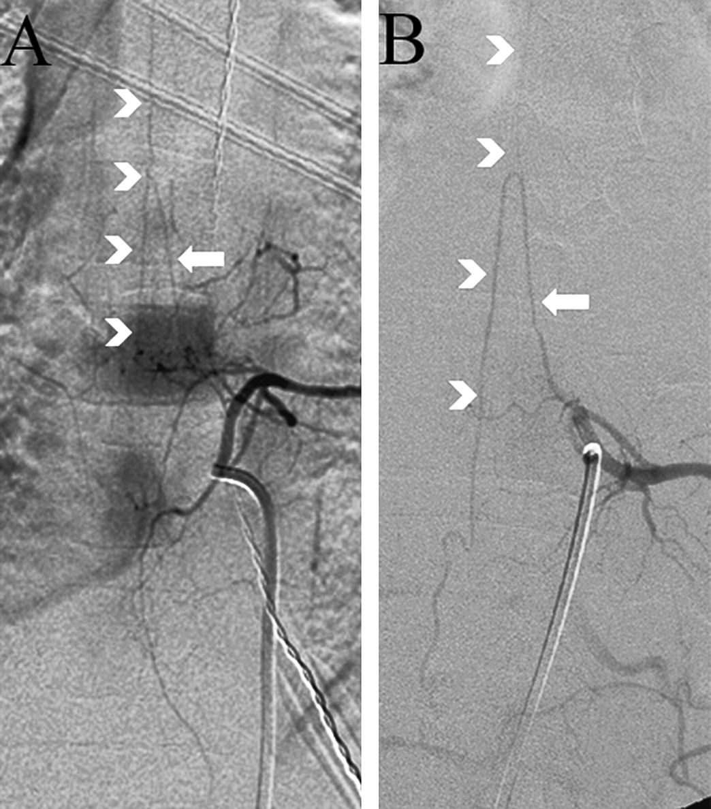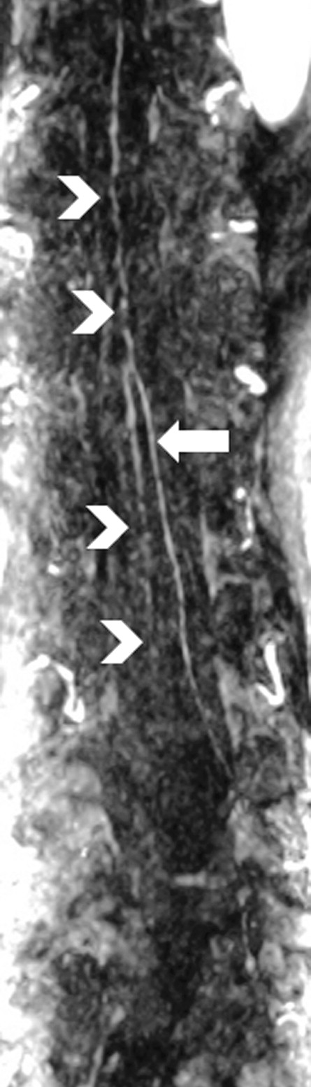

- may reach T4 level; anastomozuoja su a. spinalis ant. at the top of the hook
artery of Adamkiewicz – pagrindinis kraujo tiekėjas a. spinalis ant. apatiniams 2/3
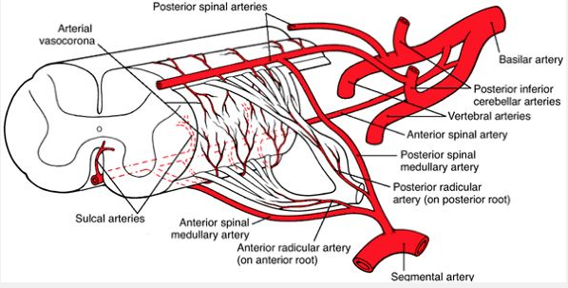

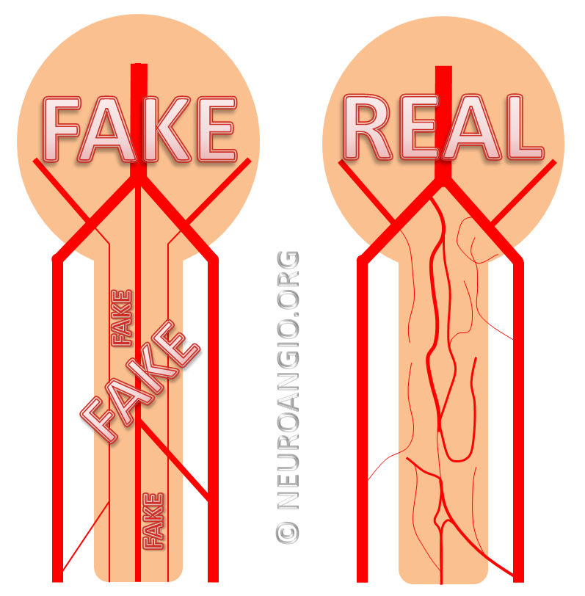

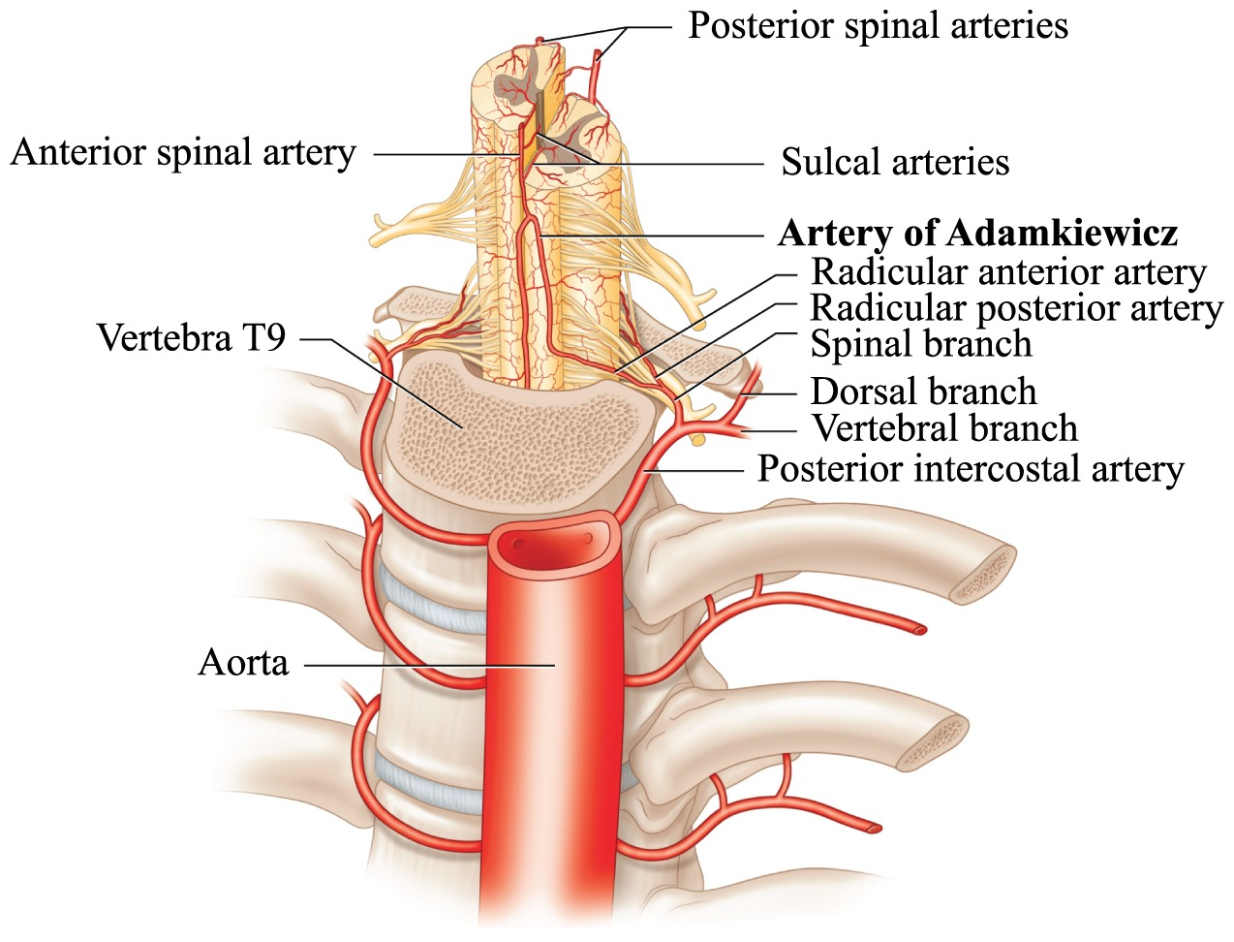
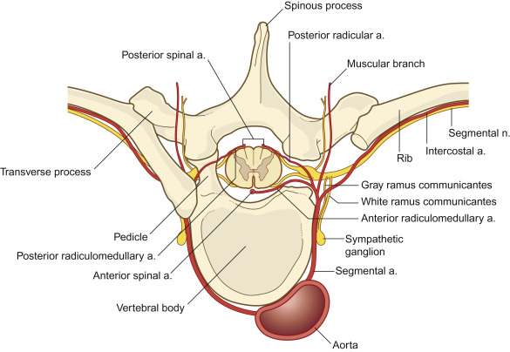
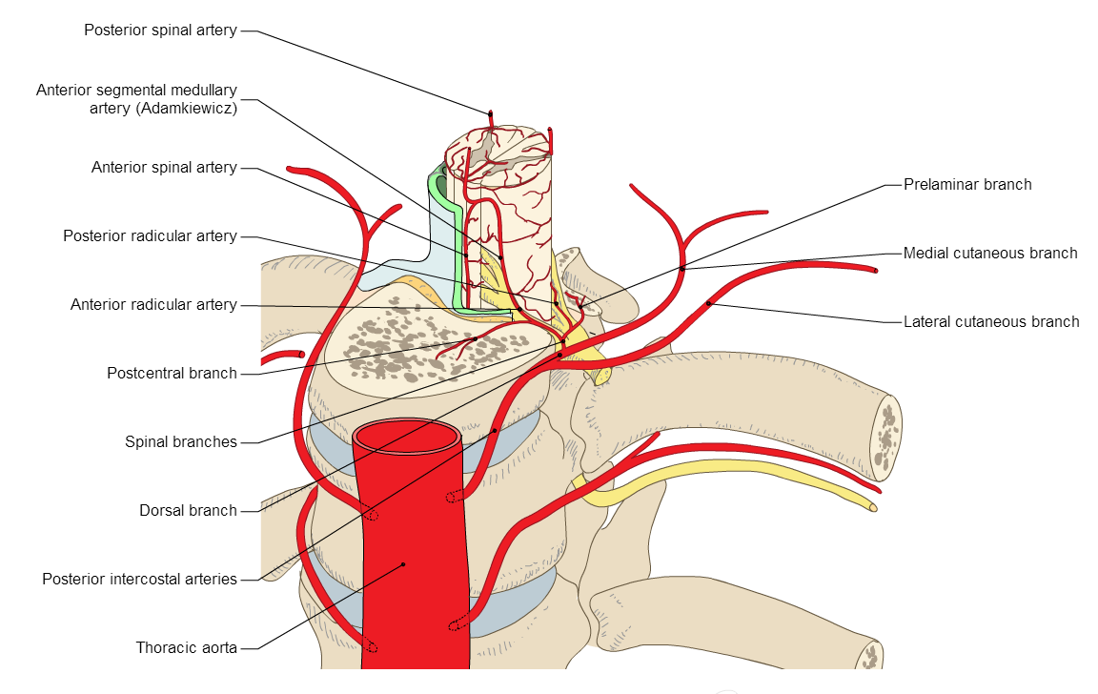
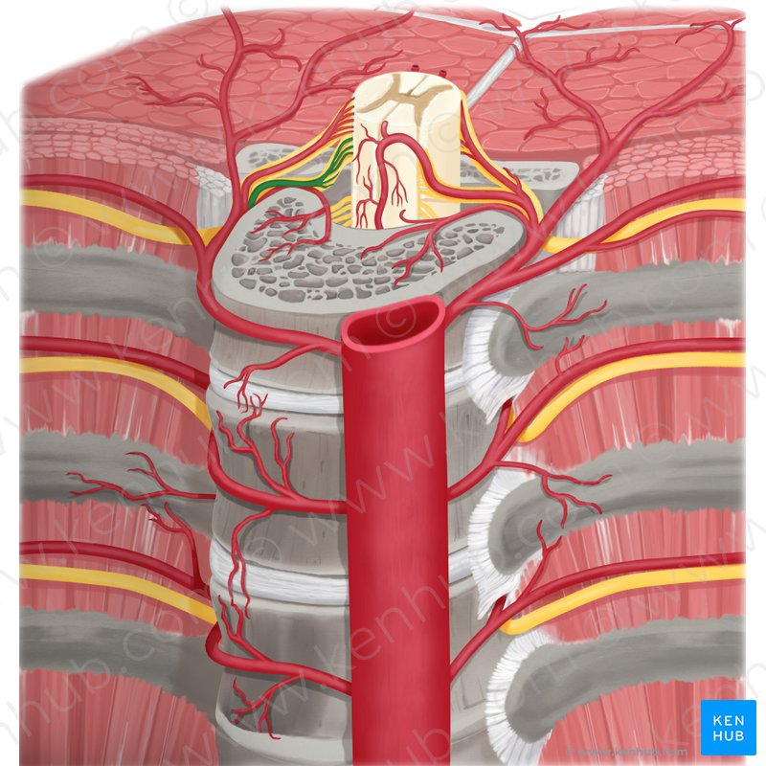

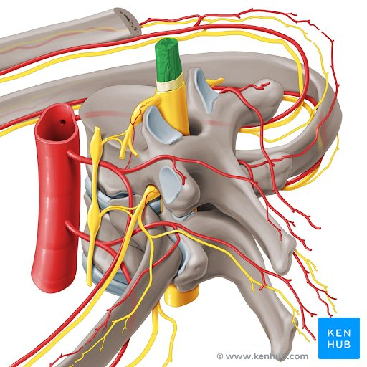

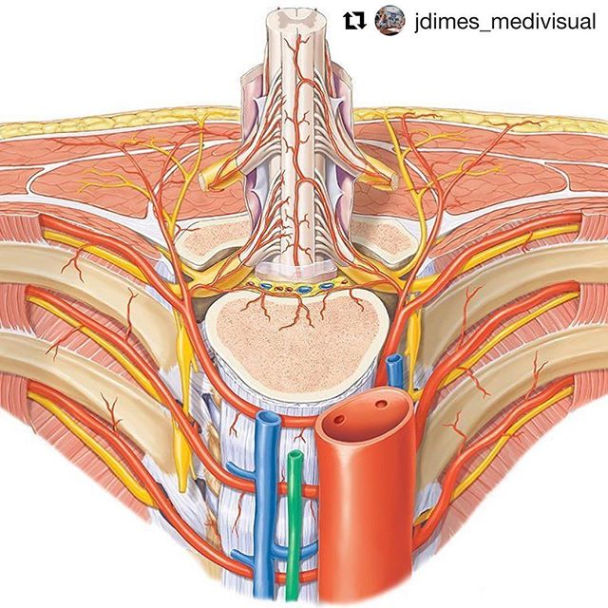

Upper thoracic anterior segmental medullary artery (s. artery of Albrecht von Haller)
- constant significant upper thoracic anterior radiculomedullary artery distinct from artery of Adamkiewicz.
- it undermines classic concept of arterial watershed zone in thoracic region.
- Albrecht von Haller documented its existence in 1754.

Regional Vascularization
- different regions of spinal cord receive unevenly distributed blood supply (importance in spinal cord hypoperfusion due to hypotension):

C₁-T₂ - richly vascularized:
most superior segments - a. spinalis ant.
lower segments - aa. radiculares (most important is artery of cervical enlargement) - feed posterior spinal arteries.

T₃₋₈ - poorly vascularized by segmental arteries (from intercostal arteries) to posterior spinal arteries; e.g. there is single radiculomedullary artery between T6 and T8.
midthoracic region is most susceptible to ischemia!

T₉-S₅ - again rich vascular supply by segmental arteries (from intercostal and lumbar arteries); most important is artery of Adamkiewicz.

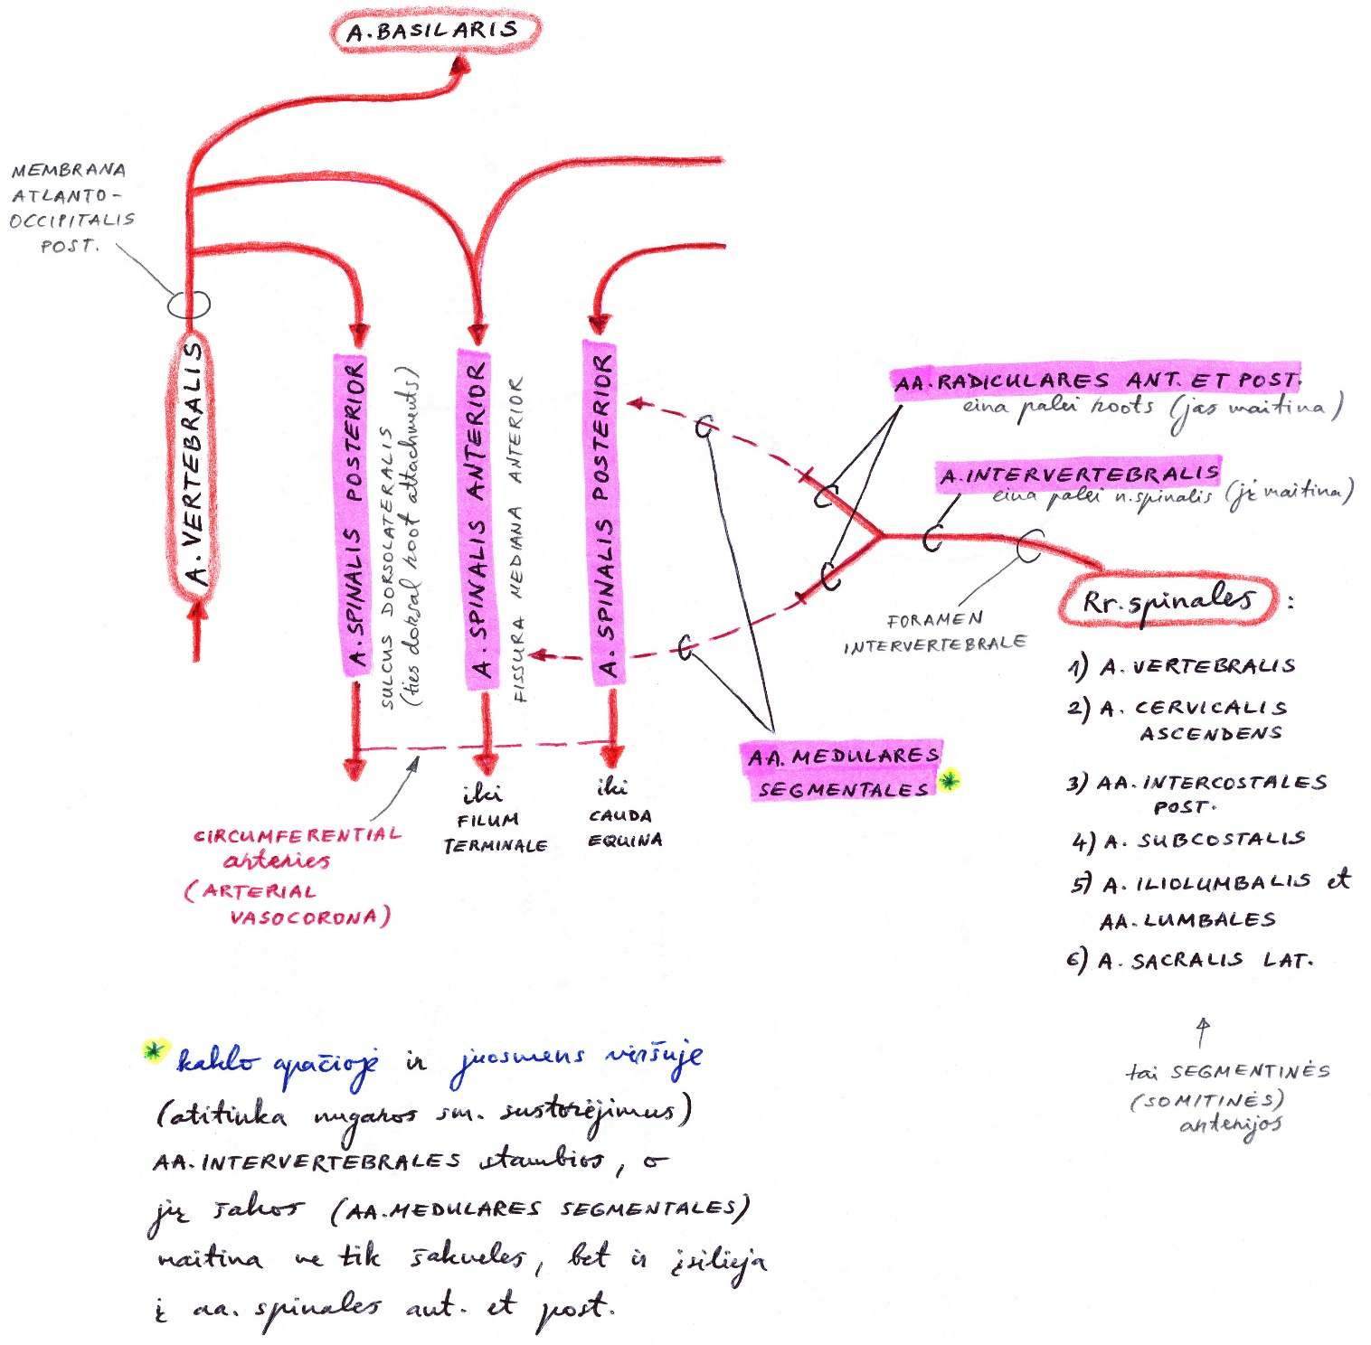

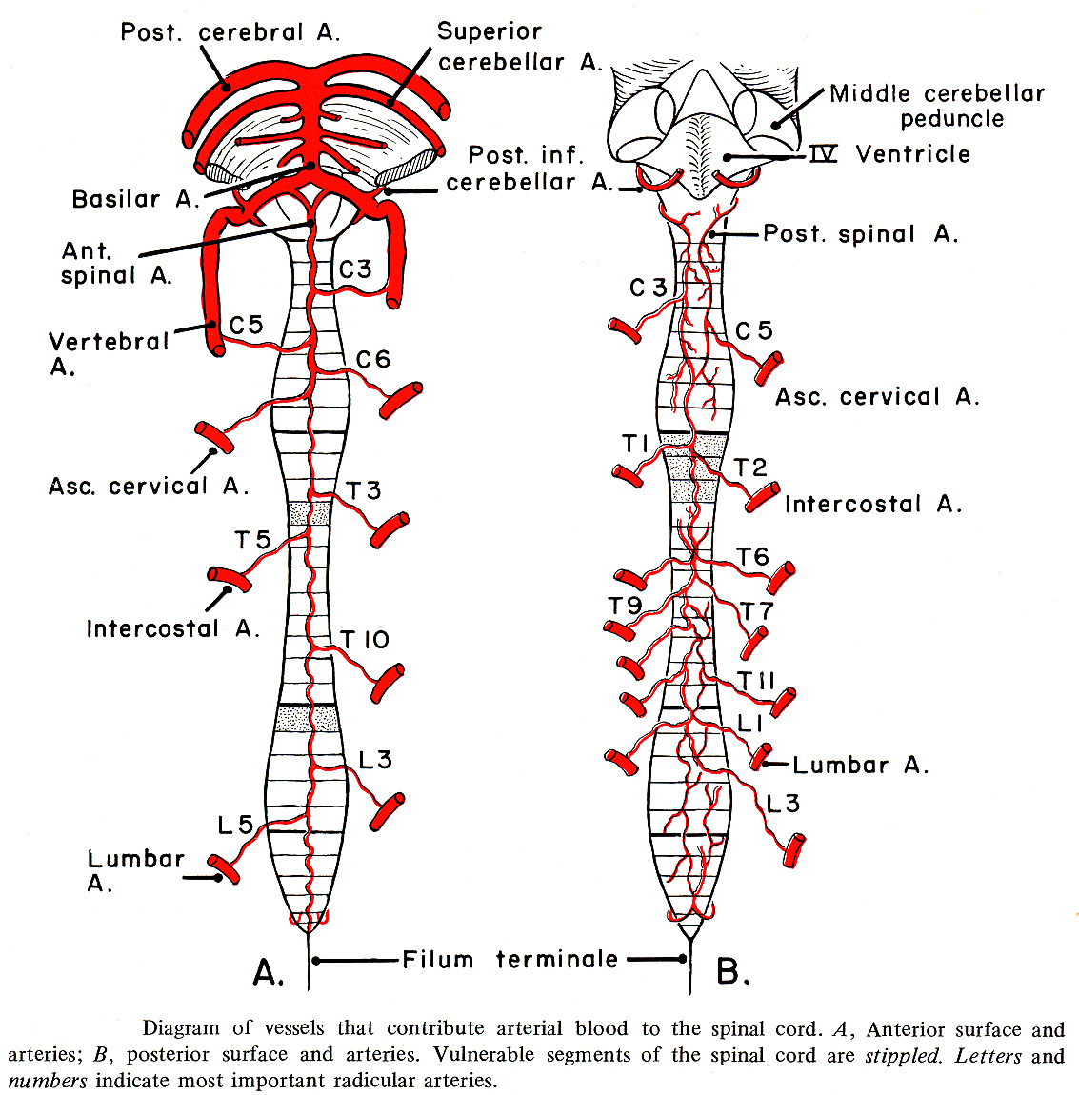

Venous drainage

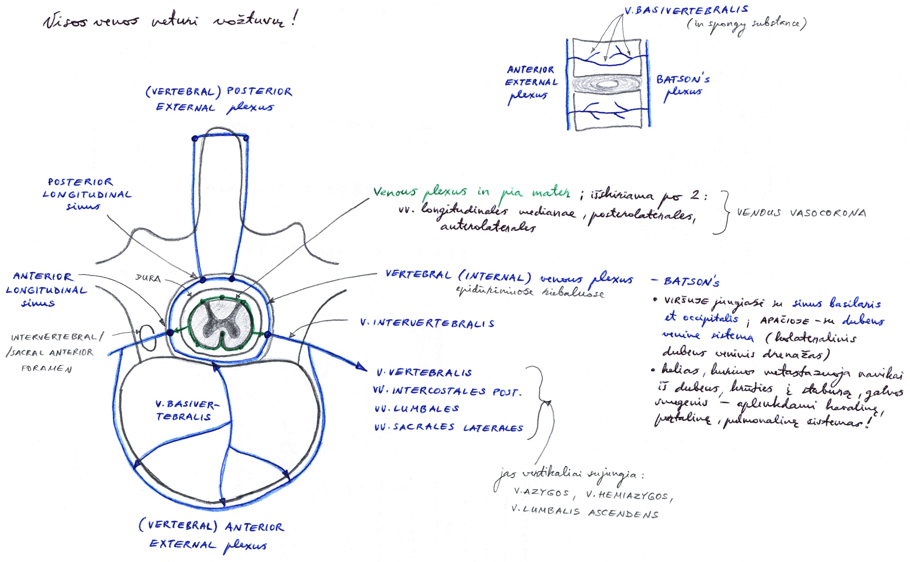

- functional valve at level of dura (oblique, zigzag course of vein coupled with a narrowed lumen) prevents reflux from the epidural veins into the intradural veins.
- superficial venous system:
- anterior median spinal vein
- posterior median spinal vein - irregular tortuous course and large caliber (< 2 mm)
- posterolateral spinal veins (x2)
- anterior and posterior median spinal veins drain into radiculomedullary veins.
  - great anterior radiculomedullary vein (GARV, diameter 1.5-2.0 mm) is easily mistaken for Adamkiewicz due its spatial course and location; H: junction of GARV with a median vein (anterior or posterior) is described as a 'coathook' configuration with more obtuse angulation cf. more acute 'hairpin' configuration of Adamkiewicz.

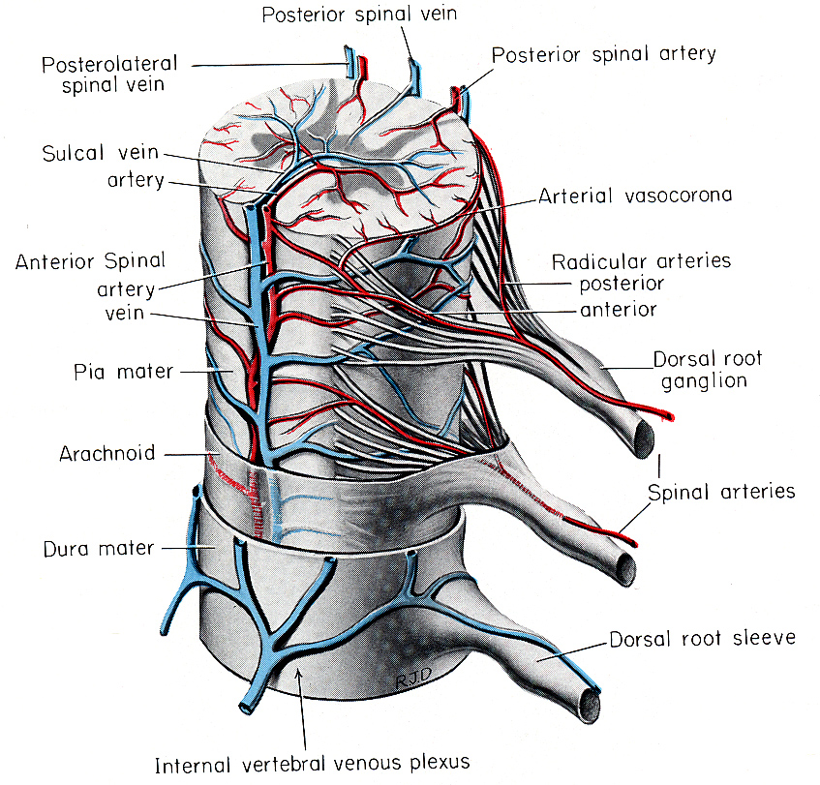

(1) Anterior median vein; (2) right deep cervical vein; (3) left deep cervical vein; (4) right vertebral vein; (5) left vertebral vein; (6) subclavian vein; (7) internal jugular vein; (8) left brachiocephalic vein; (9) superior vena cava; (10) accessory hemiazygos vein; (11) intercostal veins; (12) posterior radiculomedullary vein; (13) anterior radiculomedullary vein; (14) azygos vein; (15) hemiazygos vein; (16) lumbar veins; (17) vein of the filum terminale:
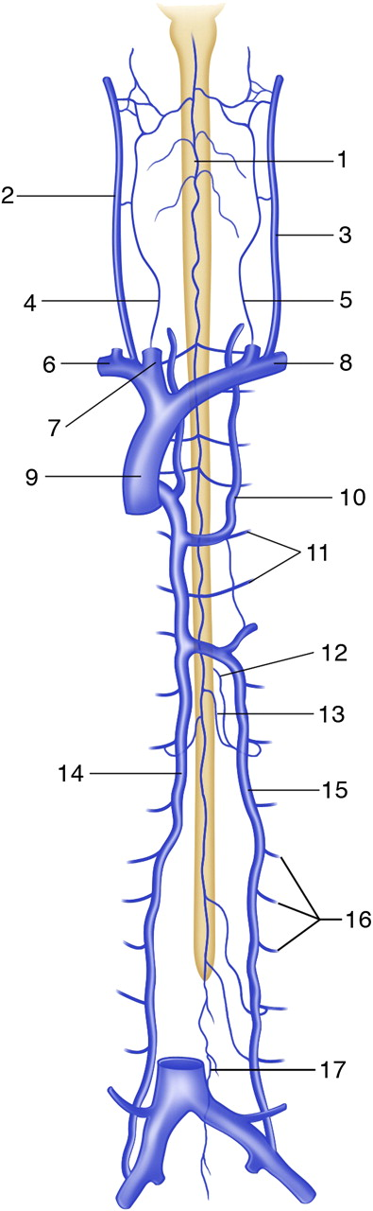

Late phase contrast enhanced MRA - anterior median vein (arrow) which continues as vein of filum terminale (arrowheads):
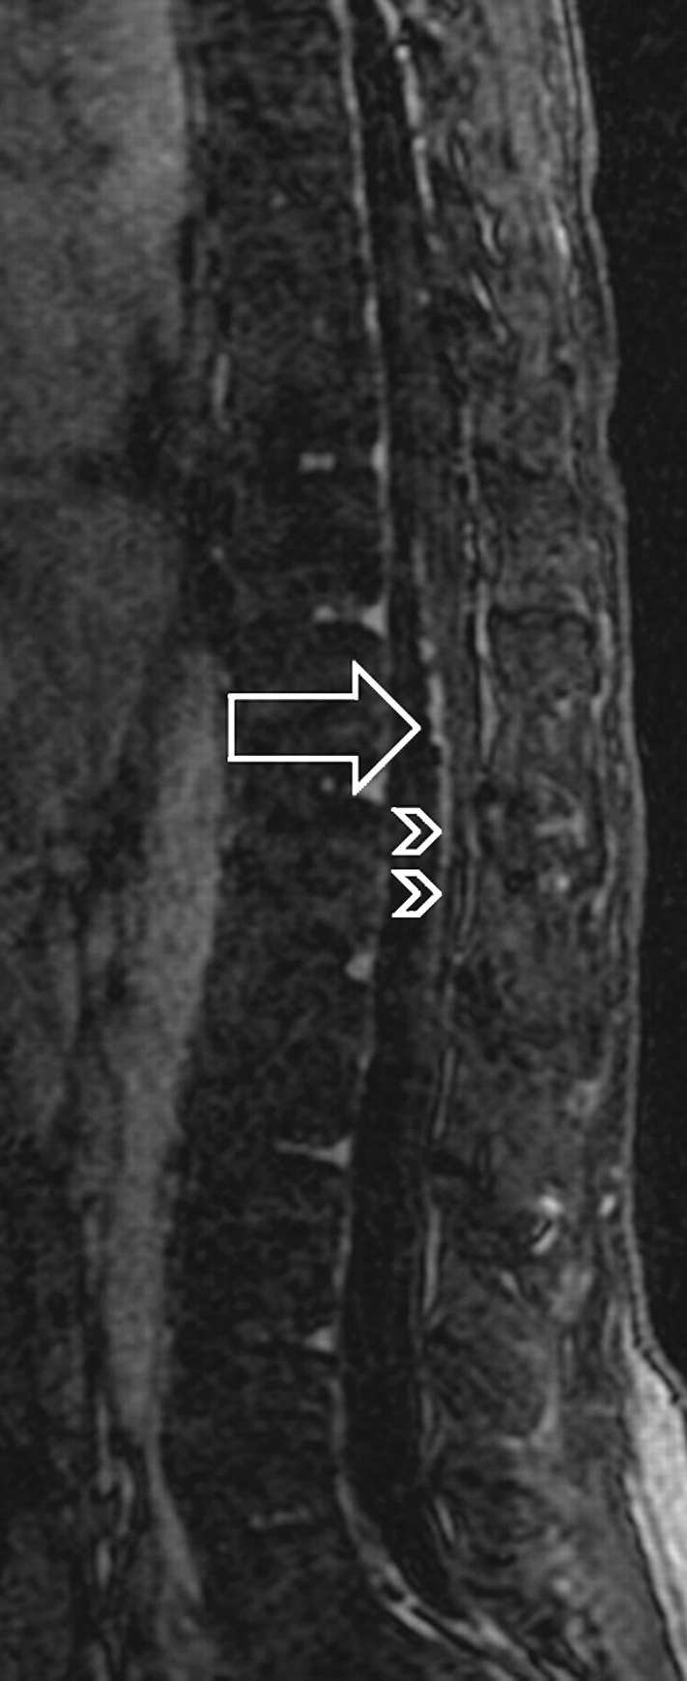

Bibliography for ch. “Vascular” → follow this link >>

Viktor’s Notes℠ for the Neurosurgery Resident
Please visit website at www.NeurosurgeryResident.net

