Blood Supply of brain (arteries)
Last updated: October 6, 2023

Aortic Arch 2
Branching patterns 2
Types 4
Anomalies 4
Cervical Carotids 5
Common carotid artery (CCA) 6
External carotid artery (ECA) 6
Middle Meningeal Artery (MMA) 9
Subclavian artery 10
Anterior circulation (internal carotid system) 12
Internal carotid artery (ICA) 12
Ophthalmic artery 15
McConnell's capsular arteries 16
Superior Hypophyseal artery 17
Meningohypophyseal Trunk (MHT) 18
Posterior circulation (vertebrobasilar system) 24
Vertebral artery (VA) 30
PICA 36
Basilar artery (BA) 39
Circulus arteriosus cerebri (Circle of Willis) 44
Regional circulation 44
Cerebral Hemispheres 52
Anterior cerebral artery (ACA) 58
Middle cerebral artery (MCA) 61
Posterior cerebral artery (PCA) 68
Choroid Plexuses 70
Basal Structures 71
Internal Capsule 71
Corpus striatum 73
Thalamus 74
Hypothalamus 74
Anastomoses / Collaterals 75
Extracranial–intracranial anastomoses 75
Intracranial anastomoses 75
Anatomical variants – see p. A201 >>
Syndromes of vascular territories – see p. Vas3 >>

- there are no end-arteries in brain, but precapillary anastomoses are insufficient in cases of occlusion – brain arteries act as end-arteries.
- extracranial arteries have structure of elastic or muscular arteries; intracranial arteries have no external elastic lamina (feature of muscular arteries) and there is no vasa vasorum.

Cerebral blood vessel innervation:
Motor innervation (mainly to large arteries):
sympathetic (neurons in superior cervical ganglia) – norepinephrine, neuropeptide Y.
parasympathetic (neurons in sphenopalatine ganglia) – acetylcholine, VIP, PHM-27.
Sensory innervation (to more distal arteries); neurons in trigeminal ganglia – contain substance P, neurokinin A, CGPR.
Touching / pulling on cerebral vessels causes pain!

Aortic Arch
Branching patterns
The most common (≈ 70-80%) aortic arch branching pattern:

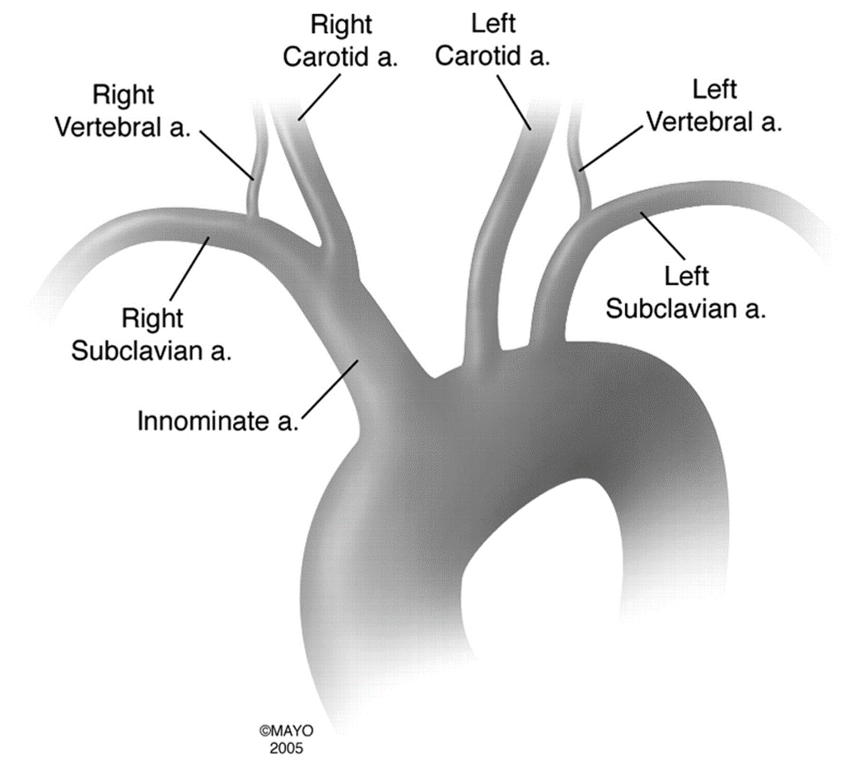

The second most common pattern (13%; 25% blacks, 8% whites) - erroneously referred to as “bovine arch” - common origin for innominate and left CCA:
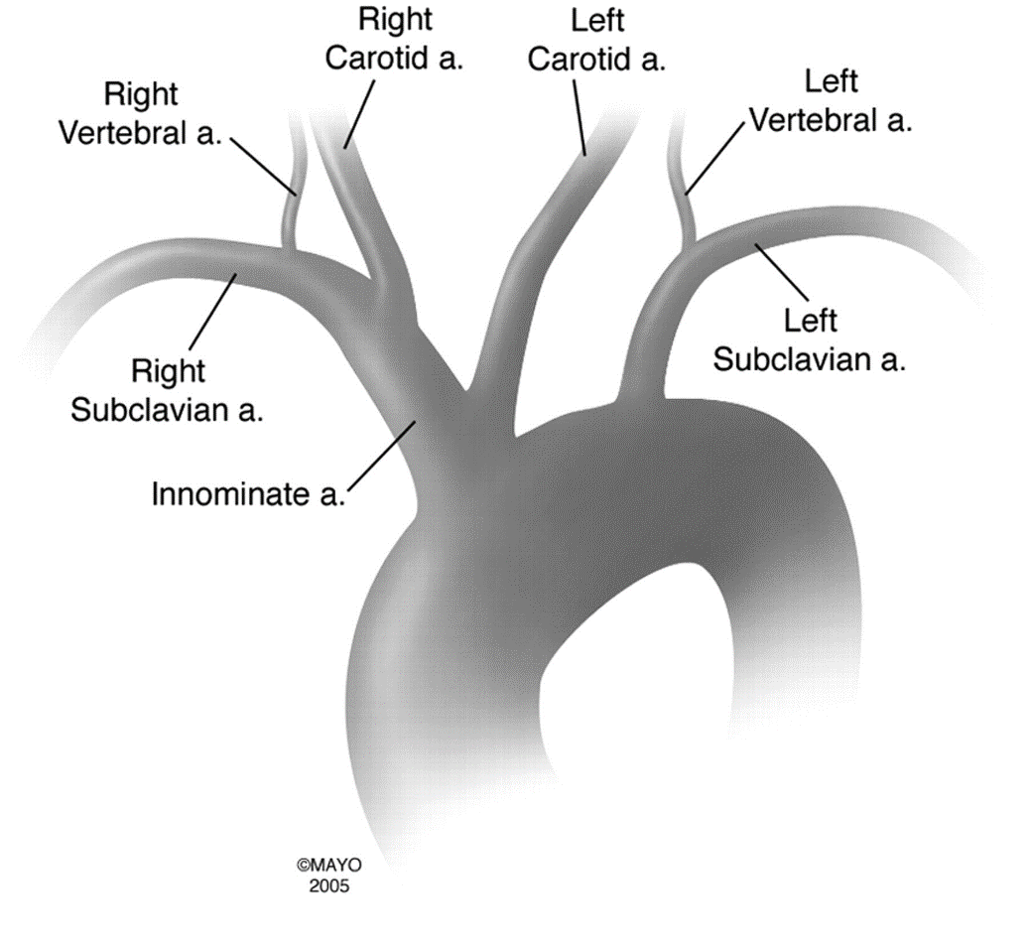

The third most common pattern (9%; 10% blacks, 5% whites) - also erroneously referred to as “bovine arch” - left CCA originates from innominate artery:
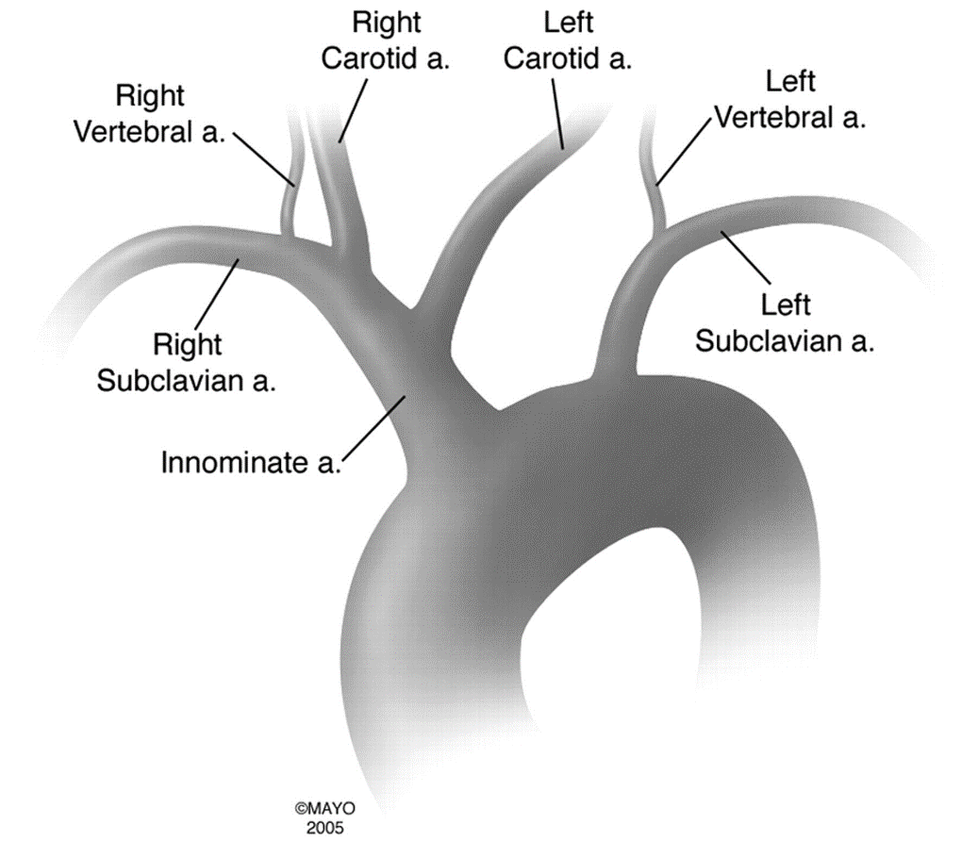

For bovine arch vessels, one needs Sims catheter to cannulate innominate artery due to acute angle.

The left CCA and left SCA share common origin (a "left brachiocephalic trunk") in 1-2%.
The left VA originates directly from the AA-not the left SCA-in 0. 5- 1% of cases.

True bovine arch found in cattle - single great vessel (brachiocephalic trunk) originates from aortic arch and splits into bilateral subclavian arteries and bicarotid trunk:
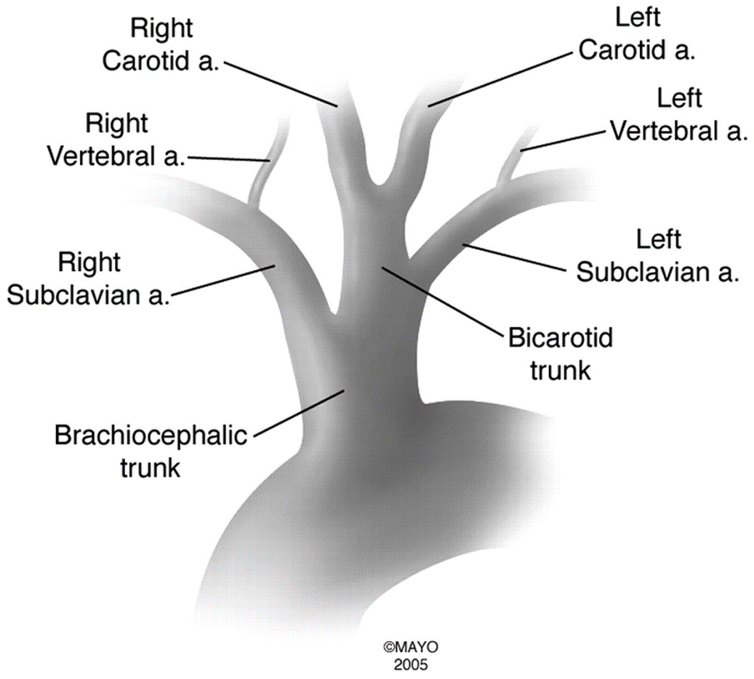

Types
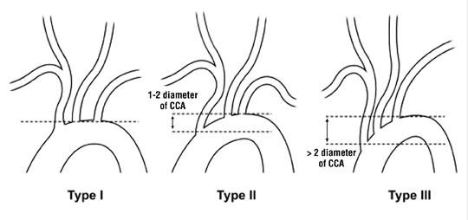
For type II-III arches, one needs angled Sims catheter to cannulate innominate artery due to acute angle.

Anomalies
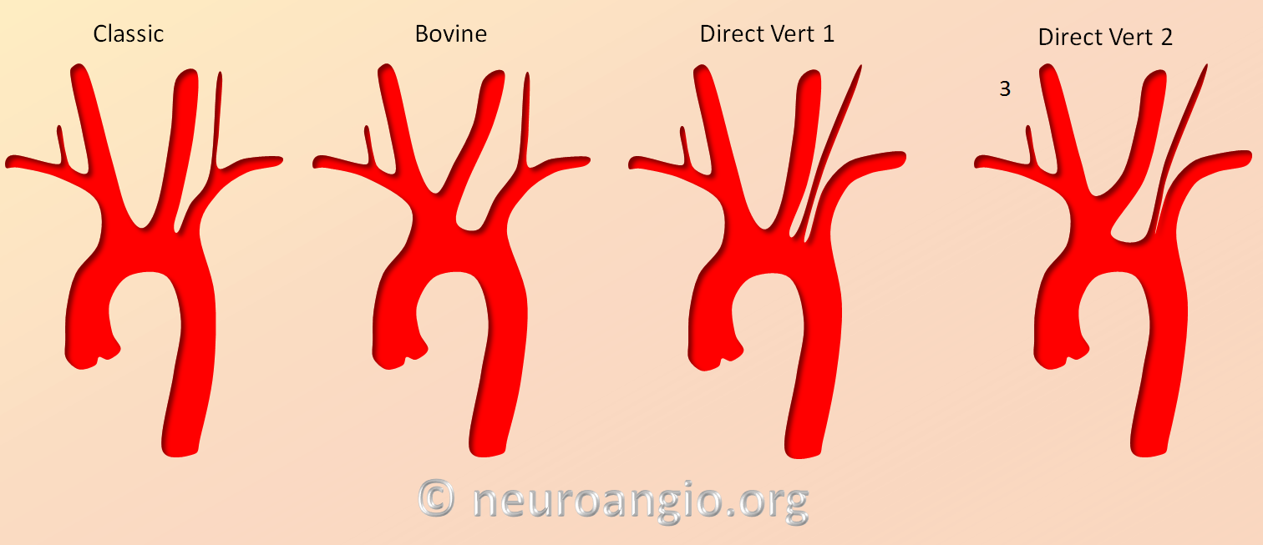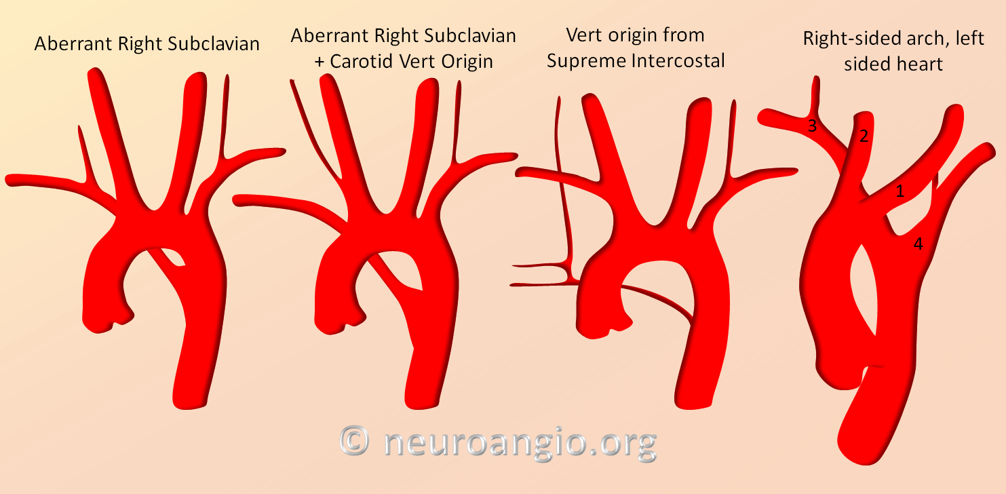
Source of picture: Neuroangio.org >>

The most common congenital arch anomaly-seen in 0.5- 1.0% of cases-is aberrant right subclavian. Here the right SCA is last-not first-branch to arise from the AA. Occasionally the aberrant right SCA arises from a dilated, diverticulum-like structure (Kommerell diverticulum).
An aberrant right SCA is not associated with congenital heart disease.

Other important anomalies include a right AA with mirror image branching, which is strongly associated with cyanotic congenital heart disease (98% prevalence).

Two anomalies that are rarely associated with congenital heart disease include a right AA with aberrant left SCA and a double aortic arch (DAA). In a DAA, each arch gives rise to a ventral carotid and a dorsal subclavian artery (symmetric "four-artery" sign).

Cervical Carotids
Common carotid artery (CCA)
- right CCA is first main branch of innominate artery (brachiocephalic trunk).
- left CCA is second main branch of aortic arch.
- CCA runs within fascial plane, carotid sheath, lateral to vertebral column.
- CCA bifurcates at C3-4 or C4-5 level (upper level of thyroid cartilage).

External carotid artery (ECA)
- supplies most extracranial head and neck structures (except orbits) + important contribution to supply of meninges!
Branches (in order) – SAL FOP MS:
- Superior thyroid
- Ascending pharyngeal
- Lingual
- Facial
- Occipital
- Posterior auricular
- Maxillary
- Superficial temporal

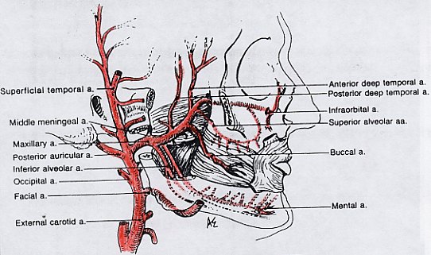
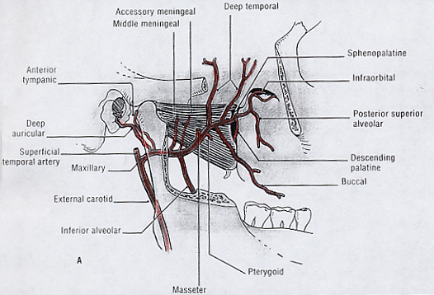
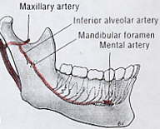

Maxillary artery:
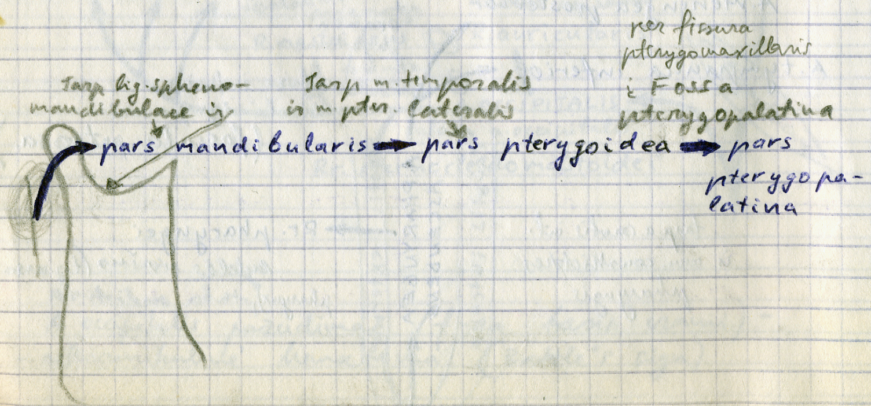

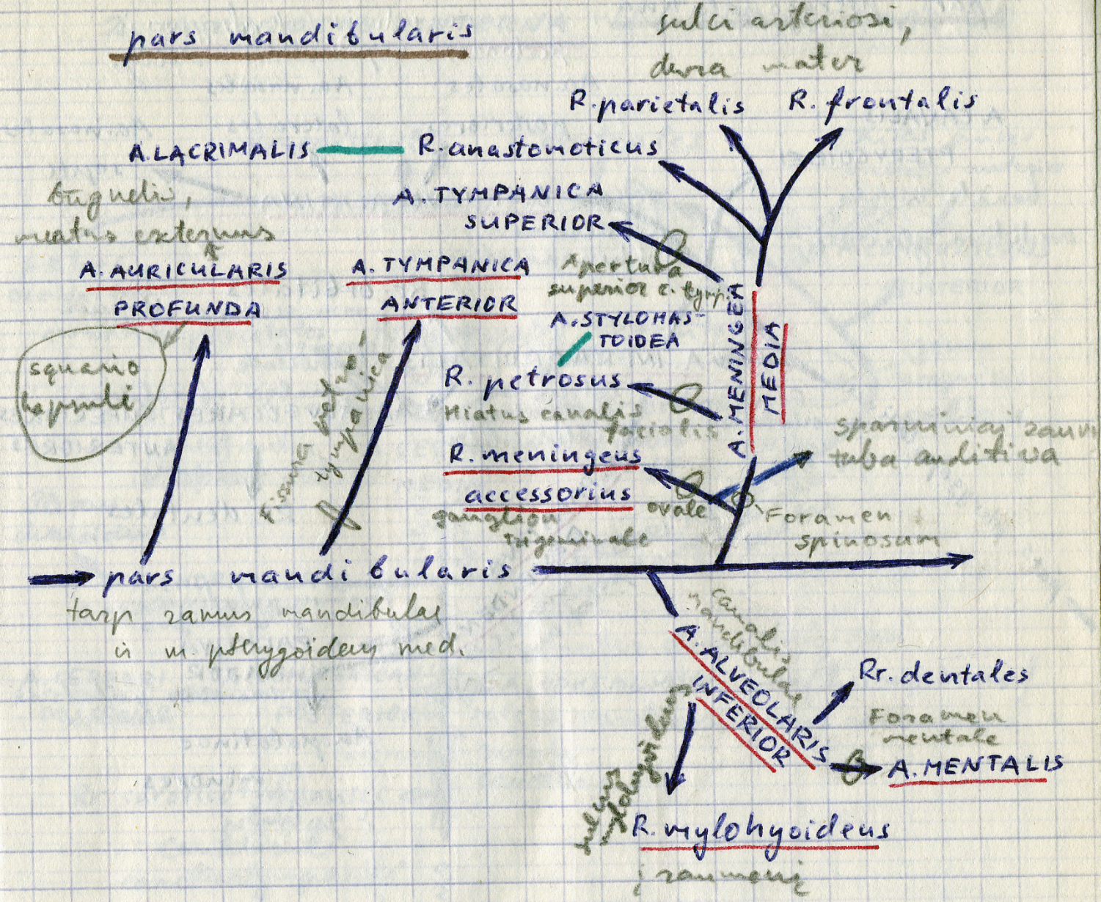

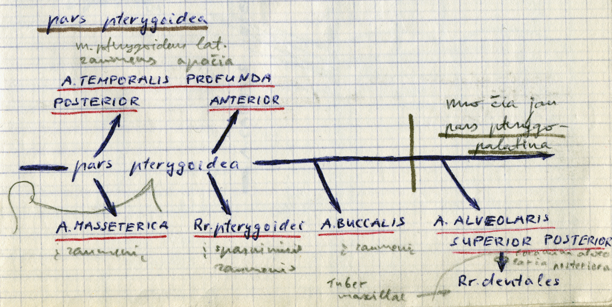

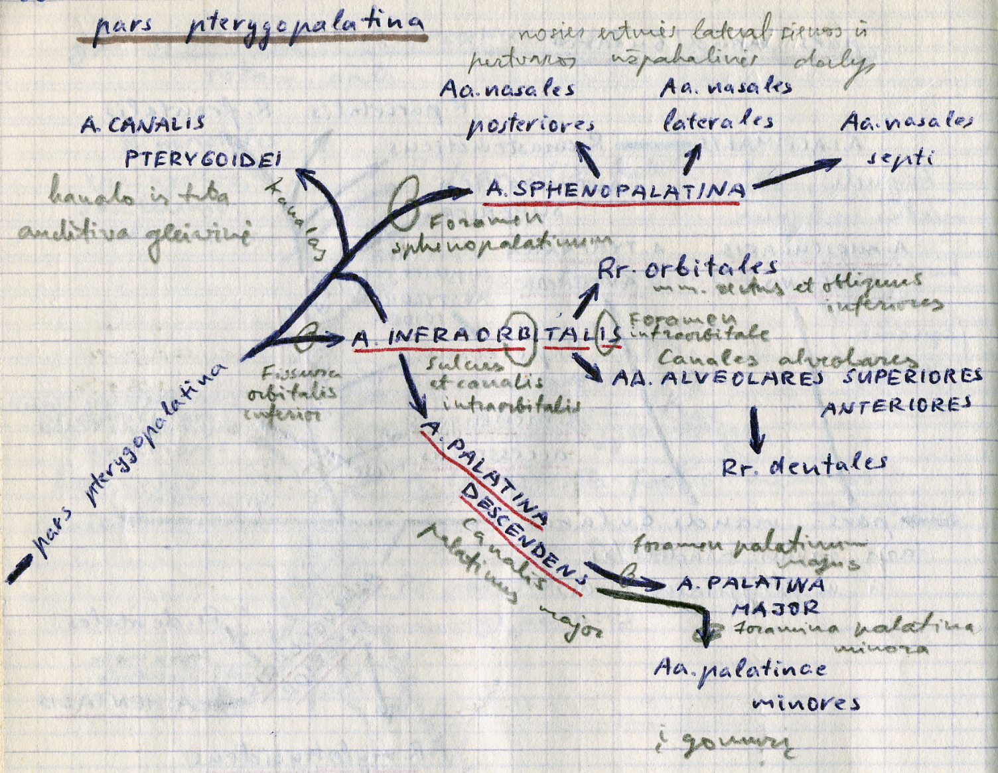

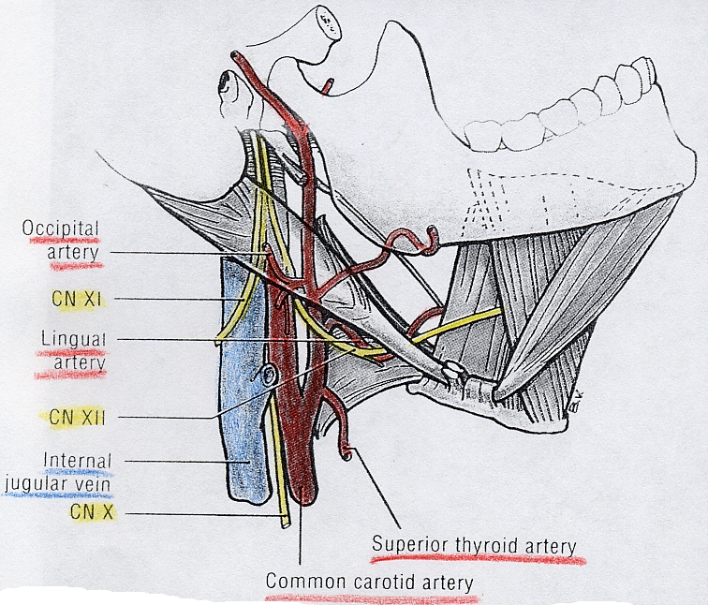

Middle Meningeal Artery (MMA)
- largest branch of Meningeal Arterial Network.
- origin - proximal Internal Maxillary Artery (IMAX)
- multiple connections to other key vessels (ophthalmic, internal carotid, MHT, ILT, ascending pharyngeal, occipital) - these can be either useful treatment routes or “dangerous anastomoses” (e.g. proximal branches - petrous branch, sphenoid branch - move microcatheter more distally before embolizing MMA).

Meningophthalmic Artery - complete MMA supply of orbit, including central retinal artery:
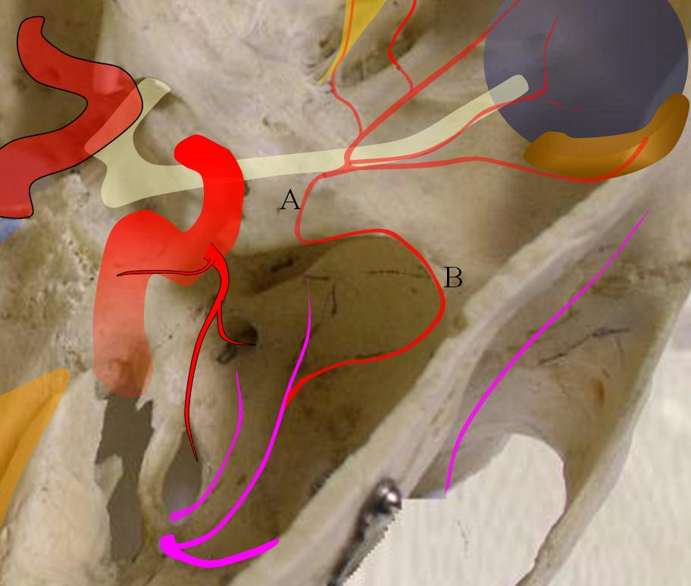
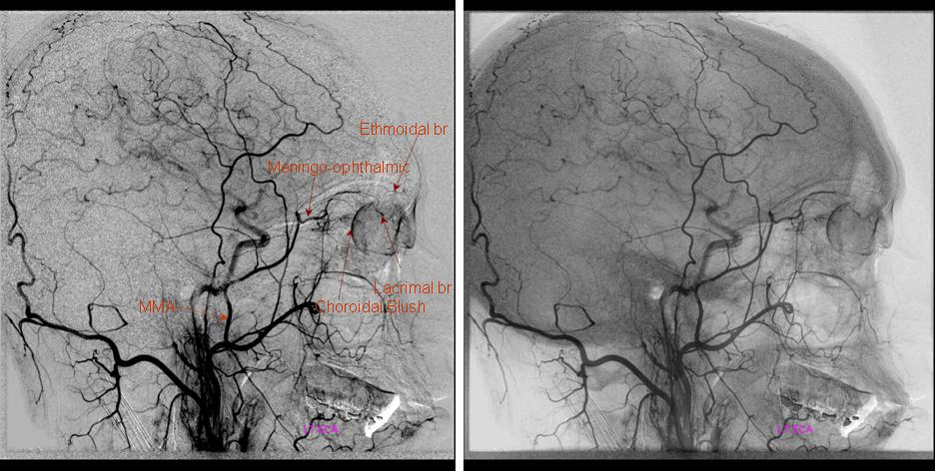
Source of picture: Neuroangio.org >>

MMA origin from ophthalmic - inability to use MMA for embolization without catheterizing ophthalmic artery (risk of blindness).

Subclavian artery
Branches (in order):
- Vertebral
- Thyrocervical trunk
- Internal thoracic (mammary)
- Costocervical trunk
- Descending scapular
- continues as axillary artery

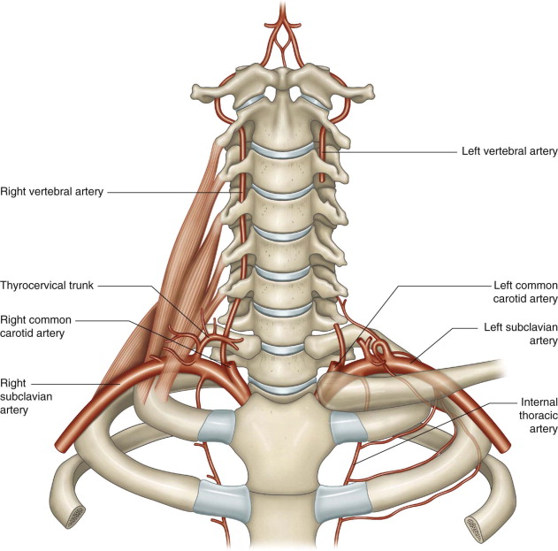

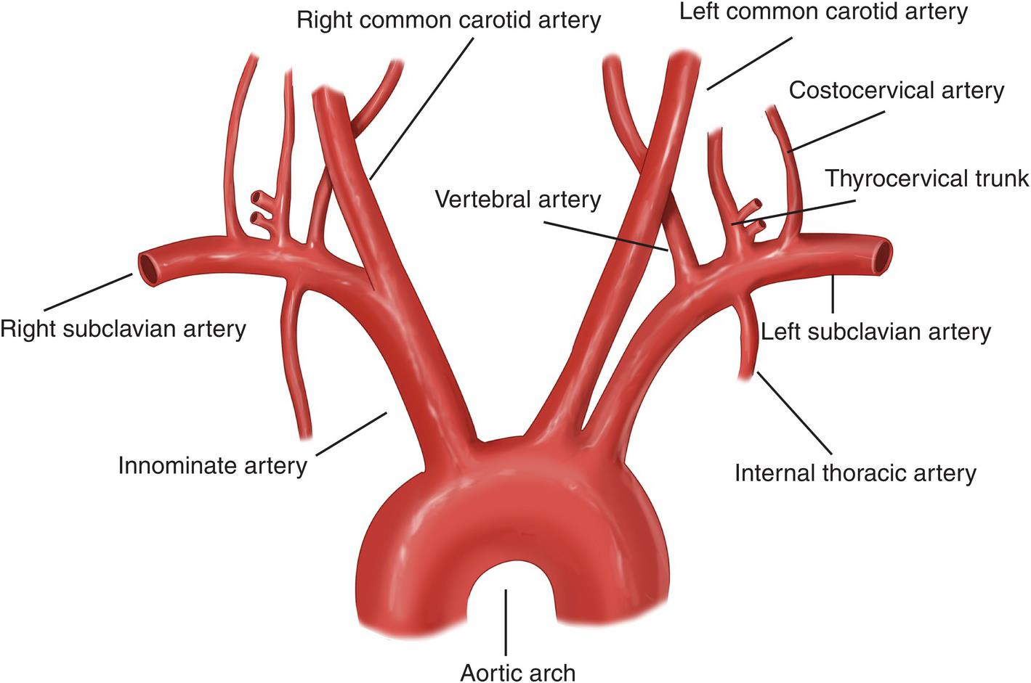
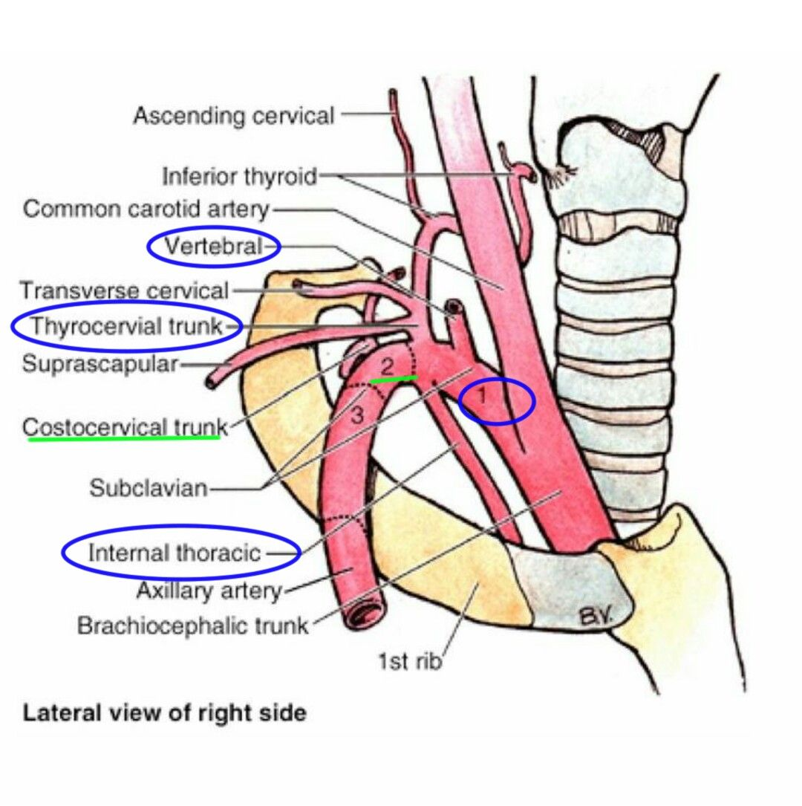

Anterior circulation (internal carotid system)
Internal carotid artery (ICA)
- prasideda nuo a. carotis communis C₃₋₄ aukštyje* (cart. thyroidea viršutinis kraštas, 3 cm below angle of mandible); at CCA bifurcation, ICA lies usually (90%) posterior and lateral to ECA.
*may be as rostral as C₁ or as caudal as T₂
- carotid bulb (most proximal aspect of cervical ICA) - prominent focal dilatation with a cross-sectional area nearly twice as large as that of the distal ICA.
- slipstreams from CCA strike CCA bifurcation and divide - approximately 30% of flow passing into ECA; majority of flow enters the anterior part of proximal ICA.
- smaller slipstream actually reverses direction in the bulb, temporarily slowing and stagnating before reestablishing normal antegrade laminar flow with the central slipstream.
- ends in middle cranial fossa (in vallecular region) when a. cerebri ant. branches off; ICA continuation – a. cerebri media.

Divided into four parts: relationship with cranial nerves – see p. Eye15 >>
- Cervical part – has no branches.
- Petrous part (osseus carotid canal → courses over foramen lacerum) – branches:
caroticotympanic arteries → tympanic cavity
- Cavernous part (lies in cavernous sinus) – course almost horizontal, next to medial wall of cavernous sinus; branches:
  - meningohypophyseal trunk see below >>
  - inferolateral trunk
  - McConnell's capsular arteries see below >>
- Cerebral (s. supraclinoid) part (pierces dura mater [ICA was extradural until now!] medial to anterior clinoid process); branches (OSPA):
- Ophthalmic artery (arises at level of anterior clinoid process; traverses optic canal) → orbita, CN2, eyeball, etc
Numerous anastomoses between internal and external carotid arteries involve ophthalmic artery (most important - facial artery and superficial temporal artery - anastomose with supratrochlear branches of ophthalmic artery)
- Superior hypophyseal artery (usually as several vessels) → median eminence
- PComA
- Anterior choroidal artery see below >>
- ICA terminus divides (lateral to optic chiasm) into ACA and MCA
“Carotid siphon” = cavernous part + cerebral part
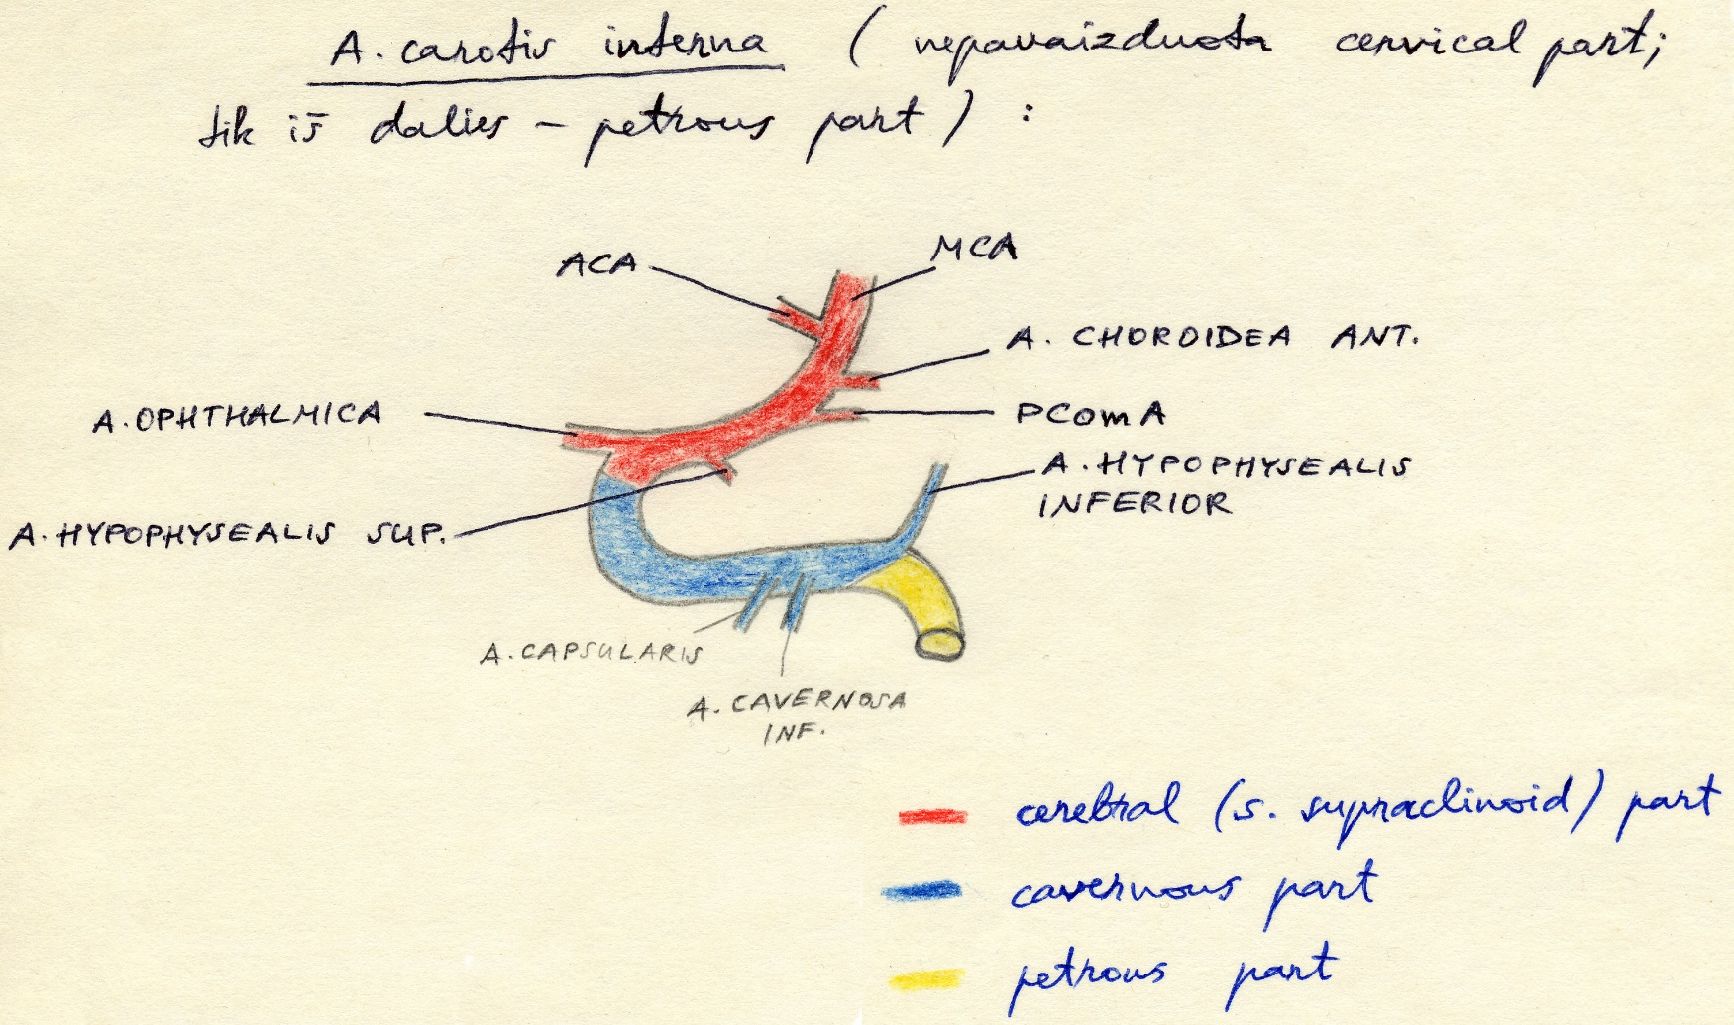

Surgically ICA has 7 parts (C5 is between dural distal and proximal rings)
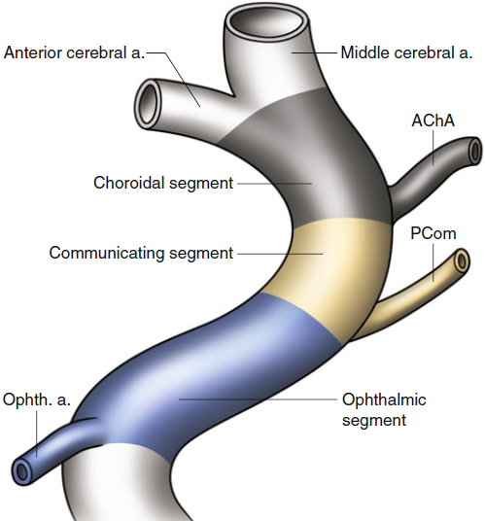

Ophthalmic artery
Typical lateral ophthalmic artery injection; choroid blush is well-seen; impossible to say which is central retinal artery (CRA):
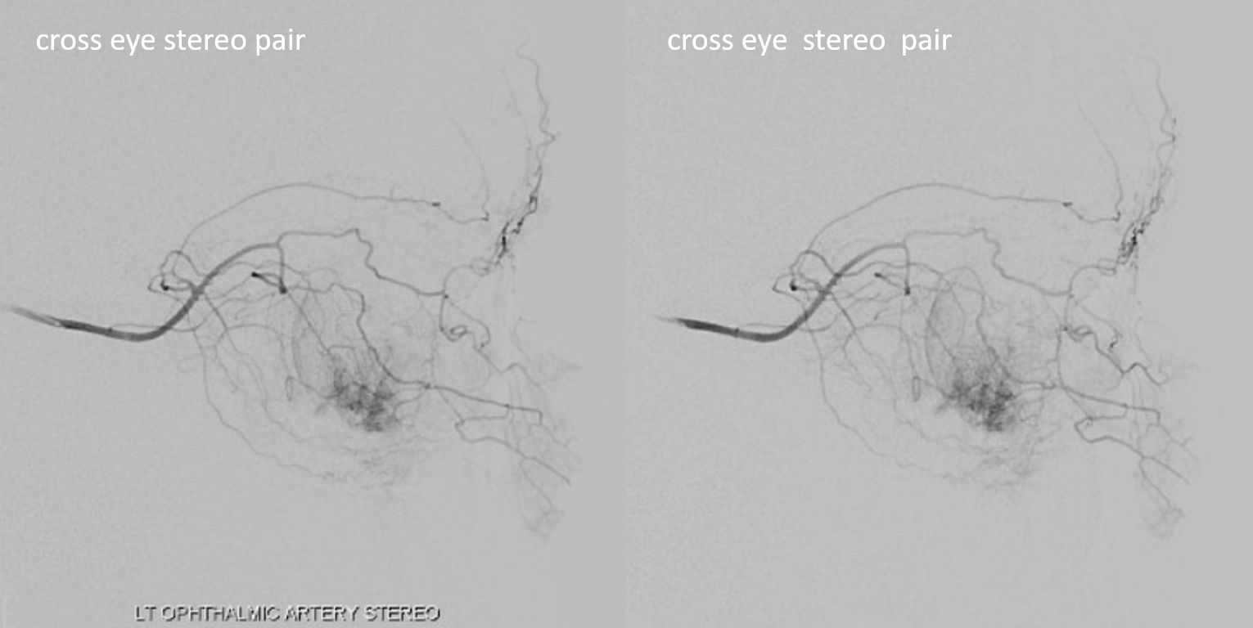
Source of picture: Neuroangio.org >>

Excellent view of CRA (note typical over the optic nerve angle of the artery):
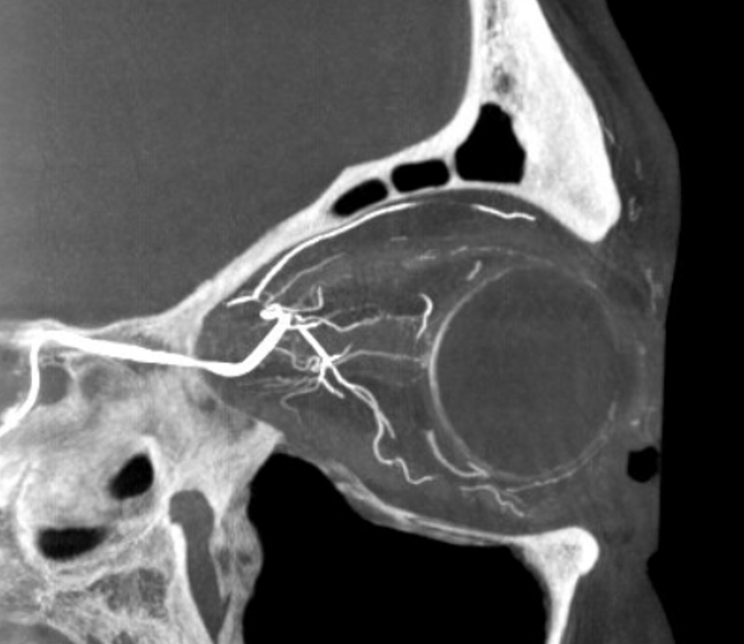
Source of picture: Neuroangio.org >>

McConnell's capsular arteries
(first described in 1953) - medial branches of cavernous ICA:
- anterior capsular artery - originates from the anteromedial aspect of the anterior loop of the cavernous ICA; reaches the suprasellar space; important role in the vascularization of tuberculum sellae meningiomas
- inferior capsular artery - originates from the inferomedial aspect of the cavernous ICA, at its horizontal portion; reaches the floor and anterior wall of the sella where it anastomoses to branches of the inferior hypophyseal artery.
- importance in the surgical treatment of tuberculum sellae and planum sphenoidale tumors through an endoscopic endonasal approach.

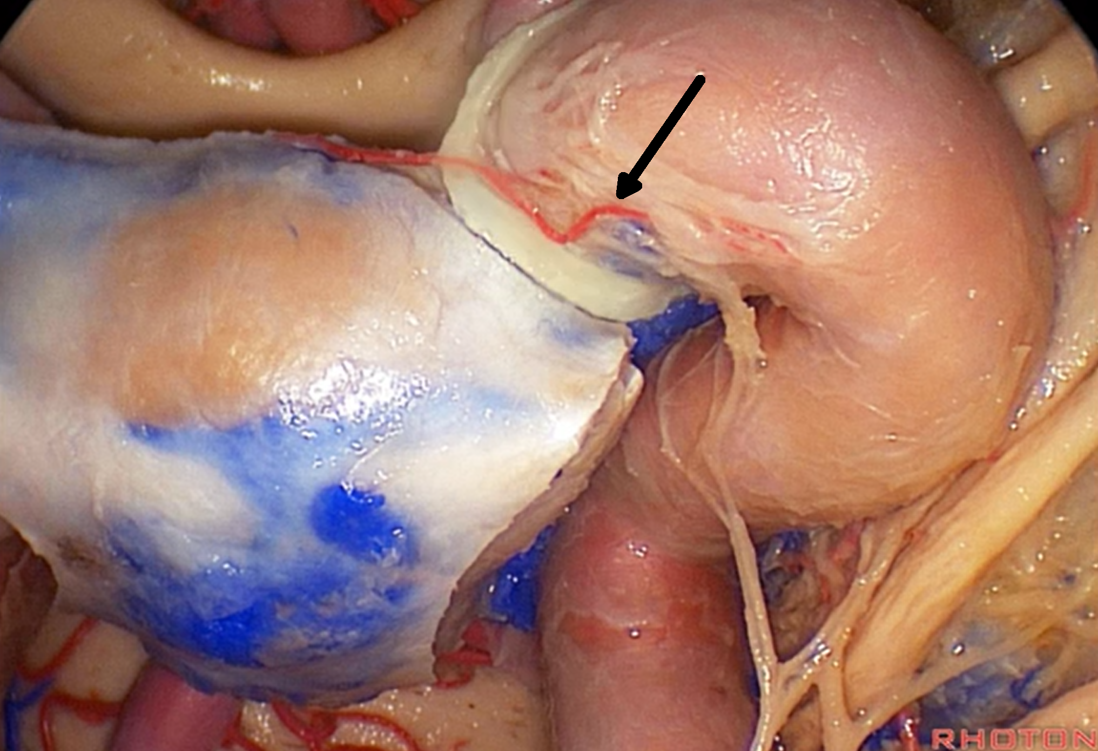

Superior Hypophyseal artery
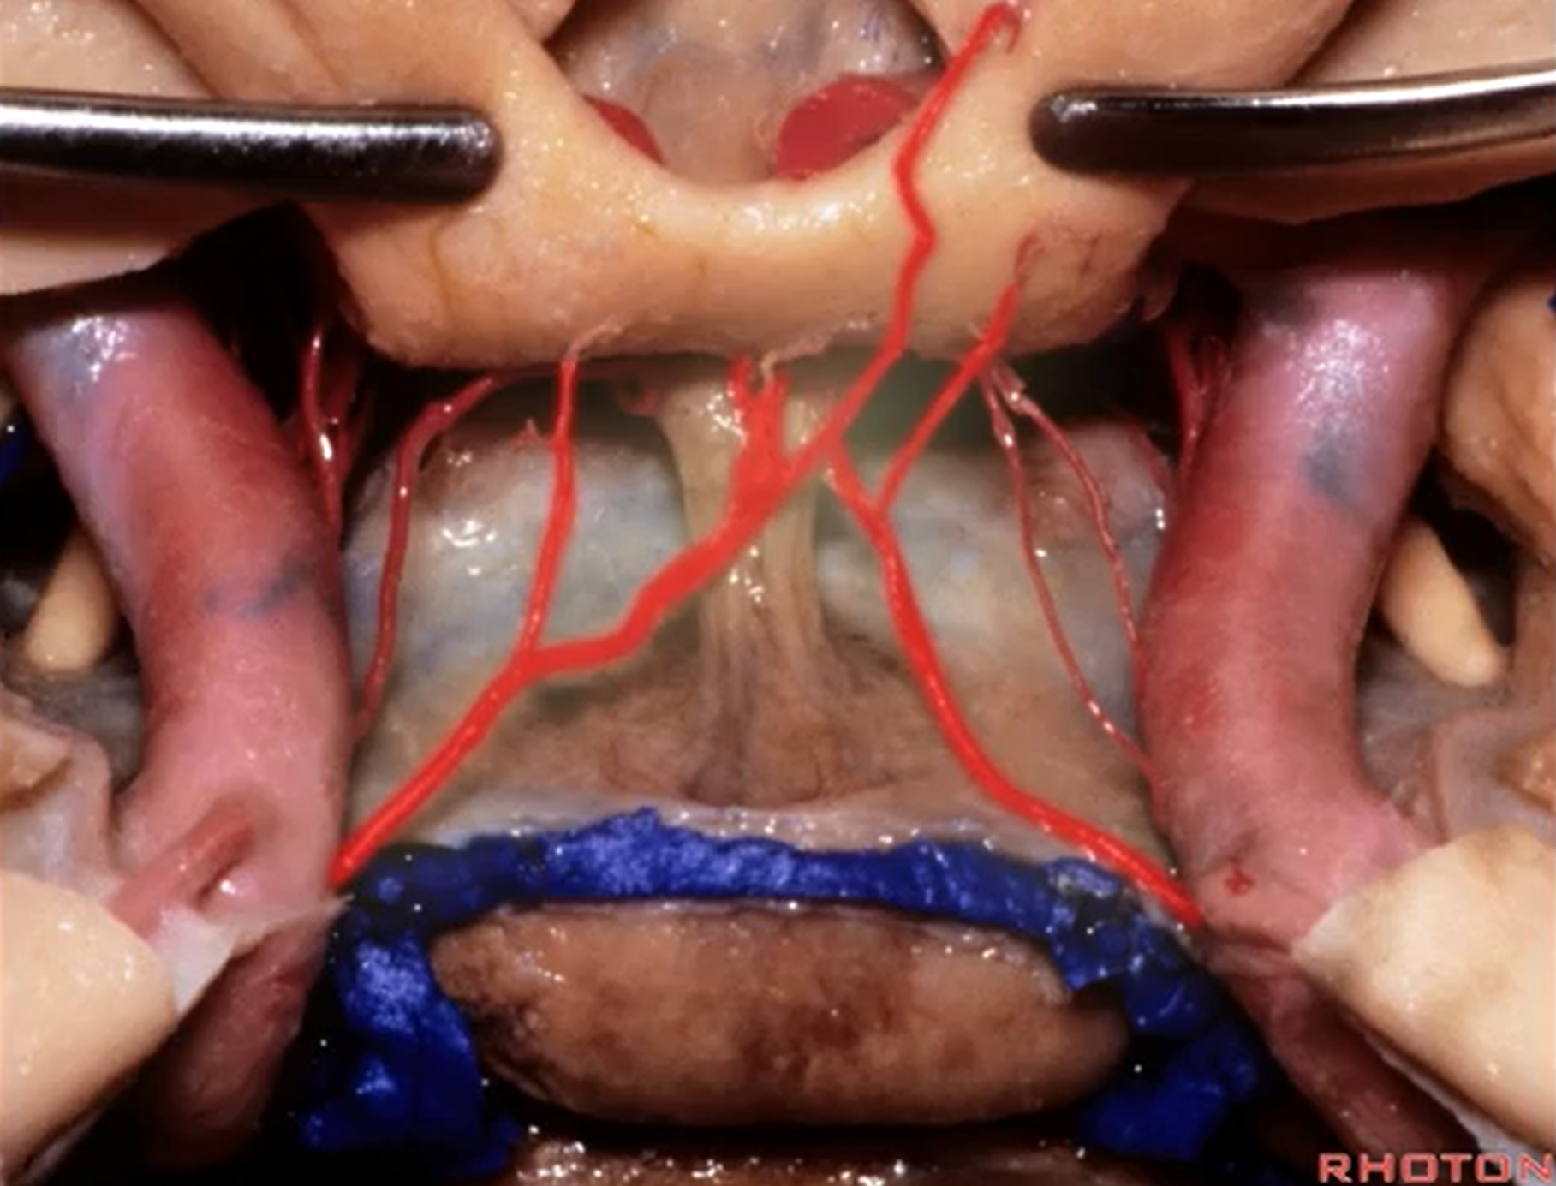

Meningohypophyseal Trunk (MHT)
- originates from proximal cavernous ICA
- may come off as single trunk or collection of vessels.
- supplies: pituitary, portions of clivus, CN III, IV, V, and VI, tentorium cerebelli and adjacent dura.
- branches of MHT (A): Variation is the rule!!!
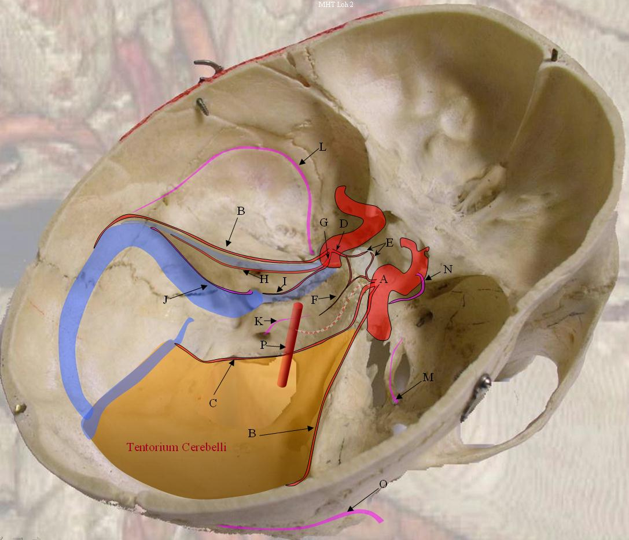
- lateral tentorial artery - along lateral edge of tentorium; in hemodynamic balance with petrosquamosal branches (L) of MMA and Occipital Artery (O)
- marginal tentorial artery (s. Bernasconi-Cassinari artery) - along free edge of tentorium; feeds tentorial notch meningiomas.
- inferior hypophyseal artery, branching into:
E: Hypophyseal branches → posterior and parts of anterior pituitary
F: Inferior clival branch - descending along dorsum sella where it is in hemodynamic balance with ascending clival braches (K) of Ascending Pharyngeal
G. lateral clival artery - branching into:
H: Lateral branch - runs alongside Superior Petrosal Sinus
I: Medial branch - runs alongside Inferior Petrosal Sinus and is in balance with Jugular branches (J) of Ascending Pharyngeal
Checkered vessel connecting MHT with Basilar Artery (P) is Trigeminal Artery.
Middle Meningeal Artery (M)

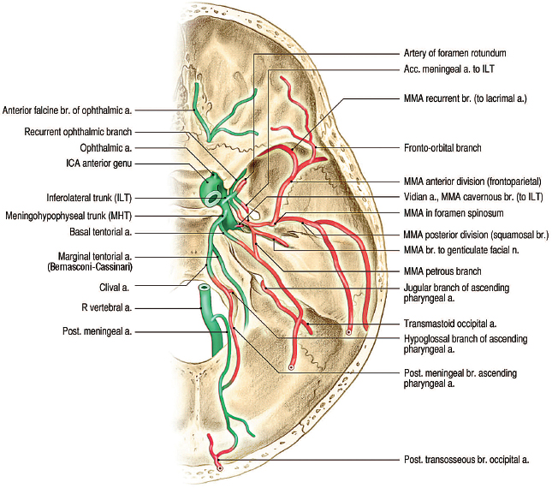

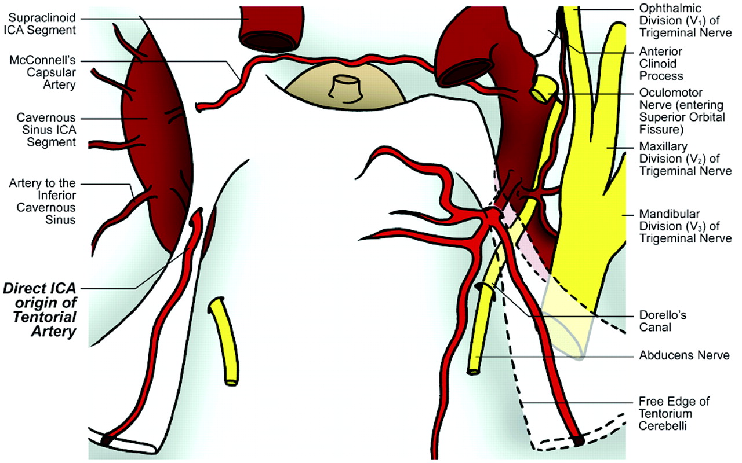

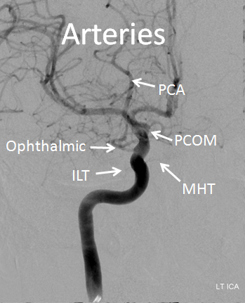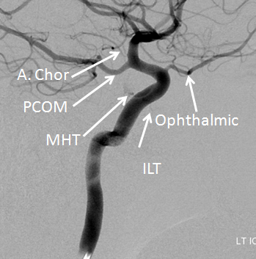
ILT – inferolateral trunk Source of picture: Neuroangio.org >>

Ophthalmic ostium (red arrow), anterior clinoid, sphenoid sinus. Proximal ring (yellow line) extends from clinoid undersurface to medial ICA wall, distal ring (purple line) comes off clinoid roof; carotid cave (pink triangle) is a small potential space under distal dural ring.
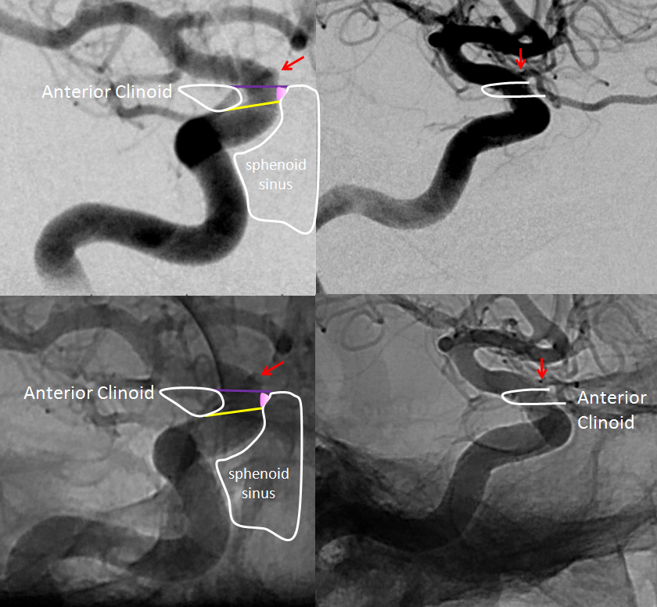
Source of picture: Neuroangio.org >>

Inferior hypophyseal artery:
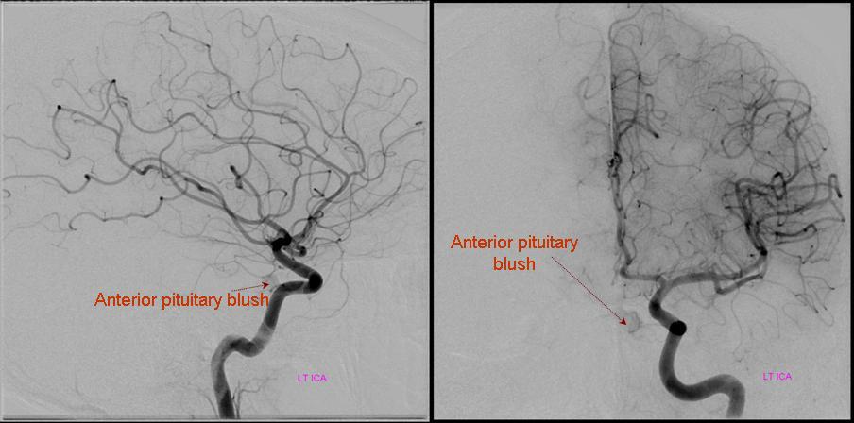
Source of picture: Neuroangio.org >>

Red= inferior hypophyseal, white=pituitary blush; purple = marginal tentorial, blue = ILT; purple = ? rotundum branch; orange = ? ovale branch:
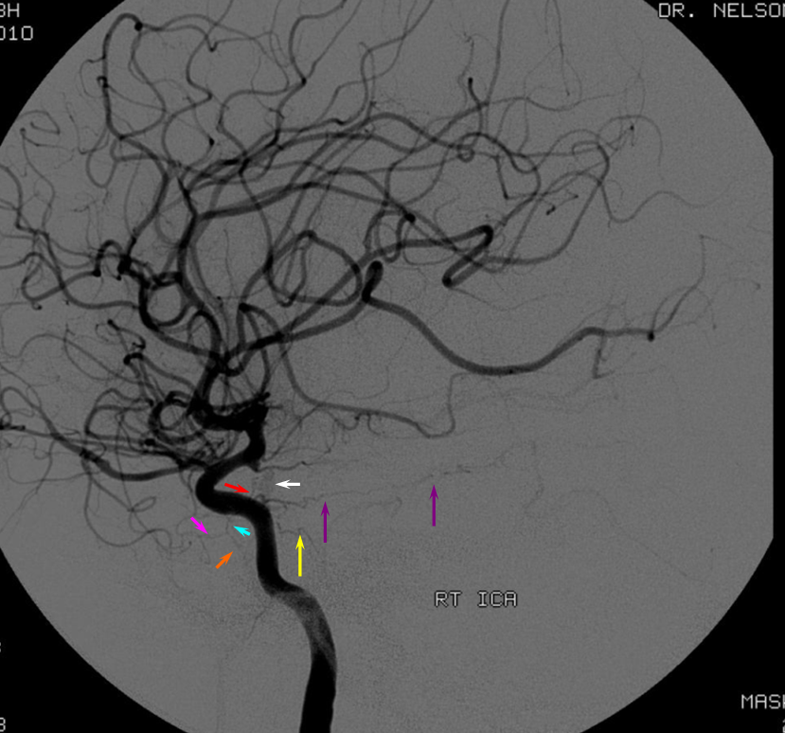
Source of picture: Neuroangio.org >>

Carotid web (white arrow) with contrast stagnation in late arterial phase (black arrow):
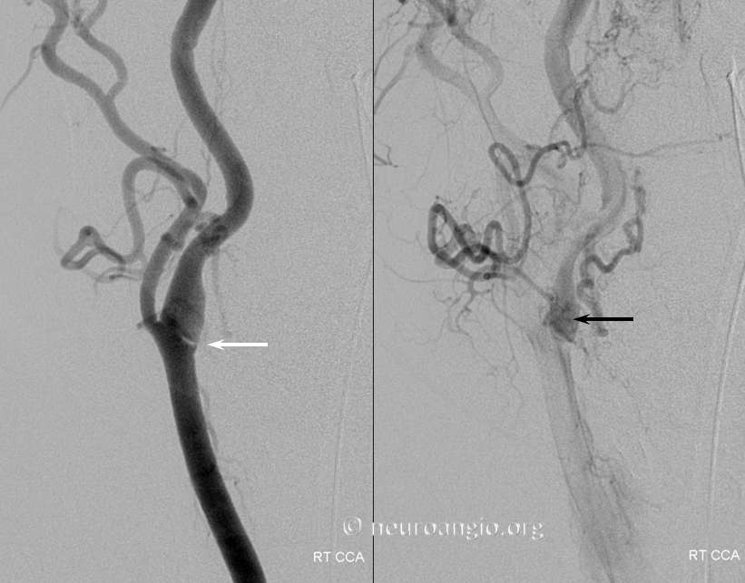
Source of picture: Neuroangio.org >>

Posterior circulation (vertebrobasilar system)
- supplies ≈ 20% of total brain.
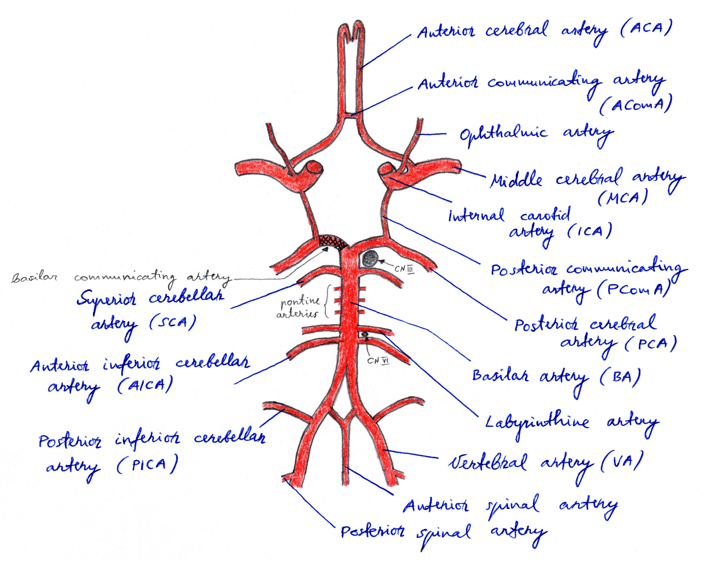
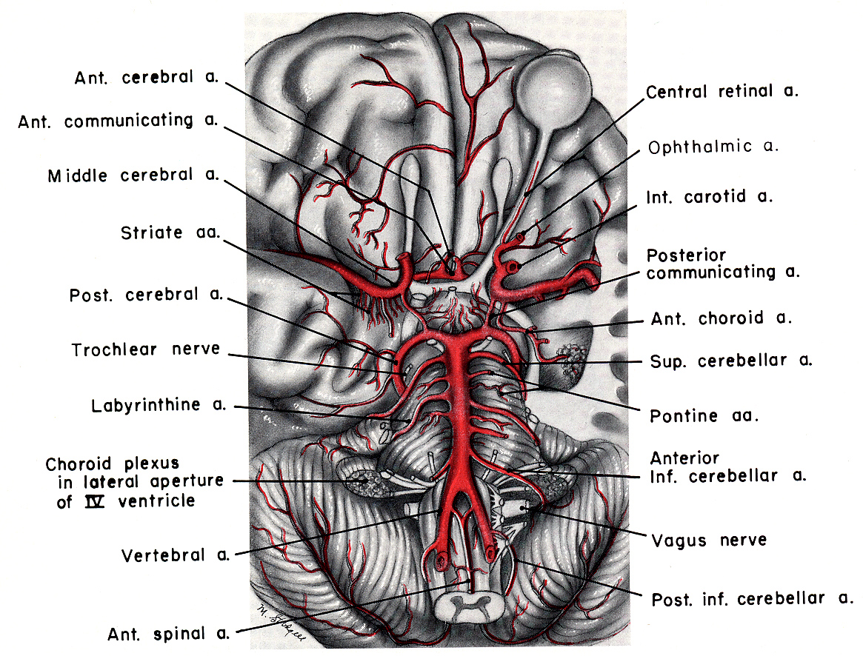

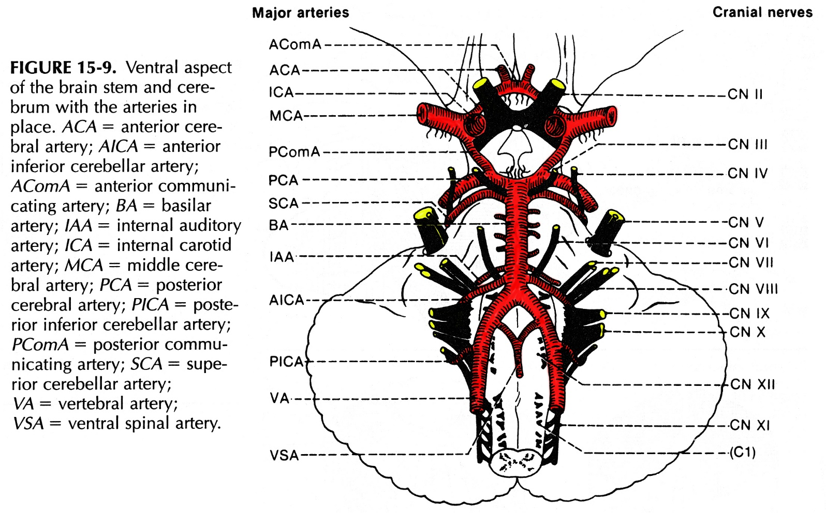

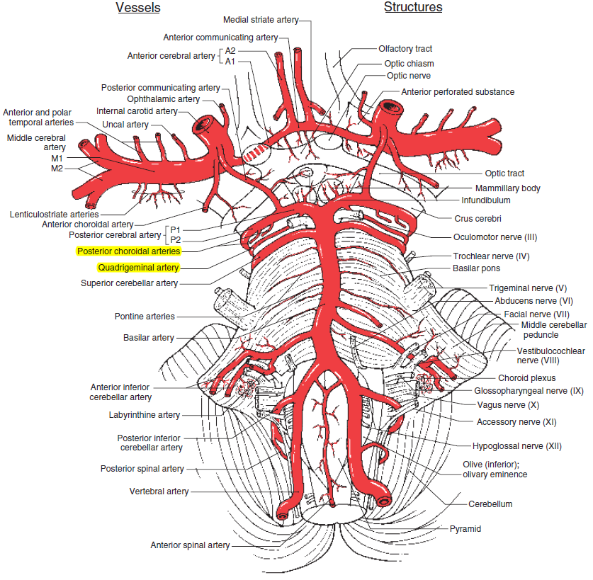
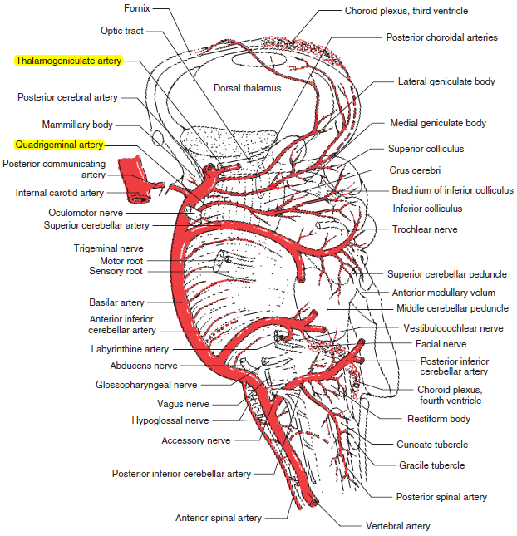

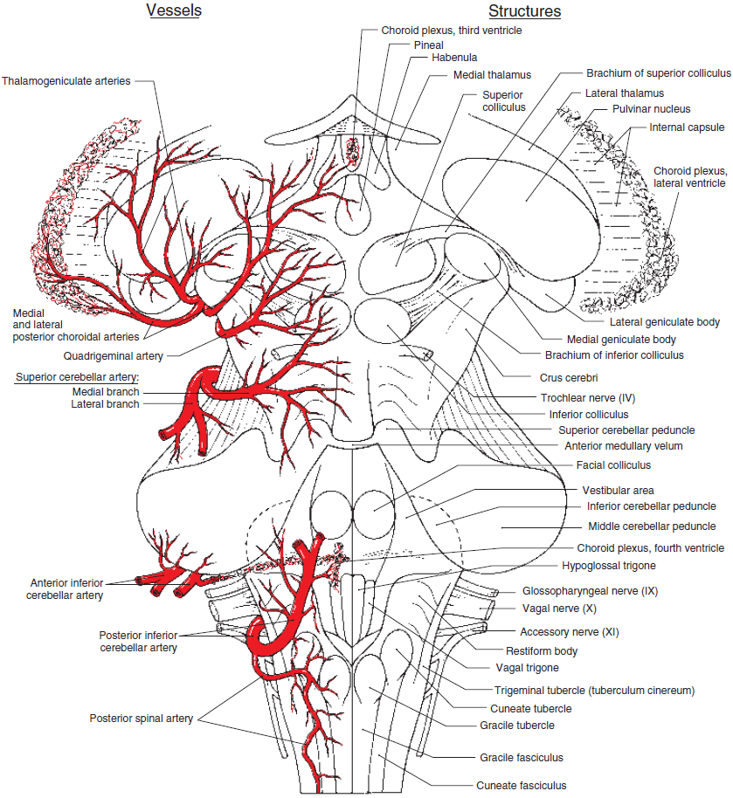

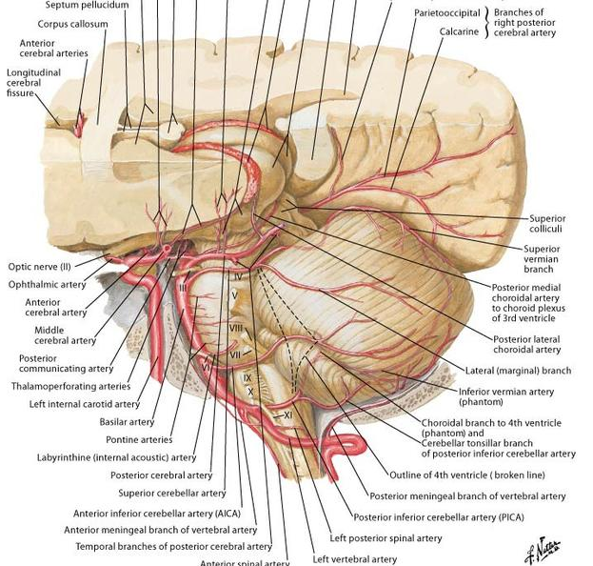

Vertebral artery (VA)
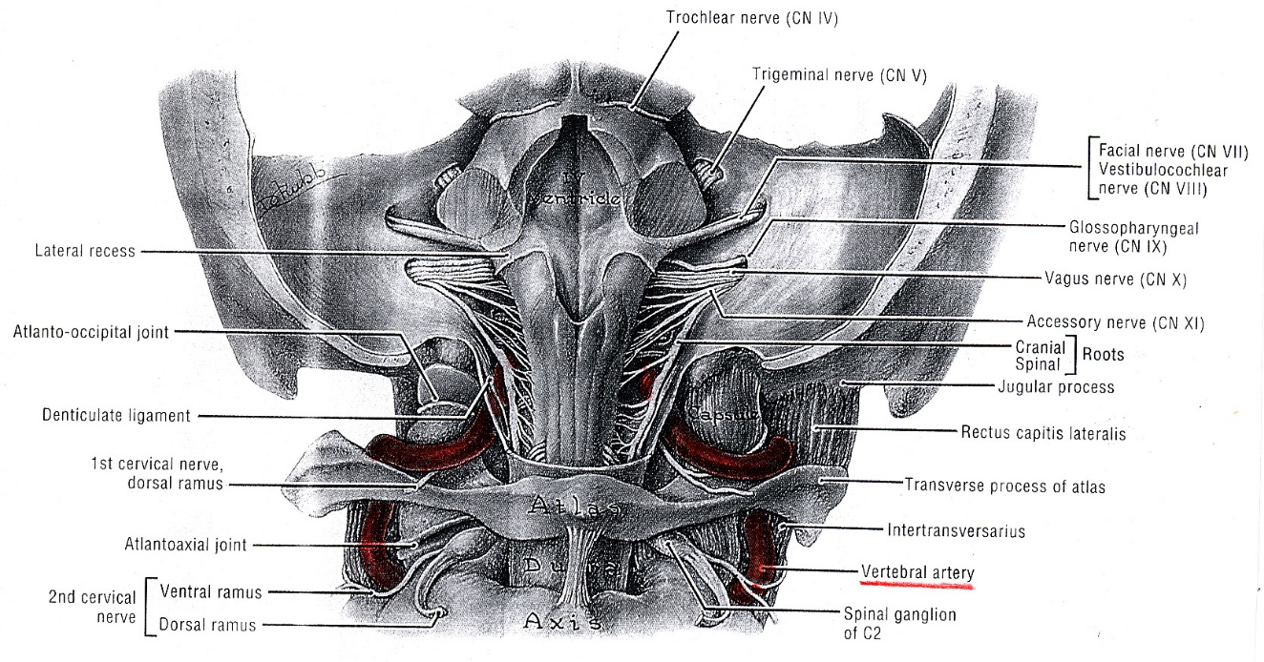

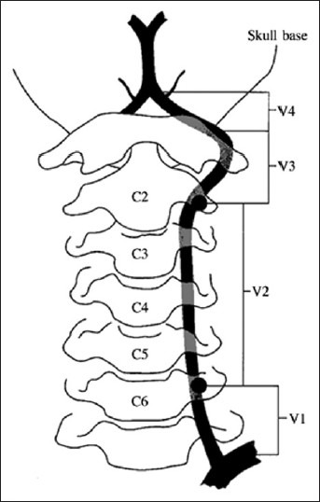

Four segments:
V₁ segment (prevertebral) - from VA origin (at subclavian artery, less often directly from aortic arch, even less often from supreme intercostal artery) to entry into costotransverse foramen of C₆.
V₂ segment - within transverse foramina C₂₋₆;
- gives rr. spinales (transverse segmental arteries) en route - make anastomoses with occipital artery, deep cervical artery, ascending cervical arteries, thyrocervical arteries or any other artery in the neck (e.g. ascending pharyngeal, contralateral VA)!
V₃ segment - tortuous course between C₂ to suboccipital triangle between atlas and occiput, where it is covered by atlanto-occipital membrane.
- makes complicated 90° turn at atlas - portion of VA that loops behind atlantoaxial joint is prone to mechanical trauma, and head rotation to 60° may cause narrowing of ipsilateral VA.
- pierces membrana atlantooccipitalis post. and dura mater, gets inside the skull through foramen magnum.
V₄ segment - intracranial portion (after VA has pierced dura mater to enter foramen magnum):
- travels on anterolateral surface of medulla oblongata.
- branches:
  - paramedian arteries* – small, numerous
  - posterior spinal arteries*
  - anterior spinal artery* – solitary (formed by anastomosis of two branches of vertebral arteries)
  - posterior inferior cerebellar artery (PICA)* – largest branch → lateral medulla, posteroinferior surface of cerebellum
  - at pontomedullary junction, both aa. vertebrales converge into basilar artery.
*feed medulla oblongata

Normal variations
- vertebral arteries are commonly unequal in size:
- left VA ≥ right VA in ≈ 75% cases.
- when one of arteries is very small, it frequently supplies only ipsilateral PICA territory (called “PICA termination of vertebral artery”).
- V1 course variations: most commonly, at C7, VA is anterior to the foramen and is located 1.7 cm anterior to the posterior cortex of the vertebral body and 1.8 cm lateral from the midline.
- V2 course variations:
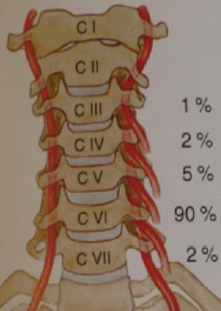
- vertebral artery most frequently enters the foramen at C6 (87-89%), however, there can be variations: 3.5-5.4% enter C7 foramen, 6% enter at C5, and < 1.4% enter above C5 (some experts say, it is deep cervical artery joining aplastic vertebral artery).
- as VA ascends cephalad, the transverse foramen moves from a more anterior and lateral position to a more posterior and medial position:
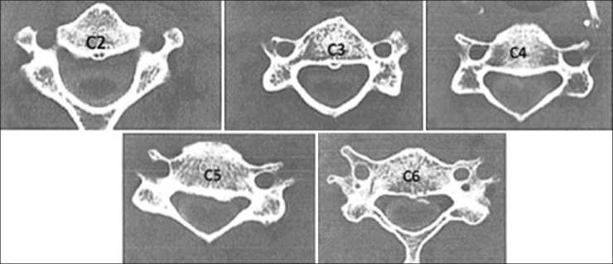
- interforaminal distances decrease from an average of 29 mm at C6 to 26 mm at C3, and the distance between the posterior wall of the foramen to the posterior wall of the vertebral body decreases from 3.5 mm at C6 to 2.2 mm at C3.
- running medially to VA in the transverse foramen is a venous and nervous plexus consisting of 1-3 veins and sympathetic nerves, and fibrous tissue connects these structures to the uncinate process.
- up to 7% of the time there may be a duplicate foramen - artery runs in the more medial foramen:
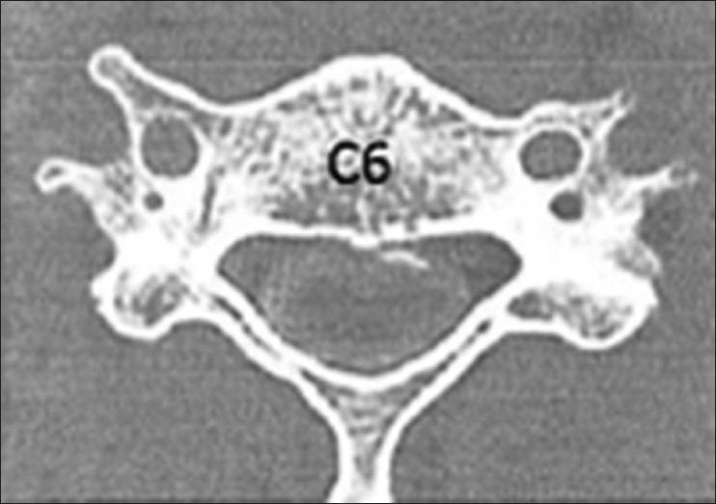
- left foramen is often slightly larger, as the left vertebral artery is more commonly the dominant vessel.
- while the transverse foramen is most often located lateral to the uncovertebral joint, there is a 2.7% risk of a tortuous or anomalous vertebral artery - in these cases, the foramen is located on average 0.14 mm medial to the uncovertebral joint (esp. in RA patients) – medialization is most common at mid vertebral body level - risk of injury in corpectomies:
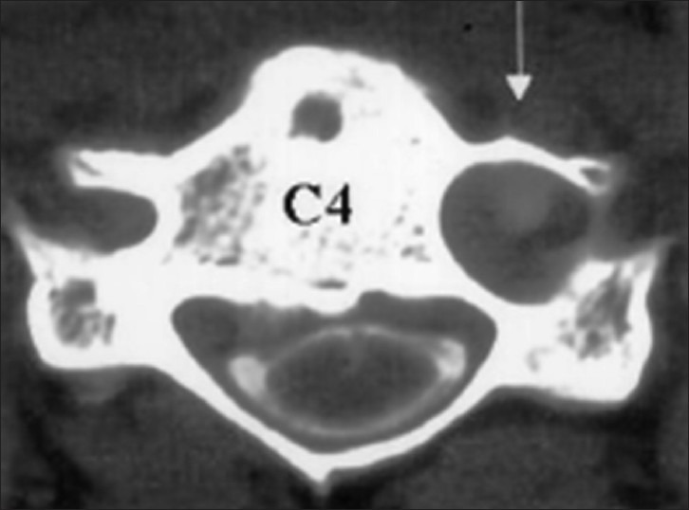

- V2 anastomoses:
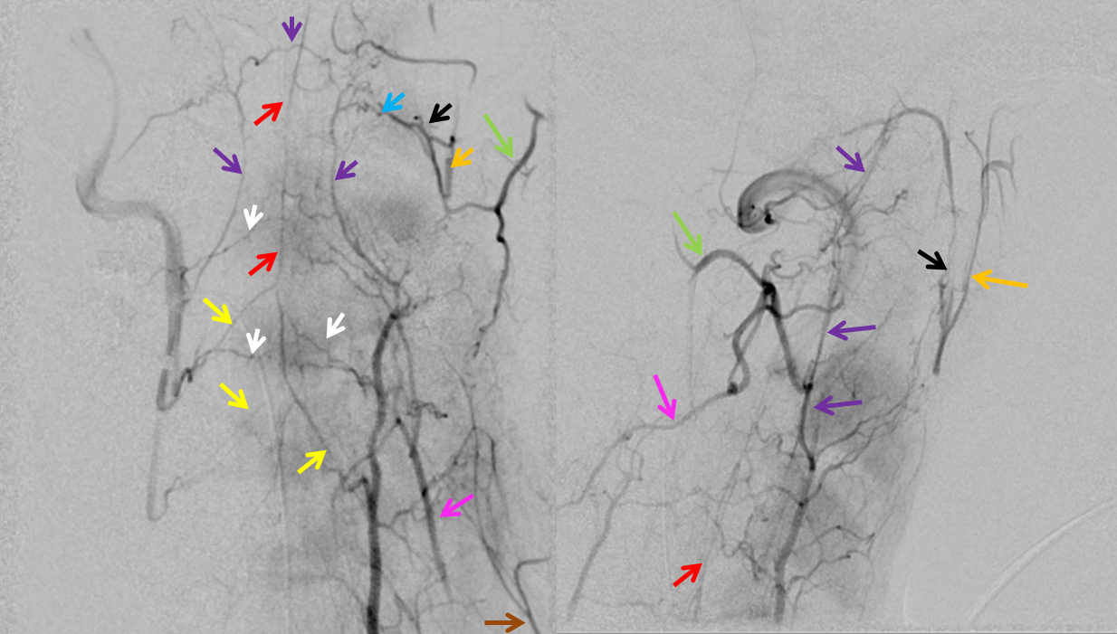
Source of picture: Neuroangio.org >>
red – anterior spinal, white – radiculomedullary, yellow — epidural arcade, purple — odontoid arcade, blue – muscular branch ascending pharyngeal; black – neuromeningeal trunk, ascending pharyngeal; orange — pharyngeal trunk, ascending pharyngeal; green — occipital; pink — deep cervical; brown – ascending cervical

- V3 course variations:
- normally, VA exits the C3 foramen, takes a sharp turn at the superior articular facet of C2, and exits C2 foramen around a 45-degree angle.
- enters C1 transverse foramen and travels horizontally in the groove of C1 superior arch.
- crosses the atlanto-occipital membrane to enter the cranial cavity approximately 15 mm lateral to midline at C1.
- 5.4% of patients have anomalous course:

- intersegmental VA (4.6%) - travels below the C1 arch after exiting the C2 transverse foramen, then enters the spinal canal without entering the C1 transverse foramen (or it can have two trunks – fenestrated VA [0.5%]):
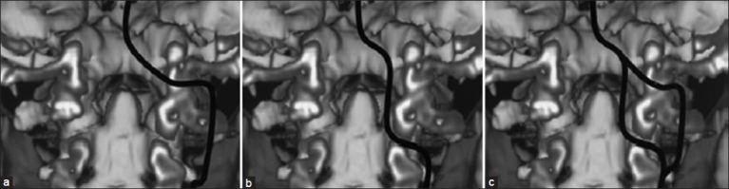

- posterior loop:
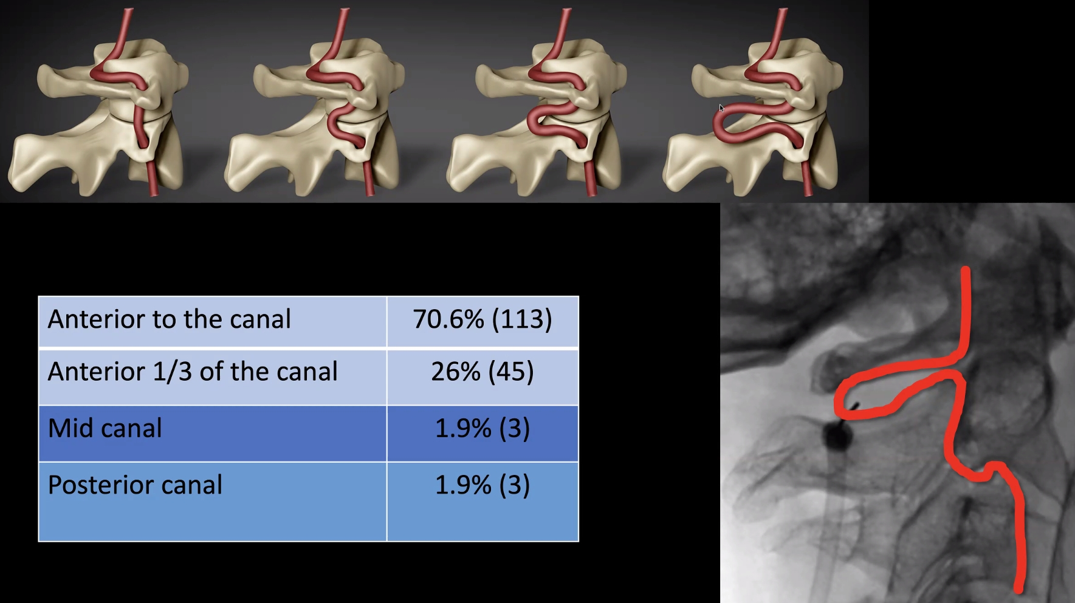

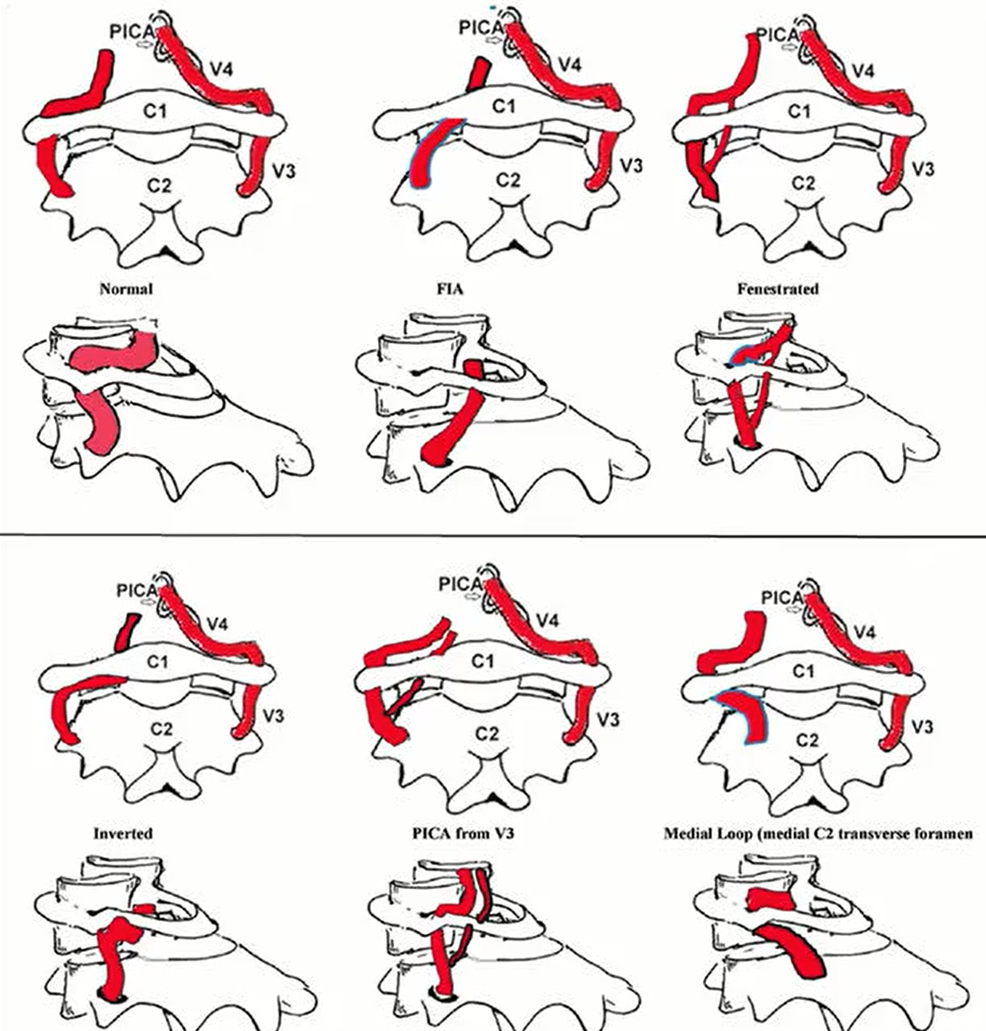

VAs, extradural PICAs change caliber (for the smaller) when they pierce dural ring of the foramen Magnum:
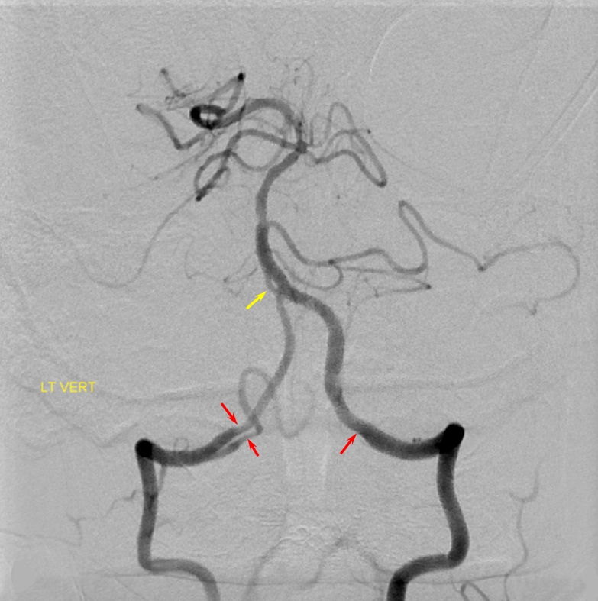
Source of picture: Neuroangio.org >>

PICA
Variants of origin (important for punctures):
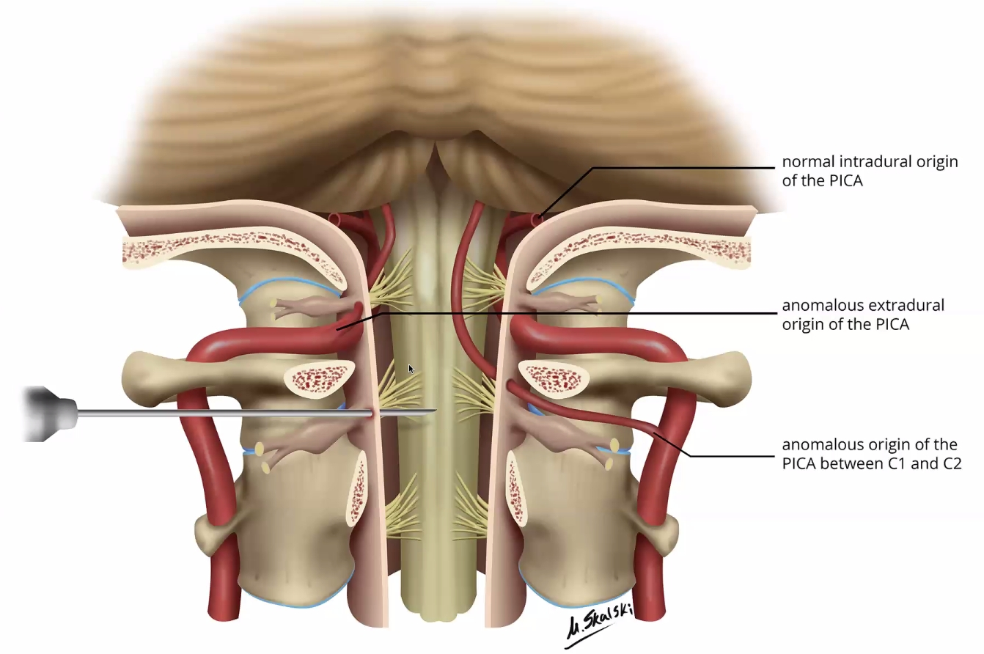
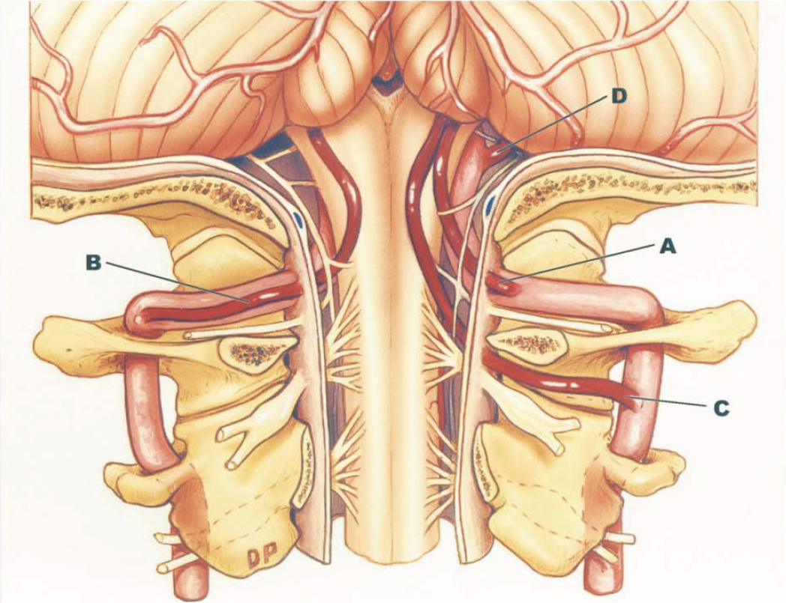
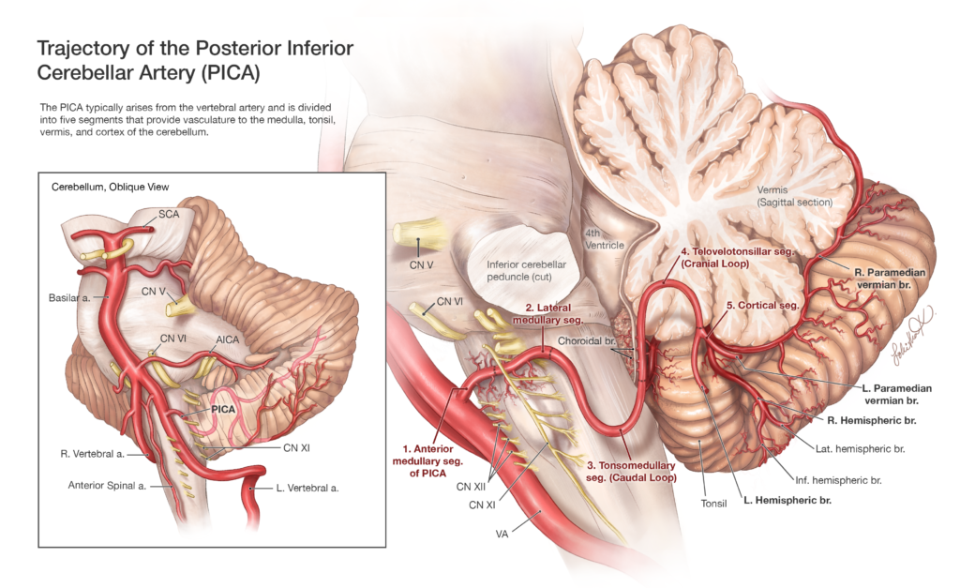
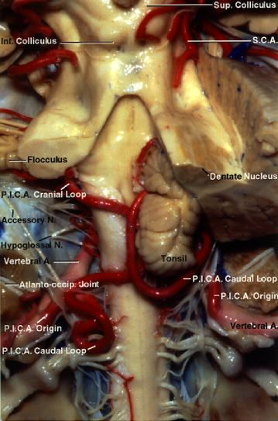

C1 origin PICA:
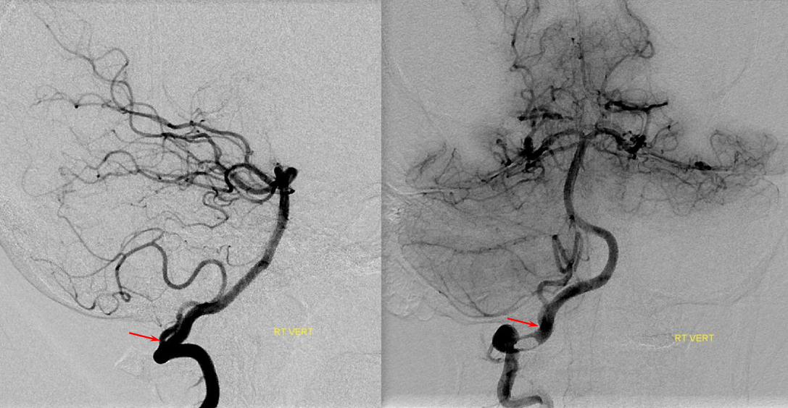
Source of picture: Neuroangio.org >>

Basilar artery (BA)
- kyla pons pilveliu (per clivus).
- branches:
  - pontine arteries – daugybinės:
rr. mediales (s. paramedian) → wedge of pons on either side of midline
rr. laterales (s. short circumferential) → lateral 2/3 of pons, middle & superior cerebellar peduncles
long circumferential (AICA, SCA): → cerebellar hemispheres
  - anterior inferior cerebellar artery (AICA) – atskyla pons lygyje
surgical anatomy of AICA – see Onc62 p.
  - labyrinthine (s. internal auditory) artery (kartais atsišakoja nuo AICA) → cochlea, labyrinth, part of CN7
  - superior cerebellar artery (SCA) – atskyla midbrain lygyje
  - ties interpeduncular fossa (just above tip of dorsum sellae) a. basilaris skyla į dvi aa. cerebri post. (PCA)
embriologiškai PCA vystosi iš PComA, o ne iš BA, todėl segmentas, jungiantis PCA su BA yra tikroji “communicating artery” (kai kurie autoriai vadina “basilar communicating artery”)
    - bifurcation of basilar arteries can appear either V-shaped (caudal fusion of posterior cerebral arteries)* or T-shaped (cranial fusion of cerebral arteries).
*frequently associated with basilar tip aneurysms

- tarp SCA ir PCA praeina CN3, tarp AICA ir a. labyrinthi praeina CN6 – aneurizmos gali spausti atitinkamus nervus.

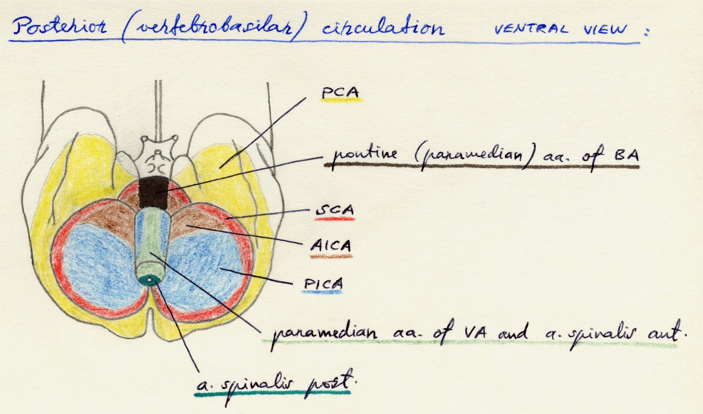

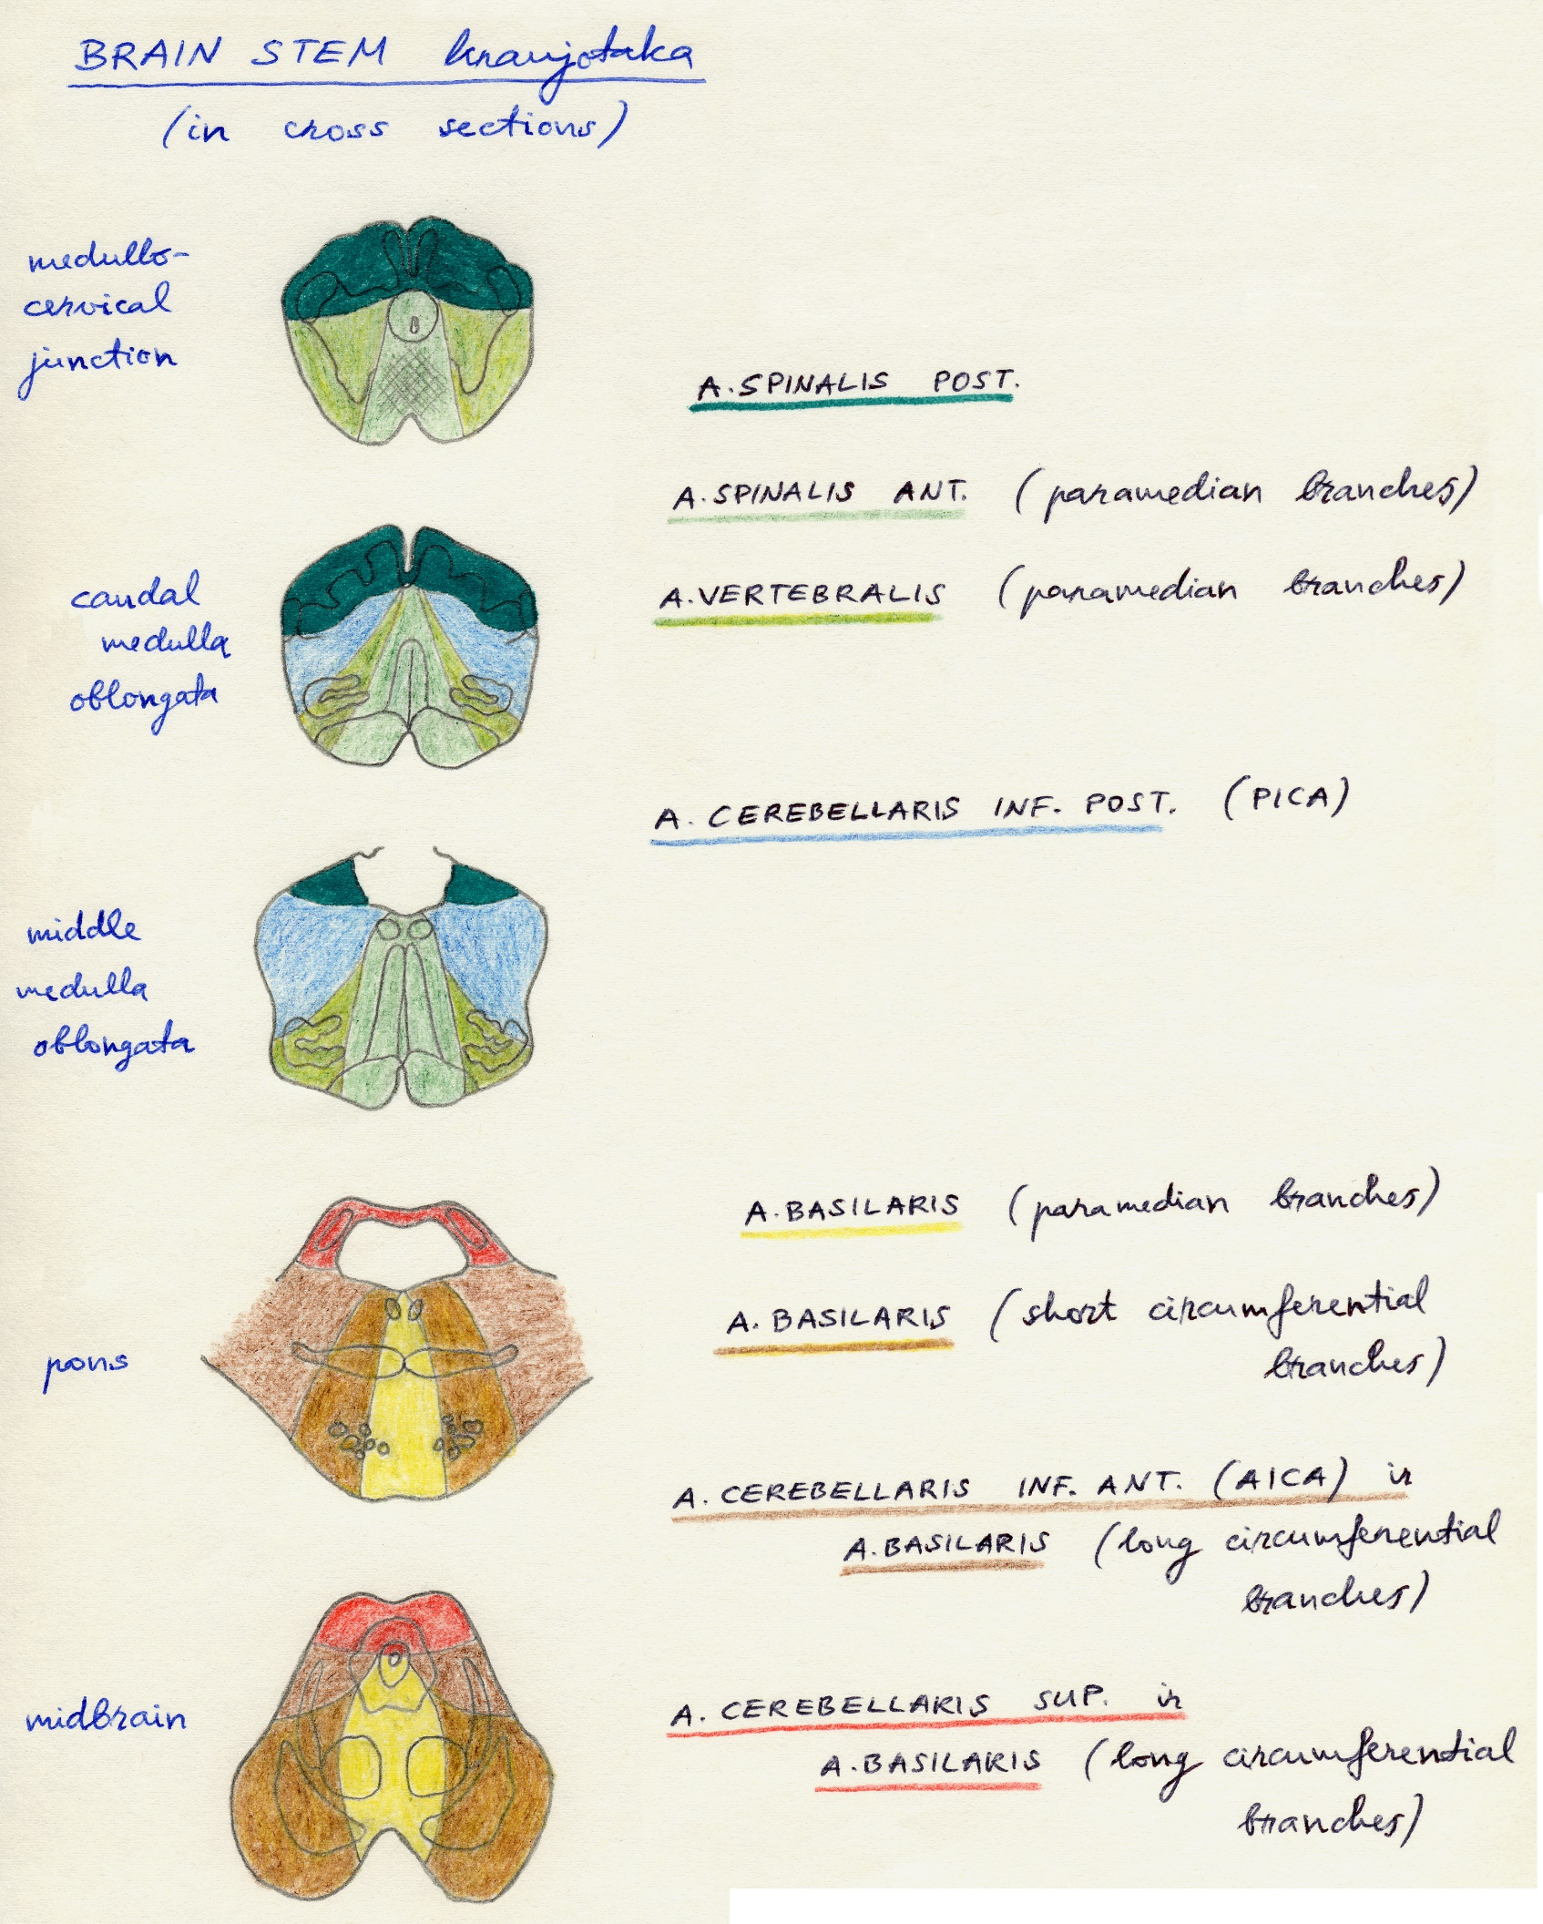

Variation in fusion patterns of the basilar artery
- it is conceptually helpful to think of BA as being “zipped” in the middle, with VA and PCA segments being “unzipped”; length of “zipped” segment, and the integrity of zipper determine the final configuration of BA:
  - “short” basilar - relative lack of fusion of caudal or rostral segments (there is no formal “number” to guide what short or long is)
  - unfused top of basilar (“unzipping” at the basilar tip)
  - fenestrated basilar - broken zipper in the middle (may mimic dissection); very rarely – complete basilar nonfusion.

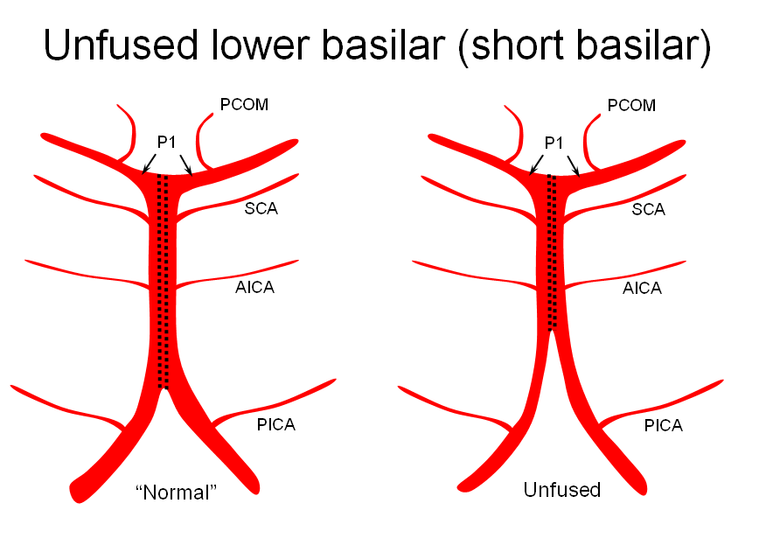
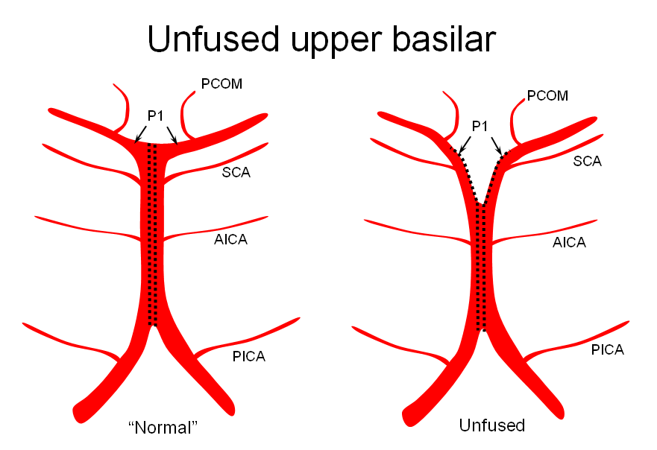
Source of picture: Neuroangio.org >>

Right SCA coming off P1:
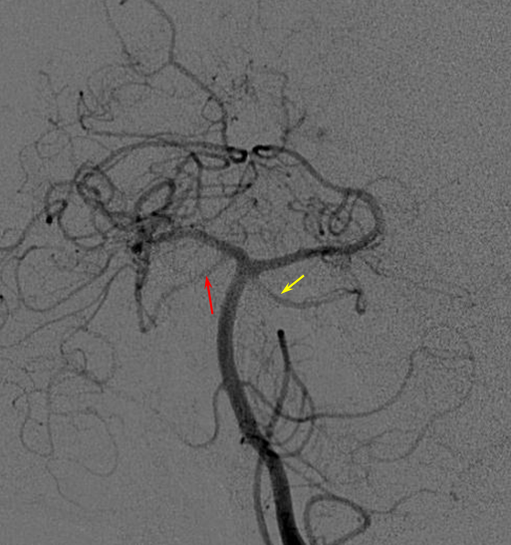
Source of picture: Neuroangio.org >>

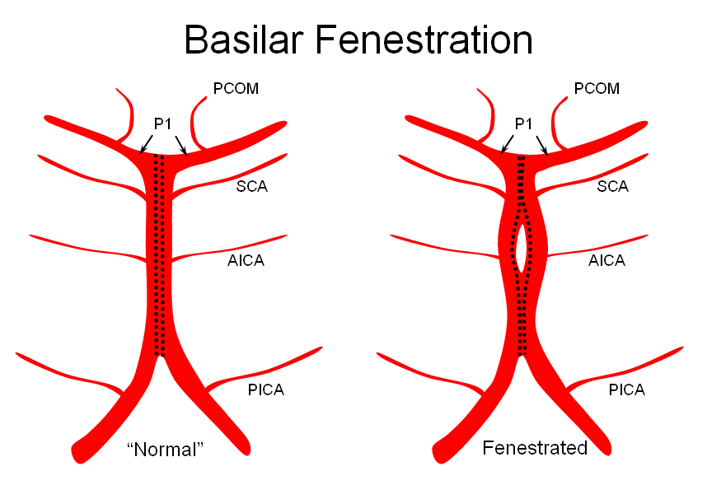
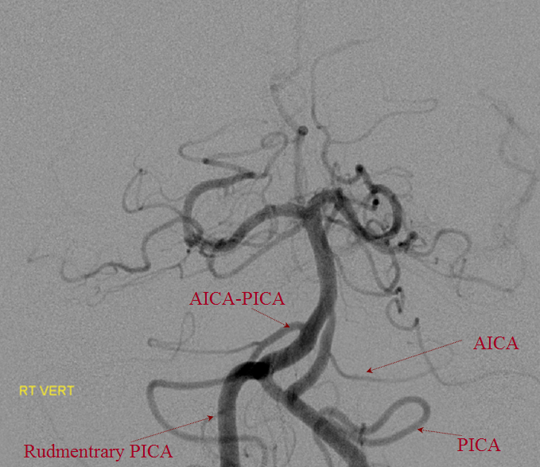
Source of picture: Neuroangio.org >>

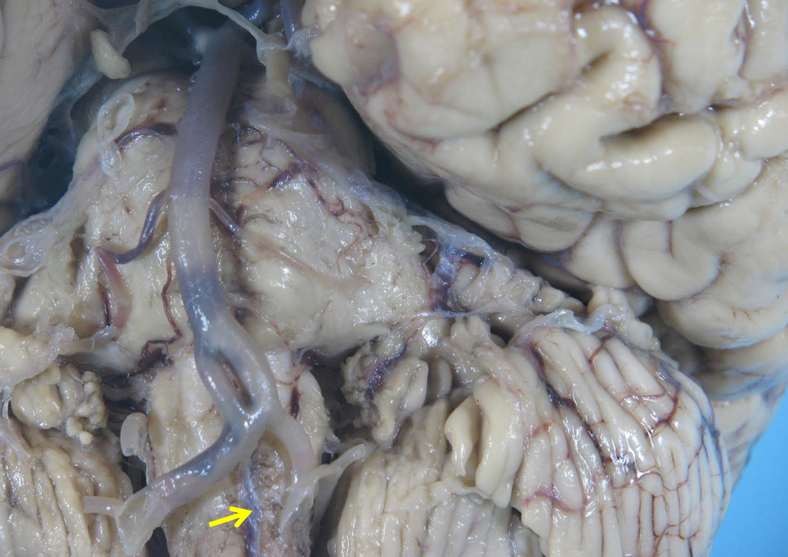
Source of picture: Neuroangio.org >>

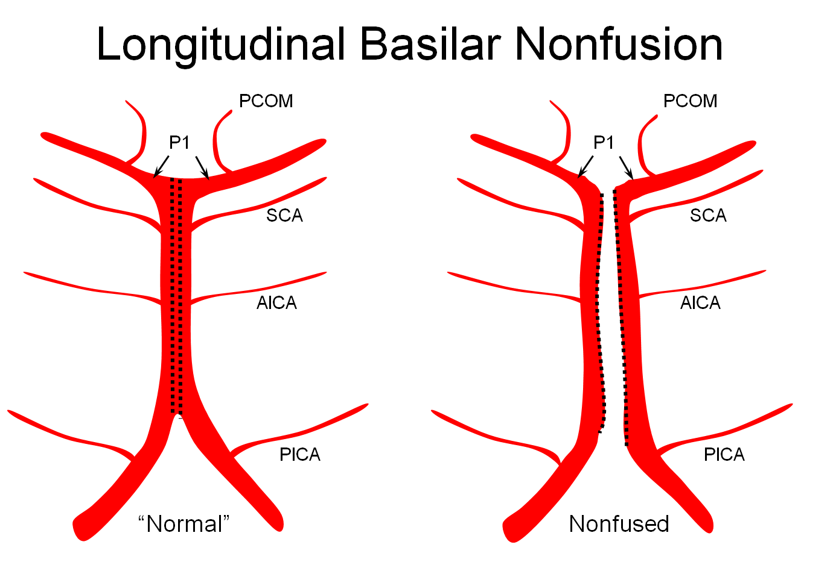
Source of picture: Neuroangio.org >>

Duplicated AICAs:
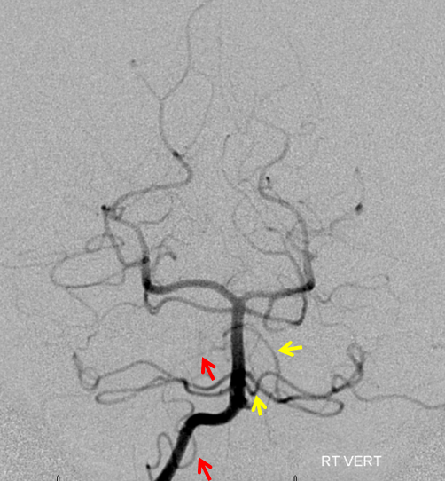
Source of picture: Neuroangio.org >>

Circulus arteriosus cerebri (Circle of Willis)
- keturios pagrindinės smegenų arterijos įeina į kaukolę (aa. vertebrales – per foramen magnum, aa. carotici internae – per canalis caroticus) ir, susirinkę ventraliniame smegenų paviršiuje, susijungia į circulus arteriosus cerebri – pentagon in area of optic chiasm, hypothalamus, and interpeduncular fossa.
- > 50% normal individuals have incomplete circle of Willis:
- hypoplasia / atresia of one or both PComA (22%)
- hypoplasia / atresia of one A₁ segment (10%).
- hypoplasia* / absence** of P₁ segment (20-30%) – in such patients PComA cannot be sacrificed during surgery.
*fetal origin of PCA with thick PComA / **fetal PCA.

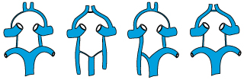

Regional circulation
From arterial circle of Willis and principal cerebral arteries (ACA, MCA, PCA, AComA, PComA) two types of branches arise:
- Cortical branches – pass in pia mater to regions of cortex;
  - undergo considerable branching – form freely anastomosing superficial plexuses.
  - smaller arteries (arising from these plexuses) penetrate cortex at nearly right angles.

- Central branches (arise from arterial circle of Willis and proximal portions of principal cerebral arteries) – supply deep structures (diencephalon, basal nuclei, internal capsule):

Anteromedial central arteries – branches of A₁ and AComA.
  - supply anteromedial thalamus & corpus striatum, anterior hypothalamus.

Anterolateral central (s. lenticulostriate, lateral striate) arteries – branches of M₁; čia priklauso ir viena A₂ šaka – medial striate (s. recurrent of Heubner) artery – it is simply the most medial of lenticulostriates (emerges from the lateral aspect of very proximal A2 – within 4 mm of AComA)
  - courses under anterior perforated substance directly parallel and superior to A1
  - perforators that ascend to anterior perforated substance.
  - supply:
- capsula interna – anterior limb + corona radiata!
- corpus striatum – putamen, head and body of caudate (but not GPi, not tail of nucl. caudatus) !
- substantia innominata.
- central portion of anterior commissure.

Red=Heubner; Yellow=lateral perforators:
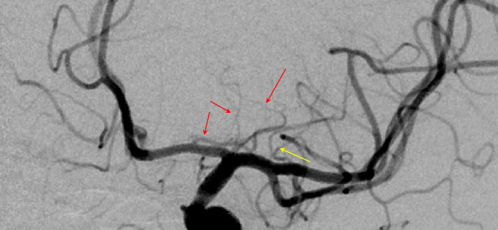
Source of picture: Neuroangio.org >>

Classic Heubner infarct:
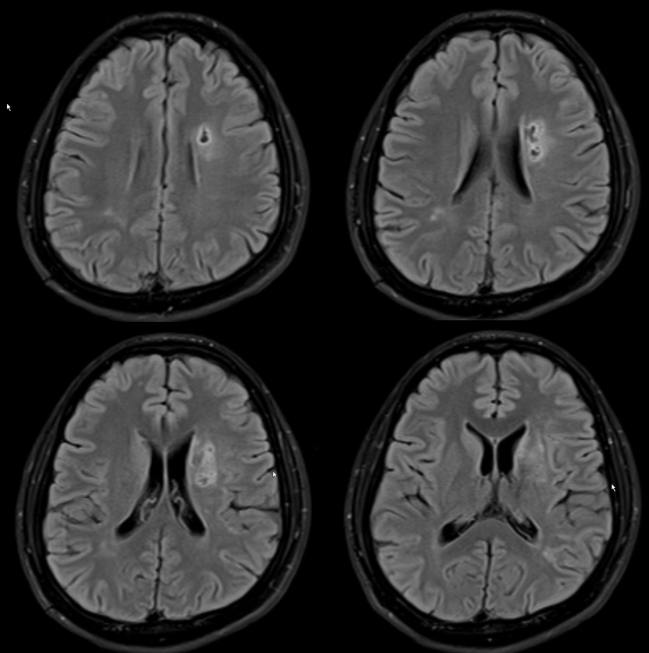
Source of picture: Neuroangio.org >>

Variations on lenticulostriate balance:
Left image: dominant “lateral” system taking over the medial family.
Center image - two lenticulostriate groups:
  - ACA lenticulostriates - Heubner and proximal A1 (white arrows)
  - M1* lenticulostriates (*if M1 is short, lenticulostriates originate from M2 superior division).
Right image: unusually highly dominant A1 segment family that is taking over the lateral lenticulostriate territory.
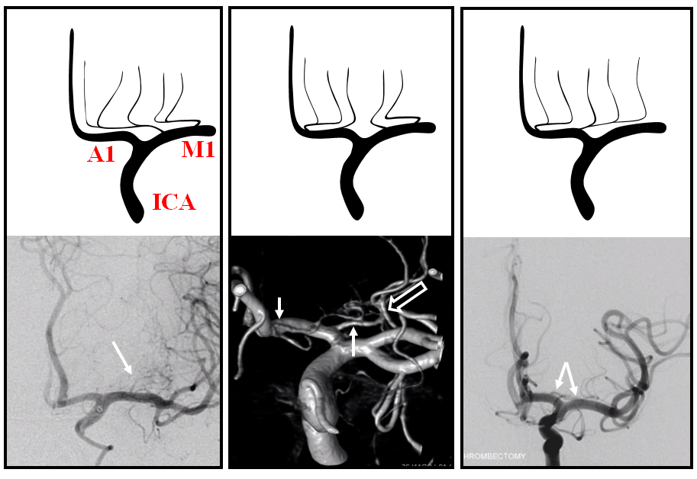
Source of picture: Neuroangio.org >>

Posteromedial central arteries – branches of BA, P₁, PComA.
  - supply:
- medial part of pedunculus cerebri – P₁ branches entering posterior perforated substance (interpeduncular fossa dugnas).
- posterior hypothalamus
- anteromedial thalamus (thalamo-perforating arteries)
artery of Percheron (posterior thalamo-subthalamo-paramedian artery) - single small artery from right or left P₁ (or top of BA – most commonly) - divides in subthalamus to bilaterally supply inferomedial and anterior thalamus and subthalamus; occlusion leads to profound level of consciousness alterations!

Posterolateral central arteries – branches of P₂.
  - supply posterolateral thalamus (thalamo-geniculate arteries).

Anterior choroidal artery (AChA) (branch of supraclinoid ICA) – long subarachnoidal course and relatively small caliber.
  - proximal (cisternal) segment - passes caudally across and below optic tract (medial to uncus), and then laterally (through crural cistern and around cerebral peduncle) → enters inferior horn of lateral ventricle through choroidal fissure of temporal lobe.
  - distal (plexal) segment - goes posteriorly in cleft of temporal horn; terminates near lateral geniculate body (or may extend around pulvinar).
- rich anastomoses between AChA and lateral posterior choroidal artery, PComA, PCA - occlusion is usually tolerated fairly well!!! (internal capsule infarct occurs in 15%)
  - supplies:
Some choroidal occlusions are nearly asymptomatic, while others can be devastating!
- choroidal plexus of temporal horn
- capsula interna – apatinę posterior limb dalį ir visą retrolenticular limb → hemiplegia
- medial globus pallidus*, tail of nucl. caudatus
- piriform cortex and uncus, amygdala, hippocampus and dentate gyri.
- ventrolateral thalamus → hemisensory deficits
- lateral geniculate body, optic tract and origin of optic radiations → various homonymous field cuts
*ligation of AChA was utilized in treatment of Parkinsonism sometimes without ill effect

Perforators (purple) coming off main AChA trunk (red) prior to plexal point* (light blue); branch to choroid plexus distal to plexal point (pink); PCOM is orange (with a large thalamic branch). MHT (dark blue) and ILT (green) branches.
*AChA enters choroidal fissure
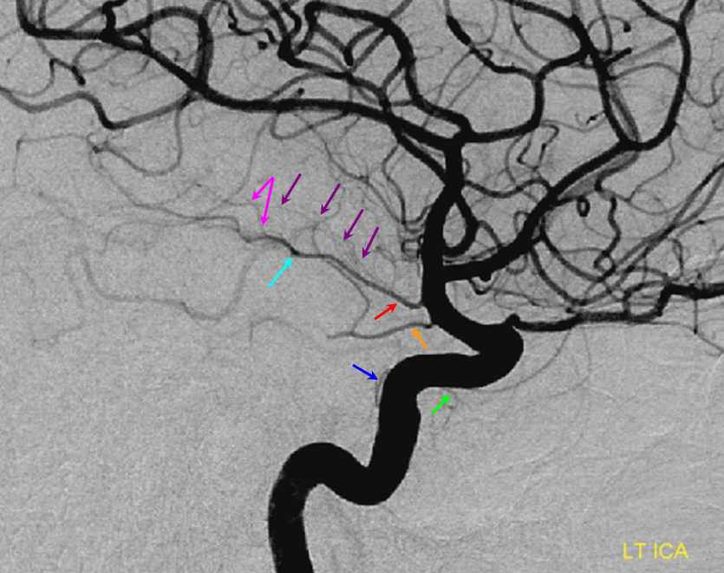
Source of picture: Neuroangio.org >>

Sometimes AChA perforators (red arrows) arise directly from adjacent ICA - these vessels are pretty much all eloquent; perforators hypertrophy to provide anastomoses between the choroidal perforator system and the lenticulostriate vessels in Moya-Moya; AChA (purple); PComA (yellow)
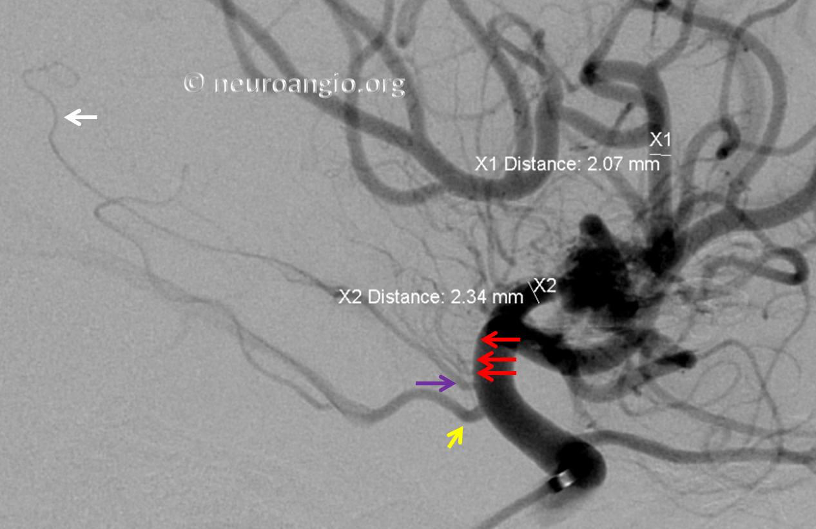
Source of picture: Neuroangio.org >>

Distances between AChA and PCOM and ICA terminus are all variable; e.g. PComA and AChA origins are nearly “fused”:
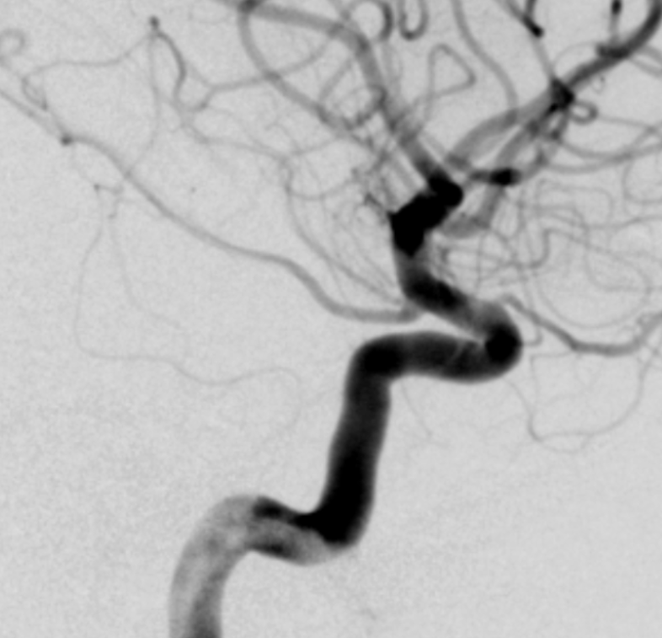
Source of picture: Neuroangio.org >>

Posterior choroidal arteries (PChA) (branches of P₂):
medial PChA – choroidal plexus of 3rd ventricle, dorsomedial thalamus;
lateral PChA – choroidal plexus of lateral ventricle.

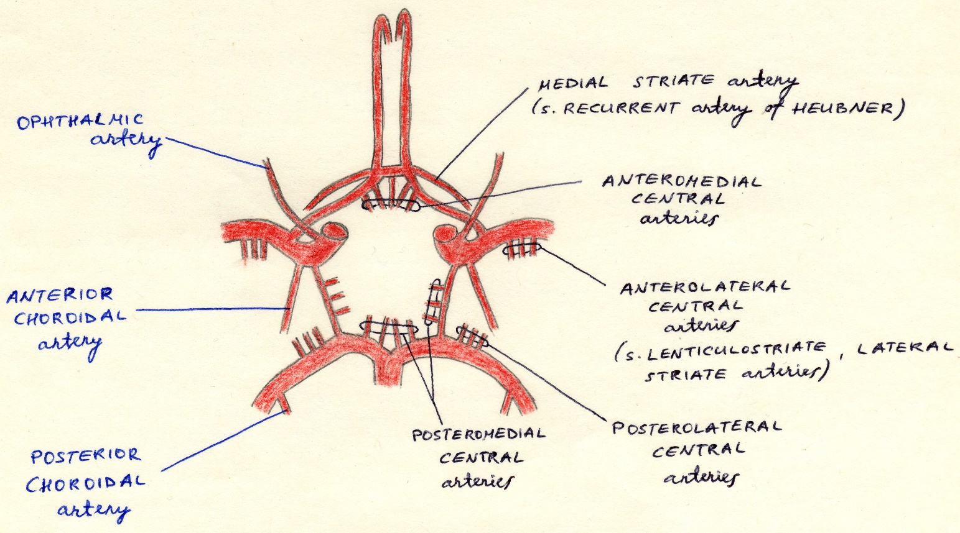
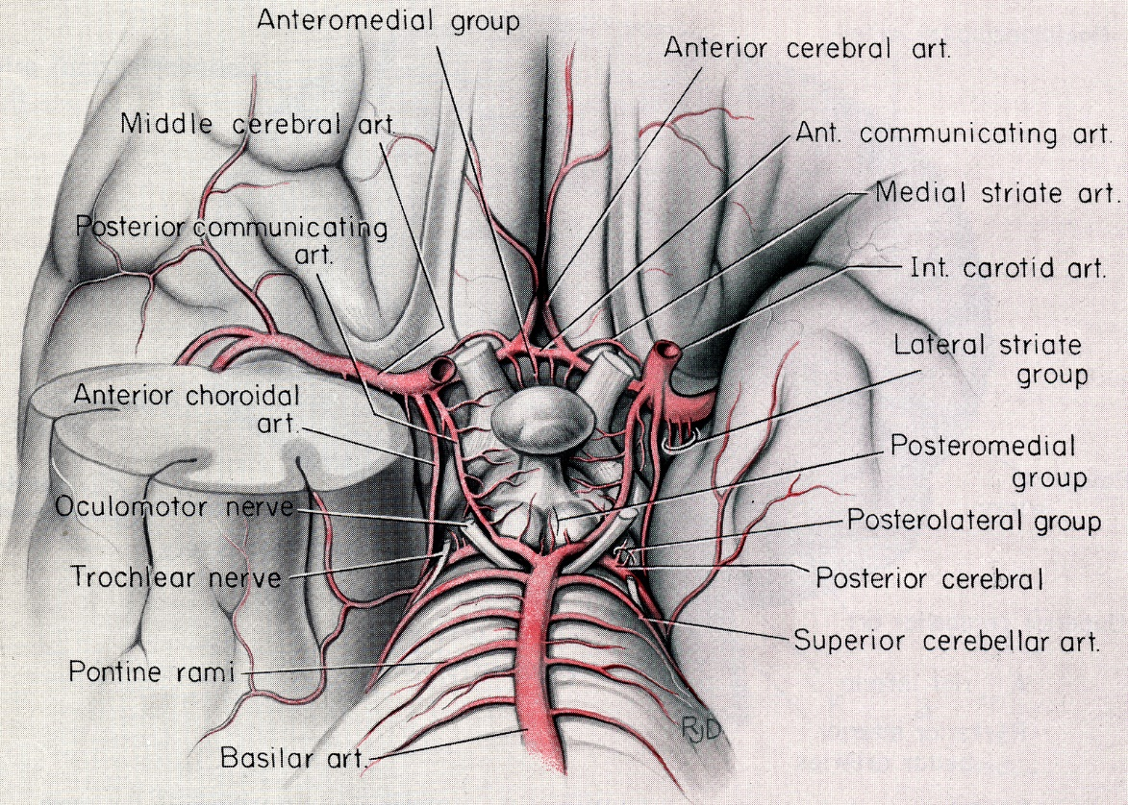
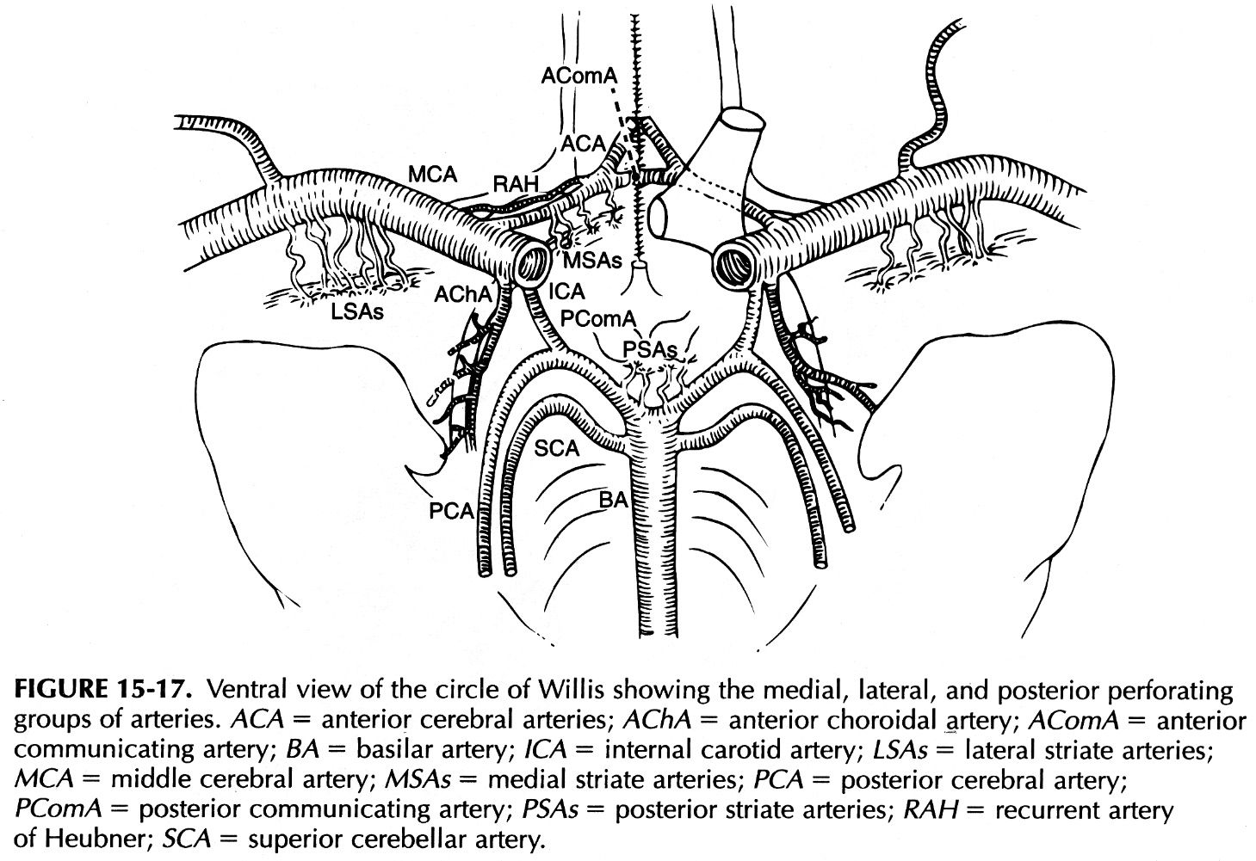

7T MRI:
Anterior Choroidal (light blue) can be traced perfectly well towards choroid plexus (dark red).
Lateral lenticulostriates (black), thalamogeniculate (dark blue double-sided arrow), as well as posterior choroidal (white), posterior inferior temporal (green) and middle inferior temporal (pink).
Tentorium cerebelli enhancement (yellow)
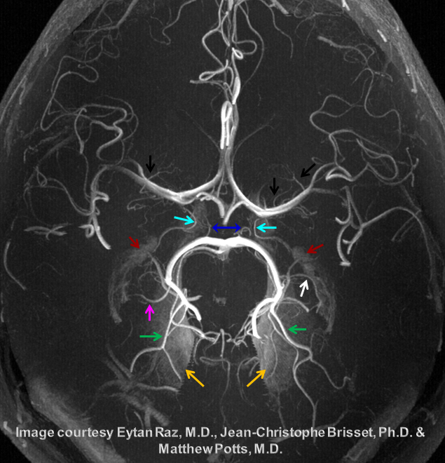
Source of picture: Neuroangio.org >>

Cerebral Hemispheres
Both receive three long circumferential arteries:
cerebrum – ACA, MCA, PCA
cerebellum – SCA, AICA, PICA

To remember distribution of ACA / MCA / PCA, pakanka atsiminti tik MCA baseiną:
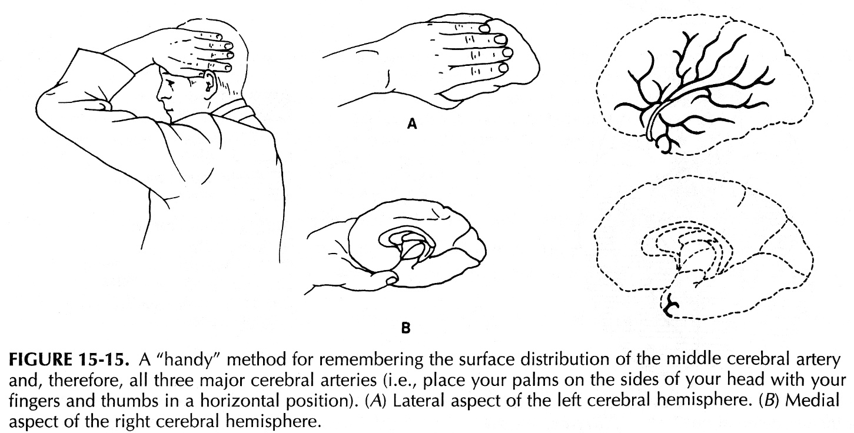

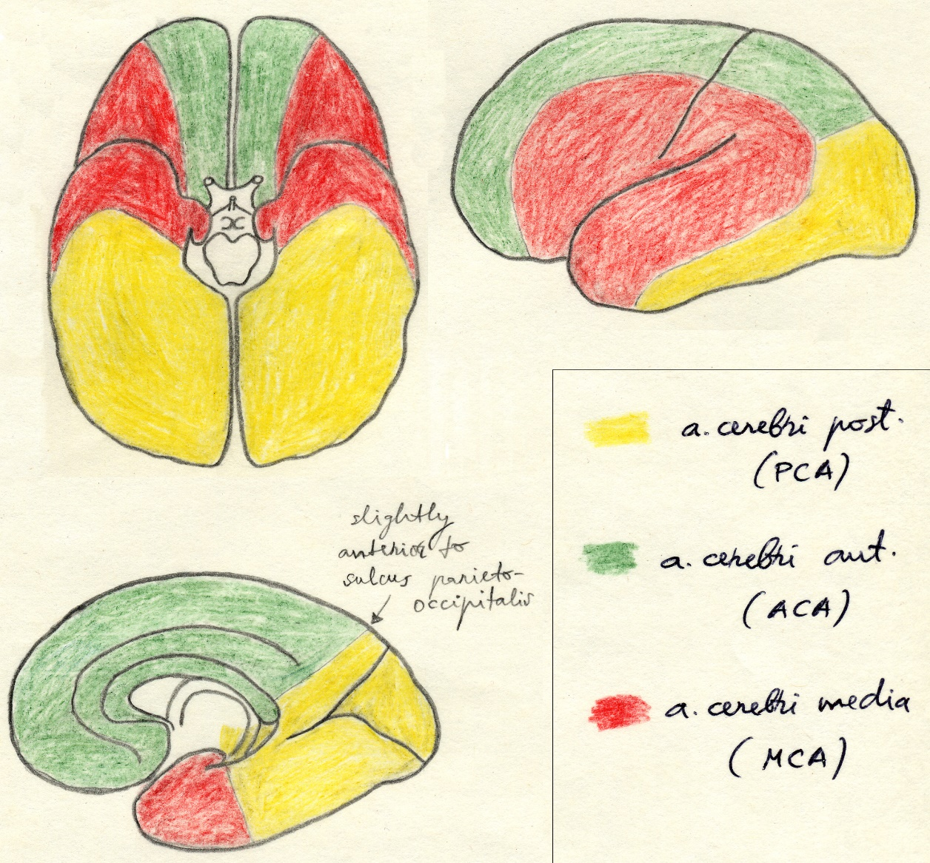

- trys smegenų poliai gauna kraują iš trijų baseinų:
frontal pole – ACA
temporal pole – MCA
occipital pole – PCA
- junction zones between arterial territories are sites of “watershed” infarcts that occur in hypotension / anoxia.

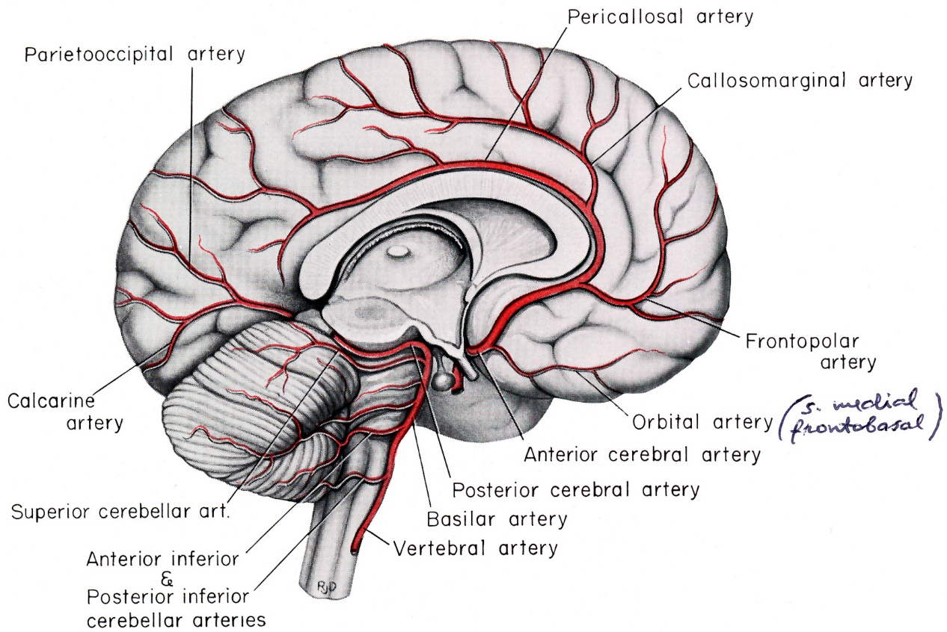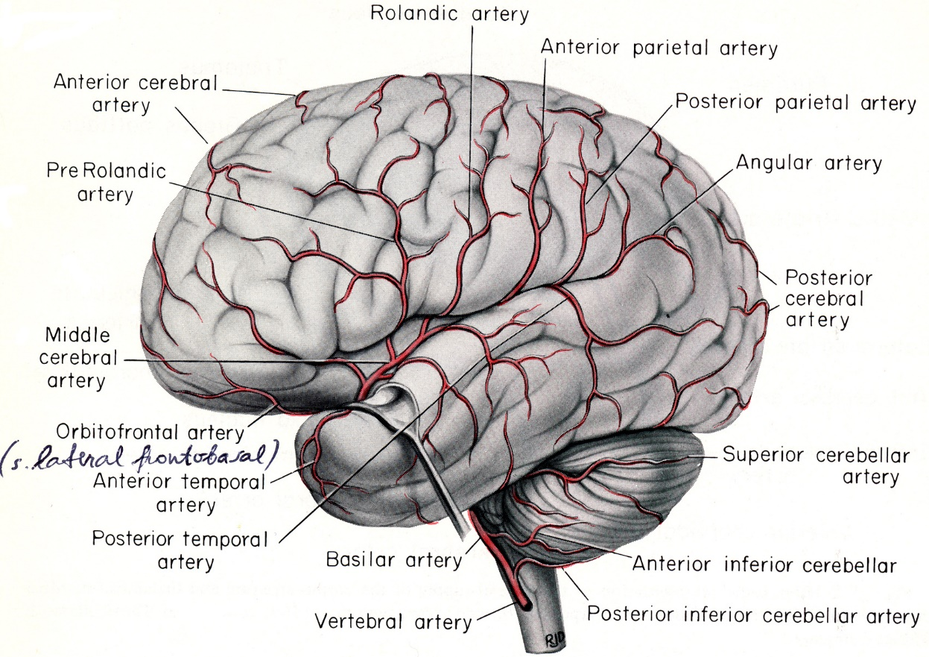

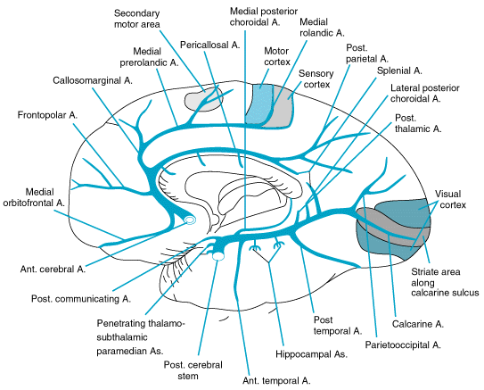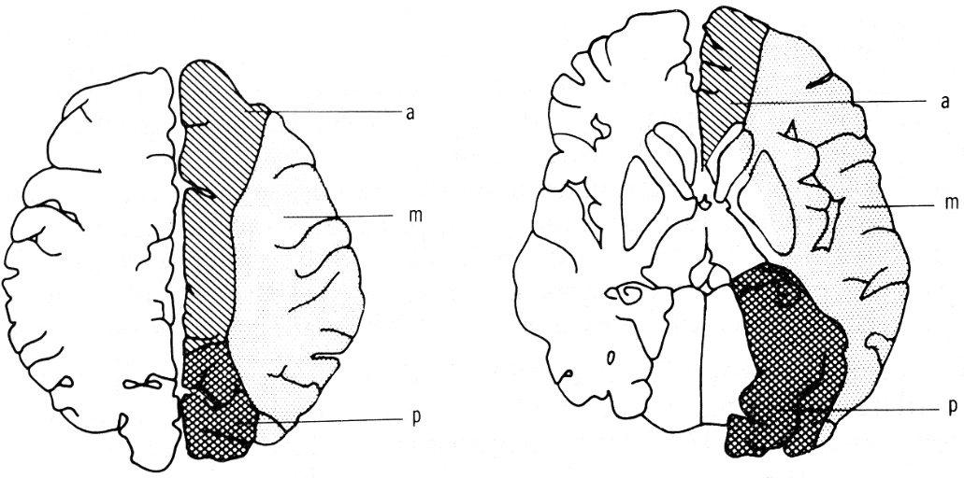

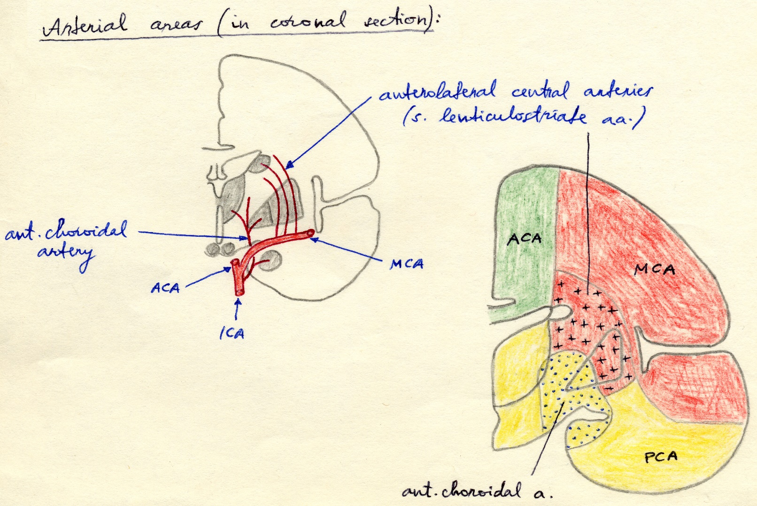
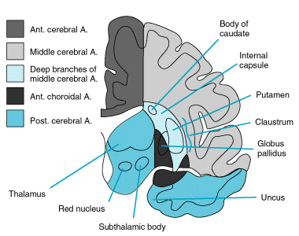

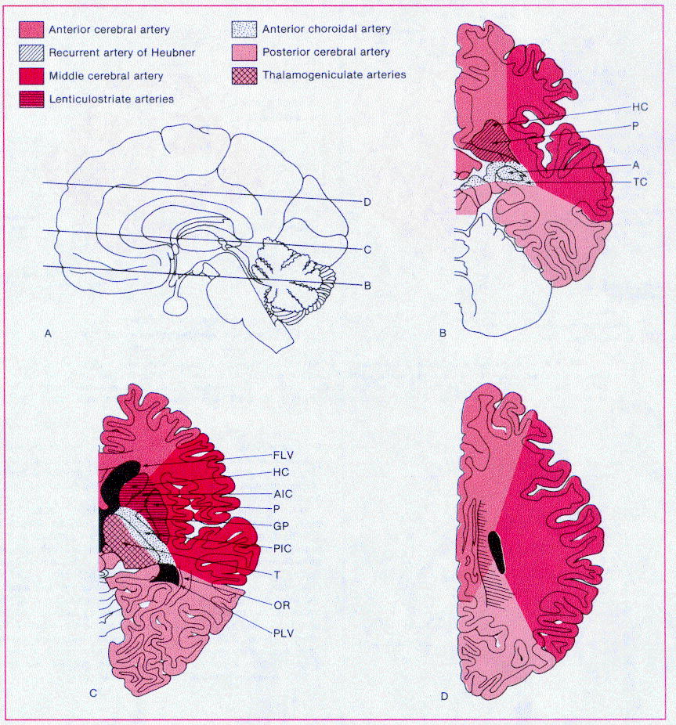
B. Plane through - head of caudate nucleus (HC), putamen (P), amygdala (A), tail of caudate nucleus (TC), hypothalamus, temporal lobe, midbrain, cerebellum.
C. Plane through frontal horn of lateral ventricle (FLV), head of caudate nucleus (HC), anterior and posterior limbs of internal capsule (AIC, PIC), putamen (P), globus pallidus (GP), thalamus (T), optic radiations (OR), posterior horn of lateral ventricle (PLV).
D. Plane through centrum semiovale.

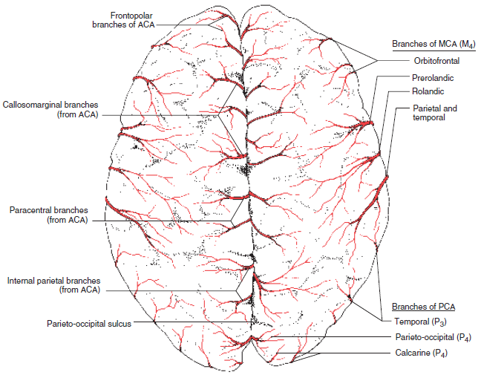

Anterior cerebral artery (ACA)
- arises below anterior perforated substance.
- passes anteromedially, dorsal to optic nerve.
- susijungia su kita puse (per AComA).
- runs superiorly, loops around genu corporis callosi.
- eina atgal in interhemispheric fissure.
- skirstoma į dvi dalis:
A₁ segment (precommunicating) – horizontal; gives anteromedial central arteries.
- common anatomical variation is hypo(a)plasia of A₁ - distal segments fill from other side via AComA.
A₂ segment (postcommunicating) – branches:
  - medial striate (s. recurrent of Heubner) artery
  - medial frontobasal (s. medial orbitofrontal, orbital) artery
N.B. lateral frontobasal artery is MCA branch
  - frontopolar artery
  - pericallosal artery* – eina corpus callosum dorsaliniu paviršiumi.
  - callosomarginal artery* – lies in cingulate sulcus.
*some authors call them A₃ segment
- azygos ACA (incidence 0.1-1%) – when both hemispheres are fed by one side ACA (has branch to opposite side) and opposite proximal A2 is missing and there is no AComA be definition.
N.B. occlusion of azygos ACA causes leg weakness – mimics spinal pathology!
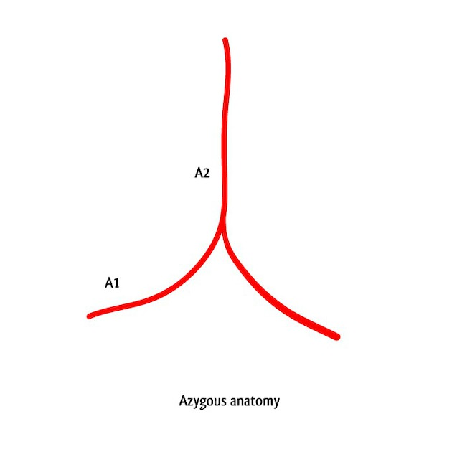
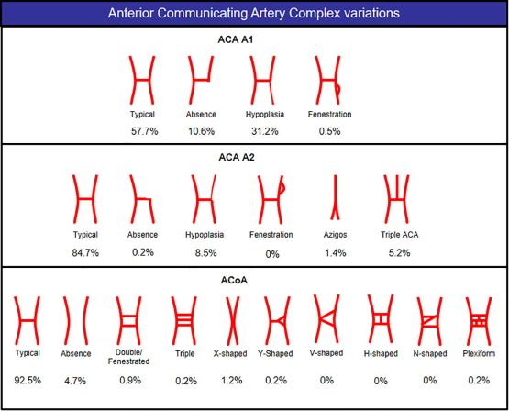

- bihemispheric ACA - if there are two A2 segments, but one contributes predominantly to both hemispheres.
- if three A2 segments are found, the third is called accessory ACA.

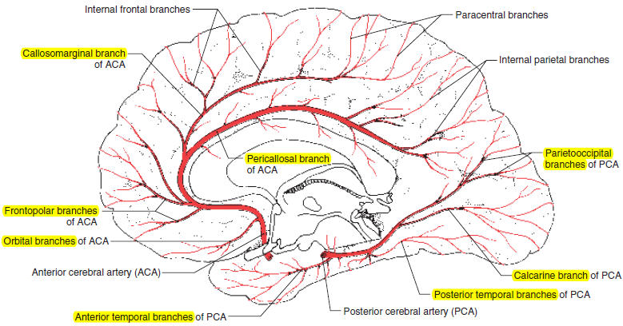

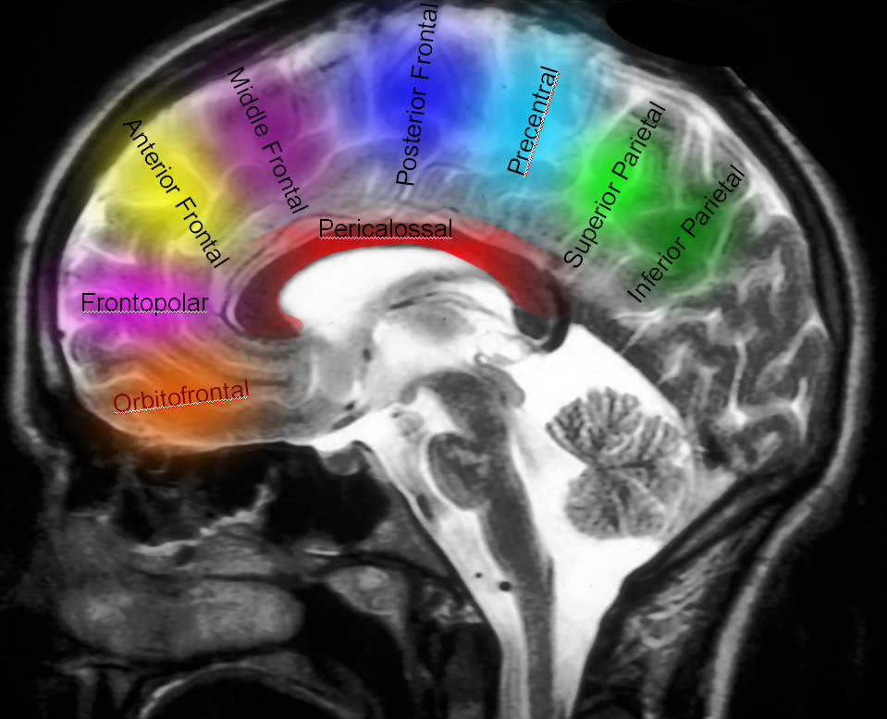
Source of picture: Neuroangio.org >>

A2 bifurcation can be very early (almost nonexistent A2) – looks like four ACAs:
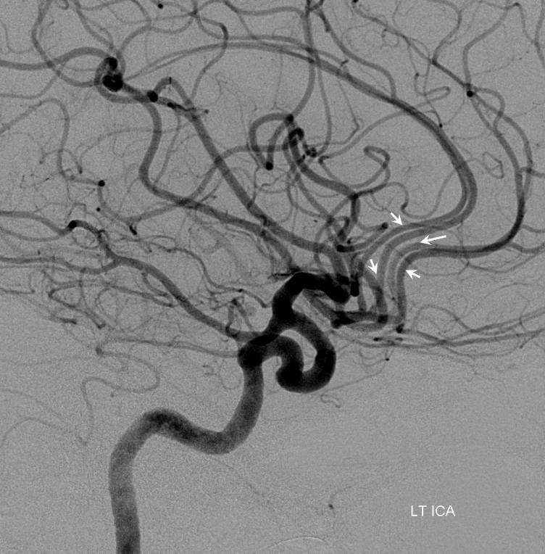
Source of picture: Neuroangio.org >>

Middle cerebral artery (MCA)
- tai ICA tiesioginis tęsinys (arises below medial part of anterior perforated substance).
- passes laterally over anterior perforated substance to enter lateral cerebral fossa between temporal lobe and insula.
- then passes posteriorly in depth of lateral cerebral fissure.
- skirstoma į dvi dalis:
M1 segment (sphenoidal) – courses horizontally in Sylvian cistern, posterior and parallel to sphenoid ridge, gives anterolateral central (lenticulostriate) arteries* and anterior temporal artery (ATA); sometimes also gives early temporal branch.
*lenticulostriate arteries enter the brain via anterior perforating substance
      - M1 can be nonexistent (accessory MCA), short, long, or infinite (with no true bifurcation).
      - Sylvian fissure split dissection should be conducted along inferior - anterior aspect of M1 to prevent injury to lenticulostriate arteries!
      - M1 makes sharp turn superiorly around the limen insulae to enter insular cistern.
M2 segment (insular) - resides on limen insula – branches to insular cortex
M3 segment (s. terminal) part* – branches to facies lateralis of cerebral hemisphere - superior and inferior divisions**:
  - lateral frontobasal artery (s. orbitofrontal artery)
  - artery of precentral sulcus (s. pre-Rolandic artery)
  - artery of central sulcus (s. Rolandic artery)
  - anterior & posterior parietal arteries – feed cortical surface above fissure
  - branch to angular gyrus – terminal branch.
  - anterior & posterior temporal arteries – feed cortical surface below fissure
*some anatomists divide: M3 segment (opercular) spreads over opercula, and M4 segment (cortical) composed of convexity branches
**considerable variability in parietal lobe supply between two divisions (in ≈ 2/3 individuals inferior division supplies region above angular gyrus)

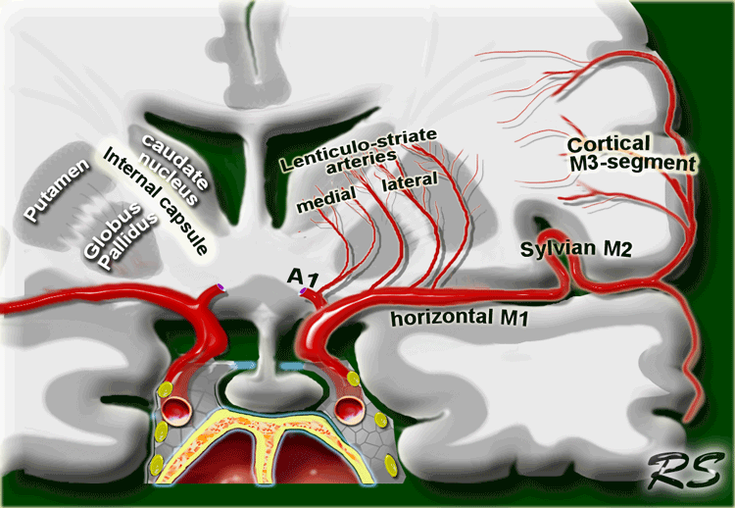
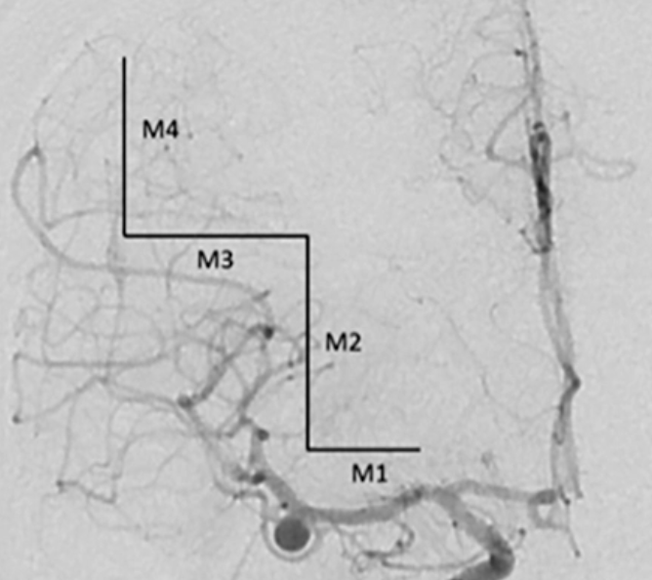
Source of picture: Neurosurgical atlas by Aaron Cohen-Gadol >>

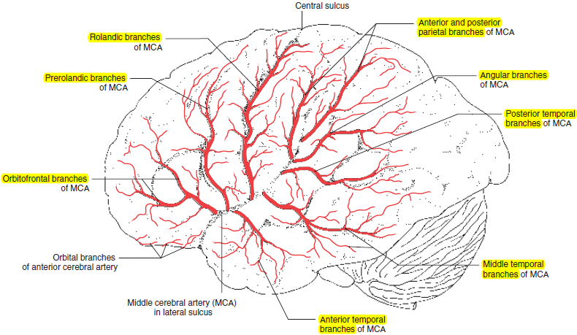

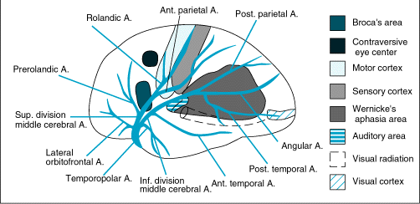

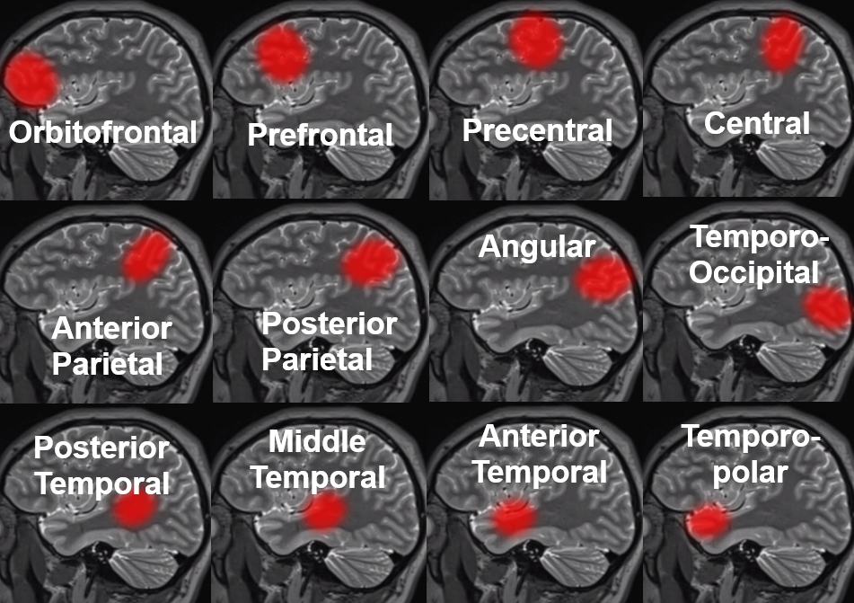
Source of picture: Neuroangio.org >>

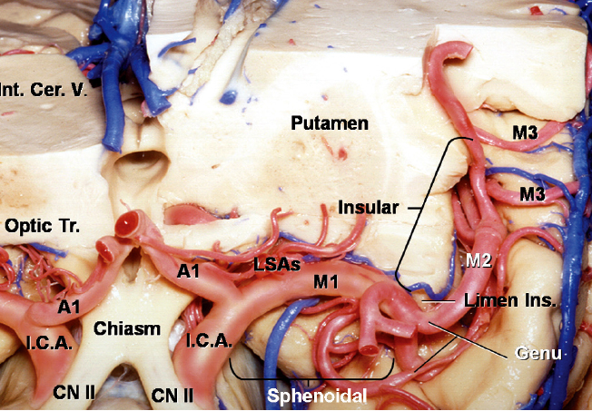
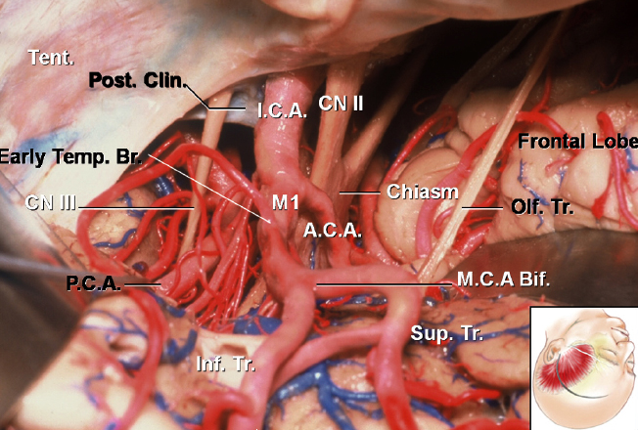
Source of picture: Neurosurgical atlas by Aaron Cohen-Gadol >>

Inferior view:
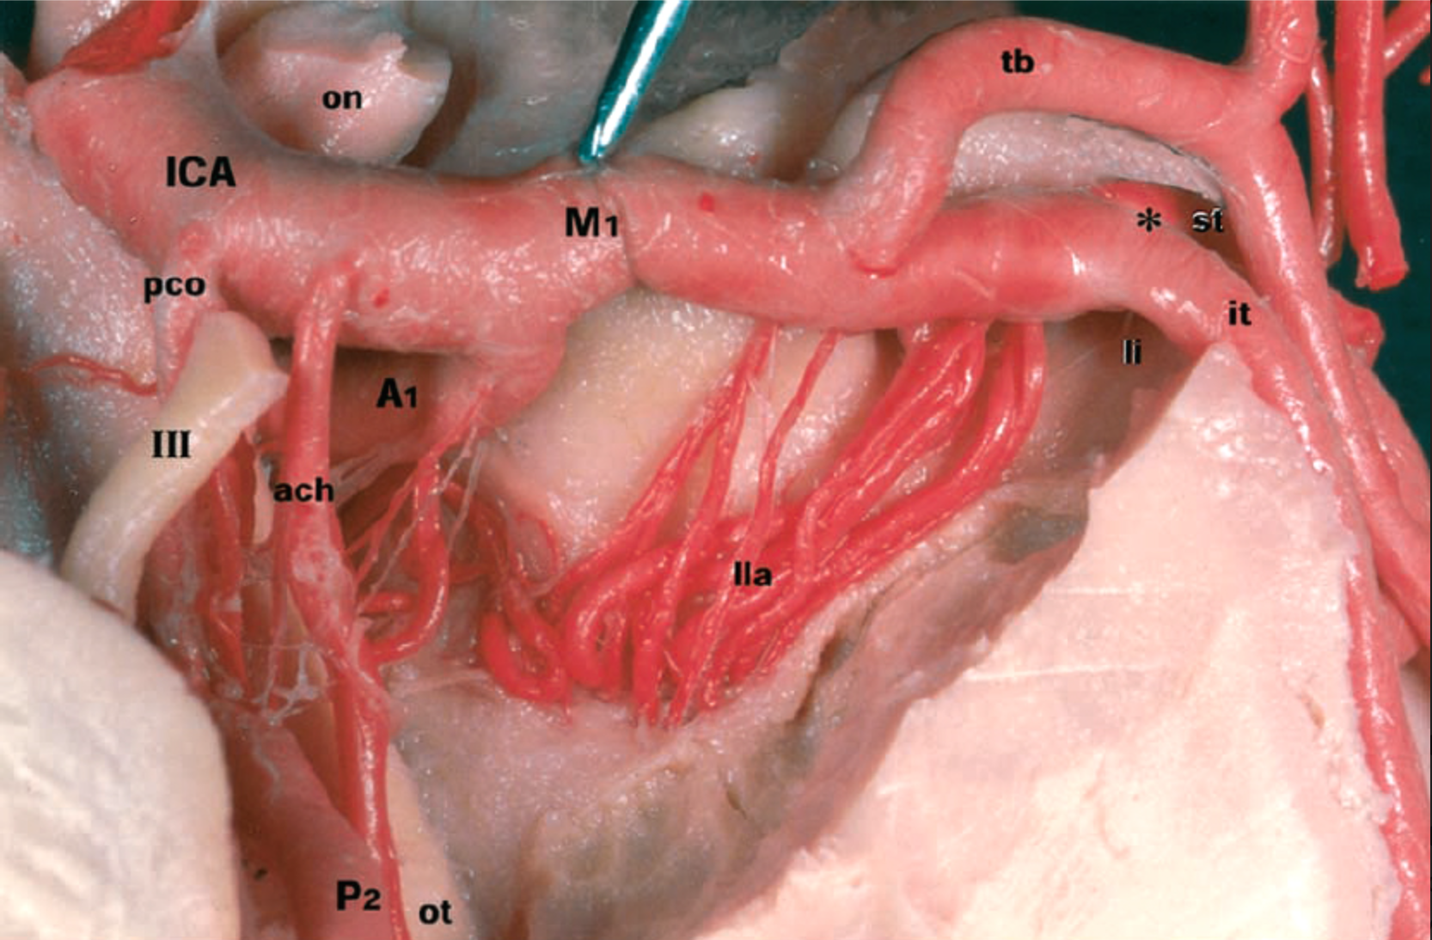
Source of picture: Neurosurgical atlas by Aaron Cohen-Gadol >> from Türe U, Yasargil MG, Al-Mefty O, Yasargil DC. Arteries of the insula. J Neurosurg. 2000; 92: 676–687.

M1 branching patterns
A – “duplicated” MCA
B – short M1
C – dominant superior division
D – trifurcation
E – pentafurcation
F – no bifurcation (just individual origins of branches)
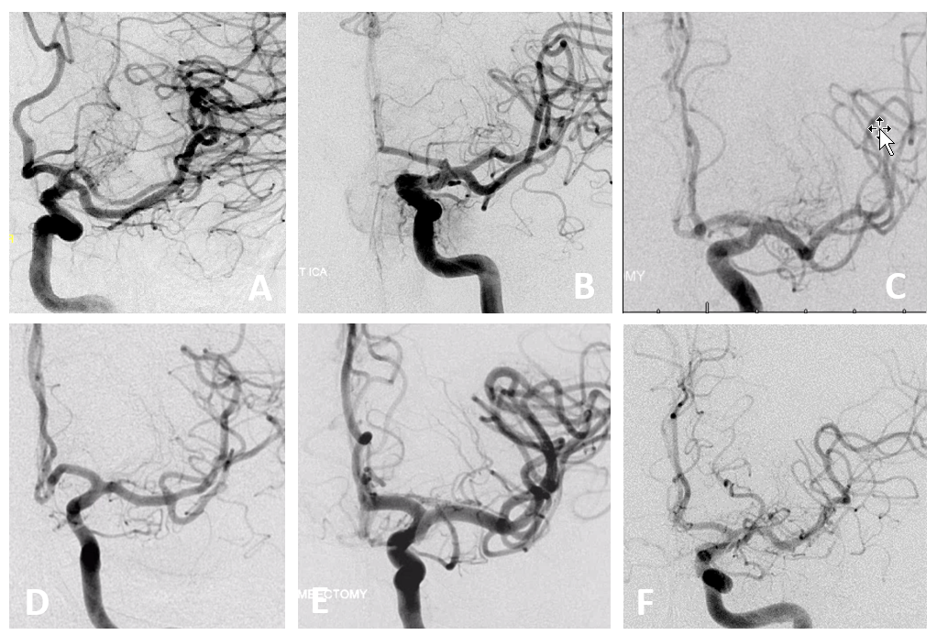
Source of picture: Neuroangio.org >>

Absent M1 segment:
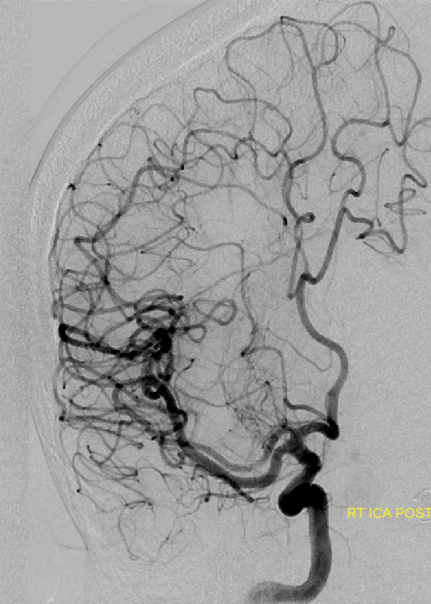
Source of picture: Neuroangio.org >>

MCA fenestration:
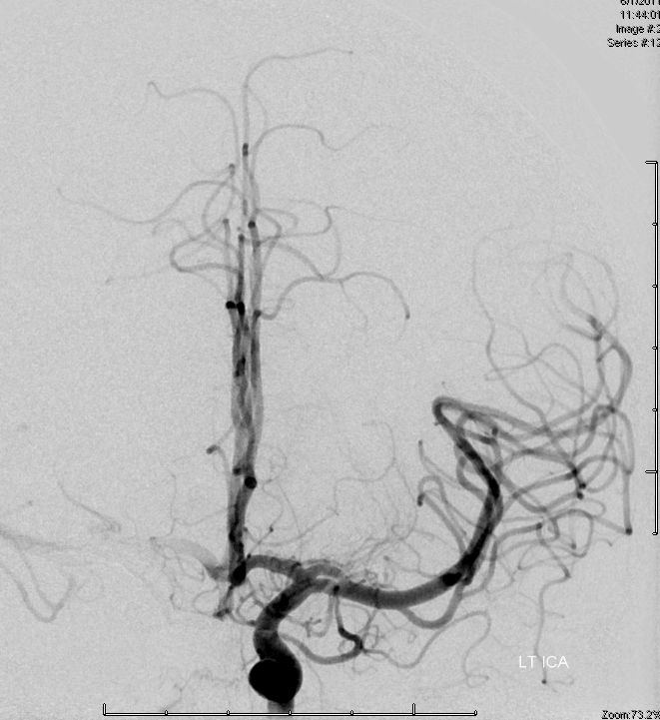
Source of picture: Neuroangio.org >>

Posterior cerebral artery (PCA)
- arises as terminal bifurcation of basilar artery ventral to midbrain.
70-75% people - both PCAs derive primarily from BA;
20% - one PCA is supplied by ICA and other by BA.
5-10% - both PCAs derive primarily from ICA (“fetal arrangement”);
N.B. 20-30% individuals have hypoplasia of at least one P₁ segment (i.e. fetal origin of PCA from ICA).
Fetal PComA prevalence ≈ 25%

- passes laterally around cerebral peduncle → passes dorsal to tentorium cerebelli, on medial-inferior surface (of temporal and occipital lobes) → branches into:
anterior division - inferior surface of temporal lobe (terminal branches anastomose with MCA branches);
posterior division - occipital lobe (terminal branches anastomose with both ACA and MCA).

Four parts - Zeal and Rhoton classification:
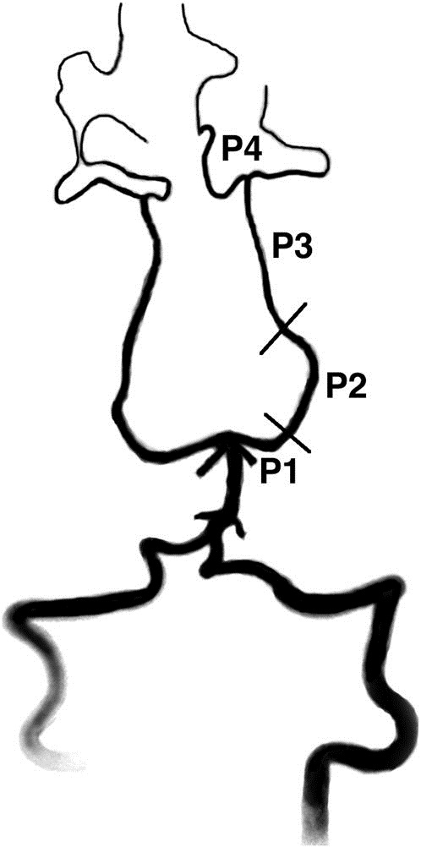
P₁ segment (precommunicating) – branches:
- posteromedial central arteries (incl. thalamoperforating artery, e.g. Percheron)
- short circumferential arteries
- collicular artery
- cerebral peduncle forms medial border of P1 segment, whereas oculomotor nerve runs laterally and inferiorly to P1 segment (between P1 and SCA).
- fetal configuration of PCA with dominant PComA and rudimentary P1 segment has been observed in 16-22% of cases in cadaveric studies.
P₂ segment (postcommunicating, s. ambient) – branches:
- posterolateral central arteries (incl. thalamogeniculate artery)
- posterior choroidal arteries:
medial → 3rd ventricle
lateral → lateral ventricle
- small circumferential branches - course around midbrain → lateral cerebral peduncles, medial lemniscus, midbrain tegmentum, superior colliculi, lateral geniculate body
Artery of Davidoff and Schechter - dural branch of P2 - supplies meninges close to falcotentorial junction.
P₃ segment (lateral occipital artery)
- P3 segment starts at posterior edge of lateral midbrain and ends at origins of parieto-occipital and calcarine arteries.
- collicular point - point at which left and right PCAs are closest to each other.
P₄ segment (medial occipital artery) = cortical (s. terminal) part;
  - gausios vardinės šakos (svarbiausia – calcarine branch, parieto-occipital artery).

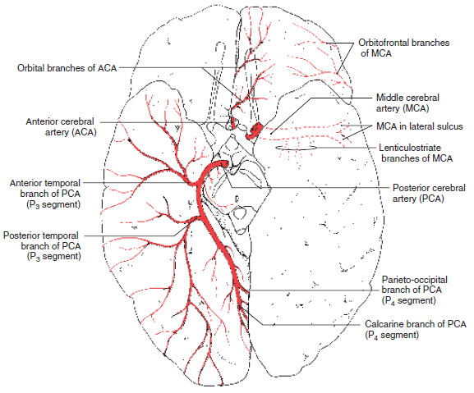

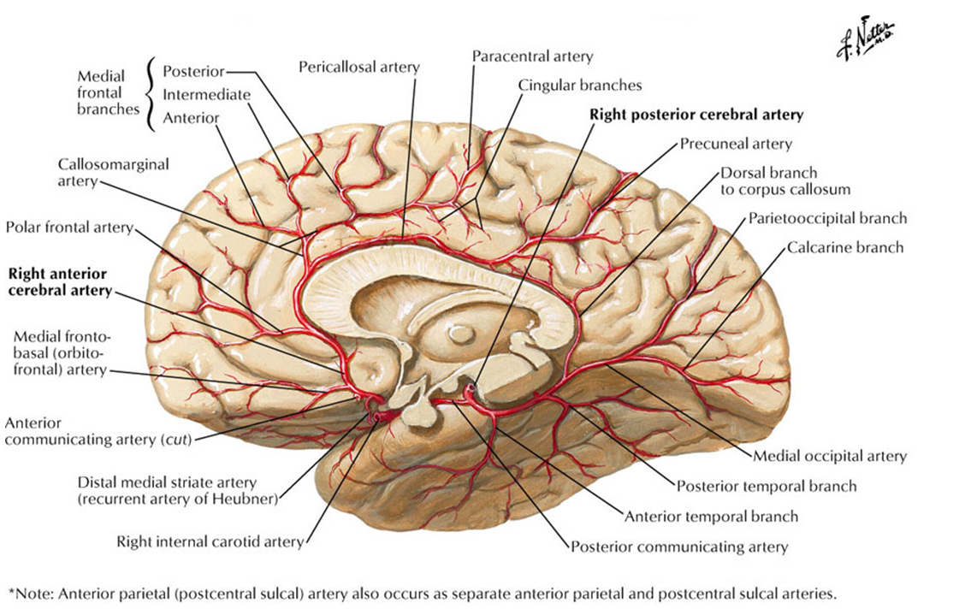

Choroid Plexuses
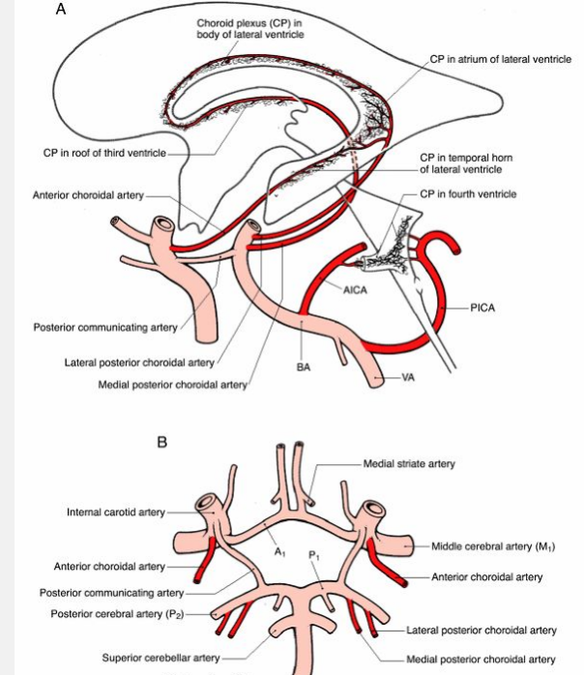

- anterior and posterior (medial + lateral) choroidal arteries → plexuses of lateral and third ventricles.
- PICA → choroid plexus in fourth ventricle.
- AICA → clump of choroid plexus protruding out of foramen of Luschka.

Basal Structures
Internal Capsule
Anterior limb*, whole upper part – anterolateral central arteries.
*rostromedial part of anterior limb – medial striate arteries
Genu – direct ICA / PComA branches.
Lower part of posterior limb, retrolenticular limb – anterior choroidal artery.

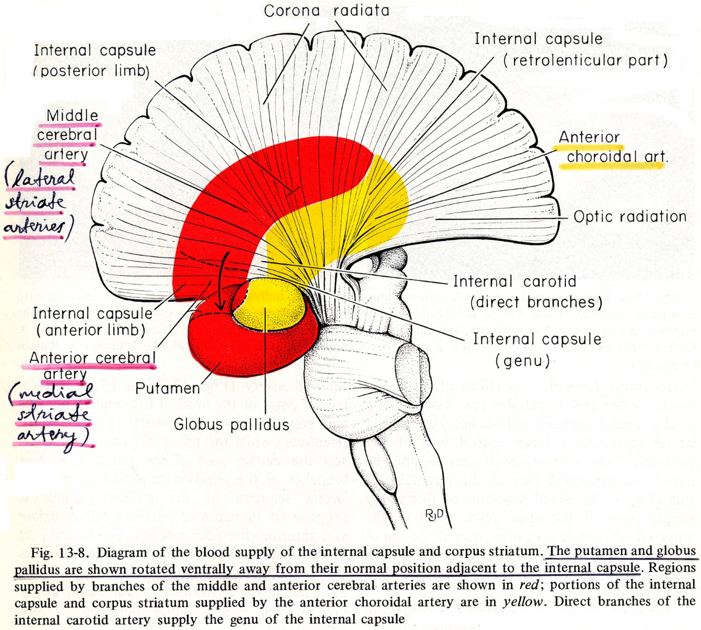
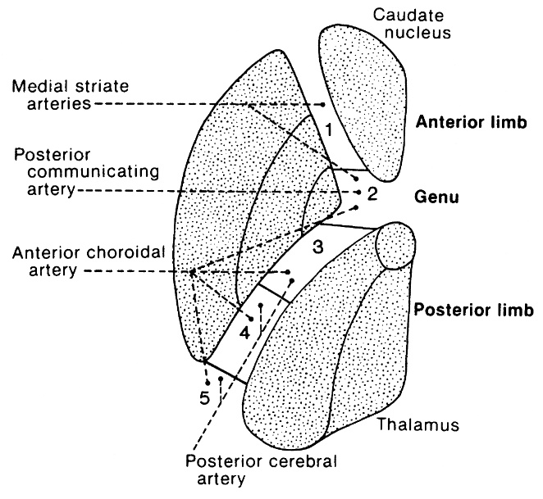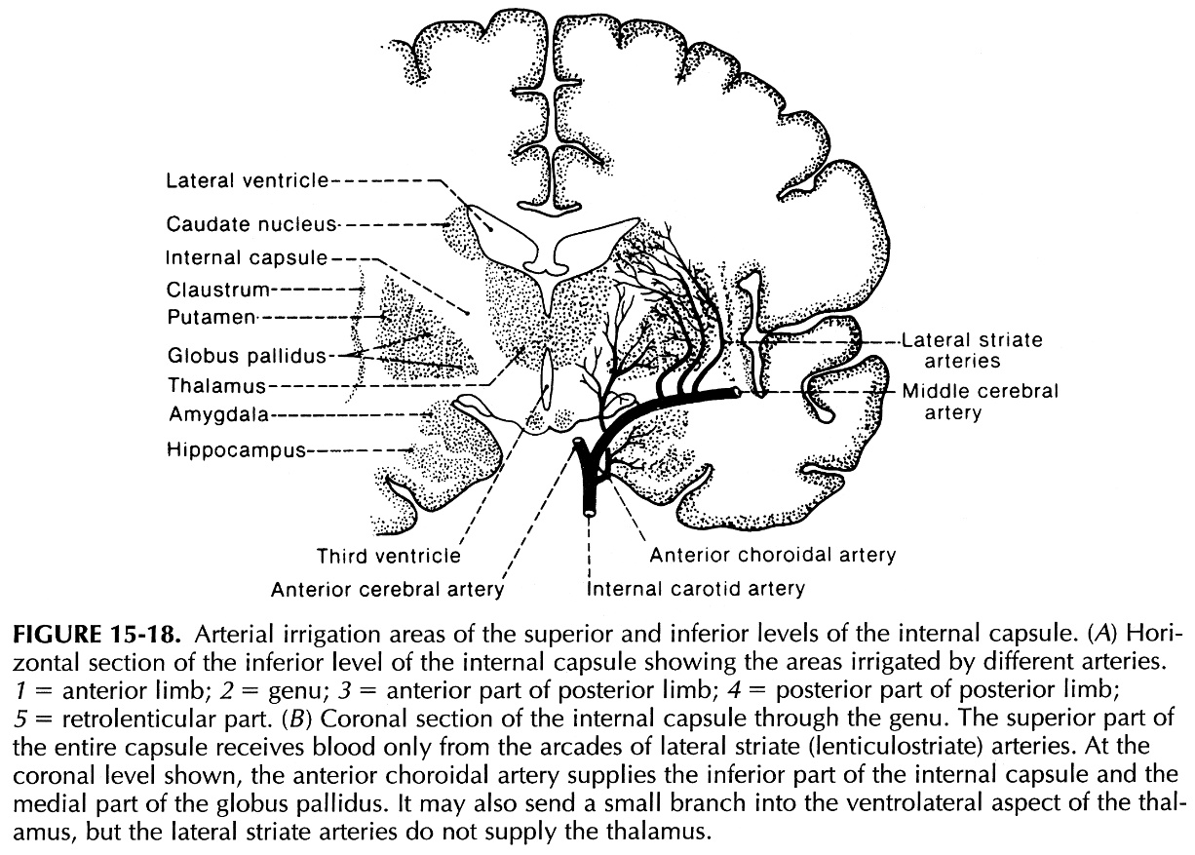

Corpus striatum
Globus pallidus – pagrinde anterior choroidal artery.
Putamen, nucl. caudatus (išsk. tail) – anterolateral central (s. lenticulostriate) arteries.
medial striate a. – rostromedial part of head of nucl. caudatus.
Tail of nucl. caudatus – anterior choroidal artery.
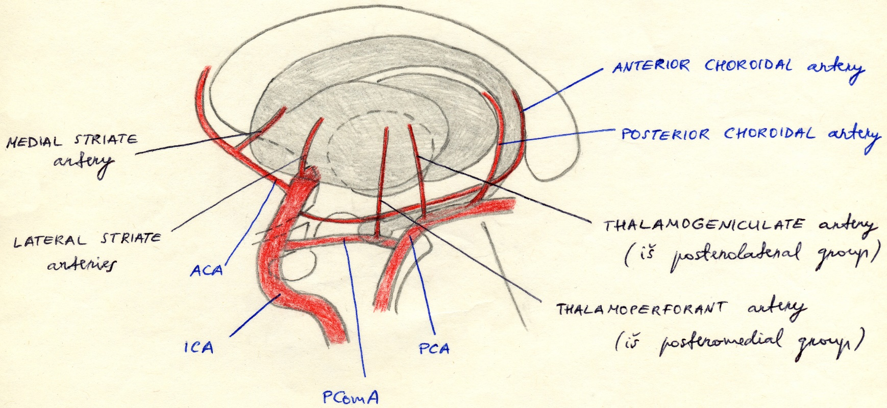

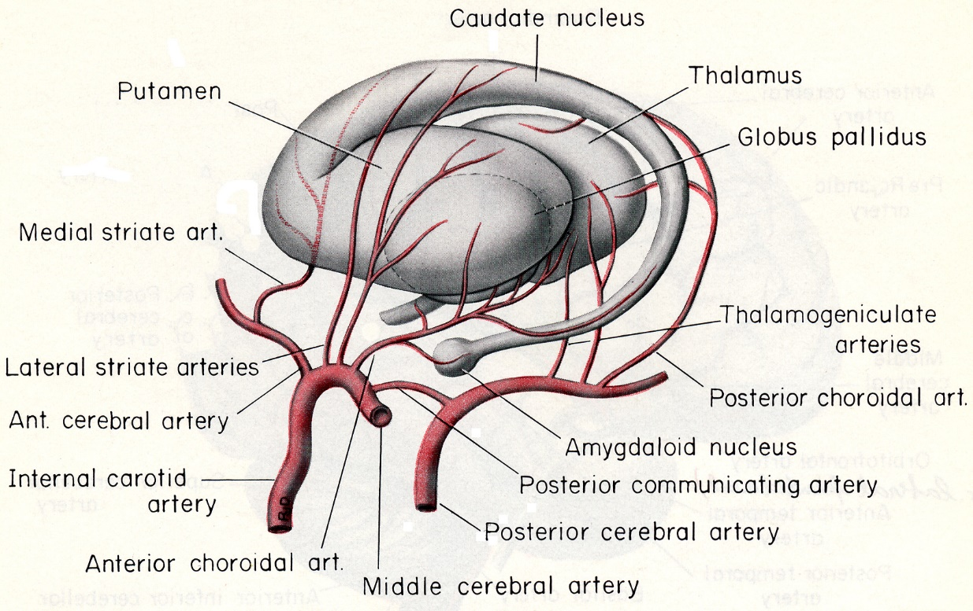

Thalamus
Anteromedial part – posteromedial central (s. thalamo-perforating) arteries ← PCA, PComA
Posterolateral part – posterolateral central (s. thalamogeniculate) arteries ← PCA
Ventrolateral part – anterior choroidal artery ← ICA
Dorsomedial part – posterior medial choroidal artery ← PCA

Hypothalamus
Anterior part – anteromedial central arteries ← ACA
Posterior part – posteromedial central arteries ← PCA

Anastomoses / Collaterals
Extracranial–intracranial anastomoses
Anastomoses between ECA and ICA:
- facial artery
- middle meningeal artery - ophthalmic artery
- superficial temporal artery
- artery of foramen rotundum
- artery of pterygoid canal (from a. maxillaris or a. palatina major) - carotid siphon

Anastomoses between ECA and posterior circulation:
- occipital artery
- ascending pharyngeal artery - vertebral artery

Numerous anastomotic channels exist between all extracranial branches of ECAs (except superior thyroid and lingual arteries) and intracranial branches of ICAs or musculospinal branches of VAs:
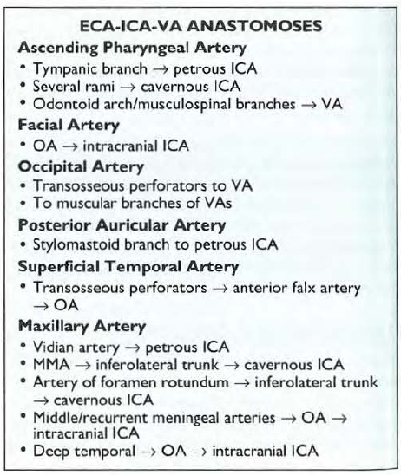

Intracranial anastomoses
- Circle of Willis see above
- Other carotico-vertebral anastomoses:
Artery | Origin | Termination | Route
Pro-atlantal intersegmental | Cervical ICA | VA | Via foramen magnum
Hypoglossal | ICA | VA | Via hypoglossal canal
Otic (exceptionally rare) | Petrous ICA | BA | Via internal auditory meatus
Trigeminal (< 1% normal people; some say it is 100% just below imaging resolution) | Cavernous ICA (meningohypophyseal trunk) | BA trunk (between AICA and SCA) | Transdural (follows the course of CN5)

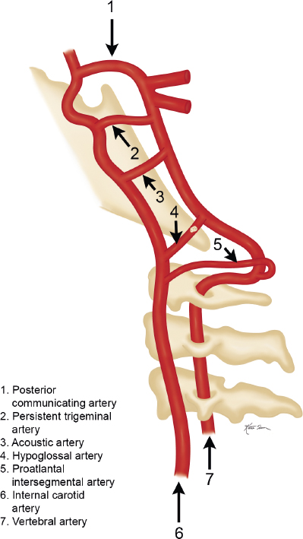
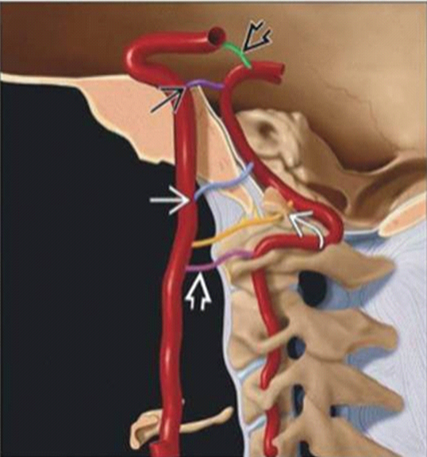

Trigeminal artery (green arrow) connects MHT (ICA) and BA (PComA is hypoplastic):
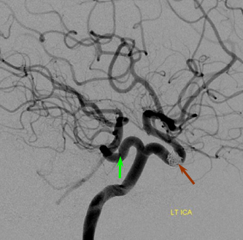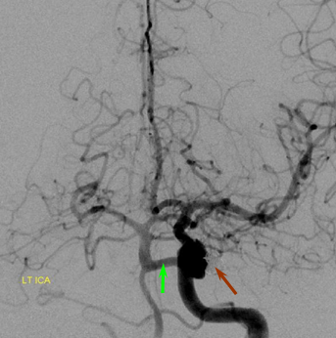
Source of picture: Neuroangio.org >>

Trigeminal artery (white arrow) with superimposed CN5 tractography:
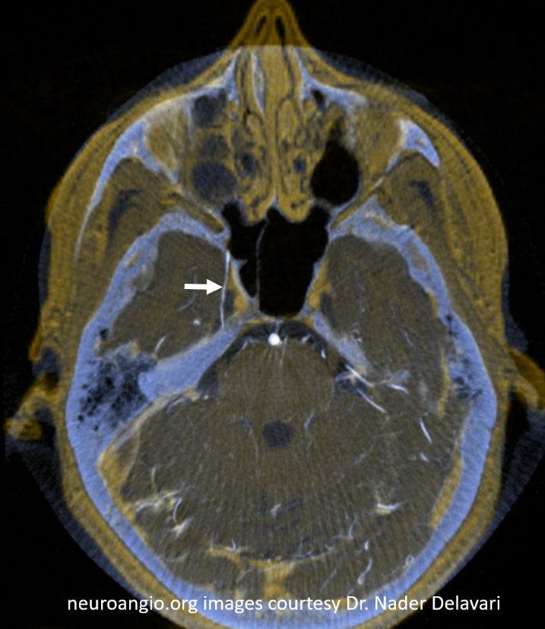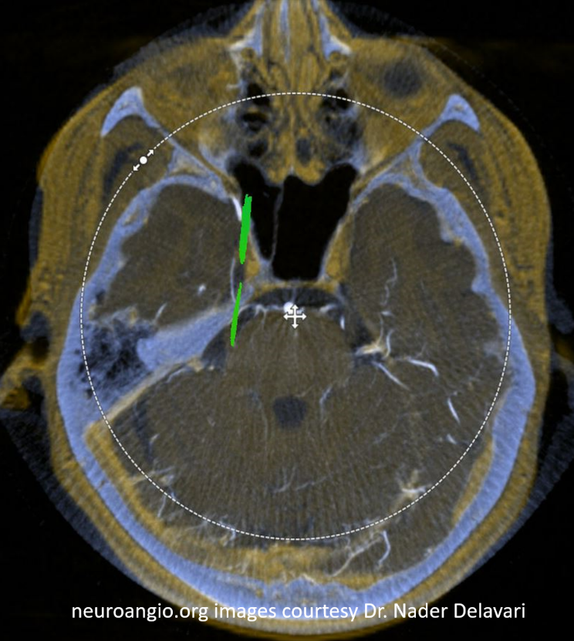
Source of picture: Neuroangio.org >>

- Leptomeningeal (pial, cortical, border-zone, watershed) collaterals - end-to-end anastomoses between distal branches of intracerebral arteries (ACA-MCA-PCA) - collateral flow across vascular watershed zones.
  - highly variable.
  - great importance in acute occlusion.

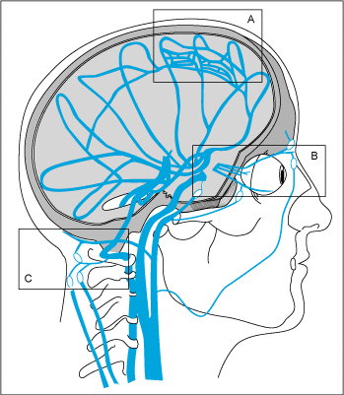 | A. Leptomeningeal anastomotic channels.  B. Anastomotic channels through orbit (branches of external carotid artery → a. ophthalmica).  C. Extracranial anastomotic channels: muscular branches (of ascending cervical arteries and occipital artery) → distal vertebral artery.

Bibliography for ch. “Vascular” → follow this link >>
Neuroangio >>

Viktor’s Notes℠ for the Neurosurgery Resident
Please visit website at www.NeurosurgeryResident.net

