Spinal Cord - somatic motor system (motor units)
Last updated: April 20, 2019

Motor unit (Charles Sherrington, 1925) - the basic unit of motor function - a motor neuron + the group of muscle fibers it innervates
- number of muscle fibers innervated by a single motor neuron varies widely - depending on the dexterity of the movements controlled and the mass of the body part to be moved:
motor units with < 100 muscle fibers finely control eye movements
single motor unit in the leg contains up to 1,000 muscle fibers.

Classification of the four types of motor unit disorders (all lead to muscle weakness):
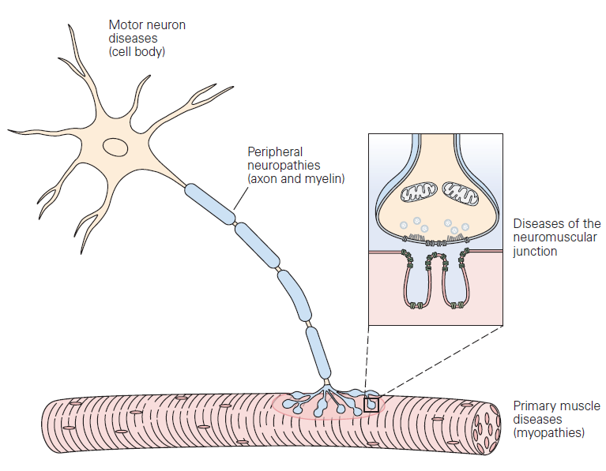

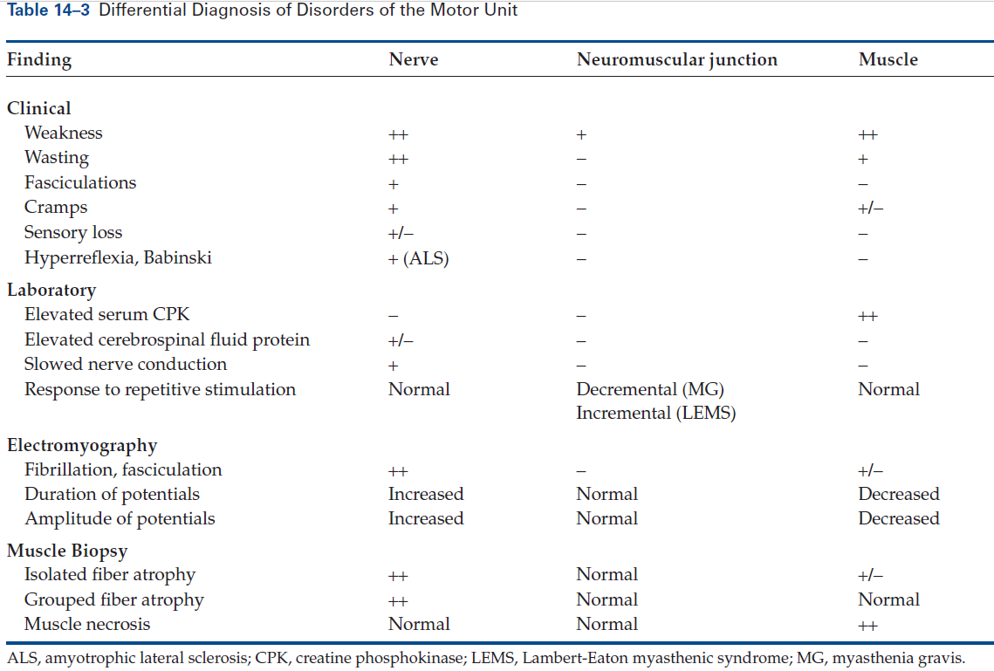

Normal and abnormal motor units (two adjacent units are shown):
Segmental demyelination: random myelin internodes are injured and are remyelinated by multiple Schwann cells, while axon and myocytes remain intact.
Axonal degeneration: axon and its myelin sheath undergo anterograde degeneration (shown for green neuron) → denervation atrophy of myocytes within its motor unit.
Reinnervation of muscle: sprouting of adjacent (red) uninjured motor axons leads to fiber type grouping of myocytes, while injured axon attempts axonal sprouting.
Myopathy: scattered myocytes of adjacent motor units are small (degenerated or regenerated), whereas neurons and nerve fibers are normal.
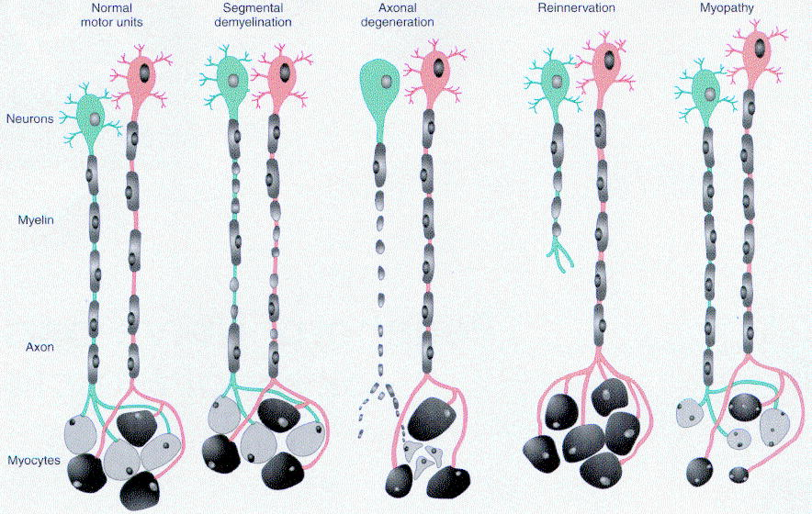

Bibliography for ch. “Spinal Cord” → follow this link >>

Viktor’s Notes℠ for the Neurosurgery Resident
Please visit website at www.NeurosurgeryResident.net

