Vestibulospinal Tract
Last updated: April 12, 2020

Involved in the maintenance of extensor tone
Fibers from lateral vestibular nucleus travel ipsilaterally within the entire length of the cord in the anterior part of the lateral funiculus laminas VII, VIII, and IX and directly to the α and gamma motor neurons and interneurons, with somatotopic organization.
Stimulation causes extension
The vestibulospinal tract arises from the lateral vestibular nucleus (Deiters nucleus) and descends ipsilaterally in the lateral funiculus of the spinal cord. Vestibulospinal neurons synapse in laminae VII, VIII, and IX of the spinal cord. Several vestibulospinal fibers synapse directly with α and ϒ motor neurons of the ventral horn.
The vestibulospinal tracts facilitate extensor muscle group tone. Lesions of the brainstem between the inferior and superior colliculi (above the vestibular nuclei and below the red nuclei) result in extensor (decerebrate) posturing of the upper and lower extremities. This results from the loss of lateral vestibular nuclei inhibition from higher brain centers.
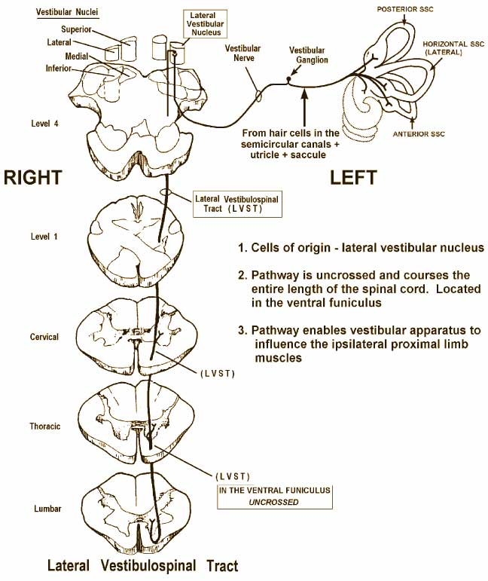

Bibliography for ch. “Spinal Cord” → follow this link >>

Viktor’s Notes℠ for the Neurosurgery Resident
Please visit website at www.NeurosurgeryResident.net

