Corticonuclear (corticobulbar) fibers
Last updated: April 20, 2019
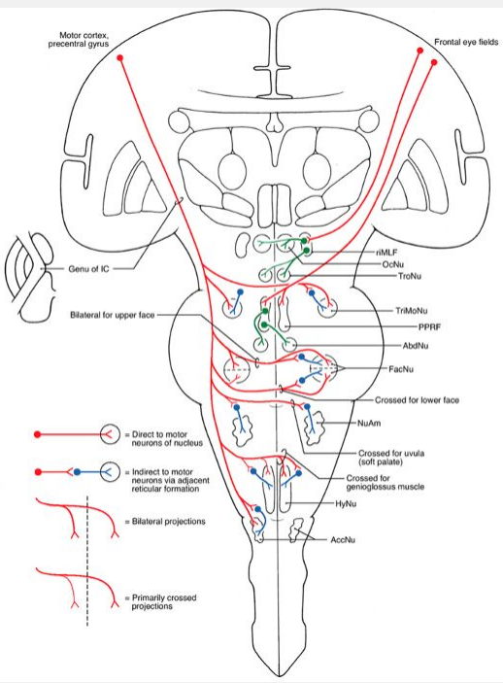

Corticonuclear (corticobulbar) fibers – 3 different systems:

Frontal eye fields (areas 6 and 8 in caudal portions middle frontal gyrus) → caudal portions of anterior limb of internal capsule → terminate:
- rostral interstitial nucleus of MLF (vertical gaze center) → CN 3, 4 nuclei
- paramedian pontine reticular formation (horizontal gaze center) → CN 6 nuclei.
- superior colliculus receives cortical input from area 8 and from parietal eye field (area 7) and projects to riMLF and PPRF

Precentral gyrus (motor cortex, area 4) → genu of internal capsule → (directly or via adjacent reticular formation nuclei) CN5, 7, 9, 10, 11, 12 motor nuclei

N.B. fibers to motor neurons of CN7 (lower face) and CN12 are primarily crossed!
N.B. fibers to motor neurons of CN11 are primarily ipsilateral!
vs. fibers to other motor neurons are equally distributed bilaterally

Postcentral gyrus (areas 3, 1, and 2) → most rostral portions of posterior limb of internal capsule → sensory relay nuclei of some cranial nerves and posterior column system – modulation of sensory information (selective attention / inattention to sensory information)

Neurotransmitter - glutamate (excitatory)

Lesions
Cortical lesions → transient gaze palsy - eyes deviate toward lesion side (away from side of hemiplegia)

Capsular lesions – contralateral deficits:
- deviation of tongue toward side of weakness
- paralysis of contralateral lower half of face (central facial palsy).
- weakness of contralateral palatal muscles - uvula will deviate toward ipsilateral (lesioned) side on attempted phonation.
- drooping of ipsilateral shoulder + difficulty in turning head (against resistance) to contralateral side

Brainstem lesions (midbrain or pons):
1) vertical gaze palsies (midbrain)
2) Parinaud syndrome - paralysis of upward gaze
3) internuclear ophthalmoplegia (lesion in MLF between motor nuclei of III and VI)
4) horizontal gaze palsies (lesion in PPRF)
5) one-and-a-half syndrome (lesion is adjacent to midline) – involves:
a) abducens nucleus
b) adjacent PPRF
c) internuclear fibers from ipsilateral abducens that are crossing to enter contralateral MLF, and internuclear fibers from contralateral abducens nucleus that cross to enter MLF on ipsilateral (lesioned) side
Clinically: loss of ipsilateral abduction (lateral rectus) + adduction (medial rectus, “one”) and loss of contralateral adduction (medial rectus, “half”); only remaining horizontal movement is contralateral abduction via intact abducens motor neurons.

Bibliography for ch. “Brain Stem” → follow this link >>

Viktor’s Notes℠ for the Neurosurgery Resident
Please visit website at www.NeurosurgeryResident.net

