Brain Stem LESIONS
Last updated: January 16, 2021

Medial syndromes of medulla and pons 4
Lateral syndromes of medulla and pons 5
Midbrain syndromes 7

- brain stem sandara labai sudėtinga – kompaktiškai susiglaudę guli įvairiausios struktūros.
- neįmanoma aprašyti visų galimų sindromų.
- patogiausia nagrinėti kraujagyslinius sindromus – geriausiai koreliuoja su topografija.

Clinical features depend on:
- Longitudinal site (midbrain, pons, medulla)
- Cross-sectional site (tegmentum vs. basis; medial vs. lateral)

Unilateral brain stem syndromes – alternating signs:
- Ipsilaterally – lesion of cranial nerves (LMN paralysis or loss of sensation) – specifies longitudinal site.
- Contralaterally – lesion of long tracts, which will decussate (descending) or has decussated (ascending) – specifies cross-sectional site;
  - alternating hemiplegia – tr. pyramidalis (dažnai kartu pažeidžiami somitiniai nervai CN3 (Weber syndrome), CN6 (Foville syndrome), CN12 (Dejerine syndrome) – jie išeina ventraliai paramedianinėje plokštumoje, šalia tr. pyramidalis).
  - alternating hemianesthesia – medial lemniscus, tr. spinothalamicus.
  - alternating hemihyperkinesia – subst. nigra (tremor), red nucleus (hemichorea).

 | Lateral |  |  | Medial
 | Long tracts |  | Cranial nerves | Long tracts |  | Cranial nerves
Pons | TrSpinthal TrRetspin  VestConn  LatLem | Hiccup | CN5 (touch)  CN7 (motor)  CN8 | TrPyr  MedLem CerebellConn | Palatal myoclonus, etc | CN6 + pontine gaze center,  MLF
Medulla | TrSpinthal TrRetspin VestConn CerebellConn |  | CN5 (pain + t-re)  CN7 (taste)  CN9  CN10 | TrPyr  MedLem |  | CN12

Bulbar Palsy – peripheral paralysis of CN9, CN10, CN12. see p. Mov3 >>
Pseudobulbar Palsy – central paralysis of CN7, CN9, CN10, CN12. see p. Mov3 >>
Bilateral lesion of tegmentum above midpontine level (rostral RF – ARAS) → coma. see p. S30 >>
Respiratory drive disturbance – kuo kaudalesnis pažeidimas, tuo labiau trinka kvėpavimo dažnis ir ritmas; medulocervikalinis pažeidimas → apnea. see p. 2115 (4-5) >> (respiratory)

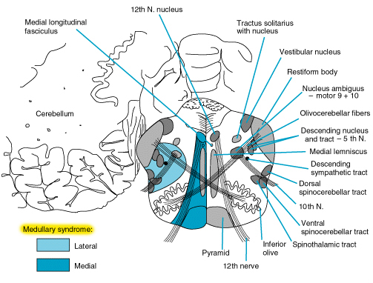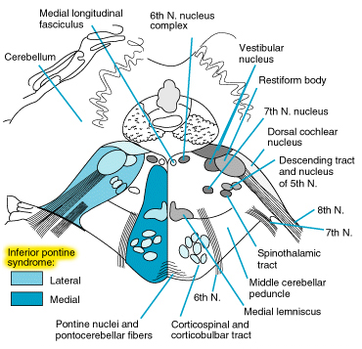

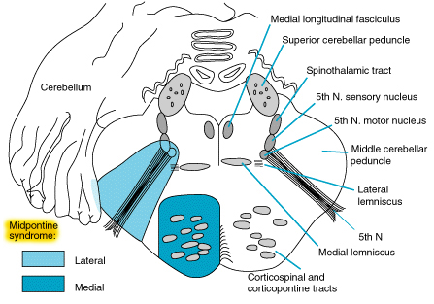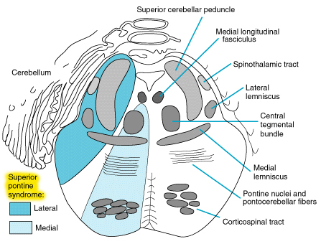

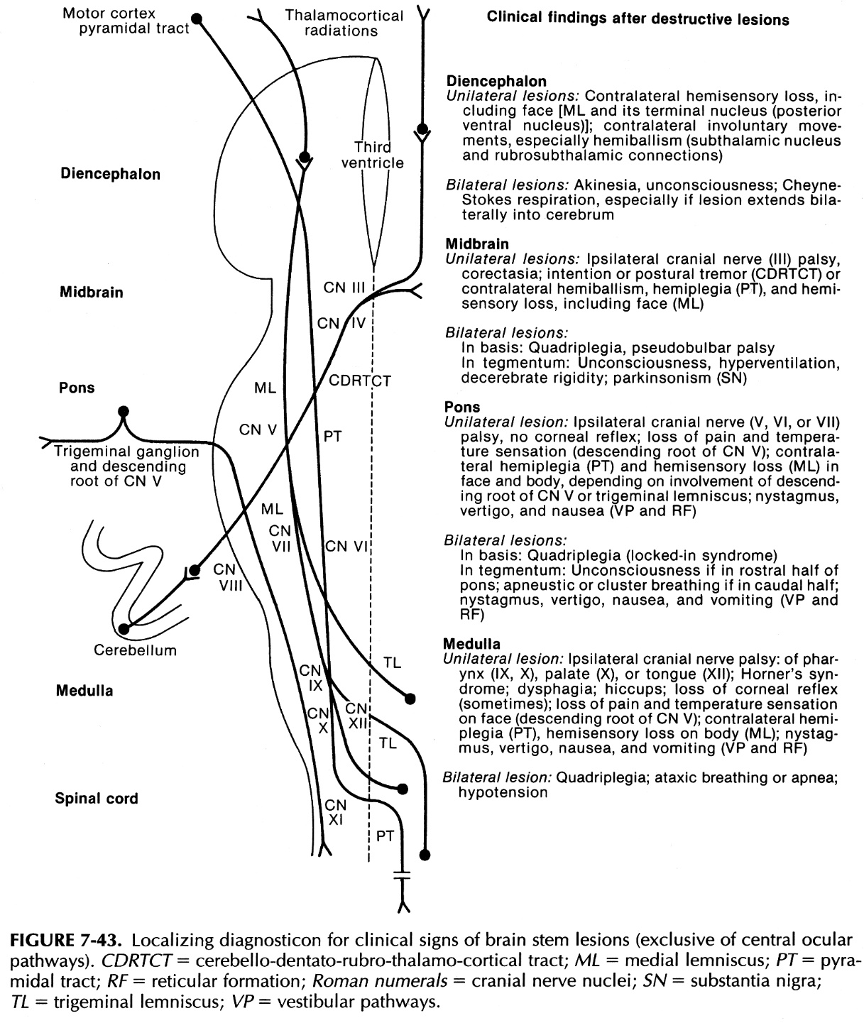

Medial syndromes of medulla and pons
- paramedian branches of a. vertebralis / a. basilaris.

Long tracts:
- Tr. pyramidalis → (contralateral) hemiplegia
- Medial lemniscus → (contralateral) loss of tactile (?), position and vibratory sensation.
- Cerebellar connections (superior / middle cerebellar peduncle; in pons only) → (ipsilateral) limb ataxia or nystagmus.

Pažeidimo aukštį nurodo įtraukti nervai:
Medial medullary (s. Dejerine) syndrome:
CN12 → (ipsilateral) tongue hemiparalysis.

Medial pontine syndrome:
- CN6 nucleus, pontine gaze center → paralysis of horizontal gaze to side of lesion.
- MLF → internuclear ophthalmoplegia (failure of adduction in horizontal gaze but preservation of convergence). see p. Eye64 >>
- Central tegmental tract → palatal myoclonus accompanied by rhythmic movements of pharynx, larynx, face, eyes, or respiratory muscles.
- gaze-evoked nystagmus – due to vestibular connections, cerebellar connections, MLF.

Foville syndrome (variant of alternating hemiplegia) – ipsilateral CN6, contralateral hemiplegia.
Millard-Gubler syndrome (variant of alternating hemiplegia) – ipsilateral CN7, contralateral hemiplegia.
Locked-in Syndrome – complete lesion of basis pontis. see p. Mov3 >>
Drop Attacks – TIA in bilateral pontine / medullary pyramidal tract. see p. Mov3 >>

Lateral syndromes of medulla and pons
- specific clinical features due to lateral structures:
- Tr. spinothalamicus → (contralateral)* loss of pain-temperature sensation in trunk and extremities.
- Nucl. sensorii of CN5 (descend from midpons to C₃) → (ipsilateral)* loss of cutaneous sensation in face: *i.e. crossed sensory loss
nucl. pontinus (pons) – touch;
nucl. spinalis (medulla) – pain and temperature (hypalgesia, thermoanesthesia, corneal hypesthesia).
- Tr. reticulospinalis (descending sympathetic fibers from hypothalamus) → (ipsilateral) Horner’s syndrome.
- Vestibular connections → vertigo, nystagmus, nausea, vomiting.
- Cerebellar connections (inferior / middle / superior cerebellar peduncles) → (ipsilateral) limb ataxia, asynergia, intention tremor.
- Hiccup – unclear cause.
No plegia, no loss of touch-proprioception!
The only contralateral sign - loss of pain-temperature sensation in trunk and extremities.

Pažeidimo aukštį nurodo įtraukti nervai:

Lateral superior pontine syndrome – superior cerebellar artery (SCA):
Lateral lemniscus → partial hearing loss.
- vertigo is less common.
- in lesions at and above superior pons (lesion of trigeminal lemniscus) – sensory loss in face becomes contralateral (as in rest of body), i.e. sensory loss is no longer crossed.

Lateral inferior pontine (s. Marie-Foix) syndrome – anterior inferior cerebellar artery (AICA):
- Pontine gaze center → paralysis of horizontal gaze to side of lesion.
- CN7 → (ipsilateral) facial paralysis
- CN8 → (ipsilateral) tinnitus, deafness
+ crossed hypesthesia (ipsilateral face loss of touch / contralateral body hypalgesia-thermoanesthesia)

Lateral medullary (s. Wallenberg) syndrome – posterior inferior cerebellar artery (PICA) (in 80-85% cases also vertebral artery – exclude VA dissection):
- Nucl. tractus solitarii (CN7) → (ipsilateral) loss of taste.
- CN9, CN10 → dysphagia, dysarthria, etc.
+ crossed* hypalgesia-thermoanesthesia (ipsilateral face / contralateral body)
*this is essentially the only location where lesion will produce crossed sensory loss
Absence of pyramidal tract findings + no change in mental status

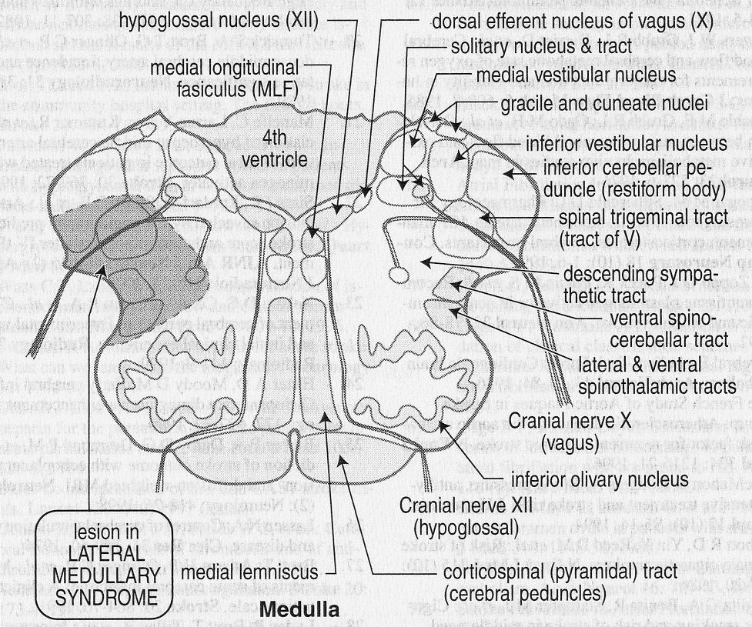

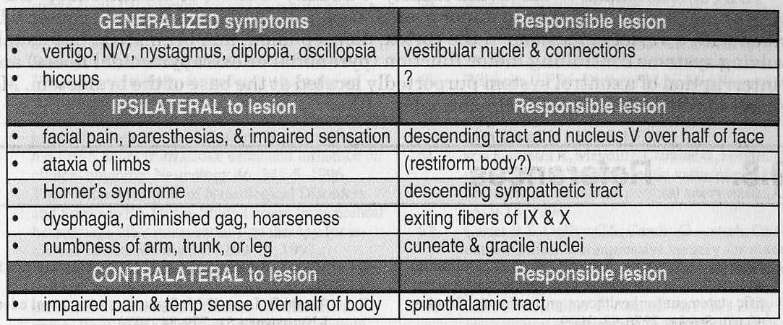

Midbrain syndromes
Išskiriami trys pagrindiniai sindromai:
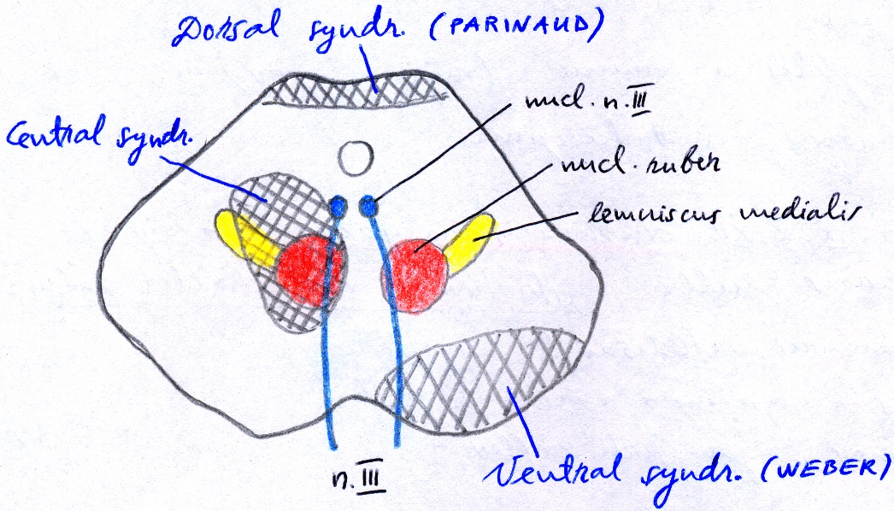

Dorsal midbrain (s. midbrain pretectal, collicular, Parinaud) syndrome – lesion of pretectal area, superior colliculi (e.g. compression from above by pineal mass; PCA infarct) → supranuclear paralysis of conjugate upward gaze → downward eye deviation (rarely, if unilateral → skew deviation);
+ Collier sign (pathological lid retraction) with Bell phenomenon (on attempt to close eyes, eyeball rolls up), mydriasis, anisocoria, light-near dissociated pupils, defective convergence, convergence-retraction nystagmus. further see p. Eye64 >>

Ventral midbrain (s. Weber) syndrome - paramedian PCA branches to midbrain - variant of alternating hemiplegia:
- Tr. pyramidalis → (contralateral) hemiplegia, incl. supranuclear CN7 palsy.
- Ipsilateral emerging CN3 fibers.

Central (s. tegmental) midbrain syndrome
- CN3 nucleus
- Medial lemniscus, tr. spinothalamicus → (contralateral) hemianesthesia
- Nucl. ruber, subst. nigra → (contralateral) hemichorea, hemiparkinsonism.
- if bilateral (rostral RF – ARAS) → coma.

Eilė papildomų sindromų: further see p. Eye64 >>
- Claude syndrome
- Benedikt syndrome
- Nothnagel syndrome

Bibliography for ch. “Brain Stem” → follow this link >>
NMS Surgery 2000, Medicine 2000, Pediatrics 2000, Emergency Medicine 1997, Neuroanatomy 1998, Radiographic Anatomy 1990, Physiology 2001

Viktor’s Notes℠ for the Neurosurgery Resident
Please visit website at www.NeurosurgeryResident.net

