Facial Nerve
Last updated: April 20, 2019

Cerebellopontine Angle
- emerges from brain stem ventrolaterally near posterior aspect of pons, 9.5-14.5 mm from midline and 0.5-2.0 mm medial to where CN8 enters brain stem.  - 23-24 mm long and 1-2 mm wide.  - runs obliquely (anteriorly and laterally) from pontomedullary sulcus to internal auditory canal.  - at times, CN7 axons pass through transverse fibers of middle cerebellar peduncle;  - within subarachnoid space, CN7 is joined by CN8, which travels lateral and slightly inferior to CN7.  - nervus intermedius runs between CN8 and motor root of CN7.  - CN5 is located anteriorly.  - in cerebellopontine angle, CN7 has no epineurium (covered only with pia mater). | 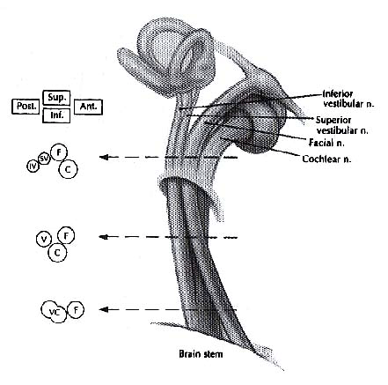
- anterior inferior cerebellar artery is found ventrally (between nerves and pons).

Internal Auditory Meatus
- meatal segment is 7-8 mm long.
- nervus intermedius joins motor root to form common trunk (lies within anterosuperior segment of meatus) - motor fibers are anterior, whereas nervus intermedius fibers remain posteriorly.
- at lateral end of meatus: horizontal partition (transverse or falciform crest) separates CN7 from cochlear nerve inferiorly; vertical crest (Bill's bar) separates CN7 from superior vestibular nerve located posteriorly.

blood supply - labyrinthine artery.

Facial Canal
segments:
- labyrinthine (3-4 mm long) lies within narrowest portion of bony facial canal; passes (forward and downward) between ampulla of superior semicircular canal and cochlea; at geniculate ganglion, nerve turns 75° posteriorly (external genu); greater superficial petrosal nerve exits 90° anteriorly from geniculate.
- tympanic (12-13 mm long) continues along medial wall of tympanic cavity, few millimeters medial to incus, superior and posterior to cochleariform process, along upper edge of oval window, inferior to lateral semicircular canal; at origin of stapedius tendon (from pyramidal process), nerve turns 120°, continuing inferiorly.
- mastoid (15-20 mm long); has two branches (nerve to stapedius and chorda tympani); during its course through mastoid along posterior aspect of external auditory canal, nerve travels slightly posteriorly and usually passes lateral to inferior aspect of tympanic annulus (at times, CN7 may be lateral to annulus during its entire descent - nerve at risk during mastoid surgery).

blood supply - superficial petrosal branch of middle meningeal artery (proximally) and stylomastoid artery (distally).

Stylomastoid Foramen
- stylomastoid foramen is between mastoid and styloid processes and deep to posterior belly of digastric.
- nerve immediately enters parotid gland.
- after traveling 2 cm anteriorly within parotid, nerve divides (at posterior border of ramus of mandible) into upper temporofacial and lower (and smaller) cervicofacial nerve; classically, these divide again at pes anserinus into temporal, zygomatic, buccal, mandibular, and cervical branches.
N.B. many anastomoses exist between these branches, and many variations in branching patterns have been described!
- after emerging from superior / anterior / inferior margins of parotid gland, branches enter deep surface of their target muscle.

blood supply - stylomastoid, posterior auricular, superficial temporal, transverse facial arteries.

Bibliography for ch. “Cranial Nerves” → follow this link >>
Goetz “Textbook of Clinical Neurology”, 1st ed., 1999 (171-183 p.)

Viktor’s Notes℠ for the Neurosurgery Resident
Please visit website at www.NeurosurgeryResident.net

