Ophthalmologic Examination
Last updated: June 3, 2019
History 1
Objective Examination 1
Pediatric aspects 1
Cornea, Conjunctiva & Sclera 1
Pediatric aspects 2
n. opticus 2
Visual acuity, s. Visus 2
Geriatric aspects 2
Pediatric aspects 2
Near Vision 3
Visual Field 3
Pediatric aspects 3
Color Vision 4
Contrast Sensitivity 4
Higher visual cortex 4
n. oculomotorius, n. trochlearis, n. abducens 4
Eyelid Position 4
Pupils 4
Pathologic pupils 5
Pediatric aspects 5
Extraocular Movements (EOM) 5
Pediatric aspects 6
Eyeball Position in Orbit 6
Supranuclear Gaze Control 6
Saccades, smooth pursuit 6
Pediatric aspects 6
Lacrimal Apparatus 6
Instrumental Eye Examination (incl. ophthalmoscopy) → see p. Eye60 >>
Tests to detect malingering or psychogenic causes → see p. Eye62 >>

History
Complaints:
  - decreased (blurry) vision - vision acuity↓; ask about:
near or far
night blindness [nyctalopia]
glare in bright light
  - visual field loss, scotomas
how patient noticed it? missing stairs if inferior visual field has been lost, noticing portions of words missing when reading, difficulty with driving
  - distortion of vision
  - crossed eyes, double vision – diplopia; ask:
near or far
one or two eyes
vertical or horizontal
  - photophobia (→ dim light to make patient feel more comfortable!)
  - itching, burning, foreign body sensation
  - pain
pain on eye movement – optic neuritis (vision loss), scleritis (no vision loss, red eye)
  - redness, discharge
  - excessive tearing / dryness
  - eyelid crusting / swelling / drooping / twitching / inability to close
  - visual hallucinations, light flashes, floaters, halos around lights
  - headache

HPI:
- glasses / contact lenses
- last eye examination, last glaucoma screening
- known eye diseases, traumas & operations: myopia, glaucoma, cataracts.
- systemic diseases (esp. diabetes, hypertension, migraine)

Objective Examination
Pediatric aspects
- infant - examination is enhanced by providing nipple or soother and by placing head on one side; physician gently strokes patient to maintain arousal, while examining closest eye.
- newborns keep lids tightly closed; attempts at separating lids increase contraction of orbicularis oculi.
- examine in subdued light (bright light causes infant to blink).
- older child should be placed in parent's lap and should be distracted by bright objects or toys.

Cornea, Conjunctiva & Sclera
Sclera & conjunctiva
Lower lid – ask patient to look up as you depress both lower lids with your thumbs.

Upper lid:
1. Ask patient to look down as you keep both upper lids lifted with your thumbs.
2. Perform lid eversion:
- patient looks down with relaxed eyes.  - raise upper eyelid slightly (so that upper eyelashes protrude), grasp eyelashes and pull them gently down and forward.  - place small stick (e.g. applicator) at least 1 cm above lid margin. | 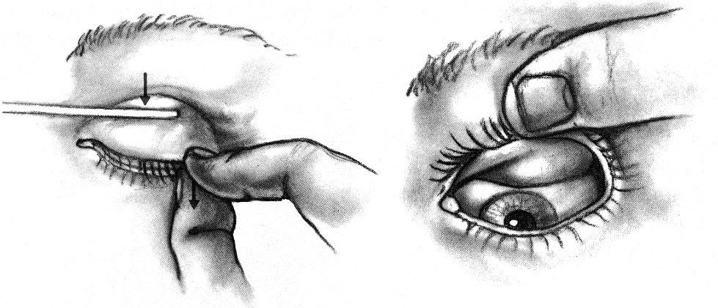
- push down on upper eyelid (do not press on eyeball itself!), thus everting it.
- secure upper lashes against eyebrow with your fingers, perform inspection.
- grasp eyelashes and pull them gently forward; ask patient to look up – eyelid will return to its normal position.

Conjunctivitis – check for preauricular LAD (viral etiology!)

Cornea should be inspected closely.
- if pain / photophobia make it difficult to open eye, instill 1 drop of proparacaine 0.5% or tetracaine 0.5% before examination.
- fluorescein staining:
- sterile, individually packaged fluorescein strip is moistened with 1 drop of sterile saline and, with eye turned upward, is touched momentarily to inside of lower lid.
- patient is asked to blink several times (to spread dye into tear film) → eye is examined under good magnification (slit-lamp) & cobalt blue illumination.
- areas where corneal / conjunctival epithelium is absent (abrasions, ulcers) will stain green.

Blue sclerae of osteogenesis imperfecta:
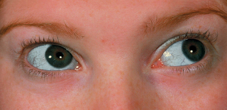

Pediatric aspects
- corneal blink reflex must be present at birth.
- small subconjunctival, scleral, and retinal hemorrhages are common in newborns.
- newborns may suffer from chemical conjunctivitis (swollen eyelids) due to silver nitrate instillation; may extend to dacryocystitis and nasolacrimal duct obstruction.

n. opticus
Patient's dress & cleanliness are clue to visual function!

Visual acuity, s. Visus
- test of central vision; first step in ocular evaluation (analogous to vital signs during general physical examination)!!!
- from neurologic (vs. ophthalmologic) standpoint, best possible vision must be determined – good ambient lighting, patient is wearing his own glasses (except reading glasses!);
if glasses are not available (or visual acuity still suboptimal even with glasses) → place pinhole directly in front of patient's glasses;
pinhole can correct most refractive errors! (pinhole only corrects ≈ 3-4 diopters (D) of refractive error)
N.B. organic causes (vs. refractive errors) of diminished vision are not corrected with pinhole!

Snellen chart:  - viewed at distance of 20 ft (6 m).  - cover one eye with card (so patient will not peek between fingers); some advice at first to test both eyes simultaneously and only then each eye separately.  - ask to read aloud smallest line; if unsuccessful → determine smallest line from which patient is able to identify > 50% letters.  - results are expressed as fraction:  numerator is 20; or 6  denominator is greatest distance from chart at which normal individual can read smallest line tested individual can read.  normal visual acuity is 20/20; or 6/6  20/15 visual acuity is better than normal;  20/100 visual acuity is subnormal.  vision when wearing glasses is recorded as “corrected” (e.g. “20/40 corrected”). | 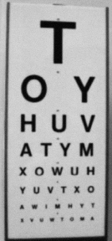
- height of letters in smallest line (that normal individual can read at 20 ft) subtends visual angle of 5 minutes; each of lines in letters are separated by 1 minute of arc (i.e. minimum separable in normal individual is visual angle of 1 minute).
- Snellen chart lines are from 20/400 to 20/10.
- if patient is unable to read largest Snellen letters (vision is worse than 20/400):
- position patient closer to chart until he can read largest letters (note distance accordingly; e.g. 10/400 – can see top letter at 10 feet).
- check ability to count fingers (CF) (and at what distance; usually at 3 feet; e.g. “counts fingers at 3 feet”)
- detect hand motions (HM) (wave hand before patient’s eye)
- have light perception (LP).
Blind eye has no light perception (NLP)!

LogMar chart  LogMar 1.0 = Snellen 20/200  LogMar 0.0 = Snellen 20/20 (normal vision) | 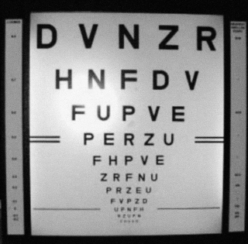

Geriatric aspects
Visual acuity remains fairly constant until age 50, then diminishes gradually until 70, more rapidly after that (nevertheless, most elderly retain good vision – 20/20 to 20/70).

Pediatric aspects
newborns – optical blink (dazzle) reflex - blink and head dorsiflexion in response to bright light (it is one of infantile automatisms / primitive reflexes - disappears after 1st year); reflex blink to visual threat;
- 28-wk premature infant blinks when bright light is directed to eyes.
- 32 wk premature maintains eye closure until light source is removed.
- 37 wk premature turns head and eyes to soft light.
- term newborn: visual fixation and ability to follow brilliant target are present (optokinetic nystagmus can be demonstrated);

infants - assessment of fixing and following in most instances is sufficient.
- when more accurate visual acuities are required → preferential looking tests (Teller's acuities) - based upon principle that child would rather look at objects with pattern stimulus (alternating black and white lines of specific widths) than at homogeneous field; smallest pattern that child seems to prefer is best visual acuity.

Objective visual acuity screening must begin at age 3 years; children unable to cooperate → repeat attempt 4-6 months later (if still unsuccessful → refer to ophthalmologist).
- in children > 3 years, Snellen E chart already can be used (child can indicate in which direction E is pointing – either orally or by positioning of fingers).
- optokinetic testing is most accurate method in early childhood!
N.B. in early childhood (before age 4-6 years), bilateral acuity must be tested – to detect amblyopia! (child usually accepts covering amblyopic eye, but resists covering normal eye during test)
- central vision progresses from birth (only light perception) to 6 years (adult vision levels).
visual acuity:
at 1-5 days ≈ 20/670
at 1 year ≈ 20/200
at 3 years ± 20/40
at 4-5 years ± 20/30
at 6-7 years 20/20
- objective screening is recommended at ages 5, 10, and 12 years.
- visual acuity should be 20/40 or better by 3-5 years and 20/30 by 6 years; failure to do that (or two-line difference between eyes) → full ophthalmologic evaluation

Near Vision
- assessed with hand-held card; acuity with near card is recorded using standard Jaeger notation (J1, J3, etc); patient wears his own reading glasses. see Near Vision testing card >>
- near vision starts to blur noticeably in 40s.

Visual Field
peripheral vision (perimeter)
Confrontation testing (crude method):  - position yourself at 1 m. distance from patient, eyes at the same level.  - patient covers one eye, other eye fixates to your nose tip;  - patient's head should be tilted away from any obstructing facial feature (e.g. heavy eyebrows, large nose);  - doctor does the same. | N 55°  O  S 60° 90°  E  65°
- cotton ball (or wiggling finger) is approached from periphery – patient responds when notices object in his visual field; some authors prefer testing in quadrants instead of +;
- cotton ball always at the same distance from you and patient – allows control by comparing to your visual perimeter * (except for temporal field [norma - 90°] – place test object behind plane of patient eye);
- by convention, record defects from perspective of patient rather than examiner.
*to position patient to better advantage, hand is held up slightly closer to examiner - this provides wider field for patient: if examiner can see target, patient can see it unless he / she has field deficit.
Names of visual field defects → see p. Eye41 >>
Homonymous defects
- both your and patient's eyes open.
- approach with target in each of four outer quadrants of patient's visual field - superotemporal, superonasal, inferotemporal, inferonasal - ask patient to point to target; slowly bring target into centre of visual field until patient detects it.

Sensory inattention (hemineglect) - test both left and right fields at the same time.

Crude test (for largely uncooperative patients) - reflex blink to visual threat.

Most precise test - quantitative instrumental perimetry.

central (macular) vision - Amsler grid (can detect small central or paracentral scotomas, metamorphopsias):
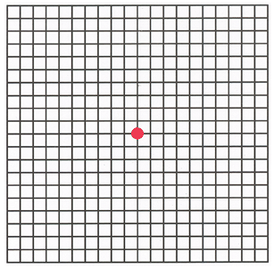
- cover one eye; hold grid 12 inches in front of eye; patient is asked if he can see red object in grid center (dot) – central scotoma; if can see dot, he is asked to fixate on dot and then to note if all four corners of diagram are visible and if any of boxes are missing, if grid areas appear desaturated, if any grid areas have missing lines, or if lines do not appear straight.
- patient is asked to outline any missing or distorted areas on the grid with a pencil.

- normal central vision extends ≈ 30° in all directions of central fixation.
- blind spot is located ≈ 15-20° temporal to fixation point.

Pediatric aspects
- child sits on parent’s lap; parent fixates child’s head in midline; approach toy from behind infant into child’s vision field – child’s eye will deviate toward toy when it is seen (visual recognition response).

General rule:
acuity is impaired by lesions of globe structures, optic nerves;
visual field defects are due to lesions of optic nerves ÷ intracranial pathways.

Color Vision
- pseudoisochromatic Ishihara or Hardy-Rand-Ritter plates.

Red desaturation (impaired ability to identify red objects) is early indicator of optic nerve pathology.

Ishihara plates
First plate is test plate (if number is not seen, it indicates poor visual acuity or functional visual loss):
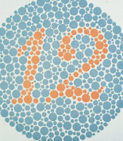; patient with red-green deficiency sees as

Second plate (if number is not seen, it indicates red-green deficiency):
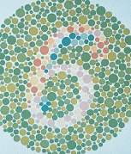; patient with red-green deficiency sees as

Contrast Sensitivity
- Pelli-Robson chart.

Higher visual cortex
Unilateral visual neglect
- wiggle fingers simultaneously in both upper temporal quadrants, then in lowers.
- letter cancellation - patient is asked to find specific letter within random array (patients with left visual neglect may find specified letter only when it appears on right page side).

Agnosias
- bedside tests - using common objects such as pen, cup, or book.
- inability to recognize faces (prosopagnosia) or interpret complex scenes (asimultagnosia) - can be tested with magazine / newspaper photos and advertisements.

n. oculomotorius, n. trochlearis, n. abducens
Review patient's old photographs - to determine chronicity of lid, pupil, dysmotility, and orbital problems.

Eyelid Position
- determined by measuring distance between central corneal light reflex* and upper and lower lid margins - margin-reflex distance (MRD) - MRD₁ for upper lid, MRD₂ for lower lid.
*light reflex is produced by shining focused light source on eyes; light reflex does not change with variation in eye position!
- compare for symmetry between eyes.
- test adequacy of lid closure in:
    - exophthalmos
    - CN7 palsy
    - unconsciousness

Pupils
N.B. if muscle relaxants have been administered to patient, only aspect of neurologic examination that may be evaluated is pupillary examination!

- shape, size in mm (both in dark [i.e. scotopic] and illuminated environment; patient fixates at distant object).
  - anisocoria? (minor anisocoria is normal!!!); is anisocoria greater in dark or in light?
  - transient fluctuations in pupillary diameter (hippus) are normal.

- direct & indirect (consensual) reaction to light – dim room light, patient fixes on distant object (to avoid accommodation), shine strong light (e.g. from ophthalmoscope) obliquely* into one eye; normally – symmetric miosis.
*alternatively – hold light at temple and shine tangentially on one eye so as to cast shadow over other eye!!
- at least 10 seconds between assessment of each eye allow consensual response to fade prior to stimulating opposite eye.
- note briskness of pupil response (if pupils do not react briskly, record vermiform constriction, iris notches).
  - swinging-flashlight test – to detect relative afferent pupillary defect (RAPD), i.e. unilateral afferent part (retina ÷ optic tract) lesion - bright flashlight is swung from one eye to other just below visual axis while subject stares at distant object in dark room - constriction of pupils should be the same when either eye is illuminated.
N.B. in afferent defects, both pupils are equal in size at all times! (unilateral optic nerve lesions cause afferent pupillary defect even with apparently normal vision, whereas with macular lesions this is late finding); in efferent defects – there is anisocoria (unless defect is bilateral)

- look for crescentic shadow on iris on side away from light – indicates narrow angle (risk for narrow-angle glaucoma); normally no shadow is cast (although lens continues to grow over life, pushing iris forward). | 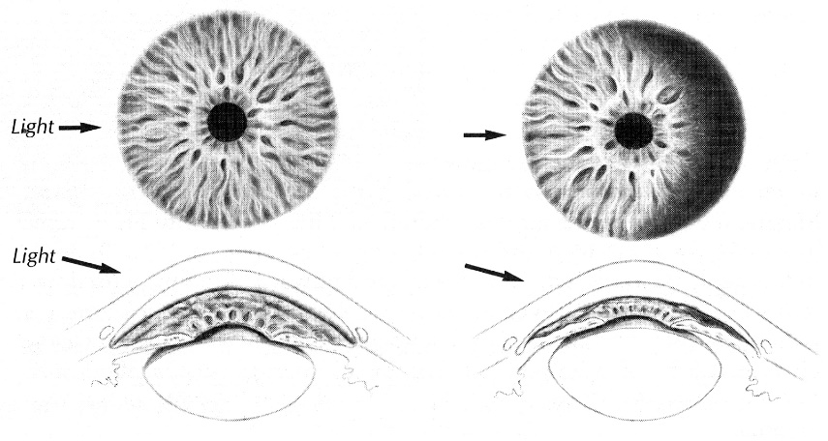

- reaction to convergence / accommodation – patient first looks at distant object and then at reading card (or other nonbright object) held few inches away; normally – miosis.

Essential anisocoria - common normal variant - one pupil is bigger than other, but otherwise they behave normally.

Pathologic pupils
Marcus Gunn pupil (relative afferent pupillary defect) - decreased direct pupillary light reflex - during swinging-flashlight test, abnormal pupil dilates when exposed to light.
Holmes-Adie (myotonic) pupil (slow idiopathic degeneration of ciliary ganglion) – unilateral (80%) moderately dilated pupil and poorly reactive to light (if at all); slowly reactive to accommodation (wait & watch carefully – eventually constricts more than normal pupil).
Argyll Robertson pupil (neurosyphilis, diabetes) – constricted, unreactive to light, but reacts to accommodation.
Hutchinson pupil (rapidly rising unilateral ICP with transtentorial herniation → CN3 compression) – pupil on lesion side first constricts, then widely dilates; other pupil then goes through same sequence.
Wernicke sign (hemianopic pupillary reactivity) - loss of pupillary constriction when light is directed to blind side of retina; pupillary constriction is maintained when light stimulates normal side.
- bilaterally constricted pupils (pinpoint) - drug (alkaloid, opioids), pons lesion.
- bilaterally widely dilated pupils - drugs (atropine, barbiturate, cocaine), anoxia, lesion in brainstem; fixed & dilated - usually irreversible injury (but if due to systemic hypoxia, pupils may recover reactivity when oxygenation is restored).

Pediatric aspects
- pupil is difficult to examine in premature (poorly pigmented iris and resistance to lid opening).
- inspect irides for Brushfield spots - white specks scattered (light-colored condensations) in linear fashion around entire iris circumference – suggest Down syndrome.
- pupillary reactivity to light is poor (but present*) during first 4-5 months.
*pupil reacts to light by 29-32nd wk of gestation.
- transient anisocoria in both bright and subdued light is common in infancy.

Extraocular Movements (EOM)
If voluntary eye movements cannot be assessed → oculocephalic & oculovestibular testing
see p. S30 >>
- Monokulinis žvilgsnio paralyžius

Ekstraokulinių raumenų testavimo kryptys
N.B. tai ne raumenų veikimo kryptys, bet būdas izoliuotai testuoti kiekvieną raumenį

m. rectus superior m. obliquus inferior N
O
m. rectus lateralis (CN6) m. rectus medialis S
E
m. rectus inferior m. obliquus superior (CN4)

also see p. Eye10-11 >>

- patient is asked to look forward (maintaining primary position), and then to look in all secondary and tertiary positions - ligonis žvilgsniu seka gydytojo pirštą, vedamą šiomis kryptimis:
  - ištestuojamos horizontalios kryptys (in absence of proptosis, none of ipsilateral sclera should be present on extreme gaze - 'burying the white').
  - ištestuojamos vertikalios kryptys; check downgaze positions twice:
    - without lifting lids (lid lag - lid-inferior gaze synkinesis?) – normally, upper lid always slightly overlaps iris.
    - with lids lifted (lids do not obscure eyes).
  - po to ore pirštu piešiama didelė H raidė – stebime abi akis iš karto.
  - gale testuojama konvergencija (it is already tested during pupillary reaction to accommodation!!!!).
- kadangi pastebėti lengvą strabizmą sunku, ligonio klausiama ar nesidvejina vaizdas (tyrimą palengvina žiūrėjimas vietoj piršto į švieselę, vieną akį uždengus raudonu stiklu);
- dvejinimasis didžiausias žiūrint pakenkto raumens veikimo kryptimi: CN4 - į vidų ir žemyn, CN6 - į išorę, CN3 - likusiomis kryptimis;
- pakenkta akimi matomas vaizdas yra periferiškesnis ir mažiau ryškus, t.y. uždengus "pakenktą" akį, išnyksta lateralesnis vaizdas.

- Heterotropia (diplopia), heterophoria – testuojama jei aptinkamas monokulinis žvilgsnio paralyžius ar pacientas pasiskundžia diplopia; details of examination → see p. Eye64 >>
- central corneal light reflex – look for symmetry (good test if patient has epicanthal folds causing pseudostrabismus).
- colored glass over one eye – ask patient where colored image is relative to white one as he views point light source.
- cover right eye – ask patient which image disappears (if right – esotropia; if left – exotropia).
- cover-uncover test (also detects heterophoria) – uždengiant, po to atidengiant vieną akį, stebima atviros akies judesiai.
- Nystagmus - ligonis fiksuoja į gydytojo pirštą laikomą ≈ 1 m atstumu; pradžioje tiesiai, po to pirštas atvedamas 3 ir 9 val. kryptimis ne daugiau 30° (i.e. in field of full binocular vision; if > 45° - nistagmas gali būti ir fiziologinis), po to 12 ir 6 val. kryptimis ne daugiau 15°.
  - kiekvienoje padėtyje laukiama > 5 sekundes (patologinis nistagmas > 3 beats):
- ar abiem akimis
- plokštuma
- kryptis pagal greitą komponentą
- kuria kryptimi žiūrint
- reguliarumas
- degree (Alexander grading scheme):
1° - nystagmus present only with gaze in direction of fast phase
2° - nystagmus present in primary gaze.
3° - nystagmus present in all gaze positions.
- is nystagmus suppressible by visual fixation? (repeat testing with Frenzel glasses)

N.B. kitaip negu tiriant EO raumenų paralyžių, čia naudojama ne “H” raidė, bet “+” ir kiekvienoje padėtyje laukiama > 5 sekundes.

rotational nystagmus
- best way to define rotational nystagmus - clockwise / counterclockwise from patient's point of view.
- rotational nystagmus during Dix-Hallpike test (see p. D1ear >>) also can be described as geotropic / ageotropic:
Geotropic means "toward earth" and refers to upper half of eye.
Ageotropic refers to opposite movement.
- if head is turned to right, and eye rotation is clockwise from patient's point of view (top half turns to right and toward ground), then nystagmus is geotropic.
- if head is turned toward left, then geotropic nystagmus is counterclockwise rotation.

Pediatric aspects
- complete ocular movement may be demonstrated as early as 25 wk of gestation utilizing doll's eye maneuver.
- check corneal light reflex and cover test at age > 3 months.
- red glass test - to assess extraocular palsies: red glass is placed over one eye, and patient is requested to follow white light in all fields of direction - child sees only one red/white light in normal muscle direction but notes separation of red and white images that is greatest in plane of action of affected muscle;
premature infants tend to have slightly disconjugate eyes at rest (one eye horizontally displaced from other by 1-2 mm); skew deviation of eyes (vertical displacement) is always abnormal and requires investigation!

Eyeball Position in Orbit
Exophthalmos (s. Proptosis)
- best noted by viewing globes from above patient's forehead – stand behind seated patient, draw his upper lids gently upward:  - relative resistance to globe retropulsion (orbital compliance) - pressing on globes (through closed lids) reveals that more force is required to ballot one of eyes into orbit (suggests space-occupying lesion in orbit).  - instrumental examination – Hertel exophthalmometer. see p. Eye60 >> | 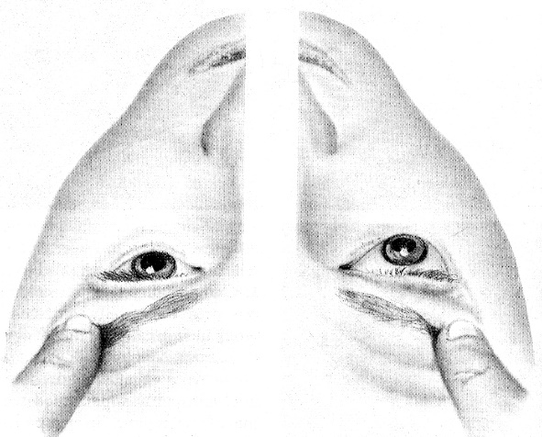

Supranuclear Gaze Control
Saccades, smooth pursuit
about testing → see p. Eye64 >>
- in normal elderly impairment of upward gaze is possible.
N.B. in supranuclear gaze palsy, all eye movements are intact during “doll’s eye” test.

Pediatric aspects
- fixation on objects develops at 2-4 weeks.
- conjugate eye movements develop soon after birth, but definitive pursuit movements are not seen for 5-6 weeks.
- at 2 months, infants follow object past midline, at 4 months they follow object to full 180° arc.
- at 3 months eyes can converge (baby begins to reach for objects at various distances).
- during first 10 days of life, eyes do not move but remain fixed (staring in one direction) as head is slowly moved throughout full range of motion (doll’s eye test).  - hold baby upright in your extended arms, fixing head in midline with your thumbs:  - rotate slowly in one direction – this causes eyes to open and to look in direction you are turning; when rotation stops, eyes look in opposite direction, following few unsustained nystagmoid movements.  - searching nystagmus is common immediately after birth (if persists after few days, may suggest blindness). | 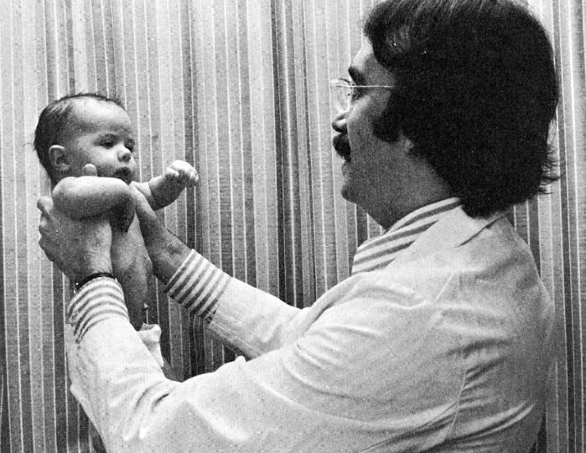
- test all children for strabismus (that may cause amblyopia ex anopsia!) at 3-4 months (before age 6 years).
N.B. intermittent alternating convergent strabismus is normal during first 3-6 months.

Lacrimal Apparatus
Lacrimal gland – elevate temporal aspect of upper lid and ask patient to look down and to opposite side.

Lacrimal drainage system – check for obstruction by pressing medial aspect of lower eyelid just inside orbital rim (watch for fluid regurgitation out of lacrimal puncta); palpate area for tenderness.

Bibliography for ch. “Diagnostics” → follow this link >>

Viktor’s Notes℠ for the Neurosurgery Resident
Please visit website at www.NeurosurgeryResident.net

