Halstead-Reitan Screening Test for Cerebral Dysfunction
Last updated: June 3, 2019

Patient's Task |  | Examiner's Instructions to Patient
1. Copy square (A) |  | First, draw this on your paper. (Point to square, item A.) I want you to do it without lifting your pencil from the paper. Make it about the same size.
2. Name square |  | What is that shape called?
3. Spell square |  | Would you spell that word for me?
4. Copy cross (B) |  | Draw this on your paper. (Point to the cross, item B). Go around the outside like this until you get back to where you started. Make it about the same size.
5. Name cross |  | What is that shape called?
6. Spell cross |  | Would you spell that word for me?
7. Copy triangle (C) | 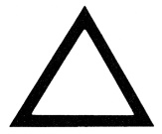 | Draw this on your paper. (Point to the triangle, item C.) Do it without lifting your pencil from the paper, and make it about the same size.
8. Name triangle |  | What is that shape called?
9. Spell triangle |  | Would you spell that word for me?
10. Name baby(D) | 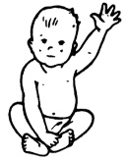 | What is this? (Show baby, item D.)
11. Write clock (E) | 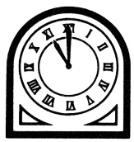 | Now, I am going to show you another picture, but do not tell me the name of it. I don't want you to say anything out loud. Just write the name of the picture on your paper. (Show clock, item E.)
12. Name fork (F) | 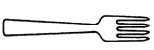 | What is this? (Show fork, item F.)
13. Read 7 six 2 (G) | 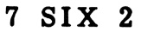 | I want you to read this. (Show item G.)
14. Read M G W (H) |  | Read this. (Show item H.)
15. Read item I |  | Now, I want you to read this. (Show item I.)
16. Read item J | 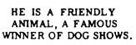 | Can you read this? (Show item J.)
17. Repeat triangle |  | Now, I am going to say some words. I want you to listen carefully and say them after me as well as you can. Say this word: triangle.
18. Repeat Massachusetts |  | The next one is a little harder, but do your best. Say this word: Massachusetts.
19. Repeat Methodist Episcopal |  | Now, repeat this phrase: Methodist Episcopal.
20. Write square (K) |  | Don't say this word out loud; just write it on your paper. (Point to stimulus word square, item K.)
21. Read seven (L) |  | Can you read this word out loud? (Show item L.)
22. Repeat seven |  | Now, I want you to repeat this after me: seven.
23. Repeat and explain He shouted the warning |  | I am going to say something that I want you to say after me. So listen carefully: He shouted the warning. Now, you say it. Would you explain what that means?
24. Write He shouted the warning |  | Now, I want you to write that sentence on the paper.
25. Compute 85 - 27 (M) | 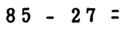 | Here is an arithmetic problem. Copy it on your paper in any way you like and try to work it out. (Show item M.)
26. Compute 17 X 3 |  | Now, do this one in your head: 17 X 3 = ?
27. Name key (N) |  | What is this? (Show item N.)
28. Demonstrate the use of a key |  | If you had one of these in your hand, show me how you would use it. (Show item N.)
29. Draw key |  | Now, I want you to draw a picture that looks just like this. Try to make your key look enough like this one so that I will know it is the same key from your drawing. (Point to key, item N.)
30. Read item O | 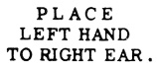 | Would you read this? (Show item O.)
31. Place left hand to right ear |  | Now, would you do what it says?
32. Place left hand to left elbow |  | Now, I want you to place your left hand to your left elbow.

Note: average person with high school education should make essentially no errors on this test and recognize immediately impossibility of command 32.
Re-test any items failed by giving tasks similar to failed one.

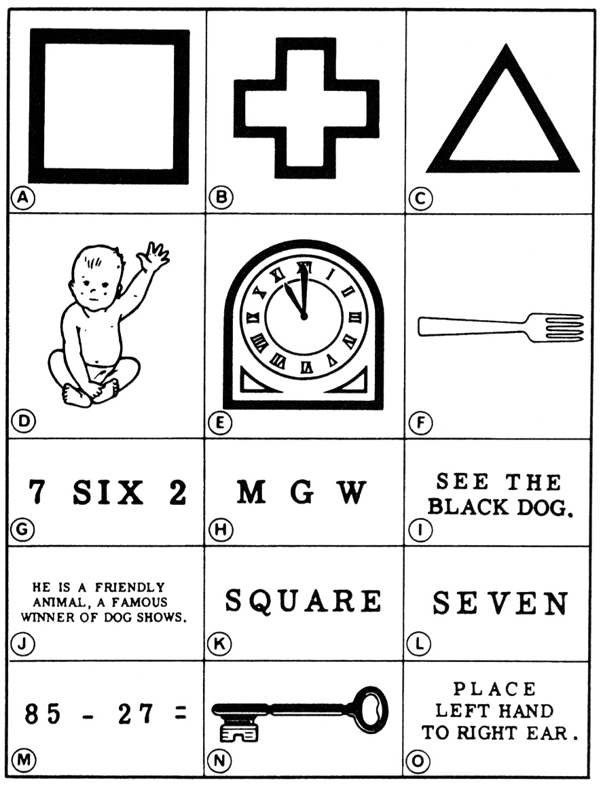

Bibliography for ch. “Diagnostics” → follow this link >>

Viktor’s Notes℠ for the Neurosurgery Resident
Please visit website at www.NeurosurgeryResident.net

