Mental Status examination
Last updated: June 3, 2019
indications 1
EXAMINATION STRUCTURE 1
Level I: consciousness 1
Level II: attention & vigilance 1
Level III: behavior 2
Level IV: language, memory, thought 2
Level V: constructional ability, calculations, learned material 4
Level VI: abstract thinking, conceptual ability, judgment, insight 4

Mental Status examination - present moment evaluation of:
- behavior
- emotions
- cognition
Sensorium = consciousness; or generic term for intellectual & cognitive functions.
- involves observation (e.g. behavior and facial expression), questioning (e.g. thought content), and testing (e.g. memory).
- make patient physically comfortable and (if possible) mentally at ease; otherwise, obtained information may reflect artifacts of interaction.
- neuropsychological testing requires standardized and replicable conditions, vs. mental status examination is often administered under difficult conditions (e.g. noisy emergency room).
- special introduction - "I have listened to your lungs and heart. To study how your brain is working, I have a series of questions that I ask of every patient" - for all but the most paranoid patients, this approach obviates any fear that individual has been singled out for test because something is amiss.
- avoid saying, "Some of these questions are very easy" – if individual cannot answer them, he or she may feel truly inadequate.
- standard scoring form is used. see p. D10a >>, p. D10b >>
also see p. D12 >>

indications
- baseline level of performance and following progress (e.g. HIV infected patient is at risk for HIV- related dementia).
- differentiation between neuropathology and psychopathology
N.B. presence of one does not exclude coexistence of the other; they often coexist:
    - some psychiatric disorders may include motor signs (e.g. catalepsy).
    - many neurologic conditions produce psychologic / interpersonal difficulties (e.g. mood disturbances in multiple sclerosis).
- differentiation among psychotic syndromes.
- assessment of psychiatric patients.
- monitoring high-risk patients:
    - elderly (diagnosing early dementia)
    - taking drugs with cns effects
    - metabolic and endocrine disorders
    - in icu, postsurgery
    - head trauma
    - anoxic patients
    - malnourished patients
    - structural brain disease

EXAMINATION STRUCTURE
- mental status examination is based on neuropsychological hierarchy (staircase, s. ladder, model) – examination proceeds from lowest function (arousal, consciousness) to highest function (executive - abstractions, insight, judgment).
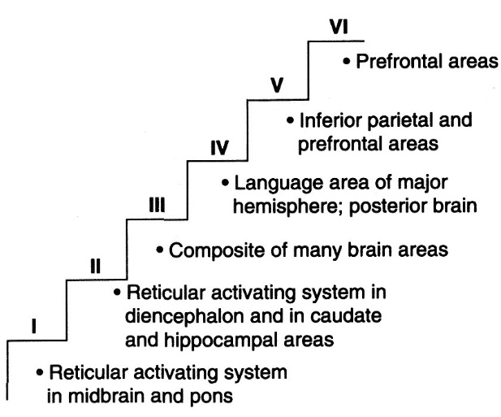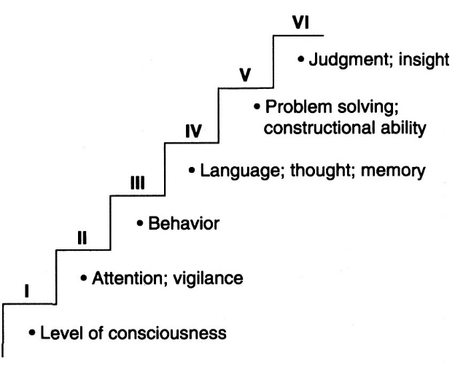

Roman numerals refer to numbered sections on score sheet.

- for many mental disorders, symptoms tend to cluster at particular "level".
N.B. dysfunction at lower levels interferes with functions at higher levels!

mini-mental status tests see p. D2 >>, p. D3 >>
- concentrate only on cognitive aspects and exclude questions concerning mood, abnormal mental experiences, form of thinking.
- easy to administer, take 5-10 minutes – scores can be used for semiquantitative monitoring.

Level I: consciousness
Brain site affected - midbrain reticular activating system (RAS); rarely, due to widespread cortical damage (e.g. CO poisoning).
  - metabolic cause in 70% of cases.

Assessment - clinical evaluation only: also see p. S30 >>
- alert - awake, aware, interacting, responsive to stimuli (not the same as “attentive”!!!).
- lethargic / obtunded - can be roused but does not maintain arousal.
- stuporous - can be roused slightly with intense stimulation.
- comatose - cannot be roused, even with painful stimuli.
- fluctuating mental state (varies during day course).

N.B. reduced level of consciousness is rarely seen in mental disorders (except - delirium, intoxication, withdrawal).

Level II: attention & vigilance
Attention - ability to focus over time on single specific type of stimulus and to screen out irrelevant stimuli.
vs. awareness – not modality specific (i.e. equal for all types of stimuli); attention depends on awareness!
Vigilance (concentration) - ability to focus attention over extended period.
Brain site affected - RAS, RAS-thalamic projection system, reticulocortical and corticoreticular connections, RAS hippocampal and caudate areas.
- development of these areas is complete at puberty.

Assessment – see p. D1 >>

Typical example is delirium (circle shows primary area of dysfunction):
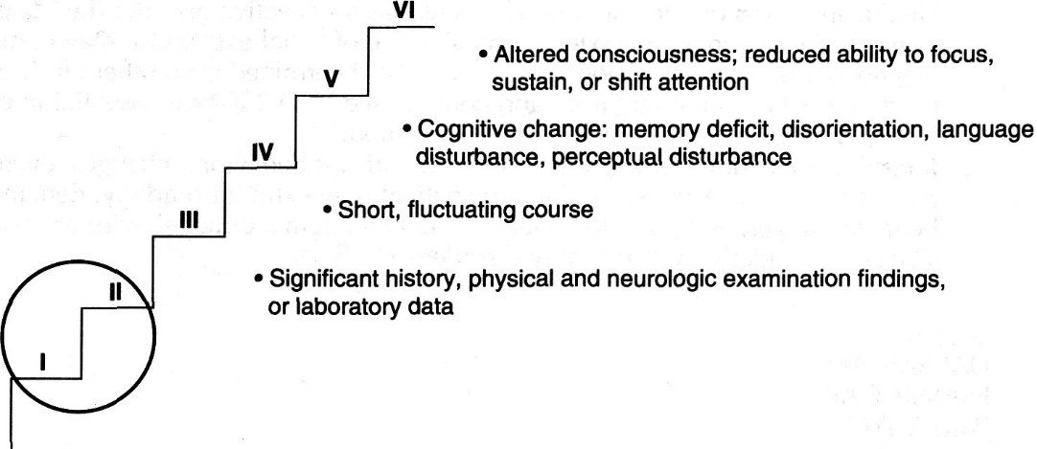

Level III: behavior
Brain site affected - many cortical & subcortical areas (e.g. limbic system, prefrontal area, caudate area).

Assessment:
- Appearance and grooming - helpful in diagnosis of almost all clinical syndromes!
examples: bizarre dress in schizophrenia, mania;
seductive dress in histrionic personality disorder;
soiled and stained clothing of demented, intoxicated patients.
- Motor activity
increased motor activity - agitated depression, mania, attention deficit disorders, delirium.
reduced motor activity - depression, catatonia, frontal lobe syndromes, parkinsonian states, delirium.
- Facial expression (little or no facial expression - depression, Parkinson's disease, minor hemisphere stroke).
- Mood and affect are emotional states:

Affect = Moment Affect ≈ Weather
Mood = Hour Mood ≈ Climate
alternatively:
Affect = outward expression of internal emotional state
Mood = emotional state experienced internally
    - mood can be determined from knowledge of patient's thought form and content;
    - mood abnormality suggests affective disorder (i.e. depression, mania, hypomania, anxiety).
Are mood and affect the same? (e.g. depressed mood and sad quiet appearance, vs. depressed mood and agitated appearance)
Labile affect – sudden shifts in emotional state (laughing one minute and crying the next without clear stimulus).
Flat affect – blunted emotional state.
- Some patients show significant behavioral changes, even during short interview (interview behavior).

Anxiety disorder (circle shows primary area of dysfunction):

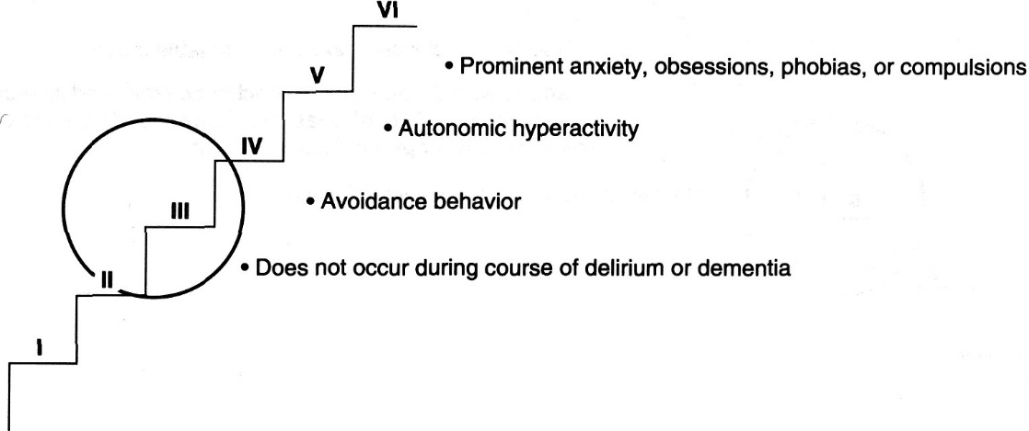

Depressed mood (circle shows primary area of dysfunction):

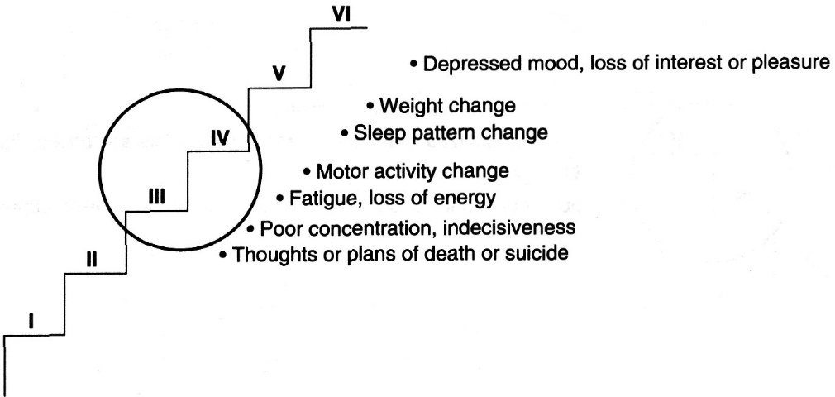

Manic mood (circle shows primary area of dysfunction):

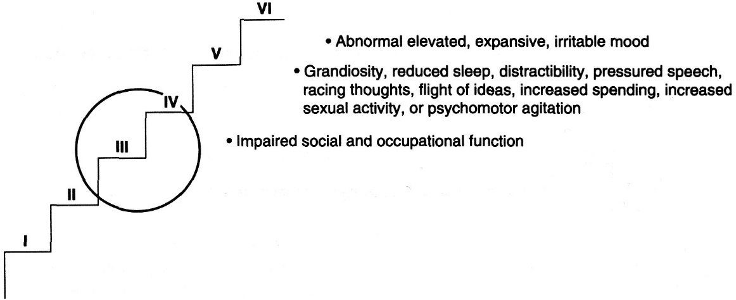

Level IV: language, memory, thought
1. Language – should be evaluated early in examination. see p. D1 >>
2. Memory → see p. D1 >>
3. Thought disorders may affect:
- content (what is said)
- form (how it is said).
- psychotic patient - disorders of both form and content.

Thought form (s. process) disorders
    - Reduced content - poverty of ideas, vague, repetitive, abstract speech that contains little information (speech is adequate in amount and contains no syntactic or vocabulary errors) - "empty philosophizing".
    - Circumstantiality - patient has trouble reaching the point because he includes unnecessary detail and parenthetical information.
    - Tangentiality - shifts in topic that at first may be related but progressively move further from initial topic.
    - Derailment (s. loose associations) - shift in thinking - patient's ideas move from one unrelated topic to another (patient is not aware of incongruity of juxtaposed ideas).
    - Clang associations (form of derailment) - patient changes topic because of sound rather than meaning of words (e.g. we went up the hill, pill that he is).
    - Blocking - sudden speech cessation that patient attributes to “losing her thought” or “having her mind become blank”.
N.B. patients who are distracted by inner perceptual disturbances (hallucinations) experience blocking.
    - Flight of ideas (in mania) - accelerated speech and rapid shifts in topic; speech may become disorganized and incoherent, but syntax and vocabulary are intact.
    - Confabulation - apparent fact fabrication to fill gaps in memory.
    - Neologisms - word inventions or distortions of standard words (e.g. grass is grumps).
    - Echolalia - meaningless echoing of words or phrases of others.
    - Perseveration - persistent repetition of words and phrases (despite physician’s direction to stop).
    - Word salad - disorganized speech - syntax is lost, vocabulary use is idiosyncratic.

Thought content disorders
Ask open-ended question, such as, "What's on your mind?".
- Illusion (delirium, schizophrenia) - misperception of real sensory stimulus (e.g. moving shadow of tree on bedroom wall appears to be figure outside window).
- Hallucination – false perception of sensory stimulus; any sensory modality can be involved:
  - auditory hallucinations (psychosis) - usually as human voice; other sounds are less common (e.g. temporal lobe epilepsy).
  - visual hallucinations (psychosis) - usually focused images (e.g. human form), less commonly, lights.
  - olfactory-gustatory hallucinations (temporal lobe disorders) – usually unpleasant.
  - tactile (haptic) hallucinations (organic states – withdrawal, abuse) - sense of touch. (e.g. formication - sense of something crawling or creeping).
  - kinesthetic hallucinations (in near-death situations) – feeling movement when none occurs.
  - hypnagogic / hypnopompic hallucinations (in normal individuals) – brief hallucinations of any kind while falling asleep / awakening.
- Delusion - fixed false belief based on incorrect reality interpretation (e.g. telephone ringing only once is absolute documentation of government plot against patient).
N.B. delusions are fixed – cannot be corrected by physician – physician should not preted to agree with delusion but should take neutral position (contradiction to patient’s delusional belief may cause patient to become angry and stop interview).
- Depersonalization – patient feels detached and views himself as strange and unreal; derealization – the same sense about reality of outside world.
- Assaultive thoughts - wishes / intentions to harm individual, group, or, rarely, institution or organization.
- Homicidal thoughts - wishes / intentions to kill another person.
- homicidal plans suggest that intention to kill is real threat.
- in several states, mental health professionals are required by law to report to potential victims possibility of assaultive attack.
- homicidal patient is involuntarily hospitalized.
- Feelings of hopelessness (usually accompany depression or grief).
- Feelings of worthlessness are common (may accompany severe depression).
- Anhedonia - inability to derive pleasure from ordinarily pleasurable activities.
- Feelings of guilt.
- Suicidal thoughts.
(a) determine probability that suicidal plan will succeed (e.g. if patient says that he might shoot himself, are there guns at home?).
(b) patient who is imminently suicidal can be involuntarily hospitalized.
- Obsessions - recurrent, persistent, uncontrollable ideas, images, impulses.
- patient realizes that ideas are intrusive, nonsense, not being imposed from outside (vs. delusions) and unwelcome (i.e. they are ego-dystonic).
- Phobias - irrational and persistent fears of object / activity / situation with compelling desire to avoid that.
- Sexual concerns are experienced by many patients - obsessions (e.g. patient thinks that his penis is too small), delusions (e.g. patient has most powerful penis in the world), phobias (e.g. patient has exaggerated fear of venereal disease).
- Somatic preoccupations are seen in patients in all branches of medicine (often unrelated to any underlying pathologic processes).
- Religiosity - preoccupation with religion - delusion (e.g. patient believes that she is God) or obsession; occurs in many psychiatric illnesses.

Psychotic disorder (circle shows primary area of dysfunction):

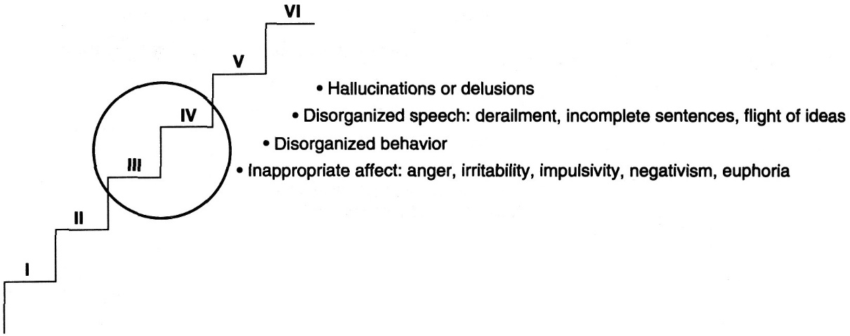

Level V: constructional ability, calculations, learned material
Constructional (graphomotor) ability - ability to copy / draw 2- or 3-dimensional shapes - complex task (involves visual, perceptual, and analytic functions of occipital & parietal lobes and motor planning and action functions of prefrontal & frontal lobes).
- right parietal lobe damage causes severe impairment in performance.
- excellent screening test - good performance suggests integrity of many neural structures (patients with early stage of dementia perform poorly!).

Calculations - ability to perform mental arithmetic (e.g. serial sevens).
- performance is highly correlated with concentration, intelligence, and education - these factors must be considered (e.g. patients with significant anxiety show impaired performance).

Learned material (fund of information) - patient is asked questions that assess her store of knowledge or general information.
- possible questions: How many minutes are in an hour? What is the function of the kidneys? How many miles lie between San Francisco and New York?
N.B. always consider patient’s cultural and educational background!
- relatively unaffected by any but the most severe psychiatric disorders!

Untimed Trails B test - patient alternates between number and letter sequences.

Letter fluency - patient names as many words as possible beginning with specific letter in 1 minute.
Category fluency - patient names as many items as possible in certain category in 1 minute.

Level VI: abstract thinking, conceptual ability, judgment, insight
- measures highest cortical functions (executive ability).

Abstract thinking (begins at age ≈ 12 years).
- Similarities - patient is asked to identify essential relation between word pairs (e.g. turnip and cauliflower, chair and table, painting and symphony).
- Proverb interpretation (dependent on cultural, intellectual, and educational background!) - ask patient to explain following proverbs: "Rome was not built in a day"; "A bird in the hand is worth two in the bush"; "Birds of a feather flock together"; "A rolling stone gathers no moss"; and "An apple falls near its tree."
  - best score - for most abstract response (e.g. it takes time to do things well);
intermediate score - for partial abstract response (e.g. don't do things too fast);
bad score – for concrete response (e.g. it took a long time to build Rome).

Conceptual ability
- patient is asked to complete series of letter and number sequences that are printed on card (affected in prefrontal damage):

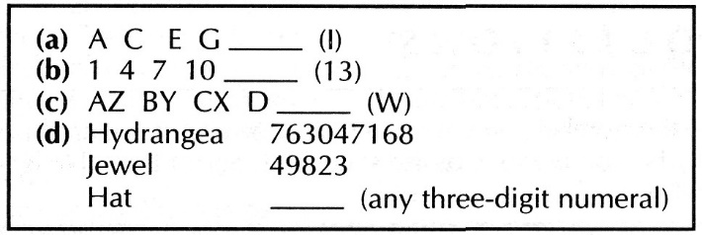

Judgment - patient's understanding of what he has done or will do in various situations.
- possible questions include: What would you do if you smelled smoke in your apartment? What would you do if you had severe chest pain while you were alone at home? What would you do if you saw a 2-year-old child playing at the end of a pier?

Insight - patient's awareness of significance of her symptoms and illness;
- if conversation with patient suggests that there may be problem with insight, patient is asked whether anything is wrong with his / her health.
- patients who lack insight (e.g. schizophrenia, bipolar disorder) may refuse treatment.

Bibliography for ch. “Diagnostics” → follow this link >>

Viktor’s Notes℠ for the Neurosurgery Resident
Please visit website at www.NeurosurgeryResident.net

