Nerve Conduction Studies
Last updated: June 3, 2019
Indications 1
Nerve Conduction Velocity 1
Axon-loss neuropathies 2
Focal conduction block 2
Demyelinating neuropathies 2
Conduction slowing 2
F-Response and H-Reflex Studies 3
Blink Reflex 4
Repetitive Nerve Stimulation 5
Normal 5
Abnormal 5

Indications
- determine functional integrity of peripheral nerves.

- among patients with true radiculopathy, most have only radicular pain and sensory symptoms, which do not have electrophysiologic correlates measurable with standard nerve conduction studies (NCS) and needle electrode examination (NEE).
- sensory nerve (SNAP) amplitude, distal latency, and nerve conduction velocity should not be affected in radiculopathy!!!! SNAP is affected only if DRG or fibers distal to it are affected:
- pathologic processes that infiltrate or extend from the intraspinal space into the neural foramen, such as malignancy, infection, or meningioma
- if DRG reside in an intraspinal location they become vulnerable to compression by disk protrusion and spondylosis; e.g. L5 radiculopathy can uncommonly be associated with loss of the superficial peroneal SNAP; however, S1 radiculopathy is almost never associated with sural SNAP amplitude loss. Although S1 DRG are even more commonly intraspinal than L5 DRG, their intraspinal location is caudal to the L5-S1 disk space where most compressive S1 radiculopathies occur.
- most valuable in the patient with motor or other focal neurologic deficits, such as muscle stretch reflex asymmetry - electrodiagnostic testing can aid in the segmental localization of the lesion, and can provide information regarding the physiology (axon loss or conduction block), age, activity, and severity of the process. Motor NCS may be insensitive in the diagnosis of motor radiculopathy for several reasons:
- most radiculopathies interrupt only a fraction of the total number of motor root fibers, whereas loss of close to 50% of motor axons in a nerve trunk is required to reliably establish a significant reduction in the compound muscle action potential (CMAP) amplitude compared with the same response on the uninvolved side.
- to identify an abnormality of CMAP amplitude in a motor radiculopathy, the muscle belly from which the CMAP is generated must be in the myotome of the injured root.
For example, a severe C8 radiculopathy is expected to produce some change in the ulnar CMAP amplitude, recording from either the abductor digiti minimi or the first dorsal interosseus. In the C5 myotome, the musculocutaneous and axillary nerve trunks can be stimulated to assess CMAPs from the biceps and deltoid muscles, respectively. However, muscles in the C6 and C7 myotomes are not spatially isolated from muscles of other myotomes, and therefore CMAPs derived from them are unreliable.

Nerve Conduction Velocity
Motor Conduction Study
- generally performed in conjunction with EMG.
- nerve is stimulated at point along its course.
  - electrical stimuli are preferred and must be of sufficient intensity to excite all fibers in nerve.
  - electrical stimulus is applied to skin directly over nerve.
* high-voltage electrical and magnetic stimulators are used to stimulate CNS pathways.
- electrical response is recorded in one of muscles supplied by nerve.
  - muscle response (normally biphasic) is recorded by surface or subcutaneous needle electrodes;
  - active electrode is placed over endplate region (muscle belly);
  - reference electrode is placed over muscle tendon.
  - recorded response is sum of electrical activity of all activated muscle fibers (within pickup region of recording electrode) - called compound muscle action potential (CMAP), or M wave.
  - stimulus intensity is increased until response no longer grows in amplitude (supramaximal stimulus), i.e. activated all nerve fibers.

Nerve is stimulated at different sites – obtained responses are compared for shape, size, and latency.
- formula to calculate conduction velocity in motor fibers:
motor conduction velocity* = distance between two stimulation sites / time difference in latencies.
*velocity is so measured only for fastest conducting fibers.
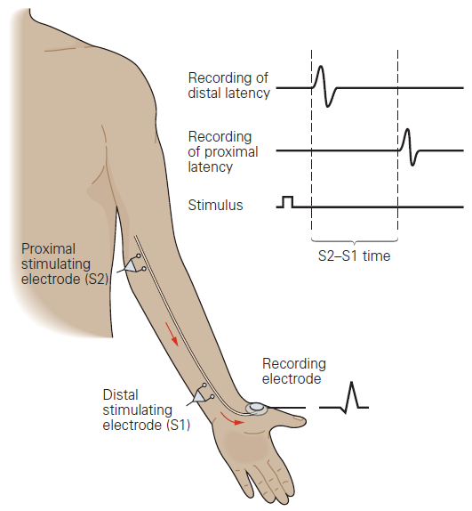

N.B. difference in latencies is used to exclude neuromuscular transmission time (i.e. if to simply use distance / latency – it would include neuromuscular transmission time).
- normal maximal motor conduction velocity:
in arms – 50-70 m/sec;
in legs – 40-60 m/sec.
nerve conduction at birth is about half of mature value achieved by 2 yr of age.
- surface recording conduction studies fail to show abnormality in slower conducting small-diameter nerve fibers; H: microneurography.

Sensory Conduction Study
- stimulating sensory nerve at one point → recording sensory nerve action potential (SNAP) (normally triphasic) at another point along course of that nerve (either orthodromically or antidromically*).
*calculated conduction velocity is same, but response is larger with antidromic stimulation.
sensory conduction velocity = distance between stimulation and recording sites / latency

Axon-loss neuropathies
Focal conduction block
- CMAP elicited by stimulating nerve proximal to block is reduced in amplitude and dispersed / completely lost compared with more distal stimulation; EMG shows denervation!!!
- sensory nerve action potentials are small / unrecordable when lesion is located between stimulation and recording sites.
- motor / sensory conduction velocities are normal (when they can be recorded) - they are determined along surviving, unaffected axons.
denervation >> conduction loss

Motor conduction block:
A. Normal. Evoked compound muscle action potential amplitude shows little change at all points of stimulation.
B. Conduction block with amplitude reduction and temporal dispersion in nerve segment between axilla and elbow.
(W = wrist; E = elbow; Ax = axilla; Erb's = Erb's point)

Demyelinating neuropathies
  - Conduction slowing!
  - Amplitudes and durations of responses:
    - all large myelinated fibers affected to same degree - amplitudes and durations of responses are unaltered.
    - different fibers affected to different degrees - dispersion of evoked action potentials → ↓amplitude of CMAP.
  - Focal conduction block (major decrease in amplitude of muscle compound action potentials on proximal stimulation of nerve, as compared to distal stimulation)
  - Marked prolongation of distal latencies.

Conduction slowing
example - myelin-loss lesions
- CMAP - size reduces as distance increases between stimulating and recording electrodes (kuo didesnis atstumas, tuo vėliau “atvyksta” impulsai lėtesnėmis skaidulomis lyginant su greičiausiomis skaidulomis → motorinės skaidulos aktyvuojamos ne vienu metu – temporal dispersion); conduction velocity↓; almost normal EMG!*
- sensory nerve action potentials - markedly attenuated / unrecordable (because of dispersion); conduction velocity↓.
*conduction slowing alone is insufficient to produce weakness or significant sensory loss, although sensory modalities requiring timed volleys of impulse transmission along their pathways, such as vibration and proprioception, can be altered.

denervation << conduction loss

Progressively more proximal stimulation resulting in dispersion of responses with conduction block:
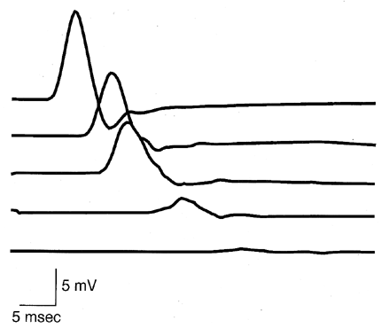

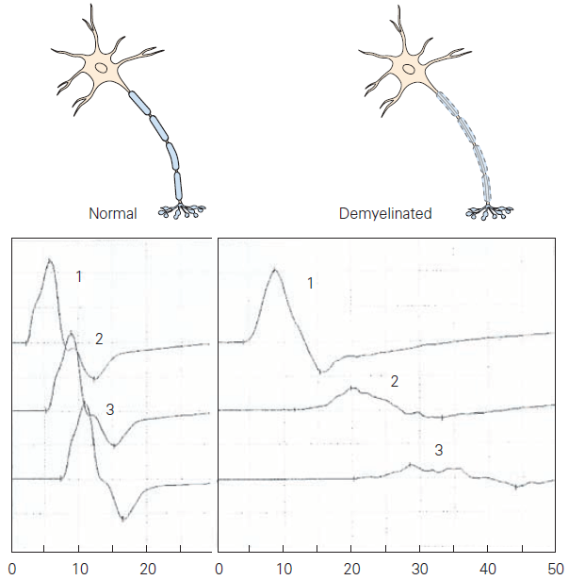

N.B. amplitude reduction may be due to:
    - conduction slowing (temporal dispersion)
    - conduction block (↓number of active fibers).
      - to differentiate two, area under negative phase is measured (loss of > 50% area indicates both temporal dispersion and conduction block are present).

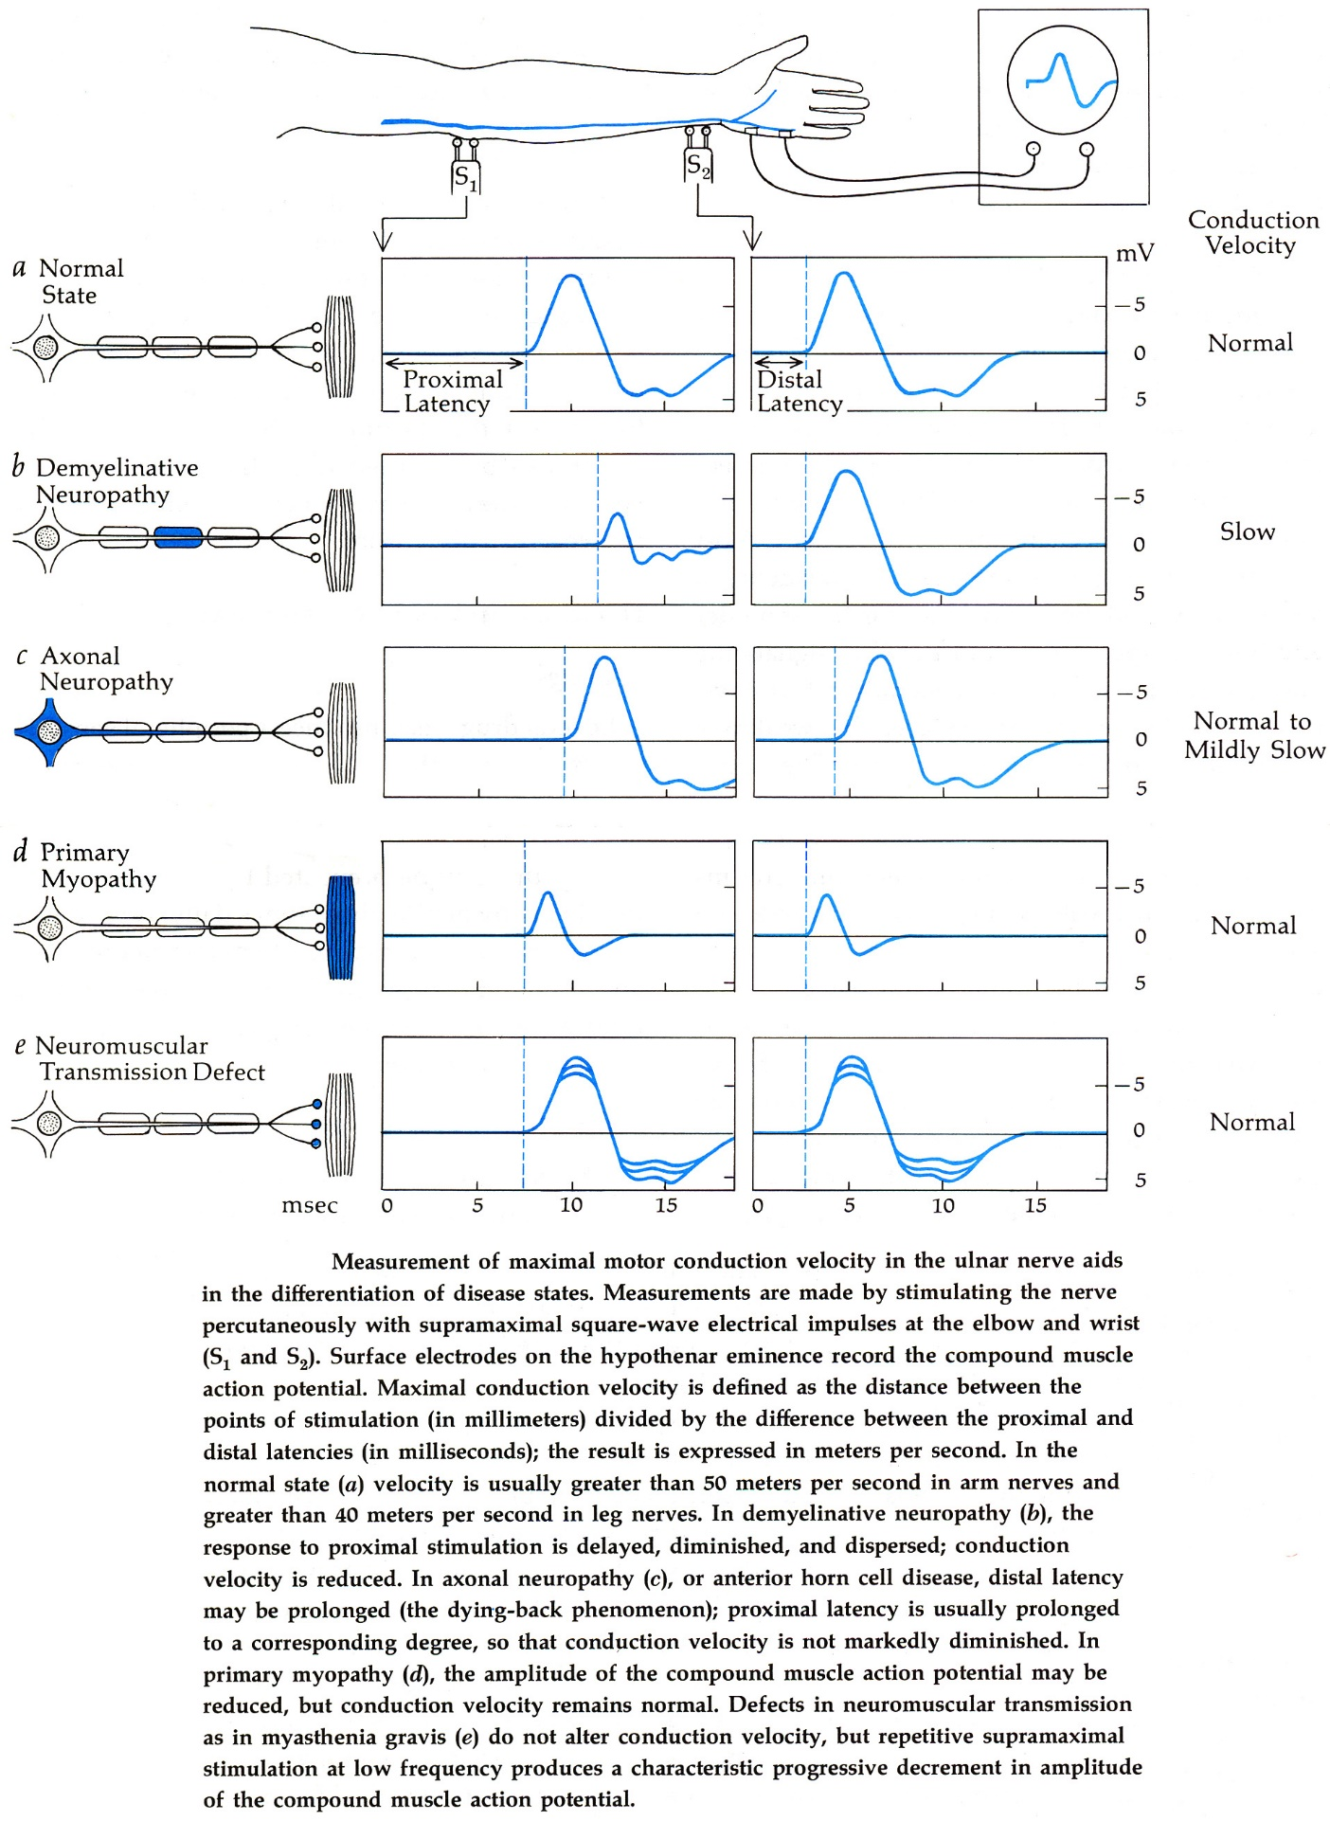

F-Response and H-Reflex Studies
- especially useful in proximal peripheral neuropathies / radiculopathies (when conventional nerve conduction studies fail to reveal abnormalities).

F response (so named because it was first observed in small foot muscles):
electrical nerve stimulation (motor fibers must be excited) → antidromic (retrograde) activation of motoneuron soma → orthograde conduction back to periphery → potential evoked from muscle (F response) – like a small echo from motor neuron that follows normal CMAP.
- stimulator is rotated 180° (cathode proximal).
- stimulus should be of greater intensity (than is required to elicit maximal CMAP); stimulus may not always elicit F response!
- F response is small (usually < 5% of CMAP)
- F response latency and amplitude vary considerably (because different anterior horn cells are activated antidromically).
- various parameters can be measured; most popular is minimum latency of ≥ 10 F responses.
- most common clinical utility - diagnosing Guillain-Barré syndrome (absent or delayed F response).

Following maximal M wave, small F response is sometimes seen:

H reflex (named after Hoffmann who first described it).
- monosynaptic reflex obtained by nerve stimulation (sensory proprioceptive fibers must be excited);
afferent pathway - spindle afferent (Ia) fibers;
efferent pathway - alpha motor axons
H reflex is similar to tendon stretch reflex*, except neuromuscular spindles are bypassed
*i.e. evaluates both sensory and motor components (vs. F response – only motor)
- H reflex occurs during submaximal stimulation, does not vary in shape, and disappears with supramaximal stimulation.
- can be recorded easily only from:
  - gastrocnemius-soleus muscle (by stimulating tibial nerve in popliteal fossa) - used in EMG laboratory to diagnose S1 radiculopathies (i.e. electrical counterpart of Achilles reflex).
  - flexor carpi radialis muscle (by stimulating median nerve).

Not easily obtained from other muscles! (except in pyramidal lesions or infants) - limited clinical utility!

    - low-intensity stimulation - H reflex is elicited from muscle.
    - stimulation intensity increases - H reflex declines and small M wave is seen.
    - higher stimulus intensity - H reflex disappears and M wave increases in size until it is maximal (then F response begins to appear).

N.B. latencies of H & F depend on subject's height, limb length!
- it is helpful to compare symmetry (normal differences in latency < 2 msec).
- prolonged H / F latencies with normal conventional nerve conduction studies suggest proximal neuropathies / radiculopathies.
- prolonged H reflex with normal F latency - dorsal root pathology.

Blink Reflex
Electrical stimulation of supraorbital nerve → trigeminal nerve → polysynaptic central pathway → facial nerve → response in orbicularis oculi muscle (recorded with surface electrodes):
R1 response - ipsilateral response with short-latency (≈ 10 msec).
R2 response - more asynchronous, bilateral response with latency of 28-30 msec.

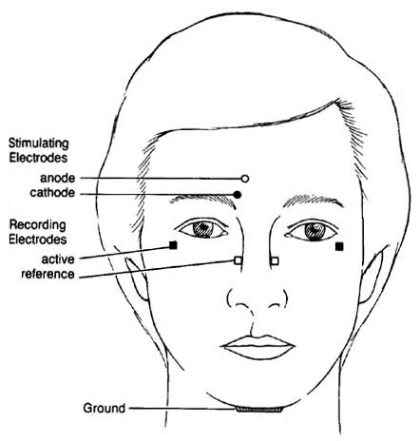

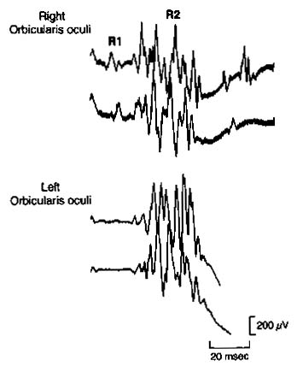

- clinical application - revealing subtle trigeminal or facial nerve lesions.
ipsilateral trigeminal lesions → lost responses or prolonged latency bilaterally.
unilateral facial lesion → delayed or absent response on affected side (regardless of which side is stimulated).

Repetitive Nerve Stimulation
- evaluation of neuromuscular transmission.
- amount of Acch released by nerve impulse (and thus size of endplate potential) is influenced by preceding activity in junctional region – i.e. amount of ACh released per impulse normally declines on repeated activity (presynaptic rundown).
  - normally of little consequence, because released Acch amount far exceeds that required to generate endplate potentials above threshold;
  - pathologic reduction in this safety factor, may alter number of muscle fibers activated by supramaximal stimulus → altered CMAP size.

Methodology:
    - application of ≥ 2 supramaximal stimuli.
    - single supramaximal stimulus applied after 30-second period of maximal voluntary activity (or tetanic stimulation).

Normal
      - no change in size of responses (at rates of stimulation up to 10 Hz).

Abnormal
- diseases with impaired neuromuscular transmission.
Postsynaptic disorders (e.g. myasthenia gravis) - progressive decrement in response size (esp. at 2-3 Hz stimulation) – due to increasing numbers of neuromuscular junctions with blocking.
- more pronounced in proximal (rather than distal) limb muscles and in facial (rather than limb) muscles.
- initial decrement may be followed (usually after 5th stimulus) by leveling off of response at reduced size.
- decrement improves immediately after 10-15 seconds of intense exercise (postactivation facilitation) – more muscle fibers are responding.
- postactivation facilitation is followed by longer-lasting period of depression, maximal between 2 and 4 min after conditioning exercise period and lasting for 10 min (postactivation exhaustion).
- miniature endplate potentials have subnormal amplitude.

Presynaptic disorders (e.g. Lambert-Eaton syndrome, botulism):
  - stimulation at slow rate → further reduction of already abnormally small response size;
  - stimulation at rapid rate → progressive increase in response size;
if faster stimulation is used [20-50 Hz], increment may be dramatic - amplitude reaches size that is several times larger than initial response.
- miniature endplate potentials have normal amplitude.

Both presynaptic and postsynaptic disorders show increased jitter on single fiber EMG.

Bibliography for ch. “Diagnostics” → follow this link >>

Viktor’s Notes℠ for the Neurosurgery Resident
Please visit website at www.NeurosurgeryResident.net

