Magnetoencephalography (MEG)
Last updated: December 22, 2020

Physics
- EEG is handicapped by high impedance of tissues through which signal must pass before being recorded.
Magnetic signals are not significantly affected by medium conductivity through which they pass!
- MEG is insensitive to conductivity variations (e.g. skull defects, vascular malformations).
- electrical currents produced by neurons create electromagnetic fields of 10⁻¹⁵ to 10⁻¹² tesla (compared with ambient magnetic field strengths of 5 x 10⁻⁵ tesla);
  - these fields are recorded by arrays of detectors [Superconducting Quantum Interference Devices (SQUIDS)] placed over scalp;
  - signals are not attenuated by bone or altered by conflicting electrical signals.
  - signal strength diminishes with square to cube of distance (e.g. signal 3 cm deep is attenuated by 80%).
- magnetic dipoles are at right angles to their electrical dipoles (electrical dipoles are oriented radially, perpendicular to cortical surface; magnetic dipoles – tangentially).
- acquired data are digitized and may be displayed similar to EEG recordings, or as graphic displays of dipole.
- using stereotactic references, magnetic spike activity may be localized in 3-D space and then onlayed over multiplanar MRI views to display anatomical location (MEG may have better potential for localizing foci from deep structures).
- improved data processing allows to focus on activity in specific region of brain (e.g. determination of sites of action of pharmacological agents, recording electromagnetic potentials from epileptic foci, evoked potentials in cortex).
- limited spatial accuracy.

MEG study of somatosensory evoked responses showing evoked spike activity in 7 x 7 cm grid reformatted in plane 5 cm lateral from midsagittal plane. Recording sites are separated 1 cm.
Numbers at top represent distances posterior and anterior to preauricular point;
numbers at right represent distance above basal plane.
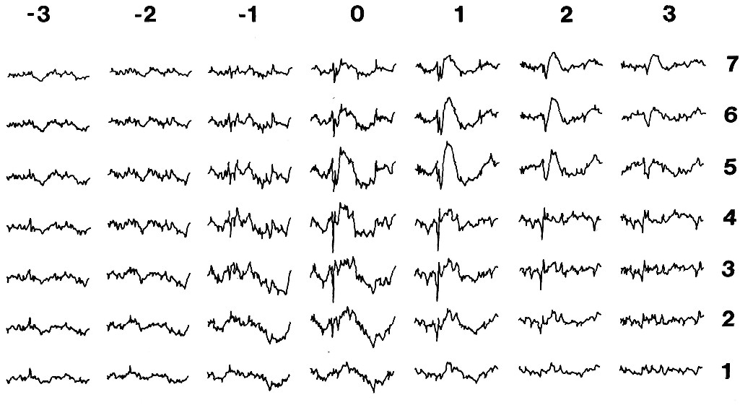

Contraindications
- pacemakers, VNS, RNS* are OK (software can filter those artefacts).
*except if RNS is on the same side as epileptogenic zone – difficulty analyzing dipoles.
- programmable VPS valves.
- metal implants in a body are OK

Procedure
- may need good sedation, e.g. clonidine – may even enhance dipole detection!

Patient instructions
Sleep deprivation: yes - to induce more epileptiform discharges.
Seizure medicines - no change necessary.

Advantages
- MEG is particularly useful in “MRI-negative” cases – re-evaluation of MRI near MEG dipole clusters may allow finding of subtle cortical abnormalities.
- 40% of patients without spikes on EEG have positive MEG!
- strongly consider MEG before every SEEG case:
Philosophically: SEEG electrode is never in the right place vs. MEG dipole always shows the true location of spike!
MEG provides nonredundant info for 1/3 of surgical candidates.
Not doing MEG is “not a benign neglect”!

Strategies
- wait a few days after MRI before MEG (MRI magnetizes tissues).
- at present, MEG role is complementary to EEG.
- negative MEG → admit to EMU, wean AEDs, and repeat MEG.

Bibliography for ch. “Diagnostics” → follow this link >>

Viktor’s Notes℠ for the Neurosurgery Resident
Please visit website at www.NeurosurgeryResident.net

