Muscle Enzymes & Serum Markers
Last updated: December 22, 2020
Muscle Biopsy 1
Muscle Selection 1
Technique 1
Open Biopsy 1
Needle Biopsy 2
Diagnostic Staining Methods 2
Normal findings 2
Atrophy 2
Cytoarchitectural Abnormalities 3
Differentiating MYOPATHIC and NEUROpathic changes 4
Neuropathic Processes 4
Myopathic Processes 5
Serum Markers 6
Urinary Markers 6

Muscle Biopsy
If patient is free of muscle weakness, muscle biopsy is unlikely to show any significant changes!

Muscle Selection
Myopathic processes do not affect all skeletal muscles equally! → risk of sampling error
- degree of muscle involvement
  - avoid clinically unaffected muscle (may not be involved pathologically).
  - avoid severely affected muscle (may only show endstage features - atrophy, fat, fibrosis).
Muscles that are moderately weak should undergo biopsy
- use Medical Research Council (MRC) strength grading and/or electrodiagnostic testing.
- best is muscle with MRC grade 4/5 strength vs. muscle with MRC grade 3/5 strength is often too severely affected, with extensive non-specific end-stage changes (up to lack of muscle fibers).

- rapidity of onset of disease process
  - slowly progressive disorder - use moderately affected muscle.
  - acute disorder – use more severely affected muscle.

- muscle's history - chosen muscle should neither be involved with another disease process (e.g. neuropathy) nor have suffered recent (i.e. within 1 month) injection or needle EMG.
needle electrode examination should be performed on only one side of body (and this should be clearly labeled in chart!) - homologous muscle in contralateral extremity is sampled.

- pathological familiarity of muscle

- accessibility of muscle

- EMG findings.

- MRI findings.

MRI of the lower limbs in the case of a toxic myopathy. T2 images show asymmetric involvement affecting only the left lower limb. Had a muscle biopsy been taken from the right gastrocnemius, the pathologic tissue would have been missed.
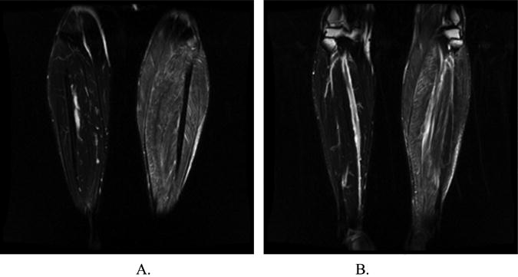

Most frequently biopsied muscles:
lower extremity - quadriceps (e.g. vastus lateralis), tibialis anterior; avoid gastrocnemius (type 1 muscle fiber predominance, greater susceptibility to random pathological changes, pennate nature*); peroneus brevis, located in close proximity to the superficial peroneal nerve, is a favored biopsy site when a nerve biopsy is also indicated.
*inadvertent sampling near myotendinous junction can occur (tends to have more central nucleation, muscle fiber size variability, and split muscle fibers); however, gastrocnemius and tibialis anterior muscles are appropriate choices in diseases with distal limb signs and symptoms
upper extremity - deltoid and biceps brachii; deltoid muscle normally has 60-80% predominance of type 1 fibers.

N.B. pathologist will need to be informed about biopsy site - muscles vary in their normal ratio of type I to type II fibers making this information necessary

Technique
Open Biopsy
- carefully avoid muscle infiltration during local anesthesia.
- small incision in belly region (i.e. away from myotendinous junction) along long axis of muscle; incision is extended only to fascia.
- quadriceps has a thick fascia.
- sectioned fascia should be sutured to prevent muscle herniation - chronic nuisance for the patient.
- site is wrapped with an elastic wrap, a light pressure for a few hours.
- no follow-up visits after the muscle biopsy are normally necessary.

Specimens
Fixed specimens should be shipped separately from frozen specimens!
include: patient's name, sampled muscle, procurement time, brief note (detailing clinical presentation and workup findings to date + list of pending studies).

- Unclamped specimen for histochemistry (most important piece)
  - 2-3 cm in length; about as round as pencil.
  - handle gently by its ends using tweezers.
  - place in cool, normal saline-moistened piece of gauze to prevent drying out (soaked gauze may interfere with freezing and produce artifacts).
  - gauze-wrapped specimen is placed in screw-cap vial.
  - transported rapidly to pathology laboratory (otherwise it may lose enzymatic activity) → freezing by immersion in liquid nitrogen-cooled isopentane → immediately placed in previously cooled specimen container → sent to outside reference laboratory.

- Clamped specimen for electron microscopy
  - can be slightly smaller.
  - gently raised (e.g. with Metzenbaum scissors) just high enough to permit placement of muscle clamp.
  - clamp is locked → muscle specimen cut just outside clamped sites.
Clamping helps avoid contraction artifact.
  - alternative - suturing muscle tissue specimen (e.g. with 3-0 silk) to piece of tongue depressor before excising it (i.e. it is sutured in situ).
  - once removed, specimen is placed in 4% buffered glutaraldehyde (or Karnovsky fixative) → embedded in plastic for electron microscopy.
N.B. EM is important in only certain diseases - congenital myopathies, mitochondrial disorders.

- Clamped specimen for histopathology - similar to specimen for electron microscopy, with exception that it is fixed in formalin → embedded in paraffin for light microscopy.

- Fourth specimen is frozen in event further studies are deemed necessary.

When specialized studies are planned (e.g. mitochondrial DNA studies), larger tissue specimens may be necessary!

Needle Biopsy
Advantages of open biopsies - larger specimen can be obtained, specimen can be fixed at its in situ length (preventing contraction artifact).
Advantages of needle biopsy - limited scarring, ability to sample multiple sites (in either same or different muscles) in single session.
Disadvantages of needle biopsy - smaller specimen size, greater orientation difficulty.

Diagnostic Staining Methods
STAINS
Hematoxylin & eosin (H & E) | Hematoxylin: nuclei, cross-striations (purple)  Eosin: cytoplasm (red), connective tissue (darker red)
 | general morphology
Modified Gomori trichrome | Nuclei, mitochondria, T-tubules, sarcoplasmic reticulum (red); myocytes (blue-green)
 | identifying ragged-red fibers.
Periodic acid-Schiff (PAS) | Glycogen (purple; type 1 > 2; glycogen storage disorders)
Oil red O | Lipid (orange; type 1 > 2; lipid storage disorders)
Sulfonated Alcian blue | stains amyloid ("sea foam" green), mast cells (red).
Alkaline Congo red | stains amyloid (red; apple green birefringence under polarized light).
REACTIONS
NADH-TR (NAD dehydrogenase-tetrazolium reductase) | oxidative enzyme - reflects concentration of mitochondria; also T-tubules, sarcoplasmic reticulum - sarcoplasm appears granular.
Type 1 (dark); type 2A (intermediate); type 2B (light)
N.B. atrophied type 2 fibers appear darker!
Succinate dehydrogenase | Krebs' cycle enzyme - selective stain for mitochondria; tubular elements are not highlighted.
Cytochrome-c oxidase | respiratory chain enzyme (orange-brown; type 1 > 2) - selective stain for mitochondria; tubular elements are not highlighted.
Myofibrillar ATPase | - most accurate method of muscle fiber typing:
ATPase (at pH 4.3)  ATPase (at pH 4.6)  ATPase (at pH 9.4) | type 1 (dark); type 2A, B (light); type 2C (intermediate)  type 1 (dark); type 2A (light); type 2B, C (intermediate)  type 1 (light); type 2 (dark)
Acid phosphatase | lysosomal enzyme - degeneration (stains red; background fir green), inflammatory cells, lysosomal storage disorders
Alkaline phosphatase | regeneration (stains black; background yellow)
Nonspecific esterase | acetylcholinesterase (yellow-red; type 1 >2) - endplates, lysosomes, macrophages, recently (i.e. within 6 months) denervated muscle fibers (appear smaller and darker).
Immunologic techniques | stain proteins that are deficient in some muscular dystrophies.

Normal findings
- cross section - muscle fibers appear polygonal and their diameters vary (within given section, they are somewhat uniform).
- intermyofibrillar pattern (best demonstrated with reactions for oxidative enzymes) should appear uniform.
- muscle fibers of different motor units are interspersed - normal muscle shows checkerboard pattern of light and dark fibers.

Atrophy
  - Denervation atrophy:
    - decrease in cell size (down-regulation of myosin and actin synthesis, resorption of myofibrils), but cells remain viable.
    - atrophic fibers in cross-section have roughly triangular shape ("angulated").
    - some fibers develop cytoskeletal reorganization - rounded zone of disorganized filaments ("target fiber").
    - while Acch receptors are normally located in center of length of muscle fibers, after denervation, fibers develop supersensitivity throughout their course.
    - during reinnervation, checkerboard pattern of type 1 and type 2 fibers is altered - fibers of same staining type are grouped (due to collateral sprout-related reinnervation); adjacent atrophied myocytes are of same fiber type ("fiber type grouping").
    - with reinnervation, motor fibers reform neuromuscular junctions at original end plates.
    - if fibers are not reinnervated within ≈ 20 months, they will be replaced by connective tissue.
  - Disuse atrophy - checkerboard arrangement is maintained; mostly affected are type 2 fibers.

Preferential atrophy:
Type 1 fibers: myotonic dystrophy (prominent), nemaline myopathy, centronuclear myopathy, congenital fiber type disproportion.
Type 2 (especially 2B) fibers: disuse, corticosteroid excess (exogenous, endogenous).

Perifascicular atrophy (fibers near edges of fascicle are atrophied) - hallmark of dermatomyositis.
Panfascicular atrophy - indicative of Werdnig-Hoffmann disease (spinal muscular atrophy type I).

Typical "grouped atrophy" with denervation:
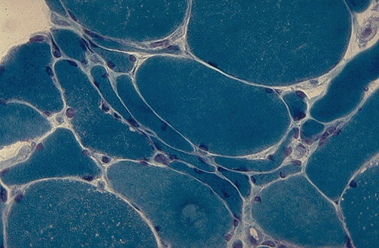
Source of picture: “WebPath - The Internet Pathology Laboratory for Medical Education” (by Edward C. Klatt, MD) >>

Cytoarchitectural Abnormalities
Preferential involvement:
Type 1 fibers: target fibers, central cores (central core disease), rod bodies (nemaline myopathy), mitochondrial abnormalities.
Type 2 fibers: tubular aggregates.

Target fibers (cardinal feature of neurogenic disorders)
  - predominant among type 1 fibers.
  - composed of three "rings":
    - central light-staining ring
    - intermediate dark-staining ring
    - peripheral normal-staining ring.

Central cores (central core disease)
  - only in type 1 fibers, which usually predominate.
  - central core - amorphous area in center* of fiber – devoid of enzymatic activity, lacks myofibrils and mitochondria - does not stain for NADH-TR, glycogen, but sometimes stains with ATPase; stains blue with Gomori trichrome stain.
*surrounded by normally staining periphery.
  - central cores resemble target fibers, but cores run whole length of fiber.

Rod bodies (nemaline myopathy - numerous subsarcolemmal rod bodies in many muscle fibers; small numbers of rod bodies may be found in muscular dystrophy, polymyositis, HIV-related myopathy, muscle injured by tenotomy).
  - spindle-shaped threadlike appearance (Gr. nema – thread).
  - predominantly, but not exclusively, in type 1 fibers.
  - reddish purple in modified Gomori trichrome stain; difficult to demonstrate with conventional H&E stain.
  - electron microscopy shows that rods represent abnormal deposition of Z-band material (α-actinin).
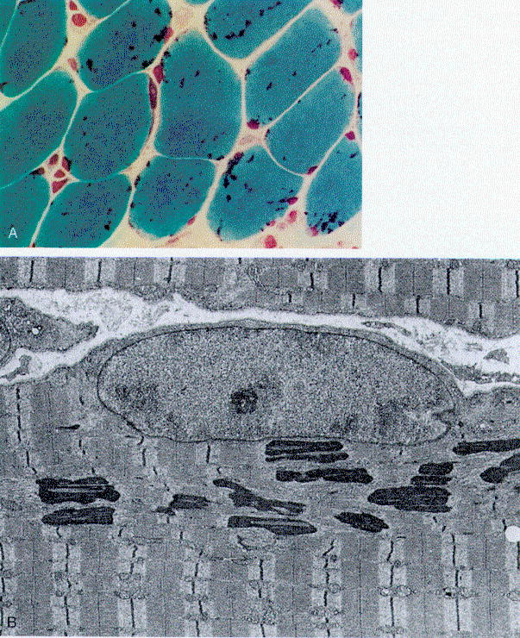

Ragged-red fibers (mitochondrial myopathies)
- subsarcolemmal* collections of mitochondria (enlarged, bizarrely shaped, with paracrystalline “parking-lot” inclusions).
*with severe involvement, may extend throughout fiber.
- mitochondria distort muscle fiber contour (irregular on cross-section – “ragged”).
- stain red with modified Gomori trichrome stain.

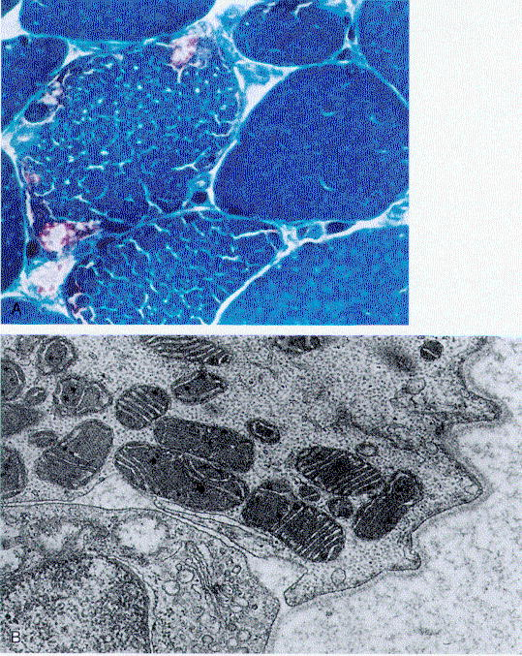

Tubular aggregates (frequently seen with hyperkalemic periodic paralysis) - faintly basophilic deposits in both interior and periphery of muscle fibers.
  - sarcoplasmic reticulum-derived collections.
  - ultrastructure - fascicular arrays of parallel double-walled 60-90 nm tubules with hexagonal array in transverse section.
  - stain red with modified Gomori trichrome stain.
  - demonstrated with NADH-TR but not highlighted by succinate dehydrogenase (vs. mitochondrial aggregates)!

Rimmed vacuoles (inclusion body myopathy, oculopharyngeal muscular dystrophy, distal myopathy, denervation)
- blue margins with H&E; red margins with modified Gomori trichrome stain.

Differentiating MYOPATHIC and NEUROpathic changes
Neuropathic Processes
Most typical attribute is atrophy!
- small angulated (in cross section) fibers - may be earliest sign!
  - not selective for fiber types, scattered throughout specimen.
  - denervated fibers appear darker (e.g. nonspecific esterase).
- fiber type grouping (sine qua non of reinnervation) - enlarging groups of contiguous fibers of same type due to collateral sprouting reinnervation → diminished normal checkerboard staining pattern.
  - must be distinguished from fiber type predominance.
- grouped atrophy (hallmark of chronic denervation) - atrophy of these reinnervation groups.
  - extreme version of grouped atrophy is panfascicular atrophy (in Werdnig-Hoffmann disease).
- target fibers
- nuclear bags
- minimal interstitial fibrosis.

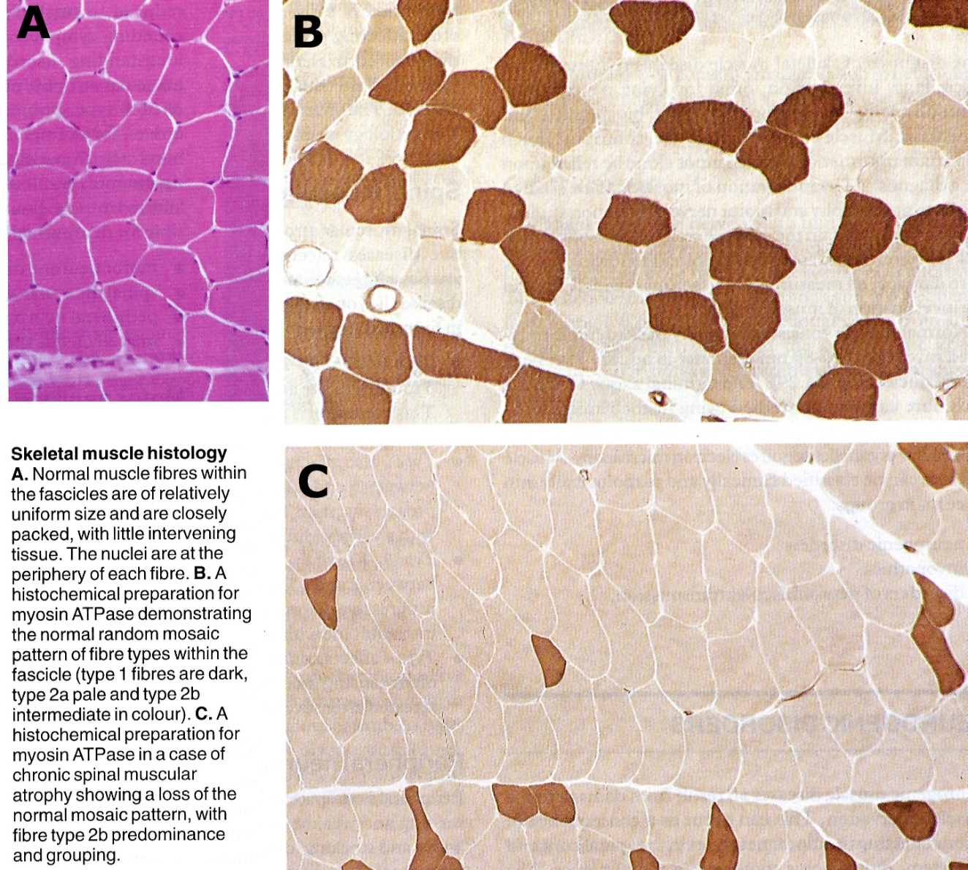

ATPase histochemical staining, at pH 9.4:
A. normal muscle showing checkerboard distribution of intermingled type 1 (light) and type 2 (dark) fibers.
B. muscle reinnervation - fibers of either histochemical type are grouped together.
C. group atrophy - cluster of atrophic fibers in center.
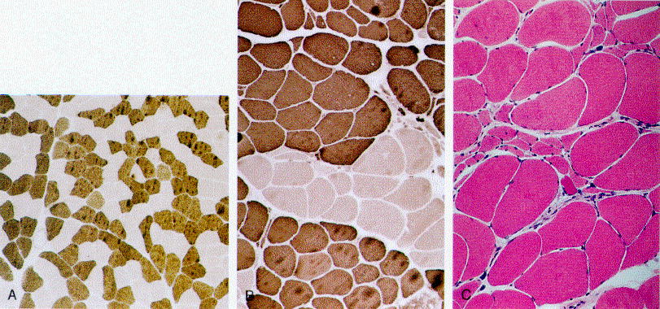

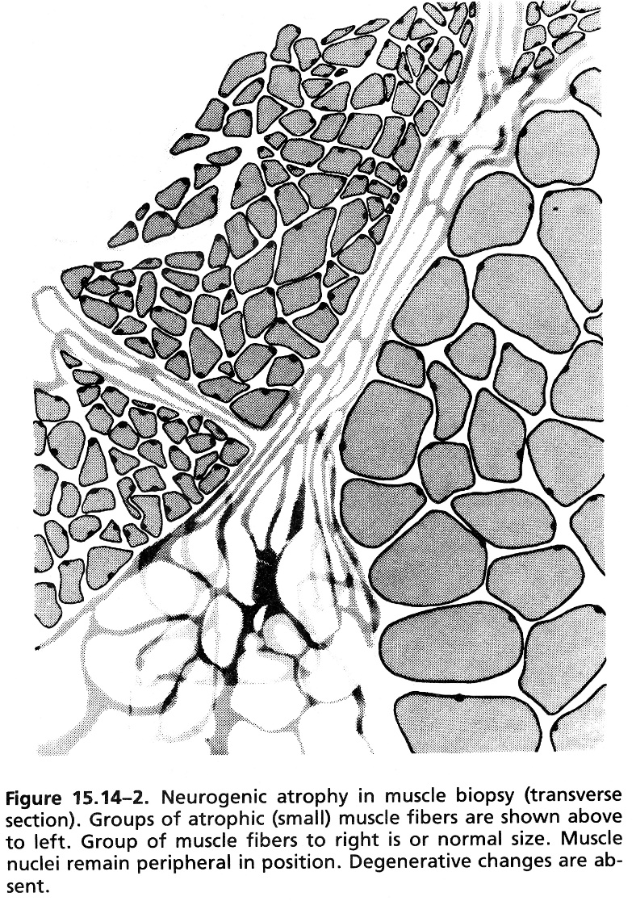 | 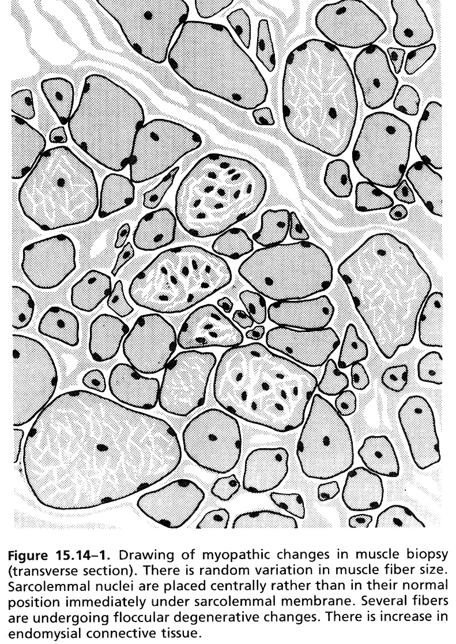
see p. A46 (5a) >>

Myopathic Processes
- random fiber loss (vs. loss of whole motor unit territories).
- if portion of muscle fiber is degenerated (segmental necrosis), muscle fiber functions as two separate fibers - portion with motor endplate (i.e. innervated fiber) and portion without it (i.e. denervated fiber).
- precursor (satellite) cells can regenerate destroyed portion.
- denervated portion can be adopted by collateral sprouting → small foci of fiber type grouping
N.B. small patches of fiber type grouping should not be considered synonymous with neuropathic process!
- not reinnervated fibers undergo degeneration → extensive collagen deposition and fatty infiltration.
- central nucleation - centrally located nuclei (normally observed in < 3% normal muscle fibers).
- especially prominent in myotonic dystrophy.
- single (para)central nucleus in every myocyte - centronuclear myopathy.
- rounded fibers
- fiber size variability - combination of atrophy and hypertrophy.
- fiber necrosis (degeneration)
- cellular infiltration with myophagocytosis
- perivascular collections - collagen vascular disorder, dermatomyositis
- most pronounced intracellularly - facioscapulohumeral dystrophy.
- fiber regeneration - basophilic sarcoplasm (rich RNA content), large internalized nuclei with prominent nucleoli.
- fiber splitting (normally occurs near myotendinous junctions - muscle biopsies from this region may appear myopathic!) - large fibers divide along segment so that, in cross-section, single large fiber contains cell membrane traversing its diameter, often with adjacent nuclei.
- various structural changes (e.g. rod bodies, central cores, ragged-red fibers, vacuoles).
- microorganisms (e.g. toxoplasmosis, trichinosis).

Active myopathic process - muscle fiber necrosis, basophilia, myophagocytosis.
Chronic myopathy - muscle fiber splitting and fibrosis.

Serum Markers
Many diseases of motor unit may not cause elevated enzymes!
Creatine phosphokinase (CPK or CK)
- lysosomal enzyme released by damaged / degenerating muscle fibers.
- found in only three organs – different isozymes:
MM for skeletal muscle
MB for cardiac muscle
BB for brain.
N.B. in differential diagnosis, isoenzyme study is not helpful - appearance of "cardiac isoenzyme" MB does not necessarily implicate heart when there is limb weakness!
- normal maximum is 50 units.
- characteristically elevated in certain diseases and magnitude of CK increase is characteristic for particular diseases:
- very high levels (at least 20 times normal) – dystrophinopathies; attacks of myoglobinuria.
- high levels - interictal phosphorylase deficiency or acid maltase deficiency; men with nonvacuolar form distal myopathy, dermatomyositis, polymyositis,
- some spinal muscular atrophies (esp. Werdnig-Hoffmann disease, Kugelberg-Welander syndrome, ALS) – usually < 500 U.
- normal people:
  - idiopathic hyperCKemia, some African individuals
  - for days after strenuous voluntary exercise!
  - generalized motor seizure or tetany
  - minor muscle trauma (e.g. EMG).

Other sarcoplasmic enzymes (AST or SGOT, ALT or SGPT, LDH) – increased in myogenic disorders together with CK, but less sensitive than CK.

Elevated AST and ALT → differentiate between:
hepatic disease → liver-specific enzyme GGT
muscle disease → muscle-specific enzyme CK

Creatinine↓ - useful indicator of diseased muscle mass.

Serum myoglobin has same diagnostic significance as serum CK.

Urinary Markers
3-methyl His - quantitative measurement of muscle breakdown.
- some of His residues of actomyosin complex are methylated after their incorporation.

Quantitative creatinine excretion – index of muscle mass.
- requires meat-free diet.
- must be done over period of ≥ 72 hours.

Bibliography for ch. “Diagnostics” → follow this link >>

Viktor’s Notes℠ for the Neurosurgery Resident
Please visit website at www.NeurosurgeryResident.net

