Brain Biopsy
Last updated: June 3, 2019
Tissue processing techniques 1
Findings 2
Inclusions, Bodies 2
Surgical technique, perioperative care – see p. Op310 >>

Tissue processing techniques
Evaluation | Technique | Fixative | Staining
Cytological | Imprint/touch | Alcohol | Rapid H & E,  Diff-Quik Papanicolaou
 | Smear/squash
Routine histological | Frozen section | Alcohol | Rapid H & E,  metachrome B, special staining
 | Paraffin section | Formalin, B5
Special histological: histochemistry, immunohistochemistry | Frozen section | None | Enzymes, biochemical reactions
 | Frozen or paraffin | Variable | Mono- or poly-clonal antibodies
Electron microscopy | Thick section | Glutaraldehyde/OsO₄ | Toluidine blue
 | Thin section |  | Lead citrate/uranyl acetate
Frozen sections:
    - may provide specific diagnosis in some cases (but in many situations definitive diagnosis can be made only after evaluation of all tissue specimens and with adjunctive studies).
    - sometimes used to guide resection of mass lesion.

Ancillary studies:
      - microbiology (e.g. bacterial, viral, fungal cultures)
      - cytogenetics (e.g. karyotype analysis)
      - molecular genetics (e.g. PCR)
      - biochemical analyses.

Findings
Inclusions, Bodies

eosinophilic
basophilic
electron microscopy

Disease | Inclusion name | Photo | Location (in cell) | Cells affected | Contents
Parkinson disease  see p. Mov10 >> | Lewy bodies | 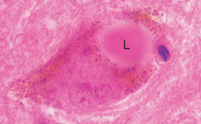 | cytoplasm | neurons | neurofilament, tubulin, α-synuclein and ubiquitin
Pick disease (frontotemporal dementia) see p. S11 >> | Pick bodies | 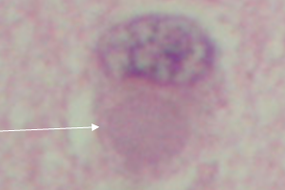 | cytoplasm | neurons
Alzheimer disease  see p. S11 >> | Neurofibrillary tangles | 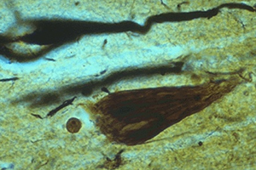 | cytoplasm | neurons | tau protein
Normal aging, neurodegenerative disorders (Alzheimer's disease, Pick disease, Creutzfeldt-Jakob disease) | Hirano bodies | 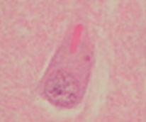 | cytoplasm | neurons | actin and actin-related proteins; no ubiquitin!
Normal aging, neurodegenerative disorders (Alzheimer's disease) | Simchowicz bodies (granulovacuolar degeneration) | 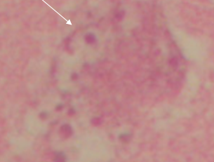  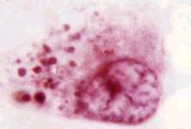 | cytoplasm |  | unknown composition
ALS  see p. Spin21 >> | Bunina bodies | 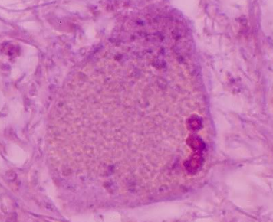 | cytoplasm | neurons | unknown composition
Familial myoclonic epilepsy | Lafora bodies | 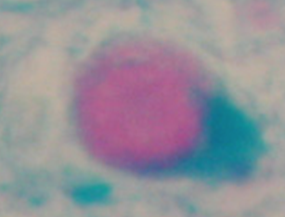 | cytoplasm | neurons
Senile degenerative process | Corpora amylacea | H&E: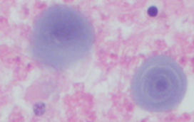  PAS: 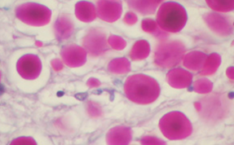
Age-associated degen. changes in substantia nigra | Marinesco bodies | 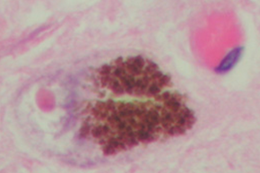 | cytoplasm | neurons | ubiquitin?
Meningioma | Psammoma bodies | 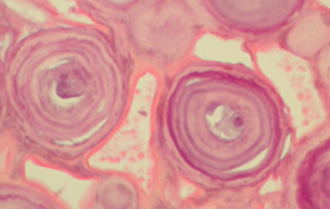
Schwannoma | Verocay body | 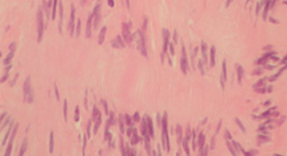 | extracellular
Neuronal ceroid lipofuscinosis (s. cerebral sphingolipidosis) | Fingerprint bodies | 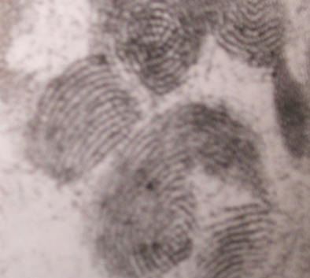
Lysosomal storage disorder, mucopolysaccharidoses I, II and III | Zebra bodies | 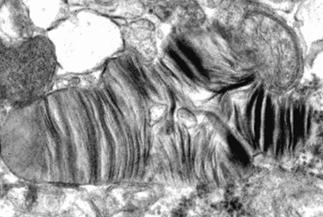
HSV, VZV | Cowdry type A | 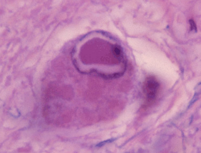 | nucleus | neurons and glia
CMV | “owl-eyes” | 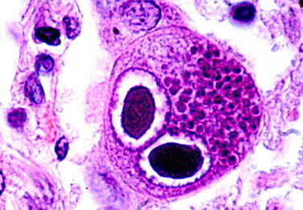
Rabies  see p. 262 (2a) >> | Negri bodies | 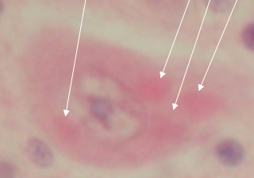 | cytoplasm | neurons
Neurosecretory granules in dilated | Herring bodies | 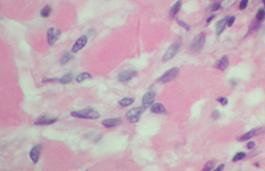 | terminal axons of neurohypophysis | neurons
Artifact of formalin fixation | Buscaino bodies | 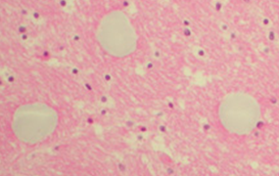

Bibliography for “Brain Biopsy” → follow this link >>

Viktor’s Notes℠ for the Neurosurgery Resident
Please visit website at www.NeurosurgeryResident.net

