MRI
Last updated: August 25, 2019
Advantages of MRI 1
Disadvantages of MRI 2
Basics 2
Physics 3
Different substances on MRI 5
MRI signal relative to gray matter with T1 – T2 differences 5
Hemorrhage on MRI 5
Contraindications 7
Contrast enhancement 8
Contrast medium 8
Adverse reactions 8
Contrast for hemodialysis patients 9
Standard MRI set 9
Pituitary gland 10
MRI modifications 10
Echo Planar Imaging (EPI) 10
Spin Density–Weighted Imaging 10
Gradient Echo Imaging 10
Fluid-Attenuated Inversion Recovery (FLAIR) 10
Short TI Inversion Recovery (STIR) 11
Fast Spin Echo (FSE) 11
CISS (Constructive Interference Steady State, s. MR cisternography) 12
FIESTA (Fast Imaging Employing Steady State Acquisition) 12
Pregnancy concerns 12
Harm to fetus 12
Gadolinium-based contrast 12
Useful Websites 13
Diffusion-weighted MRI (DW-MRI), Apparent Diffusion Coefficient (ADC) – see p. Vas3 >>
Perfusion-weighted MRI (PW-MRI) – see p. Vas3 >>
MRA – see p. D64 >>
fMRI – see p. D66 >>

MRI - most powerful imaging tool available - primary imaging technique to diagnose diseases of brain and spine!
- Gorter (1936) - concept of nuclear magnetic resonance (NMR).
- Damadian (1972) - first whole-body NMR for medical diagnosis.
- came into widespread clinical usage in 1980s.
- term MRI is now used rather than NMR to allay patient anxiety about test that has word “nuclear” in it.

Advantages of MRI
- Noninvasive
- No radiation
- Multiplanar (MRI data can be acquired in any plane in primary fashion, i.e. no need for computer-assisted reformatting or patient movement).
- Extremely sensitive, very high resolution, no artifact from neighboring bony structures
MRI is test of choice for posterior fossa and spinal canal!
- Safe contrast agent

Disadvantages of MRI
- Not as sensitive (as CT) for hemorrhage and calcification.
- Need cooperative patient because it is time consuming and patient movement during sequence will distort all images (therefore, in routine applications, MR images are acquired at resolutions similar to or lower than those of CT)
  - imaging of stroke takes ≈ 15 seconds with CT, but ≈ 30 minutes with MRI.
- MR is not as good near air-filled structures, or near metallic implants.
  - when highly accurate spatial information is required to plan treatment (e.g. stereotactic radiosurgery), MRI is often supplemented with CT!
Major advantage of MR over CT - high contrast between differing tissues, not spatial resolution
- Incompatibility
  - patients on monitors or ventilators must be converted to nonmagnetic, MR-compatible equivalents before they can enter magnet room.
  - medical implants may be inactivated or damaged, devices may malfunction (e.g. some pacemakers will react to MR pulse sequences by driving pacing at unacceptable rates).
  - design of MR magnets (long, relatively narrow bores) makes it difficult to monitor critically ill patients.
  - some large patients do not fit into magnet.
  - claustrophobic patients (≈ 5% of population) find restricted vision and movement intolerable;
H: mild oral sedation (1 hour before MRI); alternative - unit with open design magnet, strategies to reduce acquisition time; IV sedation while patient is inside magnet tunnel is not recommended!
- Interpretation of MR image is often complex and difficult (compared with CT scan).

MRI is not initial study of choice for: (noncontrast CT is better)
- SAH
- Calcifications
- Bony cortical abnormalities (fractures, etc); vs. MRI is extremely useful for bone marrow diseases!!!
- Acute head / facial trauma
- Temporal bone problems
- Immediate postoperative craniotomy patient

Basics
Unlike CT, MRI signal intensity does not have single simple interpretation – MRI signal intensity is determined by:
- Proton density (reflection of “water concentration”)
- Longitudinal relaxation rate (T1)
- Transverse relaxation rate (T2)
- Diffusion coefficient
- Magnetization transfer ratio
- Homogeneity of magnetic susceptibility
- Complex functions of tissue motion.

- because many brain structures have identical electron densities but differ on many MR parameters, MR can resolve anatomic structures that are invisible on CT!

Why hydrogen?
Many nuclei bear magnetic moment. Those relevant to biology include phosphorus 31, carbon 13, and sodium 23. However, all MRI systems use resonance of hydrogen nucleus for three reasons. First is ease of detection of MR signal. The hydrogen nucleus has largest magnetic moment of any nucleus and is therefore most detectable. Second is natural abundance of hydrogen—99.99% for 1H. By contrast, abundance of 13C is 1.1% (98% of carbon is 12C, which has no magnetic moment). Third, hydrogen is contained in water, which is in high concentration in body; in brain, concentration of water is approximately 67% by weight.

Stronger magnet – better signal!
Illustration of nuclear spins in the magnetic field B0. The net alignment of spins is along B0. This is the source of M0, or longitudinal magnetization. In reality, the net aligned versus unaligned fraction is about 1 in 100,000 in a 1.5-T field at body temperature.
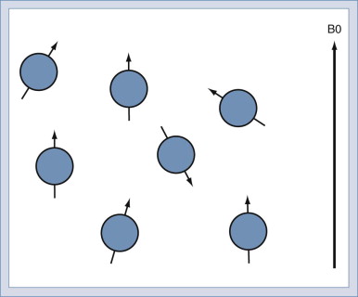

MRI scan user has choice of pulse sequence parameters such as echo time (TE) and repetition time (TR). Maximal contrast between structures of interest may be achieved by appropriate choice of sequence parameters. Conversely, inappropriate choices may result in failure to detect lesion.

By adjusting TE and TR times, proton density–, T1-, or T2-weighted images can be selected:

Weighting of Magnetic Resonance Images:
 | Short TE | Long TE
Short TR | T1 weighted | Mixed contrast—do not use
Long TR | Proton density weighted | T2 weighted
TE, echo time; TR, repetition time.

Physics
Nuclei of certain atoms, particularly hydrogen, respond to a strong magnetic field by aligning with or against the longitudinal axis of that magnetic field. This process is called magnetization. The number of hydrogen atoms aligned in the direction of the magnetic field is slightly greater than the number aligned against it, producing a net magnetization in the direction of the magnetic field. The magnitude of this net magnetization is related to the number of hydrogen nuclei in each volume of tissue (proton density). The direction of the net magnetization may be altered by the addition of energy in the form of a radiofrequency (RF) pulse of appropriate frequency. This extra energy flips the magnetization vector away from its alignment with the primary magnetic field.
When the RF pulse is terminated, the hydrogen protons will begin to realign in the direction of the external magnetic field, releasing the excess energy initially used to deflect them from alignment. The rate at which this realignment occurs depends on the rate that the added energy is released to the surrounding environment. This process is called longitudinal relaxation. The time required for 63 percent of the magnetization vector to return to alignment with the external magnetic field is designated T1, or longitudinal relaxation time.
A second component of relaxation occurs in the transverse plane around the axis of the magnetic field. The magnetization vector in the transverse plane is the sum of many nuclei rotating at slightly different frequencies, which are forced together by the application of the external RF pulse (coherence). The net magnitude of the transverse vector and its signal strength diminishes as the nuclei fan out within the transverse plane (loose coherence). The time required for 63 percent loss of the transverse coherence is designated T2, or transverse relaxation time.
The excess energy released by the protons as they realign with the magnetic field is radiated to the environment as a radio frequency "signal." The amount of signal (signal intensity) emitted per unit of volume will be correlated to a gray scale, where high signal intensity will be white and absence of signal will be black.

NMR is science that forms basis for MRI. Abundant water molecules within human body contain protons that act as microscopic magnets. When human body is placed into static main magnetic field, approximately 50 percent of magnets align parallel to this main magnetic field. The remainder align in antiparallel fashion. These magnets cancel each other out, although approximately one in million bar magnets is not canceled out and creates basis of tiny magnetic net vector. These microscopic magnets form basis of intrinsic signal that is used to generate clinical images. These net magnetic vectors align with axis of main magnet and rotate at specific frequency known as Larmor frequency. A second type of magnetic field known as gradient fields is used to augment main magnetic field and allow for anatomical localization of specific spinning protons. Finally, there is third type of magnetic field known as resonance frequency field referred to as radiofrequency (RF) pulse. This RF pulse is very low amplitude that oscillates near Larmor frequency that is 63.87 MHz for 1.5-Tesla (T) MR image. When RF pulse is applied, spinning protons become excited and flip their orientation to predetermined flip angle, which is usually 90 degrees for spin-echo technique. When RF field is turned off, these excited spinning protons convert to relaxed state, releasing energy. This energy can be measured with head, body, or surface coils and forms basis for image formation.
The intrinsic high tissue contrast medium for MRI is one of major strengths of this modality. Whereas CT uses differences in x-ray attenuation coefficients of two adjacent tissues, MR signal is intrinsic and is generated by changing proton spins in response to external RF pulse. The different macromolecular characteristics of intercellular and extracellular protons within water molecules determines intrinsic MR signal that is displayed for diagnostic interpretation. The macromolecular spin magnetization returns to its equilibrium state through process defined by two relatively independent relaxation times, referred to as T1 and T2.
After 90-degree RF pulse proton magnetization net vector rotates from axis of main magnet (z axis, longitudinal magnetization) to transverse plane (x and y axes, transverse magnetization). When RF pulse ends, longitudinal magnetization recovers toward 100 percent in exponential manner. The time it takes for proton to recover 63 percent of its longitudinal magnetization is referred to as T1 or spin-lattice relaxation. In similar fashion, when RF pulse ends, transverse magnetization is 100 percent and decays toward zero. The time it takes proton to lose 63 percent of its transverse magnetization is termed T2 or spin-spin relaxation time. The energy signal formed during this decay process is referred to as free induction decay (FID). This signal is intrinsically weak. It is enhanced by addition of second 180-degree RF pulse, which follows first 90-degree RF pulse. This second RF pulse refocuses protons and creates spin-echo signal. The time from 90-degree pulse to spin-echo signal is termed TE. This process is repeated, and repetition time between 90-degree pulses is called TR.
Images can be created that have relative T1 weighting (T1WI) or T2 weighting (T2WI) by varying TR and TE. A T1WI has TR less than 1000 msec and TE less than 50 msec. A T2WI has TR greater than 2000 msec and TE greater than 60 msec. An intermediate so-called proton density weighing has TR greater than 2000 msec and TE less than 40 msec.

Short-TR/TE sequence = T1-weighted
Long-TR/short-TE sequence = proton-density-weighted
Long-TR/long-TE sequence = T2-weighted.

Magnetic field causes alignment of atomic nuclei into one of two (or more) magnetic states. In proton-based MRI, application of radiowaves of hydrogen-specific resonance frequency (the radiofrequency pulse) to biologic tissue excites some protons into higher energy state. Following radiofrequency pulse, relaxation of these protons back to their original energy state is accompanied by emission of radiowaves that are characteristic of particular tissue. Two tissue-specific relaxation constants, known as T1 and T2 , and proton density can be measured.

MR phenomenon is complex interaction between protons in biologic tissues, static and alternating magnetic field (magnet), and energy in form of radiofrequency waves of specific frequency (Rf), introduced by coils placed next to body part of interest. The energy state of hydrogen protons is transiently excited. The subsequent return to equilibrium (relaxation) of protons results in release of Rf energy (the echo) which can be measured by same surface coils that delivered Rf pulses. The complex Rf signal or echo is transformed by Fourier analysis into information used to form MR image.
T1 And T2 Relaxation Times
The rate of return to equilibrium of perturbed protons is called relaxation rate. The relaxation rate is different for different normal and pathologic tissues. The relaxation rate of hydrogen proton in tissue is influenced by surrounding molecular environment and atomic neighbors. Two relaxation rates, T1 and T2 relaxation times, are measurable. The T1 relaxation rate is time for 63 percent of protons to return to their normal equilibrium state, while T2 relaxation rate is time for 63 percent of protons to become dephased owing to interactions among adjacent protons. The intensity of signal and thus image contrast can be modulated by altering certain parameters, such as interval between Rf pulses (TR) and time between Rf pulse and signal reception (TE). So-called T1-weighted (T1W) images are produced by keeping TR and TE relatively short. Under these conditions, contrast between structures is based primarily on their T1 relaxation differences. T2-weighted (T2W) images are produced by using longer TR and TE times.

Different substances on MRI
MRI signal relative to gray matter with T1 – T2 differences
(gray matter has intermediate signal intensity on T1 and T2)
Normal tissues: - intermediate signal; ↑ small increase; ↑↑ bright; ↓ small decrease; ↓↓ dark.
Tissue | T1 | T2
Fat | ↑↑ | ↓
Bone, calcifications* | ↓↓ | ↓↓
CSF, edema (water) | ↓ | ↑↑
Gray matter (more water) | - | -
White matter (more lipid) | ↑ | ↓
Flow void in vessels** | ↓↓ | ↓↓
*bone (calcium), air has no protons – always dark
**moving protons in vessels demonstrate signal (s. flow) void (↓↓↓ signal of both T1 and T2); CSF flow is more difficult to see (except at aqueduct of Sylvius, which is point of fastest CSF flow).

Abnormal tissues / processes:
Material | T1 | T2
Air | ↓ | ↓
Acute / subacute infarct | ↓ | ↑
Melanin | ↑ | ↑ or ↓
Demyelination |  | ↑

T1 (lipid-oriented because fat is bright) is used to obtain high-resolution anatomic detail.
T2 (water-oriented because water is bright) is more sensitive in detecting focal abnormality with small changes in water content (e.g. edema, myelin destruction, infarction, tumor infiltration).

Hemorrhage on MRI
- picture depends on precise sequence used and age of hemorrhage (hemoglobin degradation products [different paramagnetic properties] play important role).
      - not highly sensitive in first few hours!
      - GRE (gradient-recalled echo) – most sensitive MRI sequence for acute/subacute blood breakdown products.

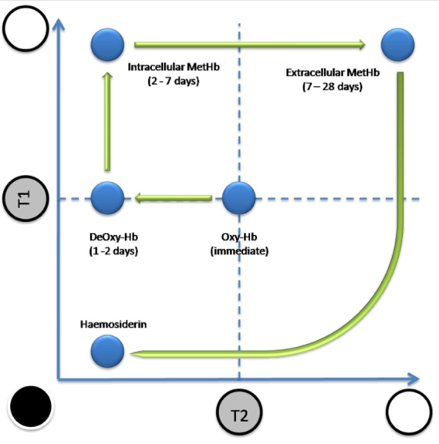

Initially – all is isointense; then follow arrows.
Hypointense: |  | Isointense: |  | Hyperintense:

Stage | Form of haem iron | T1-MRI | T2-MRI
Hyperacute (first 24 hours) | OxyHb (intracellular) | Isointense | Hyperintense → Isointense
Acute (1–3 days) | DeoxyHb (intracellular) | Hypointense | Hypointense
Early subacute (3–7 days) | Intracellular MetHb | Hyperintense
Late subacute (1–2 weeks) | Extracellular MetHb |  | Hyperintense
Early chronic (2-4 weeks) | Hemichrome (extracellular) | Isointense
Late chronic (> 2 months) | Hemosiderin, intracellular ferritin | Hypointense*
*or T2 hyperintense if fluid filled cavity

Plus:
- Gradient sequence demonstrates susceptibility artefact - show hemorrhage as black; it also exaggerates volume of bleeding ("blooming artefact").
- No contrast enhancement
- Diffusion restriction

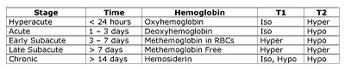

A. RBCs containing oxyhemoglobin (O) [isointense on both T1 and T2] are extravasated.  B. Oxyhemoglobin in some of cells at clot centre is converted to deoxyhemoglobin (DE) [hypointense on T1];  - clot is surrounded by variable amount of edema (small circles) [hyperintense on T2].  C. Most of hemoglobin is converted to methemoglobin (M) [hyperintense on both T1 and T2];  - DE conversion to M occurs gradually from periphery of hematoma to its center - lower signal (continued presence of DE) still evident centrally.  - progressive RBC lysis (interrupted outline).  - surrounding edema more extensive.  D. RBCs have broken down, leaving post-hemorrhagic cyst (still contains M);  - edema has resolved.  - macrophages (circles with 3 engulfed particles) surround cavity, contain hemosiderin (H) granules [markedly hypointense ring on T2].  N.B. persistence of areas of high signal from M and low signal from H is variable (can be seen for many months or almost indefinitely). | 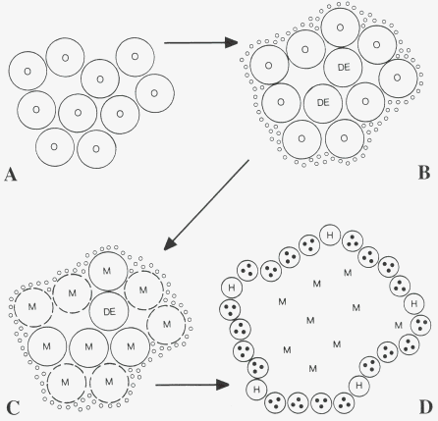

MRI appearance of hemorrhages has many complexities and variations!

Contraindications
MRI compatibility list: http://www.mrisafety.com/list_search.asp

- Intraorbital foreign bodies - can move in fluctuating magnetic field → damage structures.
Screen all patients with history of metalwork!

- Non-MRI compatible materials (pacemakers* or permanent pacemaker leads, neurostimulators**, artificial heart valves, cochlear implants, old vascular clips, ventilators, halo vests, electronic infusion devices, magnetic stoma plugs, magnetic sphincters, etc).
*risk of induced arrhythmias (because MRI also emits RF waves that can confuse electronics)
**heating of electrodes at end of wires → injury to surrounding tissue
  - ferromagnetic (metal) objects can be attracted to magnet and act as missiles if brought into magnet room.
  - stainless steel is ferromagnetic → major artefact + can get hot (may be uncomfortable to patient).
  - large implants (e.g. spinal stabilization hardware) are firmly fixed - no concern about implant movement - no absolute contraindication to MRI.
  - bone growth stimulators – use ≤ 1.5 T MRI.
  - titanium (more MRI friendly) is becoming more commonly used in spine surgery.

- Pregnancy (esp. 1st trimester) - relative contraindication (risks to fetus unknown).

Resume - screen all patients for:
- implanted devices (even if previously removed - portions of leads often remain in body after pulse generators are removed).
- intraorbital foreign bodies (esp. patients with history of metalwork)

Contrast enhancement
Indications – see p. D45 >>

Contrast medium
- paramagnetic heavy-metal gadolinium forms basis of all current intravenous MR contrast agents.
- gadolinium reduces T1 and T2 relaxation times of nearby water protons → ↑signal on T1 images.
N.B. postcontrast images are T1
- usual dosage – 0.1-0.3 mmol of gadolinium / kg (10-20 mL of contrast for average-sized adult).
- gadolinium is chelated to agent (such as DTPA) → renal excretion without toxicity (free Gd is toxic).
- gadolinium-based contrast agents approved for use in USA:
- gadopentetate dimeglumine (Magnevist)
- gadobenate dimeglumine (MultiHance)
- gadodiamide (Omniscan)
- gadoversetamide (OptiMARK)
- gadoteridol (ProHance) - new nonionic contrast agent - allows 3 times large doses (e.g. detects metastases not seen with standard method!).

Adverse reactions
(incidence is much lower than with CT contrast agents!)
  - Severe anaphylactoid reactions to gadolinium contrast (0.0003-0.01%).
  - Nephrogenic systemic fibrosis (NSF) - debilitating and sometimes fatal fibrosis of skin and connective tissues; may develop even after single exposure; affects:
  - skin - burning, itching, reddened or darkened patches, skin swelling, hardening, tightening → contractures.
  - eyes - yellow raised spots on sclerae
  - bones, joints, muscles - joint stiffness; limited range of motion, muscle weakness, pain deep in hip bone or ribs.
- time between exposure and subsequent diagnosis ranges days ÷ many months.
- diagnosis confirmation - skin biopsy.
- risk factors (contraindications):
    - acute or chronic severe renal insufficiency (glomerular filtration rate < 30 mL/min/1.73m²) – NSF is described only in HD patients.
    - acute renal insufficiency of any severity due to hepatorenal syndrome or in perioperative liver transplantation period.
- prophylaxis:
  - screen all patients for renal dysfunction by history and/or laboratory tests!
  - do not exceed recommended dose; allow sufficient time for elimination prior to any readministration (repeated or higher than recommended doses also increase risk).
  - for patients receiving hemodialysis → prompt hemodialysis following gadolinium administration.
- no consistently successful treatment.

  - Findings of gadolinium deposits several months later in brains (esp. GP, dentate nuclei) of patients who have undergone MRI body scans have led the European Medicines Agency’s (EMA's) Pharmacovigilance Risk Assessment Committee (PRAC) to recommend suspending marketing authorization for four linear gadolinium products gadobenic acid, gadopentetic acid, gadodiamide, and gadoversetamide. >>

FDA review to date has not identified adverse health effects from gadolinium retained in the brain after the use of gadolinium-based contrast agents (GBCAs) for MRI. All GBCAs may be associated with some gadolinium retention in the brain and other body tissues. However, because FDA identified no evidence to date that gadolinium retention in the brain from any of the GBCAs, including GBCAs associated with higher retention* of gadolinium, is harmful, restricting GBCA use is not warranted at this time. FDA will continue to assess the safety of GBCAs and plan to have a public meeting to discuss this issue in the future.
*publications show that linear GBCAs retain more gadolinium in the brain than macrocyclic GBCAs (but every macrocyclic agent shows some depositions + allergic-like reactions (even fatal reactions) are significantly lower with linear agents)
- gadolinium deposits are seen in all organs after 3-4 scans.
- free gadolinium is toxic to tissues.

  - Study published in JAMA showed no significant link between exposure to the agents and parkinsonism. >>

Contrast for hemodialysis patients
- gadolinium administration poses a risk of inducing a painful form of systemic fibrosis in patients with poor or no renal function.
- minimize the risk of fibrosis - increased dialysis needs to be performed to remove as much Gd as soon as possible after exposure; current recommendations - 6 hours of dialysis immediately after Gd exposure as well as an additional 4 hours of dialysis on each of the 2 following days.
- it is unknown whether increased dialysis really reduces the risk of Gd induced fibrosis.

N.B. doing HD right after MRI with gad is “off label” but common practice!

Standard MRI set
- Axial, section thicknesses 4–5 mm.
- Sagittal fast gradient echo sequence, with T1-weighted contrast.
- Axial dual echo multislice series - balanced (proton density) contrast on first echo and T2-weighted contrast on second.
  - coronal plane is preferred for dual echo in patients with epilepsy.
  - some units substitute FLAIR sequence for proton density-weighted acquisition (recognition of small cortical lesions but little other advantages).
- Many units add sagittal T2 (detection of corpus callosum involvement in MS).

Pituitary gland
- higher resolution, smaller fields of view, mainly T1-weighted contrast, both sagittal and coronal planes.
- gland is small – to avoid interslice gaps is important.

MRI modifications
Echo Planar Imaging (EPI)
- fastest imaging technique available (acquiring entire images in < 50 milliseconds; information for entire brain is obtained in 5-10 sec*):
- ability to produce motion frozen "snapshots" of function (e.g. heart action) - kinematic motion studies.
- ability to produce perfusion imaging, diffusion imaging, functional MRI.
- useful in uncooperative patients and children.
*vs. 5-10 min in routine spin echo imaging
- penalty - lower quality.

Spin Density–Weighted Imaging
- CSF has density similar to brain tissue.

Gradient Echo Imaging
- highest sensitivity in detecting early hemorrhagic changes.

Fluid-Attenuated Inversion Recovery (FLAIR)
- pulse sequence that yields heavily T2 weighted images in which CSF is nulled* (dark) → increased conspicuity of bright T2 lesions at interface with dark CSF.
*i.e. suppression of all signal from CSF (normally, on T2 CSF is bright)
with conventional (spin echo or FSE) images, cortical/subcortical or periventricular lesions are generally difficult to visualize because of lack of contrast between high-intensity cortex and high-intensity CSF.

- FLAIR is T2 when CSF is made dark:

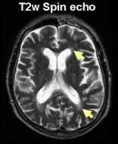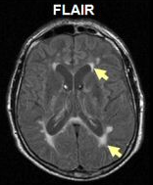

Short TI Inversion Recovery (STIR)
- suppresses signal from fat → normally bright T1 fat becomes dark.

Fast Spin Echo (FSE)
- marked reduction in acquisition time (FSE images can be obtained in less than half time required for conventional spin echo [CSE] images).
- penalties - slight loss of contrast, increased sensitivity to physiological motion.

FSE of cervical spine - vertebral artery (arrow, right image), intervertebral canals and dorsal root ganglia (arrows in left image) are shown well, but spinal cord image (centre) is degraded by motion artefact:
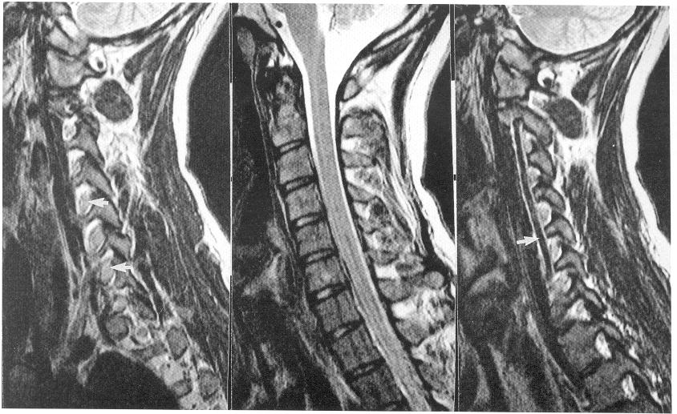

A. Fast spin-echo proton density.
B. Fast spin-echo T2-weighted.
C. Spin-echo T1-weighted.
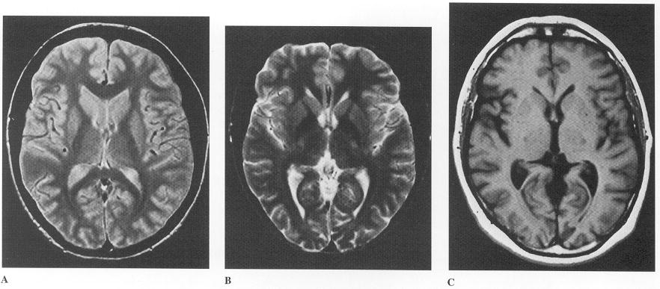

CISS (Constructive Interference Steady State, s. MR cisternography)
- strongly T2 weighted GRE sequence → combination of high signal levels and extremely high spatial resolution (excellent tissue/fluid contrast); flow-compensated, 2- or 3-dimensional gradient echo acquisition to obtain images with contrast that is proportional to the ratio of T2 relation time to T1 relaxation time → high signal-to-noise and high spatial resolution.
- best detail available of cisternal portions of cranial nerves (in combination with MP-RAGE completely removes any need for contrast in identifying acoustic neuromas).
- quite insensitive to CSF pulsations.

FIESTA (Fast Imaging Employing Steady State Acquisition)
- provides images of fluid filled structures with extremely short acquisition times → contrast and anatomic detail of small structures.

Pregnancy concerns
Harm to fetus
- no conclusive evidence that MRI exposure up to 3 Tesla is associated with fetal harm.
- theoretical concerns: noise exposure, positioning within strong magnetic fields, increase in body temperature caused by radiofrequency pulse energy deposition.
- Fetal MRI is routinely used when reliable fetal imaging cannot be obtained by ultrasonography, according to practice guidelines established by the ACR and the Society of Pediatric Radiology.
- elective imaging should be deferred to the postpartum period if possible.

Gadolinium-based contrast
- classified by FDA as class C - in animal studies, maternal exposure (to concentrations of gadolinium higher than typically administered in humans) has been associated with abortion and developmental abnormalities.
- gadolinium can enter fetal circulation.
- use of gadolinium should be avoided unless it is likely to result in changes in management that would directly benefit the patient or fetus.
- informed written consent should be obtained before gadolinium use; no specific monitoring tests are required.
- imaging of arterial / venous circulation can often be performed using time-of-flight (TOF) sequences.
- during lactation:
- no adverse outcome has been documented from very low estimated delivery of gadolinium via breast milk
- gadolinium is probably safe to use in mother without concern for direct toxicity or allergic reaction to the neonate
- 24-hour period of “pump and dump” interruption from breast-feeding is suggested by ESUR but not by ACOG or ACR.

Useful Websites
American College of Obstetricians and Gynecologists (ACOG) Guidelines for Diagnostic Imaging During Pregnancy >>

American College of Radiology (ACR) and Society for Pediatric Radiology Practice Guideline for Imaging Pregnant or Potentially Pregnant Adolescents and Women With Ionizing Radiation >>

University of California, San Francisco Guidelines for the Use of CT and MRI During Pregnancy and Lactation >>

Bibliography for ch. “Diagnostics” → follow this link >>

Viktor’s Notes℠ for the Neurosurgery Resident
Please visit website at www.NeurosurgeryResident.net

