Pneumoencephalography
Last updated: June 3, 2019

– X-ray visualization of subarachnoid spaces and ventricles by use of gas (such as air) contrast – obsolete neuroimaging technique!

- described by Walter Dandy in 1918.
- air is injected via:
  - lumbar puncture
  - ventricular puncture
- patient position is manipulated to accomplish air movement.

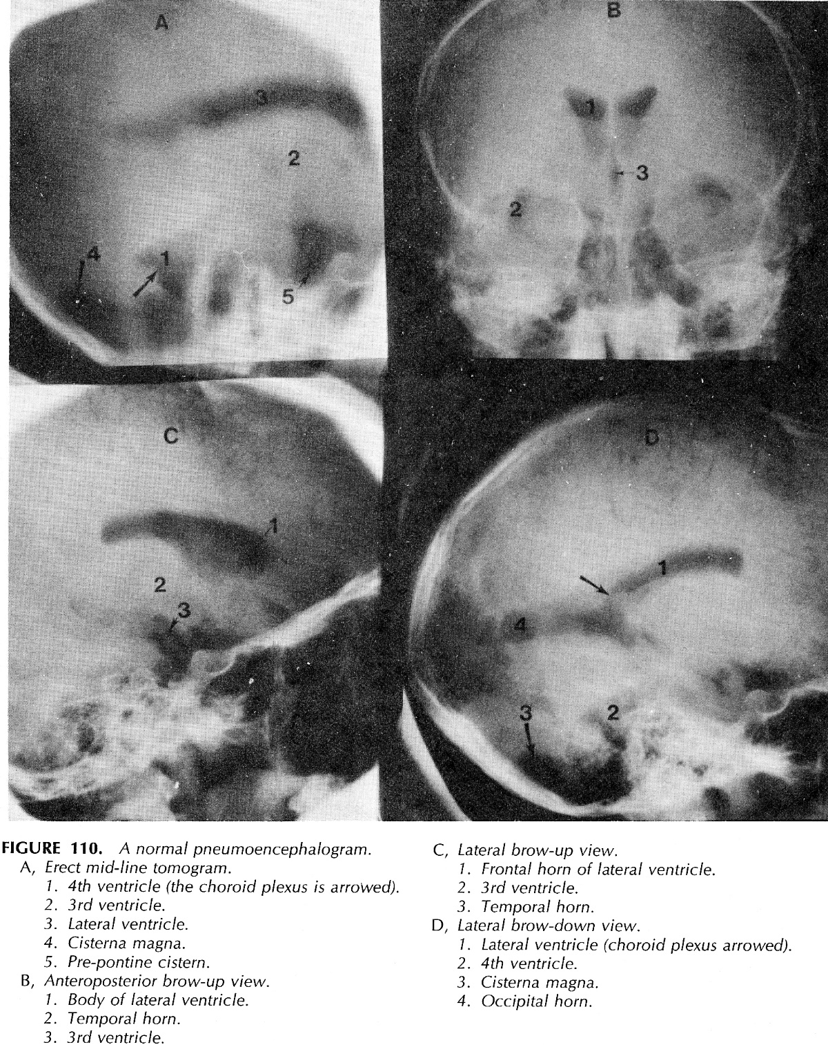

Bibliography for ch. “Diagnostics” → follow this link >>

Viktor’s Notes℠ for the Neurosurgery Resident
Please visit website at www.NeurosurgeryResident.net

