Ultrasound
Last updated: June 3, 2019

Spinal ultrasound (of infant spine) – see p. D70 >
Doppler – see p. D62 >>, p. Vas7 >>

Higher beam frequency - better axial resolution, but less tissue penetration.

A mode (amplification) - one of earliest and simplest forms of display: image is displayed as series of spikes; amplitude* is represented on y axis and depth on x axis.
- was used to identify midline head structures (echoencephalography),
*stronger echo → higher spike.

Static B mode (brightness) - represents only current line of sight of transducer - each echo is displayed as dot (static 2D image); dot brightness is proportional to echo intensity.

TM mode (time-motion) - used primarily in echocardiology: image displays movements of various parts of heart.

Real-time ultrasound - rapid, sequential generation of 2D B-scan images - images change almost instantaneously on screen with shifts in transducer position.
- may be used in conjunction with Doppler (e.g. to diagnose carotid stenosis).

Brain ultrasound (of infants)
See also D45 p.!!!
Advantages - portable, safe, noninvasive, low cost and highly effective.

Disadvantages - findings may be relatively unspecific and difficult to interpret (even for experienced sonologists).
- grey and white matter cannot be differentiated.

Sonographic "window" (not blocked by intervening bone or air) - anterior fontanelle – allows coronal and sagittal images:
  - cerebral hemispheres
  - deep ganglionic structures
  - thalami
  - ventricles
  - posterior fossa.
- posterior fontanelle - better views of posterior fossa.
- temporal fontanelles - axial views in very young.

What can be detected:
  - congenital anomalies in central (periventricular) position (Chiari malformations, Dandy-Walker syndrome, agenesis of corpus callosum, anencephaly, aqueductal stenosis, holoprosencephaly, encephaloceles)
  - hydrocephalus
  - neoplasms
  - cysts
  - periventricular hemorrhage (subarachnoid / subdural blood that is nearer transducer are harder to identify - may be confirmed by CT).
  - vascular malformations (e.g. vein of Galen malformation).
- sensitivity for hypoxic–ischemic lesions is poor (normal sonogram does not exclude this pathology);
    - cerebral edema is hyperechoic - very difficult to diagnose since there is no adjacent parenchymal organ that can provide reference in echogenicity.
    - definite infarction is hypoechoic and well demarcated.

Normal brain US:
A. Coronal section at level of internal capsule: interhemispheric fissure (long arrow), cingulate sulcus (two short arrows); callosal sulcus (short arrow), sylvian fissure (arrowhead), corpus callosum (cc), frontal horn (1), 3rd ventricle (2), caudate nucleus (3), thalamus (4), internal capsule (5), putamen and globus pallidus (6), insula (I), temporal lobe (T).
B. Coronal section at level of ventricular atria: lambdoid suture (LS), glomus of choroid plexus (white arrow), slightly hyperechogenic periventricular white matter (7).
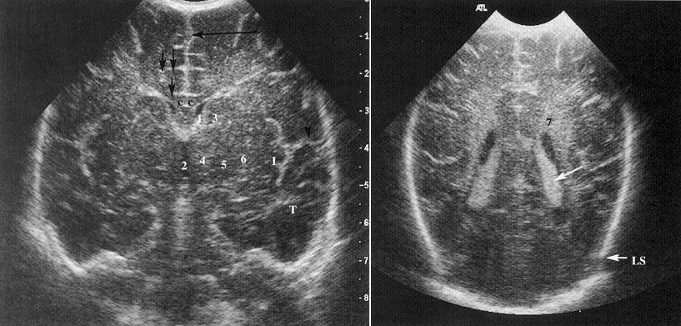

Normal brain US: sagittal section on lateral ventricle: frontal horn (1), body (2), atrium (3), glomus of choroid plexus (4), choroid plexus in temporal horn (5), caudate nucleus (6), thalamus (7), caudothalamic groove (arrow):  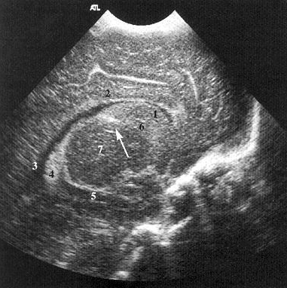 | Normal brain US: medial sagittal section:  Corpus callosum: genu (curved arrow), body (straight arrow), splenium (arrowhead), 3rd ventricle (3), 4th ventricle (4), cerebellar vermis (V), brainstem (BS) choroid plexus (CP):  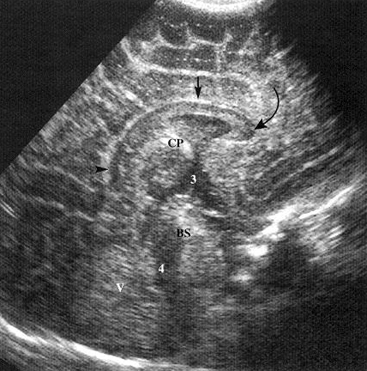
Normal neonatal brain - coronal midline scan:
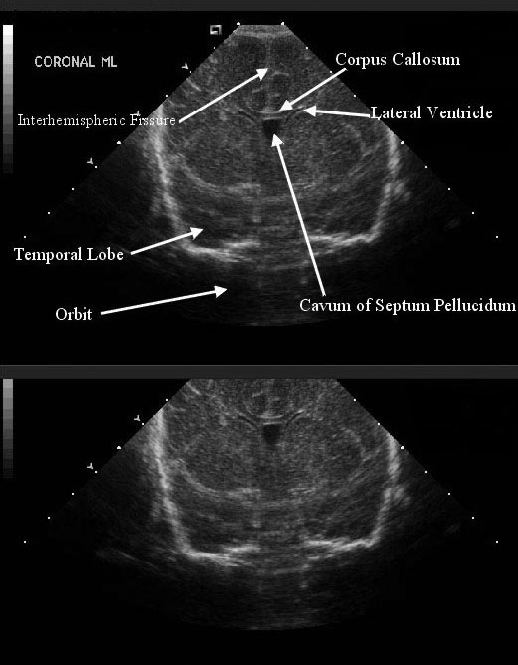

Normal neonatal brain - coronal midline scan:
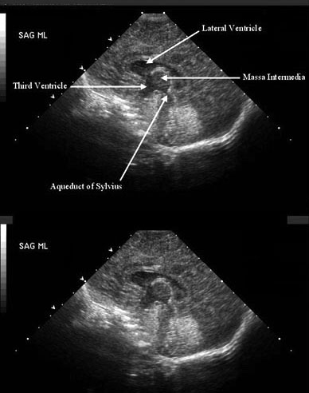

Normal neonatal brain – midline sagittal scan:
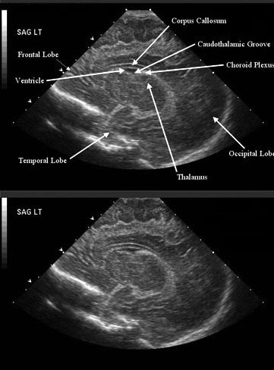

Bibliography for ch. “Diagnostics” → follow this link >>

Viktor’s Notes℠ for the Neurosurgery Resident
Please visit website at www.NeurosurgeryResident.net

