CTA, pCT, MRA, MRV
Last updated: June 3, 2019

Computed Tomography Angiography (CTA) 1
Perfusion Computed Tomography (pCT) 2
Magnetic Resonance Angiography (MRA), Magnetic Resonance Venography (MRV) 2

Computed Tomography Angiography (CTA)
- has become possible with introduction of multislice (multidetector) spiral CT machine - multiple detectors for simultaneous data collection at different locations - rapid dynamic imaging of anatomy of interest after bolus of IV contrast.
- volumetric data set is acquired during vascular phase of iodinated contrast, which is injected intravenously usually in antecubital vein (75-120 ml contrast medium at rate of 3 ml/s – patient needs at least 18G IV line).
- CTA uses ≈ 21 gm of iodine
GFR has to be > 45 (vs. > 30 for MRA)
- timing of data acquisition in relation to contrast administration is critical for maximum arterial opacification:
  - standard delay (between start of injection and image acquisition): 12 s for extracranial and 15 s for intracranial vessels.
  - automating bolus detection system (available on most machines) - adjusts for individual variations in circulation time.
- submillimeter axial images are obtained and then reformatted into 2D sagittal and coronal image data sets at 1- to 2-mm intervals.
- 3D reconstruction images are usually obtained, but interpretation of study is based primarily on original axial data set and 2D sagittal and coronal reformatted images.

Indications for CTA:
    - carotid artery stenosis / dissection
    - intracranial vascular occlusion / aneurysms (≥ 3 mm) / AVM*
*subject to ongoing research.
    - dural sinus thrombosis (CT venography).

At present, CTA is mostly employed as screening tool for aneurysms:
- to rapidly show aneurysms in symptomatic patients
- to screen asymptomatic patients at risk for cerebral aneurysms.

CTA advantages over MRA:
- less motion-sensitive
- no flow-related effects (e.g. can easily visualize slow flow or turbulent flow in aneurysms)
- fast (< 32 seconds)
- can be used in claustrophobic patients
- no MRI compatibility problems (e.g. intubated patients, aneurysm clips, cardiac pacemakers, etc).

CTA disadvantages over MRA:
- intravenous iodinated contrast!!! – side effects and only one opportunity to perform study (MRA does not require any contrast - can be repeated immediately!)
- exposure to radiation
- vessels at skull base may be obscured by enhancement in cavernous sinus or bone.
- in SAH, high density of blood can obscure bleeding aneurysm
- aneurysm clips produce artifacts (MRA has similar problems)
- calcifications can produce artifacts

Perfusion Computed Tomography (pCT)
– provides physiologic + anatomic information.
- performed with latest-generation multidetector CT scanners, which allow very rapid CT imaging.
- bolus IV injection of contrast (4-5 mL/sec) → rapid serial CT images of chosen volume obtained in multiple phases over approximately 1-minute period.
- at end of this acquisition, multiphase time-density curves corresponding to each voxel are generated within 2D image of multilevel image data set → data further postprocessed and displayed in color maps of the following perfusion parameters:
- cerebral blood flow (CBF) in mL/100 g/min
- cerebral blood volume (CBV) in mL/100 g
- mean transit time (MTT) in seconds
- pCT technology has been validated against other proven in vivo techniques (Xe-enhanced CT and PET).
- not good (but still rather useful) for posterior fossa – bone artefacts.

Indications
- Acute stroke – most common use of pCT – to determine presence of salvageable ischemic penumbra during first few hours after stroke. see p. Vas3 >>
- SAH-related vasospasm. see p. Vas25 >>
- CNS neoplasms

Magnetic Resonance Angiography (MRA), Magnetic Resonance Venography (MRV)
- images of flowing blood* without administration of exogenous contrast** - relying on:
- inflow of unsaturated spin (time-of-flight (TOF) MRA) - technique used most frequently; relies on suppression of nonmoving tissue to provide background for high signal intensity of flowing blood; areas of turbulent or slow flow may remain undetected (due to intravoxel dephasing).
- accumulation of phase shifts proportional to flow velocity (phase contrast (PC) MRA) - captures only truly patent vessels:
- reveals velocity and direction of blood flow (i.e. more sensitive for detection of slow flow); vs. TOF – mainly anatomic information.
- excellent suppression of background signal.
- can differentiate between flow and thrombus (in TOF images, both thrombus containing methemoglobin [has T1 effect] and flow can be bright whereas only flow will have signal on PC images).
*vs. anatomic images of vessels given by conventional angiography
**contrast-enhanced MRA (cMRA) is also available (GFR has to be > 30).

N.B. MRA is flow-dependent technology; absence of flow signal does not mean literally complete occlusion but rather that flow is below critical value

  - both TOF and PC techniques can be performed with 3D data acquisition (physician can sit at console and manipulate vessels in numerous projections!; vs. conventional angiography).
  - if using magnets > 1.5 T, CSF flow can give “flow void” artefacts – can be mistaken for dilated veins.

Primary uses of MRA:
- stenotic lesions in carotid artery bifurcation (MRA is best noninvasive technique!)
MRA tends to exaggerate severity of arterial narrowing and therefore does not usually miss occlusive disease of large arteries!
- noninvasive screening for intracranial aneurysms (esp. > 3-5 mm) in patients at risk.
- following patients after coiling (CTA will have metal artefacts)
  - MRA of small distal vessels are often difficult to interpret (CTA has better resolution!).

Primary uses of MRV – thrombosis of superior sagittal sinus or transverse sinuses - diagnosis & follow-up (monitoring thrombus resolution and guiding duration of anticoagulation).

A. Normal MRA (2D TOF), axial slab, through circle of Willis.
B. Another MRA at the same level - markedly diminished left MCA flow (internal carotid occlusion):
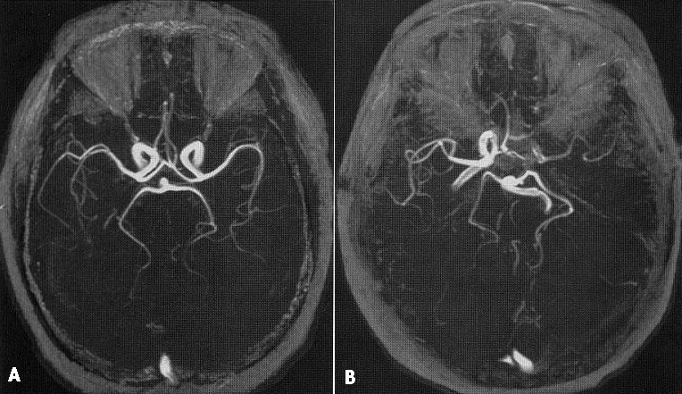

Aneurysmal dilatation of cavernous and supraclinoid portions of right ICA and aneurysm (arrow) at supraclinoid portion of left ICA: right (A) and left (B) carotid angiograms; 3D surface-rendered MRA (C):
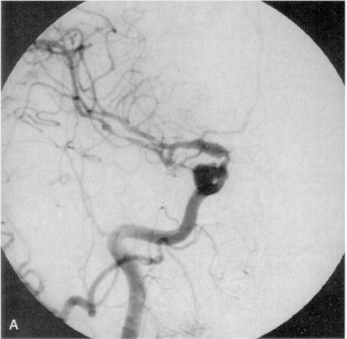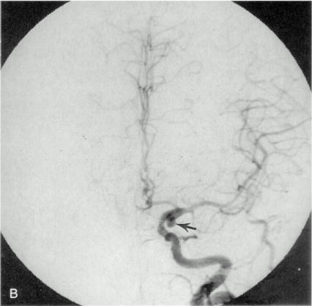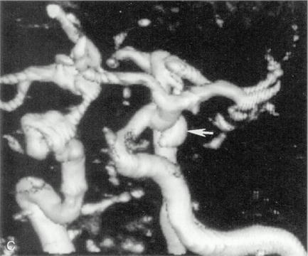

A. Normal MRV (2D PC), median sagittal slab.
B. Another MRV at the same location - lack of flow in superior sagittal and straight sinuses (dural sinus thromboses):
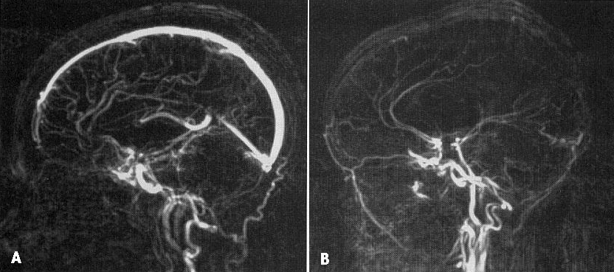

Bibliography for ch. “Neurovascular Examination” → follow this link >>

Viktor’s Notes℠ for the Neurosurgery Resident
Please visit website at www.NeurosurgeryResident.net

