PNS Demyelination
Last updated: September 5, 2017
Guillain-Barré Syndrome (GBS), Acute Inflammatory Demyelinating Polyradiculoneuropathy (AIDP) 1
Pathophysiology 1
Epidemiology 2
Clinical Features 2
Diagnosis 3
Treatment 4
Prognosis 4
Chronic Inflammatory Demyelinating Polyradiculoneuropathy (CIDP) 5
Pathophysiology 5
Epidemiology 5
Clinical Features 5
Diagnosis 5
Treatment 5
Prognosis 5
Multifocal Motor Neuropathy, s. MNMCB (motor neuropathy with multiple conduction blocks) 5
Congenital Hypomyelinating Neuropathy 6

Segmental demyelination (SD) - damage to myelin sheath: also see p. PN1 >>
- primary SD - only myelin is affected; axon is spared.
- secondary SD - changes in axon → damage to myelin.

SD produces:
- negative effects - conduction abnormalities (slowing or block) → muscle weakness, large fiber sensory loss.
  - motor aspects: conduction slowing (vs. block) does not produce clinical weakness when it affects motor axons (fact that nerve impulses are reaching muscle fibers few milliseconds later than normal is of no significance!).
  - sensory aspects:
    - uniform (vs. differential) conduction slowing does not have clinical sensory correlate.
    - differential conduction slowing (different in different types of fibers) may be detected by certain examination techniques that require transmission of highly synchronized nerve volleys (e.g. deep tendon reflexes, vibratory sensation).
- positive effects - ectopic impulse generation, abnormal "crosstalk" between demyelinated axons → fasciculations, myokymia, cramps, paresthesias.

Familial SD polyneuropathies - length-dependent polyneuropathies with predictable presentations (vary only in process severity):
- lower extremity is affected earlier and more severely than upper extremity.
- distal parts suffer first and ultimately most severely.
- sensory component tends to be involved earlier and more severely than motor.
- contralateral limbs are affected equally.
- along any specific nerve, conduction rate abnormalities are uniform.

Acquired SD polyradiculoneuropathies (N.B. roots are always affected in acquired SD cases!):
- presentation identical to familial SD polyneuropathies (e.g. CIDP, AIDP in recovery stages).
- specific presentations (e.g. AIDP early in its course):
- may be more severe in upper extremities (e.g. sural nerve may be normal, whereas median nerve may be grossly abnormal).
- motor component may be more abnormal than sensory.
- abnormalities may be (multi)focal (vs. generalized) - focal conduction slowing.
- nerves of same type, in same limb, at same level, often show very dissimilar findings.
- homologous nerves in contralateral limbs may be affected differently.
  - in acute SD polyradiculoneuropathies, conduction blocks dominate, whereas in chronic SD polyradiculoneuropathies, conduction slowing is prominent.

Classification
Acquired SD polyradiculoneuropathies
I. Acute - Guillain-Barré syndrome:
- Acute inflammatory demyelinating polyradiculoneuropathy (AIDP)
- Axonal form of GBS:
- motor (i.e. acute motor axonal neuropathy)
- motor-sensory (i.e. acute motor-sensory axonal neuropathy)
II. Chronic
Chronic inflammatory demyelinating polyradiculopathy (CIDP)
CIDP-like disorders:
CIDP with multiple myeloma
CIDP with osteosclerotic myeloma
CIDP with Waldenström macroglobulinemia
Monoclonal gammopathies of undetermined significance (MGUS):
MGUS IgM neuropathy with anti-MAC antibody
MGUS IgG, IgA, IgM neuropathy without anti-MAG antibody
Motor neuropathy with multifocal conduction block

Guillain-Barré Syndrome (GBS), Acute Inflammatory Demyelinating Polyradiculoneuropathy (AIDP)
- different autoimmune disorders with rapidly evolving sensorimotor polyradiculoneuropathy resulting from widespread:
- inflammatory PNS demyelination (AIDP)
- noninflammatory PNS axon loss (axonal form of GBS)

Pathophysiology
- autoimmune diseases against various components of peripheral nerve fibers.

Endoneural perivascular (mainly perivenous) lymphocytic infiltrates
↓
segmental demyelination → wallerian degeneration

N.B. there is no dominant antigen–antibody reaction (any number of myelin and axonal elements may be involved in inciting immune reaction)

AIDP - myelin sheath is specific target structure.
  - both humoral << cell-mediated factors - macrophages penetrate basal lamina surrounding axon, displace Schwann cell from myelin sheath, and then phagocytose myelin lamellae.
  - circumscribed inflammatory perivenular and endoneurial infiltrates (lymphocytes, macrophages) and localized demyelination scattered throughout PNS (roots ÷ distal peripheral nerve fibers).
- predilection (at least soon after onset) for roots and distal peripheral nerve fibers.
  - some axon loss also occurs.
  - during recovery, remyelination occurs, but lymphocytic infiltrates may persist.

Axonal form of GBS:
- wallerian degeneration - axon loss.
- roots affected far more extensively than peripheral nerves:
acute motor axon neuropathy - ventral roots alone;
acute motor-sensory axonal neuropathy - both ventral and dorsal roots.
- in surviving axons, macrophages are present within periaxonal spaces, surrounding compressed but otherwise normal-appearing, axons.
- some sparse demyelination also occurs.

Epidemiology
AIDP
- most common acquired demyelinating neuropathy (incidence 1-2 per 100,000 population).
- males > females.
- any age (incidence is higher in elderly).
- any time of year.
- most cases are sporadic, but clusters have been reported (derive from obvious trigger factor, such as antirabies vaccination).
- no clear relationship with HLA.

Axonal form of GBS
- small proportion of GBS cases in North America and Europe.
- occurs principally as summer epidemics in China (associated with Campylobacter jejuni).
- typically children and young adults.

Antecedent events (triggers) - associated with GBS in ≈ 70% cases (occur 1-3 weeks before onset of symptoms):
Viral - CMV*, Epstein-Barr virus*, HIV*, herpes, influenza, hepatitis.
Bacterial - Campylobacter jejuni* (gastroenteritis), Mycoplasma pneumoniae*, Borrelia burgdorferi.
Vaccination - rabies (some strains), vaccinia, influenza.
Surgery
*strong association

Cause-and-effect relationship seems very likely with HIV infection (test all patients for HIV), Hodgkin's disease.

Clinical Features
Ascending weakness, areflexia, paresthesias with little sensory loss
AIDP and axonal form of GBS are clinically indistinguishable and have similar CSF profiles!

- most patients are essentially well and lack systemic symptoms (incl. fever, lymphadenopathy [may be sign of trigger event!]).

Initial neurological symptoms vary:
  - 50% patients – distal symmetrical paresthesias (“pins and needles”) involving toes & fingers → spread proximally (but seldom beyond ankles and wrists); perioral paresthesias are less common.
N.B. do not mistake for hyperventilation symptoms!
  - symmetrical weakness can be presenting feature (but more often it is first noted few days after paresthesias begin) - begins in proximal lower extremities, soon spreads (ascends) to upper extremities; areflexia is one of earliest findings (esp. in axonal form)!
Normal ankle and knee reflexes in weak lower extremity virtually rules out diagnosis!

Progressive phase lasts few days ÷ 3-4 weeks (50% patients reach nadir by 2 weeks, 80-90% - by 3 weeks); prominent features are motor!
    - flaccid weakness varies considerably (often profound, ascending all four limbs, trunk, respiratory, bulbar, and facial muscles - Landry's ascending paralysis).
Facial diplegia is seen in 50% patients!!!
      - because spinal roots are prominently involved, GBS can involve short nerves (e.g. intercostal, cranial) as well as long ones.
      - sphincters are spared.
      - may even cause nonreactive pupils.
    - occasional fasciculations.
    - deep, poorly localized pain commonly occurs;
      - most severe in shoulder girdle, back, and posterior thighs.
      - more severe at night.
      - sometimes accompanied by muscle cramping.
    - sensory abnormalities (sensory loss) are found infrequently (vs. sensory symptoms) - vibration and proprioception are most severely affected (up to sensory ataxia and pseudoathetosis), esp. in distal extremities.
    - dysautonomia (occurs to some extent in majority of patients) - severe paroxysmal hypertension, orthostatic hypotension, cardiac arrhythmias (of all types) - may be life threatening!

Peaked symptoms persist unchanged for 2-4 weeks - plateau phase → begin to recede in extremely variable fashion (over 6-12 months).
- improvement follows gradient inverse to direction of involvement (recovery of bulbar function →→→ lower extremity weakness resolving last).
- tendon reflexes are usually last function to recover.

Acute axonal form of GBS - more rapid onset, more severe (early denervation atrphy), poor ultimate recovery.

Miller-Fisher syndrome (benign disorder - does not require specific immune therapy) - cranial nerve involvement predominates:
- ophthalmoplegia - anti-GQ1b is found in almost all patients with ophthalmoplegia
- ataxia
- areflexia.
No limb weakness!

Pathophysiologic, clinical, diagnostic stages:
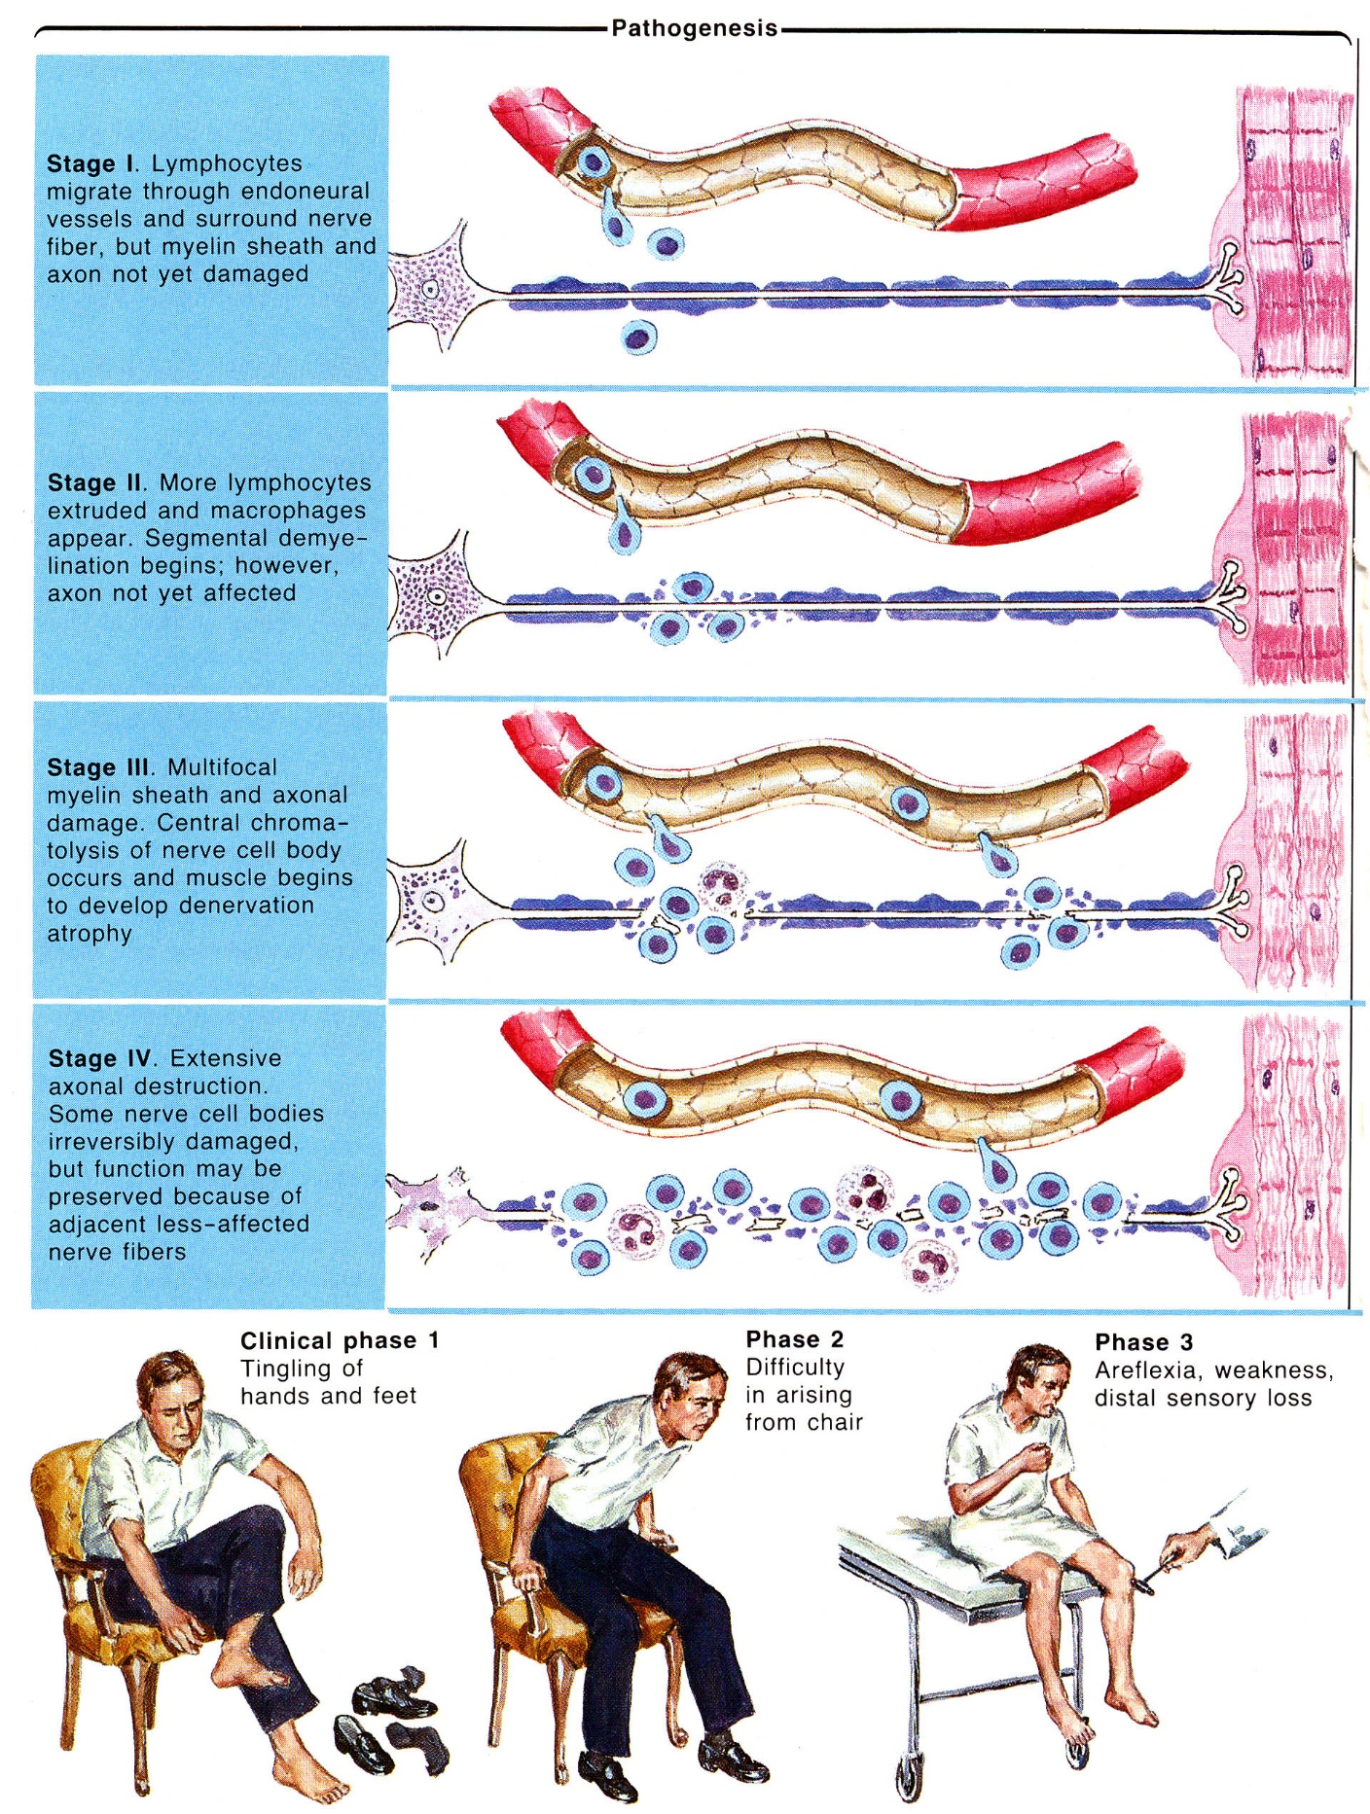

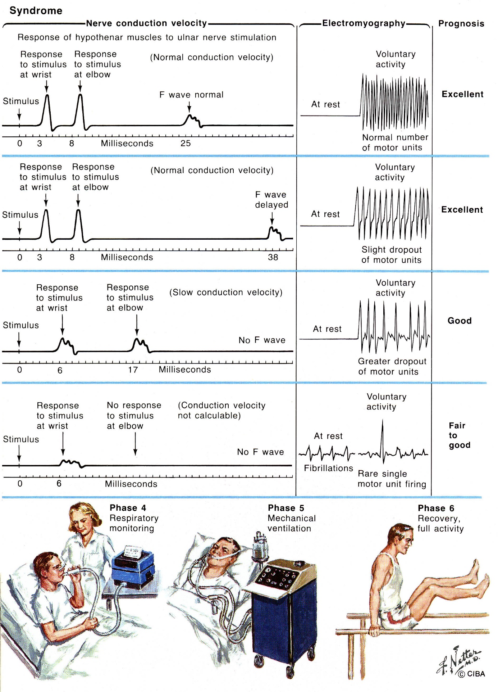
Source of pictures: Frank H. Netter “Clinical Symposia”; Ciba Pharmaceutical Company; Saunders >>

Diagnosis
Two critical laboratory studies:
- CSF analysis – protein↑ with normal cell count (albuminocytological dissociation).
- CSF protein↑ (46-400 mg/dl) is seen after first week of illness; in 10% patients (esp. mild cases) CSF protein is normal.
N.B. CSF cell count may be elevated (up to 50 lymphocytes / mm³) if GBS is superimposed on HIV infection or Lyme disease!
- Electrophysiologic (EDX) examination – segmental demyelination changes (conduction block, differential slowing) in one or several nerves (esp. motor, vs. sensory).
- prolonged F-wave latencies indicate proximal demyelination.
- EMG - acute muscle denervation.
- conduction slowing may persist for months ÷ years after clinical recovery.

N.B. both CSF analysis and EDX studies are least helpful during very initial phase of illness, which is period when specific treatment can be initiated.

MRI (with IV gadolinium) - enhancement of roots is rather specific in making diagnosis.

Antibodies:
- anti-GM₁ ganglioside - in axonal form of GBS (esp. with preceding Campylobacter)
- anti-GQ_{1b} ganglioside - in all ophthalmoplegia patients.

ESR is normal per se (unless elevated by trigger illness)

Treatment
Two components:
      - supportive care - remains cornerstone of therapy (major reduction in deaths over past few decades has been due to advances in supportive care!).
      - specific therapy.

Supportive Care – monitoring, prophylaxis and treatment of complications.
- patients with suspected GBS must be hospitalized (regardless of how mild disorder appears initially!) - rapid deterioration has been reported.
Monitor: 1) vital capacity 2) ability to swallow 3) ECG
- respiratory compromise - most serious and most common complication - weakness of respiratory muscles (esp. diaphragm) + weakness of bulbar muscles ± pulmonary complications (atelectasis, pneumonia, pulmonary embolism);
  - vital capacity is best measure of respiratory compromise degree.
  - vital capacity ≤ 15 ml/kg (or inspiratory force < 20-25 cmH₂O) → intubation.
  - intratracheal intubation may be complicated because of:
      - dysautonomia (hypotension, arrhythmias due to drugs and airway manipulation);
      - severe hyperkalemia induced by succinylcholine because of denervated musculature.
  - tracheostomies performed only if airway assistance is still needed at end of 2nd week.
- cardiovascular dysautonomia:
- paroxysmal hypertension - short-acting agents titrated against patient's BP (e.g. β-blockers).
N.B. one of main death causes is iatrogenic hypotension!
- hypotension (esp. in patients on respirators - compromised venous return) - Trendelenburg position, IV fluids, ± vasopressors.
- cardiac arrhythmias - cardiac monitoring is necessary!; treat gingerly because conduction abnormality may change very rapidly!
- pulmonary embolism (in 5% patients after 2nd week of immobilization); H: subcutaneous heparin, intermittent calf pneumatic compression; passive full-range joint movement are started immediately, active exercises begin when acute symptoms subside.
- pain – aspirin (antidepressants and anticonvulsants generally not effective), single IM injection of 40-60 mg methylprednisolone, cold or hot packs, gentle massage, limb repositioning in slight flexion.
- psychological trauma on essentially paralyzed GBS patients.

Specific Therapy – use one or another (not both):
- Plasmapheresis - treatment of choice (measurable objective improvement in at least 50% treated patients);
  - must be instituted early (preferably within 1st week; no effect after 2 weeks); indication – loss of ambulation.
  - 150-250 ml/kg over 7-10 days.
  - no effect on mortality or relapse rates.
- Intravenous immunoglobulin (IVIg) (0.4 g/kg/d for 5 days) - bulk displacement of pathogenetic antibodies from myelin.
  - equally effective to plasmapheresis!
  - treatment of choice in children.

N.B. clinical improvement that follows IVIg or plasma exchange usually cannot be readily discerned in individual patient, i.e., it is apparent only by comparing large groups of treated and untreated patients

- immunosuppressants, corticosteroids*, ACTH are not effective (ACTH is actually detrimental!), vs. CIDP!
*high-dose corticosteroids could conceivably be of benefit.
pregnancy aspects
- 1st and 2nd trimesters – nothing special.
- supportive care becomes crucial during 3rd trimester - increased respiratory demand.
- GBS is not indication for cesarean section.
- infants do not acquire GBS, even transiently, from their affected mothers.

Excellent article:
http://www.medscape.com/viewarticle/730670?src=mp&spon=26&uac=121060BZ

Prognosis
  - most patients are hospitalized for at least 1 month:
no artificial ventilation - average 5 weeks in hospital;
with respiratory support - average 21 weeks.
  - 10% patients, biphasic illness (partial recovery → relapse).
  - recurrence after full recovery occurs in ≈ 2% patients.
  - 2-5% patients die (ARDS, respiratory insufficiency, cardiovascular collapse).
  - 75-90% patients recover without serious neurological residuals.
  - 7-15% patients have permanent, substantial neurological sequelae (e.g. bilateral footdrop, intrinsic hand muscle weakness and wasting, sensory ataxia, burning dysesthesias).
  - risk factors for poor recovery:
    - age > 60
    - rapid, early evolution (quadriparesis within week)
    - very low motor NCS amplitudes on distal stimulations early in course of disease (severe axon loss or severe distal SD conduction blocks) - single most reliable outcome predictor!

Chronic Inflammatory Demyelinating Polyradiculoneuropathy (CIDP)

Very resembles Guillain-Barré syndrome, with following differences:
- no identifiable trigger events
- chronic course with hypertrophic nerve thickening
- response to immunosuppression with corticosteroids

Pathophysiology
- autoimmune disorder of PNS (spinal roots, peripheral nerves; occasionally, cranial nerves and sympathetic trunks).
Predilection for roots and proximal nerve trunks
- mononuclear infiltration in endoneurium and epineurium.
- segmental demyelination + some degree of axon loss.
- hypertrophied nerves may be palpated (recurrent segmental demyelination and remyelination → Schwann cell proliferation and collagen deposition).
- hypertrophied spinal roots may act as masses (→ spinal cord compression).

Epidemiology
- any age (mean age of onset – 4th decade).
- HLA with increased risk of CIDP: AW30, AW31, A1, B8, DRw3.
- onset or relapses on occasion are triggered by infection, vaccination.
- may relapse or worsen during pregnancy and postpartum period.

Clinical Features
- chronic sensorimotor polyradiculoneuropathy that evolves slowly (≥ 8 weeks for symptoms to reach peak*): *vs. 4 weeks for GBS
  - progressive monophasic course (≈ 66%)
  - cyclical relapsing course (≈ 33%).

Weakness with areflexia predominate over sensory symptoms.
    - weakness distribution:
      - as typical polyneuropathy - symmetrical, lower extremities > upper extremities, distal muscles > proximal muscles.
      - asymmetrical, more prominent proximally; cranial nerves may be affected.
    - weakness degree varies markedly mild ÷ severe (in majority, mild ÷ moderate); in severe cases, respiratory failure.

Sensory symptoms - mild paresthesia, modest sensory loss (stocking-glove pattern, with all modalities affected).
- pain (< 20% patients).
- occasional sensory ataxia.

Autonomic symptoms are uncommon (e.g. incontinence, impotence).

Diagnosis
- electrophysiology (key in diagnosis - normal results essentially exclude diagnosis!) - findings consistent with acquired SD (vs. axon loss).
- CSF protein↑ (to moderate degree: 23-600 mg/dl).
- in 10% patients, CSF protein may be normal.
- sural nerve biopsy (not pathognomonic) - inflammation & demyelination, well-developed onion bulb structures, prominent variability of abnormalities among nerve fascicles!
- may be normal in 25% patients.

Critical component is to exclude CIDP-like disorders:
- lymphoproliferative disorders: multiple myeloma, osteosclerotic myeloma (incl. POEMS syndrome - polyneuropathy, organomegaly, endocrinopathy [hirsutism, testicular atrophy], M-protein, skin changes), MGUS, Waldenstrom macroglobulinemia.
- screen serum & urine for M-proteins + skeletal X-ray.
- HIV infection
- HIV testing is indicated in all patients at risk!
N.B. CIDP may be presenting feature of HIV, preceding seroconversion for up to 6 months (repeat HIV testing 6 months after onset of CIDP-like disorder!).

Treatment
CIDP is very treatable disorder:
- plasmapheresis (twice weekly for 3 weeks → once or twice weekly for additional 3 weeks).
- IVIg (400 mg/kg/day over 5 consecutive days or 400 mg/kg/day once per week over 6-8 consecutive weeks).
Gamunex (FDA approved for CIPD) - 10% human Ig for IVI: 2 g/kg loading (at rate 2 mg/kg/min) → 1 g/kg maintenance (at rate 8 mg/kg/min) every 3 weeks.
- various forms of immunosuppression (vs. Guillain-Barré syndrome!!!!) – corticosteroids, azathioprine, cyclophosphamide
  - patients with minimal symptoms may not require treatment.
  - relapse → single dose of IVIg or single plasma exchange.
  - physical therapy, orthotic devices.

Prognosis
- favorable for most patients.

Multifocal Motor Neuropathy, s. MNMCB (motor neuropathy with multiple conduction blocks)
- tends to begin in young adults.
- men > women.

Clinical Features
- chronic slowly progressive or stable asymmetric motor mononeuropathy multiplex (e.g. unilateral wristdrop followed by footdrop on other side).
- often begins in upper extremities.
- tendon reflexes may be preserved or may be lost outside weakness distribution.
- some weakened muscles may be atrophic, other involved muscles may be of normal bulk (suggesting that SD conduction block is mechanism of weakness rather than axon loss).
- sensory examination is normal even in weak limbs!
N.B. weakness & atrophy without sensory disturbance may mimic ALS! (MNMCB progresses more slowly - little disability after 5 years of symptoms)

Pathology
- inflammatory demyelination (immune-mediated mechanism):
- highly focal (not at sites of entrapment neuropathy!!!).
- proximal and distal peripheral nerves, occasionally cranial nerves.
- largely spares sensory nerve fibers.
- perivascular lymphocytic infiltrates.

Diagnosis
- electrophysiology (key to diagnosis!) - persistent conduction block (focal demyelination).
Strict criteria: > 50% fall in amplitude with < 50% increase in duration of response.
- markedly increased anti-GM₁ ganglioside antibodies in serum (70% cases) - not specific to MNMCB and not required for diagnosis.
- CSF normal.
N.B. MNMCB may represent variant of CIDP (evaluate patients in same fashion as patients with possible CIDP)

Treatment
- responds favorably to IVIg, immunosuppressive therapy (azathioprine, cyclophosphamide).
N.B. corticosteroids and plasmapheresis ineffective!

Congenital Hypomyelinating Neuropathy
- lack of normal myelination* of peripheral nerves (motor and sensory) but not of CNS white matter.
*not degeneration or loss of previously formed myelin.
- autosomal recessive inheritance.
- Schwann cells are preserved, axons are normal.
- myelination proceeds at slow rate and remains incomplete (progressive condition?).
- present from birth:
  - hypotonia, developmental delay.
  - absent tendon reflexes.
  - arthrogryposis (50%).
  - cranial nerves inconsistently involved.
  - respiratory distress and dysphagia are rare complications.

Diagnosis
- slow nerve conduction velocities.
- sural nerve biopsy - lack of myelination of large and small fibers; no inflammation; ± interstitial hypertrophic reactive changes.
- muscle biopsy - mild neurogenic atrophy, no inflammation.

Bibliography for “PNS demyelination” → follow this link >>

Viktor’s Notes℠ for the Neurosurgery Resident
Please visit website at www.NeurosurgeryResident.net

