Leukodystrophies
Last updated: September 5, 2017
Adrenoleukodystrophy 2
Metachromatic Leukodystrophies (s. sulfatide lipidoses) 3
Globoid Cell Leukodystrophy (s. Krabbe disease) 4
Pelizaeus-Merzbacher disease 4
Canavan disease (s. Spongy Degeneration of nervous system) 5
Cockayne syndrome 5
Alexander disease 5

Leukodystrophies - uncommon genetic biochemical defects of:
- myelin formation (synthesis) → dysmyelination (→ loss of defective myelin); abnormal lipids incorporated into defective myelin are metachromatic.
- myelin maintenance (turnover) → demyelination (e.g. many sudanophilic leukodystrophies).
N.B. sudanophilia is produced when Sudan black reacts with neutral fat breakdown products of myelin; since myelin breakdown is result of variety of metabolic or acquired insults, sudanophilia provides no useful information about pathogenesis!
  - it is very difficult to distinguish demyelination from dysmyelination (both processes frequently operate together).
  - defects involve lysosomal or peroxisomal enzymes.
  - autosomal recessive disorders (except classic adrenoleukodystrophy - X-linked).
  - variants are recognized for many disorders (involve separate genetic loci) - follow principle “earlier age at onset, more severe clinical course”.
  - onset: first months of life ÷ 20s.
  - clinical - progressive encephalopathy.
  - progressive; late result is atrophy (at times severe).
  - neuroimaging with contrast enhancement (MRI is superior to CT) - diffuse symmetrical involvement of white matter with increased water content:
CT - abnormally low density;
T2-MRI - increased signal;
T1-MRI - decreased signal.
hypomyelination - MRI closely resembles immature brain;
dysmyelination - very bright T2-weighted images (much brighter than normal nonmyelinated white matter);
demyelination - irregular, often asymmetrical areas of increased T2-weighted signal (not as bright as in dysmyelination).
- secondary or destructive processes (demyelination) are often asymmetrical!
- symmetry with central distribution* is dominant feature in primary white matter disorders (hypo-, dys-myelination).
*subcortical U-fibres are involved rather late in disease process.
N.B. only very few diseases have sufficiently characteristic MRI findings to allow specific diagnosis! (e.g. adrenoleukodystrophy); initial diagnosis largely clinical!
  - not yet curable.

Type | Name | Enzyme Defect | Storage Material | Genetics | Age of Onset

PELIZAEUS-MERZBACHER disease
1 | Classic | Mutations in proteolipid protein (PLP) – CNS myelin component. | Sudanophilic material | X-linked (Xq21.3-q22) | Infantile
2 | Connatal (Seitelberger disease) |  |  | X-linked? | Birth
3 | Transitional |  |  | Sporadic | Infantile
4 | Adult (Löwenberg-Hull disease) |  |  | AD | Adult
5 | Variant |  |  | Not known | Variable
COCKAYNE'S syndrome
6 | Classic | Not known (DNA excision repair) | Sudanophilic material | AR (ERCC8 gene) | 6-12 months
ALEXANDER'S disease
7 | Classic infantile | Not known (dysfunction of astrocytes?) | Not known | Not known | Infants
8 | Juvenile |  |  |  | 7-14 yrs
9 | Adult |  |  |  | Young adults
CANAVAN'S disease
10 | Classic infantile | Aspartoacylase | N-acetylaspartate | AR (17p) | Infants
11 | Neonatal |  |  | Sporadic | Newborns
12 | Juvenile |  |  | Sporadic | 5 yrs-teens
Globoid Cell Leukodystrophy (KRABBE'S disease)
13 | Classic, infantile | Galactocerebroside β-galactosidase  (lysosomal enzyme) | Galactose cerebroside, psychosine | AR | 3-8 months
14 | Late onset |  | Galactose cerebrosides |  | Children, may be adults
METACHROMATIC LEUKODYSTROPHY (MLD)
15 | Classical late infantile (Greenfield) | Arylsulfatase A (lysosomal enzyme) | Sulfatide | AR (22q13.3-qter) | Late infantile (18-24 months)
16 | Juvenile (Scholz) |  |  |  | 4-10 yrs
17 | Adult (Austin) |  |  |  | Adult
ADRENOLEUKODYSTROPHY (ALD)
18 | Multiple peroxisomal enzyme deficiency (Zellweger syndrome) | Dihydroxyacetone phosphate acetyltransferase | Very long-chain fatty acids | AR | Neonatal
19 | Neonatal ALD (Ulrich’s disease) | Peroxisomal oxidation (enzyme unknown) |  | AR | Neonatal
20 | Classic form (X-linked Siemerling-Creutzfeldt disease) | Lignoceroyl-CoA ligase (peroxisomal enzyme) |  | X-linked recessive (Xq28) | 4-10 yrs

Adrenoleukodystrophy
- peroxisomal leukodystrophies: see table above >>
- single peroxisomal enzyme defect (lignoceroyl-CoA ligase) – classical (X-linked) adrenoleukodystrophy (XALD), adrenomyeloneuropathy.
- disorders of peroxisome assembly / biogenesis - neonatal adrenoleukodystrophy (NALD, Ulrich's disease), multiple peroxisomal enzyme deficiency (Zellweger's syndrome).

Pathophysiology
  - peroxisomal lignoceroyl-CoA ligase deficiency → inability to oxidize very long chain fatty acids (esp. C:25 and C:26) within peroxisomes.
  - characteristic intracellular lamellar sudanophilic inclusions (in CNS white matter, peripheral nerves, adrenal zona fasciculata and reticularis, testis) - cholesterol esters with striking excess of saturated unbranched VLCFA.
  - adrenal cortex – ballooned cells, striated cytoplasm and specific microvacuoles; → adrenal atrophy.
  - CNS & PNS:
- extensive diffuse demyelination (sparing subcortical U-fibers)
- perivascular mononuclear infiltration.

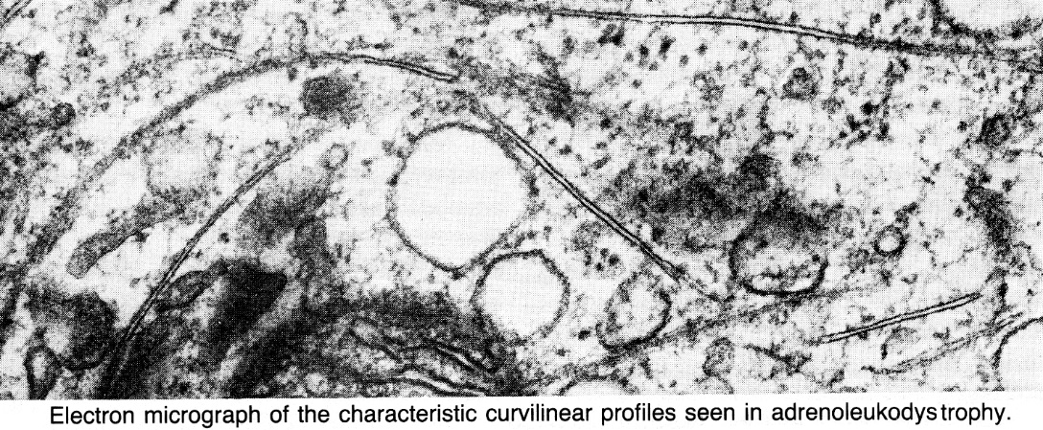

Clinical Features
N.B. affected individuals in same family may have quite different clinical courses!
    - Adrenal insufficiency (degree varies considerably): fatigue, intermittent vomiting, salt craving, hyperpigmentation (most prominent in skin folds).
    - Progressive psychomotor decline
Neonatal adrenoleukodystrophy
- dysmorphic coarse features, poor mental development, early seizures, retinopathy, hepatomegaly.
- very protracted course.

Classical (X-linked) adrenoleukodystrophy - more fulminating disorder!
- locus Xq28 is near loci for hemophilia A and red-green color blindness (defects in red-green color discrimination are frequent in ALD patients, suggesting contiguous gene syndrome).
- 4% female carriers are symptomatic.
- patients are boys with normal early development!
- childhood variant (onset at 4-10 yrs): behavioral change (abnormal withdrawal, aggression, poor memory, difficulties in school) → rapid regression of auditory discrimination, spatial orientation, speech, and writing → seizures → spastic paraparesis / quadriparesis, dysphagia, visual loss (demyelination along entire visual pathway), progressive dementia → vegetative state within 2 years of onset → death (e.g. from adrenal crisis) 1-10 yrs after onset.
- adolescent variant – onset at 10-21 yrs.

Adrenomyeloneuropathy - adult variant of XALD – onset after age of 21 yrs.
  - predominantly spinal cord & peripheral nerve involvement developing for decades (slowly progressive spastic paraparesis, bladder dysfunction, hypogonadism).
  - brain unaffected.
  - adrenal insufficiency may have been present since childhood.

Diagnosis
- unbranched saturated very long chain fatty acids (VLCFA)↑ in plasma & cultured skin fibroblasts.
- also positive in 85% female carriers.
N.B. people taking ketogenic diet may show [VLCFA]↑ in plasma but not cultured skin fibroblasts.
- CSF ≈ MS (protein↑ may be higher).  - neuroimaging - symmetric hyperdense & hypodense band-like demyelination regions proceeding in characteristic posterior-to-anterior pattern (begin in parieto-occipital white matter).  - enhancement along leading (anterior) edge of demyelination.  - adrenal function tests (esp. ACTH stimulation test) - primary adrenal insufficiency (even in absence of clinical signs).  - DNA probe is available for gene screening. | 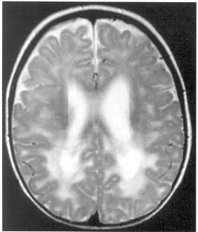
Prenatal diagnosis – [VLCFA] in amniotic fluid cells or chorionic villus sampling.

Treatment
- Dietary treatment:
- dietary avoidance of VLCFA does not lead to biochemical change because of endogenous synthesis.
- Lorenzo's oil (4:1 mixture of glycerol trioleate and glycerol trierucate) lowers endogenous VLCFA synthesis → normalized [VLCFA] in plasma within 4 weeks;
N.B. this biochemical change does not have clinical correlate!
  - neurologically intact patients → possibly reduced frequency and severity of subsequent neurological disability.
  - symptomatic patients - results are disappointing.
- Bone marrow transplants before neurologic deterioration.
- Steroid replacement (at least, during stressful periods) for adrenal insufficiency.

- immunosuppression (with cyclophosphamide) does not alter clinical course.

Metachromatic Leukodystrophies (s. sulfatide lipidoses)
- most common leukodystrophy! see table above >>, also p. 759 >>, p. 761 >>

Pathophysiology
- metachromatic - staining properties of accumulating lipid sulfatides (brown hue with toluidine blue rather than usual blue of myelin).
- autosomal recessive lysosomal enzymatic defect - arylsulfatase-A (myelin catabolism enzyme) in 22q13.3-qter.
- sulfatides accumulate in lysosomes of:
- oligodendrocytes and Schwann cells → demyelination.
- kidneys, pancreas, adrenal glands, liver, gallbladder.

Arylsulfatase has 3 isoenzymes - A, B, and C.
  - multiple sulfatase deficiency (mucopolysaccharidosis) - markedly reduced activity of arylsulfatases A and B.

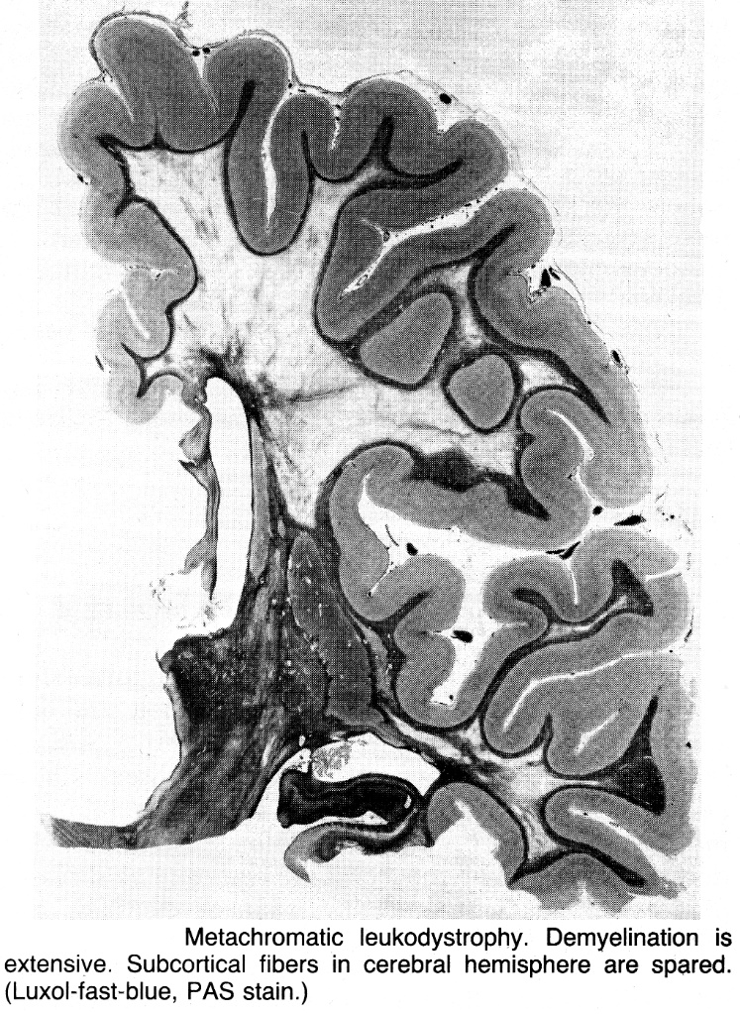

Clinical Features
Classical late infantile form (onset at 18-24 months → subacute decline over 6-12 months): megalencephaly, intellectual deterioration, seizures, peripheral neuropathy, ataxia, gait disturbance, hypotonia, bulbar signs.
  - in terminal stage, switching point occurs: hypotonia → hypertonia (frank spasticity), involuntary movements.
  - patients die by 5-10 years of age (some reach vegetative trough and live well into their teens).

Juvenile form (onset at 4-10 years): bradykinesia and poor school performance (daydreaming, confusion, emotional lability) → spastic gait, ataxia, extrapyramidal dysfunction, increased myotactic reflexes, generalized convulsions.
- deterioration is usually chronic (often not bedridden even 5-10 years after onset) - live for ≥ 20 years.

Adult form (onset after puberty): personality and mental changes → slowly progressive frank dementia, psychosis → pyramidal & cerebellar changes.
- no peripheral neuropathy.

Diagnosis
- CSF protein 150-300 mg/100 ml with no qualitative abnormalities.
- arylsulfatase-A activity↓ in urine or in leukocytes.
  - carriers have activity 25-50% of normal.
  - heterozygotes have activity 10 times more than patients.
N.B. patients with genetic deficiency of sulfatide activator protein (required for arylsulfatase A) may have MLD, but commonly used enzyme assays may fail to diagnosis this.
- metachromatic granules in urine.
- decreased nerve conduction velocities!!!
- metachromatic material in nerve biopsy.

Adult MLD
A. CT - open arrows indicate symmetrical lesions of markedly decreased absorption in white matter.
B. T₂ -MRI - black arrow shows confluent hyperintense signal in diseased white matter. So shrunken is this ribbon of white matter that gyri now extend down next to ventricle (open arrows).
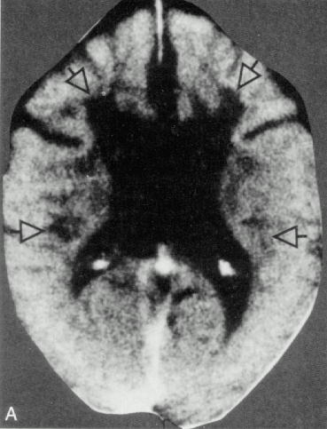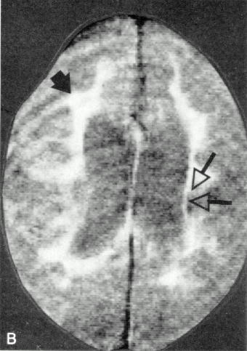

Treatment
- bone marrow transplantation.

Globoid Cell Leukodystrophy (s. Krabbe disease)
see p. 759 >>, p. 761 >>
- distributed worldwide; no gender, racial, or ethnic proclivities.
Pathophysiology
- autosomal recessive lysosomal enzymatic defect - galactocerebroside-β-galactosidase, s. β-galactocerebrosidase (gene on chromosome 14) → accumulation of galactose cerebroside, psychosine (s. galactose sphingosine)*.
*cytotoxic compound that causes oligodendrocyte injury
- myelin loss in CNS & PNS.  - white matter is atrophic and gliotic (firm-rubbery on palpation).  - globoid cells (found deep in white matter around and within vessels) are of two types (equally important in pathogenesis):  - Epithelioid cells - round, medium size, mononuclear.  - Globoid bodies – large (20-50 μ), irregular, often multinucleated.  - cytoplasm stains positively with PAS and only faintly with Sudan black.  - no metachromasia!  - electron microscopy - electron-dense granules within cytoplasm (fine filaments in both electron-dense linear or curved tubular profiles is distinctive sign in Krabbe's disease). | 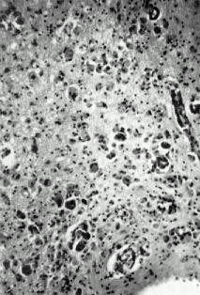
- PNS involvement (segmental demyelination) varies; histiocytes with foamy cytoplasm and tubular inclusions are present instead of globoid cells.

Clinical Features
- purely neurological syndrome (vs. other leukodystrophies).
Patients are normal at birth!
Classic infantile form (onset at 3-8 months): irritability, intermittent fever, episodic limb or trunk rigidity, heightened startle responses, feeding problems, vomiting, seizures → severe hypertonus with obvious opisthotonos.
- by 9 months of age, blindness (optic atrophy), deafness, decerebrate vegetative state.
- death at age ≈ 2 years.
Late-onset form (onset in infancy, childhood, or even in adult life) - extremely uncommon!: cortical blindness, optic atrophy, pyramidal spasticity, slowly progressive dementia.
- rate of regression is relatively slow.

Diagnosis
- enzymatic assays:
Disease or carrier state - assays on WBC, serum, fibroblasts.
Prenatal diagnosis - assays of amniotic fluid.
- CSF protein↑
- CT - periventricular hyperdensities.
- MRI - white matter involvement of cerebrum & cerebellum.
- nerve conduction velocities↓

Treatment
- no curative treatments; various attempts to enhance enzyme activity:
- liposomes containing beta-galactosidase.
- bone marrow transplantation.

Pelizaeus-Merzbacher disease
- sudanophilic leukodystrophy with almost total absence of normal myelination.
Pathophysiology
Classic form - mutations in proteolipid protein (PLP) gene (Xq21.3-q22);
  - PLP (integral membrane protein) accounts for 50% of CNS myelin proteins.
  - PLP holds outer myelin leaflets together at intraperiod line.
N.B. one mutation in this gene causes variant as familial spastic paraplegia (SPG2)
- tigroid pattern in CNS (on myelin stains) - patches of oligodendrocyte loss with sudanophilic demyelination interspaced with perivascular islands of relatively intact myelin
islands of spared myelin against nonmyelinated background
- no sparing of U-fibers!
- axons and neurons are usually well preserved.
- peripheral nerves are well myelinated!

Clinical Features
Classic form
- more prominent in males.
- onset in first few months of life: slow, rotary “cogwheel” nystagmus (nearly diagnostic!) and head tremor → ataxia, attention tremor, choreoathetosis, spasticity, dysarthria, optic atrophy, seizures, mild degree of dementia.
- by school age, affected boy is usually mute and confined to wheelchair → little further deterioration.
- death is delayed until early adulthood (from intercurrent illness).

Variants
Connatal form (Seitelberger disease) - more severe than classic form (brain, cerebellum, brain stem, and spinal cord are essentially devoid of myelin); present at birth; death within first year of life.
Transitional form – intermediate severity between classic and connatal forms; death by 5-10 yrs.
Adult form (Löwenberg-Hull disease) - very slow course, no ocular abnormalities, characteristic episodic psychotic events.

Diagnosis
- CT – hypomyelination (resembles immature brain), cerebellar atrophy.
- MRI:
- persistent myelin islands
- reversal of normal gray-white matter signal relationships consistent with dysmyelination.
- low-intensity signals from lentiform nucleus (iron deposition).
- normal CSF protein!
- normal nerve conduction velocities!
- diagnosis can be made by cerebral biopsy.
- prenatal diagnosis (in family with known mutation) - DNA analysis of chorionic villi samples.

Treatment
- no curative therapy.

Canavan disease (s. Spongy Degeneration of nervous system)
- spongiform leukoencephalopathy.
Pathophysiology
- aspartoacylase deficiency (gene on 17p) → N-acetylaspartic acid accumulation.
- changes are limited to white matter (extensive demyelination); axonal fibers and oligodendroglia are not extensively affected.
- vacuoles (excessive fluid accumulation) in variety of brain cells (esp. astrocytes) - spongy appearance.
- gigantic abnormal mitochondria (dense filamentous granular matrix and distorted cristae) in watery cytoplasm of hypertrophied astrocytes (Alzheimer type II astrocytes).
- brain is enlarged (increased water content) – megalencephaly.
- vacuoles enlarge and split myelin sheath to form cysts that communicate with extracellular space → extensive demyelination → extensive gliosis.

Clinical Features
Classic infantile form - occurs predominantly in Ashkenazi Jews and Saudi Arabians.
- begins within few months of birth: megalencephaly, apathy, hypotonia → spasticity, decorticate and decerebrate posturing, seizures, optic atrophy, dysautonomia.
- death in vegetative state by 3-4 years of age.

Neonatal form - deadly within few weeks (lethargy, hypotonia, diminished spontaneous movement, dysphagia).

Juvenile form (onset after 5 years of age): ataxia, tremor, ptosis, dementia, progressive cerebellar symptoms, spasticity, loss of vision.
- other organ systems are sometimes involved (diabetes mellitus, hyperaldosteronism, heart block).
- extends into adolescence.

Diagnosis
- N-acetylaspartate in plasma & urine.
- enzyme deficiency in cultured skin fibroblasts.
- CT & MRI – enlarged brain, increased lucency of white matter, poor demarcation of gray and white matter → severe brain atrophy (with ventricular enlargement and gaping sulci).
- CSF and nerve conduction velocities are normal.
- prenatal diagnosis and carrier detection by DNA analysis are available in > 90% cases.

Treatment
- no curative therapy.
- generous use of antiepileptic drugs and antibiotics.

Cockayne syndrome
- progressive multisystem disease.
- mutation in ERCC8 gene (important in DNA excision repair).

Pathophysiology
- no consistently specific biochemical abnormalities.
- tigroid pattern of patchy demyelination among preserved islands of myelin (similar to Pelizaeus-Merzbacher disease).
- brain is small (< 500 g) with extremely thin (atrophic) white matter.
- calcifications in globus pallidus & cerebellum, mineralization of small arteries.
- cerebral cortex may contain diffuse proliferation of bizarre multinucleated astrocytes.
- PNS - segmental demyelination with preservation of axons.
- pronounced involvement of multiple systems!!!

Clinical Features
- normal at birth.
- onset at 6-12 months.
- most survive at least into 2nd decade.

  - skin - photosensitive dermatitis.
  - CNS - mental retardation (most do not speak, but pleasant personality), progressive UMN & cerebellar dysfunction, normal-pressure hydrocephalus, neural deafness.
  - bones - peculiar cachectic appearance with facial-somatic dysplasia (extreme dwarfism, arresting facies with large ears, long aquiline beaklike nose, deep set eyes, thin lips, jutting chin, loss of severely carious teeth, microcephaly, kyphosis, joint deformities);
    - abnormally advanced bone age.
    - body proportions, although miniature, are appropriate for child's age.
    - shedding of deciduous teeth and puberty occur on time (although testes and breasts are underdeveloped).
  - eyes - retinitis pigmentosa, optic atrophy, lenticular cataracts, corneal opacities, impaired lacrimation.
  - anomalies of renal function.

Diagnosis
- neuroimaging - stippled calcification of basal ganglia and cerebellum.
- CSF protein may be elevated.
- nerve conduction velocity↓.
- skin fibroblasts show defective DNA repair when exposed to UV light.

Treatment
- treatment of normal pressure hydrocephalus (when it occurs) may be beneficial.

Alexander disease
- degenerative disorder of unknown origin.
Pathophysiology
- dysfunction of astrocytes.
- Rosenthal fibers - elongated hyaline, eosinophilic inclusions found exclusively in astrocytic footplates.
- contain B-crystal protein.
- distributed throughout most of brain (particularly numerous in subpial, subependymal*, and perivascular locations). *may obstruct cerebral aqueduct
- Rosenthal fibers are not pathognomonic (occur in pilocytic astrocytomas, craniopharyngiomas).
- although astrocytes are distended, there is no evidence of abnormal storage material within neurons.
- CNS demyelination in regions rich in Rosenthal fibers – may be secondary event!; axon cylinders are preserved.
- myelin loss is most severe frontally (characteristic frontal-to-occipital gradient).
- demyelination of centrum semiovale is so severe that it may lead to cavitation.
- PNS is not involved.

Clinical Features
Classic infantile form (onset at 6 months of age)
- psychomotor retardation → progressive spasticity, unresponsive seizures, megalencephaly (due to enlarged brain ± frank hydrocephalus*).
*obstruction of aqueduct of Sylvius by Rosenthal fibers
- no optic atrophy!
- most die in vegetative state; average disease duration 2-3 years.

Juvenile form (onset at 7-14 yrs of age)
- bulbar and pseudobulbar dysfunction, nystagmus, ptosis, full facial palsy, tongue atrophy.
- mentation tends to remain intact!!!
- no seizures.
- average disease duration 8 years.

Adult form (onset in young adults) - clinically resembles MS (blurred vision, spasticity, nystagmus, dysarthria, dysphagia).

Diagnosis
- CT - marked demyelination with frontal predominance (frontal to occipital gradient) with increased subependymal (periventricular) density:
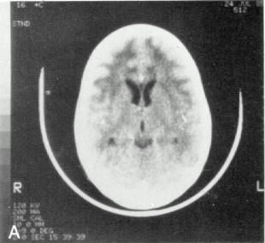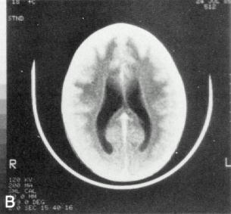

Treatment
- supportive care (good nutrition, generous use of antibiotics and antiepileptics).

Bibliography for ch. “Demyelinating Disorders” → follow this link >>

Viktor’s Notes℠ for the Neurosurgery Resident
Please visit website at www.NeurosurgeryResident.net

