Metabolic Demyelinations
Last updated: September 5, 2017
Demyelination of Corpus Callosum (Marchiafava-Bignami disease) 1
Central Pontine Myelinolysis 1

Demyelination of Corpus Callosum (Marchiafava-Bignami disease)
- primary degeneration of corpus callosum.
- first described by Marchiafava and Bignami in 1903.
- > 100 cases have been reported.
- frequent reports in Italian men (genetic predisposition?).

Etiology
- not known; possible causes / risk factors:
  - longstanding alcoholism (may have common pathogenesis with central pontine myelinolysis or Wernicke encephalopathy)
  - nutritional deficiencies
  - toxic factors

Pathophysiology
Noninflammatory demyelination → necrosis of middle lamina of corpus callosum (dorsal and ventral rims are spared!).
Constant bilateral symmetry!
    - necrosis varies from softening & discoloration to cavitation & cyst formation.
    - rostral position of corpus callosum is affected first.
    - small symmetric lesions extend and become confluent.
- other CNS areas may be involved: anterior commissure, posterior commissure, centrum semiovale, subcortical white matter, long association bundles, middle cerebellar peduncles.
- spared structures: internal capsule, corona radiata, subgyral arcuate fibers, gray matter.
- microscopy - sharply defined necrotic process with myelin loss; relative preservation of axis cylinders in periphery of lesions;
- no inflammation!
- fat-filled phagocytes are common.
- gliosis is not well advanced.

Medial necrosis of corpus callosum and anterior commissure with sparing of margins: | 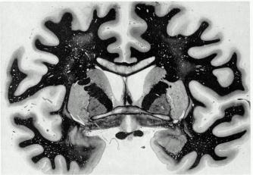
Clinical Features
- onset - middle age or elderly.
- symptoms are insidious & nonspecific (only scarcely explained by callosal lesions) - multifocal & diffuse neurologic signs:
- transient focal neurological deficits (frontal release signs)
- cognitive and behavioral (progressive dementia, depression and extreme apathy, confusion, manic, paranoid, or delusional states).
- seizures
- altered mental status (stupor → coma → death).
- slowly progressive → death within 3-6 years.

Diagnosis
CT / MRI - typical symmetric demyelinating callosal lesions.

Treatment
- no known therapy.

Central Pontine Myelinolysis
Pathophysiology
- acute symmetric noninflammatory demyelination in central basis pontis.
- demyelination and associated reduction in oligodendroglia; relative preservation of axons and surrounding neurons (lesions resemble Marchiafava-Bignami disease).
- in 10% cases, demyelination also occurs in extrapontine regions (midbrain, thalamus, basal nuclei, cerebellum; never below pontomedullary junction; rarely supratentorially).
- hypothesis - in regions of compact interdigitation of white and gray matter, cellular edema (caused by fluctuating osmotic forces) compresses fiber tracts → demyelination.
  - during prolonged hyponatremia, concentration of intracellular charged protein moieties is altered; reversal cannot parallel rapid correction of electrolyte status.

Etiology
Predisposing conditions:
- alcoholism
- liver disease, orthotopic liver transplantation surgery
- malnutrition (esp. after burns)
Cause - too rapidly corrected severe and prolonged (< 120 mEq/L for > 48 hours) hyponatremia (osmotic myelinolysis).

Clinical Features
  - Locked-in (horizontal gaze paralysis + pseudobulbar palsy + spastic quadriplegia)
  - Preserved functions: sensory modalities, vertical eye movements, blinking, breathing, alertness.
  - if demyelination extends through midbrain → vertical ophthalmoparesis.
  - if demyelination extends to pontine tegmentum and/or thalamus → delirium, coma.

Typical scenario:
- severe hyponatremia is diagnosed in person with delirium.
- IV fluid therapy is administered, and serum [Na⁺] is normal by next day.
- mental status improves, but is followed by neurologic deterioration 48-72 hours later.
- maximum recovery may require several months; full recovery has been reported.
- death is common within days or weeks.

Diagnosis
- CSF - increased opening pressure, protein↑, mononuclear pleocytosis.
- EEG - diffuse bihemispheric slowing.
- T2-MRI (imaging modality of choice) - hyperintense bright areas (water content↑) in central pons sparing peripheral rim; later central lesion diminishes in size and signal, and mild pontine atrophy may result. 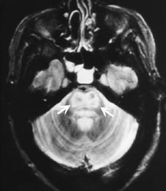 | 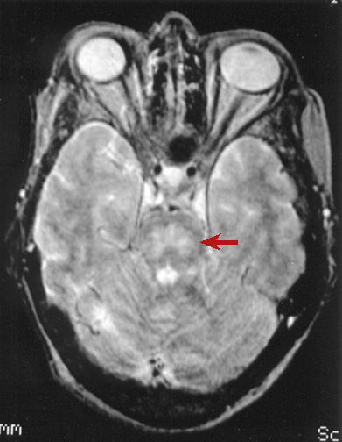

Treatment
- supportive only.
- correct hyponatremia at 10 mmol/L/24 h + free water restriction.
- vitamin supplementation for alcoholic patients.

Bibliography for ch. “Demyelinating Disorders” → follow this link >>

Viktor’s Notes℠ for the Neurosurgery Resident
Please visit website at www.NeurosurgeryResident.net

