CNS Demyelination (GENERAL)
Last updated: September 5, 2017
Common features of CNS demyelination disorders 1
Incidental white-matter hyperintensities 1
Diagnostic algorithm of pediatric onset demyelinating disorders 1

- Demyelinating (s. myelinoclastic) diseases - destruction of normal myelin - many acquired neurologic disorders.
- Dysmyelinating diseases - inadequate myelin formation or maintenance - many congenital metabolic disorders.

N.B. CNS myelin (formed by oligodendroglia) differs chemically and immunologically from PNS myelin (formed by Schwann cells), but both types have same function - to promote transmission of neural impulse along axon.

Idiopathic (presumably autoimmune)
Recurrent / chronically progressive demyelination – most common CNS demyelination disorders:
- Multiple sclerosis
- Multiple sclerosis variants:
  - neuromyelitis optica (s. Devic disease)
  - concentric sclerosis (s. Baló disease, encephalitis periaxialis concentrica)
  - Marburg variant of MS - clinically fulminant MS form
  - Schilder disease (s. encephalitis periaxialis diffusa, diffuse sclerosis)
Monophasic demyelination (may be first clinical episode of multiple sclerosis!):
- Optic neuritis
- Acute transverse myelitis
CNS complications of viral infections / vaccinations:
- Acute disseminated encephalomyelitis (ADEM)
- Acute necrotizing hemorrhagic encephalomyelitis (ANHEM)

Leukodystrophies - inherited disorders that affect myelin synthesis / turnover:
Primarily affecting CNS myelin:
- Adrenoleukodystrophy
- Pelizaeus-Merzbacher disease
- Spongy degeneration (s. Canavan's disease)
- Alexander's disease
CNS-PNS myelin:
- Metachromatic leukodystrophy
- Globoid cell leukodystrophy (s. Krabbe's disease)
- Cockayne’s syndrome

Viral infections
- Progressive multifocal leukoencephalopathy (JC virus infection of oligodendrocytes)
- Subacute sclerosing panencephalitis (measles virus infection of neurons and glia)
- Human T-cell lymphotropic virus type I -associated myelopathy.

Nutritional disorders
- Combined systems disease (s. vit. B₁₂ deficiency)
- Demyelination of corpus callosum (s. Marchiafava-Bignami disease)
- Central pontine myelinolysis

Anoxic-ischemic sequelae
- Delayed postanoxic cerebral demyelination
- Progressive subcortical ischemic encephalopathy

Common features of CNS demyelination disorders
  - affect young adults
  - inflammation + selective destruction of CNS myelin (with relative preservation of axons and PNS)
  - clinical deficits are due to:
    - effect of myelin loss on transmission of electrical impulses.
    - limited capacity of CNS to regenerate normal myelin.
    - secondary damage to axons.
  - no specific tests; diagnosis is based on distinctive clinical patterns of CNS injury.

Demyelination may have either negative or positive effects:
Negative conduction abnormalities - slowed axonal conduction, variable conduction block (in response to raised temperature or with metabolic changes in extracellular milieu) → fluctuations in function that vary from day to day, worsenings with body temperature elevation.
Positive conduction abnormalities - ectopic impulse generation (spontaneously or following mechanical stress), abnormal "crosstalk" between demyelinated axons → Lhermitte's symptom, paroxysmal symptoms, paresthesia.

Incidental white-matter hyperintensities
- focal white-matter hyperintensities, often multiple.
- in deep parietal white matter.
- seen in up to 24% of men.
- no clinical significance - no associations with neurological abnormalities, CD4 count, alcohol or drug use, hypertension or smoking.

Diagnostic algorithm of pediatric onset demyelinating disorders
Abbreviations: ADEM = acute disseminating encephalomyelitis; CIS = clinically isolated syndrome; CRION = chronic relapsing inflammatory optic neuropathy; NMO = neuromyelitis optica; RRMS = relapsing-remitting MS.
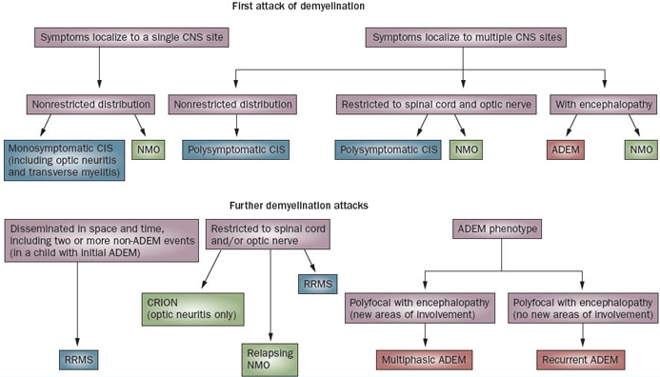

Bibliography for ch. “Demyelinating Disorders” → follow this link >>

Viktor’s Notes℠ for the Neurosurgery Resident
Please visit website at www.NeurosurgeryResident.net

