Neural Tube Disorders (s. Dysraphism)
Last updated: January 16, 2021
Classification 1
Etiopathophysiology 1
Theories 1
Etiology 1
Epidemiology 1
Classification, Pathology, Clinical Features 1
Cranioschisis 1
Encephalocele (s. Cephalocele) 2
Spina Bifida 3
Myelomeningocele 4
Diagnosis 5
Prenatal diagnosis 5
Postnatal diagnosis 5
Management 6
Encephaloceles 6
Myelomeningocele 6
Meningocele 6
Prognosis 6
Prophylaxis 6
Neurenteric Cyst, Epidermoid Cyst, Dermoid Cyst → see p. Onc30 >>

Neural Tube Disorders (s. neurulation defects, s. dysraphia) – most common CNS malformations!

Classification
→ see p. Dev1 >>

Etiopathophysiology
embryology → see p. A13 (1) >>
Theories
- reopening of closed neural tube – questionable.
- nonclosure (failure of neural folds to come together) – probably correct theory!
- normal closure begins on 20th day after fertilization and is complete by 28th day – i.e. ≈ 1-2 weeks beyond expected normal menstrual cycle - women is frequently unaware that she is pregnant during this critical time!

Etiology
– classic multifactorial;
  - epidemiological-experimental investigations have failed to identify obvious source.
  - genetic factors certainly play important role in at least conferring predisposition (monoallelic disorders are occasionally associated with neural tube defects).
  - at least in cranial region, neural tube closure occurs not in single continuous closure but at multiple sites and in coordinated pattern - each defined site is under control of different genes (susceptible to different factors).

Epidemiology
- among most common major malformations (0.001-1% of all human malformations).
- incidence - overall decline in past decades.
Myelomeningocele – 1 in 1000* live births – most common anomaly of nervous system!
*3-4 in 1000 in England, Ireland, Scotland, and Wales
Encephalocele – 1 in 5000-10000 live births.
Anencephaly – 0,1-1 in 1000 live births (greatest frequency is in Ireland and Wales)

Risk factors:
  - maternal hyperthermia
  - maternal diabetes
  - anticonvulsants (esp. valproic acid – causes dysraphism in 1-2% patients, carbamazepine)
  - previous infant / fetus with neural tube defect (risk increases 10-fold)
  - low socioeconomic status.

Classification, Pathology, Clinical Features
All cases involve bone / soft tissues ± underlying neural tissue. see p. Dev1 >>

Cranioschisis
Anencephaly (“absence of head”) - cranial neuropore closure defect (develops at ≈ 28th day of gestation) - absence of brain and calvarium; no epidermal covering.
- vast majority of cases show complete absence of most of brain.
  - anterior pituitary, eyes, brainstem are usually spared.
  - spinal cord pyramidal tracts are missing due to absence of cerebral cortex.
- neural epithelium is present in embryo, but direct contact with amniotic fluid results in degeneration of neural epithelium.
- remaining tissue covering basal cranium is highly vascular and friable membrane (area cerebrovasculosa).

Clinical Signs
- polyhydramnios.
- neurological function is limited to brainstem & spinal reflexes (seizures, at times resembling infantile spasms, have been observed in some infants).
- significant proportion are stillborn; infants who are born alive do not survive (survival can be prolonged with life support systems, creating controversy over use of anencephalic infants as organ donors).

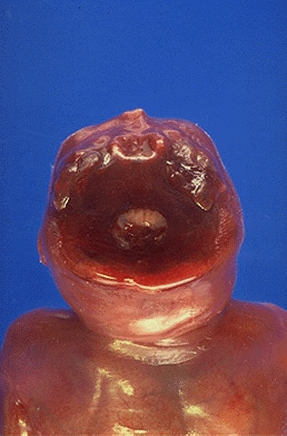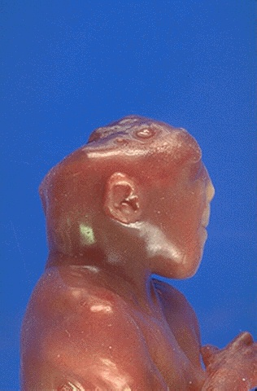
Source of pictures: “WebPath - The Internet Pathology Laboratory for Medical Education” (by Edward C. Klatt, MD) >>

"Area cerebrovasculosa" from skull base - scattered primitive neuroglial tissue elements within irregular vascular proliferation:
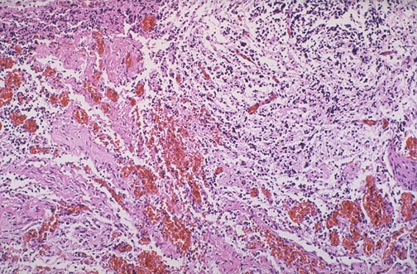
Source of picture: “WebPath - The Internet Pathology Laboratory for Medical Education” (by Edward C. Klatt, MD) >>

Exencephaly – defect in calvarium (dura, bone, skin) – exposed brain (degenerated due to exposure to amniotic fluid):
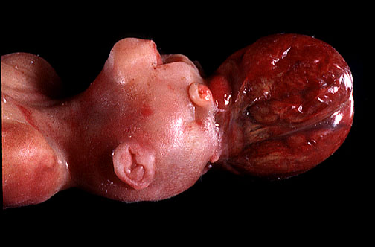

Cranium Bifidum - encephaloceles, cranial meningoceles - defect in skull & dura (but often intact epidermal covering!; vs. anencephaly, myelomeningocele) with protrusion of:
  - leptomeninges (cranial meningocele)
  - leptomeninges and underlying brain tissue (encephalocele); neural tissue (cerebral, cerebellar) within encephalocele is often abnormal and ischemic.
- in few cases portions of ventricles are also included - encephalocystocele.
- transillumination of sac may indicate presence of neural tissue within.
- incidence - 1:5 ratio to MMC.

Encephalocele (s. Cephalocele)
Pathogenetic theories:
- cranial neuropore closure defect
- correct theory - mesenchymal defect → local herniation of fully neurulated neural tissue (at 8-12 weeks of gestation).

Pathogenetic theory for acquired cephaloceles in adults - most commonly associated either with trauma (incl. iatrogenic) or increased ICP (most common locations - where bone is already thin - tegmen tympani, middle fossa into sphenoid sinus).

Location (usually midline):
occipital encephaloceles (85% in North America) - often large and have variable contents
  - Meckel-Gruber syndrome - rare autosomal recessive condition: occipital encephalocele, microcephaly, microphthalmia, cleft lip / palate, abnormal genitalia, polycystic kidneys, polydactyly.
  - Walker-Warburg syndrome - autosomal recessive congenital muscular dystrophy. see p. Mus5 >>

anterior encephaloceles:
- most common isolated malformation in southeast Asia.
- Robert's syndrome
parietal encephaloceles – less common.
sphenoidal encephaloceles – endocrine dysfunction.

Classification (Suwanwela and Suwanwela)
      - Occipital: often involves vascular structures
      - Cranial vault (comprises ≈ 80% of encephaloceles in Western hemisphere):
  - interfrontal
  - anterior fontanelle
  - interparietal: often involves vascular structures
  - temporal
  - posterior fontanelle
      - Fronto-ethmoidal s. sincipital (15% of encephaloceles); external opening into face in one of the following 3 regions:
- nasofrontal: external defect in the nasion
- naso-ethmoidal: defect between nasal bone and nasal cartilage
- naso-orbital: defect in the antero-inferior portion of medial orbital wall.
      - Basal (1.5% of encephaloceles; the only group that does not produce a visible soft tissue mass; may present as CSF leak or recurrent meningitis; may be associated with other craniofacial deformities, including: cleft lip, bifid nose, optic-nerve dysplasia, coloboma and microphthalmia, hypothalamic-pituitary dysfunction):
- transethmoidal: protrudes into nasal cavity through defect in cribriform plate
- spheno-ethmoidal: protrudes into posterior nasal cavity
- transsphenoidal: protrudes into sphenoid sinus or nasopharynx through patent craniopharyngeal canal (foramen cecum)
- fronto-sphenoidal or spheno-orbital: protrudes into orbit through superior orbital fissure.
      - Posterior fossa: usually contains cerebellar tissue and ventricular component.

Clinical Features
- protuberant mass that may be pulsatile (except basal encephaloceles); size of encephalocele varies: barely visible bulge* ÷ larger than infant's head.
*may resemble cephalhematoma
- neurological deficits correlate with extent of cortex that is herniated into cele: motor deficits, visual defects, psychomotor developmental delay.
- malformed cortex (within / adjacent to cele) → seizures.
- frequently associated with other intracranial abnormalities (e.g. hydrocephalus!, agenesis of corpus callosum, Dandy-Walker malformations, holoprosencephaly).
- prognosis is good for many patients.
N.B. encephaloceles that contain large amount of neural tissue have poor prognosis!

Nasal glioma (misleading term - not neoplasm!; better term - nasal glial heterotopia) - form of frontonasal encephalocele with no clear bony defect - may not be immediately obvious on external examination.
- may present as intranasal mass (CSF rhinorrhea following removal of nasal polyp vs. Greenberg states that it does not communicate with subarachnoid space), pharyngeal obstruction, or recurrent meningitis.
- can be associated with hypertelorism, median cleft lip, hypothalamic dysfunction.
- requires immediate imaging and prophylactic antibiotics → surgical repair.

A nasal polypoid mass in a newborn is an encephalocele until proven otherwise!

Spina Bifida
- most common form of neural tube defects!
- mostly occurs in lumbar region, followed by lumbosacral region (can also be located in cervical, thoracic, or sacral regions).
- spinal dysraphism is occasionally associated with other spinal defects (tethered spinal cord, spinal lipomas, sacral teratomas).

  - Spina bifida occulta - defect in vertebral arch without any other associated defect (i.e. without involvement of cord or meninges; skin is intact over malformation).
- most commonly - L₅ & S₁ (up to 24% of population!), C₁, Th₁.
- defect is nearly always narrow and asymmetric.
- asymptomatic or subtle clinical signs - cutaneous markings in midline of back (mark defect location): tuft of hair, cutaneous angioma or lipoma; rarely, sinus tract may communicate from skin to underlying dura.
- no clinical significance* - often found incidentally on radiographic studies.
*occasionally associated with more significant spinal abnormalities (e.g. syringomyelia, diastematomyelia, tethered cord)
- does not seem to increase risk of neural tube malformations in that individual's progeny.

  - Spina bifida manifesta (s. aperta, cystica) - defect in vertebral arch plus:
- meningocele - involves meninges alone (i.e. postneurulation disorder - neural elements are intact)
- transilluminating protruding / herniating meningeal sac is covered by skin; may be asymptomatic!
- meningocele distends with crying.
Atypical meningoceles (differentiate from dural ectasias in spondyloarthropathies):
  - anterior sacral meningocele – presacral cystic mass projecting into pelvis through anterior eccentric defect in sacrum* → constipation, bladder dysfunction, anomalies of female genital tract (e.g. rectovaginal fistula, vaginal septa).
*pathognomonic scimitar [riestas rytietiškas kardas] appearance on plain X-ray
  - intrasacral meningocele – sacral canal is expanded by meningocele which lies below normal level of termination of thecal sac.
  - lateral thoracic meningocele – intrathoracic posterior mediastinal mass through eroded intervertebral foramen; occurs (70-85%) in association with neurofibromatosis.
  - anterior thoracic meningocele with ventral spinal cord herniation; midsagittal MRI - spinal cord is displaced sharply forwards in contact with vertebral body at or very near intervertebral disc.

- myelomeningocele (most common derangement of neurulation!) - involves meninges and underlying spinal cord; no skin covering over defect.

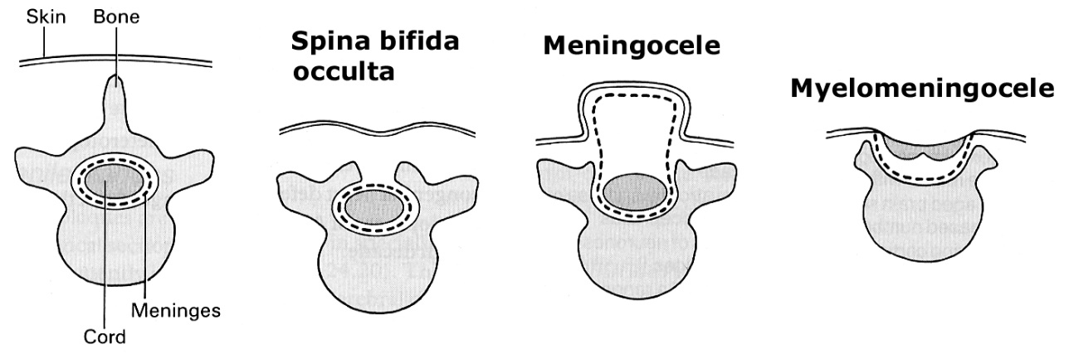

Myelomeningocele
Greatest disability of spinal dysraphism!
Pathology:
- focal segment of spinal cord fails to roll up and form tube (most commonly - failure of closure of caudal neuropore) - neural folds persist as flat plate of tissue referred to as neural placode.
- since neural tube does not fuse, cutaneous ectoderm does not come to cover neural tube (remains attached and lateral to neural plate, leaving cutaneous defect) - raw, exposed dorsal surface of neural placode represents tissue that should have formed interior of spinal cord (i.e. filleted spinal cord with visibly open central canal).
- CSF exiting from proximally formed central canal floods dorsal surface of placode.
- surrounding neural placode is thin layer of skin and arachnoid tissue, below which is subarachnoid space; enlarged subarachnoid space ventral to placode results in dorsally protruding sac on which neural placode is visible.
- nerve roots lie inferior to neural placode, with ventral roots lying medial to dorsal roots (i.e. dorsal roots exit from anterior surface of spinal cord just lateral to ventral roots).
- spinal cord is always tethered!

Transverse section through myelomeningocele: arrows demonstrate junction of neural placode (N) with dura mater and skin; subarachnoid space (S):
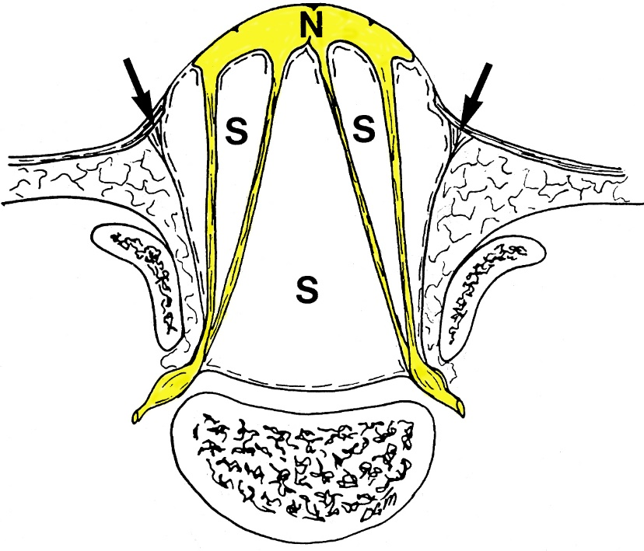
Source of picture: David C. Sabiston “Sabiston Textbook of Surgery: the Biological Basis of Modern Surgical Practice”, 15th ed. (1997); W.B. Saunders Company; ISBN-13: 978-0721658872 >>

Level of defect: thoracolumbar junction (45%) > lumbar (20%) > lumbosacral (20%*) > sacral (10%) > more rostral locations (5%).
*according to Nelson – 75% cases are lumbosacral; according to Grainger – 80-90%

Clinical Features:
- Saclike cystic structure covered by thin layer of partially epithelialized tissue.
- remnants of neural tissue are visible beneath membrane, which may occasionally rupture and leak CSF.
- Spinal cord dysfunction:
  - flaccid paralysis & sensory deficits below level of lesion:
defects above L₃ - deficits preclude ambulation (wheelchair dependent);
defects between S₁ and L₃ - assisting devices may allow ambulation;
defects below S₁ - unaided ambulation.
  - GU tract involvement (≈ 90% patients) - constant urinary dribbling, relaxed anal sphincter.
- Superimposed infection (sac rupture → meningitis; UTI)
- 75% patients have normal intelligence.
- Other defects along neuraxis and surrounding mesoderm:
  - Chiari II (s. Arnold-Chiari) malformation – most common (> 95%) finding associated with myelomeningocele! – most common cause of death!
  - hydrocephalus (80-95%; esp. with myelomeningoceles in lumbosacral region) - ventricular outlet obstruction and obliteration of posterior fossa subarachnoid cisterns are likely causes.
  - lückenschädel (> 50% cases) - regional thinning of cranial bones (radiographic and transilluminative lucencies); rarely found after 2 years of age.
  - platybasia.
  - cerebral hemisphere malformations - enlarged massa intermedia (frequent finding), agenesis of corpus callosum, polymicrogyria, pachygyria.
  - diastematomyelia, diplomyelia.
  - skeletal deformities (kyphosis, scoliosis, dislocated hips, clubfeet, Klippel-Feil syndrome) – esp. in defects above L₃ – due to intrauterine paralysis.

N.B. patients with myelomeningocele in upper thoracic ÷ cervical region usually have very minimal neurologic deficit and in most cases do not have hydrocephalus!

Late complications of myelomeningoceles:
- Scoliosis (esp. with lesions above L₃)
- Traction on cord.
- Urological complications - continue to be leading cause of morbidity in myelomeningocele!

Usual causes of death: loss of renal function, shunt complications.

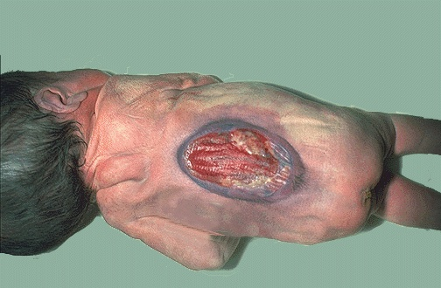
Source of picture: “WebPath - The Internet Pathology Laboratory for Medical Education” (by Edward C. Klatt, MD) >>

Lumbar myelomeningocele covered by thin layer of skin:
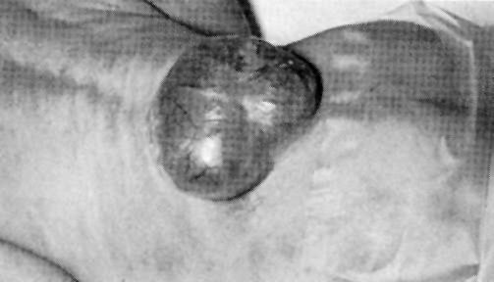

Myelomeningocele (arrow); note flaccid anal sphincter and poorly developed lower extremity musculature:
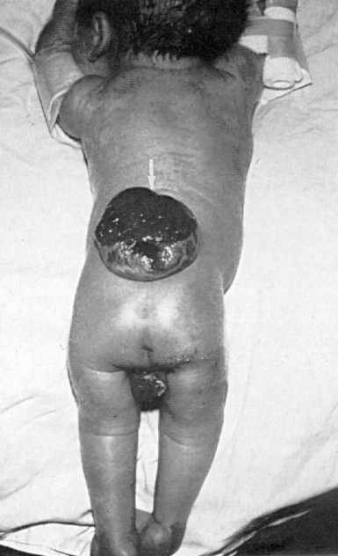

Diagnosis
Prenatal diagnosis
- Serum chemistry - through routine screening programs: see p. 71-72 (3) >>, p. 2700 >>
- serum α-fetoprotein (AFP)↑ - specificity is much lower than amniotic fluid; peak of sensitivity somewhat later than amniotic fluid (i.e. ≈ 16-18 weeks' gestation – normal AFP peak; before that time, levels may be normal).
- most common causes of false-positive AFP↑: incorrect dating of pregnancy, multiple gestation.
- further course is detailed (level II) ultrasound or amniocentesis.

- Amniotic fluid chemistry:
  - amniotic fluid α-fetoprotein (AFP)↑ (in almost all open neural tube defects, but also in gastroschisis, etc).
  - amniotic fluid acetylcholinesterase (AchE)↑ (only in almost all open neural tube defects).
Amniotic fluid AFP↑ + amniotic fluid AchE↑ - sensitivity for open defects ≈ 100% → detailed (level II) ultrasound

- Ultrasound - very high sensitivity at even 14-16 weeks' gestation.
- lemon sign (indirect sign) - symmetrical bifrontal narrowing of skull – risk of neural tube defects.

Postnatal diagnosis
- careful MRI (!) and CT.

Encephalocele
- ultrasound is most helpful in determining contents of sac.

Occipital encephalocele (MRI in newborn); at surgery, sac contained herniated dysplastic cerebellar tissue as well as CSF:
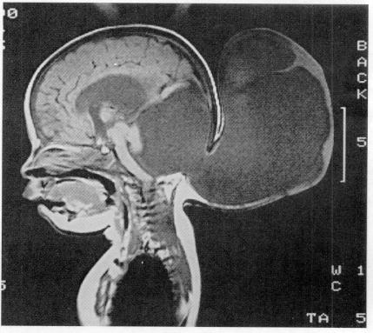
Spina bifida
- cervical spine – absence of cortical line on anterior surface of spinous process (on lateral and AP X-ray).
- lumbosacral spine – defect best seen on AP X-ray.

Myelomeningocele
- imaging is not necessary preoperatively – diagnosis is obvious clinically.
- do not overlook Chiari II, tethered spinal cord.
- every child must be screened for hydrocephalus (daily occipital-frontal circumference measurements and baseline transfontanellar ultrasound).
- orthopedic & urological assessment.

Lumbosacral myelomeningocele - MRI shows spinal dysraphism and tethered cord:
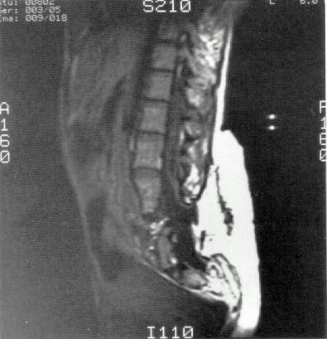

Meningocele
- US - subcutaneous cystic mass in continuity with spinal canal through bone defect.

Management
Prevention of meningitis / ventriculitis is extremely important (intellectual outcome is inversely related to occurrence of such complications) - antibiotic prophylaxis before and around time of surgery (esp. with open defects).

Atraumatic delivery (damaged CNS is more vulnerable to perinatal insults)
- prelabor Cesarian section significantly improves neurological outcome in large encephaloceles, myelomeningoceles.

Encephaloceles
Surgical management – as early as clinical conditions permit: more details – see p. Op300 >>
- Encephalocele contents:
- relocation into cranium
- resection (amputation)
- Watertight dural closure
- Bone grafting to cover calvarial defect (usually at later operation).

- indicated in most situations (exceptions – very small defects*, large defects with associated microcephaly) even if there are significant associated malformations**
*may decrease with time
**goal of surgery here - to simply improve caregiving for such infant.
- CSF leak → urgent surgery within 12-24 hours (to prevent meningitis).
- surgical prognosis is best in sporadic frontal encephaloceles; occipital encephaloceles are more commonly associated with hydrocephalus → worse cognitive outcome.
  - temporal encephalocele has high epileptogenicity - excellent outcome with resection and is commonly missed if not specifically looked for.

Myelomeningocele
- child is kept prone or in lateral recumbent position.
- defect is covered with warm saline-moistened nonadherent dressing (e.g. Telfa - to prevent injury and desiccation of neural placode).
- antibiotics (nafcillin + gentamicin), esp. if defect is leaking CSF; continue until clear that shunt is not needed.
- HUS then daily HC.
- genitourinary system evaluation.

Surgical management - closing all but prognostically worst cases. see p. Op250 >>

Conservative management
- urological management plays prominent role:
- regularly catheterize neurogenic bladder - avoid secondary dilatation of proximal urinary system → pyelonephritis, hydronephrosis.
- periodic urine cultures, assessment of renal function, renal imaging.
- some can become continent with implantation of artificial urinary sphincter at later age.
- incontinence of fecal matter is common and socially unacceptable (but does not pose same risks as urinary incontinence); many children can be "bowel-trained" with timed enemas or suppositories that allows evacuation at predetermined time once or twice day.
- ambulatory aids, orthopedic care.

Meningocele
Surgical repair – for cosmetic reasons: amputation of herniating sac, and closing dura; remainder of wound is closed in layers.
- prior to surgery, patient must be thoroughly imaged (MRI) for neural tissue involvement, if any, and associated anomalies.
- if CSF is leaking → immediate surgery (to prevent meningitis).

Prognosis
Recurrence rate for neural tube defect in subsequent pregnancy ≈ 3-5%*; raises to 7-10% after two previous abnormal pregnancies
*it is general recurrence risk for multifactorial disorders
Mortality rate:
myelomeningocele (treated aggressively) ≈ 10-15% (most deaths occur before 4 yrs).

Prophylaxis
    - Folate supplementation 4 mg/day before conception* and during early pregnancy (until 12th week).
*general diet fortification with folate in case of unplanned pregnancy
- esp. for women who have had infant / fetus with neural tube defect.
- folate mechanisms are poorly understood.

U.S. Public Health Service 1992 recommendation:
- all women of childbearing age capable of becoming pregnant must take 0.4 mg folate daily (dose should not exceed 1.0 mg/d to avoid secondary vit. B₁₂ deficiency).
- women who had pregnancy with in neural tube defect must take 4 mg folate daily (beginning 1 month prior to time pregnancy is planned).

    - Avoid heat exposure (esp. hot tub).

    - Change valproate to another anticonvulsant.

Bibliography for ch. “Developmental Anomalies” → follow this link >>

Viktor’s Notes℠ for the Neurosurgery Resident
Please visit website at www.NeurosurgeryResident.net

