Epilepsy
Last updated: February 8, 2023
Classification 3
Four‐dimensional epilepsy classification (Lüders 2019) 3
Semiology 3
Epileptogenic zone 4
Etiology 5
ILAE (2017) 5
Semiology (Clinical Manifestations) - Definitions 5
Seizure triggering factors 5
Motor 6
Elementary Motor 6
Automatism 7
Nonmotor 8
Aura 8
Sensory 9
Dyscognitive 9
Autonomic Events 10
Somatotopic Modifiers 10
Laterality 10
Body Part 10
Centricity 10
Lateralizing signs 10
Descriptors Of Seizure Timing 11
Incidence 11
State Dependent 11
Catamenial 11
Duration 12
Severity 12
Prodrome 12
Postictal Phenomenon 12
History 13
Epidemiology 13
Pathophysiology 14
Pathology 17
Etiology 17
Causes by Age of Onset 21
Seizure Classification & Clinical / EEG Features 21
Generalized Seizures 23
Tonic-Clonic Seizures (s. Grand Mal) 23
Tonic Seizures 26
Atonic Seizures 27
Clonic Seizures 27
Myoclonic Seizures 27
Absence Seizures (s. Petit Mal) 28
Focal (formerly - Partial) Seizures 31
Focal seizures with RETAINED awareness, s. without dyscognitive features (formerly - simple partial seizures, SPS) 31
Focal seizures with LOSS of awareness, s. with dyscognitive features (formerly - complex partial seizures, CPS) 32
Diagnostic Approach 36
First-time seizure 36
Seizure in known epileptic 37
History 37
Physical examination 38
Neurologic examination 38
EEG 38
Epileptiform discharges 39
Lateralized periodic discharges (LPDs) s. Periodic lateralizing epileptiform discharges (PLEDs) 40
Neuroimaging (routine) 40
Neuroimaging (advanced) 40
Blood tests 40
Lumbar puncture 41
Differential Diagnosis 41
Psychosocial Issues 42
Psychiatric Issues 43
Depression 44
Psychosis 44
Cognitive dysfunction 44
Epileptic Encephalopathy 44
Cardiological Issues 45
Sudden Unexpected Death in Epilepsy (SUDEP) 47
Apnea 49
Arrhythmias 49
Resources For Patients 49

Seizure (Latin “sacire” - to take possession of) - nonspecific clinical manifestation reflecting sudden, brief* physiologic dysfunction characterized by abnormal paroxysmal excessive hypersynchronous** discharge*** of cortical neurons:
*i.e. usually self-limited activity except for status epilepticus
**normal neuronal activity occurs in nonsynchronized manner
***high-frequency bursts of action potentials
- subjective experiential sensory phenomena
- abnormal motor activity - involuntary increase (positive) or decrease (negative) in muscle contraction to produce movement (convulsions – lay term)
- autonomic dysfunction
- inappropriate behavior
- altered consciousness
N.B. if given sufficient stimulus (e.g. convulsant drugs, hypoxia, hypoglycemia), even normal brain can discharge excessively, producing seizure!

Epilepsy (Greek “epilepsia” - taking hold of, seizing):
- group of chronic disorders with tendency for spontaneous (unprovoked, unpredictable) recurrent seizures.
N.B. although diagnosis of epilepsy requires presence of seizures, not all seizures imply epilepsy!
To diagnose epilepsy at least two unprovoked* seizures must occur more than 24 hours apart.
*no underlying CNS / systemic disorder
N.B. many persons who experience first unprovoked seizure never have second, so do not need treatment!; second unprovoked seizure is reliable marker of epilepsy (risk for further recurrence after second unprovoked seizure is > 80%).
- enduring condition in which brain region (in both hemispheres or part of the brain) has an abnormally low threshold to trigger seizures (i.e. epileptogenic zone)

Ictus - sudden neurologic occurrence such as stroke or epileptic seizure.

Every time period in epilepsy science has buzzwords: genes, ion channels, transmitters, networks (latest buzzword).

Classification
Four‐dimensional epilepsy classification (Lüders 2019)
Hans Lüders et al. Classification of paroxysmal events and the four‐dimensional epilepsy classification system. Epi Disorders. First published: 27 March 2019
Authors’ comments
- investigators have taken the highly successful and biologically relevant classification of plants and animals as a template to create a similarly relevant classification of epileptic seizures - plants and animals contain genetic evolutionary information that naturally leads to a biologically relevant classification.
- it is impossible to develop a “biologically relevant classification” system for objects, since the information contained within varies, for example, wooden boxes of different shapes, sizes, and colors - this fundamental difference in the subject matter largely explains why the ILAE's Committees have been unsuccessful in developing a biologically relevant classification of epileptic seizures that is similar to the classification of plants and animals by Linnaeus.
- semiological characteristics of epileptic seizures contain highly relevant information regarding the origin and spread of epileptic discharges - any classification of epileptic seizures should maximize the value of seizure semiology regarding the origin and spread of epileptic discharges.

Paroxysmal events are classified:
A. Non-epileptic paroxysmal events:
- Psychogenic
- Organic

B. Epileptic paroxysmal events – four independent dimensions:
- Ictal semiology
- Epileptogenic zone – especially important for surgeon
- Etiology
- Comorbidities.

Semiology
Dimensions can be described in various levels of complexity (depending on provider’s experience).

Classification of moderate-high complexity:
  - Auras: auditory, autonomic (incl. abdominal aura), gustatory, olfactory, psychic, somatosensory, vestibular, visual
  - Autonomic seizures: bradycardic, tachycardic, sialorrheic, emetic, urinary
  - Dyscognitive seizures: aphasic, akinetic, amnestic, dialeptic (i.e. alteration of consciousness – synonyms: absence, petit mal)
  - Motor seizures:
    - Simple motor seizures: clonic, myoclonic, tonic, tonic‐clonic, versive, nystagmoid, vocalization, epileptic spasm
    - Complex motor seizures: automotor, hypermotor (incl. emotional hypermotor), gelastic, dacrystic, kissing, singing, spitting, verbalization, alien limb
  - Special seizures: astatic, atonic, central apneic, hypnopompic, hypomotor, negative myoclonic, fear facies, water drinking
  - Asymptomatic EEG seizure
- seizures are broken down into 1‐4* “seizure components”, i.e. sets of ictal symptoms that have semiological similarities and common symptomatogenic zone.
*avoids excessive detail that might make the classification impractical
- components are linked in a sequence by arrows (“sequence of seizure components” - “march” of the epilepsy over the cortical surface), e.g. (1) left visual aura → (2) abdominal aura → (3) automotor (LOC) → (4) bilateral clonic seizure
- loss of consciousness (LOC) - relative unresponsiveness associated with amnesia for the episode of unresponsiveness.
  - in previous classifications, loss of consciousness was the main factor dividing focal seizures into simple or complex partial seizure (Bancaud et al., 1981).
  - LOC is indicated by adding the notation “(LOC)” following the first seizure component for which the patient is relatively unresponsive and amnestic.
- classification assumes that clinical seizures may sometimes remain limited to the first component, occasionally spread to component 2 or 3, and become bilateral only rarely, e.g.
Ictal semiology: (1) left visual aura → (2) left hand clonic → (3) left versive → (4) bilateral clonic seizure
Frequency: (1) one/week; (2) one/month; (4) one/six months
- additional signs that add lateralizing/localizing power may be added to the classification.
Ictal semiology: (1) left visual aura → (2) left hand clonic → (3) left versive → (4) bilateral clonic seizure
Frequency: (1) one/week; (2) one/month; (4) one/six months
Lateralizing signs: left Todd's paralysis; left face tonic

Epileptogenic zone
- Generalized
- Focal:
    - Hemisphere
    - Temporal: lateral temporal, mesial temporal, temporal pole, basal temporal
    - Frontal: prefrontal lateral, prefrontal mesial, basal frontal, premotor lateral, premotor mesial
    - Central: centro‐temporal, mesial central
    - Parietal: mesial parietal, lateral parietal
    - Occipital: lateral occipital, mesial occipital
    - Cingulate: anterior cingulate, mid cingulate, posterior cingulate
    - Insula: anterior insula, posterior insula
- Multifocal
- Unknown

Etiology
- Structural
- Genetic
- Inflammatory
- Infectious
- Unknown

- in all patients, the etiology of the seizures is multifactorial, including at least one (and sometimes more than one) main etiological factor (example: left parietal ganglioglioma) and a number of contributing factors, such as susceptibility genes; as genetic testing becomes routine, the multi‐etiological nature of epilepsy will become more evident.
- in general, just specifying the broad main etiological category is of no or only minimal value - encourage the specification of the most precise category in each case (e.g. left MCA infarction; SCN1A mutation).

ILAE (2017)
Fisher R.S. et al. Instruction manual for the ILAE 2017 operational classification of seizure types. Epilepsia 2017; 58: 531–542.
- Seizure type
- Epilepsy type
- Epilepsy syndrome
- Etiology

Semiology (Clinical Manifestations) - Definitions

Semiology - branch of linguistics concerned with signs and symptoms.

Seizure triggering factors
- Alcohol withdrawal
- Auditory: music, sounds, voices
- Complex cognitive
- Eating
- Hypoglycemia
- Hyperventilation
- Movement: active, passive
- Reading
- Somatosensory
- Sleep
- Sleep deprivation
- Startle
- Visual: flash, pattern evoked, eye closure, sensitivity‐off

The approximate percentage of seizures provoked by the trigger is listed following each trigger, e.g.:

Ictal semiology: automotor seizure (LOC)

Frequency: one/month

Trigger: music (100%)

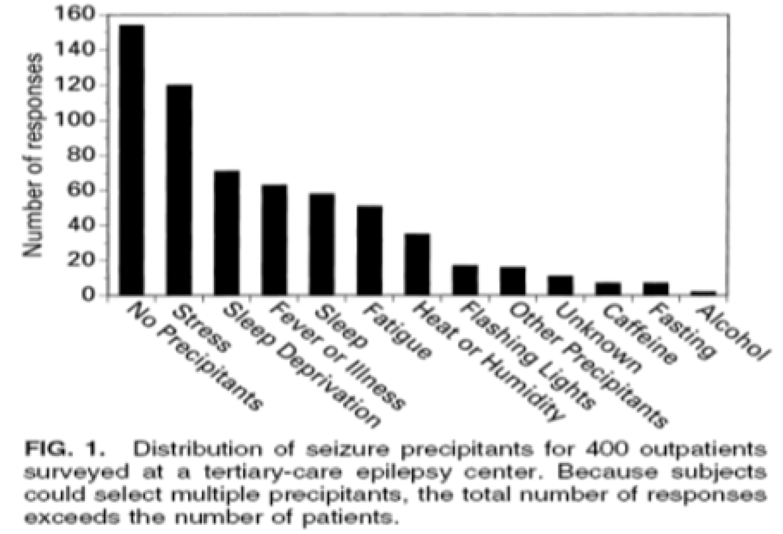

Frucht et al. Epilepsia 2000;41:1534

Motor

SYNCHRONOUS (Asynchronous) - motor events occurring (not) at the same time or at the same rate in sets of body parts.

Elementary Motor

- single type of contraction of muscle(s) that is usually stereotyped and not decomposable into phases.

Tonic - sustained increase in muscle contraction lasting a few seconds to minutes.

Epileptic Spasm (formerly Infantile Spasm) - sudden flexion, extension, or mixed extension–flexion of predominantly proximal and truncal muscles.
- usually more sustained than a myoclonic movement but not so sustained as a tonic seizure (i.e. duration ∼1 s).
- frequently occur in clusters.
- limited forms may occur: grimacing, head nodding.

Postural - adoption of a posture that may be bilaterally symmetric or asymmetric.
- ”fencing posture” – contralateral frontal lobe (supplementary motor cortex).
- “figure of 4” posture – temporal lobe contralateral to extended limb.

Versive - sustained, forced conjugate ocular, cephalic, and/or truncal rotation or lateral deviation from midline; in temporal epilepsy:
- early nonforced head turn – ipsilateral to seizure focus.
- late forced (tonic) head turn – contralateral to seizure focus.

Dystonic - Sustained contractions of both agonist and antagonist muscles producing athetoid or twisting movements, which, when prolonged, may produce abnormal postures.

MYOCLONIC (adjective); MYOCLONUS (noun) - sudden, brief (< 100 ms) involuntary single or multiple contraction(s) of muscles(s) or muscle groups of variable topography (axial, proximal limb, distal).

Negative Myoclonic - interruption of tonic muscular activity for < 500 ms (vs. atonic) without evidence of preceding myoclonia.

Clonic (s. Rhythmic Myoclonus) - prolonged myoclonus that is regularly repetitive, involves the same muscle groups, at frequency of ∼2–3 c/s.

Jacksonian March - spread of clonic movements through contiguous body parts unilaterally.

TONIC–CLONIC - sequence consisting of a tonic followed by a clonic phase. Variants such as clonic–tonic–clonic may be seen.

Generalized Tonic–Clonic Seizure (s. bilateral tonic–clonic seizure) (formerly “Grand Mal” seizure) - bilateral symmetric tonic contraction and then bilateral clonic contractions of somatic muscles, usually associated with autonomic phenomena.

ATONIC - sudden loss or diminution of muscle tone without apparent preceding myoclonic or tonic event lasting ≥ 1-2 s (vs. negative myoclonus) involving head, trunk, jaw, or limb musculature.

ASTATIC (s. drop attack) - loss of erect posture that results from atonic, myoclonic, or tonic mechanism.

Automatism
- more or less coordinated, repetitive, motor activity usually occurring when cognition is impaired and for which the subject is usually amnesic afterward.
- often resembles voluntary movement and may consist of inappropriate continuation of ongoing preictal motor activity.
- gestural automatisms have a relatively poor localizing significance (e.g. supposedly highly localizing significance of ‘frontal’ hypermotor behavior has been recently described during seizures of temporal or insular origin).

Following adjectives are usually employed to modify “automatism”:

Oroalimentary - lip smacking, lip pursing, chewing, licking, tooth grinding, or swallowing – temporal lobe (typically hippocampal); spitting or drinking – right temporal lobe.

Mimetic - facial expression suggesting emotional state, often fear.

Manual, Pedal - principally distal components (bilateral or unilateral): fumbling, tapping, manipulating movements; if bilateral – frontal lobe; postictal nose wiping – ipsilateral temporal.

Gestural - movements (often unilateral) resembling those intended to lend further emotional tone to speech, e.g. fumbling or exploratory movements with the hand, directed toward self or environment.

Hyperkinetic - increase in rate of ongoing movements or inappropriately rapid performance of a movement
- involves predominantly proximal limb or axial muscles producing irregular sequential ballistic movements, such as pedaling, pelvic thrusting, thrashing, rocking movements.

Hypokinetic - decrease in amplitude and/or rate or arrest of ongoing motor activity.

Dysphasic - impaired communication involving language (without dysfunction of relevant primary motor or sensory pathways): impaired comprehension, anomia, paraphasic errors, or a combination of these – dominant temporal lobe.

Dyspraxic - inability to perform learned movements spontaneously or on command or imitation (despite intact relevant motor and sensory systems and adequate comprehension and cooperation).

Gelastic - bursts of laughter or giggling, usually without appropriate affective tone – hypothalamic, mesial temporal, frontal cingulate.

Dacrystic - bursts of crying.

Vocal - single or repetitive utterances consisting of sounds such as grunts or shrieks.
- while vocalizations have no specific lateralizing value, nevertheless they appear to be more commonly seen in frontal lobe seizures.
- postictal cough – temporal lobe.

Verbal - single or repetitive utterances consisting of words, phrases, or brief sentences.

SPONTANEOUS - stereotyped, involve only self, virtually independent of environmental influences.

INTERACTIVE - not stereotyped, involve more than self, environmentally influenced.

Unilateral limb / eye automatisms – ipsilateral to seizure origin

Nonmotor
Aura
- subjective ictal phenomenon that, in a given patient, may precede observable seizure; if alone, constitutes sensory seizure.

Sensory
- perceptual experience not caused by appropriate stimuli in the external world.

ELEMENTARY
- single, unformed phenomenon involving one primary sensory modality:
Somatosensory - tingling, numbness, electric-shock sensation, pain, sense of movement, or desire to move.
Visual - flashing or flickering lights, spots, simple patterns, scotomata, or amaurosis.
Auditory - buzzing, drumming sounds or single tones.
Olfactory - odor, usually disagreeable.
Gustatory - taste sensations including acidic, bitter, salty, sweet, or metallic.
Epigastric - abdominal discomfort including nausea, emptiness, tightness, churning, butterflies, malaise, pain, and hunger; sensation may rise to chest or throat. Some phenomena may reflect ictal autonomic dysfunction.
Cephalic - sensation in the head such as light-headedness, tingling or headache.
Autonomic - sensation consistent with involvement of autonomic nervous system, including cardiovascular, gastrointestinal, sudomotor, vasomotor, and thermoregulatory functions. (“autonomic aura”; cf. “autonomic events” >>).
- ascending epigastric sensation, ‘typically’ of (mesio-)temporal lobe origin, may as well translate an ictal involvement of the insular cortex as that of the mesial prefrontal cortex, or be the first manifestation of a discharge within a hypothalamic hamartoma

EXPERIENTIAL
- affective, mnemonic, or composite perceptual phenomena including illusory or composite hallucinatory events.
- these may appear alone or in combination.
- included are feelings of depersonalization.
- these phenomena have subjective qualities similar to those experienced in life but are recognized by the subject as occurring outside of actual context.
Affective - components include fear, depression, joy, and (rarely) anger.
Mnemonic - components that reflect ictal dysmnesia such as feelings of familiarity (déjà-vu) and unfamiliarity (jamais-vu).
Hallucinatory - creation of composite perceptions without corresponding external stimuli involving visual, auditory, somatosensory, olfactory, and/or gustatory phenomena.
Illusory - alteration of actual percepts involving visual, auditory, somatosensory, olfactory, or gustatory.

Dyscognitive
- events in which:
(1) disturbance of cognition is predominant or most apparent feature, and
(2a) two or more of the following components are involved, or
(2b) involvement of such components remains undetermined:
otherwise, use the more specific term (e.g., “mnemonic experiential seizure” or “hallucinatory experiential seizure”).
Components of cognition:
perception: symbolic conception of sensory information
attention: appropriate selection of a principal perception or task
emotion: appropriate affective significance of a perception
memory: ability to store and retrieve percepts or concepts
executive function: anticipation, selection, monitoring of consequences, and initiation of motor activity including praxis, speech.

Autonomic Events

Autonomic Aura - sensation consistent with involvement of the autonomic nervous system, including cardiovascular, gastrointestinal, sudomotor, vasomotor, and thermoregulatory functions.

Autonomic Seizure - objectively documented and distinct alteration of autonomic nervous system function involving cardiovascular, pupillary, gastrointestinal, sudomotor, vasomotor, and thermoregularity functions.
- piloerection – left temporal lobe.
- emesis, urinary urge – right temporal lobe.
- apnea – anterior cingulate, basal forebrain (may cause SUDEP).

Somatotopic Modifiers
Laterality

UNILATERAL (HEMI-) - exclusive or virtually exclusive involvement of one side as a motor, sensory, or autonomic phenomenon.

GENERALIZED (s. “bilateral”) - more than minimal involvement of each side as a motor, elementary sensory, or autonomic phenomenon.

ASYMMETRIC - clear distinction in quantity and/or distribution of behavior on the two sides.

SYMMETRIC - virtual bilateral equality in these respects.

Body Part
Refers to area involved: bilateral, bilateral asymmetric, left, right, axial, throat, head, face, eyes, eyelid, lips, tongue, hand, arm, trunk, abdomen, leg, foot

Centricity
Modifier describes proximity to body axis:

AXIAL - involves trunk, including neck.

PROXIMAL LIMB - shoulders to wrist, hip to ankle.

DISTAL LIMB - fingers, hands, toes, and/or feet.

Lateralizing signs
- Automotor seizures with no dialepsis
- Asymmetric ending seizure - asymmetric ending of bilateral tonic‐clonic seizure or bilateral clonic seizure with either unilateral clonic jerks or a version
- Clonic seizure
- Versive seizure
- Early head deviation
- Figure of 4
- Ictal dystonia
- Ictal speech
- Immediate postictal speech
- Postictal aphasia
- Ictal unilateral automatisms
- Ictal unilateral blinking
- M2e sign
- Postictal hemiparesis
- Postictal nose wiping
- Unilateral pupillary dilation

Descriptors Of Seizure Timing
- listed in the form (adjective, noun, verb) according to principal usage:

Incidence
- number of epileptic seizures within a time period or the number of seizure days per unit of time.

Regular, Irregular - consistent (inconsistent) or predictable (unpredictable, chaotic) intervals between such events.

Cluster - incidence of seizures within a given period (usually one or a few days) that exceeds the average incidence over a longer period for the patient

Provocative Factor - transient and sporadic endogenous or exogenous element capable of augmenting seizure incidence in persons with chronic epilepsy and evoking seizures in susceptible individuals without epilepsy.

REACTIVE - occurring in association with transient systemic perturbation such as intercurrent illness, sleep loss, or emotional stress.

REFLEX - objectively and consistently demonstrated to be evoked by a specific afferent stimulus or by activity of patient.

Afferent stimuli can be elementary [i.e., unstructured (light flashes, startle, a monotone)] or elaborate [i.e., structured, (symphony)].

Activity may be elementary [e.g., motor (a movement)]; or elaborate [e.g., cognitive function (reading, chess playing)], or both (reading aloud).

State Dependent
- occurring exclusively or primarily in various stages of drowsiness, sleep, or arousal.
- upon awakening - myoclonic or primary generalized epilepsy.
- association with sleep - Rolandic or frontal lobe epilepsy.

Catamenial
- occurring principally or exclusively in any one phase of menstrual cycle.

Duration
- time between the beginning of initial seizure manifestations, such as aura, and cessation of experienced or observed seizure activity; does not include nonspecific seizure premonitions or postictal states.
- 97% of seizures stop within 2 minutes (and it stops simultaneously in entire brain – brain has innate mechanisms to abort seizure activity).

STATUS EPILEPTICUS:
- seizure that shows no clinical signs of arresting after a duration encompassing the great majority of seizures of that type in most patients
- recurrent seizures without interictal resumption of baseline CNS function.

Severity
- multicomponent assessment of a seizure by observers and patient.
Components primarily of observer assessment: duration, extent of motor involvement, impairment of cognitive interaction with environment intraictally, maximal number of seizures per unit of time.
Components primarily of patient assessment: extent of injury; emotional, social, and vocational consequences of the attack.

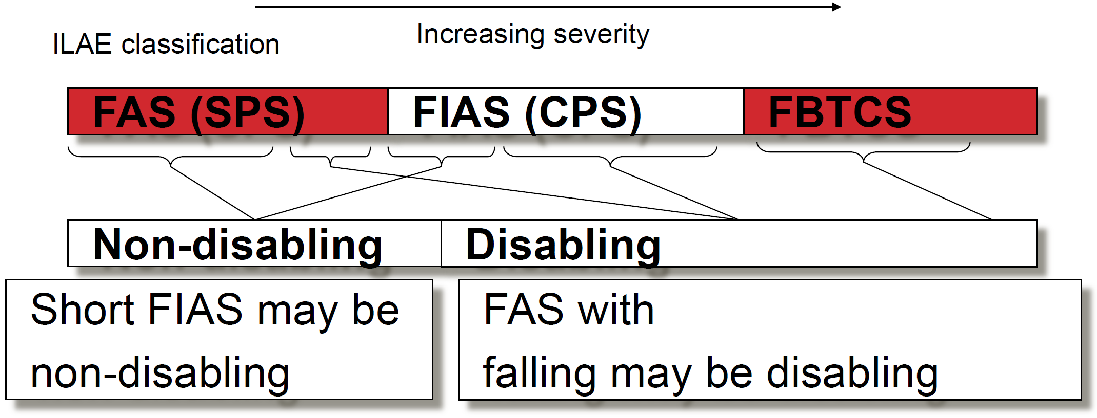

Prodrome
- preictal phenomenon - subjective or objective clinical alteration (e.g., ill-localized sensation or agitation) that heralds the onset of an epileptic seizure but does not form part of it.

Postictal Phenomenon
- transient clinical abnormality of central nervous system function that appears or becomes accentuated when clinical signs of the ictus have ended.

LATERALIZING [TODD'S (OR BRAVAIS')] PHENOMENON - any unilateral postictal dysfunction relating to motor, language, sensory, and/or integrative functions including visual, auditory, or somatosensory neglect phenomena.
- unilateral headache - ipsilateral seizure origin.

NONLATERALIZING PHENOMENON:

IMPAIRED COGNITION - decreased cognitive performance involving one or more of perception, attention, emotion, memory, execution, praxis, speech.

AMNESIA:

ANTEROGRADE AMNESIA - impaired ability to remember new material.

RETROGRADE AMNESIA - impaired ability to recall previously remembered material.

PSYCHOSIS

History
- earliest descriptions of epilepsy appear in Mesopotamian writings from 5th millennium BC.
- epileptics were believed to be possessed by demons or evil spirits (“sacred disease”).
- during middle ages, drinking of human blood, trephination, skull cauterization, sterilization were routinely practiced.
- by 18th century, epilepsy became recognized as chronic disorder of cerebral function.
- even at turn of last century, excessive masturbation was considered cause of epilepsy; this leaded to use of first effective anticonvulsants bromides.
- prior to late 19th century, entire cerebral cortex was thought to be homonymous, without regional differentiation; surgical procedures were based on theory of "counterirritation" and included random trephination, brain cauterization, appendectomy, castration - epileptics became double victims, suffering from both their epilepsy and treatments.
- in 1875, Macewen resected frontal meningioma - localized by clinical manifestation of focal motor seizures.
- in 1886, first surgery for epilepsy was performed by Sir Victor Horsley (resected traumatic cortical scar, rendering patient seizure-free).
- in 1951, Bailey and Gibbs reported series of 25 patients undergoing anterior temporal lobe resection for seizures localized only by EEG data.

Epidemiology
incidence 31-84 new cases / per 100,000 person years.
- ≈ 2/3 new cases arise in children.
- 5-10% of population will have at least one seizure during their lifetime (incidence highest during first 3 years of life; second peak is in elderly).
- lifetime risk of epilepsy diagnosis is ≈ 3% by age 75 yrs (1% from birth to age 20 yrs; 4,4% by age 85 yrs).
- in some countries, parasitic infections account for increased incidence.

prevalence 0.6-1.2% of population has active epilepsy, i.e. recurrent seizures (≈ 50% have partial seizures; 60-75% are idiopathic, i.e. etiology is not identified).
3.4 mln in US (size of Los Angeles)
- epilepsy affects males 1.1-1.5 times more often than females.
- prevalence in relatives ranges 0.5-15% (higher in idiopathic than symptomatic epilepsies); risk is higher in children of epileptic mothers than fathers (reason is not known).
by age 25 yrs, 9% children of epileptic mothers and 2.4% of children of epileptic fathers develop epilepsy.
- concordance is 70% in monozygotic twins and 10% in dizygotic pairs.

mortality is increased in epileptics!
- risk is incurred mainly by symptomatic cases in which higher death rates are related primarily to underlying disease rather than to epilepsy.
- accidental deaths (esp. drowning) are more common, however, in all patients with epilepsy.
- risk of sudden unexplained death is 20-24 times* rate in general population.
*in medically refractory epilepsy, risk approaches 50-100 times

Pathophysiology
Seizures result from dynamic interplay between endogenous factors, epileptogenic factors, and precipitating factors:

- Normal brain is capable of having seizure under appropriate circumstances, but there are differences between individuals in threshold for seizures – depends on endogenous factors:
  - genetic (check family history)
  - development - brain has different seizure thresholds at different maturational stages (young, immature CNS is more susceptible to seizures; esp. functional immaturity of substantia nigra may play special role).

- Epileptogenic factors - variety of conditions that have extremely high likelihood of resulting in chronic seizure disorder.
epileptogenesis - transformation of normal neural network into one that is abnormally hyperexcitable
- some forms of epileptogenesis are related to structural changes in neuronal networks; e.g. temporal lobe epilepsy - highly selective loss of inhibitory neurons within dentate gyrus + reorganization ("sprouting") of surviving excitatory neurons.
- epileptogenesis requires time (sometimes delay of months ÷ years between initial CNS injury and first seizure).
- one of the best examples is severe penetrating head trauma, which is associated with 50% risk of leading to epilepsy.
- kindling - processes that mediate long-lasting changes in brain function in response to repeated, gradually augmented subconvulsive stimulation of brain; kindled animal has permanent state of enhanced seizure susceptibility - models for screening new compounds that may have anticonvulsant activity.

- Seizures are episodic - many epileptics are completely normal for months or even years between seizures - there are precipitating factors that induce seizures in patients with epilepsy:
  - intrinsic physiologic processes (e.g. sleep deprivation!!!, physical stress, hormonal changes, electrolyte shifts, alkalosis).
  - exogenous factors (e.g. alcohol!!!, certain medications, systemic or CNS infection, malnutrition, highly specific stimuli in reflex seizures, hyperventilation).

Seizure initiation absences have specific mechanism (corticoreticular theory) – see below >>
- seizure is produced by sudden, brief* excessive hypersynchronous** discharge*** of cortical neurons. *except for status epilepticus
**normal neuronal activity occurs in nonsynchronized manner
***high-frequency bursts of action potentials
epileptogenicity - excitability and excessive synchronization of neuronal networks.

- biochemical / physiologic processes are same ones that provide for normal cerebral function (e.g. balance of Acch and GABA).
- neurons in epileptogenic focus show recurring Ca²⁺-dependent high-voltage, long-duration depolarizations (paroxysmal depolarizing shifts, PDS) with superimposed Na⁺-mediated high-frequency bursts of action potentials.

PDS genesis: activation of NMDA type of glutamate receptors* → extracellular Ca²⁺ influx → opening of voltage-dependent Na⁺ channels → Na⁺ influx → PDS
*prolonged NMDA receptor activation (in status epilepticus) → excessive intracellular Ca²⁺ → cell death ("epileptic brain damage").
- extracellular current flow generated by PDS → interictal EEG spike or sharp wave (characteristic epileptiform discharge that signifies susceptibility to seizures).
- PDS is followed by hyperpolarizing afterpotential (due to GABA or Ca²⁺-dependent K⁺ channels) → EEG slow wave that follows spike discharge.
- during seizure, neurons are tonically depolarized and fire continuously in sustained, synchronized high-frequency discharge (corresponding to tonic phase of seizure); seizure ends as phasic repolarizations interrupt continuous firing pattern (correlate of clonic phase) and gradually restore membrane potentials to normal or to temporary hyperpolarized state (postictal depression).
Seizures are result of shift in normal balance of excitation and inhibition within CNS.

Mechanisms leading to decreased inhibition
- Defective GABA_{A} inhibition (e.g. various mutations of GABA_{A} receptor coupled Cl⁻ channel subunits); GABA_{A} receptors are main targets of current anticonvulsants.
- Defective GABA_{B} inhibition (e.g. various mutations of GABA_{B} receptor coupled K⁺ channel subunits).
- Defective activation of GABA neurons (normally, GABA neurons are activated by means of feedforward and feedback projections by excitatory neurons); e.g. selective loss of inhibitory neurons.
- Defective intracellular buffering of calcium → premature loss of inhibitory interneurons.

Mechanisms leading to increased excitation
- Increased activation of NMDA receptors (glutamate is endogenous ligand); NMDA receptor coupled channels allow passage of monovalent (Na⁺, K⁺) and divalent cations (Ca²⁺).
- Increased synchrony between neurons due to ephaptic interactions: electrical fields created by synchronous activation of pyramidal neurons in laminar structures (such as hippocampus) increase excitability of neighboring neurons by nonsynaptic (ephaptic) interactions; changes in extracellular K⁺ and Ca²⁺ concentrations may also play role.
- Increased synchrony / activation due to recurrent excitatory collaterals (as in hippocampal sclerosis).

Seizure activity spread
- normally, spread of bursting activity is prevented by intact hyperpolarization and region of surrounding inhibition created by inhibitory neurons.
- repetitive discharges lead to recruitment of surrounding neurons via number of mechanisms:
  - increase in extracellular K⁺, which blunts extent of hyperpolarization and depolarizes neighboring neurons;
  - Ca²⁺ accumulation in presynaptic terminals → enhanced neurotransmitter release (posttetanic potentiation);
  - depolarization-induced activation of NMDA subtype of glutamate receptor-gated channels → more Ca²⁺ influx.
- recruitment of sufficient number of neurons leads to loss of surrounding inhibition and propagation of seizure activity.

Seizures are self-limited - at some point bursts of electrical discharges from focus terminate:
- active reflex inhibition - normal neurons that surround seizure are hyperpolarized (surround inhibition) - inability of seizure to propagate.
- normally, discharging excitatory neurons activate nearby GABAergic inhibitory interneurons that suppress activity of discharging cell and its neighbors.
- voltage-gated and Ca²⁺-dependent K⁺ currents in discharging neuron suppress its excitability.
- adenosine (generated from ATP released during excitation) suppresses excitation by binding to adenosine receptors on nearby neurons.
- neuronal metabolic exhaustion?
- loss of synchrony
- alteration of local balance of Acch and GABA in favor of inhibition.

- most authorities consider 30 minutes duration as upper time limit of seizure duration without any neuronal damage; > 30 minutes (status epilepticus) is associated with brain damage.

Behavioral manifestations of seizure reflect function of cortical neurons involved in generation and spread of abnormal electrical activity.
- how seizures produce coma:
- diffuse abnormal electrical discharges throughout RF and cortex.
- exhaustion of energy metabolites + locally toxic molecules produced during seizures → post-ictal state of electrical inhibition (generalized slowing of background EEG)
N.B. unwitnessed seizures can be cause of unexplained coma!

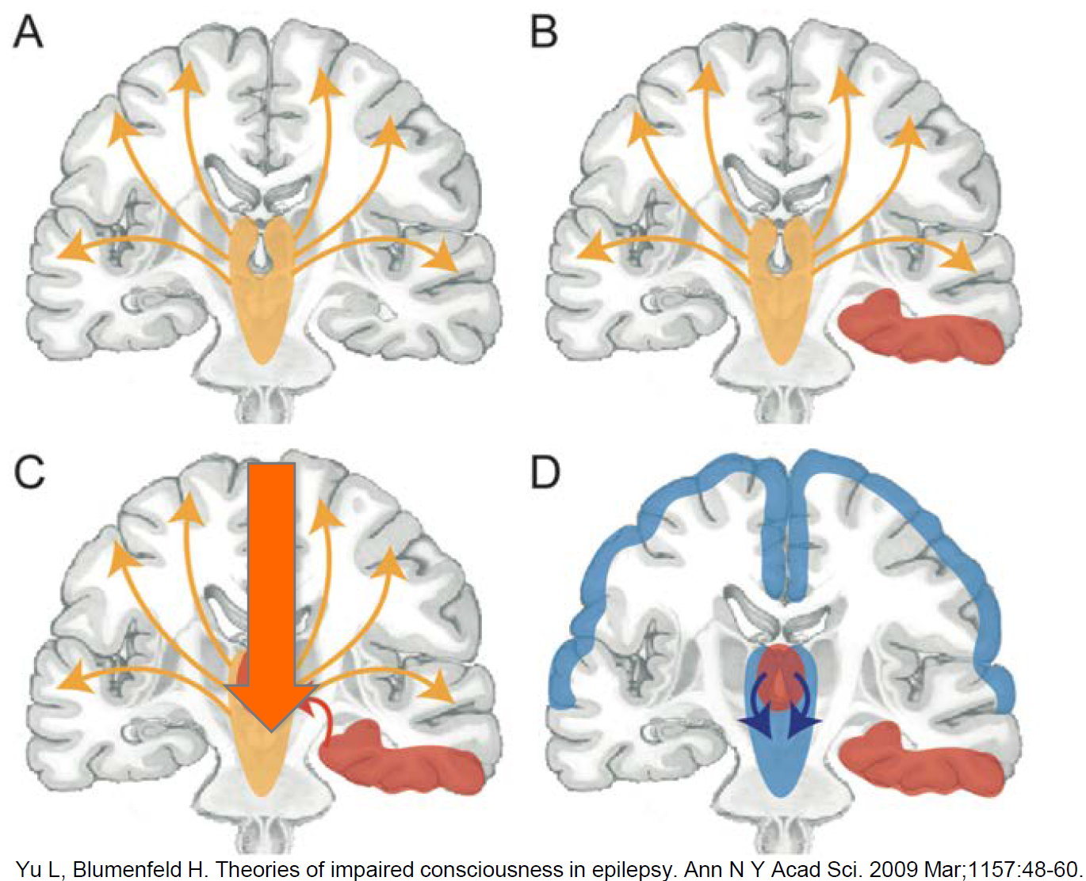

Anatomical structures
- epilepsy affects neocortex and archicortex (hippocampus, dentate gyrus) and their interconnections with diencephalon & brain stem.
- structures most susceptible to development of recurrent seizures:
  - motor cortex
  - hippocampal formation
  - amygdaloid complex.
- according to another theory, thalamus (esp. anterior) plays critical role in generating generalized seizures (and accompanying generalized spike-wave EEG patterns).

Pathology
    - no consistent, demonstrable pathologic changes in brains with idiopathic generalized epilepsy (seizures most likely result from inherited biochemical, membrane, or neurotransmitter defects).
    - anatomically / histologically focal epileptogenic area may appear perfectly normal.
    - uncontrolled seizures may produce neuron loss; irreversible brain damage is well described with status epilepticus.

Etiology
about precipitating factors → see pathophysiology >>
Idiopathic (s. primary, epileptic) seizure - not caused by any brain lesion or underlying disease.
- generally apparent by age 18.
- possible genetic predisposition;
- in most cases multiple genes determine various neuronal functions that alter seizure threshold;
- some syndromes have been mapped to single gene locus:
Syndrome | Gene Location | Gene Product
Unverricht-Lundborg disease | 21q22.3 | Cystatin B
Nocturnal frontal lobe epilepsy | 20q13.2-q13.3 | α4 subunit, nicotinic Acch receptor
Benign familial infantile convulsions | 20q13.2-13.3 | Voltage-gated K⁺ channel
Batten's disease | 16 | Unknown deletion (loss of function?)
Lissencephaly (Miller-Dieker) | 17p13.3 | Subunit, platelet-activating factor
Tuberous sclerosis (TSC2) | 16p13 | tuberin (tumor suppressor)
Tuberous sclerosis (TSC1) | 9q34 | hamartin (tumor suppressor)

Symptomatic (s. secondary, reactive) seizure - cause is known:

  - Brain injury – cause of partial seizures:
- hippocampal (mesial temporal) sclerosis - pyramidal cell loss and gliosis - most common cause of partial epilepsy! (esp. in young adults)
- congenital malformations (most common etiologies in children) – AVM, hamartoma, arachnoid cysts, meningomyelocele, focal cortical dysplasia, neuronal heterotopias.
- neoplasm - any CNS tumor can be ictogenic (esp. supratentorial low-grade and slow-growing primary neoplasms; e.g. well-differentiated gliomas) - seizures are most often partial with secondary generalization.
gangliogliomas are most common tumor cause of pediatric seizures
- CNS infection - encephalitis, postencephalitic gliosis, meningitis, subdural empyema, cerebral abscess, cerebral parasitosis [esp. neurocysticercosis], HIV and complications [esp. toxoplasmosis and lymphoma].
- 15-40% patients with meningitis will seize at least once (esp. at both extremes of age; partial seizures predominate).
- partial seizures may be sole manifestation of neurosyphilis.
- head trauma (transient mechanical and neurochemical changes within brain → immediate seizures; epidural or subdural hematoma → early seizures; cerebral contusion or laceration → cerebromeningeal scar → post-traumatic epilepsy).
see p. E9 >>
- cerebrovascular disease – stroke (most common cause of new-onset partial epilepsy in older adults; 4.2% had seizure within 14 days of CVA), hematoma, SAH, migraine, vasculitis.
- cerebral palsy
- hydrocephalus, ventriculoperitoneal shunt failure (seizures are more common in children with hydrocephalus with shunts than those without shunts).

  - Systemic disorders:
- fever (febrile seizures)
- hypoxia (incl. birth asphyxia)
- hypo-/hyper-glycemia (esp. infants) - rapid bedside glucose determination should be integral part of evaluation in patient without known epilepsy!
- hypo-/hyper-natremia, esp. acute (hyponatremia is leading cause of nonfebrile seizures in children < 2 years). see p. 2514 >>
- hypocalcemia, hypomagnesemia
- hypo-/hyper-osmolar states
- acid-base disorders (esp. high anion gap acidosis)
- liver failure (≈ 33% patients with hepatic encephalopathy) – phenytoin is first-line treatment (vs. benzodiazepines - induce coma!).
- renal failure – uremic encephalopathy, dialysis disequilibrium syndrome (acute fluid and electrolyte shifts during dialysis → cerebral edema; hemodialysis > peritoneal dialysis)
- hypertensive crisis
- pregnancy, eclampsia see p. 2646 >>
- pyridoxine dependency / deficiency
- postimmunization (esp. pertussis* and measles vaccines – may cause infantile spasms)
* now appears that association between pertussis immunization and infantile spasms is not causative but rather unmasking in otherwise predisposed children.
- thyroid disease (hypothyroidism > thyrotoxicosis)
- acute intermittent porphyria

  - Drug withdrawal:
- benzodiazepines (± with flumazenil administration)
- barbiturates
- ethanol ("rum fits") see p. E9 >>
- clonidine
- baclofen.

  - Proconvulsant drug (overdose): 15% of drug-related seizures may present as status epilepticus!

Category | Drug | Comment
Antiasthmatics* | aminophylline  theophylline | Especially but not exclusively above therapeutic levels
Antibiotics | isoniazid (antagonist of GABA); H: 1 mg pyridoxine IV for 1 mg of isoniazid ingested  lindane  metronidazole  nalidixic acid  β-lactam antibiotics (antagonist of GABA): penicillins, cephalosporins | Vitamin B6 supplement may protect  Especially with renal failure
Antidepressants | tricyclics!!!  serotonin-specific agents  bupropion | Rarely a practical problem;  desipramine may be preferable
Neuroleptics | phenothiazines!!!  clozapine  butyrophenones | 1%-4% of all patients, depending on dose  Molindone, thioridazine, fluphenazine least likely
General anesthetics | enfluraneketamine
Hormones | insulin | By means of hypoglycemia
 | prednisone | By means of hypocalcemia
 | estrogen | Especially without progesterone
Immunosuppressants | chlorambucil  cyclosporine (may affect Mg²⁺ levels)
Local anesthetics | lidocaine  bupivacaine  procaine
Some opioids | fentanyl  meperidine  pentazocine  propoxyphene
Psychostimulants | amphetamines*  cocaine*  methylphenidate  phenylpropanolamine  street drug combination "T's and blues" (pentazocine (Talwin®) + antihistamine tripelennamine)
Other | anticholinergics  anticholinesterases  antihistamines  heavy metals  hyperbaric oxygen  lithium  salicylates  mefenamic acid  oral hypoglycemics  oxytocin  flumazenil administered to treat benzodiazepine overdose | By means of water intoxication

*sympathomimetics

  - Genetic diseases (only 1% of epilepsy cases) - mendelian (e.g. phenylketonuria, lipid storage diseases, tuberous sclerosis, hyperglycinemia, Lafora's disease), chromosomal (e.g. Down syndrome), mitochondrial (e.g. MELAS, MERRF).

    - cryptogenic seizure – seizure is thought to be secondary but cause has not been identified.
    - acute symptomatic seizure - occurs within 1 week of causative disorder.
    - remote symptomatic seizure - occurs more than 1 week following causative disorder.
    - provoked seizure - in response to acute CNS insult (infection, head injury) or acute systemic insult (e.g. hypoglycemia, hypernatremia, alcohol, sleep deprivation), i.e. acute symptomatic seizure.
    - unprovoked seizure may be idiopathic, cryptogenic or remote symptomatic seizure.
    - reflex seizure, s. reflex epilepsy – epileptic seizure precipitated by specific identifiable stimuli (e.g. light*, sound, eating, reading, startle, immersion in hot water, vestibular stimulation).
*stroboscopic light patterns, complex visual images, videogames
- it was noted in ancient Rome that staring at potter's wheel could induce seizures (this test was used to demonstrate to prospective owners that slaves were seizure free).
    - lesional epilepsy - focal epilepsy in which lesion is identified on neuroimaging studies - epilepsy surgery (resection of epileptogenic lesion) is likely to be successful.
    - in any given patient, relative contribution of genetic and acquired factors determines whether epilepsy presents as idiopathic disorder or symptomatic one (failure to identify genetic component in post-traumatic epilepsy or in seizures following stroke most likely reflects relatively small genetic "load" in these situations compared with magnitude of acquired factors).

Pediatric seizures
    - most are idiopathic (75%)* or due to trauma, but most common pediatric seizure cause is fever!
*except in newborns - cause for seizures can be found in majority

New-onset seizures in adults
- primary generalized seizures rarely begin after age 18.
- seizures are more often due to underlying brain lesions or metabolic causes.
Thoroughly evaluate first-time seizure in adult!!!
- stroke is most common cause of first seizure after age 65.
- CNS degeneration associated with aging increases risk of reactive seizures; incidence of primary seizures also increases after age 60 years; Alzheimer's dementia is significant risk factor for new-onset seizures.

Causes by Age of Onset

First day  Hypoxia  Drugs  Trauma  Infection  Hyperglycemia  Hypoglycemia  Pyridoxine deficiency  Day 2-3  Infection  Drug withdrawal  Hypoglycemia  Hypocalcemia  Developmental malformation  Intracranial hemorrhage  Inborn error of metabolism  Hyponatremia or hypernatremia | Day 4 to 6 months  Infection  Hypocalcemia  Hyperphosphatemia  Hyponatremia  Developmental malformation  Drug withdrawal  Inborn error of metabolism | 6 months to 3 years  Febrile seizures  Birth injury  Infection  Toxin  Trauma  Metabolic disorder  Cerebral degenerative disease  > 3 years  Idiopathic  Infection  Trauma  Cerebral degenerative disease
see also p. E9 >> (neonatal seizures)

Seizure Classification & Clinical / EEG Features
N.B. this is classification of seizures not epilepsy!
70% patients have only one type of seizure; 30% have ≥ 2 types.

- generalized (s. BILATERAL) seizures (40% of all seizures) - initial simultaneous activation of neurons throughout both hemispheres (i.e. involve brain diffusely from beginning); no any focal features can be observed; further subdivisions are based on character of ictal motor manifestations:
  - convulsive generalized seizures (grand mal) – accompanied by abrupt full loss of consciousness and severe postictal state. further see >>
  - nonconvulsive generalized seizures – variable (no ÷ full) loss of consciousness, postictal state may be absent.
petit mal further see >>
myoclonic seizures further see >>
clonic seizures further see >>
tonic seizures further see >>
atonic seizures further see >>
- seizure discharge arises from deep midline structures in brainstem or thalamus (ARAS dysfunction) → prompt loss of consciousness.
- no aura is present.
- usually begin in childhood (before age of 20) and represent true "idiopathic epilepsy".

- partial (s. Focal) seizures (57% of all seizures) - initial activation of limited population of neurons in part of one hemisphere (i.e. localized cerebral ictal onset).
N.B. almost all seizures that begin in adulthood (after age 20) are focal (whether or not this is apparent clinically) - caused by focal brain disease!
New partial seizure represents structural lesion until proven otherwise
Up to 40% of childhood seizures are partial!
  - simple partial seizures - consciousness is preserved. further see >>
    - with motor signs (incl. jacksonian, versive, postural)
    - with sensory symptoms (incl. somatosensory, visual, auditory, olfactory)
    - with psychic symptoms (incl. dysphasia, hallucinatory, affective changes)
    - with autonomic symptoms
  - complex partial seizures - consciousness is impaired. further see >>
- simple partial onset followed by impaired consciousness (i.e. complex partial seizures evolved from simple partial seizures):
      - with automatisms
      - without automatisms
- with impairment of consciousness at onset:
- with automatisms
- without automatisms (impairment of consciousness only)
  - Partial seizures with secondary generalization, i.e. grand mal preceded by focal clinical and/or EEG manifestations (i.e. ictal activity has spread to other hemisphere).
- simple partial evolving to generalized
- complex partial evolving to generalized
- simple partial evolving to complex partial evolving to generalized
- Todd's paralysis (postictal focal neurologic deficit) indicates seizure origin from contralateral hemisphere. see below >>

- Unclassified seizures (3% of all seizures)

Initial seizure events are usually most reliable indication to determine seizure type; focal signature may be lacking for several reasons:
- amnesia for early events.
- consciousness may be impaired so quickly, or seizure generalized so rapidly, that early distinguishing features are blurred.
- seizure origin in behaviorally “silent” brain region; thus, seizure becomes clinically evident only when discharge spreads beyond ictal onset zone.

Generalized Seizures
Tonic-Clonic Seizures (s. Grand Mal)
- most common and most dramatic form of seizures! (both in idiopathic and symptomatic epilepsies)
- Vague inconsistent nonspecific prodromal (premonitory) symptoms (occur minutes ÷ days before actual convulsion): headache, mood change, ill-defined anxiety, irritability, lethargy, appetite changes, dizziness, lightheadedness, other uncomfortable feelings.
N.B. differentiate from stereotypic auras associated with focal seizures (aura is due to seizure activity, but prodrome is not!)

- Tonic phase – sudden complete loss of consciousness with fall to ground + in timely order:
  - possible few brief, bilateral symmetric muscle jerks lasting few seconds.
  - brief trunk flexion, upward eye deviation, characteristic vocalization (“epileptic cry“ - contraction of abdominal muscles produces forced expiration across spasmodic glottis).
  - generalized (trunk and limbs) extension lasting 10-15 seconds.
    - tonic phase may be preceded by brief focal behaviors (e.g. extremity jerking, head version).
    - respirations are impaired, patient becomes cyanotic, secretions pool in oropharynx, may vomit.
    - marked enhancement of sympathetic tone → tachycardia, BP↑, mydriasis, hyperglycemia (children have very little glycogen reserve and may rapidly develop hypoglycemia!).
    - tonic phase lasts 10-20 sec.

- Clonic phase - symmetric synchronous violent tonic contractions alternate with muscle atonia of gradually increasing duration until contractions cease.
    - contractions of respiratory muscles produce rhythmic grunting.
    - muscular force may be sufficiently vigorous → posterior shoulder dislocation, fractures of thoracic vertebral bodies, significant tongue and buccal injuries (from repeated biting).

- Seizure terminates with final generalized tonic spasm.

- Postictal state (gradual recovery over hours): flaccid coma (several minutes) → confusional state → myalgia, headache, lethargy (patients prefer to sleep), mental dulling, lack of energy, mood changes lasting as long as 24 hours.
    - prolonged consciousness alteration after unwitnessed seizure may produce diagnostic confusion.
    - in secondarily generalized cases, self-limited focal neurologic deficit (Todd’s palsy → see below >>) may occur – indicates focal epileptogenic site!

- most TCS are less than 90 seconds duration.
- tonic phase is generated in brain stem, whereas clonic seizures are generated in neocortical structures.
- serious autonomic alterations (dysautonomia) occur during tonic-clonic phases:
  - transient apnea, hypoxia, lactic acidosis
  - urinary incontinence is common (vs. fecal incontinence is rare).
  - transient hyperglycemia
  - mild CSF pleocytosis
  - serum [prolactin]↑
- complications:
- trauma
- skeletal muscle damage (up to frank rhabdomyolysis)
- aspiration pneumonia
- neurogenic pulmonary edema - relatively common, although often subclinical (hypoxia, clinical evidence of pulmonary congestion); caused by centrally mediated sympathetic generalized vasoconstriction + increased pulmonary capillary permeability; can be clinically and radiographically confused with aspiration pneumonia; managed with ventilatory PEEP support.
- SUDEP (sudden unexpected death in epilepsy) - related to acute pulmonary edema, cardiac arrhythmia, suffocation.
- prognosis for idiopathic TCS (esp. in childhood) is better than for focal or secondary generalized seizures, which tend to persist if untreated.

EEG
Ictal EEG (always abnormal, but may be obscured by movement artifact):
Tonic phase - generalized low-amplitude fast activity (20-40 Hz) → bilaterally synchronous, symmetric 10 Hz rhythm (epileptic recruiting rhythm) → gradually becomes intermixed with increasing amounts of slow activity:
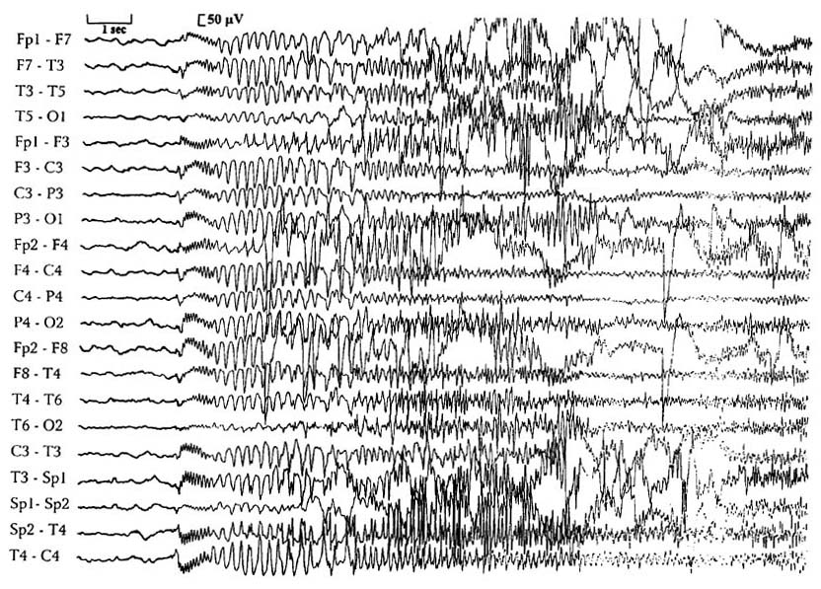
Clonic phase - generalized spike-wave activity (high-amplitude polyspikes interrupted by slow waves).
N.B. spike-wave activity characterizes clonic phase.
Postictal period - generalized suppression or low-amplitude slow activity.

Interictal EEG:
Secondarily generalized TCS - background abnormalities and focal slowing & epileptiform activity.
Primary generalized TCS - normal background and generalized bilaterally symmetrical and synchronous (poly)spikes or spike-wave complexes at 3-4 Hz:
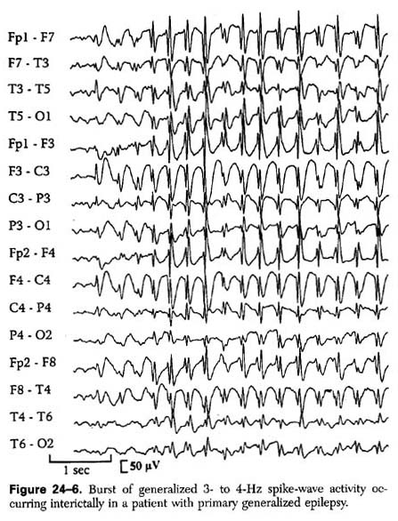

Tonic Seizures
- tonic contractions (sustained, nonvibratory) of axial musculature.
- usually involves flexion of upper extremities and flexion or extension of lower extremities (commonly produce sudden, unexpected falls).
- abrupt onset.
- consciousness impairment and autonomic alterations are lesser than in grand mal.
- characteristic guttural cry or grunt as air is forced through adducted vocal cords
- seizures last up to 1 minute (typically < 10 seconds).
- rapid return to baseline.
- frequently occur dozens of times per day (commonly occur in clusters during drowsiness and NREM sleep).
- usually associated with epileptic syndromes having mixed seizure phenotypes (such as Lennox-Gastaut syndrome).

EEG
Ictal EEG - generalized electrodecremental response - low-voltage beta frequency (15-25 Hz) activity ("beta buzz"); may evolve into high-amplitude 10 Hz rhythms, generalized theta or delta activity.
Interictal EEG - poorly organized background + generalized spike-wave discharges < 3 Hz (slow spike-wave complexes) or (multi)focal spikes and sharp waves.

↑
Tonic or atonic seizures typically indicate clinically significant brain injury
↓

Atonic Seizures
≈ drop attacks (see p. Mov3 >>) lasting 1-2 seconds, but consciousness is usually impaired, although recovery is rapid.
- may be limited to head-neck musculature (head drop) or may involve all postural musculature (unexpected falls and injuries).
- atonic ≠ astatic (astatic seizure - loss of erect posture resulting in fall; astatic seizure may occur with atonic, tonic, and myoclonic seizures).
- loss of tone may be preceded by series of myoclonic jerks.
- atonic and tonic seizures are often present in same patient (usually children with symptomatic generalized epilepsy syndromes).

EEG
Ictal EEG – brief, generalized (poly)spike-wave discharges; in prolonged seizures - generalized spike-wave discharges followed by diffuse generalized slowing.
Postictal changes are not prominent.

Clonic Seizures
- hypotonia or generalized tonic spasm → series of fairly symmetric, bilateral synchronous semirhythmic muscular jerks.
- no significant autonomic changes, no postictal confusion.
- rare (usually seen in children with febrile illnesses).

EEG
Ictal EEG – generalized 10 Hz rhythm intermixed with slow waves of variable frequency.
Interictal EEG - generalized (poly)spike-wave discharges.

Myoclonic Seizures
- bilaterally symmetric (rhythmic saccadic), very rapid body jerks (single or repetitive) for few seconds.
- may be restricted to facial and shoulder girdle muscles, or may affect entire body.
- consciousness is usually preserved!
- often cluster shortly after waking or while falling asleep.
- may occur at any age, and are often result of permanent neurologic damage; commonly observed in neonates and children with idiopathic or symptomatic epilepsy.
- myoclonic seizures are caused by cortical dysfunction (vs. nonepileptic myoclonus - subcortical or spinal dysfunction).

EEG
Ictal EEG – generalized 4-5 Hz fast polyspike-wave complexes (may or may not be time-locked to muscular contraction).
Interictal EEG varies depending on etiology - from normal background rhythms with generalized epileptiform discharges to severe background abnormalities with multifocal spike discharges.

- idiopathic generalized epileptic myoclonus (abnormal subcortical influences on diffusely hyperexcitable neocortex) - spike discharges precede generalized myoclonic jerks.
- reticular reflex myoclonus (originates in brain stem structures) - generalized, synchronous muscle contractions precede electrographic correlate.
- cortical reflex myoclonus (form of focal epilepsy) - unilateral or asynchronous jerks restricted to few contiguous muscles preceded by spike discharges in contralateral sensorimotor cortex.

Absence Seizures (s. Petit Mal)
Typical absence - sudden attack of impaired consciousness (behavioral arrest with motionless staring and unresponsiveness).
- no overt motor manifestations (except for possible eyelid and perioral flicker, small amplitude finger twitching) - may be mistaken for daydreaming or inattention.
- duration rarely exceeds 10 seconds.
- begin and end abruptly - no warning (aura), no postictal state!!!
- amnesia for event.
- commonly precipitated by hyperventilation!!! and infrequently by photic stimulation.
Hyperventilation for 3 minutes can induce an absence seizure and results in quick diagnosis during the clinic visit
- typically occur in neurologically normal children with idiopathic generalized epilepsy (significant inherited predisposition). see p. E9 >>
N.B. diagnosis of new-onset absence seizures in adulthood is incorrect in vast majority of cases (consider temporal lobe complex partial seizures with relatively minor automatisms).
Key distinction – absence vs. complex partial seizures
- unrecognized & untreated, absence seizures can occur hundreds of times each day (suddenly decreased school performance or overall attention is subtle manifestation of frequent absence seizures).
- pathophysiology is explained by corticoreticular theory - generation of abnormal oscillations within thalamocortical circuitry;
- circuitry includes pyramidal neurons of neocortex, thalamic relay neurons, and neurons in nucleus reticularis thalami (NRT).
- thalamic neurons have ability to shift between oscillatory and tonic firing modes.
- during normal wakefulness, tonic firing and EEG desynchronization take place.
- with oscillatory rhythmical firing, thalamic EPSP (excitatory postsynaptic potential) threshold is raised → dampening of signal transmission to cortex → impairment of consciousness (as in normal sleep).
- oscillatory behavior relies on nucleus reticularis thalami, which is composed of GABAergic neurons.
- thalamic relay neurons have GABA_{B} receptors in cell body.
- GABA_{b} -mediated inhibition triggers key event - low-threshold Ca²⁺ current via voltage-dependent Ca²⁺ channels (T-channels; T = transient) in thalamic relay neurons → sustained oscillatory burst firings between thalamic relay and cortical pyramidal neurons.
- anti-absence agents (ethosuximide, valproic acid) suppress T-channel currents; GABA_{B} agonist baclofen worsens seizures; anticonvulsants that increase GABA levels (e.g. gabapentin, tiagabine, vigabatrin) exacerbate absence seizures!

Differentiating staring due to absence from that of complex partial seizures:
FEATURES | ABSENCE | COMPLEX PARTIAL
Sleep activation | None | Common
Hyperventilation | Induces the seizures | No activating effect
Seizure frequency | Frequent, many per day | Less frequent
Seizure onset | Abrupt | Slow
Aura | None | If preceded by a simple partial seizure
Automatism | Rare | Common
Progression | Minimal | Evolution of features
Cyanosis | None | Common
Motor signs | Rare, or minimal | Common
Seizure duration | Brief (usually <30 sec) | Minutes
Postictal confusion or sleep | None | Common
Postictal dysphasia | None | Common in seizures originating from dominant hemisphere

Atypical absence:
- begin and end more gradually;
- less marked alteration of consciousness;
- duration exceeds 10 seconds;
- rarely provoked by hyperventilation or photic stimulation.
- commonly accompanied by various motor features:
- absence with clonic movements, esp. eyelid, facial clonus (myoclonic absence)
- absence with atonic states (atonic absence)
- absence with tonic contractions
- absence with automatisms (various stereotyped movements, usually of face, hands) - may be mistaken for temporal lobe complex partial seizures.
- tend to occur in neurologically impaired individuals with diffuse / multifocal cerebral dysfunction (e.g. Lennox-Gastaut's syndrome) – treatment is less successful.

EEG
Ictal EEG – abrupt onset (and abrupt end) of symmetric generalized 3 Hz doublets (spike & rounded wave):
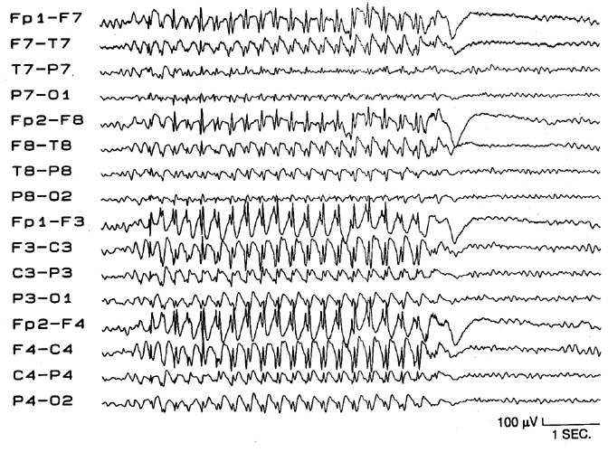
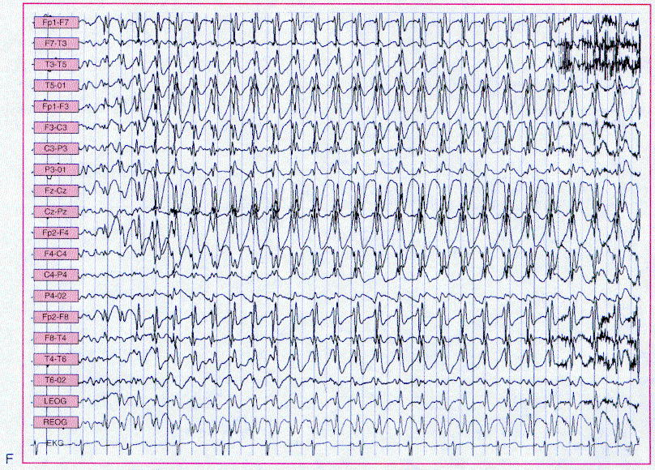
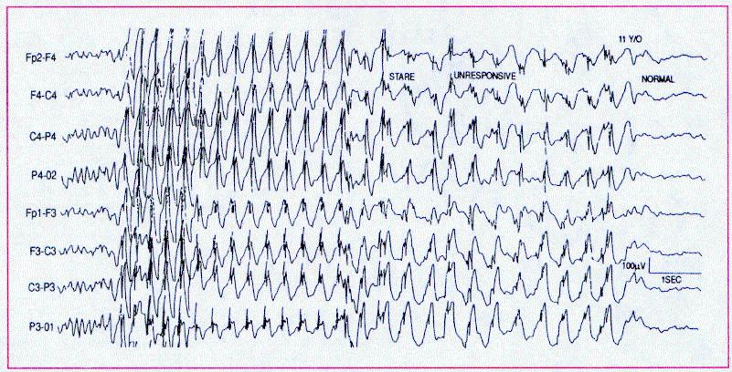

Interictal EEG:
- typical AS – generalized 3 Hz spike-wave complexes* superimposed on normal background.
*usually precipitated/aggravated by hyperventilation
- atypical AS – irregular (0.5-4 Hz) spike-wave complexes superimposed on abnormal background.
- EEG abnormalities (less well formed, and of lesser amplitude) may persist into adulthood despite absence of clinical seizures.

Focal (formerly - Partial) Seizures
Focal seizures with RETAINED awareness, s. without dyscognitive features (formerly - simple partial seizures, SPS)
- seizures with motor / sensory / autonomic / psychic symptomatology during which consciousness is preserved.
N.B. multiple symptoms & signs may occur during single seizure!
By definition, ictal activity does not spread to other hemisphere – all sensory / motor symptoms remain ipsilateral!
    - SPS can occur in isolation or preceding complex partial or tonic-clonic seizures.

      - Motor features - focal clonic / tonic activity, vocalizations, speech arrest.
- epileptic focus is in contralateral frontal lobe; tonic activity and version may be seen in parietal and occipital lobe epilepsy (supplementary or secondary motor areas); focus in supplementary motor area can cause bilateral tonic posturing!
- classic "Jacksonian march" (focal clonus in distal muscles spreads over seconds to minutes proximally along motor homunculus in primary motor cortex: hand → face → etc) occurs only rarely.
- versive seizures - sustained, forced, involuntary contralateral conjugate turning of eyes or head (particularly common in SPS) – “look away from epileptogenic focus”.

      - Sensory features - somatosensory, simple hallucinations (visual, auditory, vestibular, gustatory, olfactory).
- epileptic focus is in primary sensory cortex.

      - Autonomic phenomena - epigastric rising sensation, pallor, sweating, flushing, piloerection, mydriasis, salivation, urinary incontinence.
- epileptic focus is in limbic structures (mesial temporal or, less commonly, frontal lobe).

      - Psychic symptoms:
  - affective and cognitive disturbances (e.g. unwarranted fear, depression)
  - dysmnesias (e.g. déjà vu, jamais vu)
  - illusions / hallucinations of visions (e.g. polyopsia, micropsia, macropsia) / sounds (e.g. familiar voices) / self-image / time (e.g. feeling of unreality or detachment, time distortion).
  - dysphasia
- epileptic focus is in temporal lobe (for affective and cognitive disturbances), cortical association areas (for complex illusions or hallucinations).

    - patients can interact normally with environment during seizure except for limitations imposed by seizure on specific localized brain functions.
    - average seizure persists for 10-22 sec.
    - no postictal state, no amnesia!
    - Todd's paralysis – postictal self-limited focal paralysis* (not more than few days) that occurs in limbs involved in jacksonian epilepsy (i.e. postictal depression of epileptogenic cortical area);
term also includes other related focal neurologic deficits (e.g. numbness after sensory seizure, blindness after occipital lobe seizure). *up to complete hemiparesis
    - first signs / symptoms strongly suggest site of seizure origin (epileptogenic focus); postictal deficits can reliably identify hemisphere of seizure origin.
N.B. careful neurological examination should be performed immediately following seizure!
    - differential diagnosis - conditions with transient symptoms without impairment of consciousness:
- prodromal symptoms of complex partial and grand mal seizures.
- movement disorders
- transient ischemic attacks
- migraine
- psychiatric disease.

EEG
Ictal discharge occurs in limited circumscribed area of cortex - only < 1/3 SPSs show changes on surface EEG (esp. when epileptic focus is close to recording electrodes; e.g. SPS arising from perirolandic area) - may require intracranial electrodes for detection.
      - spikes need to spread to ≈ 6 cm² of cerebral cortex before they can be detected with scalp electrodes.
Interictal EEG → see complex partial seizures >>

Focal seizures with LOSS of awareness, s. with dyscognitive features (formerly - complex partial seizures, CPS)
- focal seizures with alteration of consciousness* and often with automatisms ("psychomotor" element). *more exactly, it is loss of awareness, not complete loss of consciousness
N.B automatisms do not occur in SPS!
    - many used to be classified as psychomotor seizure, often attributed to temporal lobe but they can arise from any cortical area.
    - clinical manifestations reflect origin and propagation of epileptic focus (as in SPS).
    - alteration of consciousness implicates more extensive spread (than in SPS) usually involving both cerebral hemispheres (at least basal forebrain and limbic areas).
    - epileptogenic focus may be in any hemispheric lobe.
    - aura (occurs in 60% patients) - subjective (sensory, psychic) epileptic symptoms (reported by patient) in absence of objective signs preceding alteration of consciousness.
N.B. aura is not “warning” (as was once considered)! aura is seizure!
Aura is SPS preceding CPS
N.B. aura is highly stereotypic for individual patient!
By definition, aura lasting > 30 minutes, is simple partial status epilepticus.

Temporal lobe CPS see p. E9 >>
N.B. 70-80% of all CPS arise in temporal lobe (and > 65% of these originate in mesial temporal lobe structures - hippocampus, amygdala, parahippocampal gyrus) - psychomotor epilepsy, s. temporal lobe epilepsy, limbic epilepsy were formerly used as synonyms of all CPS.
- CPS begins with aura (usually epigastric rising sensation) → activity arrest and motionless stare → unilateral or bilateral automatisms***, often with dystonic arm / hand posturing contralateral to seizure discharge (± head turning ipsilateral* or contralateral** to seizure discharge,)
*most temporal seizures (i.e. if the turns to the right, seizure onset is in the right temporal lobe)
**mostly temporal seizures with secondary generalization
***oro-alimentary (lip-smacking, repeated swallowing), gestural (fumbling, picking at clothes or objects, hand wringing, and patting - expressed maximally in limbs ipsilateral to epileptogenic focus), verbal (stereotypical repetitive sounds or phrases - associated with nondominant temporal lobe seizures), clumsy perseveration of ongoing motor task, eye movements, speech disturbances.
Uncinate seizures (obsolete term: "uncal fits") - CPS with olfactory aura (e.g. kakosmia) - seizures originating in inferior medial temporal lobe, usually in hippocampal region; quite high association with brain tumors!
Gelastic seizures - pathologic laughter unaccompanied by any emotional content.
Cursive seizures - running is prominent symptom.
    - CPS lasts 1-2 min (vs. petit mal ≈ 10 seconds, SPS ≈ 10-20 sec).
    - postictal state (for several minutes) is common (vs. SPS, petit mal).
- without EEG, it is difficult to determine when ictal state ends and postictal behavior begins!
- postictal nose wiping (wiping of nose twice with one hand in postictal period) - nose-wiping hand is usually ipsilateral to temporal lobe of onset.
- postictal dysnomia lasting > 2 minutes suggests onset in dominant temporal lobe.
    - consistent finding is amnesia for ictal event (but not for aura), although during episode patient may remain responsive to surroundings (e.g. patients may drive automobiles, ride bicycles, play musical instruments), but behavior is inappropriate (vs. SPS).
    - seizure frequency varies but is most commonly several times per month (vs. petit mal – several times per day).
    - 33% patients have psychologic difficulties, and 10% have schizophreniform or depressive psychoses.
    - extratemporal seizures may propagate to medial temporal lobe and produce seizure semiology indistinguishable from medial temporal lobe onset seizures; most commonly from:
- cingulate gyrus via cingulum
- orbitofrontal cortex via uncinate fasciculus
- occipital lobe via inferior longitudinal fasciculus.

Frontal lobe CPS are atypical and often differ dramatically from temporal lobe CPS: see p. E9 >>
- begin and end abruptly (auras are uncommon)
- brief, with few, if any, postictal symptoms
- prominent, but often bizarre, motor manifestations (e.g. asynchronous thrashing or flailing of arms and legs, pelvic thrusting, pedaling leg movements, loud vocalizations) - at first can suggest psychogenic attacks!!!
- tendency for seizures to cluster and to occur at night or in morning, tendency for status epilepticus
- minimal or nonlocalizing changes with scalp EEG.
Some frontal lobe seizures are considered pseudoseizures for many years until appropriate diagnosis is made by video-EEG!

Range of potential clinical behaviors linked to CPS is so broad that extreme caution is advised before concluding that stereotypic episodes of bizarre or atypical behavior are not due to seizure activity. H: detailed EEG studies.

Differential diagnosis:
  - absences
  - psychogenic seizures (up to 25% patients in EMU!!!), fugue states, mental status fluctuations in dementia.
  - sleep disorders
  - syncope
  - transient global amnesia
  - migraine, transient ischemic attacks

EEG ≈ 1/3 patients show no changes on surface EEG (because CPS often arise from medial temporal lobe or inferior frontal lobe); H: sphenoidal or surgically-placed intracranial electrodes.

Ictal EEG - rhythmical sinusoidal activity or repetitive spike discharges maximal over one region or hemisphere; may become more generalized as seizure proceeds; postictally - transient flattening of traces and then polymorphic slow activity with localized or generalized distribution.

Interictal EEG - normal, or may show brief focal epileptiform discharges.

Repetitive focal spike activity in right anteromesial temporal region (right sphenoidal electrode at Sp2):
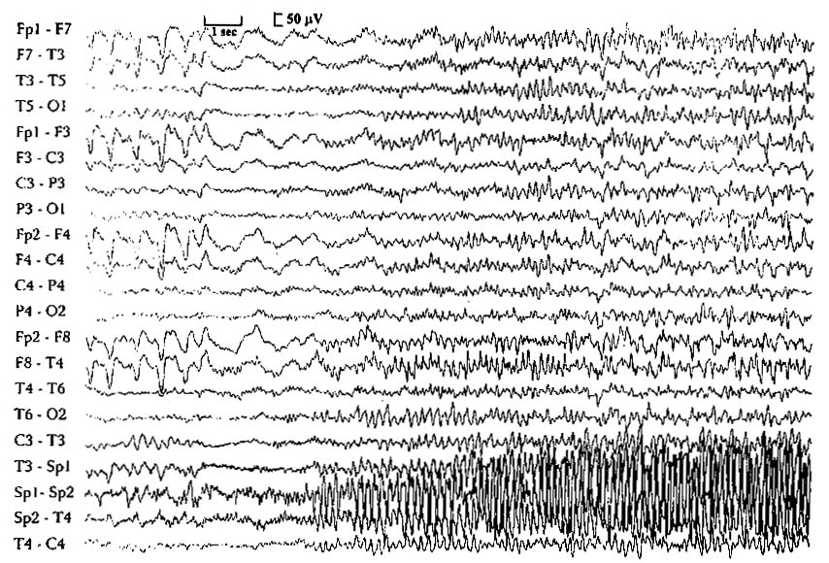

Focal spike discharges in right central region:
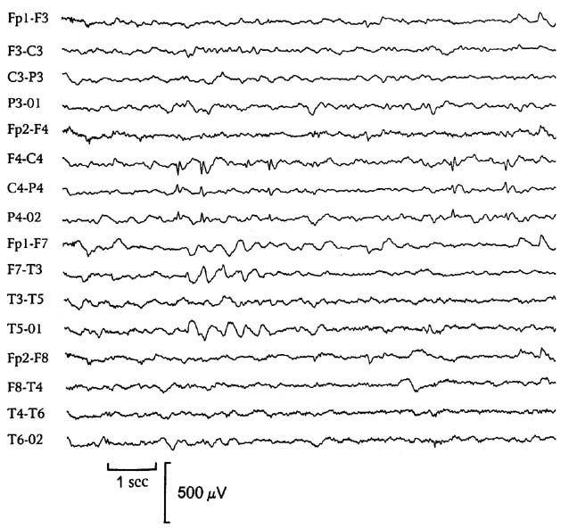

Diagnostic Approach
Distinguish between diagnostic workup (i.e. to establish cause) and detailed preoperative workup (i.e. to localize focus)!
First-time seizure
Because epilepsy is not a single homogeneous disorder, and because seizures may be symptoms of both diverse brain disorders and otherwise normal brain, it is neither possible nor desirable to develop inflexible guidelines for what constitutes "standard" or "minimal" diagnostic evaluation!
- diagnostic evaluation has three objectives:
- whether patient had true seizure (vs. another provoked paroxysmal event)
- classify seizures and type of epilepsy accurately and determine whether clinical data fit particular epilepsy syndrome.
- seek for specific underlying cause.
It must never be assumed that first-time seizure is idiopathic!
Adult patients who experience first seizure should have:
- Complete history - most important diagnostic tool!
- Metabolic work up; need for particular laboratory studies (incl. blood, CSF) is determined on individual basis
- MRI w/wo (CT may fail to detect small tumors); even MRI may miss some tumors – repeat MRI in 3-6 months!!! (and possibly 1 and 2 years later)
If above are negative then:
- EEG → sleep deprived EEG
- if both EEGs are normal, 2-yr recurrence rate of seizures is 12%
- if one or both EEGs showed epileptic discharges, 2-yr recurrence rate is 83% (recurrence rate with focal epileptic discharges [87%] is slightly higher than for generalized epileptic discharges [78%])
- presence of nonepileptic abnormalities in one or both EEGs had 41 % 2-yr recurrence rate
van Donselaar C at al “Value of the electroencephalogram in adult patients with untreated idiopathic first seizures.” Arch Neurol49: 23 1-7, 1992.
- ECG (incl. Holter monitoring), echocardiography - if there is history of cardiac arrhythmia or valvular disease, family history of arrhythmia, sudden unexplained death, or episodic unconsciousness.

Among pediatric patients with first-time seizures, laboratory and radiologic evaluations are often costly and not helpful; detailed history and physical exam are more helpful

Seizure in known epileptic
- Identify underlying cause and precipitating factors
- Determine adequacy of current therapy.

History
- must be obtained from patient (after clearance of postictal state) + reliable observers.
N.B. patient may not be aware of all his/her seizures.
- Precipitating factors (head trauma, ingestion, fever, alcohol, sleep deprivation, menses, etc)
N.B. true seizures are rarely provoked by emotional upset or fright!
- Premonitory symptoms and signs (e.g. palpitations, lightheadedness).
- Mode of onset; presence of focal signs (aura!!!, focal sensory symptoms, focal motor signs)
- Features of seizure:
  - alteration of consciousness (most common way to assess preserved consciousness is asking patients if they remembered event - patients often remember aura but are unaware that they were unable to respond to environment).
  - involuntary movements – which body parts? (epileptic focus localization)
  - incontinence – may be only objective evidence of unwitnessed seizure.
  - cyanosis.
- Temporal progression, duration
- Mode of termination – postictal state (occurs with all seizures except simple partial and typical absence): drowsiness, disorientation, paralysis, amnesia for ictus and preceding events.
- Presence of previous ictal events; if yes, then:
Key feature of epileptic seizures is stereotypic nature!
- age at seizure onset
- course of seizure disorder
- pattern to seizure occurrence (circadian, catamenial)
- drugs used, doses and blood levels achieved, therapeutic or adverse effects.
- neurologic status between attacks.
- Risk factors for epilepsy:
- past medical history - abnormal gestation, febrile seizures, head injury, encephalitis or meningitis, stroke, etc
- family history of epilepsy.
- developmental history in children
- For established epilepsy:
- treatment & compliance
- how seizures affect patient's QOL (quality of life) - useful question is “How would your life change if you no longer had seizures?”

Physical examination
- vital signs should be evaluated.
  - fever can cause seizures (low-grade temperature elevation immediately after convulsive generalized seizure is expected).
  - tachypnea, tachycardia, abnormal BP that persists beyond immediate postictal period may indicate toxic exposure, hypoxia, CNS lesion.
- look for sequelae of convulsive seizures - tongue injury, posterior shoulder dislocation, back pain, etc.
- examine skin for neurocutaneous disorders.

Neurologic examination
- findings are usually normal in patients with epilepsy.
    - occasional focal findings may provide etiologic clues.
    - elevated ICP (papilledema) can both cause and result from ictal activity.
    - failure of steady improvement of postictal depression of consciousness suggests underlying encephalopathy.
    - asymmetry in size (of hands, feet, face) signifies longstanding abnormality of cerebral hemisphere contralateral to smaller side.
    - absence seizures can be triggered by hyperventilation for 2-3 minutes.

EEG
- most useful test to support epilepsy diagnosis and to classify specific epileptic syndromes.
See also p. D27 >>
Epilepsy can be definitively established only by recording characteristic ictal discharge during representative clinical attack.
- two key questions to answer by interictal EEG:
- whether epileptiform discharges are present
- is pattern of epileptiform discharges localized (focal) or generalized
- in general, normal interictal EEG implies better prognosis.
- background EEG activity also guides to prognosis - slowed background implies poorer prognosis.
N.B. slowed background is “normal” during postictal state!
- anticonvulsants do not necessarily affect EEG; barbiturates and benzodiazepines cause beta or fast wave patterns.
- EEG is not helpful in determining if CNS injury will go on to develop seizures (because in such circumstances epileptiform activity is common regardless of whether seizures occur).

Definitive focal diagnosis before surgery requires EEG recording during seizure with simultaneous video recording (video EEG). see p. E11 >>
N.B. video EEG is gold standard!

Epileptiform discharges
(interictal hallmark of epilepsy!) - abnormal paroxysmal events containing sharp waves or spike discharges, at least in part.
- strongly associated with seizure disorders.
- type of epileptiform discharge may suggest specific epileptic syndrome.
- recorded in 30-50% epileptic patients on first routine EEG and in 60-90% by third-fourth routine EEG; further EEGs do not increase yield appreciably (thus, 10-40% epileptics do not demonstrate interictal discharges).
Absence of epileptiform discharges does not rule out epilepsy diagnosis!
- present in only < 50% of epilepsy patients
Epileptiform discharges do not establish epilepsy diagnosis –
- found in 2-5% normal people (and up to 3.5% healthy children)!
Maneuvers to increase chance of catching epileptiform discharges:
- EEG within 24 hours of seizure
- sleep after 24 hrs sleep deprivation, esp. awake to sleep transition (for grand mal); NREM sleep has activating effect on seizures due to synchronization of brain electrical activity.
Every patient getting EEG ideally should be sleep deprived – increases chances of capturing abnormalities!
- hyperventilation (for petit mal)
- photic stimulation (for grand mal)
- special electrode placements
- long-term monitoring (computerized analysis programs to screen EEG are used):
    - simultaneous closed circuit television and EEG (CCTV/EEG) monitoring ± antiepileptic drugs discontinuance - in specially designed hospital unit; emphasis is usually on behavioral events, not interictal EEG activity; major indications - documenting psychogenic seizures and other nonepileptic paroxysmal events, evaluation for epilepsy surgery.
    - outpatient ambulatory EEG (especially helpful in pediatrics) - not substitute for CCTV/EEG; major limitations - limited coverage of cortical areas, lack of expert supervision, absence of video documentation of behavioral changes.
- software for automatic spike detection (e.g. Persyst 13).

Lateralized periodic discharges (LPDs) s. Periodic lateralizing epileptiform discharges (PLEDs)
- lateralized (confined to single hemisphere) discharges that occur with regular periodicity (e.g. at 1-2 Hz) in setting of focally slow or attenuated background – continuum between interictal and true ictal discharges.
- suggest presence of acute destructive hemispheric insult (typically in obtunded patients with focal neurological deficit and often recurrent seizures).
- commonly replaced after several weeks by continuous polymorphic slow-wave disturbance.
- very high association with clinical and electrographic seizures; 17% progress to epilepsy.

Neuroimaging (routine)
- must be performed in:
- all patients > 18 years
- children with suspected partial epilepsy* (head trauma, abnormal development, abnormal physical examination, persistently abnormal mental status, partial seizure types, focal slow-wave abnormalities on EEG, ICP↑, etc).
*except benign focal epilepsy syndromes.
N.B. routine imaging is not necessary for children with idiopathic epilepsy!
e.g. imaging is not required to evaluate absence seizures

MRI is more sensitive than CT in detecting potentially epileptogenic lesions.
- modern MRI has great sensitivity! (e.g. high-resolution 3T MRI)
- MRI should be obtained even if patient has already had CT in ED.
- CT should usually be omitted if MRI can be obtained early.
- both axial & coronal planes should be imaged with both T1 & T2 sequences!!!
- gadolinium injection does not increase sensitivity for detecting cerebral lesions (even in focal seizures), but may assist in differentiating possible causes.
- special MRI techniques exist (e.g. imaging in coronal plane perpendicular to long axis of hippocampus, MRI measurement of hippocampus volume).

Neuroimaging (advanced)
- used for evaluation for surgical candidacy. see p. E11 >>

Blood tests
    - routine blood tests are rarely diagnostically useful in otherwise healthy children or adults.
e.g. although hypoglycemia / electrolyte abnormalities may cause seizures, abnormalities sufficient to cause seizures are rarely associated with normal mental function;
    - febrile seizures (first or recurrent) also do not require routine laboratory studies.
    - routine blood tests are necessary (and frequently informative) in older patients with systemic disease.

      - CBC* - assess periodically during therapy with specific drugs (e.g. carbamazepine, ethosuximide, valproate). see p. E5 >>
      - Electrolytes (calcium, magnesium)*
      - Glucose – almost routine test!
      - BUN
      - Liver function tests*; periodically assess transaminases during therapy with specific drugs (e.g. carbamazepine, valproate, phenytoin, primidone / phenobarbital). see p. E5 >>
*baseline before antiepileptic therapy is begun.
      - Blood / urine samples for substance abuse (esp. cocaine) - for adolescents and young adults with unexplained generalized seizures.
      - Serum prolactin levels shortly after seizure** - to assess etiology (epileptic vs. nonepileptic); considerable variability precludes routine clinical use.
**typically elevate ≥ 3-4-fold (esp. in generalized tonic-clonic seizures).
      - Anti-treponemal serologic test - for every adult with acquired partial seizures. see p. 239 (11) >>
      - Serum levels of anticonvulsants see p. E5 >>

Lumbar puncture
- indicated only in suspicion of meningitis, encephalitis (occasionally, subarachnoid hemorrhage).
- also indicated in all HIV-infected patients.
N.B. if seizure was focal or if mass lesion is suspected, be sure there is no papilledema or midline shift before doing LP!
- repeated generalized seizures and convulsive status epilepticus cause transient disruption of BBB → slightly increased CSF protein and CSF pleocytosis (up to 100 WBC)* for 24-48 hours.
*should be attributed to seizures only in retrospect; infection or intracranial inflammatory processes should always be assumed first!

Differential Diagnosis
- Syncope (most common systemic disturbances mistaken for epilepsy!) - related to head or body posture (vs. seizure – no immediate precipitating factors), preictal diaphoresis; rare urinary incontinence; facial pallor (vs. seizure – cyanosis).
- ictal tonic-clonic movements are much more forceful and more prolonged than "twitches" (brief multifocal myoclonus) sometimes associated with syncope; syncopal myoclonus originates in brainstem and is not accompanied by cortical discharge on EEG.
- in seizures consciousness is lost abruptly and for minutes (vs. syncope – loss occurs over several seconds, duration also several seconds, no postictal confusion!).
- ictal EEG shows progressive slowing → generalized attenuation → rapid reversal in association with recovery.
- Benign neonatal myoclonus (most common nonepileptic disorder that is confused with seizures in newborns and young infants) - repetitive jerks after feeding while infant is falling asleep, during sleep or on awakening; EEG is normal; no treatment is indicated.
- Movement disorders
- Panic attacks, anxiety attacks with hyperventilation - patients typically describe suffocating sensation or "lack of oxygen", racing heart beat or palpitations, trembling or shaking; prolonged hyperventilation results in muscle twitching or spasms (tetany), and patient may faint.
- Attention deficit disorder may be mistaken as absence seizures.
- Some sleep disorders:
  - parasomnias (confusion with complex partial seizures, esp. in children) – movements slow and trance-like; lack complex automatisms, stereotyped postures, and clonic movements typical of epileptic seizures.
  - automatic behavior syndrome (microsleeps in excessive daytime sleepiness) - patient stimulation easily stops episode, unlike epileptic seizure.
  - narcolepsy ± cataplexy
- Some migraine events (confusional migraine, basilar migraine) may be mistaken for seizures; migraine symptoms tend to have more gradual onset and longer duration.
- Transient ischemic attacks - "negative" nature of predominant symptoms which develop simultaneously over affected areas (vs. epilepsy – “positive” symptoms with sequential spread from one body area to another), absence of clonic motor activity and confusion.
- Pseudoseizure (psychogenic seizure); see p. E9 >>
N.B. most distinguishing feature of true epileptic seizures is stereotypy!
- 75% children with pseudoseizures also have epilepsy!
- behaviors such as pelvic thrusting, head turning from side to side, bizarre vocalizations usually are not seen in epileptic seizures (exception - frontal lobe seizures).
- Transient global amnesia
- Paroxysmal vertigo
- Metabolic disturbances - alcoholic blackouts, delirium tremens, hypoglycemia, hypoxia, psychoactive drugs (e.g. hallucinogens).

Psychosocial Issues
Many patients with epilepsy are completely normal between seizures and able to live highly successful and productive lives!
Cultural stigma about epilepsy is still alive - many epileptic patients harbor fear of becoming mentally retarded or dying during seizure.
Epilepsy Foundation of America (Landover, Maryland) (tel. 1-800-EFA-1000) is patient advocacy organization and has wealth of materials about epilepsy suitable for patient, family, and public education.
- quality of life often suffers more from neurologic abnormalities, psychological factors, adverse drug effects than from seizures per se - psychosocial concerns are major focus of most follow-up visits!
- important is episodic nature of epilepsy - periods of relative well-being are punctuated by unpredictably occurring attacks that are graphic reminders of medicine's failure.

Most important problems for adults:
  - loss of mobility (legally cannot drive - one of most disruptive social consequences of epilepsy!!!) and other lifestyle limitations. see p. E5 >>
  - discrimination at work (employers frequently have unrealistic fears about physical effects of seizure, potential for liability, and impact on insurance costs)
N.B. federal and state legislation is designed to prevent employers from discriminating against patients with epilepsy! - patients should be encouraged to claim their legal rights; health providers can act as strong patient advocates.

children suffer most from:
- uninformed friends
- overly attentive parents (handicap child by being restrictive) - parents should be encouraged to treat child as normally as possible!
- restriction of physical activity is unnecessary (except supervision while bathing and swimming).
N.B. developmental tasks build on one another, and failure to complete early tasks can compromise subsequent developmental competence.

Psychiatric Issues
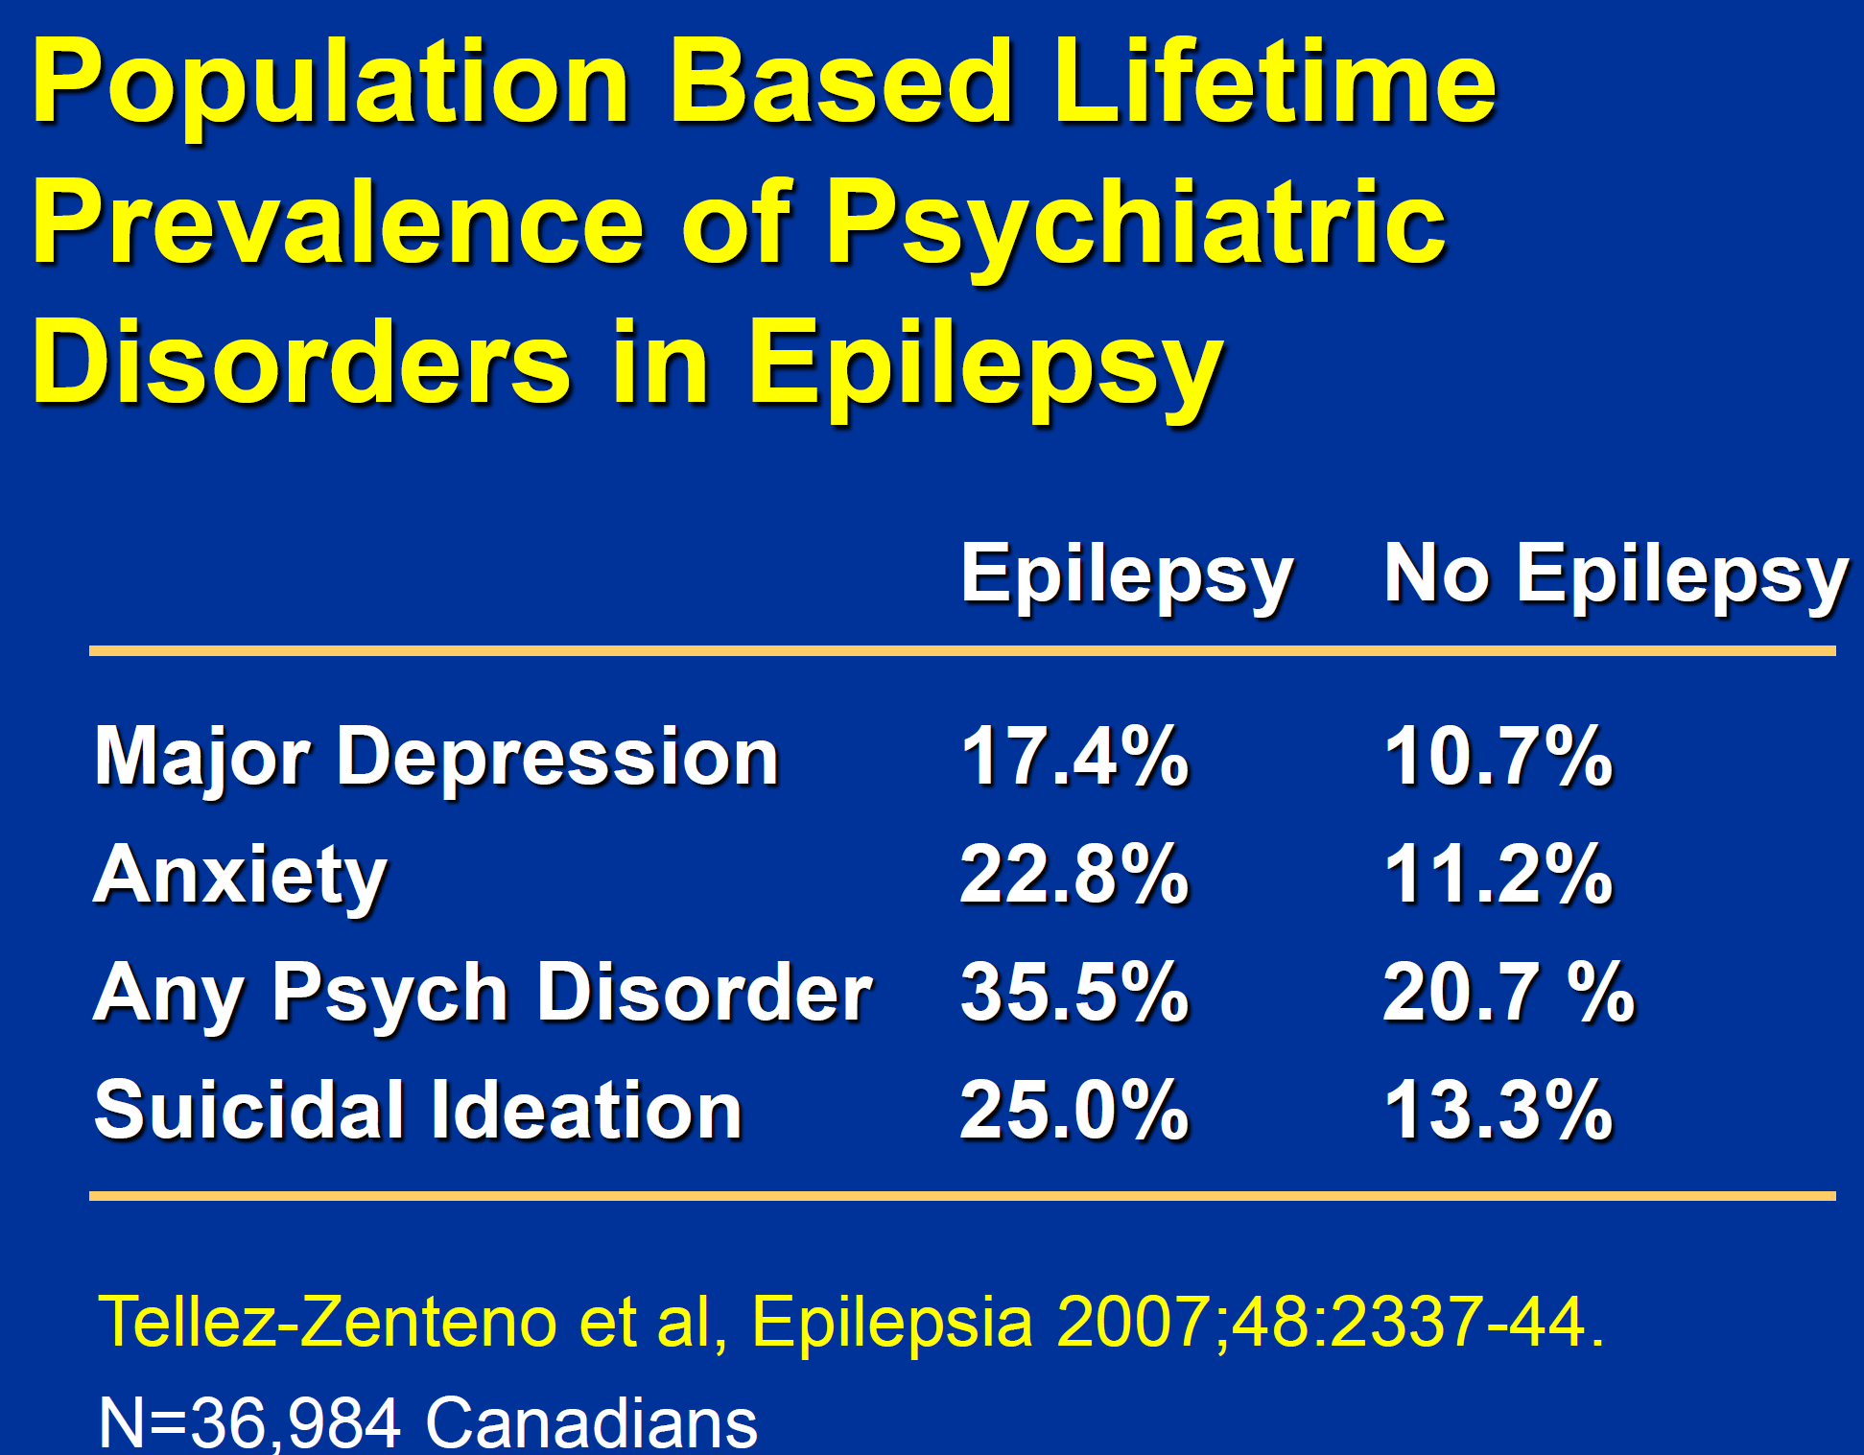

Ongoing controversy about stereotypical "interictal personality" (esp. in partial-complex epilepsy).
        - predominant view - unusual / abnormal personality traits are, in most cases, not due to epilepsy but result from underlying structural brain lesion, effects of antiepileptic drugs, or psychosocial factors!

Depression
Depression and suicide are more common in epileptics than in patients with other neurologic disorders or in disease-free controls.
    - depression occurs in ≈ 20% epileptics.
    - curiously, depression sometimes follows successful epilepsy surgery.
    - treatment of depression:
      - barbiturates and ethosuximide may adversely affect mood.
      - tricyclic antidepressants reduce seizure threshold in experimental models of epilepsy, but this is not practical concern in humans.
      - MAO inhibitors neither induce seizures nor increase seizure frequency.
      - SSRI have no effect on seizures.
      - modern electroconvulsive therapy does not worsen epilepsy.

Psychosis
Relation between psychosis and epilepsy is controversial (no convincing evidence shows that interictal psychosis is manifestation of epilepsy).
        - interictal aggressive behavior is not more common in epileptics.
        - ictal or postictal violence is rare and is not directed*; directed aggression during seizures occurs in < 0.02% patients with severe epilepsy; it is certainly less common in general epilepsy population.
*e.g. undirected pushing or resistance occasionally occurs postictally when attempts are made to restrain confused patients.
        - postictal psychosis (s. postictal delirium) - uncommon limited psychosis that follows flurry of seizures (usually after interval of appropriate behavior); does not lead to chronic psychosis.
        - interictal psychosis - rare phenomenon; occurs after period of increased seizure frequency: brief lucid interval (lasting up to week) → agitated, psychotic behavior (lasting days to weeks); resolves spontaneously but may require treatment with antipsychotics.
        - treatment - high doses of phenothiazines, butyrophenones, and clozapine lower seizure threshold in experimental animals and occasionally induce seizures in nonepileptic patients!

Cognitive Dysfunction
N.B. cognitive difficulties in epilepsy have a larger effect on quality of life than the seizures them self!
Progressive mental deterioration is usually related to neurologic disease that caused seizures.
        - frequent interictal EEG abnormalities are associated with subtle dysfunction of memory and attention.
        - frequent seizures from temporal lobe → impairment of short-term memory (may progress over time); left temporal lobe epilepsy - verbal memory; right temporal lobe - visual spatial memory.
      - in temporal lobe epilepsy some studies show the rate of cognitive issues may be as high as 80%
        - learning disabilities are more common in children with epilepsy!
        - children with poorly controlled epilepsy show progressive declines in serial IQ.
        - treatment – cognitive rehab such as Home Based Self-Management and Cognitive Training Changes Lives (HOBSCOTCH).
Home Based Self-Management and Cognitive Training Changes Lives. Accessed October 7, 2020. https://www.hobscotch.org

Epileptic Encephalopathy
        - abundant epileptiform activity interferes with development resulting in cognitive slowing and often regression, and sometimes is associated with psychiatric and behavioral consequences.
        - epileptiform activity can cause regression in an individual with normal development or preexisting developmental delay, who then shows developmental plateauing or regression.
        - amelioration of epileptiform activity may improve the developmental consequences of the disorder, i.e. EE is caused by seizures (vs. developmental encephalopathy – caused by underlying pathology).

N.B. epileptic encephalopathies can cause varied neurocognitive and behavior difficulties even in the absence of frequent seizures!

Cardiological Issues
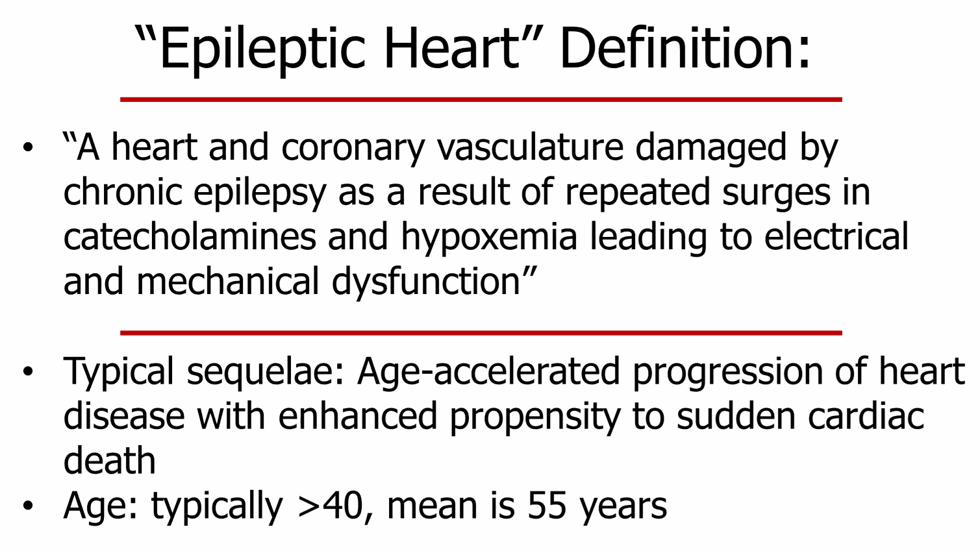

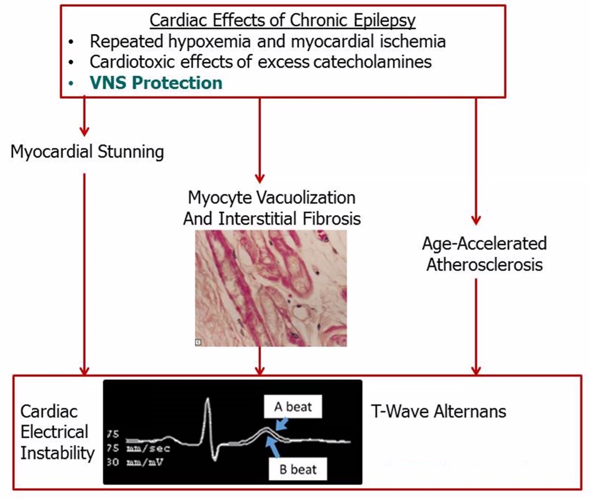

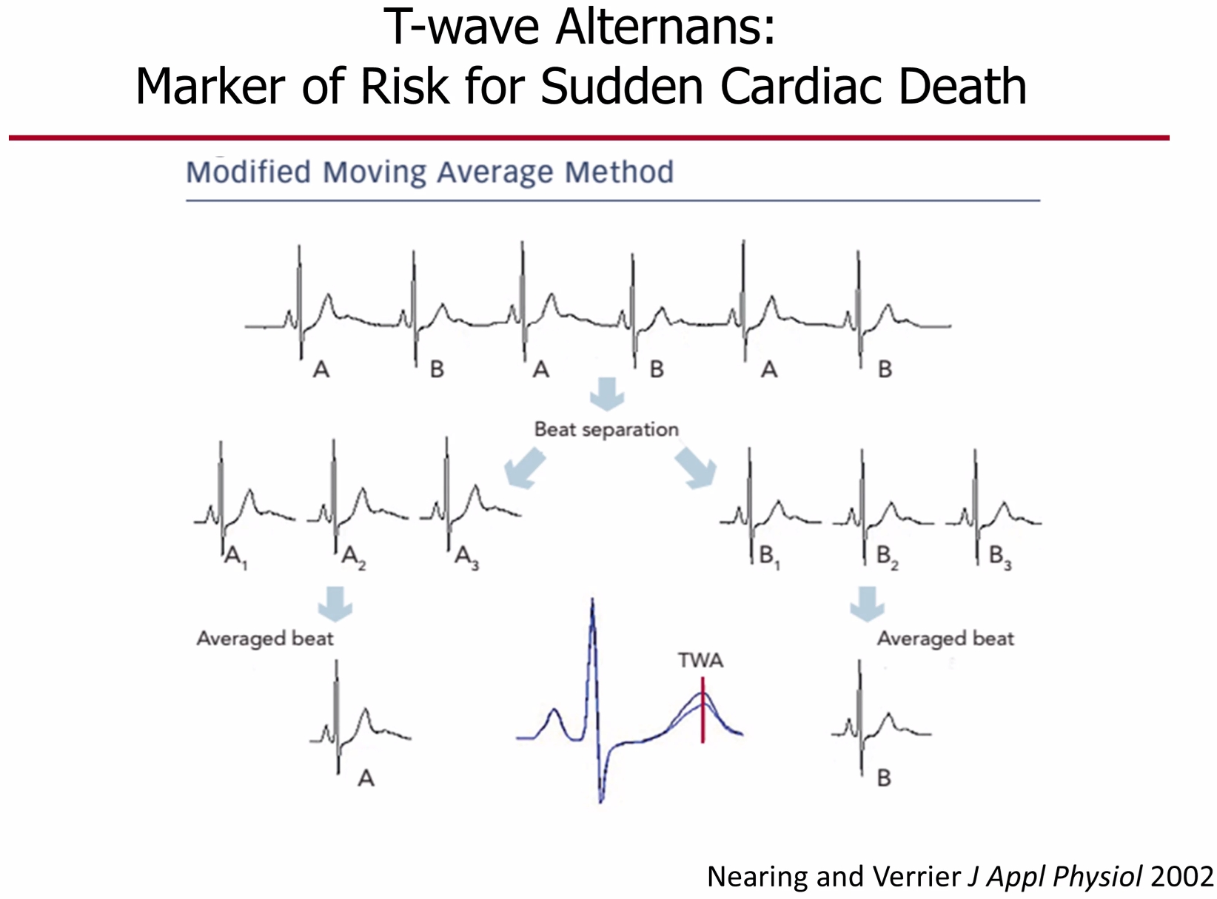

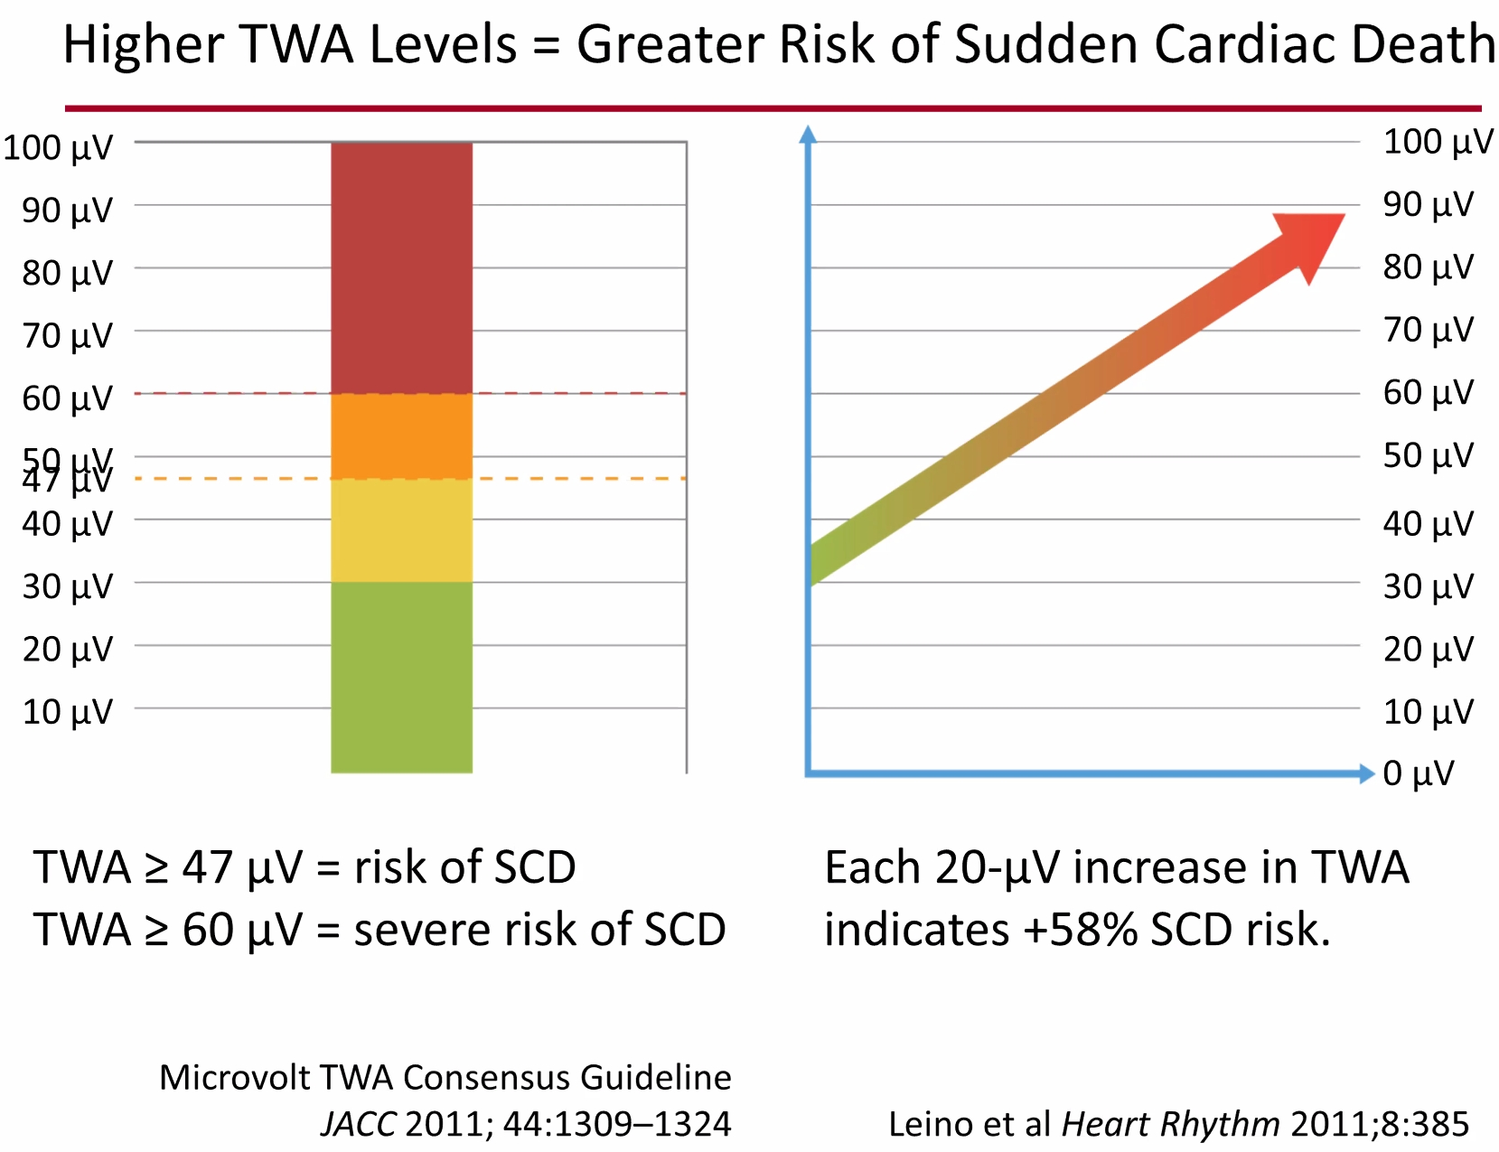

TWA can be detected using ambulatory patch monitors.

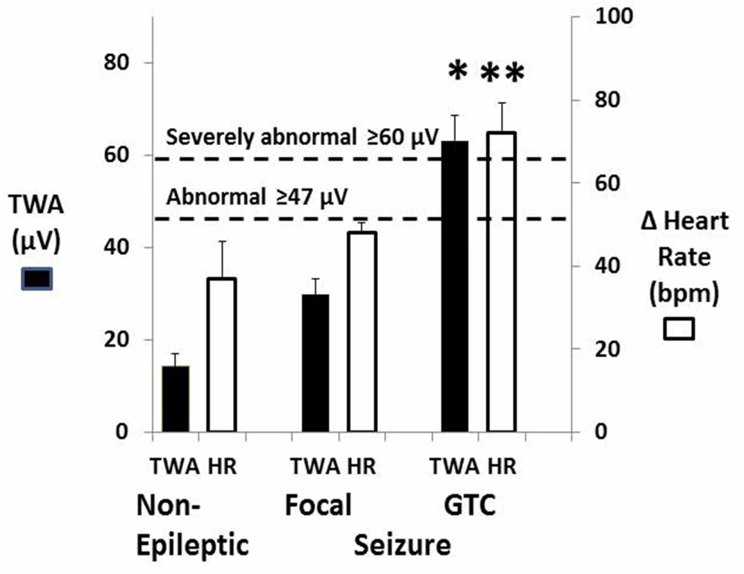

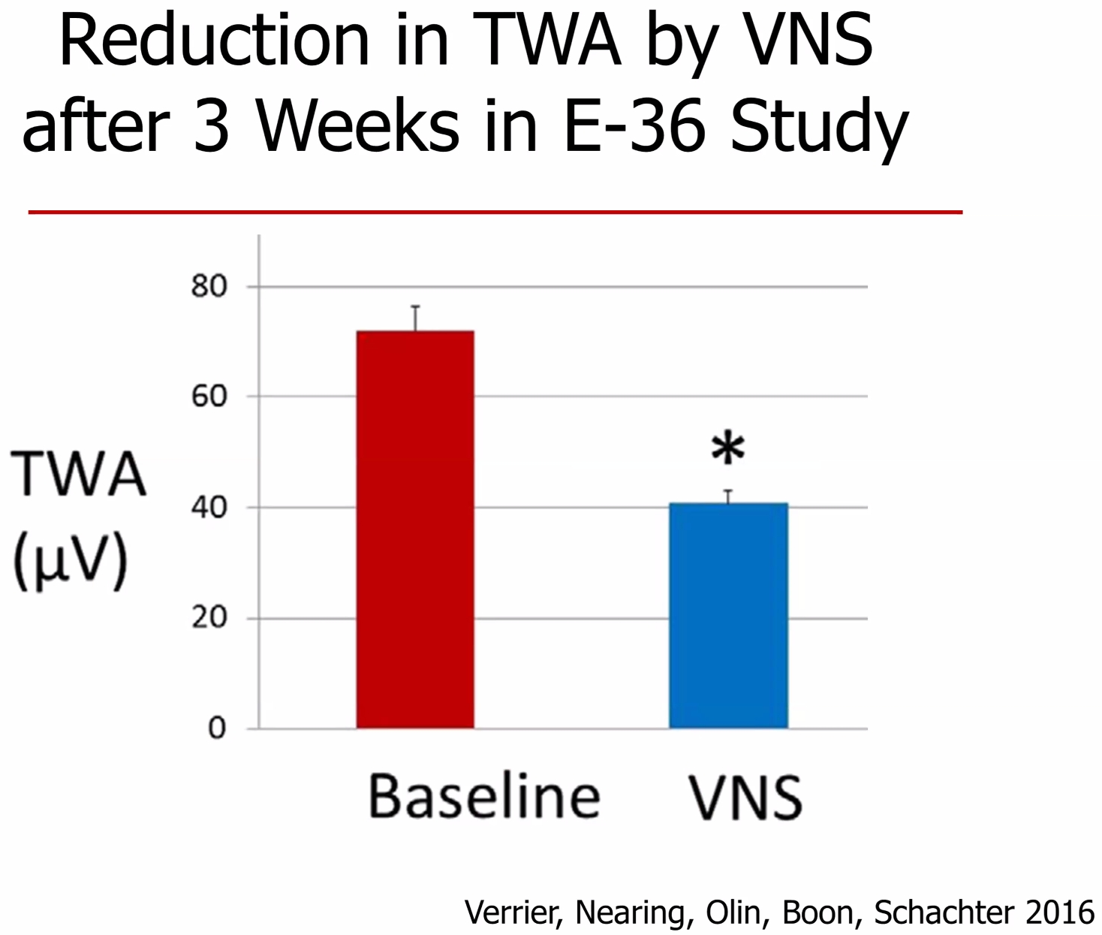

Sudden Unexpected Death in Epilepsy (SUDEP)
- sudden, unexpected, witnessed or unwitnessed, nontraumatic and nondrowning death in patient with epilepsy, with or without evidence of seizure and excluding documented status epilepticus, in which postmortem examination does not reveal toxicological or anatomical cause of death.

Annual Incidence: 2017 AAN/AES SUDEP practice guideline summary describes the risk of SUDEP for adults with epilepsy as small
1:1000 (0.58-2:1000) in general epileptic population
0.22:1000 (or 1:4500) in children with epilepsy*
*in some specific childhood epilepsy syndromes, such as Dravet syndrome, incidence is known to be much higher (up to 49% of deaths of patients with Dravet syndrome were due to SUDEP)
4:1000 in patients in EMU – patient must be warned that the goal of staying in EMU is to provoke seizures but that may lead to death!
6-9:1000 in candidates for epilepsy surgery.
Uncontrolled seizures increase risk of death 13 times above general population average (SUDEP, status epilepticus, suicides, accidents, etc) - leads to 50K annual deaths in the U.S. (vs. 40.2K from breast cancer).
SUDEP accounts for a relatively small proportion of the overall mortality in patients with epilepsy!!!
N.B. percentage of SUDEP as a cause of mortality overall varies depending on the study population (higher SUDEP rates among patients treated in specialized centers – sicker patients); e.g. 1.6% of all deaths in population-based epilepsy cohort (Ficker et al.) vs. 7.1% in hospital-based cohort (Aurlien et al)
Risk factors:
- generalized tonic-clonic seizures, particularly at ≥ 3 convulsive seizures per year - 15-fold increased risk of SUDEP (18:1000)
- drug-resistant epilepsy (i.e. absence of seizure freedom)
- not escalating treatment in medically refractory epilepsy
- seizures during sleep
- other potential risk factors (evidence is minimal or incomplete): male sex; epilepsy onset before 16 years of age; disease duration > 15 years; patients < 16 with intellectual disability; structural brain lesion, or abnormal neurological exam; alcohol use; psychiatric comorbidities, particularly in female patients
- other factors:
  - prior status epilepticus (odds ratio [OR] of 7.83 for SUDEP cases vs controls matched for age, epilepsy duration, and sex)
  - prior epilepsy surgery (OR, 4.23)
  - taking several antiepileptic drugs (OR, 4.7).
*AEDs might prevent SUDEP by improving seizure control or might potentially trigger SUDEP following their sudden withdrawal, or by exerting direct effects on cardiac control.

Mechanism:
        - death most likely to occur during or shortly after seizure (theory – global brain activity suppression after ictus).
        - coincidence of several precipitating factors (e.g. ictal asystole occurring + postictal respiratory depression → fatal decrease in cerebral oxygen supply → sudden death).

Prophylaxis:
  - seizure freedom (esp. eliminating grand mal)
  - nocturnal supervision (e.g. seizure-alerting systems, presence in the bedroom of another individual at least 10 years of age and of normal intelligence)
  - implantation of cardiac pacemaker-defibrillator device.
N.B. approach must be individualized (e.g. the limited potential benefit of co-sleeping with a grown child for some families is outweighed by the psychological need for independence, but for other families results in anxiety reduction that is a significant emotional benefit).

Patient counseling
for patients - American Academy of Neurology (AAN)/ American Epilepsy Society (AES) Summary of Practice Guideline for Patients and their Families 2017 >>
for providers - AES position statement on SUDEP counseling 2019 >>
        - AES recognizes that the majority of patients with epilepsy, families, and caregivers want to be informed of SUDEP risk by their healthcare providers.
        - scenarios in which SUDEP counseling should be considered:
- convulsive seizures, particularly if frequent (3 or more per year)
- Dravet syndrome
- seizures during sleep
- history of non-adherence to treatments
- patients with concerns about the risks of dying from epilepsy
- new epilepsy diagnosis

Apnea
        - amygdala stimulation causes apnea.

Arrhythmias
Epilepsy ≈ 3-fold increased risk of lethal cardiac arrhythmias!

Ictal – all self-limited, no deaths reported (actually, ictal asystole with no brain perfusion stops the seizure)
        - ictal asystole recurs in 40% cases – implant pacemaker
        - ictal asystole only happens in focal seizures – not a risk factor for SUDEP (vs. postictal asystole in generalized seizures)

Postictal – much more ominous.

Resources For Patients
CDC website >>

Epilepsy Foundation >>

American Epilepsy Society (AES) >>

Bibliography for ch. “Epilepsy and Seizures” → follow this link

Viktor’s Notes℠ for the Neurosurgery Resident
Please visit website at www.NeurosurgeryResident.net

