Surgical Treatment of Epilepsy
Last updated: February 8, 2023
Definition of pharmacoresistance 3
Epidemiology of pharmacoresistance 3
Challenging the above figures 4
Mechanism of pharmacoresistance 5
Indications 6
Referral to Epilepsy Center 6
Level of care and mortality 7
Barriers for timely referrals 8
Timing of Surgery 10
Strategies to improve patient agreement 11
Contraindications 11
Definitions of surgical zones 12
Node vs. Network disease 14
Common Epileptic Pathologies 16
Presurgical Evaluation (Non-Invasive, Phase I) 16
Scalp (surface) EEG 17
Neuroimaging (routine) 17
CT 18
MRI 18
HARNESS-MRI protocol 18
MRI-negative cases 19
Neuroimaging (advanced) 19
Special MRI postprocessing 20
Tractography (DTI) 20
Hippocampal Volumetry 20
Cortical Unfolding 20
¹HMR (Proton) Spectroscopy 21
fMRI 21
Resting state fMRI 21
EEG-fMRI 21
nTMS (navigated transcranial magnetic stimulation) 23
Mapping for eloquent cortex 23
Epilepsy palliation 24
PET (positron-emission tomography) 24
SPECT (single-photon emission computerized tomography) 25
SISCOM (Subtraction Ictal Spect CO-registered to Mri) 25
Magnetoencephalography (MEG) 27
MSI 28
Neuropsychological testing (Neuropsychometry) 30
Multidisciplinary Conference 30
Presurgical Evaluation (Invasive, Phase II) 30
Chemical Wada (Intracarotid Amobarbital test) 31
Indications 31
Procedure details 31
Side effects 32
Interpretation 32
Noninvasive alternatives to Wada 33
UAMS protocol 33
Electrical Wada 35
Intracranial EEG (icEEG) 36
Algorithm (treatment) 36
Focal Epilepsy 40
Temporal 40
Mesiotemporal 41
Nonmesiotemporal (neocortical temporal, extratemporal) 41
Extratemporal 42
Eloquent Cortex 42
Language localization / Lateralization 43
Generalized Epilepsy 43
Genetic (s. idiopathic, primary) generalized epilepsy 43
Lennox–Gastaut type (s. symptomatic, cryptogenic generalized epilepsy) 43
Preoperatively 44
AED 44
Types of Surgery 44
Surgical Philosophy 45
1. Resection / Ablation 45
Temporal Resections 45
Lesionectomy 45
Lesioning 45
Tailored Neocortical Resection 46
Multilobar Resection 48
2. Disconnections 48
Multiple Subpial Transections (MST) 48
Hemispherectomies (functional, anatomical) 48
Corpus Callosotomy 48
3. Neuromodulation 49
Comparison Of Neuromodulations 49
Seizure Outcomes 51
Stimulation Time 52
Psychiatric Side Effects 52
Deep Brain Stimulation (DBS) 52
Vagus Nerve Stimulation (VNS) 53
Responsive Neurostimulation (RNS) 53
Transcranial Magnetic Stimulation (nTMS) 53
Postoperatively 54
AED 55
Before discharge 55
Surgery Outcomes 55
Seizures 55
Classification of outcomes 57
Seizure Freedom 58
Seizure worsening / De Novo seizures 58
Surgical refractoriness 59
Quality of Life 59
Psychiatric 60

Definition of pharmacoresistance
Drug-resistant ≠ Treatment-resistant

N.B. pharmacoresistance is diagnosed by history taking!

Medical intractability (pharmacoresistant epilepsy)
- Failed 2 medications
2 trials of AEDs at optimal doses with appropriate medications are sufficient to consider referral of patients with focal seizure disorder for presurgical evaluation
- Commission on Therapeutic Strategies of the International League Against Epilepsy (ILAE) definition (officially adopted at the ILAE's 2009 meeting in Budapest, Hungary):
"drug-resistant epilepsy - failure of adequate trials of two tolerated and appropriately chosen and used AED schedules (whether as monotherapies or in combination) to achieve sustained seizure freedom." – i.e. complete epilepsy control!

- Failed 3 medications – obsolete!!!
- some advocate at least 3 regimens, including 2 trials of high-dose monotherapy + 1 trial of 2-drug therapy.

- these therapeutic trials can be accomplished within 6-12 months - depending on frequency of seizures at baseline (i.e. how quickly can see treatment results).
- no rationale to try different medications with the same mechanism of action.

Epidemiology of pharmacoresistance
20-30% patients are not controlled adequately with AED!
(≈ ½ of them are potential surgery candidates)

Prevalence of pharmacoresistance: 17% (if count > 1 sz / month) or 26% if count > 1 sz / year)

- among all patients with epilepsy, 60-70% are expected to become seizure-free with AEDs:
47% of patients respond to first AED
additional 14% respond to second AED
additional 3% respond to third AED
36% of patients are refractory

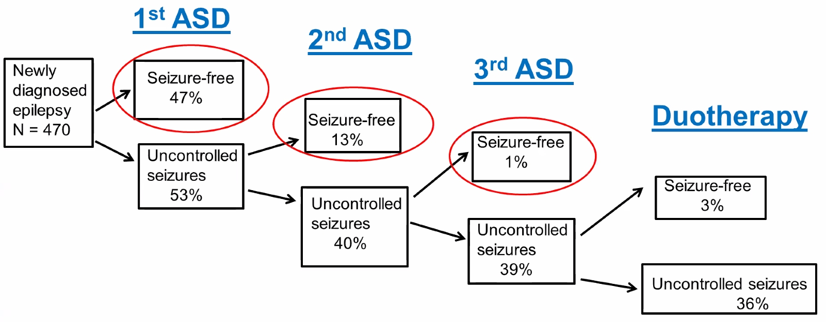

Kwan P, Brodie MJ. Early identification of refractory epilepsy. N Engl J Med. 2000;342(5):314–319

N.B. development of new medications did not change these figures! (same numbers in 2008 Kwan and Brodie study)

Response to first AED is most important predictor of drug-resistant epilepsy!

Challenging the above figures
It is true that in Kwan and Brodie’s seminal 2000 study, only 4% of the entire study cohort achieved seizure freedom after 2 failed medications. And in the 2018 follow-up by Chen et al, only 4.4% of the study cohort became seizure-free on a third medication regimen.
N.B. most people in the 2000 and 2018 studies didn’t try a third medication regimen - so they cannot be included when calculating a success rate (i.e. seizure freedom rate for any given medication regimen must include only the patients who tried that regimen, and exclude those who have not)
2018 Kwan and Brodie study: among people who tried a 3rd medication, 23.6% achieved seizure freedom. (15% - 4th, 14.1% - 5th, 14% - 6th medication):
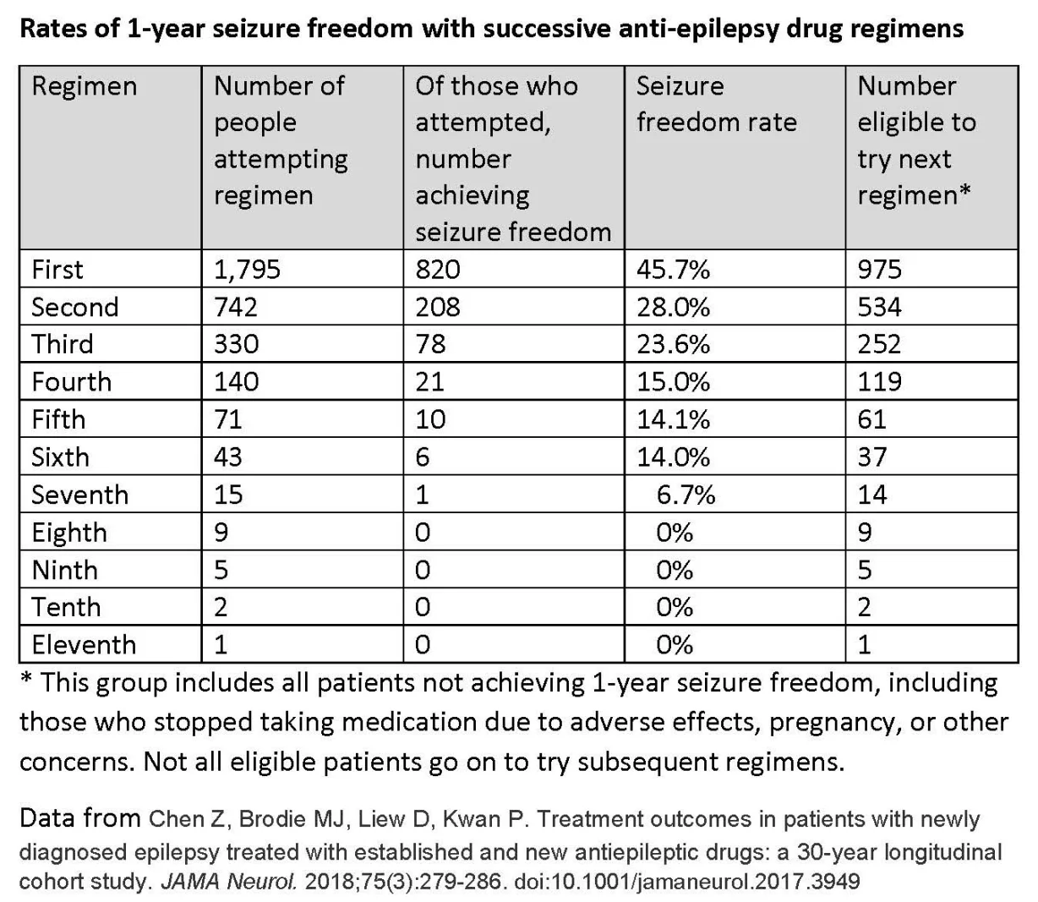

- another study showed slightly more optimistic results: 18.5% and 16.5% were made seizure free with a third and fourth AED, respectively, and decreased to 0% after 5 or 6 previous AED failures.
Schiller Y, Najjar Y. Quantifying the response to antiepileptic drugs: effect of past treatment history.
Neurology 2008;70(1):54–65

- CRT (16 U.S. centers) of 38 patients with mesial temporal lobe epilepsy of < 2 years duration who failed 2 brand-name AEDs: 0 of 23 patients assigned to continued medical optimization achieved seizure freedom with drug adjustments alone during 2 years of follow up (vs. 11 of 15 in the surgical group became seizure free).
Engel J Jr, McDermott MP, Wiebe S, et al. Early surgical therapy for drug-resistant temporal lobe epilepsy: a randomized trial. JAMA. 2012 Mar 7;307(9):922-30.

- positive therapeutic expectations of AEDs vary according to epileptic syndrome:
- 80-90% of patients with idiopathic generalized seizures are expected to become seizure-free;
- only 50% of patients with focal seizure disorders are expected to become seizure-free (seizure-freedom may decrease to 30% in cases of temporal lobe epilepsy secondary to mesial temporal sclerosis or be as high as 95% in cases of benign rolandic epilepsy of childhood).

Mechanism of pharmacoresistance
- remains incompletely understood.

Target hypothesis - changes in the AED targets, such as ion channels, lead to decreased drug efficacy.

Transporter hypothesis - efflux pumps are thought to restrict AED movement into cells and to be overexpressed in patients resistant to AEDs; P-glycoprotein (Pgp) is one such multidrug transporter that has been implicated in drug-resistant epilepsy.

Indications
Seizures refractory to appropriate medical management
+ seizures seriously limit patient's activities*
+ well-defined epileptogenic focus not involving eloquent cortex – obsolete condition**.
*patients' quality of life must be included (e.g. even as few as 2-3 seizures year may be disabling to individual whose occupation requires transportation with motor vehicle; vs. homebound patients who are not physically harmed by their seizures).
**cortical resection must not intentionally produce significant neurologic deficit such as aphasia or hemiparesis; this is obsolete – RNS / DBS / VNS can treat those patients!

N.B. pharmacoresistance per se is not an indication for surgery!

DRUG-RESISTANT ≠ TREATMENT-RESISTANT

Make sure it is epilepsy and not something else (once a while a mistake is made when cardiac arrhythmias mimic epilepsy)

Complex partial seizures or partial seizures with secondary generalization are seizure types most amenable to surgical resection

Today, most “ideal” pathology for surgery is right-sided temporal lobe epilepsy.
N.B. temporal lobe epilepsy is most medically refractory but surgical results are the best!
- studies show that surgical results for frontal lobe epilepsy are also good.

Canadian Appropriateness of Epilepsy Surgery (CASES) tool - a highly sensitive guide for determining candidacy for epilepsy surgery
Jette N, Quan H, Tellez‐Zenteno JF, et al. Development of an online tool to determine appropriateness for an epilepsy surgery evaluation. Neurology. 2012;79:1084–93
Online: www.epilepsycases.com

Referral to Epilepsy Center
- individuals who have continued seizures after treatment with ≥ 2 AEDs has failed are very unlikely to achieve seizure freedom with medical treatment alone → guidelines recommend that these patients be referred to a comprehensive epilepsy center.
Engel J Jr, Wiebe S, French J, et al. Practice parameter: temporal lobe and localized neocortical resections for epilepsy: report of the Quality Standards Subcommittee of the American Academy of Neurology, in association with the American Epilepsy Society and the American Association of Neurological Surgeons. Neurology. 2003;60(4):538–547.
Labiner DM, Bagic AI, Herman ST, et al. Essential services, personnel, and facilities in specialized epilepsy centers-revised 2010 guidelines. Epilepsia. 2010;51(11):2322–2333.
Cross JH, Jayakar P, Nordli D, et al. Proposed criteria for referral and evaluation of children for epilepsy surgery: recommendations of the Subcommission for Pediatric Epilepsy Surgery. Epilepsia. 2006;47(6):952–959.

Patients in whom ≥ 2 AEDs (appropriately chosen and tolerated) have failed to completely control epilepsy (sustained seizure freedom) should be considered drug resistant and referred to a comprehensive epilepsy center for surgical evaluation

National Association of Epilepsy Centers >>
- if you see a family doctor, and you are continuing to have seizures, you should ask for another opinion after 3 months.
- if you are seeing a neurologist, and the seizures have not been brought under control after 9 to 12 months, then you should ask for a referral to a specialized epilepsy center.
N.B. only one‐third of cases general neurologists aligned with epileptologists’ opinions.
Erba G, Moja L, Beghi E, et al. Barriers toward epilepsy surgery. A survey among practicing neurologists. Epilepsia. 2012;53:35–43.
- NAEC recommends that patients whose seizures are not fully controlled after treatment for one year be referred to a level 3 or 4 specialized epilepsy center.
N.B. patients benefit from the advanced care provided by epilepsy centers if they continue to have seizures despite treatment with two medications, experience unacceptable side effects, are / want to become pregnant.

Level of care and mortality
- patients with epilepsy are at an elevated risk of premature mortality.

Canadian study – all-cause premature mortality in epilepsy vs level of care
Lowerison MW, Josephson CB, Jetté N, et al. Association of Levels of Specialized Care With Risk of Premature Mortality in Patients With Epilepsy. JAMA Neurol. 2019;76:1352-1358.
- retrospective study of 23 653 adults (2002-2016).
- carefully control for age, sex, sociodemographic factors, disease severity, and comorbidities.
- 60% were not exposed to specialist neurological care, 40% received care by a neurologist, and 9% received care in the comprehensive epilepsy program.
- standardized mortality rate was 7.2% for the entire cohort; by level of care:
9.4% - for those receiving nonspecialist care;
5.6% - for those seen by a neurologist (HR 0.85; 95% CI 0.77-0.93);
2.8% - for those seen in the comprehensive epilepsy program (HR 0.49; 95% CI 0.38-0.62).
- exposure to specialist care (non-neurologist vs. neurologist vs. comprehensive epilepsy program) is associated with an incremental reduction in the risk of premature mortality from all-causes. Those referred to a comprehensive epilepsy program received the greatest benefit.
N.B. importance of early referral!
- possible causes of the observed benefit:
- expediting an accurate initial diagnosis
- selecting the right antiepileptic drug at the first opportunity
- experience in using rational polytherapy
- greater chances of receiving a new drug with fewer adverse effects
- access to epilepsy surgery

Mortality Over Time
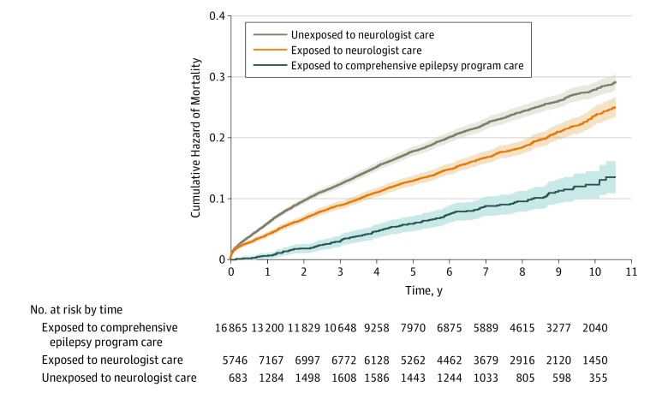

Barriers for timely referrals
- epilepsy surgery results in significantly:
- reduced mortality
Sperling MR, Barshow S, Nei M, Asadi‐Pooya AA. A reappraisal of mortality after epilepsy surgery. Neurology. 2016;86:1938–44
- increased quality of life
Choi H, Sell RL, Lenert L, et al. Epilepsy surgery for pharmacoresistant temporal lobe epilepsy: a decision analysis. JAMA. 2008;300:2497–505
- referral rates from physicians and approval rates by patients for presurgical assessment remain constantly low.
- neurologists from several countries defined medically refractory epilepsy as a failure of 3-5 AED monotherapy trials = delaying referral to epilepsy surgery
Hakimi AS, Spanaki MV, Schuh LA, Smith BJ, Schultz L. A survey of neurologists’ views on epilepsy surgery and medically refractory epilepsy. Epilepsy Behav. 2008;13:96–101.
Erba G, Moja L, Beghi E, et al. Barriers toward epilepsy surgery. A survey among practicing neurologists. Epilepsia. 2012;53:35–43.
- in two recent surveys from Canada and Italy, > 50% of affected patients stated that they considered epilepsy surgery to be very dangerous and > 60% saw it as a last resort treatment only.
Erba G, Messina P, Pupillo E, Beghi E; OPTEFF Group. Acceptance of epilepsy surgery among adults with epilepsy—what do patients think? Epilepsy Behav. 2012;24:352–8
Hrazdil C, Roberts JI, Wiebe S, et al. Patient perceptions and barriers to epilepsy surgery: evaluation in a large health region. Epilepsy Behav. 2013;28:52–65.

Study of 185 German patients in tertiary epilepsy care center (Charité University Hospital) - how many patients with intractable focal epilepsy were recommended by their epileptologists to undergo presurgical evaluation with noninvasive v EEG and how many patients followed this recommendation.
Mirja Steinbrenner et al. Referral to evaluation for epilepsy surgery: Reluctance by epileptologists and patients. Epilepsia. 17 January 2019
- high decision rates against presurgical assessment:
- 43% were recommended presurgical evaluation by their epileptologists, and only 30% of these patients consented (79% of these had vEEG).
- 10% of all patients actually underwent noninvasive presurgical assessment, and 5% of these eventually proceeded to resection.

Epileptologists
- the most frequent reason for nonreferral by epileptologists - low seizure frequency (31%):
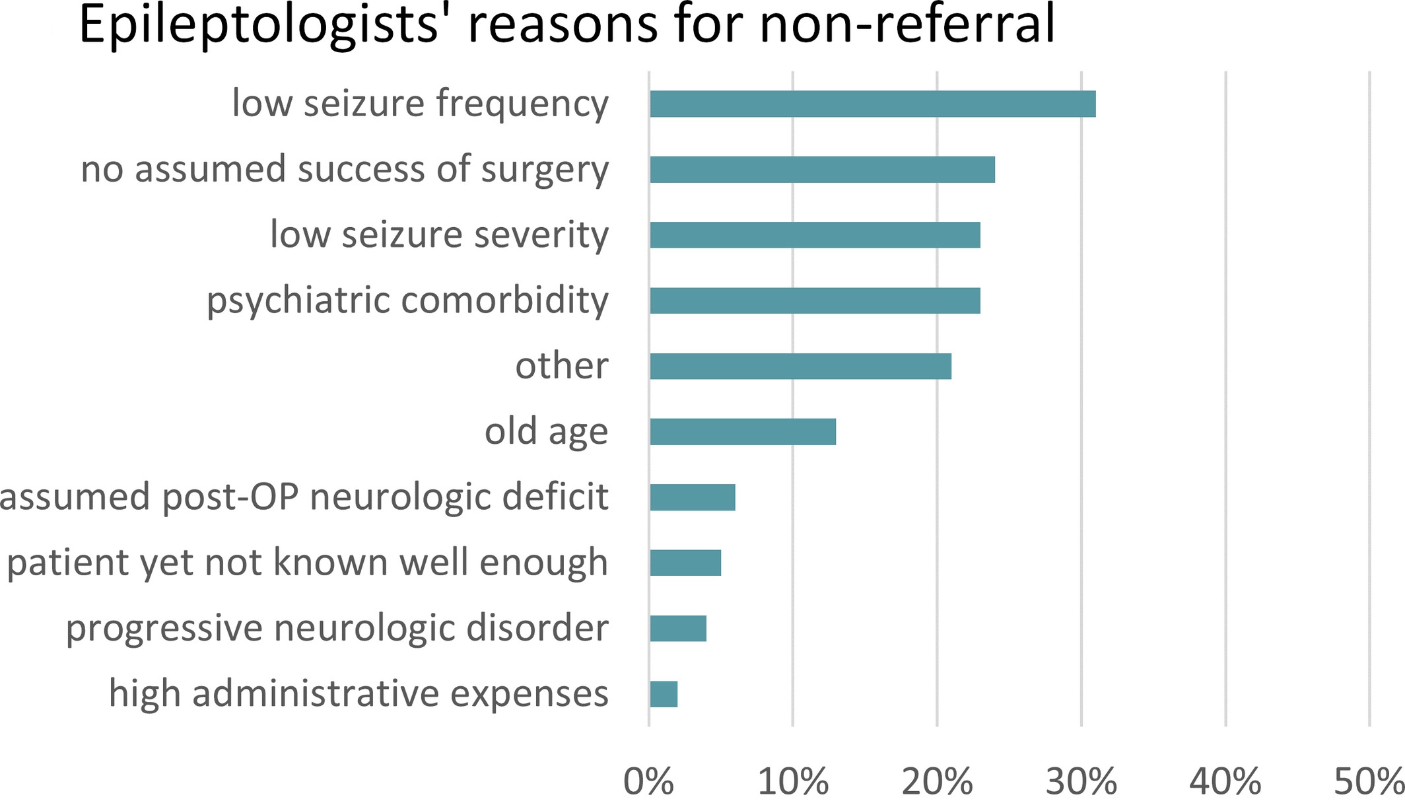
Comments:
- low seizure frequency and severity may be reasonable in some cases (e.g., patients who have one or two focal seizures with impaired awareness per year or who have focal aware seizures exclusively) ;
- severe intellectual disability - even patients with an IQ of 50‐69 have been reported to become seizure‐free in 37% of cases.
- age > 60 years is not associated with a more unfavorable outcome after seizure focus resection, and patients of this age group should also be offered surgery if eligible
- variables independently associated with nonreferral by epileptologists:
- older age of patients (odds ratio [OR] = 1.03)
- no previous evaluation for epilepsy surgery (OR = 4.04)
- presence of legal guardianship (OR = 4.29)
- ≥ 11 years of professional experience (OR = 4.62) - reflects higher vigilance of younger generation of epileptologists due to an update in training on the benefits of epilepsy surgery.

Patients
- patients declined most often due to overall fear of brain low surgery (50%):
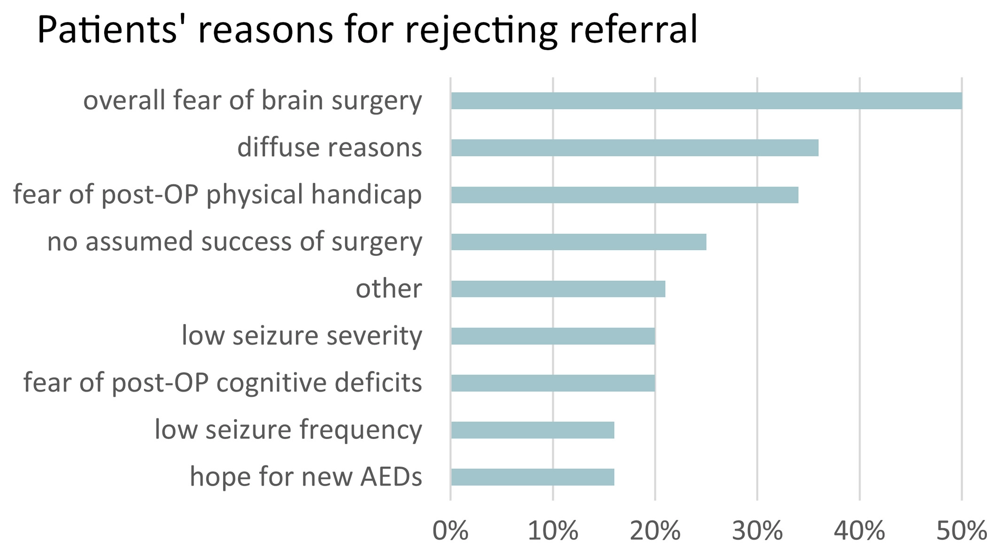
Other reasons:
- wanting to wait for the evaluation until their children were older in case something “bad” happened to them.
- being content with the current seizure situation and not wanting any change (e.g. seizure freedom may result in reduction or loss of disability pension).
- independent predictors for patients’ rejection of presurgical evaluation:
- older age (OR = 1.08)
- lifetime number of antiepileptic drugs ≥ 5 (OR = 4.47)
- focal aware seizures (OR = 4.37)
- absence of focal seizures with impaired awareness (OR = 11.24).

Timing of Surgery
Surgery should be performed as early as possible!!! (surgery is no longer therapy of last resort)
Epilepsy is progressive disease! (kindling, new foci, network damage)
- intractable seizures, the longer they persist, portend poorer prognosis for seizure remission and psychosocial outcome (e.g. "mirror" foci can become established as independent foci).
- strategy of trying all combinations of drugs is not acceptable in syndromes known to have excellent chances of benefiting from surgery.
- it is especially important in children, when epileptogenic discharges interfere with normal development! (language can shift to opposite hemisphere if surgery is performed while patient is < 6 years).
N.B. even patients only few months of age are treated surgically if surgery is treatment of choice!

Despite reported success, surgery for pharmacoresistant seizures is often seen as a last resort. Patients are typically referred for surgery after 20 years of seizures, often too late to avoid significant disability and premature death.
- neurosurgery in patients’ minds is notorious for poor outcomes and mortality in severe TBI, malignant tumors, vascular pathology.
- patients don’t know that neurosurgery for epilepsy is very safe (made possible by technological advances and multidisciplinary team work).

Tell patients about the risk of SUDEP in uncontrolled epilepsy! It is not to scare your patient; it is your obligation (“I am obligated to tell you about SUDEP, the same as I tell my patients about diagnosis of cancer and life expectancy”)

Given results of Brodie (2000) and Schiller (2008) studies, timing of surgery should be individualized:
- for MTS in which the seizure-free rate is high and the risk low after both ablative and resective surgery, surgery may be considered earlier, that is, after 2 drug failures.
- when the chance of seizure freedom after surgery is possibly lower, such as in the absence of MTS, and risk is correspondingly higher in the setting of preserved neurocognitive functions, ablative surgical treatment might be delayed until after a more exhaustive regimen of AEDs or neuromodulation have been attempted.

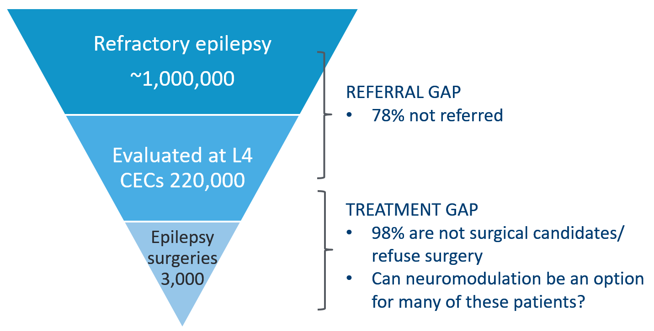

Do not delay neuromodulation – involved networks may get damaged as time goes.

Strategies to improve patient agreement
- we work in strong multidisciplinary team.
- reassure - we do not remove normal brain tissue.
- when counseling patient, talk about complications at the last step (cf. car sales people – do not start with “with the car you can get into accident and die”

Contraindications
- benign partial childhood epilepsy
- significant noncompliance
- progressive neurologic diseases
- severe concurrent medical illness

Relative contraindications:
- generalized epilepsy (indication for corpus callosotomy or VNS or DBS)
- mental retardation / low IQ (< 70)
- psychiatric disease (psychosis or other serious psychiatric disorder)
- multiple seizure types arising from different brain regions (unless one seizure type is most frequent and disabling)
- coexistence of epileptic and nonepileptic seizures.

Not contraindications:
- epileptogenic focus in dominant hemisphere
- epileptogenic focus in eloquent cortex
- bilateral or multifocal epileptogenic foci
- neurological deficits on examination

Definitions of surgical zones
Epileptogenic lesion s. Seizure Onset Zone (SOZ) – lesion / area able to produce seizures; needs to be included in resection.

Epileptogenic zone (EZ) (ictal onset zone + ictal forming zone) for topography see p. E1 >>
– cortical area that needs to be resected / disconnected / thermo‐coagulated / thermo‐ablated / desynchronized by multiple transections in order to make patient seizure free.
- it cannot be determined directly (unless surgery is done and patient became seizure free) but it is deduced by outlining related cortical areas, including the irritative zone, the seizure onset zone, the epileptogenic lesion, the symptomatogenic zone, and the functional deficit zone.
- may be larger than lesion visible on MRI (includes lesion and surrounding margin, sometimes extends beyond brain lobe boundaries; e.g. cavernoma itself is not epileptogenic but adjacent hemosiderin-lade cortex is) – role of intracranial EEG.
N.B. it is essential to resect EZ and not just SOZ

Irritative zone – cortical area generating epileptiform discharges but whose resection is not necessary*; usually larger than epileptogenic zone.
*irritative spikes cease after surgical resection of epileptogenic zone!

Symptomatogenic zone – cortical area that produces clinical symptoms but whose removal is not necessary (e.g. seizures may begin silently in frontal lobe and produce typical temporal lobe complex partial seizure when discharge has spread there); cortical stimulation studies have shown that often region producing auras is much larger than epileptogenic zone.

Functional deficit zone – cortical area showing hypometabolism on FDG-PET; much larger than epileptogenic zone (e.g. in medial TLE, hypometabolism involves both medial and lateral temporal lobe cortex ± subtle regions of hypometabolism in frontal lobe).

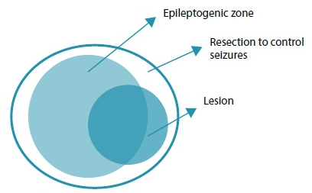

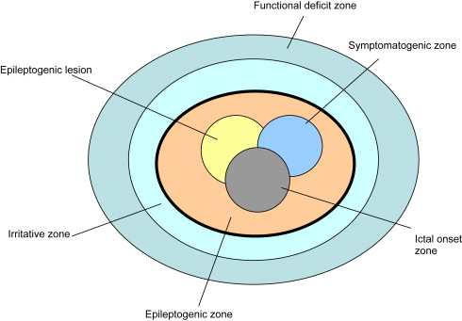

Zones may or may not overlap:
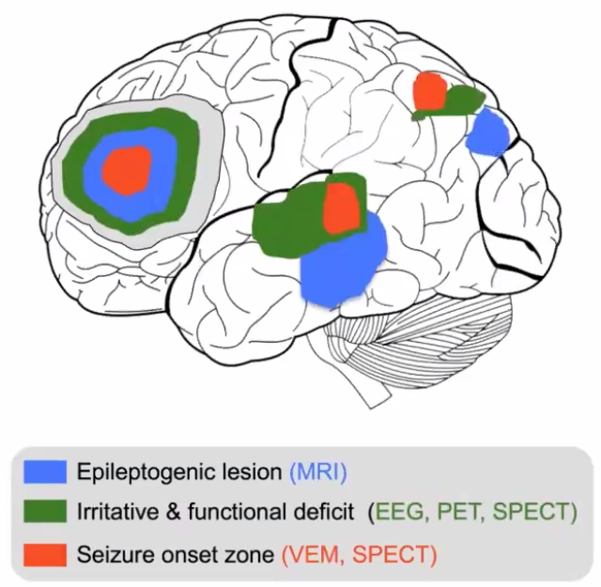

Node vs. Network disease
There were/are proponent experts in each theory:
In the 1950s, Penfield and Jasper established surface electrocorticography as the mainstay for defining an “epileptogenic focus,” and Bailey and Gibbs wrote that "surgical eradication of focal seizure activity was comparable to eradicating a tumor.”
vs.
SEEG philosophy (originated by Talairach and Bancaud) focuses on determining the regions of cortex generating clinical manifestation of the seizure whereby the chronologic occurrence of ictal clinical signs (semiology) is crucial for elucidating “anatomo-electro-clinical” organization of seizures.

Paradigm shift in 2020s: EPILEPSY SURGERY AS NETWORK SURGERY!

- generalized epilepsy – EZ (node) is entire brain (meganode)
- why some patients become seizure free after callosotomy if it is node disease - two nodes across corpus callosum can no longer synchronize oscillations.
- focal epilepsy – small local network (mininetwork).
Definition for focal epilepsy: seizure onset at ≤ 4 contiguous contacts
- treatment goal – resect / ablate primary source and neuromodulate network nodes (“take seizure network offline” – role of SEEG exploration).
In 2020s emphasis is shifted from resection and seizure freedom to modulation and improved quality of life, with the ultimate goal of arresting seizures indefinitely.
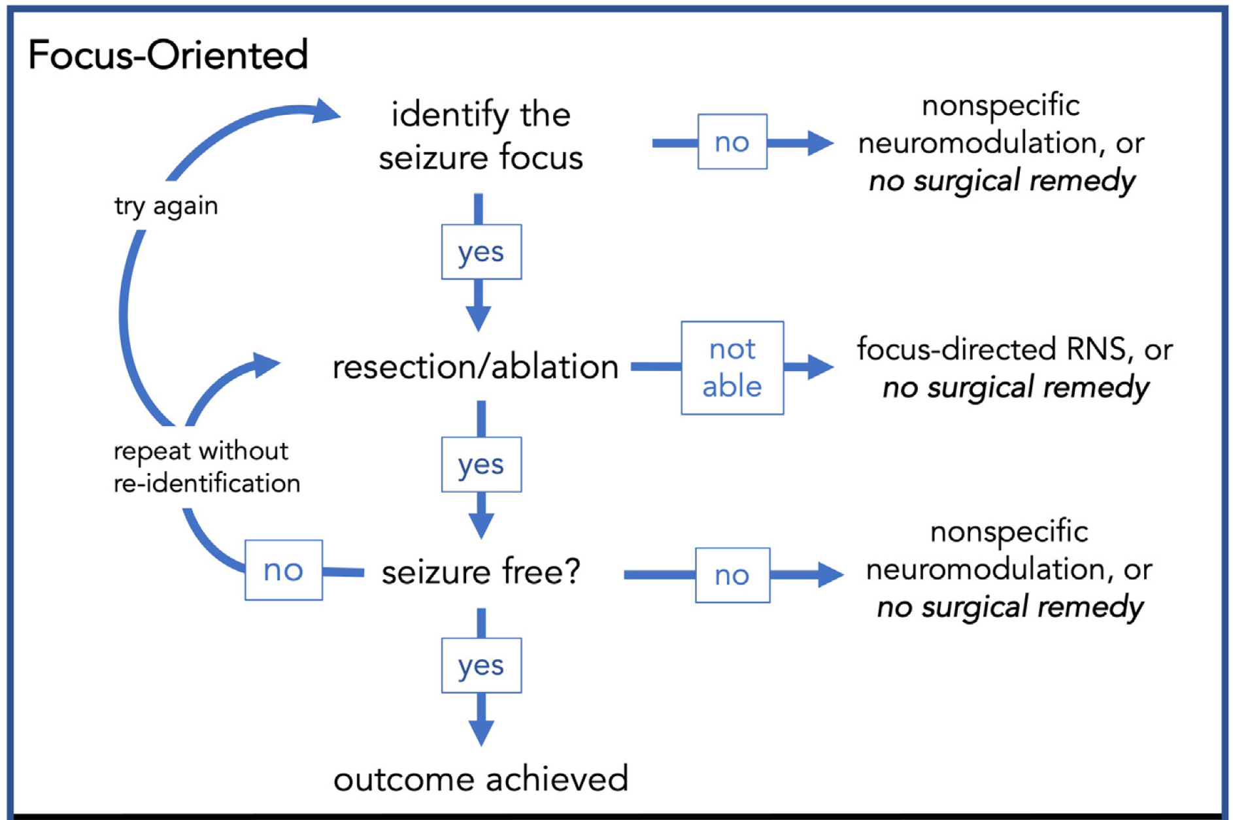
Richardson 2022

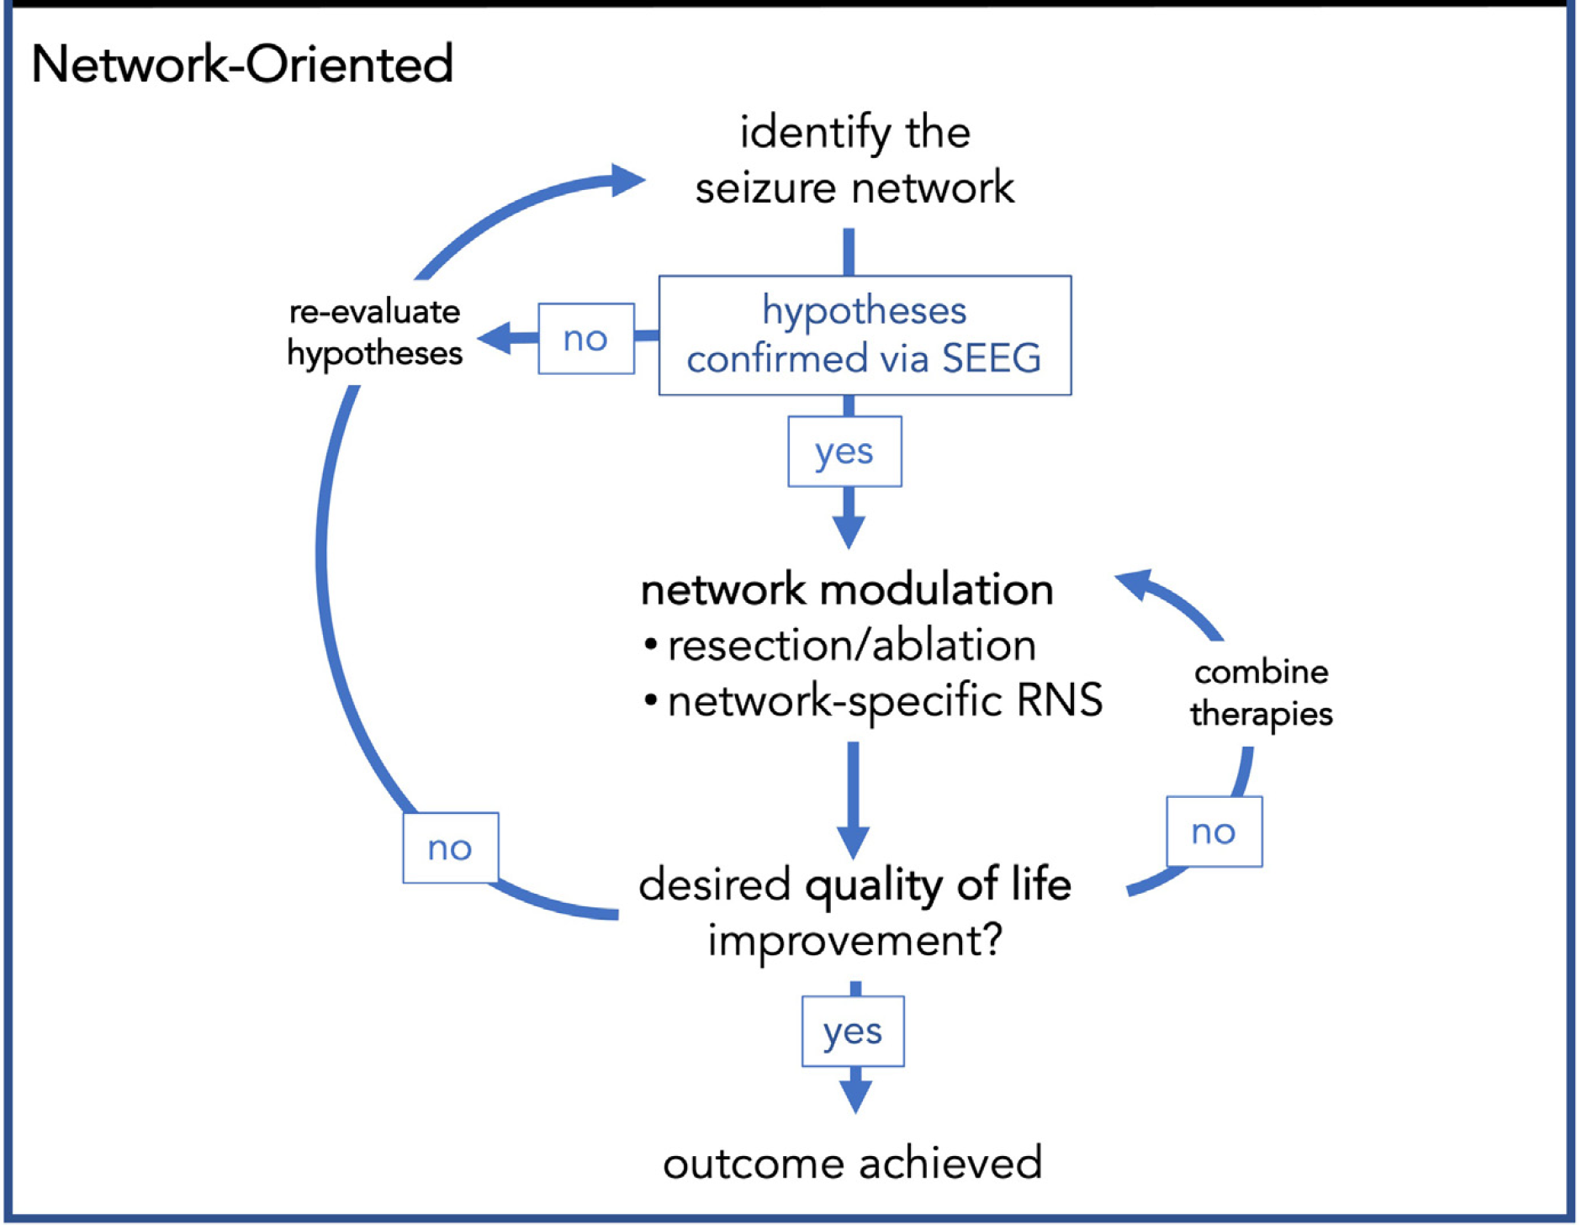
Richardson 2022

- downfall of approaching epilepsy surgery solely from the perspective of focus hunting: if a resection is performed and the patient is not seizure free, the interpretation is that one “didn’t get enough” or did not find “the right focus.”

Common Epileptic Pathologies
- hippocampal sclerosis is #1 among adults (44.5% surgical specimens; only 15% in children)
- malformations of cortical development are #1 among children (39.3% surgical specimens with focal cortical dysplasia occupying 70.6%).
- tumors (mainly ganglioglioma) are #2 in all age groups.
- vascular malformations (mainly cavernomas) - found in 6.1% of specimens.
- TBI, intracranial infections, neurosurgical procedures may leave glial scars (gliosis) - found in 4.9% of specimens - hyperintense on T2 and often associated with cortical atrophy.
- infections - Rasmussen's encephalitis, herpes simplex encephalitis, neurocysticercosis (most common cause of infection-related epilepsy worldwide).

Presurgical Evaluation (Non-Invasive, Phase I)
- goal is to define epileptogenic zone.

Surgical treatment is presently limited by our inability to localize epileptogenic focus.

Comparison of phase I methods:
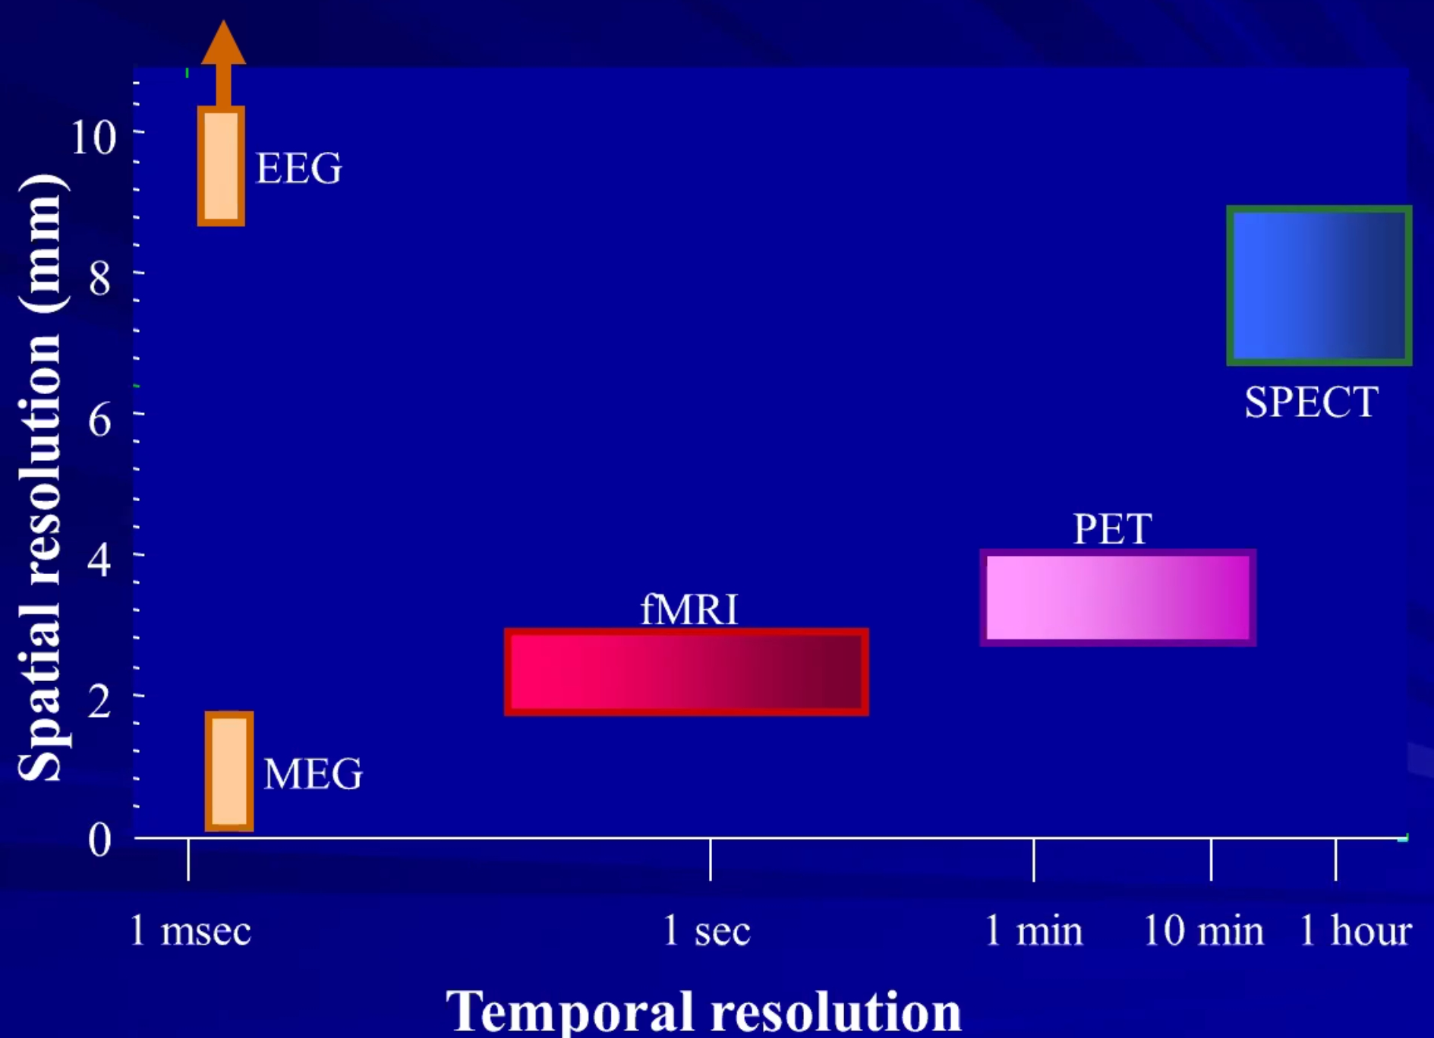

- all methods can be done for patients of all age groups.

Scalp (surface) EEG
All surgical candidates should begin presurgical evaluation with EEG-audio-video monitoring to record actual seizures (weaning from anticonvulsants may be necessary) – so called phase I monitoring.

N.B. seizures may begin in areas distant from (or even contralateral to) location of interictal epileptiform activity - ictal discharges are most reliable means of localization!
- interictal EEG is normal in 30% cases; remaining of cases often have nonspecific findings.
- since it is impossible to record from all cortical & subcortical structures from which seizures may arise, exact onset may not involve recording electrodes until spread of discharge has occurred (i.e. early ictal changes are often not identified in scalp recordings).
- foci in mesial or basal cortical areas are particularly apt to escape detection; extratemporal seizures are more difficult to localize (e.g. epilepsy of occipital or frontal lobe origin may have interictal activity at temporal region).
- modified electrode placements, dense array, and semi-invasive techniques increase yield.

Neuroimaging (routine)
see also p. E1 >>, p. E9 >> (temporal lobe epilepsy, diagnosis)
CT
- it is now replaced by MRI (only need for high-resolution CT is for intraoperative neuronavigation planning)
- seizure focus may enhance with IV contrast shortly following a seizure.
- small cortical lesions, particularly in orbitofrontal and medial temporal regions, are not detectable on CT.

MRI
All patients with focal epilepsy should undergo MRI without and with IV contrast.
MRI is usually not indicated for genetic and self-limited epilepsy syndromes (such as benign childhood epilepsy with centrotemporal spikes).
Lesional MRI = less chances for medication success, more chances for surgical success

- desirable ≥ 3 Tesla
N.B. higher field strength – more geometrical distortion, motion and susceptibility artifacts (caused by air-ﬁlled cavities such as nasal cavities)
- there is software (e.g. FreeSurfer) for automated cortical thickness analysis – esp. useful for focal cortical dysplasia (FCD) detection
N.B. MRI and ictal EEG can be discordant or negative in up to 40% of potentially preoperative cases!
ILAE members can take hands-on practice sessions to review major neuroanatomical landmarks: https://www.epilepsy-imaging.org/#/

ILAE protocol

HARNESS-MRI protocol
- mandatory and optional sequences for epilepsy.
Bernasconi et al., 2019
Mandatory sequences
- 3D magnetization-prepared rapid gradient-echo (MPRAGE, Siemens), Spoiled gradient-echo (SPGR, GE), Turbo field echo (TFE, Phillips)
- 3D fluid attenuation inversion recovery (FLAIR) - very useful for evaluation of epileptogenic lesions; sagittal FLAIR provides a complete antero-posterior view of signal distribution along the length of the hippocampus and parahippocampus.
N.B. FLAIR images are not sensitive to epilepsy-associated pathology in neonates and infants < 2 yo, as the myelination process is not yet complete.
- 2D coronal turbo spin echo (TSE) with acquisition plane perpendicular to the hippocampus long axis) – T2 high in-plane resolution for optimal visualization of hippocampal volume, shape, and internal structure on coronal cuts.

Optional sequences
- 3D gadolinium-enhanced T1 – to rule out tumor-like lesions, vascular malformations, or infectious processes.
- 3D susceptibility weighted imaging – T2 sensitive to iron deposits, blood products and calcifications.

Surgery planning sequences
- 3D gadolinium-enhanced T1 – to plan trajectories avoiding vasculature.
- 3D FGATIR – to plan ANT DBS.

MRI-negative cases
- even experienced observers may miss small and subtle lesions - preferably, an observer with expertise in epilepsy imaging should review the scans.
- it is often necessary to repeatedly review the MRI, in the context of new information such as PET, EEG, MEG.
- most commonly missed etiology – FCD (esp. bottom of sulcus); then temporal pole encephaloceles, hypothalamic hamartomas and subtle double cortex.
- if truly MRI-negative, proceed with advanced outpatient imaging: MEG, PET (if nonrevealing → ictal SPECT).
Positive result from advanced imaging often requires verification by depth electrode SEEG recordings.

Methods to increase MRI sensitivity
7 Tesla scanners

Neuroimaging (advanced)
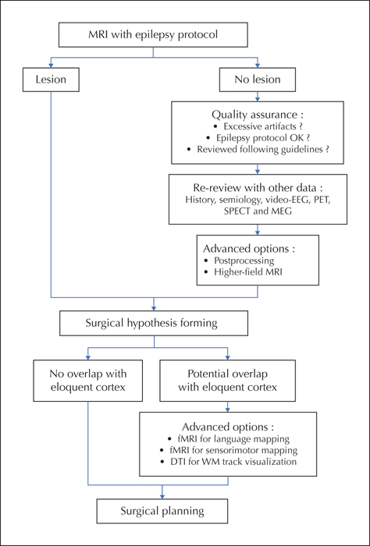

Special MRI postprocessing
Tractography (DTI)
- displays of optic radiations and pyramidal tracts are the most relevant for epilepsy surgery.

Hippocampal Volumetry

Cortical Unfolding

¹HMR (Proton) Spectroscopy
Helps with pathology lateralization:
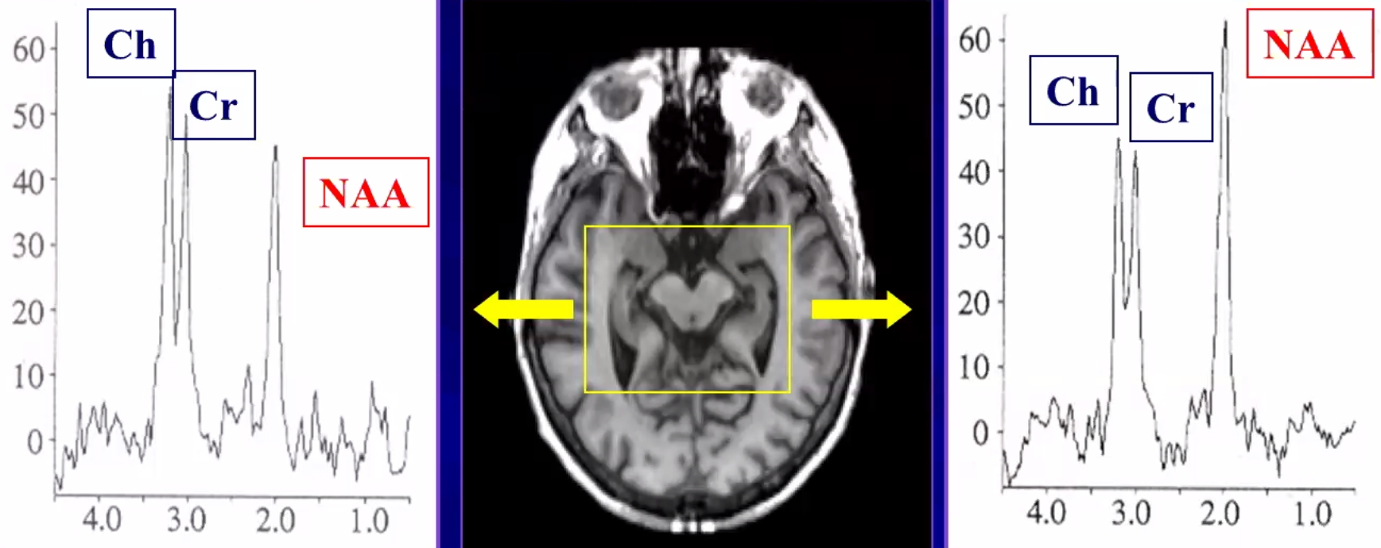

fMRI
- used to determine language dominant side; less commonly – relation of eloquent cortex to EZ

Resting state fMRI
– network analysis; becoming popular for developing surgical strategies and predicting surgery outcomes.
- TLE patients have different subcortical connectivity seen on rs-fMRI (“recovers” after successful surgery).

EEG-fMRI
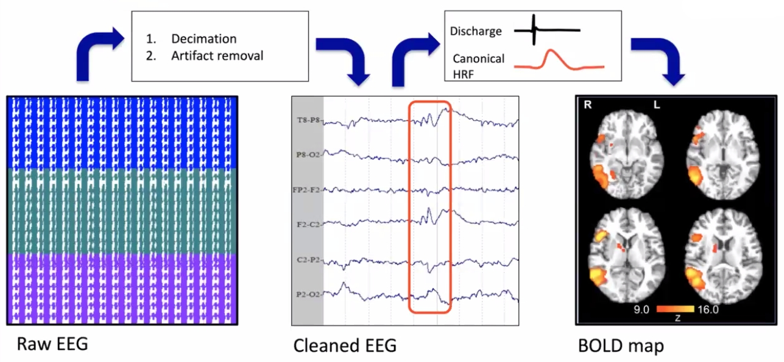

- developed in 1993 by Ives et al.
- indicated for patients that have ≥ 1 epileptiform discharges / min.
- An et al (2013) demonstrated 87.5% sensitivity, 76.9% specificity, 70% PPV, 90.9% NPV – for ILAE class I & II surgery outcomes if resection included BOLD signal areas.
- can be combined with SEEG – resect area around electrode contacts with HFO (high-frequency oscillations) + area with corresponding BOLD signal on fMRI.
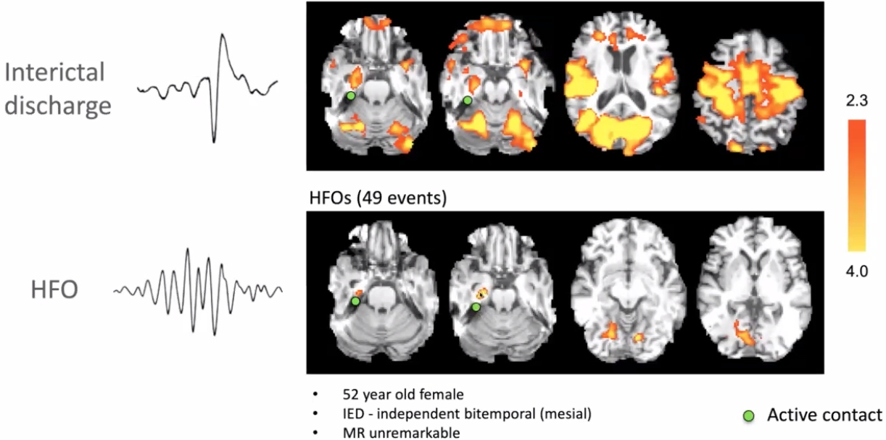

Patient with refractory seizures arising from a brain tumor (possibly DNET) in the left mesial temporal region associated with blurring of the grey-white matter interface in the ipsilateral temporal pole:
(A) FLAIR displaying the lesion (red box);
(B) Scalp EEG-fMRI analysis of left frontotemporal discharges (F7-T3) shows a maximum BOLD response on the left amygdala and hippocampus + additional smaller BOLD cluster at the temporal pole (superior temporal gyrus).
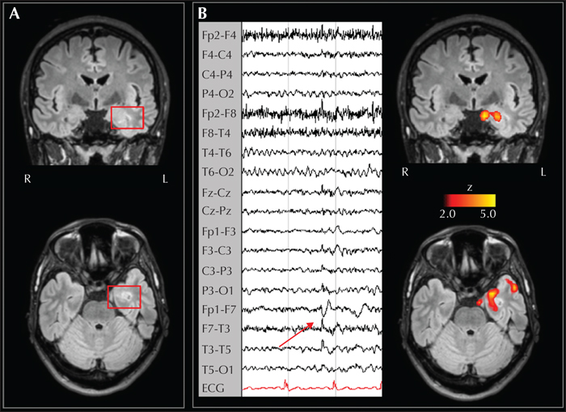

nTMS (navigated transcranial magnetic stimulation)
Mapping for eloquent cortex
- FDA approved for “presurgical motor and language mapping”.
- possible for noncooperative patients (vs. MEG, fMRI)
- cannot reach deep parts of brain (solution – TDCS – transcranial direct current stimulation).
- studies show it may be more accurate than fMRI (as compared to gold standard – Direct Cortical Stimulation):
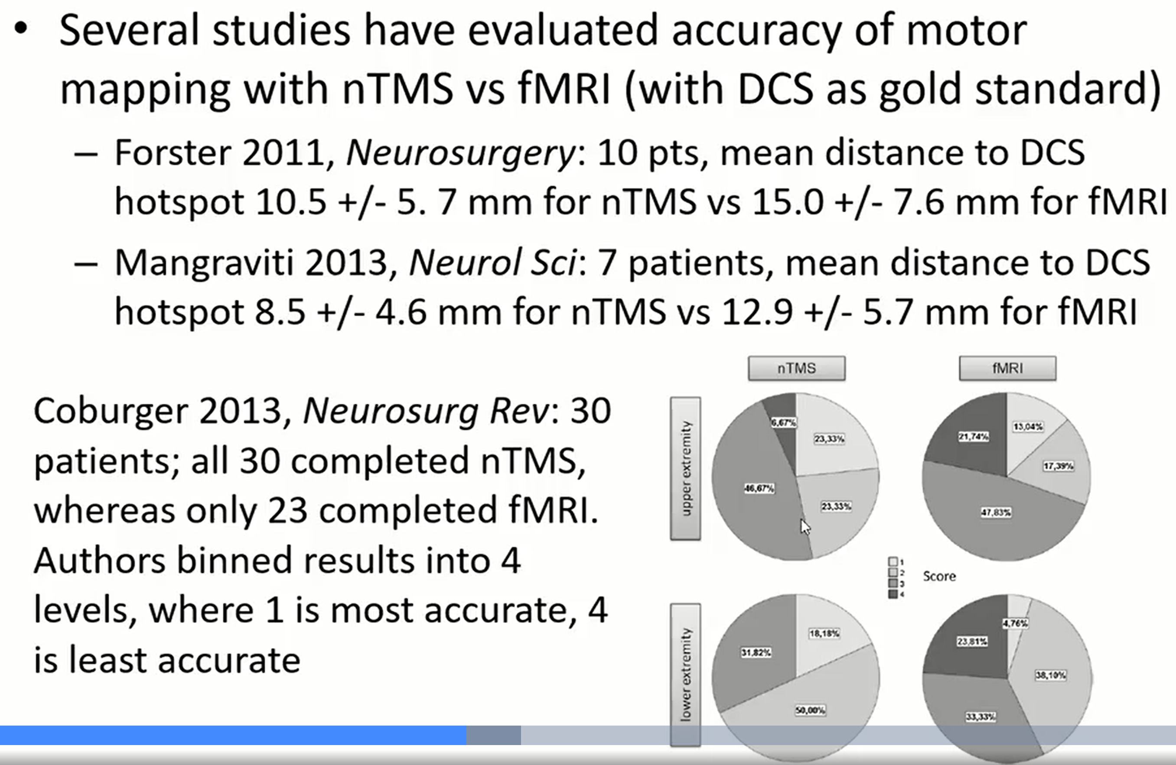

Epilepsy palliation
- see below >>

PET (positron-emission tomography)
(FDG-PET, ¹¹C flumazenil-PET)
- determines functional deficit zone in focal epilepsy.
- shows hypometabolism.
N.B. PET often shows hypometabolism in temporal lobes of pediatric patients – ignore it (esp. if symmetric).
N.B. temporal lobe is relatively hypometabolic compared to other lobes.
- FDG is made in an expensive medical cyclotron and "hot-lab" (automated chemistry lab for radiopharmaceutical manufacture), and then delivered immediately to scanning sites because of the natural short (110-minute) half-life of Fluorine-18.
- after injection need to scan the patient within 30 minutes (vs. SPECT – have 4 hours).
- PET:
- has highest accuracy for temporal lobe foci, which are diagnosed most easily with MRI and EEG.
- is least reliable for extratemporal nonlesional foci, which also are most difficult to define with MRI and standard EEG.
- PET is superior to interictal SPECT.
- indications:
- discordant MRI and EEG findings
- normal MRI findings.
- cannot do PET if given insulin recently (glucose goes into muscle).
- PET can be combined with simultaneous EEG – helps to avoid false lateralizations from hypermetabolism due to unrecognized ictal / postictal events as well as frequent interictal epileptiform discharges.
- quantitative PET – patient’s PET subtracted from population-normalized template PET.

SPECT (single-photon emission computerized tomography)
- gamma-emitting tracer used is 99mTc-HMPAO (hexamethylpropylene amine oxime) - emits gamma rays that can be detected by a gamma camera.
- HMPAO allows 99mTc to be taken up by brain tissue in a manner proportional to brain blood flow (i.e. SPECT is assessment of regional cerebral blood flow in 3D).
- SPECT is more widely available (than PET), because the radioisotope is longer-lasting and far less expensive.

Interictal SPECT - shows hypoperfusion; resolution is inferior to that of PET; useful only for SISCOM.

Ictal SPECT - hyperperfusion during seizure - high localizing value* (only if ictal injection occurs within 20 seconds of ictal onset - then may scan within next 4 hours**).
*70-100% in temporal epilepsy vs. 33-63% in extra-temporal epilepsy
**vs. PET – within 30 minutes
- may also see hyperperfusion in ipsilateral basal ganglia, contralateral cerebellum.

SISCOM (Subtraction Ictal Spect CO-registered to Mri)
- much higher accuracy than either ictal or interictal SPECT! (may provide alternative to depth electrode studies)
- requires two SPECT scans (separated by ≥ 48 h to accommodate radionuclide washout) - during interictal period and within seconds of seizure onset.
- using computer software, these scans are subtracted from each other.
- subtracted scan then can be co-registered onto MRI to provide support for focus location.

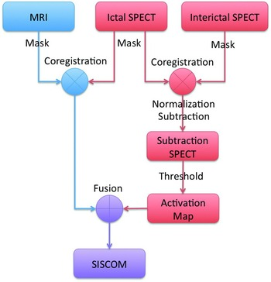

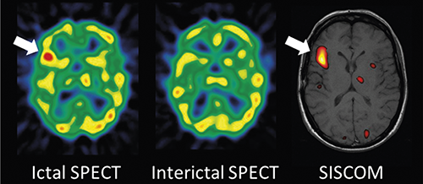

N.B. in MRI-negative cases, reliability of functional neuroimaging is much reduced, and positive result from functional imaging generally requires verification by depth electrode recordings!

Multimodal imaging with interictal FDG-PET (middle) and ictal SPECT (right) which guided focused re-review of MRI (left, T1-weighted MPRAGE sequence) - hypometabolism on interictal PET (arrow) and hyperperfusion on ictal SPECT both pointed to a region in the left orbitofrontal cortex → re-review of the MRI revealed a cortical malformation characterized by gray-white blurring and thickened cortex (arrow). Resection of this region led to postoperative seizure freedom and surgical pathology-confirmed FCD:
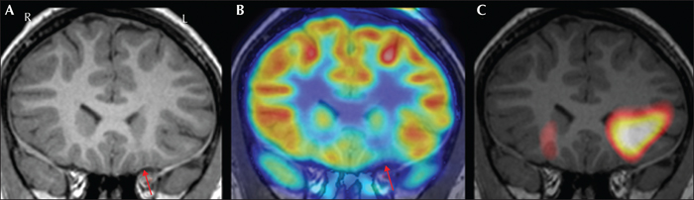

Magnetoencephalography (MEG)
- method for 3D detection of deep epileptic foci; records magnetic fields produced by brain electrical activity; requires sophisticated expensive suite (well isolated, far from highways).
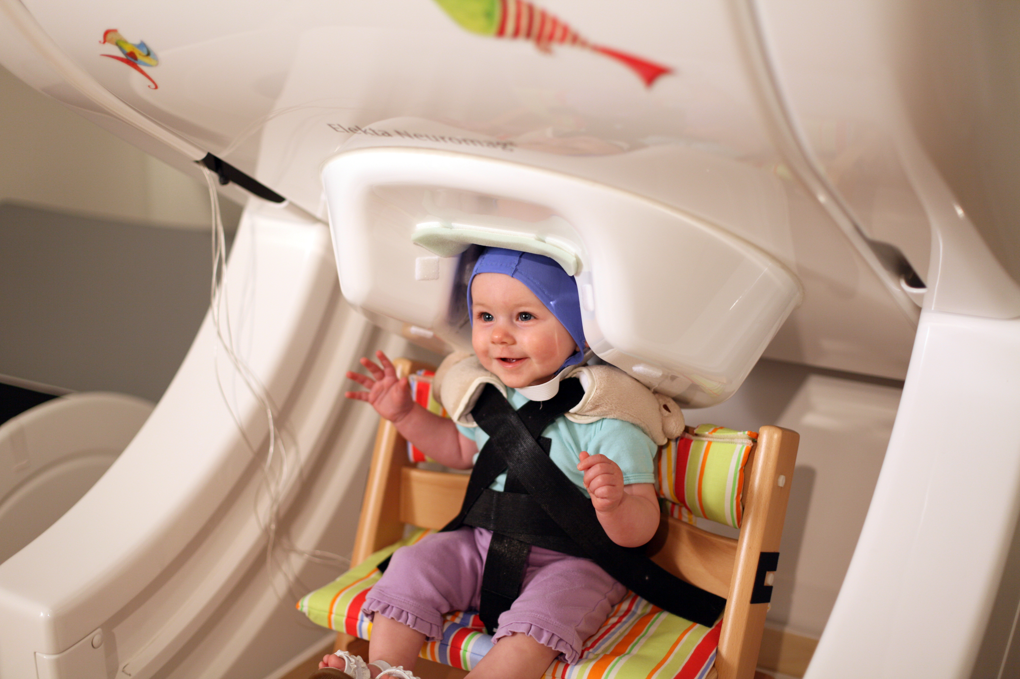

EEG detects gyri (radial currents).
MEG detects sulci (tangential currents); sulci have larger area than gyri (MEG detects more spikes):
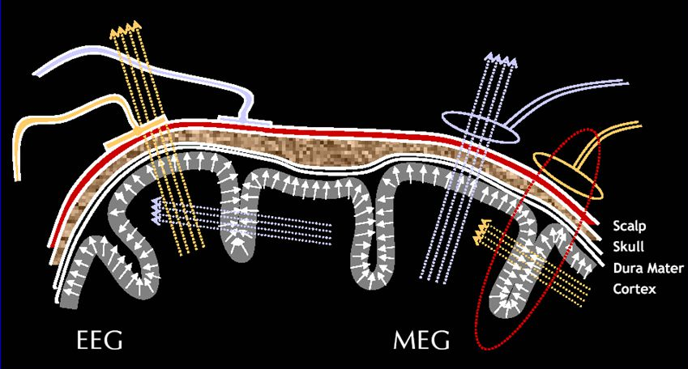

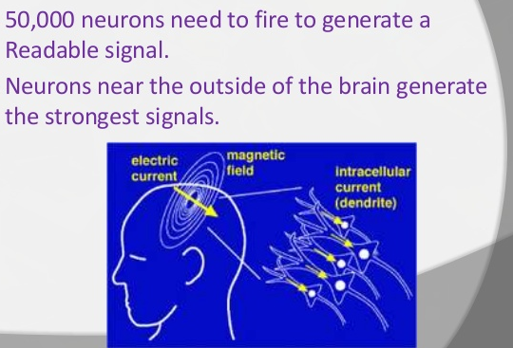

- MEG is closer to pathophysiology (electrical discharge) than PET, SPECT.

MSI
- routine way to export MEG results onto MRI
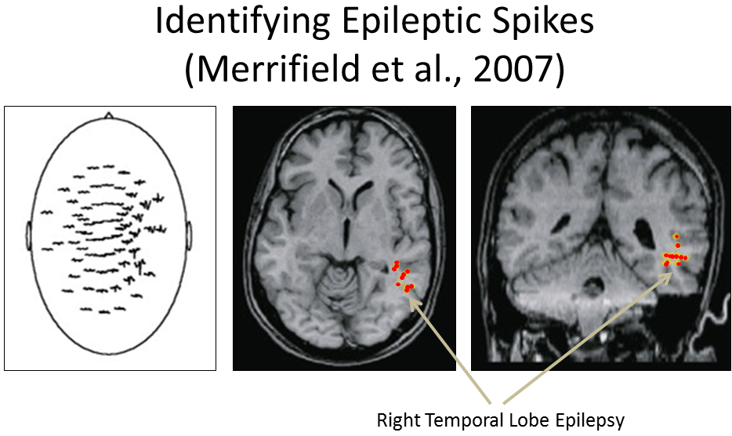

MSI patterns:
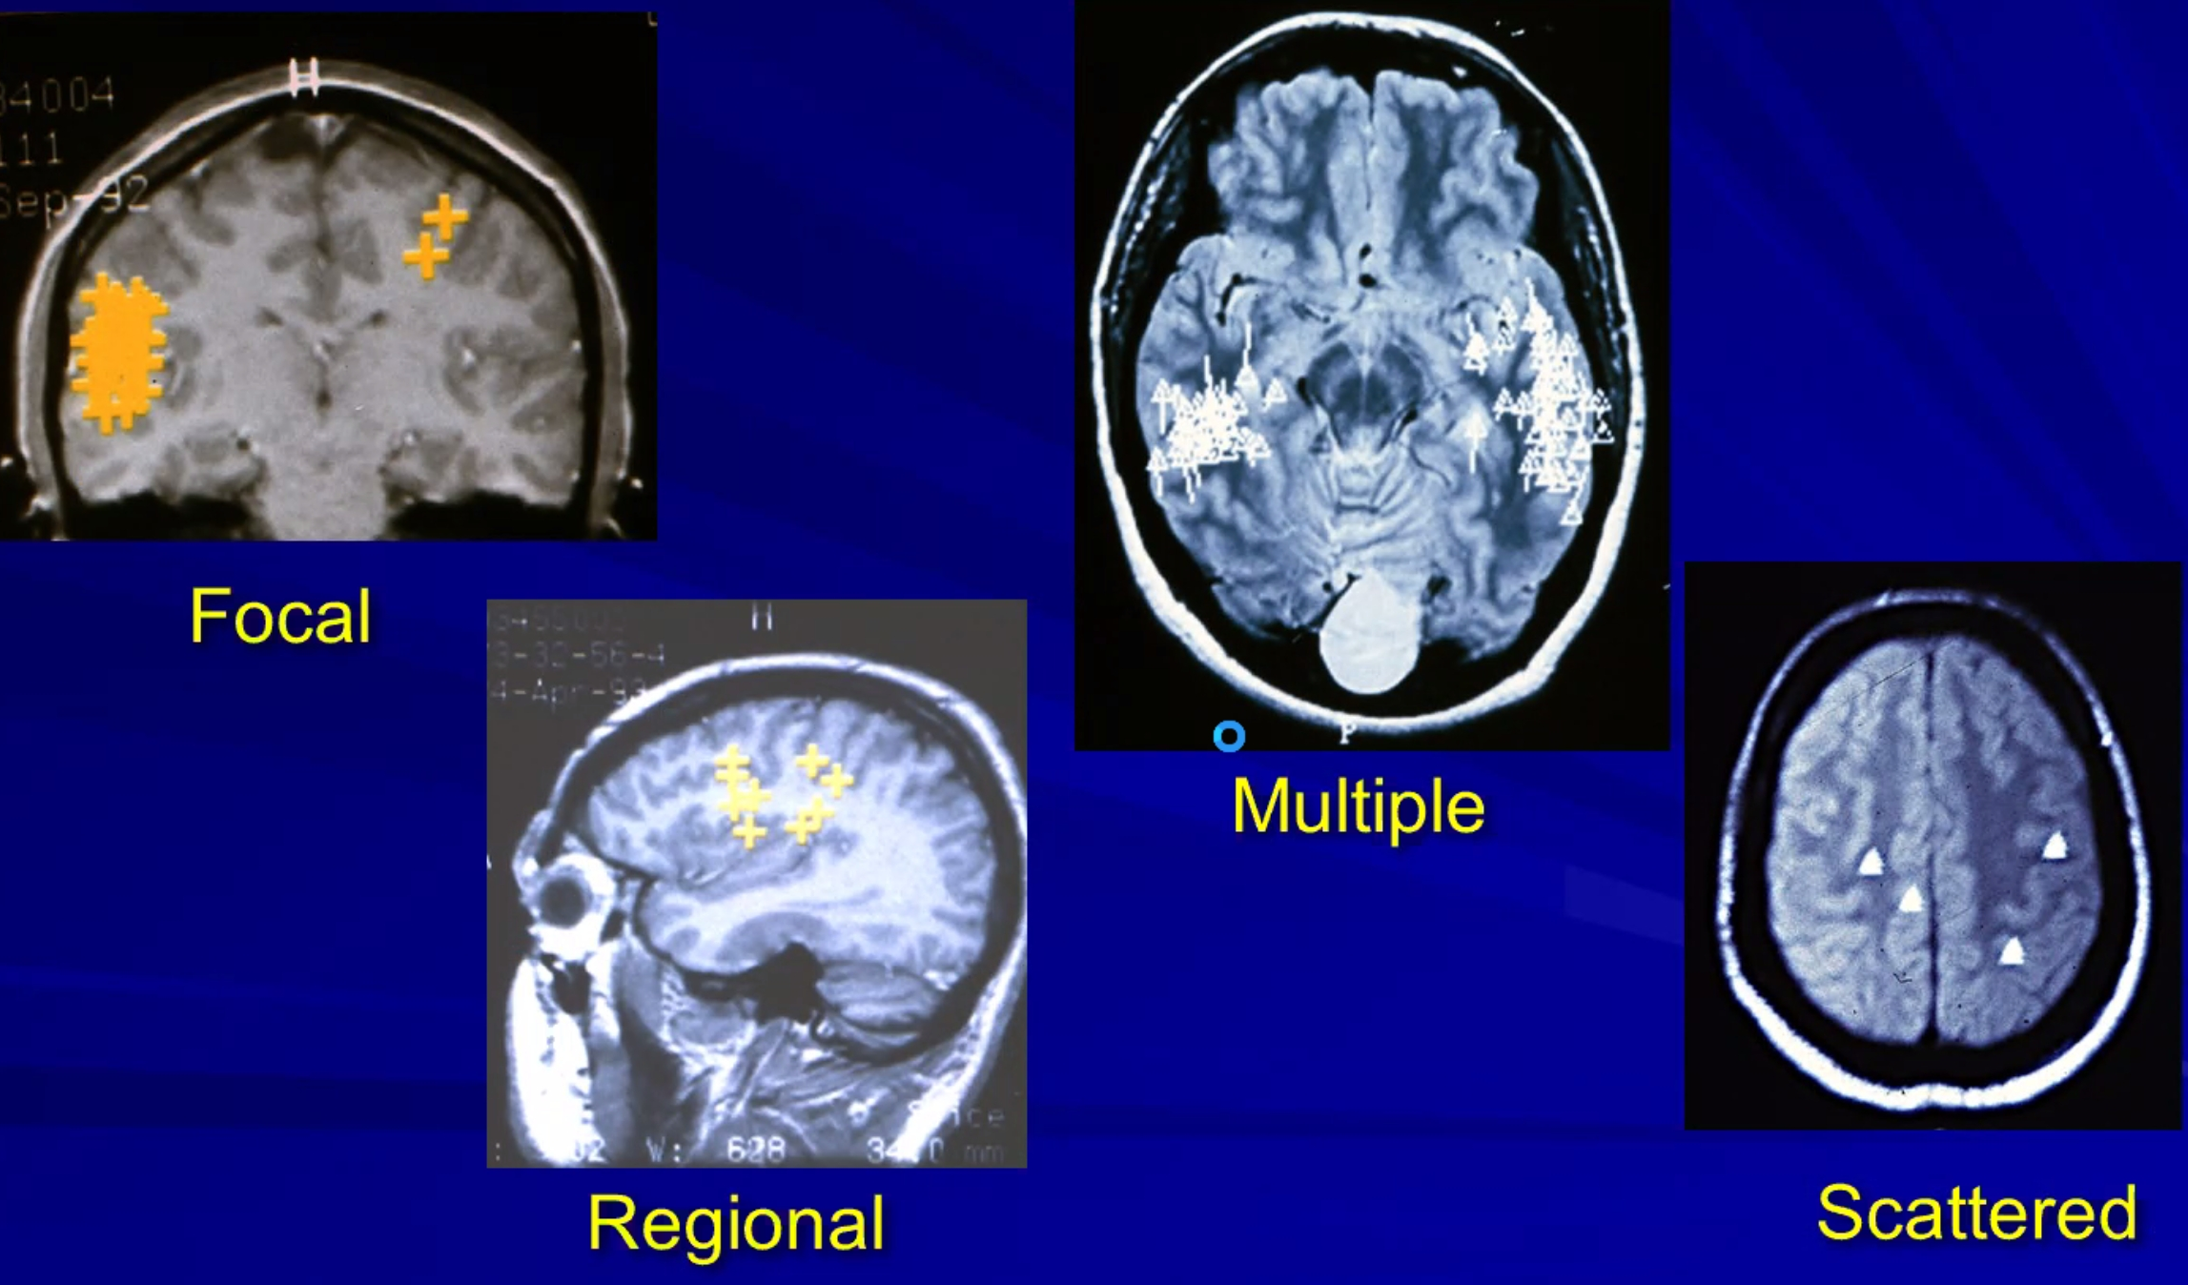

- diagnostic accuracy 57-70% in temporal cases (44% - extratemporal cases).

Neuropsychological testing (Neuropsychometry)
- routinely, all surgical candidates undergo extensive neuropsychological testing (possible exception – VNS candidates).
- testing is not standardized between centers.
- test battery contains:
  - personality inventory (e.g. Minnesota Multiphasic Personality Inventory)
  - tests of memory and language
temporal mesial sclerosis in dominant hemisphere – memory↓
  - tests for interhemispheric transfer (before callosotomy) - cross-retrieval and naming of objects, cross-replication of hand postures, cross-localization of fingertips.
  - other tests, depending upon interests of neuropsychologist.
- goals of testing:
- to help localize epileptogenic focus (subtle deficits in cognitive functioning might provide additional localization that neurologic examination misses); it is not reliable because very few tests reliably measure frontal and temporal lobe function.
- identification of significant cognitive problems (e.g. memory problems - might not be a candidate for temporal lobectomy).
- predicting postoperative cognitive deficits.
- formulating postoperative vocational goals.
- testing results are valid for max 18 months.
- patients are instructed to continue their medications as usual but abstain from marijuana for ≥ 72 hours
- AEDs are known to affect processing speed; many tests are timed so AEDs may have effect on results; there are no tools to differentiate AED side effect from true encephalopathy, thus, neuropsychologist’s expertise and insight are needed.
- topiramate is has well-researched negative side effect on verbal processing and memory.
- levetiracetam has mood effects.

Multidisciplinary Conference
  - final results of noninvasive testing (phase I) are presented to multidisciplinary epilepsy surgery conference (neurologist specializing in epilepsy, epilepsy neurosurgeon, neuropsychologist, epilepsy nurse, speech pathologist, neuroradiologist, and psychiatrist).

Conference decides on:
  - need for WADA test (phase II)
  - need for intracranial EEG (phase III)
  - surgical plan

  - in most scenarios, there are several reasonable options, which are not mutually exclusive, and some differences among centers, and even among epileptologists, are expected - this is why all comprehensive epilepsy centers make decisions after discussions at multidisciplinary conferences.

Presurgical Evaluation (Invasive, Phase II)
Two goals:
- Further define epileptogenic zone – intracranial EEG (icEEG) >>
- Map brain function:
  - fMRI >>
  - MEG >>
  - nTMS >>
  - WADA: chemical (>>), electrical (>>)

Chemical Wada (Intracarotid Amobarbital test)
- so called phase II testing
- named after Japanese epileptologist Juhn Atsushi Wada, of the University of British Columbia - he developed the test while he was a medical resident in Japan just after World War II, when he was receiving training in neurosurgery. Wada developed the technique of transient hemispheric anesthetization through carotid amytal injection to decrease the cognitive side effects associated with bilateral electroconvulsive therapy.
Wada J (1949). "A new method for the determination of the side of cerebral speech dominance. A preliminary report of the intra-carotid injection of sodium amytal in man". Igaku to Seibutsugaki, Tokyo. 14: 221–222.
- injection of 100 mg sodium amobarbital (Amytal®)* / propofol into carotid artery - to temporarily anesthetize (inactivate) hemisphere in ipsilateral carotid artery distribution (includes amygdala and anterior hippocampus) - allows independent testing function of contralateral hemisphere.
*barbiturate derivative that activates GABA_{A} receptors
- does WADA need to be bilateral even if pathology unilateral? Wada is the difference score between the two hemispheres as they relate to each other and to baseline (if the second hemisphere couldn’t happen due to a seizure, decision can be made after unilateral WADA, it is just not ideal)

Indications
- preparation for ablative surgery (once epileptogenic focus has been identified) - injection ipsilateral to epileptogenic zone:
  - Which hemisphere contains language function (dominant hemisphere inactivation → aphasia; nondominant → dysarthria); fMRI is much less useful here.
  - Functional adequacy of contralateral hippocampus to sustain memory (before anterior temporal lobectomy to avoid permanent amnesia).
N.B. failure of memory function is contraindication to resection of hippocampus and parahippocampal structures on injected side!
Some experts believe that WADA is more important for temporal neocortical resections (and not so much for SAH).
  - Prognosing seizure-free outcome.

- never has been standardized - there is no such thing as the Wada Test - major efforts to establish procedural uniformity across epilepsy centers have been made, but many different versions of the test still remain.
- some centers insist on Wada tests even when clearly right-handed patient is diagnosed with right temporal focus

Procedure details
- instruct patient as to what is expected.
- catheter is passed into ICA (as for standard carotid arteriograms).
- 4-vessel arteriography must verify that blood flows to corresponding hemisphere and there is:
  - no cross flow
N.B. significant cross-flow is relative contraindication to anesthetizing side of dominant supply (patient goes to sleep).
  - no persistent embryonal communication between anterior and posterior circulation (e.g. trigeminal, otic, hypoglossal, pro-atlantal arteries) – will cause brainstem failure!
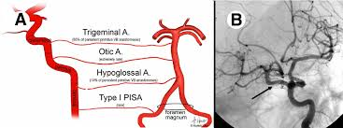
N.B. fetal PComA is not contraindication but will cause cortical blindness.
  - no significant vascular abnormalities - Wada test may be grossly inaccurate with high flow AV fistulas, such as AVM
- start on side of lesion (Wada testing is almost always performed with bilateral carotid amobarbital injections).
- have patient hold both arms in air and count loudly - inject Amytal rapidly; effect starts almost instantaneously, begins to subside after ≈ 8 minutes.
- contralateral hemiparesis + ipsilateral EEG slowing (> 50%) must appear (confirmed adequacy of injection); if not, add 25 mg more of drug.
- patient is monitored to make certain that recirculation has not affected both sides simultaneously during testing.
- assess language by showing patient pictures of objects and ask them to name each one out loud and remember each one.
- assess memory by asking patient to name as many of pictures as they can 15 minutes after test: if they have difficulty, ask them to pick out pictures from a group that contains additional ones not shown to patient.
- may repeat procedure on other side (use lower Amytal doses with each subsequent injection).

Caveats:
- portions of hippocampus may be supplied by posterior circulation (not anesthetized by ICA injection).
- despite aphasia, sometimes ability to sing is preserved - music and singing uses a different part of the brain than speech and language.

Side effects
  - Drastic personality changes are rarely noted, but disinhibition is common.
  - Shivering are often seen.
  - Recovery of speech is dysphasic (contains errors in speech or comprehension) after a language dominant hemisphere injection.

1% risk of vessel dissection and stroke!

Interpretation
Memory scores of > 50-67% have been deemed passing scores.
- operational definition of failure = corrected score < 5
- if WADA is failed but ablation is still recommended, amygdalohippocampectomy is preferred over temporal lobectomy, as studies show better verbal outcomes.

N.B. WADA test is still associated with false positives and negatives!

Noninvasive alternatives to Wada
Wada test has angiography risks – so check for noninvasive alternatives:

fMRI - can lateralize language
Practice Guideline of American Academy of Neurology:
Szaflarski J.P. et al. Practice guideline summary: use of fMRI in the presurgical evaluation of patients with epilepsy: report of the Guideline Development Dissemination and Implementation Subcommittee of the American Academy of Neurology. Neurology. 2017;88:395-402.
  - fMRI using verbal memory or language encoding should be considered for predicting postoperative verbal memory outcome (Level B recommendation).
  - fMRI using non-verbal memory encoding may be considered for predicting postoperative visuospatial memory outcomes (Level C recommendation).

nTMS
MEG - can lateralize language
Near-infrared spectroscopy
H₂¹⁵O-PET

UAMS protocol
Prerequisites:
Providers-Neurology, Neuropsychology and Interventional Neuroradiology
Location: IR suite
Ancillary: EEG tech with vEEG setup (full montage)
Medication: Amytal (amobarbital sodium preparation) (at least 1 vial for each side)

Team member specific considerations
EEG tech
- Must be vEEG (live) with patient’s face and hand in clear unobstructed view
- Audio recording should be ON with appropriately placed microphone
- EEG tech at the machine side annotating the record
  - Injection times
  - Delta slowing
  - 50% delta-theta reduction
  - Strength assessment by MD
  - EEG return to baseline
- EEG screen should also be clearly visible to the Epilepsy MD
- Perform a baseline at least 15 min recording before the start of the procedure (during baseline assessment by Neuropsychology, prepping etc)

Nursing
Amytal (amobarbital sodium preparation)
- Needed 20 cc of sterile water and 500 mg of amobarbital for EACH side
- Reconstitute MAXIMUM 30 min before use
- Add 5 cc of sterile water to amobarbital vial.
- Do not shake. Only rotate vial.
- The dose should also be mixed and allowed to dissolve for > 5minutes.
- Withdraw solution into a 25 cc syringe
- Wash amobarbital vial with additional 5 cc of sterile water. Withdraw into 25 cc syringe containing first 5 cc or amobarbital solution
- Add another 10 cc sterile water to 25 cc syringe containing amobarbital solution. Mix
- Final concentration: 25 mg/cc
- Carefully note and label the syringe with the time the medication was mixed.
- Discard if not clear in 5 minutes and discard if a precipitate forms.
- Attach 0.22 micron filter (yellow disc) to Amytal syringe. Give 6 ml (150 mg) Amytal to IR MD by pushing it through the 0.22 micron filter (not pulling up through filter) into 12 ml sterile syringe MD is holding.
- Amytal once mixed it must be used within 30 minutes. Be prepared to mix a second dose.
  - The time gap between two sides injection must be minimum 30 min and preferably 40 min so the previously reconstituted via CANNOT be used for the other side.
- Usual injection Amount
  - First injection (either side); 3 ml (75 mg)
  - Repeat injections in 1 ml (25 mg) bolus up to 3 ml (75 mg)
- Patient’s both hands should be out of the sterile field and freely accessible to Epilepsy MD for testing

IR MD
- Baseline assessment by Neuropsychology before catheter placement
- Patient’s both hands should be out of the sterile field and freely accessible to Epilepsy MD for testing
- Side planned as the surgical side to be injected first.
- Pre (amytal)-injection contrast run-through
  - Cross-filing?: Yes/ No
  - Fetal PCOM?: Yes/ No
- Pre-injection assessment by Neuropsychology (please see below)
- Re-explanation of strength testing to the patient by Neurology MD
- Patient to raise both hands in air and count from 1 to 20 at a paced rate
- Inject at cue of Epilepsy MD around Count ~ #5-6
- Inject 3 cc (75 mg) over 3-4seconds
  - If flaccid contralateral hemiparesis does not occur after 5 secs, inject additional 1 cc (25 mg – total 100 mg)
  - If flaccid contralateral hemiparesis still does not occur after 5 secs, inject additional 1 ccs (25 mg – total 125 mg).
  - If flaccid contralateral hemiparesis still does not occur after 5 secs, inject remaining 1 ccs (25 mg – total 150 mgs.
  - If flaccid contralateral hemiparesis still does not occur, stop procedure and check catheter position.
    - If the lack of hemiparesis was due to inappropriate catheter placement, wait 45 minutes from initiation of injection, then repeat the original injection sequence.
    - If catheter placement is appropriate, wait 45 minutes from initiation of injection.
      - Draw up 175 mg (7 cc) in 10 ccs sterile water. Hand inject 6 cc (150 mg) over 4 seconds. If flaccid contralateral hemiparesis still does not occur after 5 secs, inject the final 1 cc (25 mg).
- Usual range of Amytal dose 75-125 mg
- Preferred maximum dose: 150 mg
- Absolute maximal dose: 175 mg
- Time difference between two side injections, minimum 30 min (or complete recovery, whichever is later) preferably 40 min.

Neurology MD
- Baseline strength or arm, sensation, vision AND grip
- Contralateral hemiparesis achieved? Yes/ No __/5
- Check grip strength
- Speech arrest? Yes/ No
- Amytal effect on EEG
  - Delta/theta slowing (ipsilateral)?
  - 50% reduction of EEG delta/theta ipsilateral to injection (or primarily theta background): for memory item presentation by Neuropsychology
- Regularly check strength (may need repeat dose if strength improving fast)
- No items presented after strength had recovered to three-fifths in the hand contralateral to injection.
- Repeat Neuro exam between side injections

- Time difference between two side injections, minimum 30 min (or complete recovery, whichever is later) preferably 40 min.

Neuropsychology
- Once the patient is arrived and prior to beginning of procedure (catheter placement) approximately 5-10 minutes of baseline testing
- Rule out cross-filing and fetal PCOM before Amytal injection
- Two minutes prior to injection the first test stimulus is shown
- One minute prior to injection the second test stimulus is shown
- Re-explanation of strength testing to the patient by Neurology MD
- Patient to raise both hands in air and count from 1 to 20 at a paced rate
- Inject Amytal at cue to Epilepsy MD ~ at Count #5-6
  - Neurology MD to asses and confirm
    - Hemiparesis
    - EEG ipsilateral delta slowing
- Neuropsychology and neurology run Wada protocol (Neurology monitors strength and EEG; Neuropsychology does language/memory testing per Emory Clinic protocol).
- 50% reduction of EEG delta/theta ipsilateral to injection (or primarily theta background),
- Per Neurology MD: Memory item presentation
- No items presented after strength had recovered to three-fifths in the hand contralateral to injection.
- Assessment of both spontaneous and recognition memory:
  - After full motor recovery and return of a 10-s epoch of the patient’s usual baseline EEG frequencies.
  - At 12 minutes post injection recognition memory testing occurs
- Time difference between two side injections, minimum 30 min (or complete recovery, whichever is later) preferably 40 min.

Electrical Wada
- allows high-precision testing in preparation for highly-selective ablations (esp. when chemical Wada was nonpermissive).
- using depth electrodes.
- simultaneously stimulating across all 8 electrode contacts while patient completes consecutive Wada based memory tests.
- protocol (Dr. Gross): different amplitudes (5, 7.5, 10 mA), pulse frequency 100 Hz, and 500 msec pulse duration.

Intracranial EEG (icEEG)
(subdural strips and grids, depth electrodes) – so called phase III monitoring – only when noninvasive studies fail to adequately delineate epileptogenic zone. see p. E13 >>
- it may include Stimulation Cortical Mapping - determines areas of eloquent cortex that should not be encroached upon at time of operation. see p. E13 >>

Algorithm (treatment)
Seizure semiology is extremely important in diagnosing ictal zone and seizure propagation network!

Medically refractory disabling focal seizures
↓
Focus can be localized → NO → VNS or DBS
↓YES
How many foci → 2 → RNS; more than 2 → VNS or DBS
↓ 1
Safe to resect and cognitive risk is low → NO → RNS (or multiple subpial transections?)
↓YES
Will it be curative → NO → RNS
↓YES
Ablation (resection, laser, SRS, RF, FUS)

N.B. RNS data (in bitemporal epilepsy) may support later resection / laser ablation

Yale algorithm
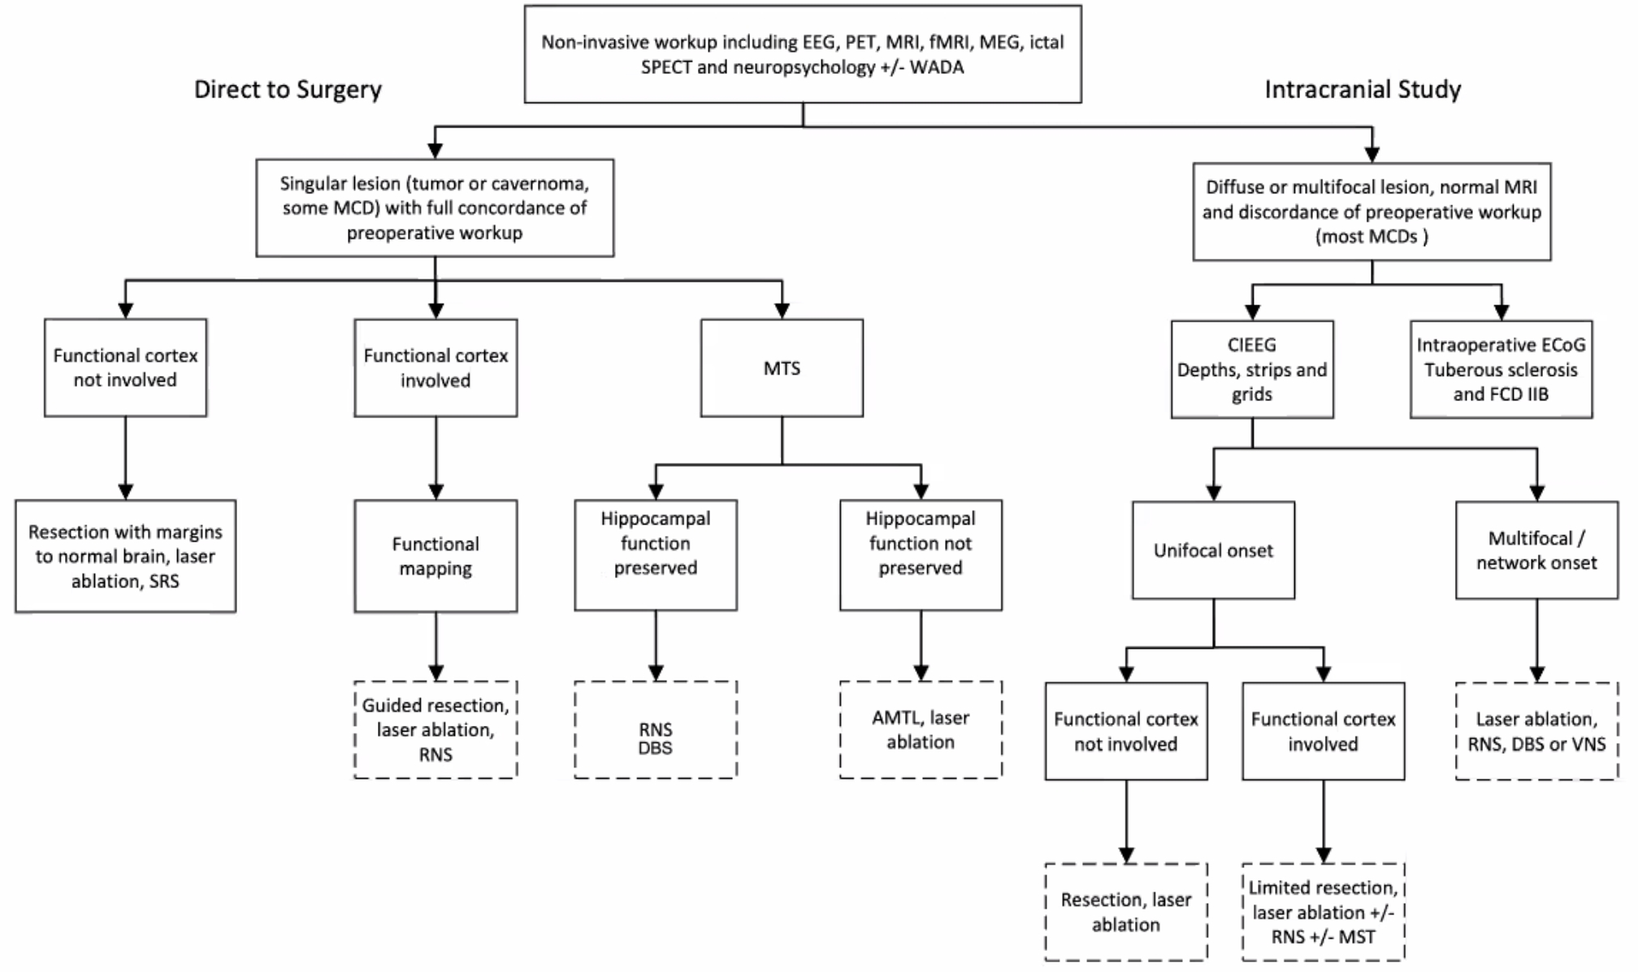
Gerard J et al.

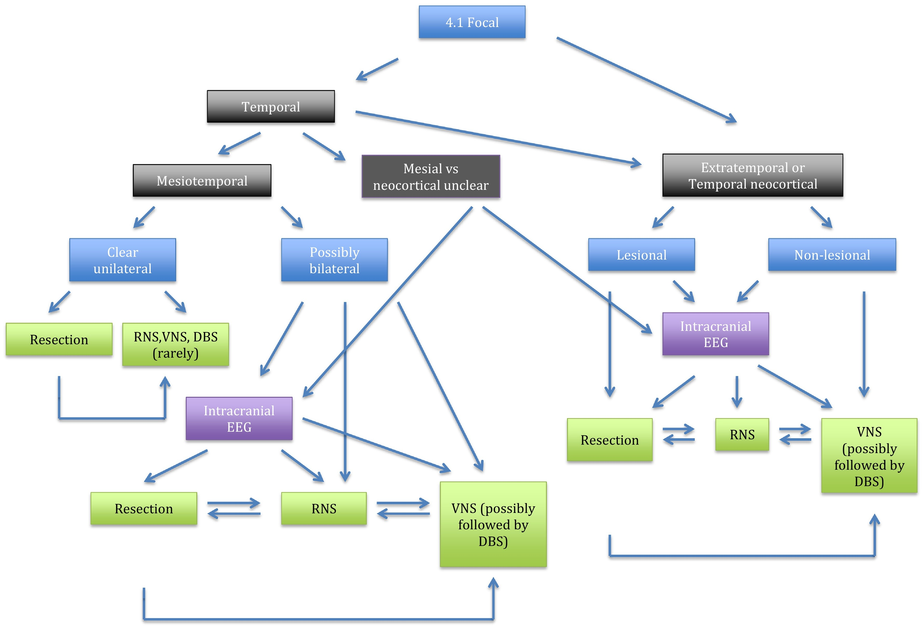
Benbadis et al. 2018

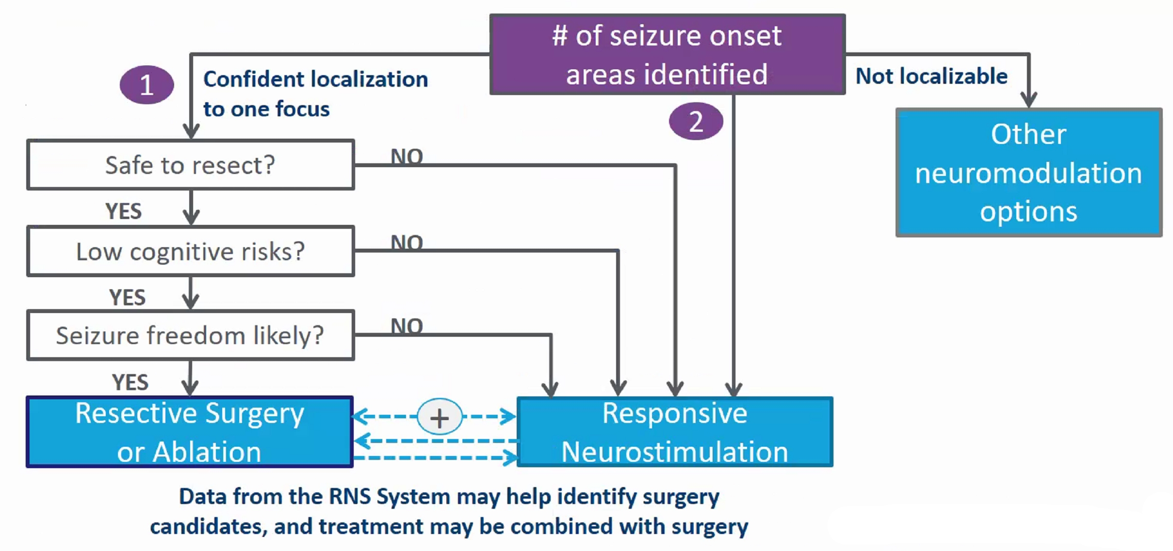

Alternative algorithm
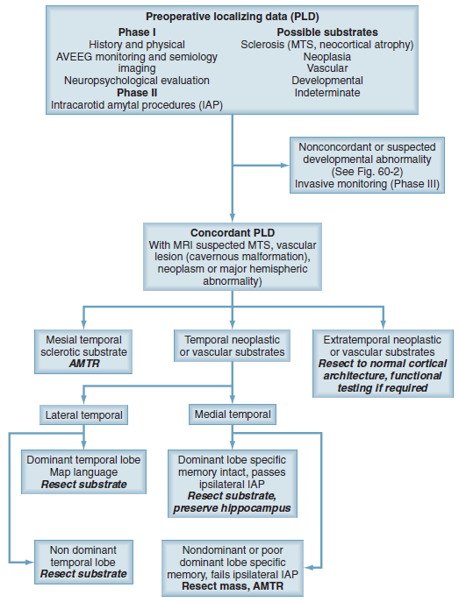

Alternative algorithm (fig. 60-2)
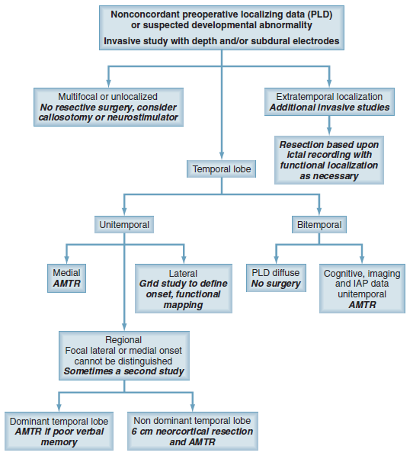

Focal Epilepsy
- key dichotomies: temporal vs. extratemporal
↓
mesial vs. neocortical
- distinguishing mesial vs neocortical temporal may at times require intracranial EEG, but once that is done, the neocortical temporal group generally follows the same course as extratemporal.

Temporal
Outcomes in bilateral or non-resectable temporal lobe
- VNS – 60-62.5% response
- ANT DBS – SANTE trial - 44.2% response
- RNS - 74 % response in hippocampal epilepsy
- Hippocampal DBS – 25-100% response in hippocampal epilepsy
- CM DBS – not as effective on focal epilepsy
- STN DBS – too limited data
- TMS – probably ineffective for mesial TLE

Mesiotemporal
Unilateral
- resective surgery or ablation is by far the treatment of choice.
- traditionally, en bloc resection of anterior lateral and mesial temporal lobes structures has been performed. However, the potential for neuropsychological decline (especially in dominant temporal lobe surgery) has led to the development of selective amygdalohippocampectomy (LITT of the mesial structures is an effective option).
- very rarely, neurostimulation may be preferable if memory is superior on that side, but this should be exceptional because a minor verbal memory decline is usually offset by seizure freedom.

Bilateral
- the issue is “how bilateral is it?” (continuum from minimal or weak evidence on one side, to definitely and clearly bilateral):
- high concern for bilateral disease (independent seizures on surface EEG, bilateral mesial temporal sclerosis (MTS) on MRI, conflicting lateralizing findings)
- low concern for bilateral disease (very rare interictal spikes on the opposite site)
- most often - anywhere in between high and low concern.
- options:
- straight unilateral resection
- bitemporal intracranial EEG
- high concern for bilateral disease* → RNS (data may allow an eventual resection should there be a strong unilateral predominance).
*RNS is preferred over short-term intracranial EEG in order to ascertain lateralization based on a larger sample of seizures (hundreds), rather than on a limited number of seizures obtained in EMU (and usually on reduced doses of AEDs).

Nonmesiotemporal (neocortical temporal, extratemporal)
Lesional
Here, much of the approach depends on the nature of the lesion and, specifically, its suspected nature (tumor, vascular malformation, cortical dysplasia, etc.), size, location (with respect to eloquent cortex), and the degree of certainty (based on semiology and EEG) that the lesion is indeed causing the seizures. If the lesion is a suspected neoplasm, then its potential for evolution into higher grades becomes part of the equation, favoring resection for tumor reasons rather than epilepsy reasons. If the lesion itself is static and not concerning for a neoplasm, then lesionectomy has the highest probability of seizure freedom and will usually be preferred, with neurostimulation being a distant second choice, and probably only appropriate if the resection would involve critical eloquent cortex. Here, a partial resection can be combined with neurostimulation, though RNS can interfere with serial MRI surveillance of lesions. Another complicating factor in lesional focal epilepsy is the potential for dual pathology. Resection can be done with or without intracranial EEG or ECoG. Hemispherectomy represents an extreme example of lesional resection (e.g., hemimegalencephaly, Rasmussen's Syndrome) and also belongs in this category.

Nonlesional
This scenario (neocortical + nonlesional) is the most challenging and a very common scenario at level-4 epilepsy centers.

      - Strongly lateralized (hemisphere known) Strong lateralization can be based on interictal discharges, ictal EEG, or seizure semiology (e.g., consistent head version prior to secondarily generalized convulsions). This scenario, most commonly frontal, will require intracranial EEG to cover the area in question (frontal, frontotemporal, parietal, occipital, etc.). Since the area is usually extensive, sEEG is increasingly preferred to subdural grids and strips, but both can be used.

      - Not confidently lateralized (hemisphere unclear) Such cases have often been referred to as “fishing expeditions.” In the past, they could only be pursued with abundant amounts of hardware (bilateral strips and grids), resulting in a higher rate of complications and a relatively poor outcome. For that reason, many centers have tended to not pursue these cases for possible resective surgery. The advent of frameless robot-assisted sEEG, allows better surveying both in space (numerous depth electrodes on both sides) and time (electrodes can remain in place for weeks with little morbidity). Therefore these cases can now be reasonably pursued, “displacing” palliative neurostimulation treatments. One approach here is initially bilateral frontotemporal sEEG, which after the first few seizures can be focused by adding depth electrodes on the confirmed side of seizure onset once clarified [24]. Subdural electrodes and sEEG can also be combined. In this scenario, neurostimulation is also a reasonable option, since it carries less morbidity and the chances of seizure freedom with resective surgery are lower than in temporal or lesional cases.

Extratemporal
- VNS – efficacy in focal epilepsy does not appear to be limited to temporal lobe
- RNS – 37% response rate in neocortical epilepsy
- CM DBS – not as effective on focal epilepsy
- ANT DBS – Sante trial did not demonstrate efficacy in this subgroup
- STN DBS – was efficacious in small #’s tested and FLE was main target
- TMS – may be effective for MCD
- Hippocampal DBS - N/A

- posterior quadrant epilepsies – counsel for hemianopsia risk as often big resections (or disconnection) is needed.

Eloquent Cortex
- Resections
- need mapping - grids are ideal (but preceding SEEG may guide grip implantation)
- resections in eloquent cortex are feasible and safe (as long as preservation of functional areas is observed)
- outcomes are excellent in lesional epilepsies.
- in non-lesional epilepsies, if intracranial recordings provide convergent data, seizure freedom has high probability
- role of LITT is limited – cannot provide mapping

- Neuromodulation
- reserved for nonresectable areas (as determined by direct cortical mapping).
- can be combined with resection (limited topectomy) and mapping (precisely guides RNS electrode placement).

Language localization / Lateralization
  - fMRI
  - MEG
  - High-density EEG
  - TMS
  - WADA
  - Cortical stimulation (intraop vs implanted electrodes)

Generalized Epilepsy
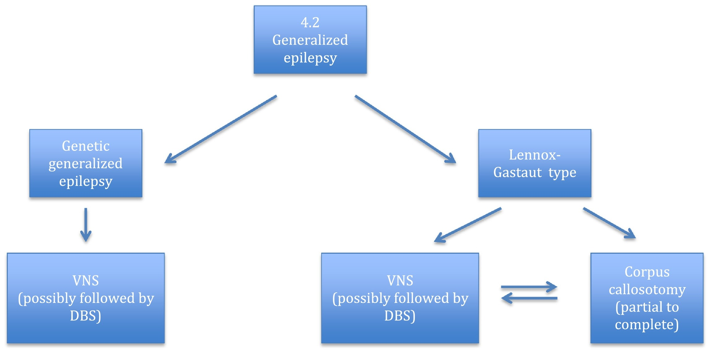
Benbadis et al. 2018

Genetic (s. idiopathic, primary) generalized epilepsy
- this group is usually not medically intractable, but it can be.
- occasionally, when bifrontal epileptiform discharges mimic generalized spike–wave complexes (“secondary bilateral synchrony”), distinguishing a GGE from a frontal lobe epilepsy can be challenging, and it is generally safer to err on the side of GGE and only pursue surgically if there is strong evidence for a focal onset.

Lennox–Gastaut type (s. symptomatic, cryptogenic generalized epilepsy)
- usually with cognitive impairment (developmental intellectual disability), neurologic abnormalities such as cerebral palsy, and characteristic EEG abnormalities.
- cause may be genetic, structural, or metabolic but is often unknown.
- this group can also be considered multifocal rather than “generalized” (epilepsy with ≥ 3 “foci” is equivalent to “generalized”).

Resective surgery and RNS are never options for the generalized epilepsies, but corpus callosotomy, VNS, and DBS can be. Technically, VNS for generalized epilepsy is off label in the US but is nonetheless one of the most common uses of VNS (endorsed by AAN guidelines). Corpus callosotomy is almost never performed in patients with GGE since they are usually mentally and neurologically healthy, but is a viable option for LGS type and while it is most often used in children, it can be performed in adults. Compared with neurostimulation, corpus callosotomy is more invasive, more ambitious, and may have more immediate effects. Neurostimulation is less invasive than callosotomy (VNS less than DBS), and the therapeutic effect is delayed, taking weeks to months. Preferences to use callosotomy or VNS first vary, and both are acceptable strategies that are not mutually exclusive. Additionally, since both are palliative procedures, some patients will benefit from both sequentially. Very rarely, patients with LGS-type of generalized epilepsy with a lesion can benefit from a focal (lesional) resection.

Lastly, patients with true multifocal epilepsy, i.e., related to truly multifocal discrete lesions such as tubers or cavernomas, can be considered for resection if it is confidently proven that one lesion is the source of a majority of the seizures.

Outcomes
- VNS – 44-67% response
- ANT DBS – Sante trial limited to CPE
- CM DBS – 0-100% response
- RNS – by definition excluded
- Hippocampal DBS - by definition excluded
- STN DBS- N/A
- TMS – N/A

Preoperatively
AED
  - valproate can cause bleeding disorders - routinely check coags and bleeding time - if values are abnormal, decrease or discontinue* valproate and recheck values before surgery!
*at least 3 weeks prior to surgery (replace with another medication).
  - on surgery morning, patient receives usual medication dosage with few sips of water.
  - some centers taper anticonvulsants, and completely D/C 1 day before surgery (???).

Types of Surgery
Ablations s. Resections (curative) - resection of seizure focus (up to entire hemisphere):
- lesionectomy
- neocortical resections
Disconnections (palliative) - used when eloquent brain is involved to disconnect seizure focus from other functional parts of brain:
- callosotomy
- hemispherectomy
- multiple subpial transections
Stimulation s. Neuromodulation
- RNS
- DBS
- VNS

Only 10-30% of pharmacoresistant patients are candidates for resective surgery (rest of patients – neuromodulation)

Surgical Philosophy
Nodes vs. Networks – biggest debate about pathophysiology of epilepsy and may affect surgical philosophy.

Goals of surgery – node removal / disruption (i.e. lesion resection or stimulation with RNS / DBS) vs. network disconnection (lesioning) or neuromodulation (DBS / VNS).

Analogy with oncology – hope to remove critical portion of abnormal neurons, so then local inhibitory mechanisms will take care of the reminder.

1. Resection / Ablation
Temporal Resections
see p. E15 >>

Lesionectomy
– for structural lesions delineated by MRI ± electrocorticography.
- most often in frontal lobe.
- all larger arteries or veins adjacent to or crossing gyri should be preserved.
- avoid resection of deep fiber pathways in white matter, i.e. stay in cortex (white matter is not epileptogenic).
- most common mistake is to remove only gross tumor and not immediate surrounding tissue (leaving epileptogenic tissue and clinical seizures).
e.g. small vascular abnormalities surrounded by hemosiderin can be extremely epileptogenic.

N.B. lesion in eloquent cortex – need ECoG to guide resection (else high risk of postop status epilepticus)
- if planning awake mapping, tell the patient “if you become noncooperative, we will implant grid and will send you to EMU for extra-operative mapping”.

Lesioning
- for structural lesions delineated by MRI ± electrocorticography.
- for disconnecting (e.g. callosotomy)

Available modalities:
- Laser ablation (LITT)
- RF-ablation (e.g. guided by SEEG)
- Stereotactic radiosurgery (SRS)
- Focused ultrasound (FUS)

Tailored Neocortical Resection
– for nonlesional extratemporal epilepsy – resection guided by SEEG and/or intraoperative electrocorticography.
Tailored - no two operations are identical!
- epileptiform discharges recorded acutely during surgery define boundaries of cortical resection.
N.B. be prepared for larger craniotomy as epileptiform discharges may encompass larger area than expected!
- eloquent cortical regions are spared.
*Brazilians call intraop ECoG as an alternative to SEEG in poor countries: ECoG uncovers (interictal spikes) and guides resection of “dormant” EZs that would emerge later if only “active” EZ was removed.

Technique for topectomy:
(a) The pia over the center line of the gyrus is coagulated with bipolar electrocautery and (b) divided with microscissors. (c) The pial flap is then elevated and the gray matter evacuated with gentle suction.
Bipolar electrocautery is used for small vessel hemostasis, and occasionally to disrupt tissue that is not easily suctioned. (d) The resection is carried down to the bottom of the gray matter of the sulcus. White matter in the gyrus may be resected to this level, but not further.
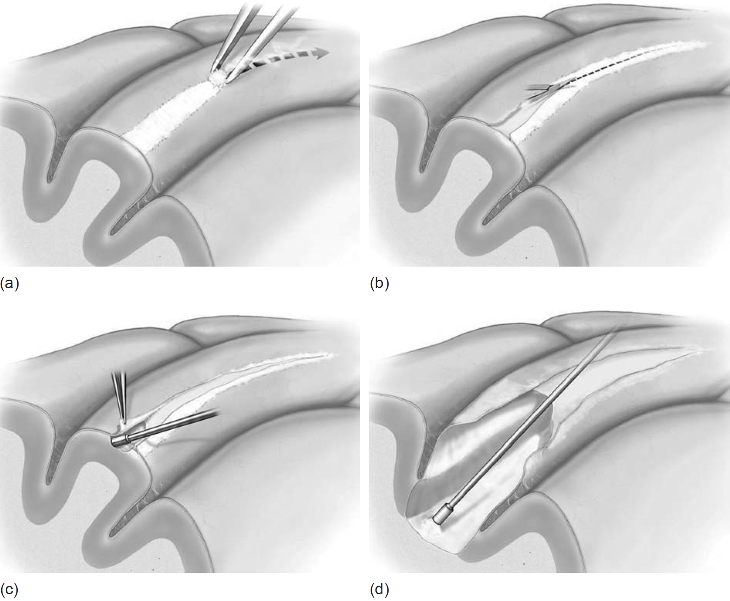
Source of picture: Lüders “Textbook Of Epilepsy Surgery” 1st ed. (2008); Publisher: CRC Press; ISBN-10: 1841845760; ISBN-13: 978-1841845760 >>

Preservation of vessels in topectomy. Respect for the vasculature is of the utmost importance, as sacrifice of en passage arteries or bridging veins may result in infarction of adjacent, functional cortex, leading to loss of function or a new epileptogenic focus:
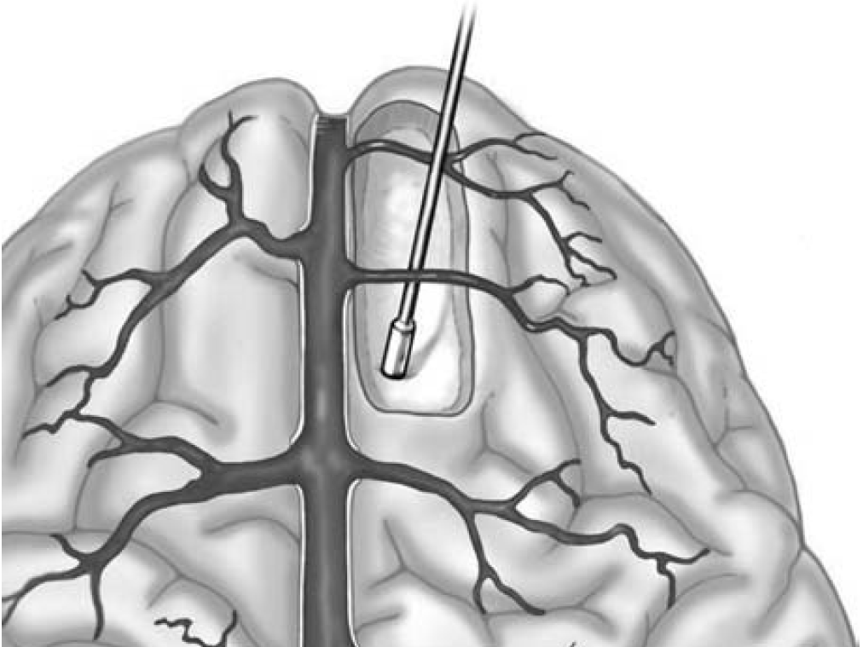
Source of picture: Lüders “Textbook Of Epilepsy Surgery” 1st ed. (2008); Publisher: CRC Press; ISBN-10: 1841845760; ISBN-13: 978-1841845760 >>

Multilobar Resection
  - corticectomy (resection of grey matter)
  - lobe excision (resection of grey and white matter)
  - lobe disconnection
  - combination.
- usually involves frontoparietal, parieto-occipito-temporal, or parieto-occipital lobes.
- indications as for functional hemispherectomy.

2. Disconnections
Multiple Subpial Transections (MST)
see p. E17 >>

Hemispherectomies (functional, anatomical)
see p. E19 >>

Corpus Callosotomy
see p. E21 >>

3. Neuromodulation
- electrical stimulation was first used therapeutically for epilepsy in the 1970s, when the cerebellum became the first therapeutic target for electrical stimulation in human patient epilepsy, with mixed results.

Neuromodulation may help bridge the treatment gap for many refractory patients:
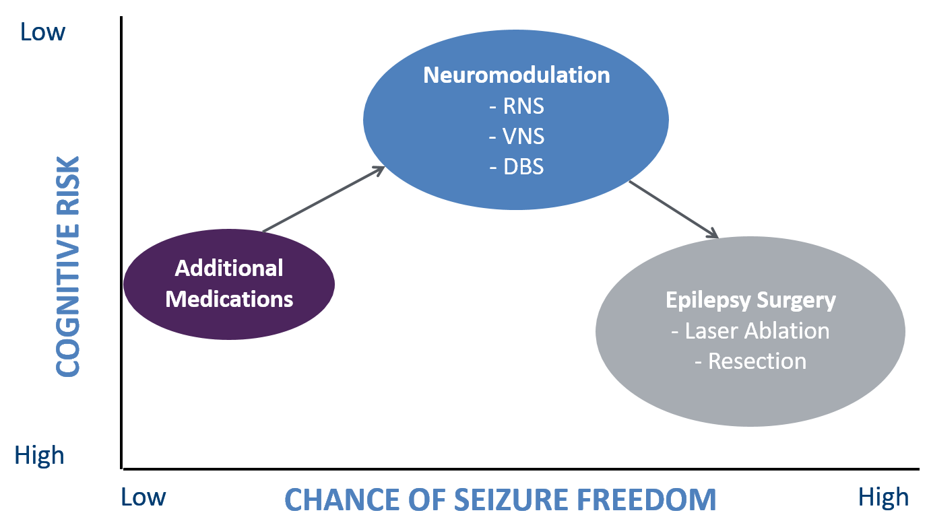

Two theories (mutually nonexclusive and maybe overlapping)
- Modulation of Network / Node
- Disruption of Network / Node abnormal resonance / synchrony

Comparison Of Neuromodulations
Feature | VNS | DBS | RNS
Closed-loop | Partially (newer models may detect tachycardia) | No (newer models record LFPs) | Yes (detects electrographic activity)
Newest model | Sentiva (2017) | Percept PC (2020) | 320 (2019)
Generalized or multifocal epilepsy | Yes | Probably (limited evidence) | No
Invasiveness (intracranial) | No | Yes | Yes
Recording capability | No | Low resolution sensing: 6 data points/hr, 5 Hz range | High resolution sensing: 250 data points/sec, 1-125 Hz range
Recording capacity | No | No | Yes (1 MB)
Indication for depression | Yes | No | No
Positive effects on mood & cognition | Yes | Unknown | Probably
Children | Yes | No | No (predicted in 2024)
Patient compliance needed | No | No | Yes
Feedback to the patient | None / swipe magnet to feel stimulation | Yes | Yes
MRI | Yes, exclude C7-T8 region (up to 3 T) | Yes, full body (up to 3T with Percept®) | Yes, full body (up to 1.5 T)
MRI exclusion zones | Yes | No | No
Side effects during stimulation | Yes | No (memory?, depression?) | No
IPG site | Infraclavicular | Infraclavicular | Cranial
Regulatory approval (2018 December) | The whole world (FDA in 1997) | USA (FDA in 2018), Europe (CE mark), Canada, Australia | USA only (FDA in 2013)
Outcomes
Biomarker predictors of therapeutic response* | Non-lesional epilepsy, generalized seizures | Temporal theta-band desynchronization, hippocampal-evoked potentials, increased functional connectivity between ANT and the default mode network | None
Median seizure reduction at 1 year | 45% (EO5) | 41% (SANTE) | 67% (Post-approval)
Best median seizure reduction** | 76% at 10 yrs | 75% at 7 yrs | 75% at 9 yrs
Seizure remission*** | Long term follow up: 8% were seizure free | At 7 yrs: 18% of patients experienced at least one 6-month seizure-free period, 7% were seizure-free for the preceding 2 years | At 7 yrs: at least one seizure-free period lasting:  ≥ 3 months - 39% of patients  ≥ 6 months - 29% of patients  ≥ 1 year - 16% of patients
*reliable predictors of therapeutic response are lacking across neuromodulation options! (also failure of one neuromodulation option does not predict response to another neuromodulation option)
**follow up studies dismissed patients who stopped using devices or were lost for follow up – if to count those as treatment failures, responder rate (50% seizure burden reduction) remains stable over time at ≈ 40% across different devices.
***medical therapy alone in drug-resistant epilepsy gives 12-month seizure-remission in 33.4% of patients at 7 years!
Handforth, A et al. Vagus nerve stimulation therapy for partial-onset seizures: a randomized active-control trial. Neurology. 1998;51(1):48-55.

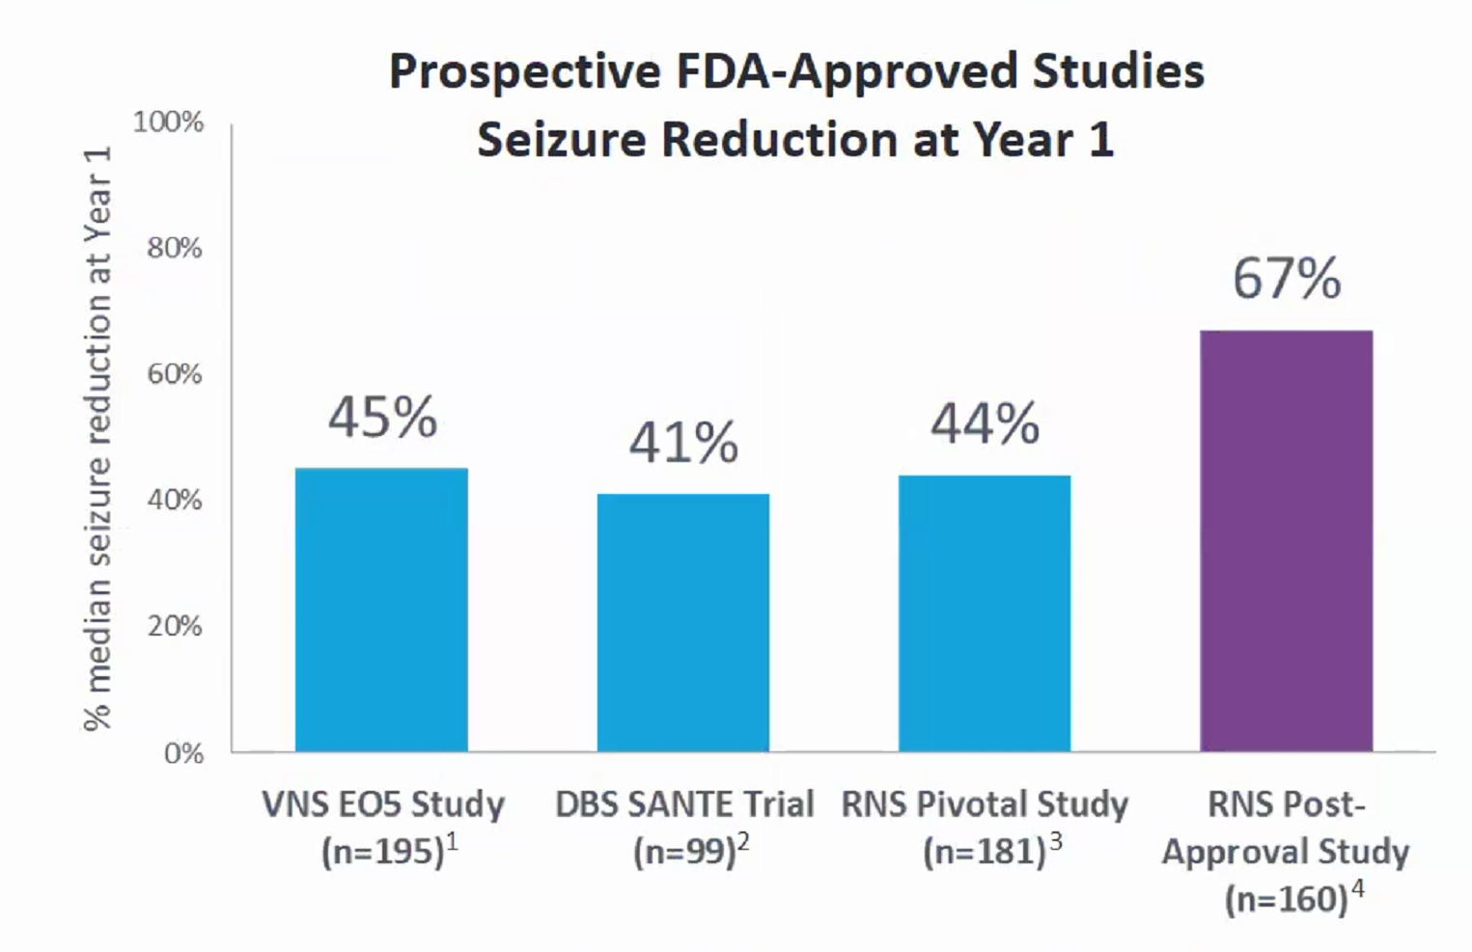

DBS and VNS may seem similar but DBS gets physically into epilepsy network.
- regardless of neuromodulation modality chosen, the optimal time interval to adjust parameters (if no efficacy) – 3 months.

DBS vs RNS if either is placed in seizure focus – different opinions (FDA approved only RNS)

Seizure Outcomes
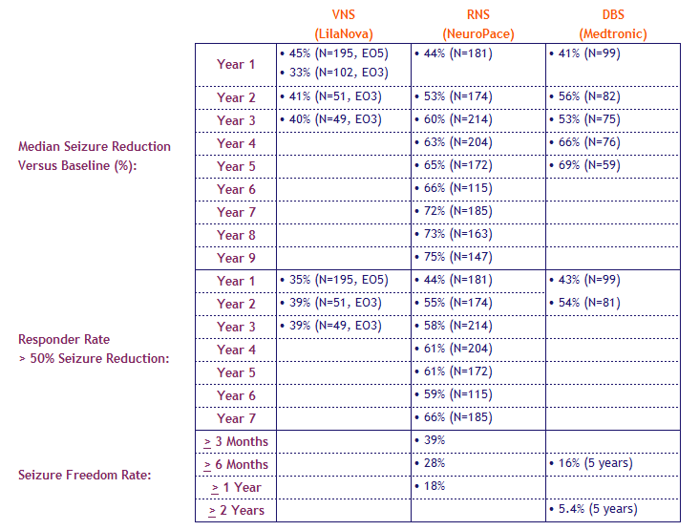

Stimulation Time
Average time stimulation is delivered in 24 hrs:
RNS – 6 mins
VNS – 130 mins
DBS – 240 mins

Psychiatric Side Effects
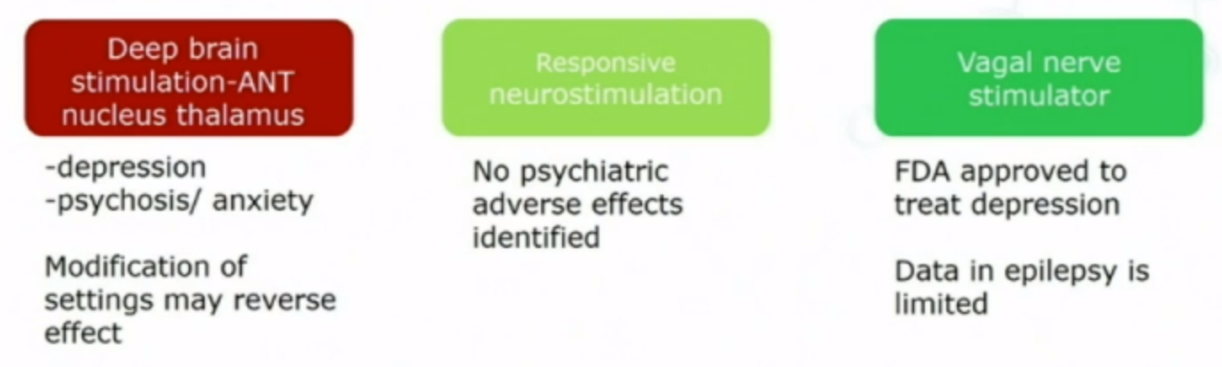

Deep Brain Stimulation (DBS)
see p. E27 >>

Vagus Nerve Stimulation (VNS)
see p. E23 >>

Responsive Neurostimulation (RNS)
see p. E25 >>

Transcranial Magnetic Stimulation (nTMS)
- cortical stimulation with low-frequency trains decrease cortical excitability.
- some studies show ne efficacy.
- Randomized Double Blind Sham Controlled Trials
Study | Theodore (NIH) 2002 Neurology | Fregni (Sao Paulo) 2006 Ann Neurol | Cantello (Multicenter Italy) 2007 Epilepsia
N | 24 | 21 | 43
Sz Type /Location | Mesial TLE 10  Lateral TLE 10  Frontal 3  Parietal 1 | neocortical | mTLE 7  Neocortical 34
MRI | all lesions except MS were excluded | all malformation of cortical development (MCD) | Posttraumatic 6  MTS 5  Hemiatrophy 4  Cortical dysplasia 2  Tuberous Sclerosis 1
Stim Target | EEG identified seizure focus | MRI abnormality in 17, vertex in 4 with diffuse MCD | Vertex
Stim Parameters | 1 Hz, 120% MT, 900 stim bid x 7 days | 1 Hz, 70% max coil output, 1,200 stim/day x 5 days | 0.3Hz, 120% MT, 1,000 stim/day x5 days
Outcome | No sig diff in stim vs sham, trend for better results in neocortical | Stimulated  2 weeks 72% p=0.003  4 weeks 53% p= 0.002  8 weeks 58% p=0.001  Sham – no change | No effect

- Fregni et al. 2006:
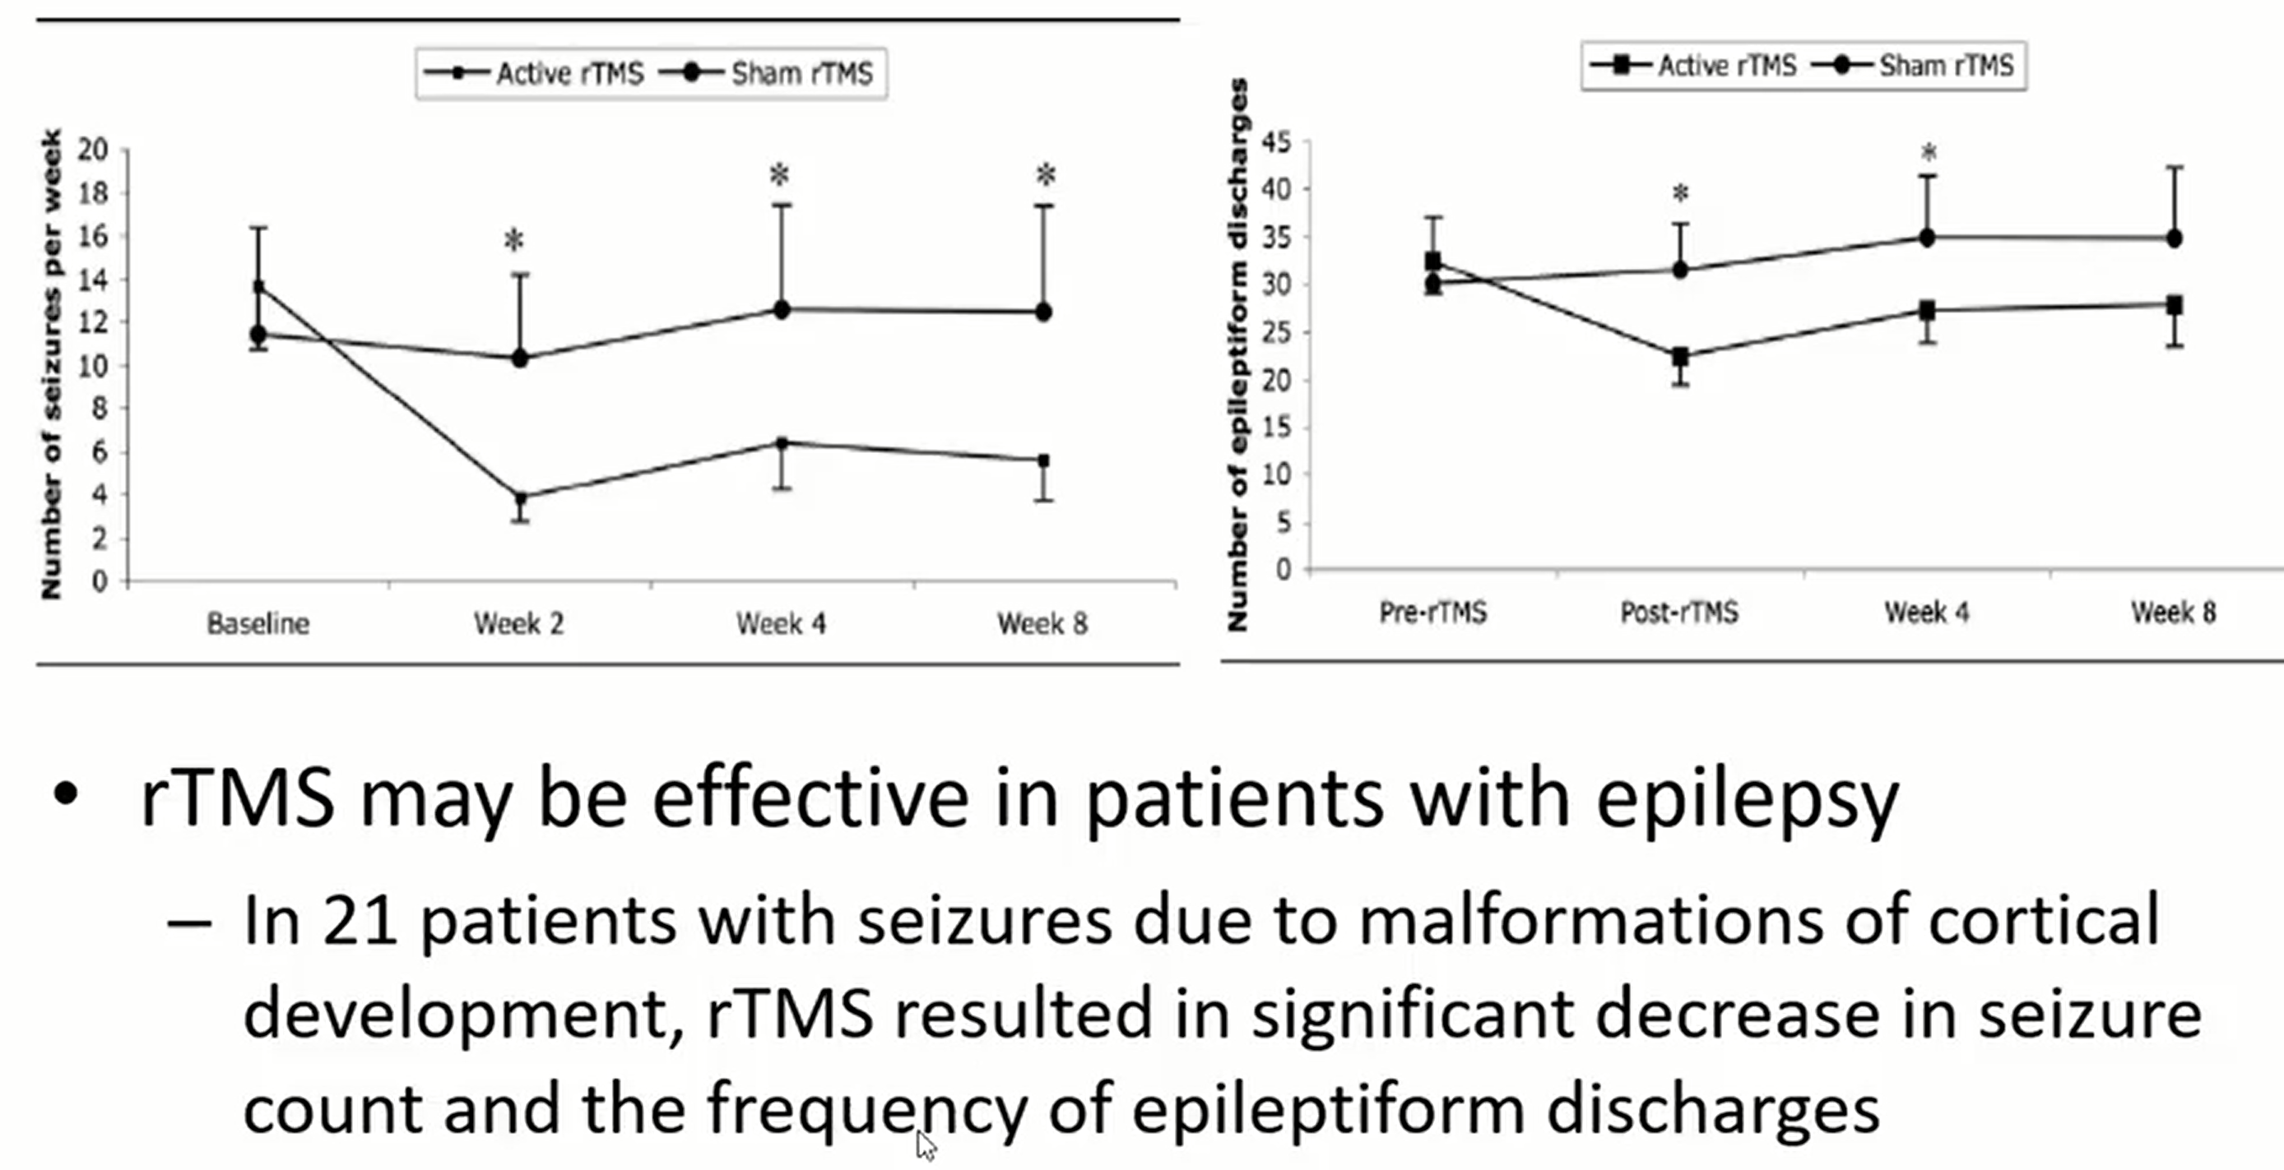

- Chinese trial:

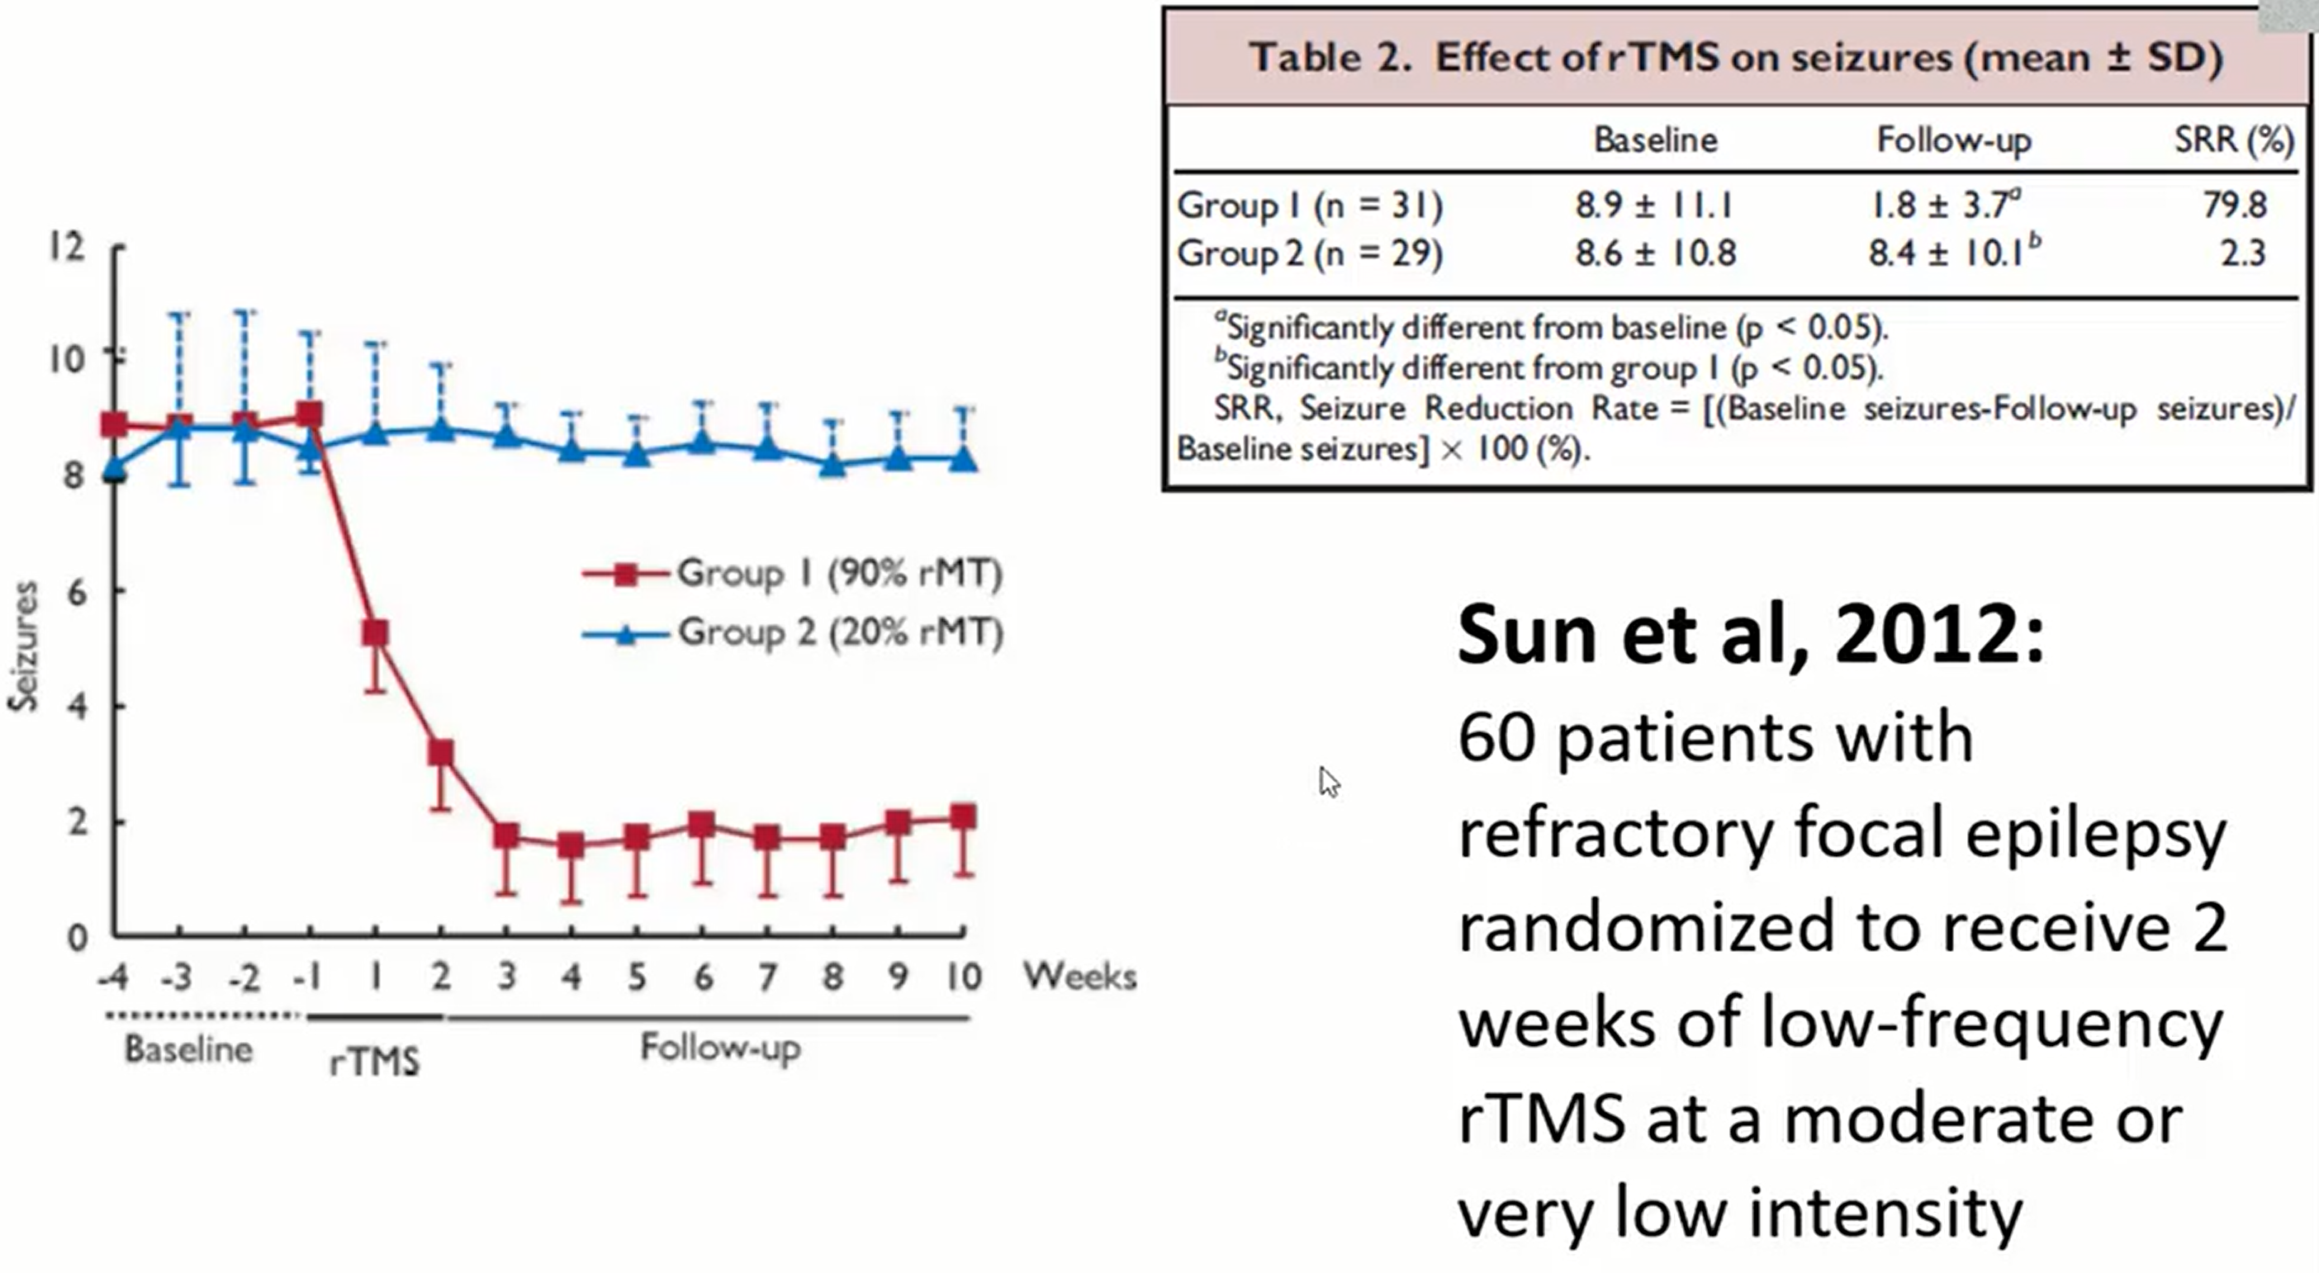

Postoperatively
- patient is returned to seizure monitoring room in epilepsy unit (vs. overnight ICU).

AED
Patients generally need to remain on AED therapy (for ≈ 2 years); some continue to require AED therapy to remain seizure free (e.g. if pathology showed heterotopia, then other foci of heterotopia likely exist).
N.B. surgery is not indicated if patient expects to be AED-free!
- even if almost seizure free can try to reduce medication.

60% of patients (53% in temporal lobe epilepsy) are able to stop all AEDs (22% remain seizure-free and medication-free after > 5 years)
- if patient is taking 2 AEDs, least effective drug is tapered after 1 year.
- if patient is seizure free at 2 years, remaining drug can be tapered.
- one seizure during or after withdrawal → resume single medication therapy.
- negative risk factors: multiple lesions, EEG abnormalities, post operative seizures, longer preoperative seizure duration - but even they deserve a chance to be free of medication if seizure free!
- Can weaning medication make things worse? Probably not (Kerling 2009, Jehi 2012)
  - 70% regain control (Menon et al 2012).
  - those who recur are controlled with less aggressive regimen.
- postoperative seizures:
  - seizures within first 24 hours ("honeymoon seizures") do not correlate with poor long-term seizure outcome - may be due to irritation and edema of tissues adjacent to resection (neighborhood seizures).
Convulsions in immediate postop phase are common in first 3-5 days, if they are stereotypic of seizures prior to surgery, they may indicate lower changes of success and seizure freedom, but otherwise, they are not of huge concern unless they do not stop.
Acute postoperative seizures (up to 1 week after surgical resection) are not counted as evidence of recurrent epilepsy
  - seizures after 48 hours (with adequate serum AED levels) do not bode well for eventual outcome.
N.B. many patients may continue to have components of preoperative auras;
  - some may have occasional seizures for few years which then cease (wind down);
  - others may be seizure-free for few years, then have recurrence.

Alternative view – early withdrawal of AEDs - safe and does not affect long-term seizure outcome or cure, might unmask incomplete surgical success sooner (identifying patients who need continuous drug treatment and preventing unnecessary continuation of AEDs in others).
  - if seizures recur postop, only minority do recur during AED withdrawal.
  - if seizures recur, restarting AED helps regain control.

Before discharge
- neuropsychiatric evaluation? (usually delayed for 6-12 months)
- serum anticonvulsant levels
- EEG

Surgery Outcomes
Seizures
The only reliable predictor of seizure-free outcome – resection of lesional focus! (unclear if laser ablation qualifies for that)
- goal of epilepsy surgery:
palliative epilepsy surgery - seizure reduction (still can be very desirable for some patients, e.g. getting rid of convulsive seizures)
radical epilepsy surgery - seizure freedom
- in medical therapy, > 50% reduction in seizures = success
- seizure control is assessed at 1, 3 & 6 most post op, and then annually.
  - 90% of seizures that recur do so within 2 years; per Dr. R. Gross – if seizures recur, they do it within 6 months (therefore, outcomes are measured earliest at 12 months).
  - neuromodulation antiseizure effect keeps improving over time.
“It takes time for epilepsy to develop, it takes time to undevelop”

Procedure | Seizure Free (%) | Improved* (%)
Anterior temporal lobectomy | 76 | 24.0-27.2
Amygdala-Hippocampectomy | 68.8 | 22.3
Extratemporal cortical resection | 25.0-60 | 18.2-35.2
Lesionectomy | 66.6 | 21.5
Hemispherectomy | 67.4-77.3 | 18.2-21.1
Corpus callosotomy | 7.6-8.0 | 60.9-80.0
*50% reduction of seizure frequency
Long-term (> 5 years) outcome combining all kinds of epilepsy surgeries – 22% seizure free and no AEDs

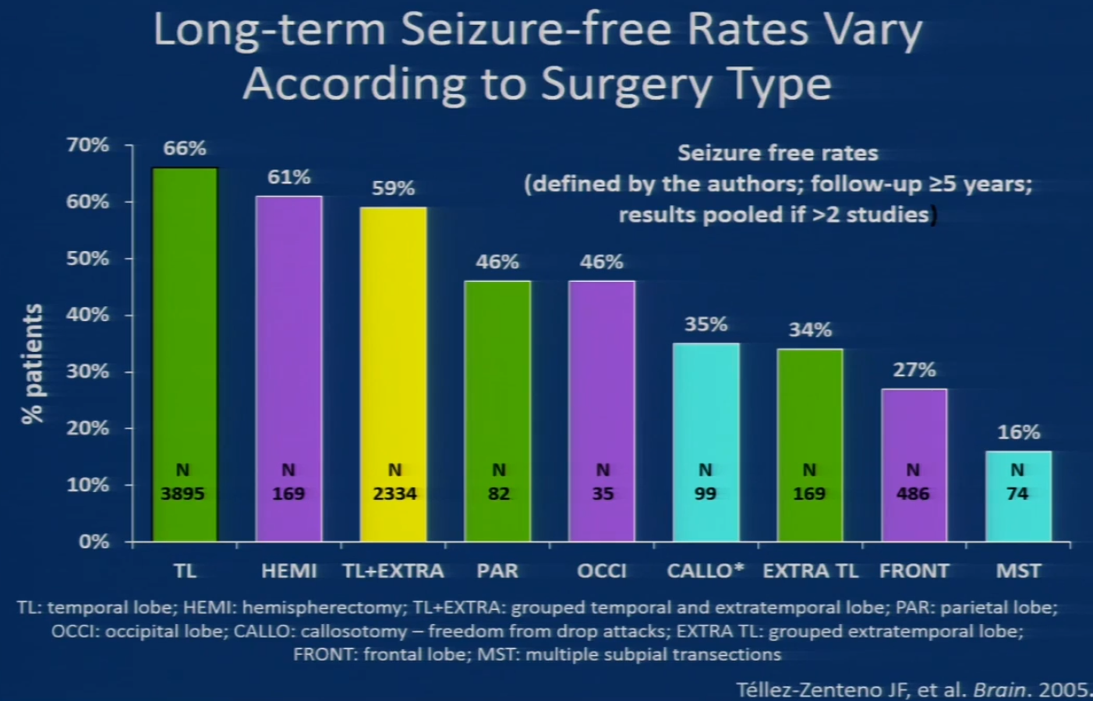

- ablative surgery is associated with improvement in intelligence, in psychiatric and behavioral disorders, in social and vocational function (abnormal brain tissue resection may remove undesirable functional effects which are interfering with function of other cortical areas).
N.B. cognitive function starts to improve after successful surgery but after the lag period.
- parents often wonder whether their child's personality will change or if he / she will become more depressed or anxious after undergoing resection of temporal or frontal lobe surgery – surgery doesn't appear to have major effect on mood or anxiety in children, and some kids even do better.
- running down phenomenon - gradual decline of seizures over several months or years until seizure freedom is achieved after surgery.

Classification of outcomes
Jerome Engel's classification of postoperative outcome:

Class I: Free of disabling seizures
      - Completely seizure free since surgery
      - Nondisabling simple partial seizures only since surgery
      - Some disabling seizures after surgery, but free of disabling seizures for at least 2 years
      - Generalized convulsions with AED discontinuation only
- class 1 includes patients with residual auras.
  - auras do not bother patient if they are infrequent.
  - depending on nature of auras (e.g. intense fear), they can affect quality of life.

Class II: Rare disabling seizures (“almost seizure free”)
- Initially free of disabling seizures but has rare seizures now
- Rare disabling seizures since surgery
- More than rare disabling seizures since surgery, but rare seizures for the last 2 years
- Nocturnal seizures only

Class III: Worthwhile improvement (> 90% reduction)
- Worthwhile seizure reduction
- Prolonged seizure-free intervals amounting to greater than half the followed-up period, but not < 2 years

Class IV: No worthwhile improvement (< 90% reduction)
- Significant seizure reduction
- No appreciable change
- Seizures worse

ILAE classification of postoperative outcome:
- Completely seizure free; no auras
- Only auras; no other seizures
- 1-3 seizure days per year; ± auras
- 4 seizure days per year to 50% reduction of baseline seizure days; ± auras
- Less than 50% reduction of baseline seizure days; ± auras
- More than 100% increase of baseline seizure days; ± auras

Seizure Freedom
Factors predictive of freedom from seizures:
    - MRI-detectable lesion (unless functional constraints limit extent of resection); better temporal than extratemporal.
    - concordant interictal epileptiform discharges.
    - more extensive resections.

Seizure worsening / De Novo seizures
Population-Based Register Study
Johan Bjellvi et al. Risk Factors for Seizure Worsening After Epilepsy Surgery in Children and Adults: A Population-Based Register Study. Neurosurgery, Volume 87, Issue 4, 1 October 2020, Pages 704–711
- 2-year seizure outcome - 1407 procedures.
- increased seizure frequency compared to baseline - 4.0%
- new-onset TCS (grand mal) - 3.9% (6.6% in patients without preoperative TCS).
- risk factors:
      - reoperations compared to first surgeries
      - lower age of onset
      - lower age at surgery
      - shorter epilepsy duration
      - preoperative neurological deficit
      - intellectual disability
      - high preoperative seizure frequency
      - extratemporal procedures
      - nonresective procedures (for new-onset TCS)

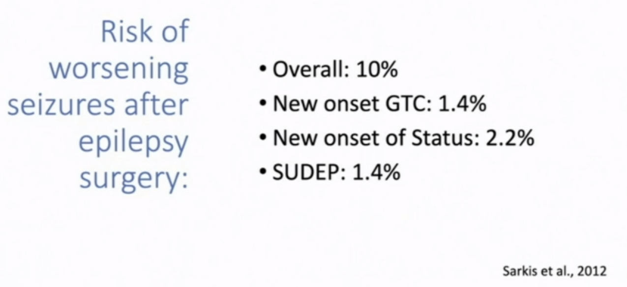

Surgical refractoriness
“Widespread, ‘malignant’ epileptogenic network with a tendency to develop new epileptogenic zones upon resection of the prior zone, causing a progressive disease state”
Yardi Ruta et al. Long‐term outcomes of reoperations in epilepsy surgery. Epilepsia. Volume 61, Issue 3 p. 465-478.27 February 2020
- 898 patients (one-third were pediatric patients and 68% underwent temporal lobe resection), 110 had reoperations (92 had one resection prior to the index surgery and 18 patients had ≥ 2 prior resective surgeries).
- 2 years after index surgery - Engel I score:
69% of patients with no prior surgeries
42% of patients with 1 prior surgery
33% of patients with ≥ 2 prior resections (P < .001).
- odds of seizure freedom diminish with each additional operation.
- risk factors for “surgical refractoriness”: male sex (P = .011), history of secondary generalization (P = .016), increasing number of prior surgeries (P = .002).

Quality of Life

Quality of life in pediatric patients (surgery vs. medications):
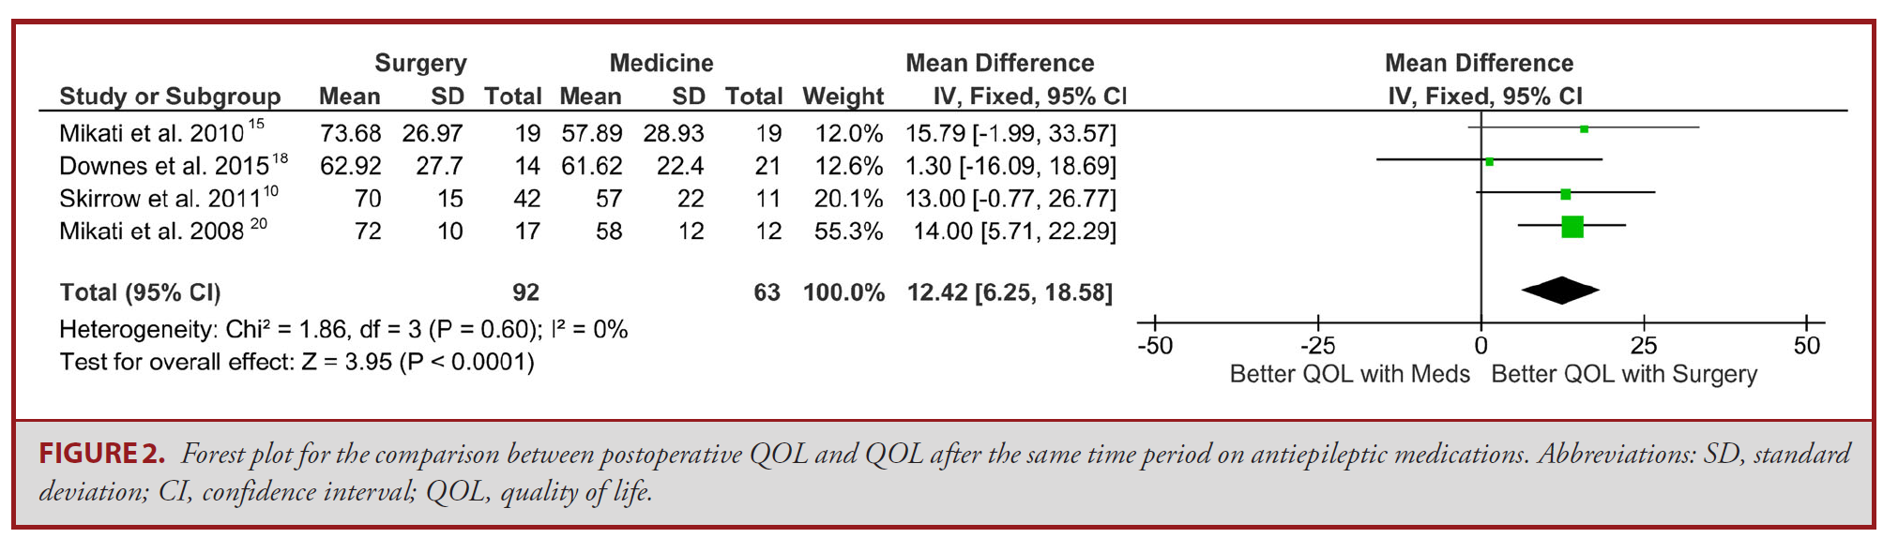

Subgroup with seizure freedom:
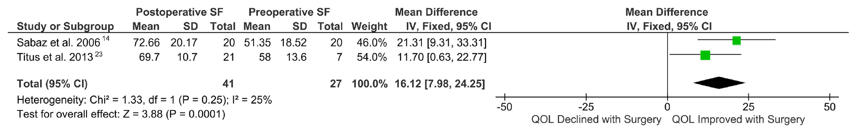

Subgroup with residual seizures:
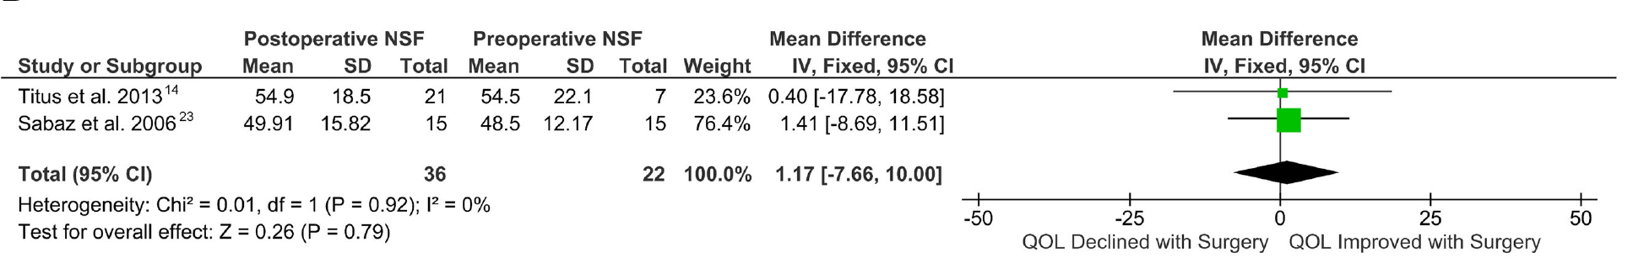
Maragkos et al. 2020
- when looking at the secondary outcome of IQ, there was a significant improvement of about 10 IQ points in patients treated surgically than matched controls treated medically.

Psychiatric
De Novo Psychopathology
Novais F et al. Predicting De Novo Psychopathology After Epilepsy Surgery: A 3-Year Cohort Study.
Epilepsy Behav. 2019;90:204-208. doi:10.1016/j.yebeh.2018.11.037. PMID: 30573340.
- 106 patients
- psychiatric evaluations were made before surgery and every year, during a 3-year follow-up period.
- resective surgery (93%) and ANT-DBS (7%).
- survival analysis model was used to determine pre- and postsurgical predictors of de novo psychiatric events after surgery.
- 15% developed de novo psychiatric disorders that were never identified before surgery.
    - significant predictors - multilobar epileptogenic zone (P = .001) and ANT-DBS (P = .003).
    - hypotheses:
        - failure to establish adequate baseline.
        - surgery eliminates seizures, which could be an endogenous psychiatric treatment (ECT – a medically monitored generalized seizure - is a particularly effective treatment for depression).

Bibliography for ch. “Epilepsy and Seizures” → follow this link

Viktor’s Notes℠ for the Neurosurgery Resident
Please visit website at www.NeurosurgeryResident.net

