Vestibular Physiology
Updated: May 11, 2019
Central Vestibular Pathways 1
Rotational Acceleration 1
Linear Acceleration 1
Labyrinthectomy 1

Although most of responses to stimulation of vestibular receptors are reflex in nature, vestibular impulses also reach cerebral cortex - conscious perception of motion + orientation in space.

Central Vestibular Pathways
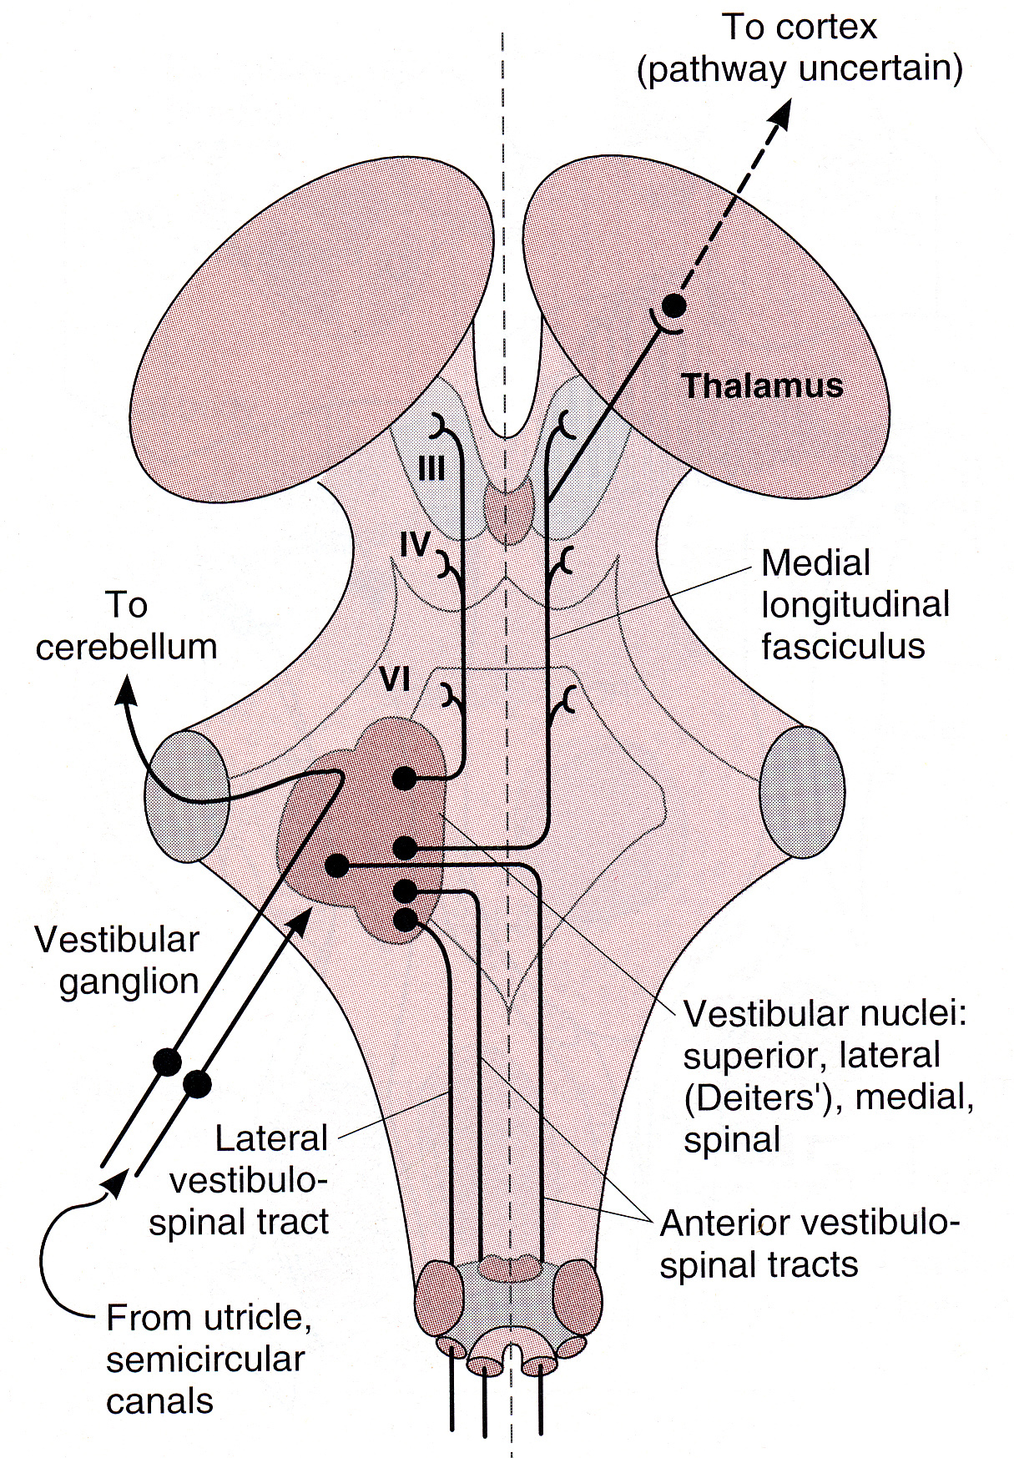
Source of picture: William F. Ganong “LANGE Review of Medical Physiology”, 21st ed. (2003); Publisher: McGraw-Hill / Appleton & Lange; ISBN-10: 0071402365; ISBN-13: 978-0071402361 >>

Rotational Acceleration
rotational acceleration in plane of given semicircular canal stimulates its ampullar crista.
[linear acceleration fails to displace cupula and therefore does not stimulate cristae].
Movement of cupula in one direction causes increased spike rate in single nerve fibers from its crista, whereas movement in opposite direction inhibits neural activity.
Since canals on one side of head are mirror image of those on other side, endolymph is displaced toward ampulla on one side and away from it on other.
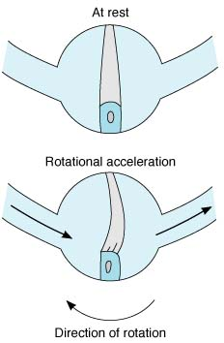  Cupula on crista top closes off ampulla and is flexible. | 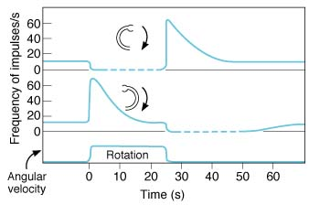  Average time course of impulse discharge from ampulla of two semicircular canals during rotational acceleration, steady rotation, and deceleration.

- when rotation is started, endolymph, because of its inertia, is displaced in direction opposite to rotation → fluid pushes on cupula, deforming it → this bends processes of hair cells.
- when constant speed of rotation is reached (no acceleration), fluid spins at same rate as body and cupula swings back into upright mid position.
- when rotation is stopped, deceleration produces displacement of endolymph in direction of rotation → cupula is deformed in direction opposite to that during acceleration → returns to mid position in 25-30 seconds.
- start and end of rotation are accompanied by nystagmus (see p. Eye64 >>) - it is consequence of vestibulo-ocular reflex that maintains visual fixation on stationary points while body rotates, although it is not initiated by visual impulses and is present even in blind individuals.
- vertigo is sensation of rotation in absence of actual rotation and is prominent symptom when one labyrinth is inflamed.
- semicircular canals can be stimulated experimentally by caloric irrigation test (see p. S30 >>) – this causes nystagmus, vertigo, nausea [to avoid these symptoms when irrigating ear canals in treatment of ear infections, it is important to use fluid at body temperature].

Linear Acceleration
linear acceleration stimulates utricular and saccular maculas.
- utricle responds to horizontal acceleration and saccule to vertical acceleration.
- otoliths are more dense than endolymph, and acceleration in any direction causes them to be displaced in opposite direction, distorting hair cell processes + maculae also discharge tonically in absence of head movement (because of gravity pull on otoliths).
- excessive stimulation causes motion sickness.

Labyrinthectomy
Unilateral Labyrinthectomy → unbalanced discharge from remaining normal side.
- rats develop abnormal body postures and roll over and over as they continuously attempt to right themselves.
- postural changes are less marked in humans, but symptoms are distressing; motion aggravates symptoms, but efforts to minimize stimulation by lying absolutely still are constantly thwarted by waves of nausea, vomiting, diarrhea; fortunately, compensation occurs and after 1-2 months symptoms disappear completely.

Bilateral Labyrinthectomy → defects of orientation in space.
- especially hazardous during diving – vision is the only remaining tool to orient where water surface is (water pressure sensed by cutaneous receptors is equal over the body); if vision is obscured, drowning may occur due to disorientation.

Bibliography for ch. “Otology” → follow this link >>

Viktor’s Notes℠ for the Neurosurgery Resident
Please visit website at www.NeurosurgeryResident.net

