Auditory Physiology
Last updated: May 11, 2019
Physics 1
Sound Waves 1
Extra-axial Auditory Physiology 2
Sound Conduction 2
Traveling Waves 2
Functions of Inner & Outer Hair Cells 2
Action Potentials in Auditory Axons 2
Intra-axial Auditory Physiology 3
Cochlear Nuclei 3
Primary Auditory Cortex 3
Other Cortical Areas 3
Masking 3

Physics
Sound Waves
- sound sensation is produced when sound waves (longitudinal vibrations of molecules in external environment, i.e. alternate phases of condensation & rarefaction of molecules) strike tympanic membrane.
- sound wave speed:
air (at 20 °C at sea level) - 344 m/s (1200 km/h, 770 miles/h).
fresh water (20 °C) - 1450 m/s.

A is record of pure tone.  B has greater amplitude (louder than A).  C has same amplitude as A but greater frequency (pitch is higher).  D is complex wave form that is regularly repeated - perceived as musical sounds.  musical sounds are made up of wave with primary frequency (determines pitch) plus number of harmonic vibrations (overtones) that give sound its characteristic timbre; timbre variations permit us to identify sounds of various musical instruments even though they are playing notes of same pitch.  Waves like that shown in E, which have no regular pattern (aperiodic), are perceived as noise. | 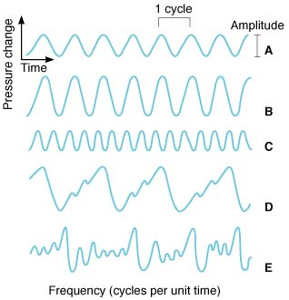

Loudness correlates with amplitude.
Pitch correlates with frequency.
- pitch is also determined by other factors in addition to frequency (see below).
- frequency affects loudness (since auditory threshold is lower at some frequencies than others) and vice versa – loudness affects pitch (see below).

Amplitude of sound wave can be expressed in terms of maximum pressure change at eardrum, but relative scale (e.g. decibel scale) is more convenient:
- sound intensity in bels is logarithm of ratio of intensity of that sound and standard sound.
- 1 B = 10 dB
dB = 10 log (sound intensity / standard sound intensity)
- sound intensity is proportionate to sound pressure²
dB = 20 log (sound pressure / standard sound pressure)
e.g. 60 dB is sound pressure 1000 times the threshold
20 dB is sound pressure 10 times the threshold
- standard sound (adopted by Acoustical Society of America) corresponds to 0 dB at pressure level of 0.000204 dyne/cm² - just at auditory threshold for average human.  N.B. remember that decibel scale is log scale:  0 dB does not mean sound absence but sound level of intensity equal to standard (i.e. 0.0002 dynes/cm²);  0÷140 dB range (threshold pressure ÷ pressure that is damaging to Corti organ) actually represents 10⁷-fold variation in sound pressure.  atmospheric pressure at sea level is 1 bar, and range 0÷140 dB is 0.0002-2000 μbar. | 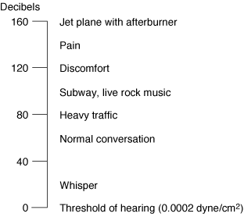

Sound frequencies audible to humans range 20÷20,000 Hz.  - threshold of human ear varies with sound pitch - greatest sensitivity being in 1000-5000 Hz range (maximal at 4000 Hz – sensitivity at this frequency corresponds to 0 dB).  - pitch of average male voice in conversation is ≈ 120 Hz and average female voice ≈ 250 Hz.  - pitch discrimination is best in 1000-3000 Hz range and is poor at high and low pitches.  - number of pitches that can be distinguished by average individual is ≈ 2000 (trained musicians can improve on this figure considerably). | 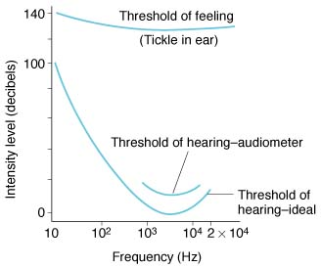  Human audibility curve: middle curve is that obtained by audiometry under usual conditions; lower curve is that obtained under ideal conditions; at 140 dB (top curve), sounds are felt as well as heard.

Sound pitch depends on:
- Frequency of sound wave (primary pitch determinant)
- Loudness - low tones (< 500 Hz) seem lower and high tones (> 4000 Hz) seem higher as their loudness increases.
- Duration: pitch cannot be perceived unless sound lasts > 0.01 s; with durations between 0.01 and 0.1 s, pitch rises as duration increases.

Extra-axial Auditory Physiology
Auditory Vibrations
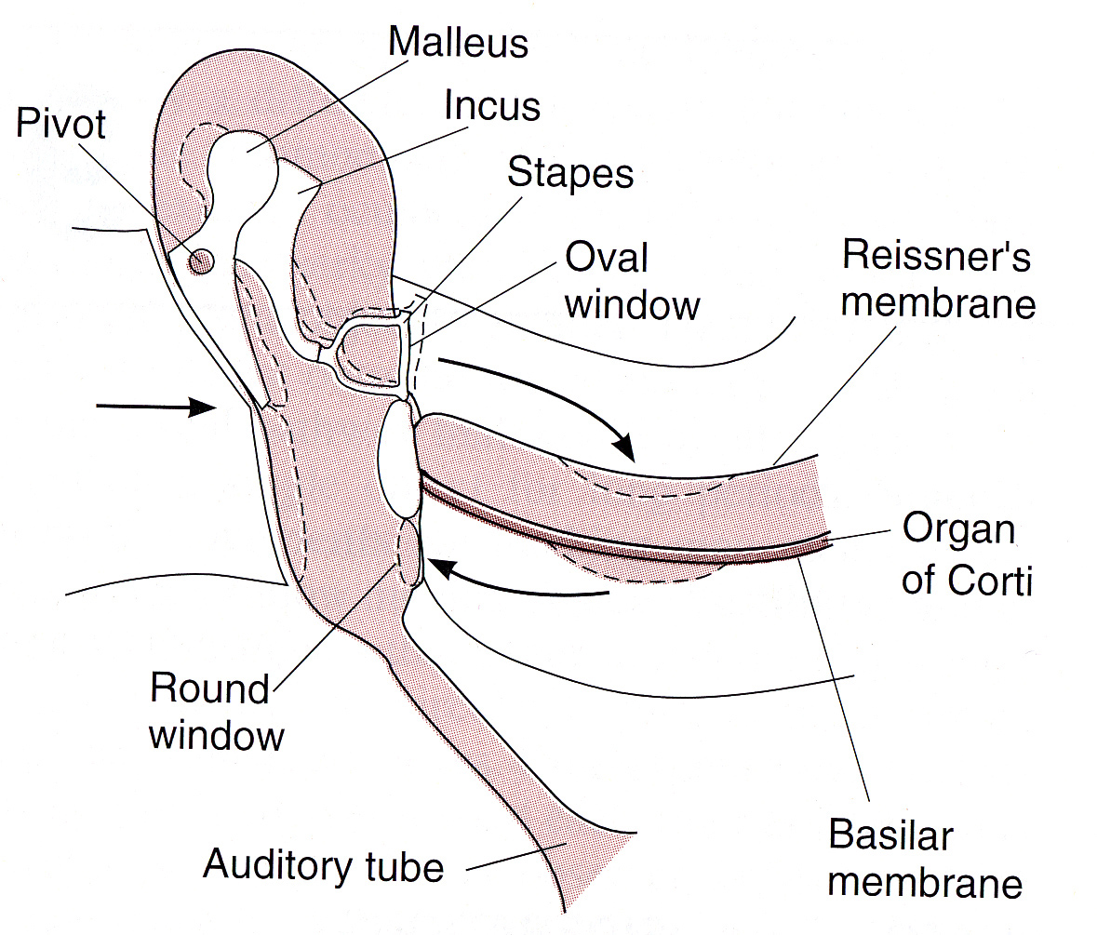
Source of picture: William F. Ganong “LANGE Review of Medical Physiology”, 21st ed. (2003); Publisher: McGraw-Hill / Appleton & Lange; ISBN-10: 0071402365; ISBN-13: 978-0071402361 >>

Sound Conduction
ossicular conduction (pathway for normal hearing, so clinically is called air conduction) - via tympanic membrane and auditory ossicles.
air conduction (unimportant in normal hearing) - sound waves initiate vibrations of secondary tympanic membrane that closes round window.
bone conduction - vibrations of skull bones (e.g. extremely loud sounds, tuning forks applied directly to skull) – directly stimulate inner ear (bypassing external-middle ear).

Traveling Waves
- stapes footplate movement sets up traveling wave in perilymph of scala vestibuli.  - as wave moves up cochlea, its height increases to maximum and then drops off rapidly (very little of wave ever reaches helicotrema!);  - distance from stapes to this point of maximum height varies with frequency of initiating wave.  - high-pitched sounds generate waves that reach maximum height near base of cochlea; low-pitched sounds generate waves that peak near apex.  - peaks of fluid waves in scala vestibuli depress flexible Reissner membrane into scala media; consequently flexible basilar membrane is readily depressed into scala tympani (i.e. sound produces distortion of basilar membrane, and site at which this distortion is maximal is determined by frequency of sound wave). | 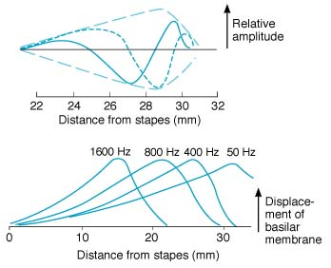  Top: solid and short-dashed lines represent wave at two instants of time; long-dashed line shows "envelope" of wave formed by connecting wave peaks at successive instants.  Bottom: displacement of basilar membrane by waves generated by stapes vibration at shown frequencies.
- fluid displacements in scala tympani are dissipated into air at round window.
- tops of hair cells (in organ of Corti) are held rigid by reticular lamina, and hairs of outer hair cells are embedded in tectorial membrane; when stapes moves, both membranes move in same direction, but they are hinged on different axes, so there is shearing motion that bends hairs.
- hairs of inner hair cells are not attached to tectorial membrane, but they are apparently bent by fluid moving between tectorial membrane and underlying hair cells.

Functions of Inner & Outer Hair Cells
Also see p. Ear12a >>
inner hair cells - primary sensory cells that generate action potentials in auditory nerves.
outer hair cells - motile, shortening when depolarized and lengthening when hyperpolarized.
- innervated by cholinergic efferents (from superior olivary complexes).
- improve hearing by increasing amplitude and sharpening peaks of vibration of basement membrane (though process by which they do this is controversial).
- sounds generated by these cells can be measured (otoacoustic emissions) – indicator of healthy cochlea.

Action Potentials in Auditory Axons
- major determinant of pitch perceived is place in Corti organ that is maximally stimulated (i.e. peak depression of basilar membrane);  at low sound intensities, each axon discharges to sounds of only one frequency (this frequency varies from axon to axon depending upon part of cochlea from which fiber originates).  at higher sound intensities, individual axons discharge to wider spectrum of frequencies (particularly to frequencies lower than that at which threshold simulation occurs), because of wider basilar membrane vibrations.  - sound loudness is encoded by spike rate (frequency of action potentials) in single auditory nerve fiber; also as sound intensity increases more axons (“neighbors” of given frequency) are activated. | 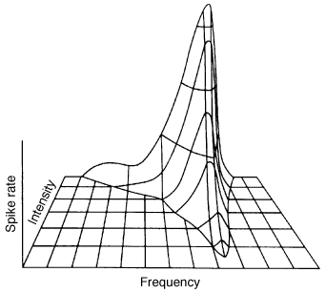  Relation of spike rate in individual auditory axon to sound frequency and intensity.

Auditory pathways retain tonotopic organization – orderly neuron arrangement by frequency sensitivity (analogous to retinotopic, somatotopic organizations); especially prominent in cochlear nuclei but becomes less precise in more rostral structures.
Auditory pathways are bilaterally represented & redundant – CNS lesions very rarely cause deafness (vs. vestibular pathways – highly lateralized system).

Intra-axial Auditory Physiology
Central Auditory Pathways → see p. Ear23a >>

Cochlear Nuclei
- response of individual second-order neurons in cochlear nuclei are like those of individual primary auditory nerve fibers.
- major difference is presence of sharper "cutoff" on low-frequency side in medullary neurons (i.e. greater specificity of second-order neuron to sound frequency).

Primary Auditory Cortex
- low tones are represented anterolaterally and high tones posteromedially in auditory cortex.
- it is pitch and not frequency per se that is coded in auditory cortex (i.e. processing of pure frequencies into pitch occurs at subcortical level).

Other Cortical Areas
- auditory pathways in cortex resemble visual pathways in that there is increasingly complex processing of auditory information along them.
- organized in two general paths (like visual pathways):
  - Dorsal-parietal pathway concerned with sound localization ("where" pathway).
  - Ventral-temporal pathway – sound identification ("what" pathway), including areas where neurons respond selectively to voices (analogous to face-selective areas in visual system).
- cortical lesions may not impair simple frequency discrimination, but impair complex sound features detection (incl. localization in space).
- auditory system is modified by experience and other factors; examples:  - individuals who become deaf before language skills are fully developed, viewing sign language activates auditory association areas outside primary auditory cortex.  - individuals who become blind early in life are demonstrably better at localizing sound than individuals with normal eyesight.  - babies rapidly develop enhanced neuronal responses to sounds unique to their native language after 6 months of age, whereas responses to sounds that are not unique gradually disappear.  - musicians have increased auditory areas activated by musical tones (in addition, violinists have altered somatosensory representation of finger areas; musicians also have larger cerebellums because of learned precise finger movements).  - planum temporale (portion of posterior superior temporal gyrus) is regularly larger in left than in right cerebral hemisphere, particularly in right-handed individuals - involved in language-related auditory processing; asymmetry is even greater, in musicians and others who have perfect pitch. | 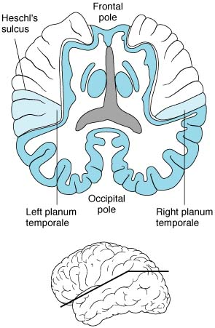  Left and right planum temporale in brain sectioned horizontally along plane of sylvian fissure (shown in insert at bottom).

Masking
- presence of one sound decreases individual's ability to hear other sounds - due to refractoriness (relative or absolute) of previously stimulated auditory receptors and nerve fibers.
- related to sound pitch.
- masking of background noise raises auditory threshold (i.e. because of background noise we hear other sounds less well).

Bibliography for ch. “Otology” → follow this link >>

Viktor’s Notes℠ for the Neurosurgery Resident
Please visit website at www.NeurosurgeryResident.net

