Temporal Bone Anomalies
Last updated: May 11, 2019
Developmental defects 1
External and middle ear 1
Inner ear 1
Tegmen tympani defect 1
Etiology 1
Pathology 1
Clinical Features 2
Diagnosis 2
Treatment 2
Transmastoid repair 2
Middle cranial fossa surgery 2
Case series 4

Developmental defects
External and middle ear
(both are derived from first and second branchial arches and clefts):
- deformity of auricle
- partial or complete atresia of external auditory canal
- ossicular abnormalities
- conduction defects - may be surgically correctable.
- may be accompanied by anterior malposition of facial nerve (CN7 location must be identified preoperatively!).

Atresia of external auditory canal (coronal CT) - external canal is not visible because of bony atresia (white arrow); mastoid segment of CN7 canal (arrowheads) is anteriorly displaced into same plane as vestibule* - very susceptible to injury as atresia plate is surgically removed.
*normally, canal is at level of posterior semicircular canal.
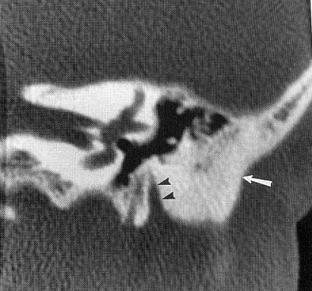

Inner ear
(derived from auditory vesicle) - vary from abnormalities involving solely semicircular canals to complete aplasia of otic capsule.
- sensorineural deafness - not surgically correctable (may be helped by cochlear implants).
- Mondini defect - partial or total absence of cochlear turns.

Mondini’s defect (axial CT) - right cochlear turns are absent except for portion of basal turn (arrowhead); left cochlea was normal:
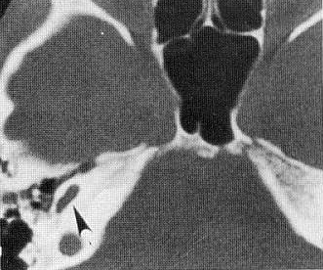
Source of picture: John H. Juhl “Paul and Juhl’s Essentials of Radiologic Imaging”, 7th ed. (1998); Lippincott Williams & Wilkins; ISBN-10: 0-397-58421-0 >>

Tegmen tympani defect
Etiology
- congenital skull base defects
- congenital defects of the tegmen tympani develop ventral to the geniculate ganglion and may be due to incomplete ossification of the tegmental process of the otic capsule.
- inadequate closure of the petrosquamous suture may be a factor as well.
- trauma
- infection (e.g. necrotizing inflammations of the temporal bone in diabetes mellitus)
- tumours
- idiopathic
- iatrogenic cases (after mastoid cavity surgery due to chronic otitis media with or without cholesteatoma)

Pathology
- defects in the tegmen tympani may be accompanied by defects in the overlying dura, with resultant CSF egress or encephalocele (rare; 25% of defects are associated with small meningoceles or meningoencephaloceles).
    - after years of exposure to physiologically normal CSF pressures, these faults may fistulize into the tympanomastoid compartment and predispose to the development of an encephalocele:

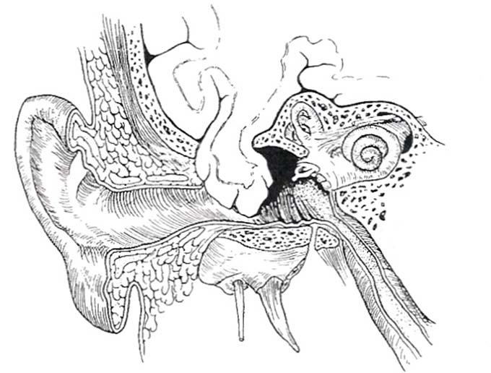

Clinical Features
- CSF otorrhea – otorhinorrhea
- CSF otorrhea can result in hearing impairment and predispose to meningitis (20% of cases have a history of one or more bouts of meningitis).
- seizures or neurological deficits are additional risks, particularly when associated with an encephalocele.

Diagnosis
CT and MRI, as well as testing with fluorescein dye, provide confirming diagnostic data.

Treatment
Three surgical approaches - middle fossa approach, transmastoid approach, combined approach.

Transmastoid repair
- can result in the loss of hearing.
- after any existing meningoceles or meningoencephaloceles have been cauterized or amputated, small grafts of autogenous fascia or cartilage are used to plug defects found.
- area is covered with temporalis fascia graft, reinforced by a pedicled muscle-fascia graft and, if needed to obliterate the mastoid cavity, a free graft of subcutaneous abdominal adipose tissue.

Middle cranial fossa surgery
- risk of epilepsy.
- intraoperative facial nerve monitoring.
- exposure does not need to extend medial to the arcuate eminence and requires less retraction of the temporal lobe.
- fullness of the temporal lobe aids in tightly sealing the tegmen tympani defect; however, the option of lumbar CSF drainage may lessen the degree of temporal lobe retraction and is utilized very effectively in MCF approaches.
- careful elevation of the dura from a posterior-to-anterior direction and complete avoidance of bipolar cautery on the MCF floor are essential to preserve facial nerve function.

Copeland Technique
- curvilinear incision is made beginning in front of the tragus of the ear and ending at the temporoparietal junction.
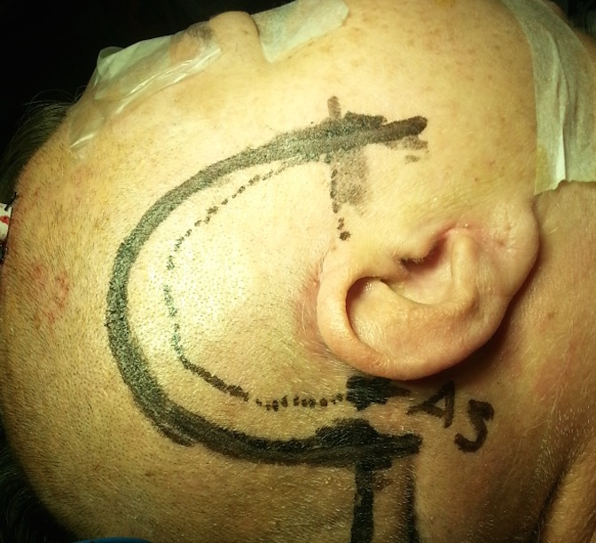

- scalp and pericranium are separated from the temporalis fascia which is harvested for later use.
- temporalis muscle is then released from its bony origin and turned inferiorly to expose the squamous temporal bone, root of the zygoma, and external auditory canal:
1 - posterior root of the zygoma
2 - asterion.
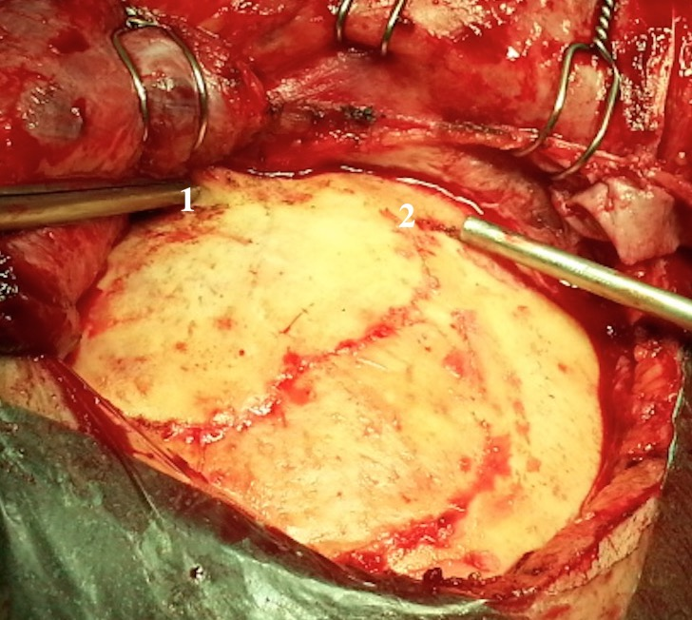

- craniotomy is performed anteriorly and posteriorly to the external auditory meatus and attempts are made to keep the inferior margin flush to the floor of the middle fossa (1 - external auditory meatus):
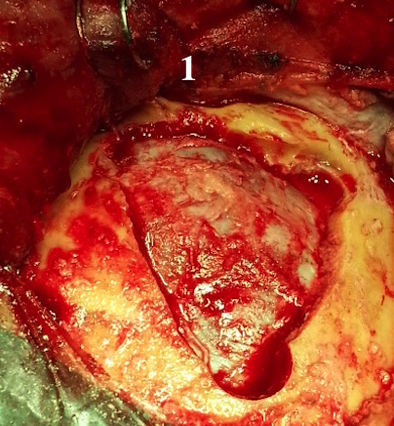

- temporal dura is dissected off the skull base in a posterior to anterior direction to avoid injuring the greater superficial petrosal nerve or dehiscent geniculate ganglion and facial nerve:
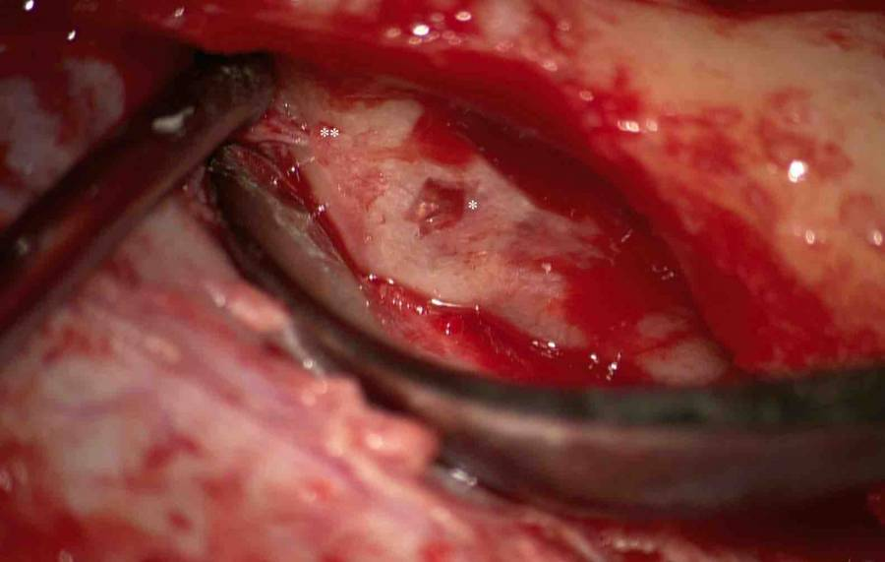
* Defect
** Greater superficial petrosal nerve

- mannitol (0.5 mg/kg IV) is given to assist with atraumatic elevation of the temporal lobe.
- option of a lumbar external drainage system for cerebrospinal fluid release may lessen the degree of temporal lobe retraction.
- encephaloceles are amputated; any obvious encephalocele is carefully removed from the middle ear taking great care not to disarticulate the ossicles
- breaches in the dura are repaired with 5–0 or 6–0 Prolene.
- if dehiscent, the superior semicircular canal is occluded with bone dust and bone wax.
- middle fossa floor is then resurfaced using the fascia-bone-fascia technique:
- generous piece of temporalis fascia is first laid over the tegmen defect(s).
- split-thickness bone graft at least three times the size of the tegmen defect is next harvested from the craniotomy flap; rather than simply placing this over the fascia, however, Copeland et al. modified the technique to include fixing the graft to the inferior edge of the craniotomy margin using a single straight plate and two screws from a craniotomy fixation system
- finally, the remaining temporalis fascia is laid over the secured bone graft, against the native subtemporal dura, completing the fascia-bone-fascia sandwich.
- entire construct is covered with fibrin sealant.
- craniotomy and wound are closed in typical fashion.

Case series
2017
Twenty-six patients the mean age at surgery was 60 ± 14 years and 65% of patients were female. The majority of defects involved both the tegmen mastoideum and tympani (69%); multiple defects were present in 11 patients. Small craniotomy (2 × 3 cm) was performed and defects were repaired using composite grafts constructed with fascia, bone, and/or cartilage, and dural substitute affixed with suture. The suture tail was left long and passed from the middle fossa through the defect into the mastoid. At average follow-up of 8.3 months, no patients of recurrent CSF leak were noted. Significant improvements in both mean pure-tone average and air-bone gap were noted for the entire cohort (p = 0.04 and p = 0.02, respectively).
A combined transmastoid-middle cranial fossa for the repair of lateral skull base CSF fistula and encephaloceles using the suture “pull-through” technique is efficacious and the complication profile is favorable. This method facilitates reliable placement of a composite graft in the center of lateral skull base defects through a small craniotomy that minimizes temporal lobe retraction.
O'Connell BP, Hunter JB, Sweeney AD, Thompson RC, Chambless LB, Wanna GB, Rivas A. Outcomes of the Suture “Pull-through” Technique for Repair of Lateral Skull Base CSF Fistula and Encephaloceles. Otol Neurotol. 2017 Jan 24. doi: 10.1097/MAO.0000000000001321. [Epub ahead of print] PubMed PMID: 28121968.

2014
Twenty-two patients who underwent surgical repair of tegmen defects associated with cerebrospinal fluid (CSF) leakage and/or meningocele/meningoencephalocele by a combined transmastoid/minicraniotomic approach.
A retrospective review of videos of surgery and charts of patients with tegmen tympani or tegmen antri defects and CSF leakage, temporal lobe encephalocele, and/or meningoencephalocele.
All patients underwent the combined approach and had their defects closed, without significant intraoperative or postoperative complications.
Mastoidectomy with temporal minicraniotomy represents an effective approach in patients with tegmen tympani dehiscence; the advantages of this technique are the control of the floor of the middle cranial fossa and the possibility to reach bony defects located anteriorly without manipulation of the ossicular chain and temporal lobe.
Marchioni D, Bonali M, Alicandri-Ciufelli M, Rubini A, Pavesi G, Presutti L. Combined approach for tegmen defects repair in patients with cerebrospinal fluid otorrhea or herniations: our experience. J Neurol Surg B Skull Base. 2014 Aug;75(4):279-87. doi: 10.1055/s-0034-1371524. Epub 2014 May 2. PubMed PMID: 25093152; PubMed Central PMCID: PMC4108494.

2013
8 individuals who presented with CSF otorrhea and MCF encephaloceles associated with conductive hearing loss. Defects in the tegmen tympani were noted in all patients on preoperative cranial imaging, and 6 patients had an associated encephalocele. The average age was 57 years (range 26 to 67) with a male:female ratio of 7:1. Most defects occurred on the left side (6 left/2 right). A standard MCF approach and repair of the dural defect with an autologous dural graft (Durepair or DuraGen, Medtronic, Minneapolis, Minnesota, USA) and a synthetic polymer glue (DuraSeal, Covidien, Mansfield, Massachusetts) was performed in each case with universal success. Resolution of the CSF otorrhea was noted in all cases. All cases but one exhibited an improvement in hearing. Facial nerve monitoring was standard. All patients exhibited normal facial function postoperatively. Prophylactic lumbar drain placement was only utilized in the first three patients. The MCF approach is an excellent route to effectively repair CSF leaks and encephaloceles due to tegmen tympani and dural defects.
Braca JA 3rd, Marzo S, Prabhu VC. Cerebrospinal Fluid Leakage from Tegmen Tympani Defects Repaired via the Middle Cranial Fossa Approach. J Neurol Surg B Skull Base. 2013 Apr;74(2):103-7. doi: 10.1055/s-0033-1333616. Epub 2013 Jan 22. PubMed PMID: 24436896; PubMed Central PMCID: PMC3699214.

2005
11 defects of the tegmen tympani or the mastoidal roof, at least one previous meningitis. Transtemporal approach was also performed in large defects of the tegmen tympani and mastoidal roof as well as in recurrences.
Bryson E, Draf W, Hofmann E, Bockmühl U. [Management of occult malformations at the lateral skull base]. Laryngorhinootologie. 2005 Dec;84(12):921-8. German. PubMed PMID: 16358203.

Bibliography for “Temporal Bone Anomalies” → follow this link >>

Viktor’s Notes℠ for the Neurosurgery Resident
Please visit website at www.NeurosurgeryResident.net

