Retinal Physiology
Last updated: May 9, 2019
Photoreceptor Mechanism 1
Ionic Basis 2
photosensitive compounds 2
Rhodopsin 2
iodopsins 2
Synaptic Mediators in retina 2
Image Formation 3
Color Vision 4
Dark Adaptation 4

- in cones, saccules are formed by infoldings of cell membrane, but in rods, disks are separated from cell membrane.  - fovea contains no rods; each foveal cone has single midget bipolar cell connecting it to single ganglion cell (1 foveal cone → 1 fiber in optic nerve).  - in extrafoveal retina, rods predominate, and there is good deal of convergence (flat bipolar cells make synaptic contact with several cones, and rod bipolar cells make synaptic contact with several rods). | 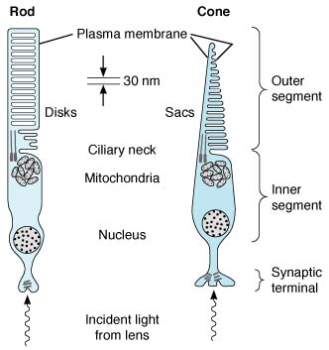
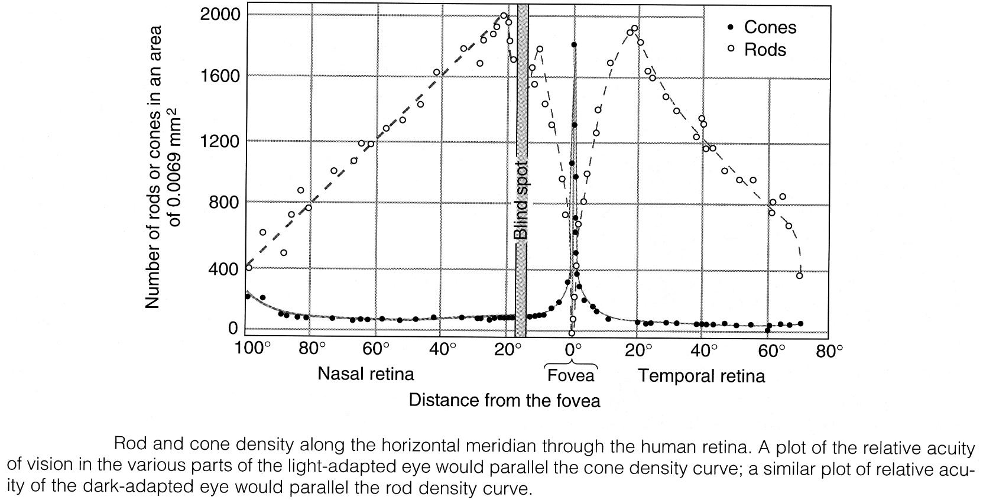
Source of picture: John Bullock, Joseph Boyle III, Michael B. Wang “NMS Physiology”, 4th ed. (2001); Lippincott Williams & Wilkins; ISBN-13: 978-0683306033 >>

- in each human eye - 6 million cones, 120 million rods; only 1.2 million nerve fibers in each optic nerve - overall convergence ≈ 105:1.
- divergence from this point on - twice as many fibers in geniculocalcarine tracts (as in optic nerves), and neuron number in visual cortex is 1000 × fiber number in optic nerves.

 | Cones | Rods
Size | smaller | larger
Threshold | high | exquisitely low
Distribution | ubiquitous (concentrated in fovea) | peripheral retina only (not in fovea)
Convergence | in fovea limited | extensive
Illumination | photopic (daylight) | scotopic (twilight)
Function | central-detail-color vision | peripheral-poor detail-achromatic vision

Photoreceptor Mechanism
- only ganglion cells generate all-or-none action potentials.  - all other cells produce only local, graded potentials:  rods, cones, horizontal cells – hyperpolarizing potentials.  bipolar cells - either hyperpolarizing or depolarizing potentials.  amacrine cells - depolarizing potentials and spikes (may act as generator potentials for propagated spikes produced in ganglion cells).  - cone receptor potential has sharp onset and offset;  rod receptor potential has sharp onset and slow offset.  rod (R) on left is receiving light flash, whereas rod on right is receiving steady, low-intensity illumination. H, horizontal cell; B, bipolar cells; A, amacrine cell; G, ganglion cell. | 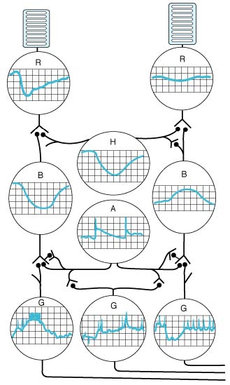
- curves relating receptor potential amplitude to stimulus intensity have similar shapes in rods and cones, but rods are much more sensitive:
    - rod responses are proportionate to stimulus intensity at levels of illumination that are below threshold for cones; rods respond to light entering at any direction (i.e. rods detect absolute illumination).
    - cone responses are proportionate to stimulus intensity at high levels of illumination when rod responses are maximal and cannot change; cones respond only to light entering directly along their axis (i.e. cones generate good responses to changes in light intensity above background but do not represent absolute illumination well).

Ionic Basis
In the dark:  - in outer segments Na⁺ channels are open (held open by cGMP) - current flows from inner to outer segment.  - current also flows to synaptic ending.  - Na⁺-K⁺-ATPase in inner segment maintains ionic equilibrium.  - in the dark, cells are depolarized (– 40 mV) and neurotransmitter release is steady! →→→ ganglion cells fire at constant rate even in the dark!  Light increases conversion of cGMP to 5′-GMP → some Na⁺ channels close → hyperpolarizing receptor potential → reduced neurotransmitter release →→→ change of rate of action potentials in ganglion cells. | 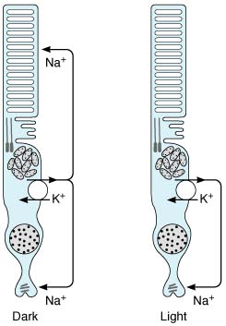

photosensitive compounds
- made up of opsin (protein) and retinene₁ (aldehyde of vitamin A₁).
(retinene₂ is found in eyes of some animal species)
- since retinenes are aldehydes, they are also called retinals (A vitamins are alcohols and are called retinols).

Rhodopsin
- photosensitive pigment in rods.  - opsin is called scotopsin.  - peak sensitivity at 505 nm (wavelengths of visible light range 397-723 nm).  - makes 90% of total protein in rod disks membranes.  - structure - one of many serpentine receptors coupled to G proteins; retinene₁ is parallel to membrane surface. |  |  | 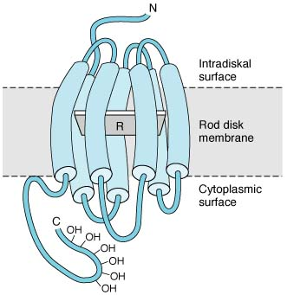
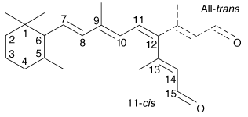 | In the dark, retinene₁ is in 11-cis configuration.  The only action of light is to photoisomerize retinene₁ to all-trans isomer.
- further sequence:  - alteration of scotopsin configuration.  - activation of associated heterotrimeric G protein (transducin, s. G_{t1}).  - transducin exchanges GDP for GTP, and α subunit separates (α subunit remains active until its intrinsic GTPase activity hydrolyzes GTP).  - α subunit activates cGMP phosphodiesterase: cGMP → 5′-GMP.  - cGMP normally maintains Na⁺ channels in open position (cGMP-gated Na⁺ channels), so decline in cytoplasmic cGMP concentration causes some Na⁺ channels to close → hyperpolarizing potential. |  | 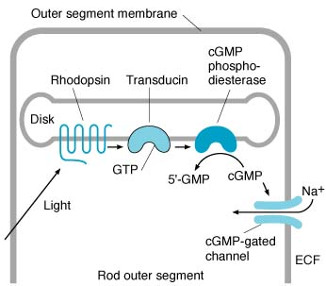
N.B. rod receptors are capable of producing detectable response to as little as one photon of light! – due to cascade amplification.

Rhodopsin regeneration  - all-trans retinene₁ separates from scotopsin (bleaching).  - some of rhodopsin is regenerated directly.  - some of retinene₁ is reduced (by alcohol dehydrogenase in NADH presence) to retinol (vitamin A₁), and this reacts with scotopsin to form rhodopsin.  - all reactions (except of all-trans isomer formation) are independent of light - rhodopsin amount in receptors varies inversely with incident light level! | 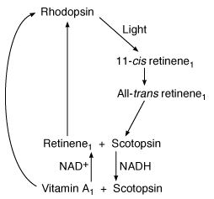

cGMP resynthesis
- light also reduces Ca²⁺ concentration in cells.
- Ca²⁺ concentration decrease:
  - activates guanylyl cyclase.
  - inhibits light-activated cGMP phosphodiesterase.

iodopsins
- photosensitive pigments in cones.
- there are three different kinds of cones - subserve color vision - respond maximally to wavelengths of 440, 535, and 565 nm.
- resemble rhodopsin - each contains retinene₁ and photopsin, spans cone membrane seven times, but has characteristic structure in each type of cone.
N.B. type of photopsin determines wavelength maximally absorbed!
- there are no separate intracellular disks (like in rods).
- responses to light ≈ in rods (G protein differs somewhat from rod transducin - G_{t2}).

Synaptic Mediators in retina
acetylcholine, glutamate, dopamine, serotonin, GABA, glycine, substance P, somatostatin, TRH, GnRH, enkephalins, β-endorphin, CCK, VIP, neurotensin, glucagon.
- kainate receptors - between cones and one type of bipolar cells.
- amacrine cells are the only cells that secrete acetylcholine.
- dopamine is secreted along border between inner nuclear and inner plexiform layers and spreads through retina by diffusion; dopamine affects structure of gap junctions (these allow current to pass freely through horizontal cells in dark - enlarging receptive fields of photoreceptors); light increases dopamine release → horizontal cells decoupling → reduced current flow.

Image Formation
Processing of visual information in retina involves sequential formation of three images:
First image - formed by light action on photoreceptors.
Second image in bipolar cells.
Third image in ganglion cells.
- in formation of second image, signal is altered by horizontal cells, and in formation of third, it is altered by amacrine cells.
- third image reaches occipital cortex (little change in impulse pattern in lateral geniculate bodies).

Inhibitory feedback from one photoreceptor to another mediated via horizontal cells: activation of photoreceptors triggers horizontal cell hyperpolarization, which in turn inhibits response in nearby photoreceptors - lateral inhibition (i.e. activation of particular neural unit is associated with inhibition of activity of nearby units - general phenomenon in mammalian sensory systems - helps to sharpen stimulus edges - improves discrimination).

Receptive field - part of retina whose photoreceptors (rods & cones) pertain to single ganglion cell (optic nerve fiber).
- receptive field is circular; in fovea – only 10 μm ø; in peripheral retina – up to 1 mm ø.
- cones in center of receptive field (field center) convey information directly to ganglion cells (via bipolar cells);  cones at periphery of receptive field (field surround) reach ganglion cell indirectly – via horizontal cells (horizontal cells synapse with axons of field center cones).  - receptive fields are organized into center-surround antagonistic regions.  N.B. rods are not organized into center-surround receptive fields! | 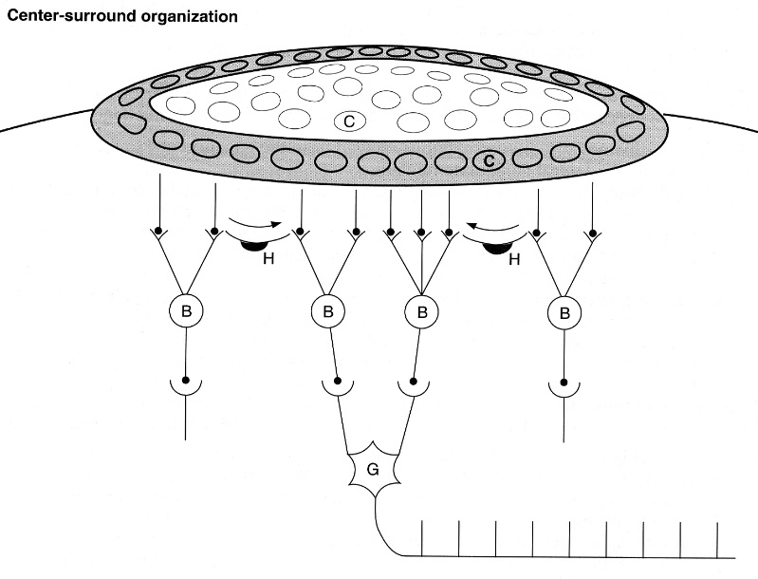
Ganglion cell response to stimulation of its receptive field depends on:
- type of receptive field (“on” or “off” type)
- part of field that is illuminated (center or surround).
“on-center” receptive field is stimulated by light falling at field center* and inhibited by light falling at field surround (via lateral inhibition)**

* glutamate (released by cones at field center) opens cation selective channels in bipolar cells → depolarization of bipolar cells and ↑release of neurotransmitter → ganglion cell firing rate↑

**cones (at field surround) stimulate horizontal cells → horizontal cells release GABA → depolarization of field center cones → hyperpolarization of bipolar cells → ganglion cell firing rate↓
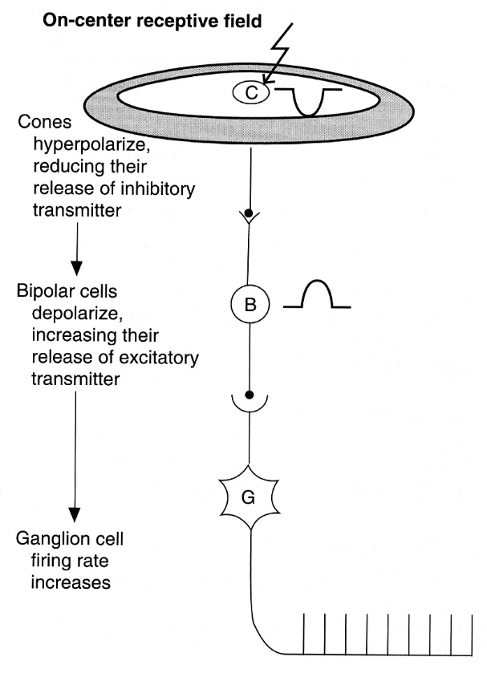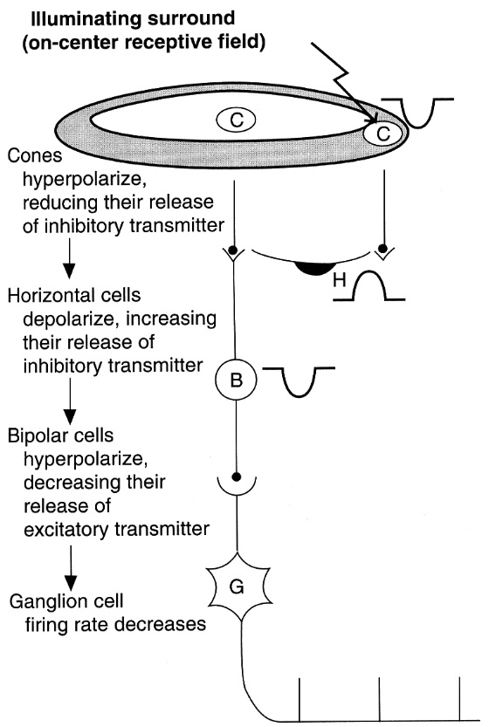
Source of picture: John Bullock, Joseph Boyle III, Michael B. Wang “NMS Physiology”, 4th ed. (2001); Lippincott Williams & Wilkins; ISBN-13: 978-0683306033 >>

“off-center” receptive field reacts in exactly opposite fashion; e.g. glutamate (released by cones at field center) opens K⁺ channels (or closes Na⁺ channels) in bipolar cells → hyperpolarization of bipolar cells and ↓release of neurotransmitter → ganglion cell firing rate↓ | 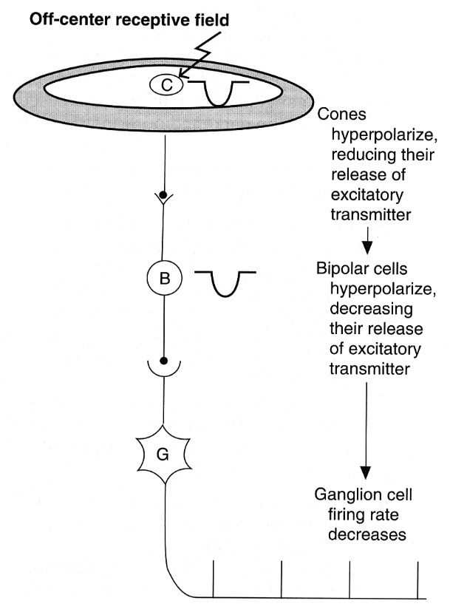
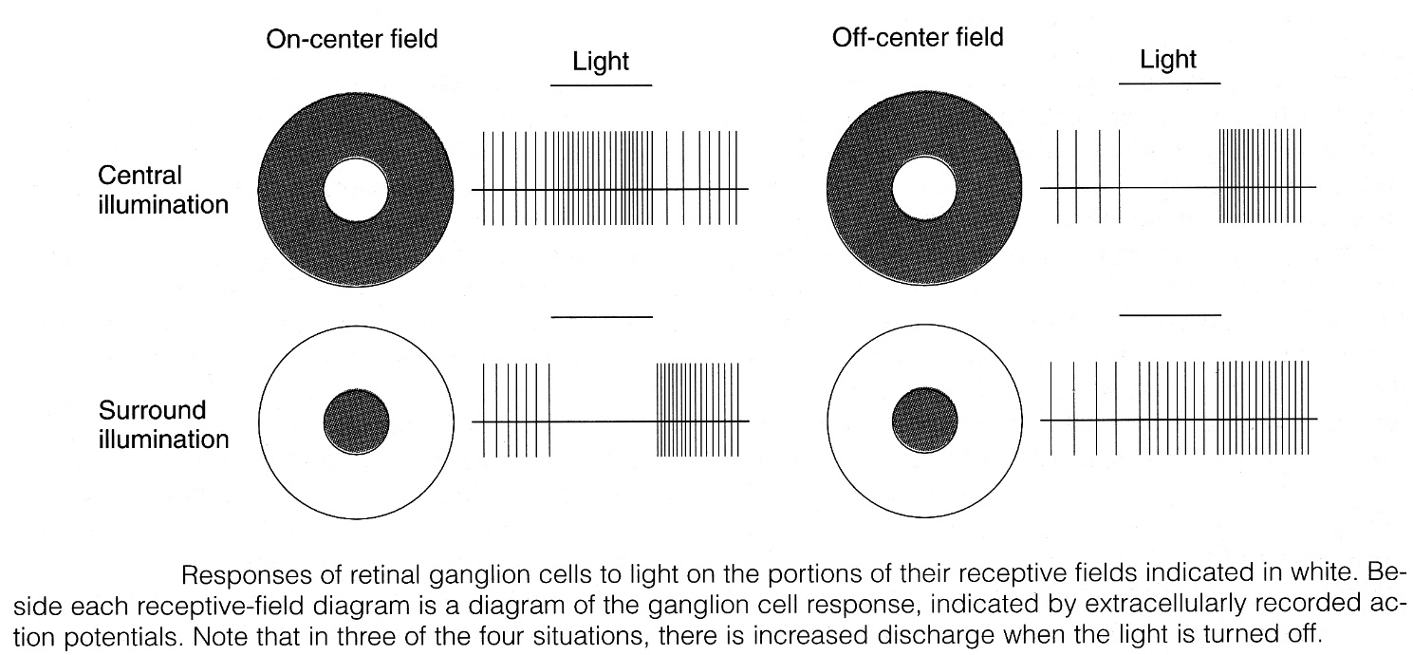
Source of picture: John Bullock, Joseph Boyle III, Michael B. Wang “NMS Physiology”, 4th ed. (2001); Lippincott Williams & Wilkins; ISBN-13: 978-0683306033 >>

- “on” and “off” receptive fields occupy overlapping regions in retina – light striking any retinal region activates both types of receptive fields (light intensity is signaled by difference in firing rates between “on” and “off” receptive fields).  - in either case, net response depends on complex switching action in retina.  - when entire receptive field is equally illuminated, it has little or no effect on ganglion cell firing: | 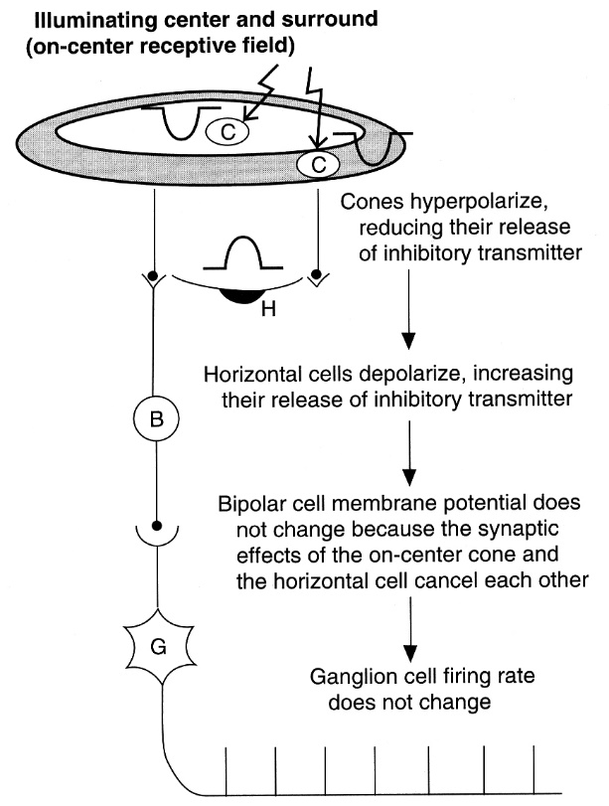

Color Vision
- colors have three attributes: hue, intensity, saturation (degree of freedom from dilution with white).
- for any color there is complementary color that, when properly mixed with it, produces sensation of white.
- black is sensation produced by light absence, but it is positive sensation (blind eye does not "see black" it "sees nothing").
- white or any spectral color can be produced by mixing various proportions of red light (723-647 nm), green light (575-492 nm), and blue light (492-450 nm).
Red, green, and blue are primary colors
- color perceived depends in part on background color.

Young-Helmholtz theory - three kinds of cones exist - each containing different photopigment (maximally sensitive to one of three primary colors).
S pigment (blue-sensitive or short-wave pigment) absorbs maximally blue-violet light (peak 440 nm).  M pigment (green-sensitive or middle-wave pigment) absorbs maximally green light (peak 535 nm).  L pigment (red-sensitive or long-wave pigment) absorbs maximally yellow light (peak 565 nm), but sensitive enough in red portion of spectrum. | 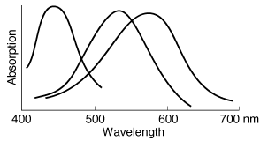
there is variation in L pigment (62% normal individuals have Ser at site 180, whereas 38% have Ala – different absorption peaks).

- rhodopsin gene is on chromosome 3.
- S pigment gene is on chromosome 7.
- M pigment and L pigment genes are arranged in tandem on Xq chromosome (their opsins show 96% homology of amino acid sequences).
- many mammals are dichromats (have only two cone pigments), but humans are trichromats.

Dark Adaptation

When one passes from brightly lighted to dim environment, retinas slowly become more sensitive to light (visual threshold↓) - dark adaptation.  - maximal in 20 minutes (some further decline possible over longer periods).  - persons who need maximal visual sensitivity in dim light (e.g. radiologists, aircraft pilots) can avoid having to wait 20 minutes to become dark-adapted if they wear red glasses when in bright light (red light stimulates rods to only slight degree).  When one passes suddenly from near darkness to bright sunlight (light intensity increases by 10 log units, i.e. by factor of 10 billion), light seems uncomfortably bright until eyes adapt (visual threshold rises) – light adaptation.  - occurs over 5 minutes.  - strictly speaking, it is merely disappearance of dark adaptation.  - another mechanism - pupil diameter↓ - when it reduces from 8 to 2 mm, its area decreases by factor of 16 and light intensity is reduced by > 1 log unit. | 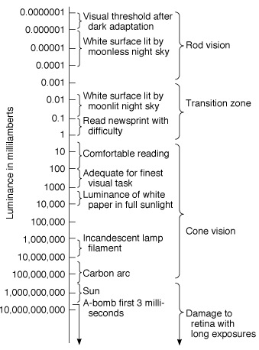

Components to dark adaptation:  - first drop in visual threshold (rapid but small in magnitude) - adaptation of cones.  - further drop occurs as result of adaptation of rods (mainly – rebuilding rhodopsin stores). | 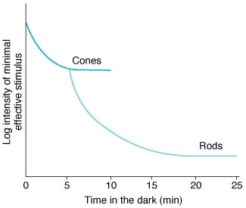

Bibliography for ch. “Ophthalmology” → follow this link >>

Viktor’s Notes℠ for the Neurosurgery Resident
Please visit website at www.NeurosurgeryResident.net

