Visual Pathways and Cortex
Last updated: May 9, 2019
Primary Visual Cortex (V1, area 17, striate cortex) 1
Other Cortical Areas Concerned With Vision 2
Visual Perception 2

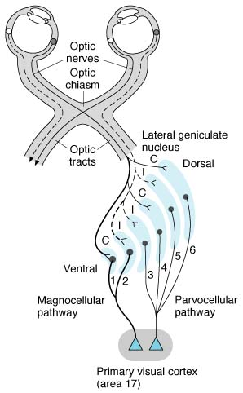 | - lateral geniculate body contains six well-defined layers:  layers 1-2 have large cells and are called magnocellular;  layers 3-6 have small cells and are called parvocellular.  - layers 1, 4, 6 receive input from contralateral eye;  layers 2, 3, 5 receive input from ipsilateral eye.  - only 10-20% input to lateral geniculate nucleus comes from retina!;  there is major feedback input from visual cortex - visual processing related to perception of orientation and motion.

- two kinds of ganglion cells exist in retina:
large ganglion cells (M cells) - add responses from different kinds of cones - are concerned with movement, stereopsis, flicker; project to magnocellular portion;
small ganglion cells (P cells) - subtract input from one type of cone from input from another - concerned with color, texture, shape, fine detail; project to parvocellular portion.
- interlaminar region (of lateral geniculate) receives input from P ganglion cells (via dendrites of interlaminar cells that penetrate parvocellular layers); intralaminar region projects (via separate component) to blobs in visual cortex. | 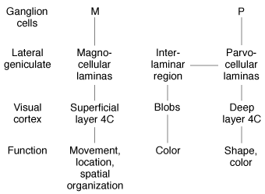

Primary Visual Cortex (V1, area 17, striate cortex)
- visual cortex has six layers (like rest of neocortex).
- there are many nerve cells associated with each fiber.
- magnocellular and parvocellular pathways end in layer 4 (in its deepest part, layer 4C).
thick, light-colored layer 4 is visible to naked eye and has been termed line of Gennari’s (it is particularly well developed outer line of Baillarger’s; composed largely of tangentially disposed intracortical association fibers)
- axons from interlaminar region end in layers 2 and 3 - contain blobs - clusters of cells (≈ 0.2 mm in diameter) that contain high concentration of mitochondrial cytochrome oxidase - concerned with color vision.
- like ganglion cells, lateral geniculate neurons and neurons in layer 4 respond to stimuli in their receptive fields with “on” centers and inhibitory surrounds or “off” centers and excitatory surrounds.
- responses of neurons in other visual cortex layers are strikingly different:
simple cells - respond to bars of light, lines, or edges, but only when they have particular orientation.
complex cells - respond maximally when linear stimulus is moved laterally without change in its orientation.
simple and complex cells have been called feature detectors because they respond to and analyze certain stimulus features.
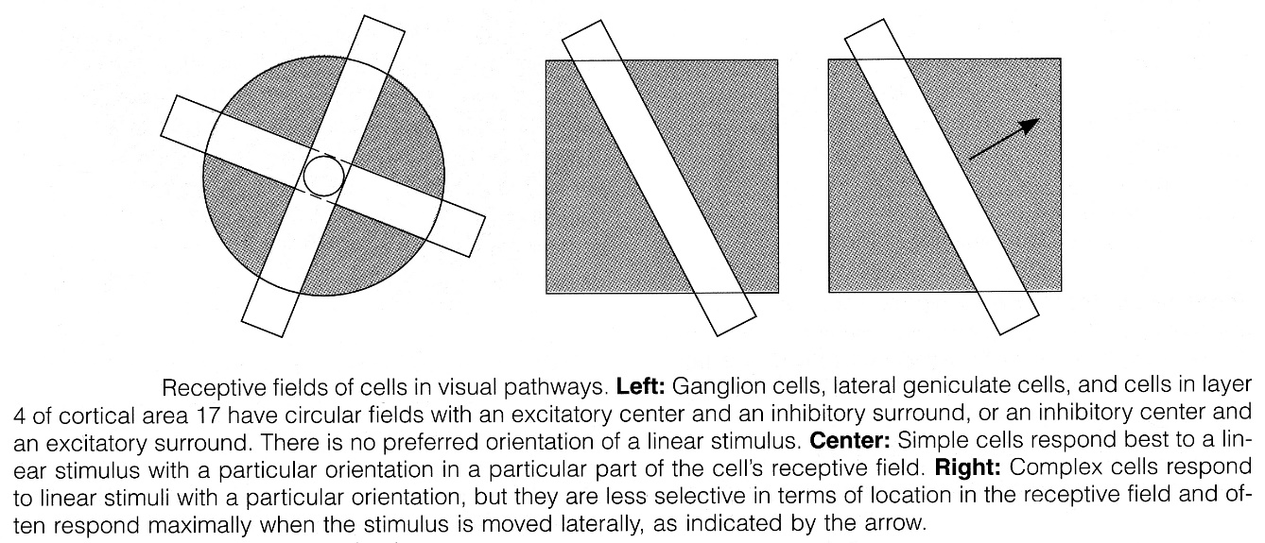
Source of picture: John Bullock, Joseph Boyle III, Michael B. Wang “NMS Physiology”, 4th ed. (2001); Lippincott Williams & Wilkins; ISBN-13: 978-0683306033 >>

- visual cortex (like somatosensory cortex), is arranged in vertical columns that are concerned with orientation (orientation columns); each column is ≈ 1 mm in diameter.
- orientation preferences of neighboring columns differ in systematic way - as one moves from column to column across cortex, there are sequential changes in orientation preference of 5-10° - for each ganglion cell receptive field, there is collection of columns (in small area of visual cortex) representing possible preferred orientations at small intervals throughout full 360° (i.e. lines of any angle at any point on retina are decoded by specific column in cortex).
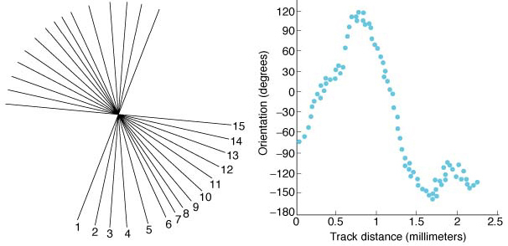
Left: Orientation preferences of 15 neurons encountered as microelectrode penetrates visual cortex obliquely; preferred orientation changes steadily in counterclockwise direction.
Right: Results of similar experiment plotted against distance traveled by electrode; there are number of reversals in rotation direction.

Ocular dominance columns  - geniculate cells and layer 4 cells receive input from only one eye.  - in layer 4, cells receiving input from one eye alternate with cells receiving input from other eye – in vivid pattern of stripes (dark stripes represent one eye, light stripes the other):  - in other layers: ≈ half simple and complex cells receive input from both eyes by differing degree (i.e. between cells to which input is totally from ipsilateral or contralateral eye, there is spectrum of cells influenced to different degrees by both eyes). | 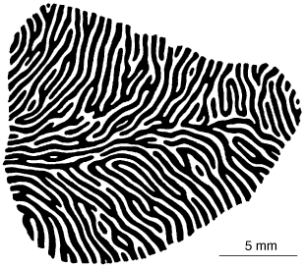

Primary visual cortex segregates information about color from that concerned with form and movement, combines input from two eyes, and converts visual world into short line segments of various orientations.

- bilateral destruction of occipital cortex causes subjective blindness (e.g. pupillary reflex is intact); however, there is appreciable blindsight (residual responses to visual stimuli even though they do not reach consciousness); e.g. when these individuals are asked to guess where stimulus is located during perimetry, they respond with much more accuracy than can be explained by chance.

Other Cortical Areas Concerned With Vision
- primary visual cortex (V1) projects to many other parts of brain (identified by number [V2, V3, etc] or by letters [LO, MT, etc]).
- visual projections from V1 can be divided roughly into:
dorsal (parietal) pathway - concerned primarily with spatial orientation ("where"), motion; extension of magnocellular pathway; parietal lobe is devoted to directed attention.
ventral (temporal) pathway - concerned with object recognition ("what") - shape and recognition of forms and faces; represents continuation of parvocellular pathway.
- V8 is uniquely concerned with color vision.

V1 (primary visual cortex) – begins processing in terms of orientation, edges, etc.
V2, V3, VP – continued processing, larger visual fields
V3A – motion
V4v – unknown
MT/V5 – motion; put to control of movement
LO – recognition of large objects
V7 – unknown
V8 – color vision.

There is parallel processing of visual information along multiple paths; eventually all information is pulled together into what we experience as conscious visual image.

Visual Perception
Intensity
- encoded by firing rate of ganglion cells
- at very low light levels, only rods are active.
- at high light levels, only cones are involved; overall responses are attenuated by receptive field phenomena (“on” & “off”).

contrast – is encoded when one ganglion cell is stimulated and its neighbor is inhibited; depends on receptive field phenomena (“on” & “off”):
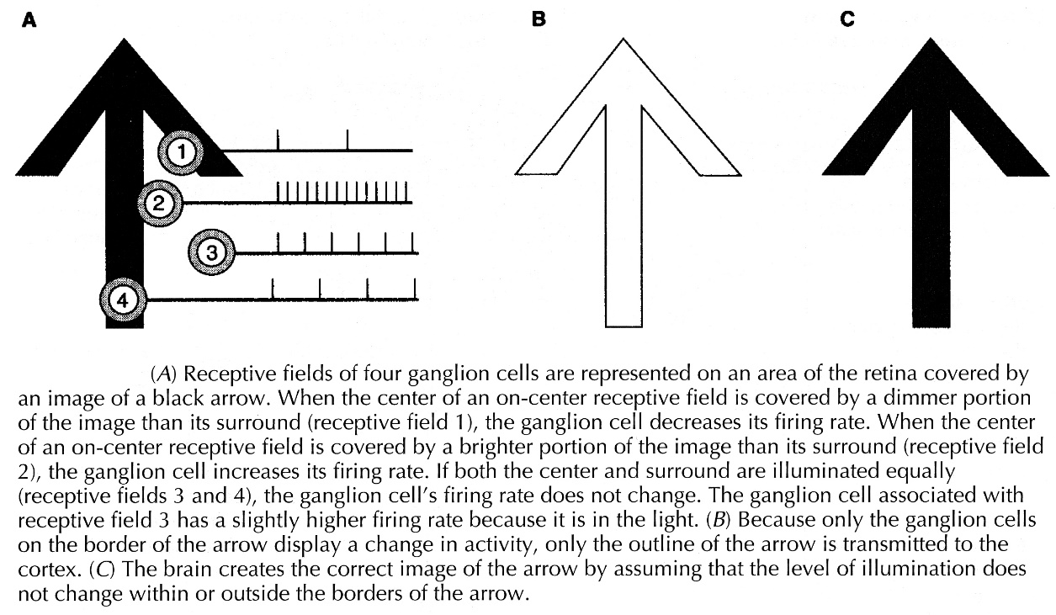
Source of picture: John Bullock, Joseph Boyle III, Michael B. Wang “NMS Physiology”, 4th ed. (2001); Lippincott Williams & Wilkins; ISBN-13: 978-0683306033 >>

form (shape)
- information about form is decoded in orientation columns (in visual cortex).

depth
- information about depth is decoded in ocular dominance columns (in secondary visual cortex, areas 18-19).

Color
- color is mediated by ganglion cells that subtract / add input from one type of cone to input from another type.
- three neural pathways project to V1:
red-green pathway - differences between L-cone (red) and M-cone (green) responses;
blue-yellow pathway - differences between S-cone (blue) and sum of L-cone and M-cone (red + green = yellow) responses;
luminance pathway - sum of L-cone (red) and M-cone (green) responses.
- these pathways project to V1 (blobs & layer 4C) → V8.
- magnocellular (M) pathway is not involved in color vision!

Bibliography for ch. “Ophthalmology” → follow this link >>

Viktor’s Notes℠ for the Neurosurgery Resident
Please visit website at www.NeurosurgeryResident.net

