Gaze and Autonomic Innervation Disorders
Last updated: May 9, 2019
Pupillary Syndromes 1
Anisocoria 1
Benign / Non-neurologic Anisocoria 1
Ocular Parasympathetic Syndrome, Preganglionic 1
Ocular Parasympathetic Syndrome, Postganglionic 2
Horner Syndrome 2
Etiology of Horner syndrome 2
Localizing Tests 2
Diagnosis 3
Flow diagram for workup of anisocoria 3
Light-Near Dissociation 3
Bilateral Fixed (Unreactive) Pupils 3
Ocular Misalignment Syndromes 4
Diplopia 5
Heterotropia (diplopia), heterophoria testing 5
N. Oculomotorius (CN3) 8
Clinical Features 8
Etiology 8
N. Trochlearis (CN4) 9
N. Abducens (CN6) 9
MLF Syndromes 10
Conjugate Gaze Disorders 11
Saccade system 11
Opsoclonus 12
Ocular flutter 12
Smooth pursuit system 12
Vertical gaze 12
Vestibulo-ocular System 13
Nystagmus Syndromes 14
Types of spontaneous nystagmus 14
Oculomotor Examination – see p. D1eye >>, p. Eye60 >>

external ophthalmoplegia - dysfunction of extraocular muscles, levator palpebrae muscle.
internal ophthalmoplegia - dysfunction of pupillary sphincter muscle, ciliary muscle.

Pupillary Syndromes
Anisocoria
- if anisocoria is < 1 mm and remains the same in both light and dark and if the pupils are round and reactive – physiologic anisocoria.
- anisocoria greater in dark – Horner syndrome.
- anisocoria greater in light – ocular parasympathetic disease.

N.B. even if one eye is completely blind, pupil sizes should be equal (unless iris trauma!).
N.B. because both oculosympathetic and oculomotor (parasympathetic) innervation participates in lid elevation, ptosis, if present, generally indicates abnormal eye.

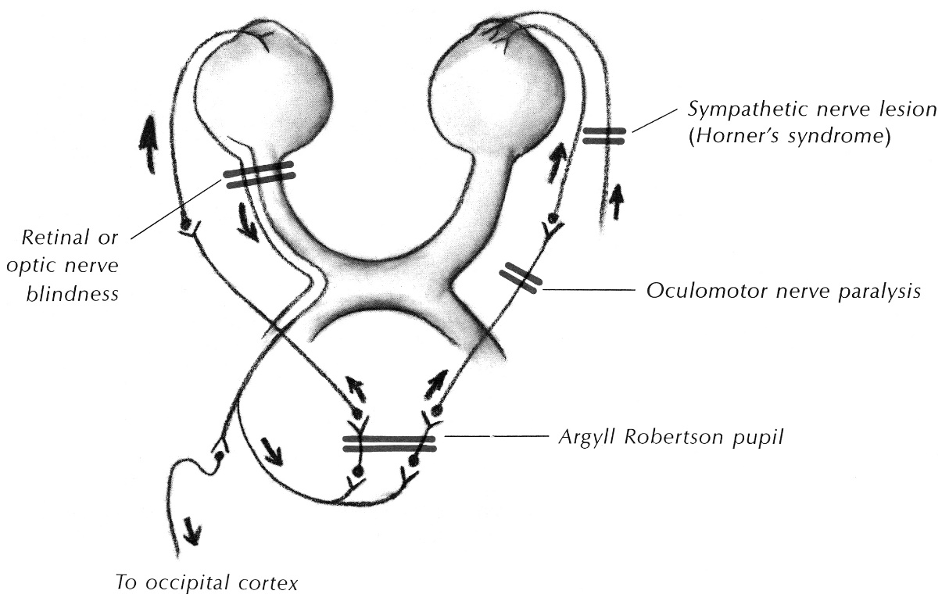

Benign / Non-neurologic Anisocoria
20% of population has anisocoria (of at least 0.4 mm in dim light) – it is neurologically insignificant anisocoria:
- simple anisocoria (s. see-saw anisocoria, essential anisocoria, physiologic anisocoria, simple-central anisocoria) - common benign pupil inequality that may change from one hour to the next.
- consensual response weaker than direct response (i.e. illuminated pupil is smaller one) – due to selective dysfunction of intercalated neuron that connects midbrain pretectal nuclei and Edinger-Westphal subnucleus.
- hippus (pupillary unrest) – normal intermittent pupillary dilation & constriction, independent of illumination, convergence, or psychic stimuli.
- with age, pupils normally become smaller (maximal pupil diameter decreases at ≈ 0.5 mm per decade).

Other anisocoria causes:
Iris damage – trauma, surgery, previous inflammation or uveitis.
Pharmacologically dilated pupil (does not constrict to pilocarpine 1% solution!!!).

Ocular Parasympathetic Syndrome, Preganglionic
CN3 dysfunction → ipsilateral fixed mydriasis (no reaction to light / accommodation).
N.B. anisocoria is greater in bright light (larger pupil is abnormal); vs. sympathetic dysfunction.
- extra-axial compression (e.g. PComA aneurysm*, temporal lobe herniation**) frequently involves pupillary sphincter because pupillomotor fibers are arranged on nerve outside.
*patient is conscious
**patient is unconscious
- pupillary function is often spared with ischemic lesions (mainly affect central core of nerve).
- rarely cause is intrinsic midbrain lesion.

Fixed mydriasis in comatose patient → see p. S30 >>

Ocular Parasympathetic Syndrome, Postganglionic
Damage to ciliary ganglion / long posterior ciliary nerves → Holmes-Adie (myotonic) pupil – moderately dilated, regular, 80% unilateral:
- reacts very little to light (but may contract slowly if light stimulus is maintained for up to 30-40 seconds);
- normal reaction to accommodation (wait & watch carefully – eventually constricts more than normal pupil) - light-near dissociation.
- redilatation after stimulus is also very slow.
- diluted muscarinic agonists (e.g. 2.5% methylcholine, 0.1% pilocarpine) → hypersensitive constrictor response (denervation hypersensitivity).
- axons degenerate one by one, producing segmental paralysis of progressively more iris segments (iris examination under magnification allows to perceive segmental loss of constriction around pupil margin and vermiform iris movements often are visible); after period of time, all sectors become involved → pupil becomes fixed at small diameter with paretic accommodation (blurred vision); condition is permanent.

Holmes-Adie syndrome
- idiopathic degeneration of spinal root & ciliary ganglia → Holmes-Adie pupil + patchy or generalized loss of deep tendon reflexes.
- no important sensory or motor defect apart from areflexia.
- most commonly in young women; sudden onset.

Horner Syndrome
Horner syndrome – lesion of sympathetic supply to face (posterolateral hypothalamus ÷ brainstem ÷ cervical spinal cord up to Th₂ ÷ cervical sympathetic chain ÷ pathways on internal carotid artery to orbit) → ipsilateral:
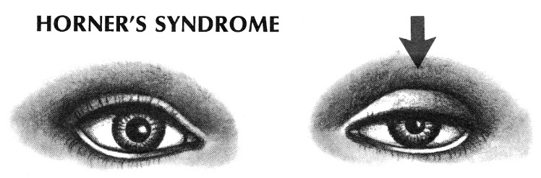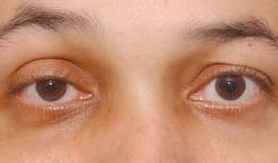

- Weakness of pupillodilator → miosis
  - anisocoria is greater in dim light (small pupil is abnormal) - under usual clinical testing conditions, pupillary reaction to light remains normal.
  - in congenital Horner's syndrome, iris does not become pigmented and remains blue-gray.

- Weakness of Müller’s smooth muscle in lids:
upper lid → mild ptosis (can be overcome by asking patient to look up).
lower lid → mild elevation (inverse ptosis).
  - both MRD₁ & MRD₂ ↓
  - this contributes to illusion that eye is displaced backward (enophthalmos).
  - because Müller’s smooth muscles work in opposition to orbicularis oculi muscle, it is sometimes difficult to distinguish – is it one side with sympathetic dysfunction or is it other side with facial nerve dysfunction. H: cocaine test.

- Disrupted sympathetic fibers serving skin → altered vasomotor tone (flushing) and decreased sweating (anhydrosis); according to lesion level anhydrosis affects:
    - central, first-order neurons → ipsilateral body
    - second-order neurons → ipsilateral face
    - postganglionic fibers → ipsilateral area just above brow
      - these fibers travel with internal carotid plexus → nasociliary branch of ophthalmic nerve.
      - sympathetic fibers to lower face skin travel with branches of external carotid artery after leaving sympathetic paravertebral chain near skull base.

Etiology of Horner syndrome
I. Central lesions involving hypothalamo-spinal pathways (reticulospinal tract) at dorsolateral brain stem tegmentum:
Wallenberg lateral medullary syndrome (occlusion of posterior inferior cerebellar artery) - ocular sympathetic palsy + ipsilateral facial numbness, contralateral pain and temperature loss in extremities, vertigo, dysphagia, dysarthria. see p. A59 >>

II. Preganglionic lesions:
  - Pancoast tumor (malignancy in neck or next to lung apex) → compression of sympathetic chain.
  - trauma (e.g. penetrating neck wounds).
  - suppurative infections and granulomatous diseases in cervical lymph nodes (e.g. sarcoidosis, tuberculosis).

III. Postganglionic lesions at level of internal carotid plexus (no facial anhidrosis - pupillodilator and sudomotor axons follow separate paths along branches of internal and external carotid arteries, respectively):
- Raeder paratrigeminal syndrome - mass lesions in middle cranial fossa involving carotid sympathetic plexus, near Meckel cave → postganglionic Horner syndrome, trigeminal neuralgia.
- Raeder paratrigeminal syndrome, type II - ocular sympathetic dysfunction during episodic pain (retrobulbar and orbital) that is typical of cluster headache (migraine variant); sympathetic fibers are affected by carotid artery wall edema.
- carotid artery dissection (accompanied by acute ipsilateral facial or neck pain).
- atherosclerotic disease affecting vasa nervorum originating in carotid artery (most common cause of Horner's syndrome!).

Localizing Tests
- local instillation of drugs that affect sympathetic neurotransmission in pupil:
5-10% cocaine test - 1 drop into each eye
- cocaine blocks norepinephrine reuptake.
- abnormal miotic pupil will not dilate (lack of normal sympathetic fibers) - within 40-60 minutes, anisocoria will increase (postcocaine anisocoria > 0.8 mm is sufficient to diagnose Horner syndrome).
- antihypertensive medications may prevent cocaine pupillary dilatation.
- positive test indicates lesion anywhere in sympathetic pathway.

1% hydroxyamphetamine test - 1 drop into each eye (> 24-48 hours must be passed from cocaine test!)
- causes release of norepinephrine stores in postganglionic nerve terminals.
- pupil will not dilate (to extent of normal eye) in postganglionic lesion.
- in preganglionic lesion, drug will dilate abnormal pupil as well as normal side.

1% phenylephrine test
- direct α-agonist that in low concentration (1%) dilates pupil only in postganglionic lesion (denervation hypersensitivity of pupil).

Diagnosis
MRI of pulmonary apices and paracervical area.

Flow diagram for workup of anisocoria
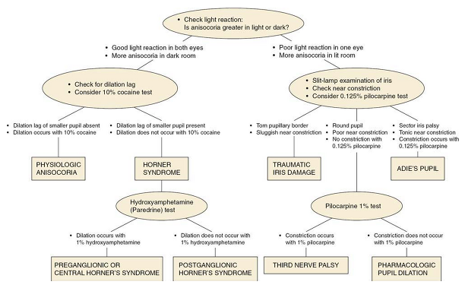

Light-Near Dissociation
Argyll Robertson pupil - bilateral:
    - miosis (pupils are small, irregular)
    - unreactive to light
    - reacts to accommodation.

Variants and Etiology:
- input failure (most common cause!) – due to bilateral visual afferent lesions (up to optic tract) – false light-near dissociation!
- output failure:
diabetes mellitus (peripheral neuropathies);
neurosyphilis (mechanism remains unknown);
Holmes-Adie pupil;
Fisher syndrome (variant of acute idiopathic demyelinating polyradiculopathy - ophthalmoplegia, ataxia, and areflexia);
midbrain lesions (e.g. Parinaud syndrome) - generally pupil is large (vs. classic description of Argyll Robertson).

Inverse Argyll Robertson pupil – unreactive to accommodation, reacts to light - due to damage to Perlia nucleus (part of CN3 nuclear complex; integrator for convergence).

Bilateral Fixed (Unreactive) Pupils
- failure of both pupils to react to both light and near stimuli
N.B. absent response must be confirmed with magnifying lens (esp. < 2 mm pupils)!
Constricted pupils:
- pons lesion (in comatose patient) – damaged sympathetic innervation descending via brainstem; pupils react to light but this is visible only through magnifying glass.
- drugs:
- cholinergics [e.g. pilocarpine for glaucoma], most sedatives [e.g. barbiturates, clonidine, phenothiazines] (antagonize sympathetic outflow at hypothalamic level)
- opioids (antagonize sympathetic outflow + stimulate parasympathetic system → extremely small “pinpoint” pupils).

Dilated pupils:
- drugs (anticholinergics, barbiturates, cocaine), pharmacological mydriasis (iatrogenic or self-administered) - pupils won’t constrict to 1-4% pilocarpine.
- (post)seizure
- hypothermia
- diffuse anoxia-ischemia (bad prognosis).

Pupils in midposition (4-6 mm diameter) - dorsal or rostral midbrain lesions (in comatose patient) – damage to Edinger-Westphal nucleus & origins of CN3 + descending sympathetic efferent fibers;
  - pupils constrict to 1-4% pilocarpine.
  - ominous finding! - area is adjacent to superior pole of midbrain reticular formation - unless etiology can be reversed quickly, patient's coma is usually irreversible.
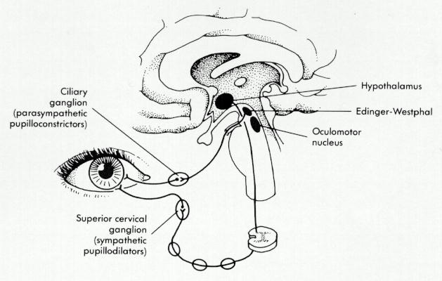

Ocular Misalignment Syndromes
Misalignment of visual axes → binocular double vision (diplopia).
- ischemic, inflammatory, malignant causes tend to be associated with pain in ipsilateral eye or orbit, with wide radiation (to brow, frontal, temporal regions, into cheek and even to mandible).
N.B. not infrequently, intraorbital lesions, even malignant ones, can involve cranial nerves without pain (pain absence ≠ lesion is benign).

Tropia - deviation of visual axes during binocular vision → binocular fusion is lost → diplopia.
Phoria - latent eye deviation or deviation when one eye is covered (phoria is suppressed by fusion stimuli during binocular vision).

Orthotropia – normal eye position.
Heterotropia (s. strabismus, squint) – abnormal alignment of visual axes:
esotropia – eyes converge
exotropia – eyes diverge
hypertropia – one eye is higher than other; skew deviation – eyes move in opposite directions equally.
Magendie-Hertwig sign – skew deviation in acute cerebellar lesions.

Orthophoria – normal binocular fixation in absence of fusion stimulus.
Heterophoria – tendency for eye deviation from parallelism, prevented by binocular vision (so asymptomatic under normal conditions).

Paralytic (nonconcomitant*) heterotropia - paralysis of one or more ocular muscles (due to innervation or mechanical problem).
*diplopia increases in fields of action of paralyzed muscles.
    - eye motion is limited.
    - horizontal nonconcomitant heterotropias can be further subclassified according to gaze direction (up or down) where divergence is greater:
V-pattern esotropia - esodeviation with greater esotropia in downgaze.
V-pattern exotropia - exodeviation with greater exotropia in upgaze.
A-pattern esotropia - esodeviation with greater esotropia in upgaze.
A-pattern exotropia - exodeviation with greater exotropia in downgaze.

Nonparalytic (concomitant*) heterotropia - unequal ocular muscle tone due to supranuclear abnormality (e.g. Parinaud midbrain syndrome); eye disuse (e.g. severe refractive error, impaired vision due to disease) may also result in nonparalytic strabismus.
*diplopia does not vary with ocular movements (i.e. malalignment of visual axes is equal in all directions of gaze).
    - function of individual muscles is intact (unless secondary contraction occurs) – range of eye movements is full.
    - nonparalytic strabismus usually starts in childhood (esotropia is commonest type) and may be not constant; constant squint risks amblyopia!
N.B. heterophoria is also nonparalytic condition (muscular imbalance).

Etiology of oculomotor dysfunction:
      - Thyroid orbitopathy - most common disease to affect ocular motility! (also causes compressive optic neuropathy).
      - Ischemic microvascular disorders (cause large proportion of cranial mononeuropathies) - arteriosclerotic disease (e.g. diabetes, hypertension), collagen vascular diseases (e.g. periarteritis nodosa SLE).
N.B. diabetic infarction is one of commonest causes of isolated mononeuritis! (spontaneous complete recovery after ≈ 6 weeks is virtually rule).
      - Cavernous sinus syndrome - often involves CN 3, 4, 5_{1,2} , 6.
  - inflammatory diseases of unknown etiology
  - aneurysms of internal carotid artery siphon
  - carotid artery and dural branch-cavernous sinus fistula
  - tumors (e.g. meningiomas of medial sphenoid ridge, pituitary tumors expanding laterally).
  - mucocele of sphenoid and ethmoid sinuses
  - Tolosa-Hunt syndrome - granulomatous (e.g. sarcoidosis) or primarily lymphocytic inflammation in cavernous sinus & superior orbital fissure.
manifest primarily by painful ophthalmoplegia that improves with steroid treatment (differentiate from malignant lymphomas, which may also respond transiently to steroid administration!).
      - Orbital syndrome:
- orbital tumor
- orbital wall fracture
- disorders with pathology identical to Tolosa-Hunt syndrome:
orbital inflammatory pseudotumor - when collagenous tissues & fat are primarily involved;
orbital myositis - when extraocular muscles are primarily involved (muscle swelling seen on orbital CT).
- eye is painful.
- mechanical limitation of ocular motility.
- proptosis (or enophthalmos in case of fracture) with resistance to retropulsion.
- vascular congestion.
- eyelid abnormality other than ptosis (e.g. retraction, lid-lag, swelling).

      - Myasthenia gravis - looks like “pupil-sparing CN3 palsy”; in general, can imitate almost all cranial nerve palsies, including internuclear ophthalmoplegia.

      - Chronic progressive external ophthalmoplegia, s. ocular myopathy - most frequent manifestation of mitochondrial myopathies.
N.B. fraction of mitochondrial volume in extraocular muscles is several times greater than that of any other skeletal muscle!
- autosomal dominant inheritance (localized to both 10q22-23 and 3ql4-21) with onset at age > 20 yrs.
- nuclear gene defect somehow leads to communication errors between nuclear and mitochondrial genomes → multiple mitochondrial deletions as mtDNA replicates;
- mtDNA deletions increase over time; when reach critical number, clinical symptoms develop.
- slowly progressive bilateral symmetrical* paralysis (ciliary and iris muscles are not involved); starts with ptosis; ends with complete paralysis. * no diplopia!
- no variability during day (vs. myasthenia gravis).
- muscle biopsy is still definitive test - characteristic ragged red fibers. see p. D30 >>

If sporadic with onset < 20 yrs. - may be part of Kearns-Sayre syndrome caused by single mitochondrial deletion. see p. Met5 >>

      - Many drugs can be associated with diplopia, particularly at toxic levels (e.g. carbamazepine, phenytoin).

If more than one of cranial nerves is affected, lesion is probably in cavernous sinus, superior orbital fissure, or orbital apex!

Diplopia
- seeing two separate images of the same object.
binocular diplopia - results from misalignment of visual axes (disappears when either eye is covered).
N.B. at minimal angles of binocular divergence, patient often describes visual experience as “blur that clears on covering either eye”.
N.B. if strabismus is congenital, diplopia is not present - due to cortical suppression of image in deviating eye (amblyopia ex anopsia, s. suppression amblyopia) to avoid confusion and diplopia; amblyopia does not develop in adults!
- angle of deviation between eyes (and consequent distance between two images):
- progressive - compressive lesions, degenerative conditions.
- stationary or remitting - inflammatory diseases, ischemic causes.
- if developing ptosis (e.g. progressing CN3 palsy, end of day in myasthenia gravis) occludes visual axis → patient reports diplopia “improvement”.

monocular diplopia (persists when opposite eye is covered):
  - irregularities of eye refractive media (mostly crystalline lens [early cataract] or cornea) - images are split within eye and fall on two retinal places of that eye; diplopia improves / disappears with pinhole.
  - retina deformity in or near macula - two or more sets of photoreceptors are activated simultaneously.
  - cerebral form (lesions in nondominant occipital-parietal lobes) - present in both eyes together and singly (binocular monocular diplopia); does not improve with pinhole.
  - psychogenic / malingering

polyopia - seeing ≥ 3 simultaneous images of single object (includes monocular diplopia).

Heterotropia (diplopia), heterophoria testing
horizontal diplopia - disorders of lateral rectus or medial rectus muscles:
If paretic muscle is lateral rectus (one or both) - visual axes converge (esotropia).
- ask patient to cover right eye → right image disappears (i.e. “homonymous” diplopia).
- diplopia only for distant objects (when visual axes must be parallel; for closer objects, only medial recti work!).
If paretic muscle is medial rectus (one or both) - visual axes diverge (exotropia).
- ask patient to cover right eye - left image disappears (i.e. “crossed” diplopia).
crossed (X) = eXotropia
- no single image at any distance (vs. in esotropia).

vertical diplopia - disorders of superior (rectus, oblique) or inferior (rectus, oblique) muscles on either or both sides; differentiation is available using Parks 3-step test.
Parks 3-step test
- test helps to elucidate which of 4 extraocular muscles responsible for vertical eye movements may be weak.
- determine which eye appears higher: with head in normal position, with head turned to left and to right, with head tilted left and tilted right (Bielschowsky head tilt test).
- answer questions (each step reduces by half number of possible affected muscles until only 1 remains):
Step 1: Which eye is higher in primary gaze? (this reduces possibilities of muscles from 4 pairs to 2 pairs); e.g. if right eye is higher, weakness resides either in muscles depressing right eye or in elevators of left eye.
Step 2: Is deviation greater with left head turn or with right head turn? (only one pair remains); e.g. if right eye deviates most when head is turned to right (both eyes are turning to left), then only right superior oblique muscle or left superior rectus muscle remains.
Step 3: Is deviation greatest with tilting head to left or to right? Test relies on physiologic torsional balancing reflexes provoked by head tilt – normally higher eye extorts (inferior oblique muscle), while lower eye intorts (superior oblique muscle); intorters and extorters have opposite vertical functions - when there is paretic muscle, unopposed vertical action of other muscle makes hyperdeviation more apparent.

In paralytic strabismus
In primary gaze, involved eye may be used for target fixation, but this then results in normal eye secondary deviation (which eye patient chooses for fixation is matter of habit which may be influenced by visual acuity - strong tendency to fixate with better eye).
primary deviation refers to fixation with normal eye;
secondary deviation results from fixation with paretic eye.
- in primary gaze, degree of esodeviation is different depending on fixating eye (observed during cover-uncover test in each eye) – due to Hering law of equal innervation:
Secondary deviation is larger! - in primary gaze, fixating weak eye is struggling to abduct even to midposition (against her medial rectus tone); according to Hering's law, contralateral yoked medial rectus also receives such large stimulation → normal eye adducts to great degree.
When normal eye is fixing, standard amount of innervation is required → lesser deviation.
In nonparalytic strabismus, deviation remains the same regardless of fixating eye!

- Central corneal light reflex – look for symmetry.
Hirschberg method – ask patient to fixate to light source held at your midforehead; note corneal reflex; then turn patient’s head to various directions (while patient maintains fixation) – look if corneal reflex symmetry changes.
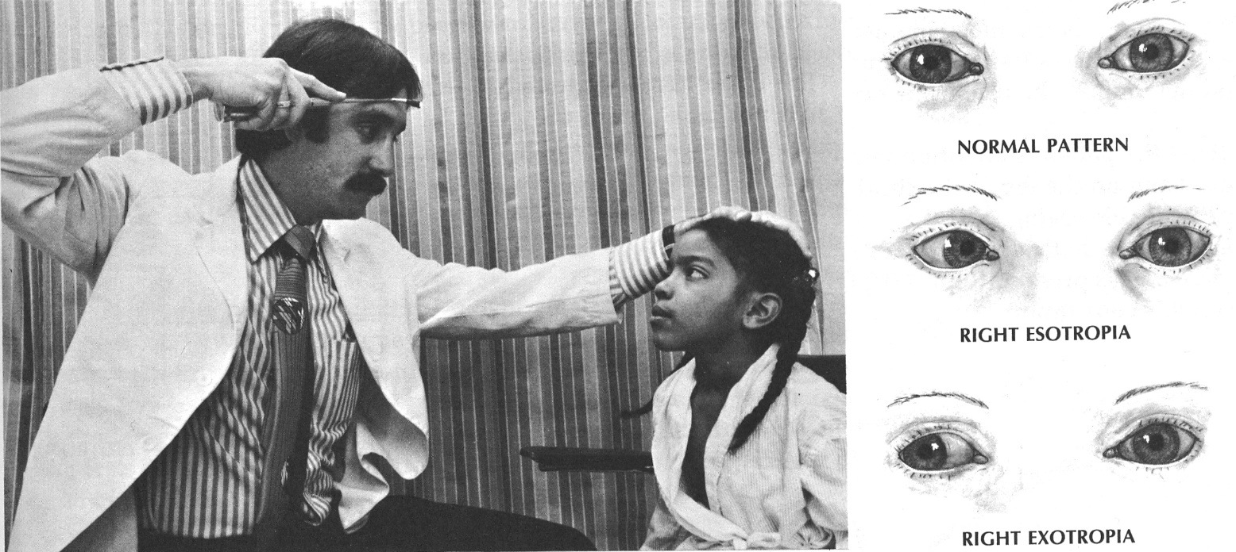

- Establish which image is seen by which eye:
  - cover one eye – ask patient which image disappears (interpretation – see above).
  - colored glass over one eye – ask patient to view point light source - where colored image is relative to white one?
- Maddox rod - series of cylinders lying parallel to one another; point of light viewed through Maddox rod appears as line (perpendicular to orientation of cylinders); line can be made to appear horizontal or vertical by reorienting Maddox rod in front of subject's eye. | 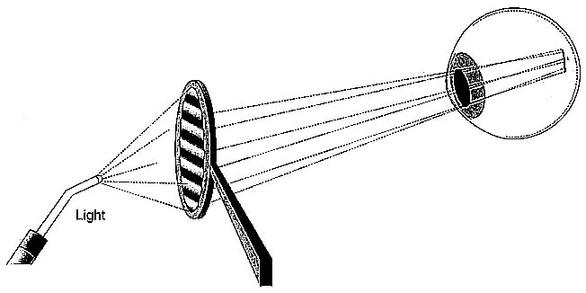
- Maddox rod is always placed over right eye (by convention) - that makes right eye deviating eye because patient is instructed to "look at the light" and he / she can see light only with left eye.
- inset at right of each figure illustrates relative positions of images of object of regard (OR) seen with left eye and of line created by viewing through Maddox rod (MR) with right eye:
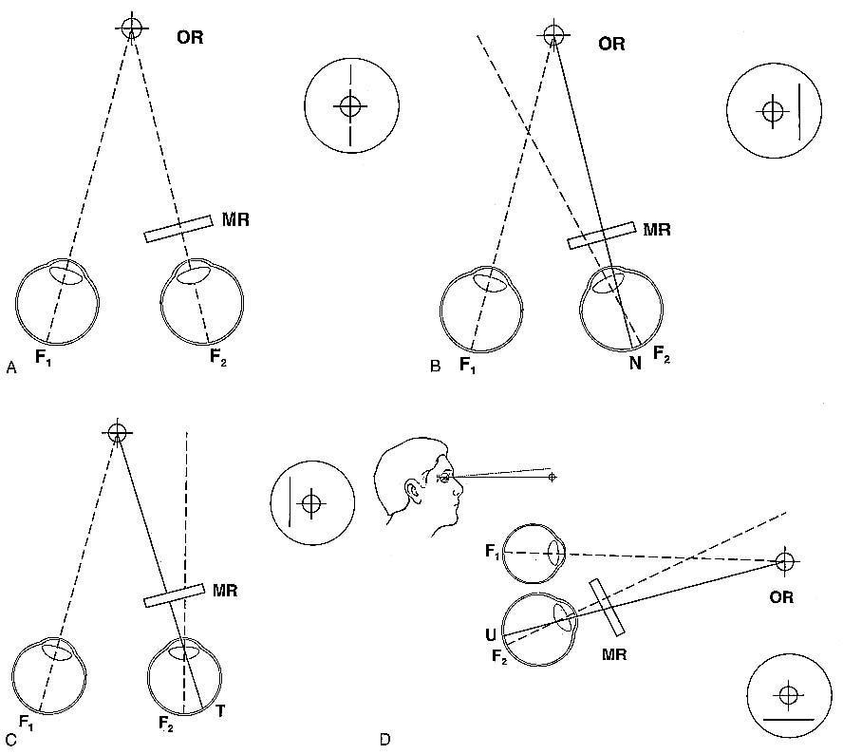

A. Orthophoria - visual axes are slightly convergent, and image is formed on both foveae (F₁ , F₂) - line (right eye image) runs through light (left eye image).
B. Esophoria - right eye image falls on nasal retina so line appears to be on temporal (right) side of light (left eye image) - homonymous diplopia.
C. Exophoria - right eye image falls on temporal retina so line appears displaced nasal to light - crossed diplopia.
D. Right hyperphoria (MR is reoriented to give horizontal line) - right eye image falls on upper retina so line appears displaced below light.

Maddox rod advantages over colored-glass test:
- more accurate mixed (horizontal and vertical) diplopia examination - patient can easily judge vertical deviation by viewing horizontal line and horizontal deviation by viewing vertical line.
- because two dissimilar images (point of light and colored line) are viewed, images are more completely dissociated and deviation is maximized (vs. when patient views two differently colored but otherwise similar images, fusion mechanism works and deviation smaller than maximum results).

- Cover-uncover test (objective test!!!) - patient is asked to maintain accommodative fixation at Snellen chart (or on light source held at your midforehead); place your hand on patient’s head and your thumb in front of one eye (patient constantly tries to maintain fixation).  Alternate cover test - moving occluder (thumb) quickly back and forth from one eye to other.  - at any time one eye is covered, so fusion reflex doesn’t operate.  - heterophoria and heterotropia can be detected, but cannot be distinguished.  - if suddenly uncovered eye was deviated under cover, it will make saccadic movement to attain fixation (e.g. saccade toward nose indicates that eye was exodeviated).  - in orthophoria, neither eye moves as they are alternately covered. | 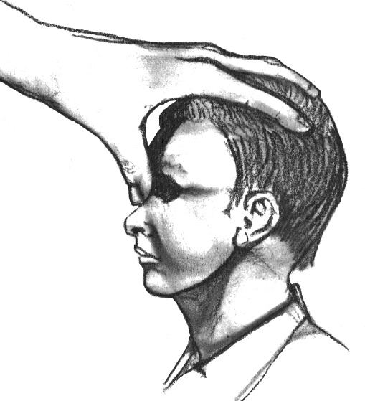

Cover-uncover test - distinguishes heterotropia from heterophoria:
 | Phoria | RE Tropia | LE Tropia
Cover RE | RE deviates under cover, LE maintains fixation | None: LE keeps fixation | LE takes up fixation: conjugate binocular shift occurs, but only LE observed
Uncover RE | RE monocular refixation movement - fusion reestablished | None: LE keeps fixation | RE resumes fixation: conjugate binocular shift observed
Cover LE | LE deviates under cover; RE maintains fixation | RE takes up fixation: conjugate binocular shift occurs, but only RE observed | None: RE keeps fixation
Uncover LE | LE monocular refixation movement - fusion reestablished | LE resumes fixation: conjugate binocular shift observed | None: RE keeps fixation
- in using this table, one column (condition) should be considered at a time.

N.B. in phoria, covered eye always moves (but you can see this only during uncovering of that eye) – you can always see movement during uncovering!
N.B. in tropia, binocular movements are observed only when fixating eye is covered (covering-uncovering nonfixating eye does not change anything)

N.B. heterophoria / heterotropia are eye deviations relative to one another – covered eye always drifts into deviated position relative to uncovered eye; when uncovered, deviated eye makes monocular movement to refixate (observed as conjugated binocular movement). ← test this statement!?

- patient with heterotropia has tendency for one eye to always be deviated when neither eye is covered - because patient has chosen (unconsciously) to fixate with other eye (this does not mean that deviated eye has weak muscles);
if habitually fixating eye is covered, another eye takes up fixation (because refixation is conjugate binocular movement, covered eye deviates under cover); on uncovering eye, two scenarios are possible:
- fixating eye maintains fixation further (esp. if visual acuity is equal in either eye).
- habitually fixating eye refixates (conjugate binocular saccade).
N.B. cover tests rely upon ability to fixate!
In eccentric fixation (foveal vision so poor that it is not used for fixation) or amblyopia (in congenital strabismus) deviating eye will not move to take up fixation!

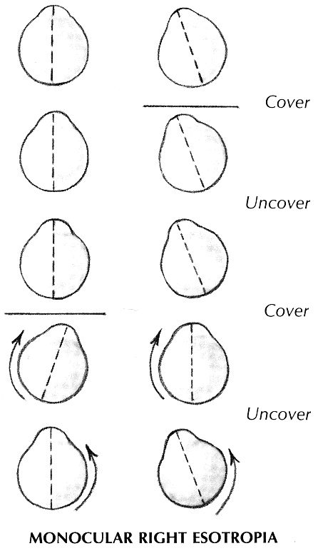

- Prism test - patient is asked to maintain fixation on light source held at your midforehead; hold 4D prism, base out, in front of one eye while observing other eye;
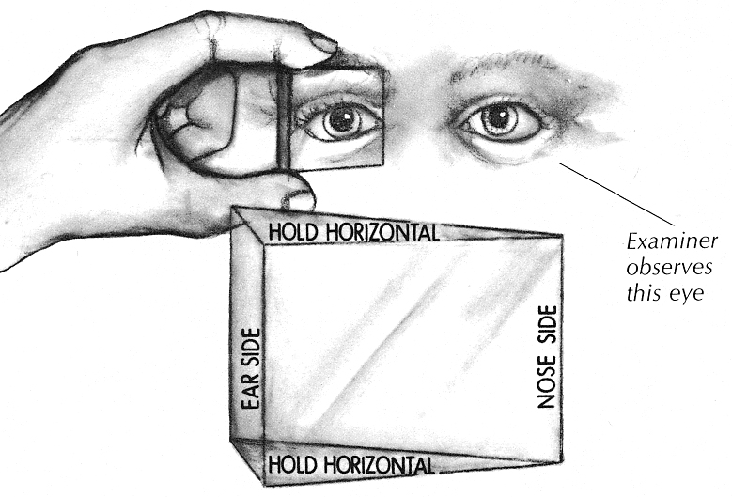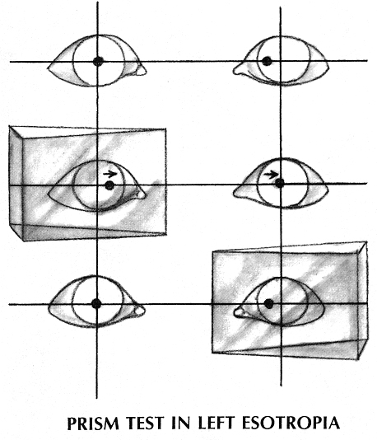

- if observed eye moves (inward or outward) and remains in whichever position it has moved, strabismus is present! (eye under prism also moves to take new fixation; but amblyopic eye will not move under prism!)
- heterotropia can be quantified by using prisms positioned such that deviating eye need not move to fixate; prism power (in diopters) used to prevent deviation quantifies tropia.

Pseudosquint (wide epicanthic folds give appearance of esotropia) – eyes are correctly aligned (confirmed by corneal reflection; neither eye moves as they are alternately covered).

Treatment of diplopia:
- patch one eye (driving is not recommended).
- prism placed in spectacle of one or both eyes; inexpensive plastic prism can be applied to patient's own glasses for short-term treatment.
- botulinum toxin type A (Botox) injections into specific extraocular muscles.
- surgical correction (N.B. it is better undercorrect than to overcorrect!).

N.B. permanent vision loss can occur if congenital strabismus and its attendant suppression amblyopia are not treated before age 4-6 yr.! (time when vision is developing)
  - nonparalytic strabismus (muscle imbalance):
    - corrective glasses / contact lenses
    - miotics (e.g. echothiophate iodide 0.03% bid)
    - orthoptic training (eye exercises)
    - botulinum toxin, surgical correction (resection of muscles)
  - amblyopia - patching normal eye is mainstay of treatment for all causes!

N. Oculomotorius (CN3)
Clinical Features
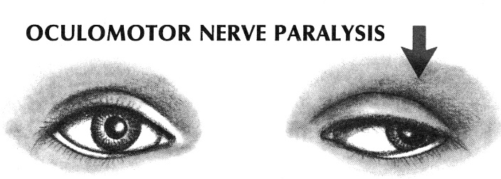

Isolated right CN3 palsy:
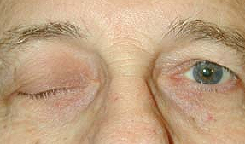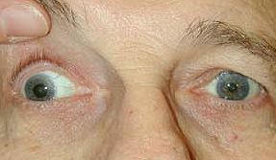

Horizontal EOM testing (inability to adduct right eye, but normal abduction):
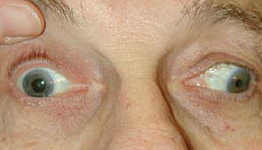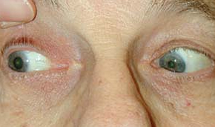

- Defect of ocular elevation, depression, adduction → lateral-downward eye deviation* (unopposed lateral rectus and superior oblique) when eye is in primary position → mixed (horizontal + vertical) diplopia - oblique image separation.
*way to remember this combination is to think of losing boxer - “knockdown and knockout".
  - in attempted downgaze, there is globe intorsion (normal action of superior oblique muscle) - can best be observed by using conjunctival blood vessels as landmarks (vessels nasal to limbus move down while vessels on temporal side stay stationary or move up).
  - nerve divisions may be lesioned in isolation:
superior (superior rectus and levator);
inferior (medial and inferior recti, inferior oblique, ciliary ganglion).

- Levator palpebrae paralysis → upper eyelid ptosis (doesn’t correct when patient looks up): restriction of upper visual field → loss of all vision (when pupil is completely covered – diplopia is usually not a problem).
    - MRD₁↓ with unchanged MRD₂
    - proptosis (due to recti tone↓) is possible.

- Pupillary sphincter paralysis → fixed mydriasis (no reaction to light / accommodation).
N.B. anisocoria is greater in bright light (larger pupil is abnormal); vs. sympathetic dysfunction.
    - can cause symptomatic glare in bright light.

- Ciliary muscle paralysis → loss of accommodation (farsightedness).

Levels of lesions:
- Nuclear – adds additional features: bilateral ptosis (contralateral ptosis is partial, because of input from undamaged nucleus at that side) + bilateral upgaze palsy (superior rectus subnucleus output is totally contralateral with its fascicles coursing through opposite superior rectus subnucleus).
- Fascicular intramedullary (various stroke syndromes - penetrating PCA branches to midbrain):
Benedikt syndrome (ventral mesencephalic tegmentum) – concomitant involvement of red nucleus & superior cerebellar peduncle (→ contralateral hemichorea, hemiataxia, hemiathetosis).
Claude syndrome (mesencephalic tegmentum - more dorsal than in Benedikt syndrome) – concomitant involvement of dorsal red nucleus (→ ipsilateral gross “flapping” tremor) or dentato-rubro-thalamic tract (→ contralateral cerebellar ataxia).
Difference from Benedikt syndrome - more prominent cerebellar signs without involuntary movements.
Central midbrain syndrome – concomitant involvement of red nucleus, subst. nigra & medial lemniscus. see illustration in p. A59 >>
Nothnagel syndrome – concomitant ipsilateral cerebellar ataxia, dizziness, staggering, and rolling gait, often nystagmus.
Weber syndrome (s. ventral midbrain syndrome) – concomitant involvement of cerebral peduncle (→ contralateral hemiplegia, supranuclear CN7 palsy).
see illustration in p. A59 >>
- Fascicular extramedullary

Etiology
Intramedullary (nuclear, fascicular) lesions - primarily by small infarcts of medial penetrating vessels from basilar artery.

Extramedullary lesions:
- ICP↑ with uncinate (transtentorial) herniation → CN3 compression;
most common scenario: traumatic hemorrhage → unconsciousness with ipsilateral CN3 paresis (seen by “doll’s eye” or caloric test) with dilated unreactive pupil (Hutchinson pupil).
N.B. large fixed pupil should suggest herniation syndrome unless patient is awake and alert!!! (“surgical” CN3 palsy involves pupil!)
N.B. normal pupil with CN3 plegia in comatose patient suggests metabolic etiology!

- Saccular aneurysms of PComA (at its junction with internal carotid artery)
  - cerebral angiography should be used in evaluating of nontraumatic CN3 palsy.
  - pupil is mostly affected* (“surgical” CN3 palsy involves pupil!).
  - treatment: aneurysm neurosurgery → diplopia & ptosis surgery (if chronic palsy persists).
N.B. 30% of acute CN3 palsies are due to PComA aneurysms (if acute – due to rapid aneurysm growth or sentinel bleed – both need urgent treatment!!!)

- Small vessel (vasa nervorum) ischemic disease (e.g. diabetes, hypertension)
  - typically spares pupil* (“medical” CN3 palsy spares pupil!)
  - no treatment helps (prescribe temporary prism as Fresnel paste on).
  - deficits tend to improve over 6-8 week period.
*pupillary fibers travel in CN3 superficial layer.

- Cavernous sinus syndrome; invading masses are most likely to lesion CN3 prior to involvement of other cranial nerves (because of CN3 has close proximity to unyielding interclinoid ligament above and petroclinoid ligament below).

Marcus Gunn syndrome (“jaw-winking”) – unilateral misdirected neuronal connections (miswiring) between CN3 and CN5 → congenital synkinesis: activation of levator palpebrae upon use of muscles of mastication (e.g. suckling in infant), i.e. elevation of ptotic lid to position higher than opposite side on mouth opening.
- patient can raise lid voluntarily and on upward gaze.
- sometimes autosomal dominant familial trait.
- cosmetic distortion sometimes is sufficient to lead to surgical therapy.

Marin Amat syndrome (s. inverted Marcus Gunn phenomenon) - eye closes when jaw opens.
- may follow Bell's palsy.

N. Trochlearis (CN4)
- most common neural cause of isolated vertical diplopia:
- eye is extorted & elevated (hypertropia).
- differentiate from skew deviation (both eyes move in opposite directions equally).

Isolated left CN4 palsy (primary gaze showing left hypertropia):
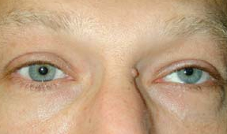

Isolated left CN4 palsy (right gaze with left inferior oblique overaction):
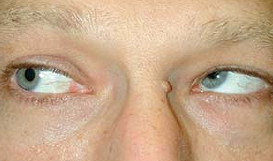

- image separation is widest in downgaze (difficulties walking down stairs!) when eye is adducted.
- compensatory head triad (patient so avoids diplopia!):
  - head tilting to side opposite palsy → incyclodeviation of normal eye compensates extorsion.
  - head turning away from affected side - keeps involved eye abducted.
  - head down - keeps eyes in upgaze.
Some patients develop head tilt toward side of lesion (paradoxic head tilt) - to create wider separation of images (allows to suppress or ignore one image more easily).
- diagnosis - Parks 3-step test, review family photographs (head tilt in childhood is evidence of congenital CN4 palsy).
- treatment - Plager treatment plan based on Knapp recommendations (e.g. for deviation > 15 prism diopters, 2-3 muscle surgeries are required).

Bilateral CN4 lesions - in major head trauma: dorsal midbrain and both fourth nerves are impacted in niche of tentorium cerebelli.
- because of bilateral injury to ARAS, patient is unconscious for protracted period of time → complaints of vertical diplopia.
- torsional diplopia + downgaze horizontal diplopia (V-esotropia) predominate.
- right hypertropia dominates during left gaze and left hypertropia during right gaze!
- treatment - modified Harada-Ito procedure (bilaterally superior oblique tendon is split and anterior fibers are advanced anteriorly and laterally – correction of large* excyclotorsion).
* patients can fuse up to 8° of cyclotropia before becoming symptomatic

Associated CN3 palsy (e.g. cavernous sinus syndrome)
- CN4 palsy is difficult to diagnose in presence of CN3 palsy - small increment of depressor deficit (superior oblique muscle) cannot be readily discerned from depressor palsy that results from inferior rectus muscle (CN3).
- best diagnostic marker – no globe intorsion on attempted down gaze.

Congenital CN4 palsy
- exact pathology unknown - dysgenesis of CN4 nucleus, abnormalities of peripheral nerve, abnormal superior oblique muscle or tendon (abnormally lax, abnormal insertion, tendon absence).
- patients may develop facial asymmetry due to long standing compensatory head tilt, but head tilt works as amblyopia preventer (by maintaining fusion)!

N. Abducens (CN6)
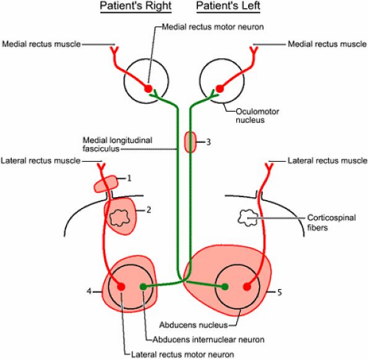

      - Nerve root lesion - in primary position eye is adducted (medial strabismus, s. esotropia) → horizontal diplopia (practically present in all eye positions; most pronounced during gaze towards affected side, disappears during gaze to the opposite side)

Isolated right CN6 palsy:
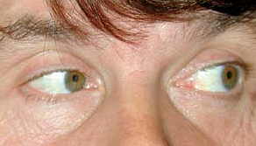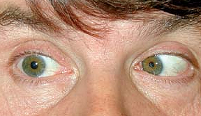

- CN6 is susceptible to stretching and distortion more than other cranial nerves are!!!
- long intracranial course along bony ridges of calvarium (esp. petrous ridge);
- nerve is fixed on one end at its emergence from pons and at other end, at Dorello canal in petrous tip.
CN6 can be stretched during small brainstem shifts secondary to changes in CSF pressure gradients:
    - ICP↑ with any large intracranial masses remote from CN6 (false localizing CN6 paresis!).
    - ICP↓ after lumbar puncture.
- CN6 can be compressed in cavernous sinus by nasopharyngeal tumor.
- Gradenigo syndrome – apical petrositis with localized meningitis involving CN5 & CN6.
see p. CN5 >>
Surgical treatment
Some residual lateral rectus function exists → graded recession/resection.
No residual lateral rectus function → transposition procedure (e.g. Hummelsheim or Jensen) + weakening antagonist medial rectus.

      - Caudal basilar pontine lesion (axons arising from abducens motor neurons pass adjacent to corticospinal fibers)
- Foville syndrome - concomitant contralateral hemiparesis.
- Millard-Gubler syndrome - concomitant contralateral hemiparesis + CN7 dysfunction.

      - Internuclear ophthalmoplegia (INO) – see below >>

      - Nuclear lesion = nerve lesion + INO +:
  - affected pontine lateral gaze center → ipsilateral conjugate horizontal gaze paralysis (both eyes cannot look to affected side; adduction of contralateral eye is less severely affected); convergence and gaze to the contralateral side are intact!
  - peripheral CN7 palsy (CN7 fascicles wrap over superior aspect of CN6 nucleus);
Möbius syndrome – see p. CN7 >>

      - One-and-a-half syndrome – see below >>

Duane's syndrome - deficient CN6 innervation to lateral rectus with compensatory innervation by CN3 → limited abduction with:
- widening of palpebral fissure on attempted abduction.
- globe retraction and narrowing of palpebral fissure on attempted adduction.
  - most cases are sporadic.

Wildervanck (cervico-oculo-acoustic) syndrome - combination of Duane's anomaly, Klippel-Feil anomaly, and perceptive deafness.

MLF Syndromes
In addition to motor neurons, abducens nucleus also contains interneurons - axons of these cross midline, enter medial longitudinal fasciculus (MLF), and ascend to terminate on motor neurons in oculomotor nucleus that innervate medial rectus muscle on that side.

Unilateral MLF lesion (internuclear ophthalmoplegia, INO)
- symptoms occur when patient volitionally attempts to look contralaterally (i.e. contralaterally to MLF lesion side):
- paralysis of ipsilateral eye adduction (→ horizontal diplopia)
N.B. convergence is preserved (convergence supranuclear pathways enter midbrain directly, without looping down into pons and back through MLF!)
- monocular nystagmus of contralateral eye with fast phases away from lesion side (oscillopsia);
nistagmo prasmė – refleksiškai panaudojamas vienintelis būdas (t.y. konvergencija) priversti dirbti ipsilateralinį m. rectus med. – contralateral eye tai žiūri į šalį, tai grįžta konvergencijai.
- eyes remain straight with parallel visual axes when viewing distant objects in primary gaze position ← main difference from CN3 lesion or primary medial rectus muscle defect (either of which causes exotropia in primary gaze).
- when MLF dysfunction is mild, adducting eye deviates fully but slower - abducting eye completes movement earlier than adducting eye.

Left internuclear ophthalmoplegia:
Left gaze showing full abduction. Right gaze with severe adduction deficit.
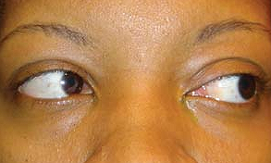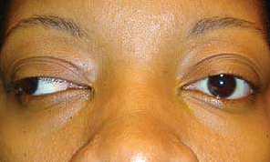

Isolated MLF syndrome has exquisite localizing value - highly discrete lesion deep in brain stem tegmentum (this area contains ARAS, along with cranial nerve nuclei, various ascending and descending sensory and cerebellar pathways – so isolated MLF syndrome suggests highly discrete lesion):
in children – can be first sign of brain stem glioma.
in adult (< 40 yrs.) – small demyelinating MS plaque (lesion may be bilateral!).
in elderly (> 60 yrs.) – small infarction (usually unilateral).

- in isolated MLF syndrome always consider myasthenia gravis (although such presentation is not typical for myasthenia).

1½ (one-and-half) syndrome - unilateral large pontine lesion that involves:
  - CN6 nucleus, PPRF → ipsilateral lateral rectus paralysis, contralateral medial rectus paralysis
  - MLF carrying impulses from contralateral PPRF → ipsilateral medial rectus paralysis
Clinically – loss of medial and lateral voluntary eye movement on lesion side (“one”) and loss of medial horizontal eye movement on contralateral side (“half”); the only remaining horizontal movement is abduction of contralateral eye.

Bilateral MLF lesions
- paralysis of horizontal gaze (if pontine basis is more widely damaged → additional tetraplegia – so called locked-in syndrome. see p. A59 >> , p. Mov3 >>
- MLF also carries complex ascending influences from vestibular nuclei and PPRF gaze centers; bilateral lesions → paralysis of vertical pursuit and vestibulo-ocular reflex movements, but spared vertical saccades (accessory nuclei for vertical saccades apparently have connections with cerebral hemispheres independent of supranuclear pathways that operate via PPRF); although vertical saccades are spared, eye position signal is abolished - gaze paretic nystagmus occurs with upgaze and downgaze effort.

Conjugate Gaze Disorders
Supranuclear control dysfunction → conjugate gaze palsy (eyes simultaneously fail to achieve full movement); visual axes remain parallel or appropriately convergent - patient does not experience diplopia!!!
Dysconjugate eye movements indicate disorder:
- at or below (peripheral to) cranial nerve nuclei
- in internuclear pathways

- in subtle deficit, eyes achieve full movement but move more slowly than they should (generally no subjective symptoms).
- even with complete lack of gaze in particular direction, patients often have no complaints but automatically turn their head to compensate (major exception is loss of downgaze - creates much difficulty when walking and especially in negotiating stairs and other uneven terrain).
- cerebellum also contributes to conjugate gaze mechanisms; lesions of cerebellar pathways → abnormal conjugate gaze.

Saccade system
Separate cortical zones generate different kinds of saccades!
Components of saccade: pulse (burst discharge in agonist with total inhibition of antagonist) → step (increased level of agonist and decreased level of antagonist discharge to maintain new eccentric position).

Spontaneous saccades - internally triggered but not goal directed.
Testing - watch patient during speech or other motor activity.

Intentional saccades - generated by voluntary internal thought and decision to act; further classified as:
- predictive saccades - made toward repetitive stimulus presented at predictable location.
- memory-guided saccades - made to remembered location where target is no longer present.
Testing (patient keeps head stationary facing straight ahead to avoid introducing vestibulo-ocular components):
- Give verbal directions to follow (e.g. "look left", "look down").
- Visually guided saccades - ask to look at examiner's nose and then to look at object* 30° to either side of midline (ask to refixate gaze from examiner's nose to one object, then back to nose).
*appropriately placed object – examiner’s arms semiextended (elbows 90° flexed), hands just a bit in front of his / her own facial plane.

Reflexive saccades - triggered by external stimulus (visual or auditory) that subject is instructed to look at when it occurs.
Testing - examiner's hands at the same positions as for intentional saccade testing; patient is instructed to refixate between two hands, but only when examiner moves fingers of one or other hand (i.e. patient is waiting for trigger signal that will result in reflex eye movement).

Antisaccades - eye movement in direction opposite to saccade stimulus.
Testing - patient is asked to look in opposite direction to novel visual target (i.e. patient must suppress natural tendency to make saccade to newly appearing visual stimulus).

During all tests observe such saccade characteristics:
- latency (e.g. increased latency)
  - normal human takes 200 (180-250) milliseconds to generate saccade.
- velocity (larger saccades are faster than smaller ones, but it is virtually impossible to perceive these subtle velocity variations by direct observation).
  - pathology often slows velocity sufficiently to be perceived as slow by direct inspection.
  - major velocity slowing indicates cerebellar or brain stem disorders (frontal lobe lesions cause only minor slowing).
- metrics
- accuracy (if dysmetria exists, multiple small additional saccades are necessary to complete movement)
hypermetric saccades - overshoot target.
hypometric saccades - fall short of target.
N.B. up to 3 saccades may be necessary in normal eyes to correctly achieve target 25-30° to either side of center; each corrective saccade is separated by normal obligatory intersaccadic interval (≈ 200 milliseconds); ≥ 3 saccades (esp. if different between gaze sides) indicate pathology.

unilateral frontal eye field damage (e.g. cerebral infarction resulting in contralateral hemiparesis) → defective saccades to contralateral side:
acute stage - eyes and head tonically turned to ipsilateral side (“žiūri į pažeidimo pusę”);
chronic stage – saccades already achieve full amplitude, but remain hypometric (± prolonged latency).
- brainstem reflexes (e.g. “doll's eye” maneuver) successfully bring eyes to contralateral side!

N.B. excitatory lesions (e.g. epileptic focus) have opposite effects than damaging lesions!

unilateral pontine horizontal gaze center damage (e.g. pontine infarct also with contralateral hemiparesis) → defective saccades to ipsilateral side (akys “žiūri tolyn nuo pažeidimo”).
- “doll's eye” maneuver will not bring eyes past midline!

- optokinetic nystagmus (OKN) may be used for testing (when pursuit movements are normal):
  - use striped drum, squares on flag, or tailor's tape with stripes.
  - patient is asked to count lines as they pass.
Norma - as stimulus passes in front of patient, slow eye pursuit in movement direction is followed by rapid jerk in opposite direction that repeats as long as stimulus is present.
Left frontal lesion (defective saccades to right, but intact smooth pursuit to right):
stimulus rotated to right → normal optokinetic nystagmus.
stimulus rotated to left → tonic eye deviation to left.

bilateral frontal eye field damage → paralysis of horizontal saccades (i.e. paralysis of volitional horizontal gaze); reflexive horizontal deviations (e.g. “doll's eye” maneuver) are intact.

Congenital ocular motor apraxia - benign deficiency of horizontal saccades that resolves with maturity; infants perform head thrusts past object of regard (achieving fixation by contraversive vestibular “doll's eye” movement and then maintaining it while slowly rotating head back).

Repetitive eye movements in which saccades are abnormal: opsoclonus, ocular flutter.
Opsoclonus
- continuous multidirectional saccades with no intersaccadic interval.
Etiology:
adults - brain stem encephalitis, cerebellar lesions;
infants, children – rare (2%) paraneoplastic (immune-mediated?) manifestation of neuroblastoma (as opsoclonus-myoclonus syndrome).

Ocular flutter
- bursts of saccades in one plane (typically horizontal) with no intersaccadic interval.
- shares pathophysiological mechanisms with opsoclonus.

Smooth pursuit system
Testing requires that stimulus be present (patients cannot produce voluntary smooth eye movements in stationary visual environment or in darkness!!!).
  - ask to hold head still while following examiner's finger with eyes (optokinetic nystagmus drum also may be used).
  - finger movement must be within patient's visual field and slow (40-50° per second – i.e. target excursion from extreme right to extreme left gaze should take ≈ 5 seconds).
  - normal pursuit is smooth with no inserted saccades.
  - if target is moved too rapidly, smooth pursuit system falls behind producing saccadic pursuit.
  - most frequent abnormality is subnormal gain - eyes fall progressively behind target; visual system does not tolerate retinal position error → catch-up saccade is inserted (these saccades occur rhythmically, because it requires about the same time to generate needed position error throughout course of pursuit movement) - low-gain pursuit with catch-up saccades (s. saccadic pursuit, cogwheel pursuit in patients Parkinson's disease).

unilateral occipital eye field damage → defective smooth pursuit to ipsilateral side (also with contralateral homonymous hemianopia).
- alternative damage sites (with the same clinical picture) - middle temporal and medial superior temporal cortexes (recipients of occipital eye field input), deep parietal lobe (interruption of descending occipitomesencephalic system for pursuit eye movements).
- supranuclear conjugate gaze disorder may occur with lesions of midbrain & rostral pons – here saccades & pursuit are defective in the same direction (the same final common pathway)!

Bidirectional (bilateral) symmetrical low-gain pursuit may be nonspecific abnormality (has no localizing value – fatigue, many drugs, elderly).

bilateral occipitoparietal (superior occipitotemporal)* lesions → Balint syndrome; one component of syndrome is defective smooth pursuit in all directions (optic ataxia); visually guided saccades have increased latency and diminished accuracy (intentional saccades relatively preserved!). also see p. Eye62 >>, p. A156 (2) >>
*visual association area

Vertical gaze
Vertical gaze palsy is not caused by cerebral hemisphere disease!
Midbrain tectum & pretectal areas mediate vertical gaze - lesions in these regions cause upward and downward gaze palsies.
N.B. immediate supranuclear apparatus for generating vertical gaze is in midbrain! (receives bilateral hemispheric input)
- vestibular system stimuli can still drive eyes upward or downward (vs. in contrast to horizontal gaze system, in which RF lesion can block all stimuli for horizontal gaze).

Parinaud syndrome (s. Parinaud ophthalmoplegia, midbrain pretectal syndrome, dorsal midbrain syndrome) – lesion of pretectal area, superior colliculi (e.g. compression from above by pineal mass; PCAS infarction); see illustration in p. A59 >>
- paralysis of conjugate upward gaze (upward gaze traktas eina dorsaliau negu downward gaze traktas) → downward eye deviation (rarely, if unilateral, skew deviation).
- upward pursuit is less affected (eyes elevate on “doll’s eye” maneuver).
- additional signs:
  - Collier sign (pathological lid retraction) with Bell phenomenon (bandant užsimerkti, akys pakyla į viršų).
  - mydriasis, anisocoria, light-near dissociated pupils - due to interruption of periaqueductal afferent light input to CN3 nuclei.
  - defective convergence, convergence-retraction nystagmus (rhythmical backward movements of globes into orbits with convergence movements of two eyes) during attempted upward gaze - best demonstrated by downward-moving OKN stimuli: failure of inhibition leads to cofiring of oculomotor neurons with convergence-retraction nystagmus and related fleetingly blurred vision or diplopia.

Paralysis of downward gaze is usually due to bilateral lesions in mesencephalon under CN3 nucleus.

Ocular bobbing [angl. bob – linktelėti galva] - sudden conjugate downward deviation of eyes with slow return to normal position; it is not rhythmic, is coarser than nystagmus, may vary in amplitude, and is occasionally asymmetric.
- classic for bilateral pontine damage (but also seen in some comatose patients with metabolic derangements, bilateral hemisphere lesions, cerebellar hemorrhage compressing brainstem).
- unilateral bobbing (nystagmoid jerking) signifies pontine disease.

Ocular dipping - slow, cyclic, conjugate downward movement followed by faster upward movement - diffuse anoxic cortical damage.

Oculogyric crisis [oculogyria - limits of eyeball rotation] - incapacitating dystonic conjugate upward eye deviation for minutes or hours.
- seen in encephalitis lethargica and as neuroleptic side effect.

Vestibulo-ocular System
Oscillopsia - illusory sense of movement (oscillation) of visual environment as head moves (i.e. peculiar sense of movement of objects viewed when patient moves → inability to recognize objects when head is moving but normalizes when head is stationary) - direct consequence of foveal image slippage during head movement; illusion ceases when head is immobile (vs. vertigo).
- classic sign of bilateral vestibular dysfunction (loss of vestibulo-ocular reflex) – normal rapid adaptation is lost and gaze is stabilized only by slower optical system.

Vertigo - rotational illusion; present when head is immobile (usually aggravated by head movement); accompanied by rhythmical nystagmus.

Testing
- Static imbalance between two vestibular systems (on either side of midline).
- manifests as spontaneous nystagmus;
slow-phase velocity reflects degree of imbalance between tonic states on two sides;
nystagmus plane is plane of affected semicircular canal (but central lesions [e.g. cerebral vermis] cause pure upbeating nystagmus).
- nystagmus may be present in primary gaze, but typical vestibular nystagmus emerges (or is worse) when fixation is prevented (e.g. by covering eye or wearing Frenzel goggles [strong spherical convex lenses eliminate ability to focus and fixate]).
- small amplitude nystagmus can be observed with ophthalmoscopy, electronystagmography.
- nystagmus should be assessed in primary position, and in upward, downward, right, and left gaze – estimate amplitude in various gaze positions:
vestibular nystagmus – rhythmical, unidirectional, and steady in all gaze positions;
gaze-evoked nystagmus – amplitude and frequency changing with different gaze angles.

- Dynamic imbalance - manifests during vestibular stimulation, as VOR gain greater in one direction than in other.
- head-shake test: ask patient to shake head, first horizontally and then vertically, for 10-15 seconds in each direction.
- after each movement interval, eyes should remain fixed on stationary visual target - observe eyes for nystagmus (after horizontal shaking, nystagmus slow phases are toward lesion side; after vertical shaking, induced horizontal nystagmus slow phases are opposite to lesion side; N.B. many factors may disrupt or inverse this nystagmus directionality!).
- head-thrust test (s. rapid doll's head test) - examiner stands in front of patient, and patient focuses on examiner's nose; examiner slowly rotates patient's head to one side, roughly 30°, then, while asking patient to continue to fixate, head is rapidly rotated to opposite mirror image position - if eyes make compensatory movement after head is stopped to reacquire target (refixation saccade), test is abnormal - indicates output of one or both labyrinths is depressed.

- Vestibulo-ocular reflex (VOR) gain see p. D1ear >>
- oscillopsia test (s. dynamic illegible E test) - patient is asked to read Snellen chart (or near acuity card) with head stationary and during horizontal and then vertical sinusoidal head oscillations (at velocity of 1-2 cycles per second, ± 30°).
normal VOR gain → eyes remain fixed on optotypes (maintain acuity within 2 lines of acuity at rest).
abnormal VOR gain → eyes slip off fixation (visual acuity↓ during head motion).
- rotational chair test - eye position is monitored with nystagmography; comparing eye velocity to head velocity (i.e. velocity of chair) determines VOR gain.

- Eliciting normal (!) vestibular nystagmus
  - rotational stimulation - rotate patient at constant velocity (one turn every 3 seconds) in swivel chair for 45 seconds.
- during rotation, nystagmus occurs in same direction as head is rotated (rotatory nystagmus).
- abrupt stopping induces postrotatory nystagmus (direction opposite to rotatory nystagmus):
rotation with head upright → horizontal nystagmus;
rotation with head tilted to one shoulder → vertical nystagmus;
rotation with neck extended and head back → torsional nystagmus.
- advisable to wear Frenzel goggles (so patient cannot suppress nystagmus with visual fixation) or in dark room (use nystagmograph).
- particularly useful for quantitative analysis during follow-ups.
  - caloric stimulation - another (accurate and reproducible) way to stimulate semicircular canals. see p. S30 >>

Nystagmus Syndromes
Nystagmus - repetitive (cyclical) ocular movement: for testing see p. D1eye >>
- pendular nystagmus - cyclical bidirectional slow phases (due to congenital poor visual acuity, brainstem or cerebellar dysfunction); often marked asymmetry and dissociation between eyes. H: gabapentin.
- jerk nystagmus - alternating slow and fast phases:
slow phase is abnormal;
fast phase is normal saccade returning visual axis to its original position - eyes repeatedly return to starting position;
nystagmus direction is defined by direction of fast phase!

Spontaneous nystagmus – present at rest within 30° visual field.
Induced nystagmus – normal physiologic phenomenon (e.g. “train nystagmus”, nystagmus during caloric stimulation)
Provoked nystagmus – pathologic nystagmus produced by certain maneuvers (e.g. Dix-Hallpike maneuver, head shaking); does not occur in normal people.

Types of spontaneous nystagmus
Nystagmus type | Direction | Worst in gaze position | Visual fixation effect
Congenital (s. fixation) | Bilateral (may be pendular) | Central | Worsens
Vestibular | Unidirectional | Away from lesion | Suppresses
Gaze-evoked | To direction of gaze | Extreme from central

Cyclical abnormal signals that enter conjugate gaze-generating systems
Most frequent clinical example - congenital (s. fixation) nystagmus – most pronounced in central position and during visual fixation.
- eyes are pulled off object; normal saccade brings re-foveation.
- almost always bilateral, symmetric, and conjugate; pendular or jerk; variation of slow-phase trajectory from one patient to other; disappears during sleep.
- few have nystagmus at birth (term “infantile nystagmus” is more appropriate).
- no subjective complaints!
- site of abnormal signal generation is unknown; classically divided into:
- afferent (sensory deficit, amblyopic) nystagmus - due to various visual (sensory) disorders; manifests at age ≥ 2-3 months; treatment depends on cause (e.g. gabapentin).
- efferent (idiopathic infantile) nystagmus - due to oculomotor (neurologic) abnormality; manifests before age 2 months!!!
      - genetic mechanism is traced to X chromosome;
      - hallmark of idiopathic infantile nystagmus is gaze-dependent, variable intensity resulting in "null zone" where nystagmus is least marked and visual acuity is maximized (→ adoption of anomalous head posture);
      - treatment – baclofen (only for nystagmus persisting to adulthood), surgical procedures (Anderson or Kestenbaum) to move eyes into null zone (to diminish anomalous head position).
- subtypes exist - nystagmus associated with albinism (features ≈ idiopathic infantile n.), latent / manifest latent nystagmus (associated with infantile strabismus; appears / increases when one eye is covered [latent]), spasmus nutans (see below).

    - Tonic bias (abnormal positive influences on conjugate gaze mechanisms):
- unilateral vestibular system disorders (vestibular nystagmus) – most common cause of acquired nystagmus!
- unilateral smooth pursuit system disorders
- both vestibular system and pursuit mechanism are organized into two bilaterally symmetrical, tonically active systems in which right and left sides oppose each other.
- vestibular system works together with pursuit system.
- when disease affects one side more than other, net tonic drive or bias develops → eyes drift with constant velocity toward side with less activity.
- tonic influence of each side is contraversive, so unopposed contraversive tone of intact side imposes eye drift toward lesion side; drift is checked by rhythmically occurring saccades in opposite direction (i.e. nystagmus beats toward healthy side).
- degrees of horizontal vestibular nystagmus:
1° - nystagmus present only with gaze in direction of fast phase
2° - nystagmus present in primary gaze.
3° - nystagmus present in all gaze positions.
N.B. vestibular nystagmus is worst in gaze direction away from lesion side – Alexander law.
- treatment:
botulinum toxin type A (Botox) injections into specific extraocular muscles.

peripheral vestibular disorders – horizontal* unidirectional nystagmus (often associated with tinnitus, hearing loss), that is inhibited by visual fixation.
*in benign paroxysmal positional vertigo nystagmus is rotational
central vestibular disorders – nystagmus may be rotational, vertical (unidirectional or bidirectional); nystagmus is not inhibited by visual fixation (exceptions exist).

    - Inadequate holding power in eccentric gaze (deficit of gaze-holding mechanism [i.e. neural integrator network]) - gaze-evoked nystagmus - most common form of nystagmus!!!
- initial intentional saccade → backward drift toward primary position; when sufficiently large retinal error signal is generated, another saccade is generated to refixate eccentric point.
Always beats to side of gaze (vs. vestibular nystagmus – always beats to one direction)!
- etiology – central gaze disturbance:
- recovering from gaze palsy.
- structural lesions of neural integrator network (vestibulocerebellum, region of nucleus prepositus hypoglossi and adjacent medial vestibular nucleus [NPH/MVN], interstitial nucleus of Cajal).
- drugs (barbiturates, phenytoin), alcohol.
- may be physiologic in extreme (> 40-45°) horizontal gaze positions (end-point nystagmus).
- differentiation from vestibular nystagmus:
- slow phase velocity is determined by difference between generated oculomotor force and resisting forces that pull eye back to primary position;
resisting forces (elastic elements in extraocular muscles & tendons) are greater when eye is in more eccentric position; as eyes drift back, resisting forces lessen and slow phase velocity declines exponentially (vs. in vestibular nystagmus, slow phase has constant velocity).
- nystagmus depends on continued oculomotor force (subject effort to look in direction of deficient holding power); as urge to maintain the eccentric position wanes, nystagmus slows down; nystagmus stops in primary gaze position (vs. vestibular nystagmus keeps fixed rhythm and may be present in primary gaze).

Downbeat nystagmus
- nystagmus with fast phase beating downward.
Etiology:
- tone from anterior semicircular canals is relatively higher than tone within posterior semicircular canals.
- craniocervical junction disorders (e.g. Arnold-Chiari malformation).
- bilateral lesions of cerebellar flocculus
- bilateral lesions of MLF (carries optokinetic input from posterior semicircular canals to CN3 nuclei).
- treatment – clonazepam.

Upbeat nystagmus
- nystagmus with fast phase beating upward.
Etiology:
  - large amplitude nystagmus that increases with upward gaze - lesion of anterior vermis of cerebellum.
  - small amplitude nystagmus that decreases with upward gaze and increases with downward gaze - lesions of medulla.
  - tone from posterior semicircular canals is relatively higher than tone within anterior semicircular canals; e.g. lesions of ventral tegmental tract / brachium conjunctivum (which carry optokinetic input from anterior semicircular canals to CN3 nuclei).

Torsional (rotary) nystagmus
- accentuated on lateral gaze.
- most vestibular nystagmus types have torsional component.
- etiology:
- lesions of anterior & posterior semicircular canals on the same side.
- lesions of lateral medulla.

Horizontal nystagmus
- unilateral disease of cerebral hemispheres – slow drift toward intact hemisphere side.
- peripheral vestibular lesion – slow drift toward lesion side.

Seesaw nystagmus – pendular nystagmus: one eye moves upward as other moves downward; often combined with torsional rotation (down and out, up and in - as in see-saw); often seen with parachiasmal / parasellar lesions.

Spasmus nutans – classic triad:
- nystagmus – fine (small amplitude), asymmetric (disconjugate), rapid (oscillations), sometimes monocular
- head-nodding movements
- torticollis
- benign - begins after 4 months of age and disappears until 4-5 years.
- rarely may be early sign of gliomas (chiasmal, suprachiasmal, 3rd ventricle)!

Periodic alternating nystagmus
- conjugate, horizontal jerk nystagmus with one direction for period of 1-2 minutes → neutral phase lasting 10-20 seconds → nystagmus begins to beat in opposite direction for 1-2 minutes.
- mechanism – disruption of vestibulo-ocular tracts at pontomedullary junction.
- treatment – baclofen.

Bruns nystagmus
- may be first manifestation of slow-growing cerebello-pontine angle tumor.
- peripheral vestibular nystagmus (small amplitude nystagmus in primary position with fast phase away from lesion side) + slow gaze-evoked nystagmus with gaze to lesion side.

Bibliography for ch. “Ophthalmology” → follow this link >>

Viktor’s Notes℠ for the Neurosurgery Resident
Please visit website at www.NeurosurgeryResident.net

