Cataract
Last updated: May 9, 2019
Etiology 1
Symptoms & Signs 1
Diagnosis 3
Staging 3
Treatment 4

Cataract - developmental or degenerative lens opacity.

Etiology
- Aging (senile cataract) - leading causes of blindness in world!!!
- Traumatic cataract - secondary to blunt or penetrating ocular trauma.
- Chronic exposure - X-ray, infrared (glass-blower's cataract), UV, electric shock.
- Systemic disease (e.g. diabetes mellitus!, neurofibromatosis-2)
- Chronic uveitis
- Systemic medications (e.g. chronic corticosteroids).

Symptoms & Signs
- progressive, painless vision loss.
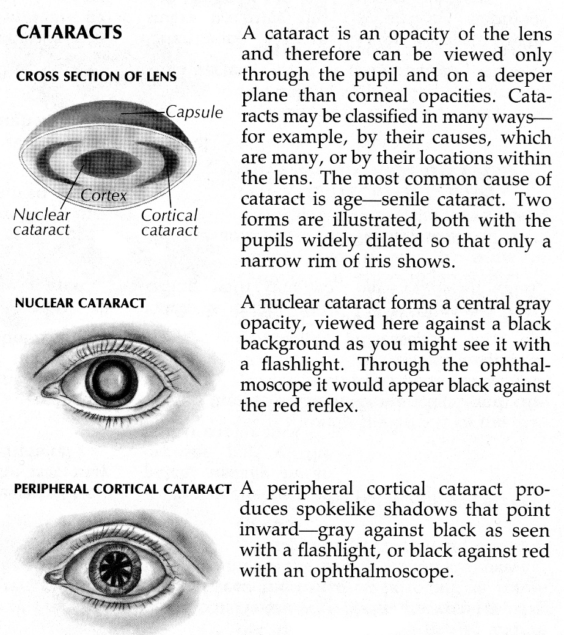

nuclear cataract (opacity in central lens nucleus) - excessive nuclear sclerosis and yellowing; nucleus can become very opaque and brown (brunescent nuclear cataract).
- clinical features:
- gradual, progressive lens thickening → myopia develops in early stages (myopic shift) - presbyopic patient discovers that he can read without his glasses (temporary second sight).
- distance acuity is decreased most (good near vision!).
- if nuclear changes are concentrated in inner lens layers → refractile area occurs in lens center → monocular diplopia.
- correlation with smoking.
- histology - homogenous lens nucleus with loss of cellular laminations.

cortical cataract - due to changes in ionic composition and hydration of lens fibers.
- clinical features:
- visual acuity long remains intact until late stages when cortical spokes compromise visual axis.
- mild glare is possible.
- correlation to solar UV exposure, diabetes, drug ingestion.
- histology - hydropic swelling of lens fibers with globules of eosinophilic material (morgagnian globules) seen in slit-like spaces between lens fibers.

posterior subcapsular cataract (granular and plaquelike opacities beneath posterior lens capsule).
- correlation (≈ as cortical cataract) to solar UV exposure, diabetes, drug ingestion.
N.B. if presents in children – may be specific feature of neurofibromatosis-2
- clinical features:
- opacities are located at crossing point of light rays - disproportionately affects vision (esp. near acuity!).
- particularly troublesome in bright light (disabling glare).
- histology - posterior migration of lens epithelial cells in posterior subcapsular area, with aberrant enlargement of epithelial cells (Wedl or bladder cells).

Nuclear cataract - dark brown nucleus that casts shadow on retroillumination:
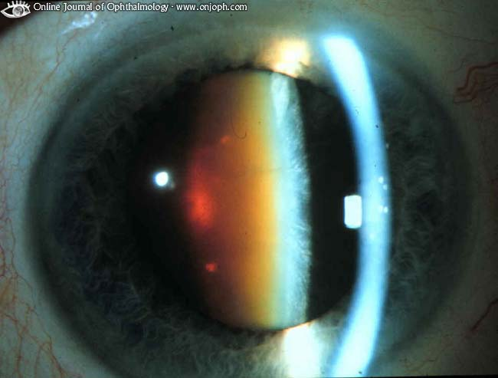
Source of picture: “Online Journal of Ophthalmology” >>

Nuclear & Cortical Cataract - nucleus is condensed, lens periphery has cuneiform opacities:
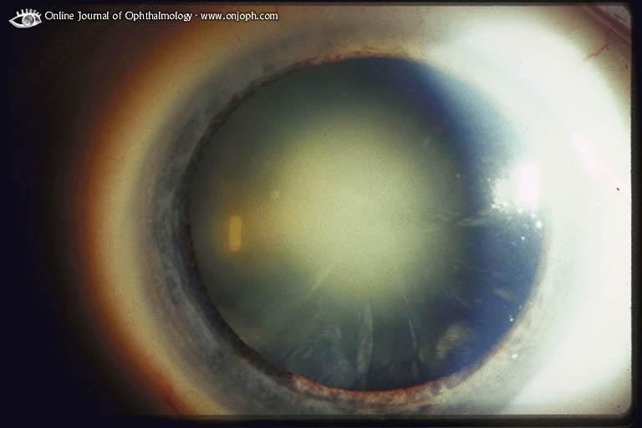

Posterior Subcapsular, Nuclear and Cortical Cataract
slitlamp - opacities in anterior cortex, nucleosclerosis, posterior subcapsular changes:
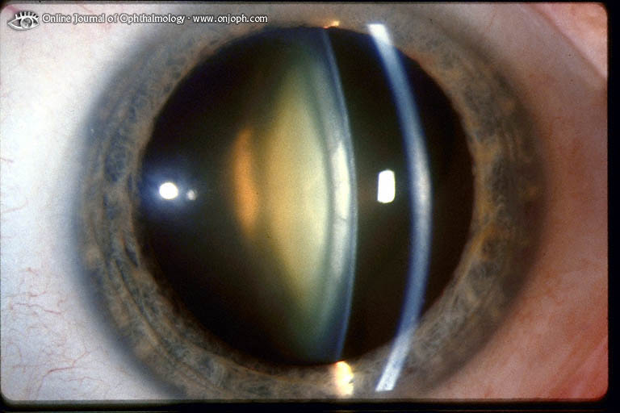
Source of picture: “Online Journal of Ophthalmology” >>

retroillumination - shows subcapsular changes but only suggests nucleosclerosis:
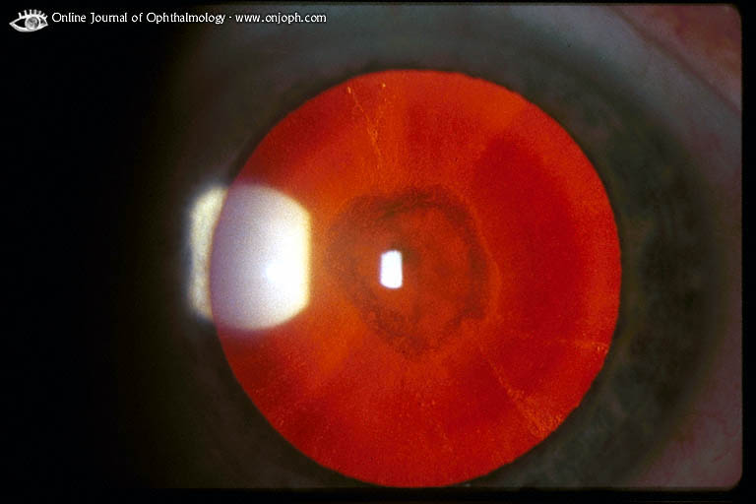
Source of picture: “Online Journal of Ophthalmology” >>

- rarely, cataract swells, producing secondary glaucoma and pain.

Senile cataract prevalence in general population ≥ 75 yrs:
nuclear - 65.5%
cortical - 27.7%
posterior subcapsular - 19.7%
N.B. alcohol is associated with all cataract types!

Traumatic cataracts:
Blunt trauma classically forms stellate- or rosette-shaped posterior axial opacities:
- may be stable or progressive.

Penetrating trauma (disruption of lens capsule) forms cortical changes; may remain focal (if small) or may progress rapidly to total cortical opacification.

Blunt trauma:
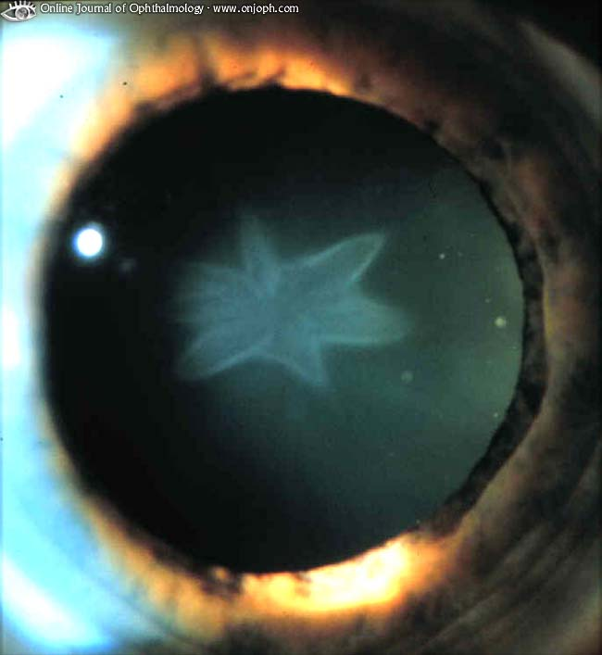
Source of picture: “Online Journal of Ophthalmology” >>

Siderosis lentis:
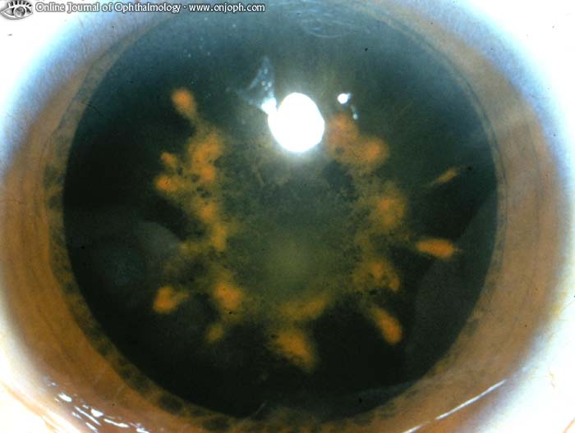
Source of picture: “Online Journal of Ophthalmology” >>

Diagnosis
Ophthalmoscopy
N.B. before pupils are dilated for ophthalmoscopy, increased intraocular pressure and shallow anterior chamber must be ruled out!
- gray / yellow-brown opacities in lens.
- examination of dilated pupil with ophthalmoscope held 30 cm away discloses subtle opacities - as dark defects in red reflex; large cataract obliterates red reflex.

Slit-lamp examination provides more details.

Staging
- based on visual acuity:
acuity < 20/200 - mature cataract.
acuity > 20/200 - immature cataract.
can still read at 20/20 but lens opacity confirmed by slit lamp - incipient cataract.

Mature cataract:
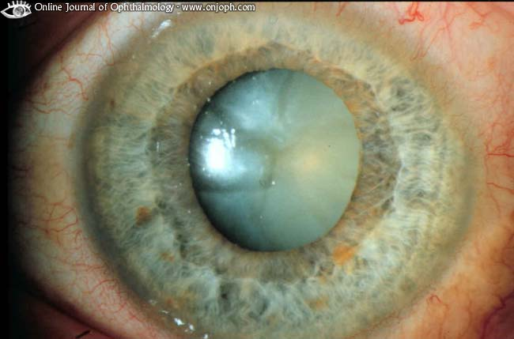
Source of picture: “Online Journal of Ophthalmology” >>

Mature cataract: whitish opacification of whole lens with bulging of lens material in pupillary area (imminent phacolytic glaucoma):
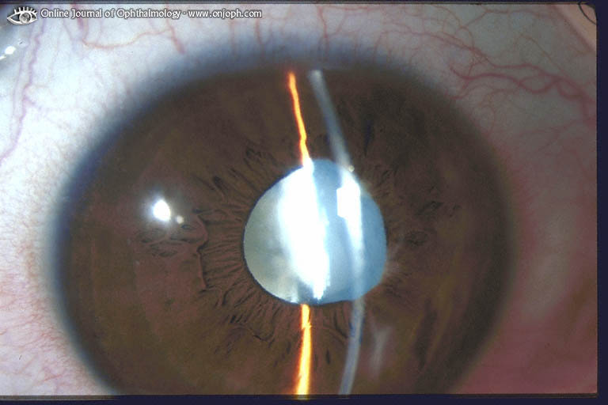
Source of picture: “Online Journal of Ophthalmology” >>

Morgagni cataract - hypermature cataract in which brown nucleus gravitates within liquefied milky-white capsule (risk of phacolytic glaucoma):
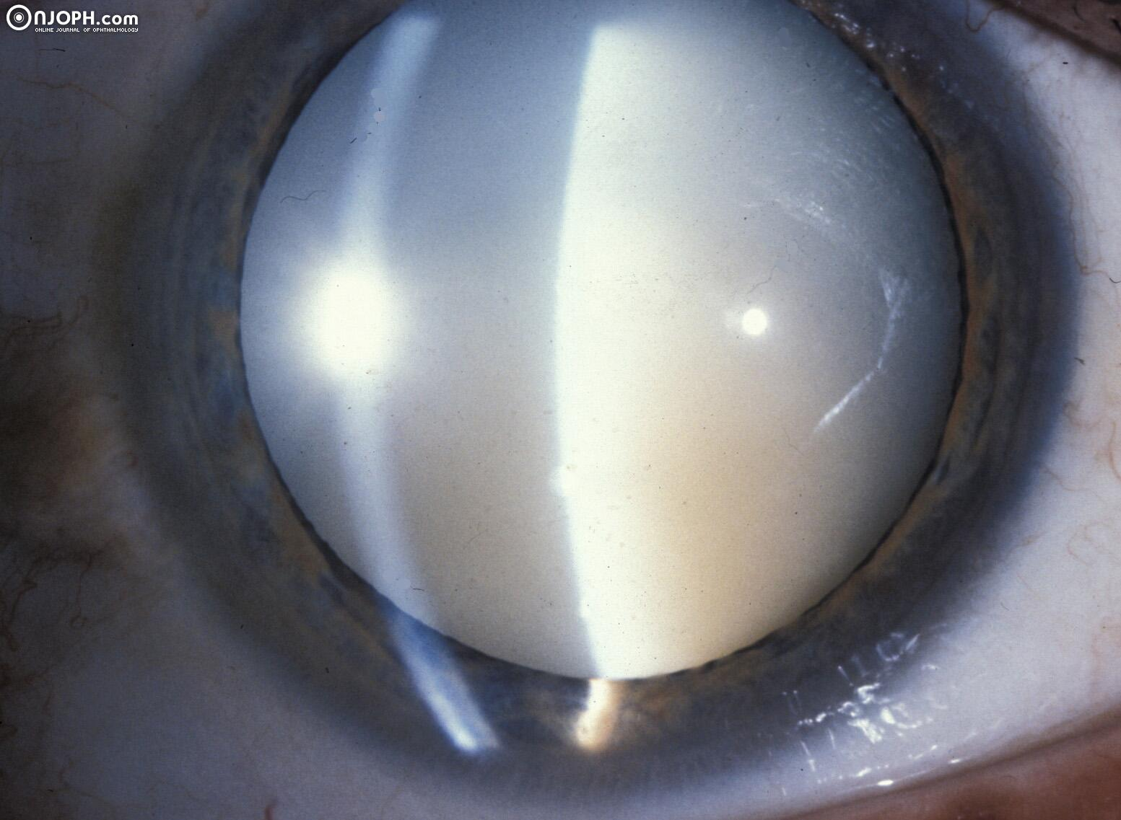
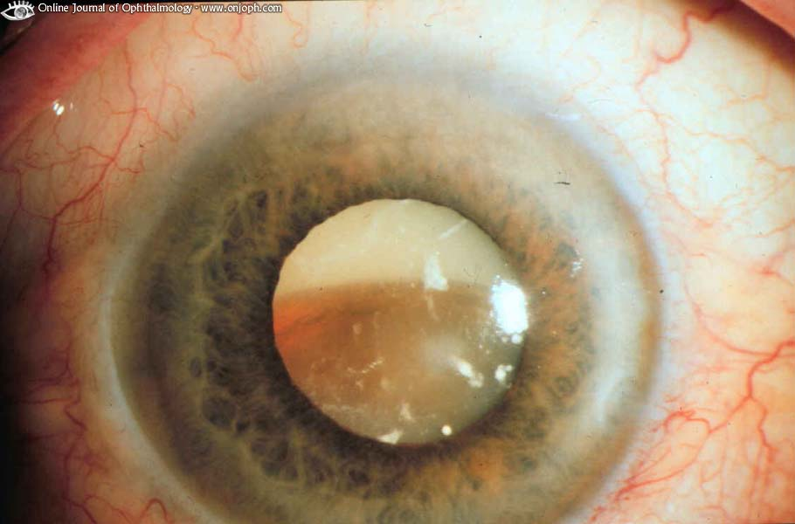
Source of picture: “Online Journal of Ophthalmology” >>

Treatment
No proven medical treatment exists to delay, prevent, reverse development of senile cataracts!
- frequent refractions & eyeglass changes maintain vision during cataract development.
- chronic pupillary dilation is helpful for small lenticular opacities.
- UV-coated glasses must be worn in sunlight.
- investigated medications:
  - aldose reductase inhibitors, sorbitol-lowering agents
  - aspirin
  - glutathione-raising agents
  - antioxidant vitamins C and E.

Surgery
- indications:
  - maximally corrected vision ≤ 20/50 (6/15)
  - subjective visual impairment that prevents activities (e.g. driving, reading, occupational activities).
  - disabling glare (most common with posterior subcapsular cataracts).
  - lens-induced diseases (e.g. phacolytic glaucoma, phacoantigenic uveitis).
  - need to visualize fundus for management of diseases (e.g. diabetic retinopathy, glaucoma).
- 30-60 min prior operation instill 1 gtt 2,5% phenylephrine to achieve good mydriasis.
- local anesthesia + IV sedation.

Extraction techniques
- intracapsular cataract extraction (now rarely performed) - removing cataract in one piece (i.e. extraction of entire lens, including posterior capsule).
- no need to worry about subsequent development of capsular opacity.
- less sophisticated equipment needed.
- uses larger limbal incision (often 160-180°) - following risks: delayed healing, significant against-the-rule astigmatism, iris incarceration, postoperative wound leaks, vitreous incarceration, corneal edema.
- because posterior capsule is not intact, IOL must be implanted either in anterior chamber or sutured to posterior chamber (both are more difficult than simply placing IOL in capsular bag).
- indication - severely impaired zonular integrity (doesn’t allow successful extracapsular lens removal and IOL implantation).
- absolutely contraindicated in children & young adults, cases with traumatic capsular rupture.

- extracapsular cataract extraction (ECCE) - removing hard central nucleus in one piece (through opening in anterior capsule), then removing soft cortex in multiple small pieces; retention of posterior capsule integrity.
- smaller incision is required; less short and long-term complications.
- better anatomic IOL placement (in capsular bag).
- intact posterior capsule also reduces iris & vitreous mobility that occurs with saccadic movements (endophthalmodonesis).
- main requirement is zonular integrity.

- phacoemulsification - dissolving hard central nucleus within eye by ultrasound, then removing soft cortex in multiple small pieces.
- differs from standard ECCE by method of nucleus extraction - ultrasonically driven needle fragments nucleus and aspirates lens substrate through needle port.
- uses smallest incision (≈ 4 mm)!!!
- with advent of phacoemulsification, patients are advised against delaying lens extraction to point when cataract is hard and mature and likelihood of postoperative complications increases.

Intraocular lens (IOL) - plastic or silicone; implanted intraocularly (such eye is called pseudophakic):
  - in front of iris (anterior chamber IOL)
  - attached to iris and within pupil (iris plane IOL) - now rarely used (high frequency of postoperative complications).
  - behind iris (posterior chamber IOL) - most common placement.
- IOL power must be compatible with refractive error of fellow eye to avoid postoperative anisometropia.

aphakia may be better choice in highly inflamed eyes and young children; they experience better outcomes if lens implantation is deferred;
- if IOL is not implanted, contact lenses / thick glasses are needed.

Postoperative period:
- eye shield for a few hours after; then wear shield while sleeping;
- tapering schedule of topical antibiotics & topical corticosteroids for 4 wk.
- avoid Valsalva maneuver, heavy lifting, bending forward too far, eye rubbing.
- refraction is stable at 6-8th postoperative week - corrective lenses can be prescribed.
- 95% eyes achieve vision ≥ 20/40 (6/12).

Complications of cataract surgery: retinal detachment, cystoid macular degeneration, bullous keratopathy, choroidal hemorrhage (causing intraocular contents to be expulsed through incision), endophthalmitis, posterior capsular opacification (treatable with YAG laser), glaucoma.

CONGENITAL CATARACT
- Chromosomal abnormalities - trisomies (Down, Edward, Patau syndromes).
- Metabolic disease (e.g. galactosemia [classic "oil droplet" cataract], hypoglycemia, dystrophia myotonica)
- Intrauterine infection (toxoplasmosis, rubella, cytomegalovirus, herpes simplex [i.e. TORCH])
- Maternal disease during pregnancy.

- may present as irregular red reflex, nystagmus, squint, amblyopia.
- if opacity is in visual axis, it is considered visually significant and may lead to blindness (deprivation amblyopia)!
if cataract is small, in anterior lens portion, or in periphery, no visual loss may be present.
- treatment - visually significant cataract must be removed within first 17 weeks (ideally < 2 months);
  - extracapsular extraction with primary* posterior capsulectomy and anterior vitrectomy is procedure of choice!
*young eyes develop capsular opacification very quickly necessitating primary capsulectomy at time of cataract extraction;
intracapsular extraction in children is contraindicated (because of vitreous traction and loss at Wieger capsulohyaloid ligament).
  - IOL routinely is not placed!
  - postoperative visual correction with spectacles / contact lenses / epikeratophakia (suturing of human cornea, lathed like contact lens, onto recipient's cornea) is difficult but necessary to achieve good vision.
- in unilateral cases, refractive amblyopia is serious risk! (even after cataract is removed – because quality of image in operated eye is inferior to that in normal eye).
- postoperative - many years of refractive correction (contact lenses or aphakic glasses), possible patching for amblyopia, frequent glaucoma screenings throughout life!

Bibliography for ch. “Ophthalmology” → follow this link >>

Viktor’s Notes℠ for the Neurosurgery Resident
Please visit website at www.NeurosurgeryResident.net

