Corneal Disorders
Last updated: May 9, 2019
Corneal Abrasion 1
Treatment 1
Superficial Punctate Keratitis 1
Corneal Ulcer 2
Etiology 2
Symptoms & Signs 2
Diagnosis 4
Treatment 4
Bacterial keratitis 4
Peripheral Ulcerative Keratitis (Marginal Keratolysis; Peripheral Rheumatoid Ulceration) 5
Keratoconjunctivitis Sicca (KCS) 6
Symptoms & Signs 6
Diagnosis 6
Treatment 6
Phlyctenular Keratoconjunctivitis 6
Interstitial (Parenchymatous) Keratitis 7
Keratomalacia (Xerotic Keratitis; Xerophthalmia) 7
Keratoconus 8
Etiology 8
Pathology 8
Clinical Features 8
Diagnosis 8
Treatment 8
Bullous Keratopathy 8
Neurotrophic Keratopathy 8
Treatment 9
Corneal Transplantation (s. Penetrating Keratoplasty) 9
Indications 9
Donor Tissue Selection 9
Surgical Technique 9
Postoperative Management 9
Complications 9
Prognosis 9
Herpetic keratitis → see p. 256 (5) >>
Acute follicular conjunctivitis, epidemic keratoconjunctivitis → see p. 258 (2) >>

Any cornea opacification in red eye is corneal infection until proven otherwise (opacification may or may not take up fluorescein) - this is ophthalmic emergency!

Corneal Abrasion
- defect limited to epithelial layers and does not penetrate Bowman membrane.
- most common eye injury.
- will heal rapidly without serious sequelae.
- etiology - any form of contact lens wear (multiple abrasions on central cornea, epithelial disease (e.g. dry eye), physical or chemical ocular injuries (e.g. foreign bodies under eyelid).
- normally corneal epithelial cells are shed continuously into tear pool and simultaneously replenished by cells moving:
    - anteriorly from basal epithelium layer (rapid - requiring 7-10 days).
    - centrally from limbus (slow - may require months)
  - limbal damage causes delayed healing, recurrent epithelial erosions, corneal vascularizations, conjunctival epithelial ingrowth.
  - symptoms - foreign body sensation, sharp pain aggravated by lid movement, photophobia, tearing, circumcorneal conjunctival injection and occasionally eyelid swelling.
  - diagnosis - slit lamp examination with fluorescein staining; tetracaine drop will cause burning → pain relief.
  - close follow-up care is necessary (because of ever-present danger of abrasion progressing to ulcer) until no staining with fluorescein occurs.
N.B. essentially all corneal ulcers begin with abrasion!
abrasions from vegetable matter - high risk for fungal ulcers;
abrasions from contact lens wear - risk for pseudomonal and amebic keratitis.

Treatment
  - ophthalmologists justify topical antibiotic (topical fluoroquinolones) for even minor corneal abrasion.
  - severe pain → oral NSAIDs ± soft bandage contact lens.
N.B. outpatient use of anesthetic eye drops is risky – overuse may soften cornea and lead to ulceration!
  - eye may or may not be patched (N.B. patching should not be performed in eyes at higher risk of infection - contact lens wearers, trauma caused by vegetable matter).
  - abrasions should heal in 48 h.

Superficial Punctate Keratitis
- scattered, fine, punctate loss of corneal epithelium.
- etiology - viral conjunctivitis; blepharitis; keratitis sicca; trachoma; UV exposure (e.g. “snow blindness”); contact lens overwear; drugs - topical or systemic (e.g. adenine arabinoside); preservative toxicity.
- symptoms - photophobia, foreign-body sensation, lacrimation, conjunctival hyperemia, decreased vision.

Multiple erosions in center of cornea due to tight contact lens fit:
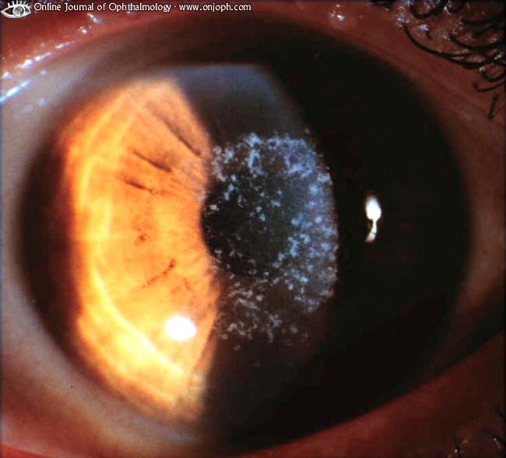
Source of picture: “Online Journal of Ophthalmology” >>

Dry eye disease; fluorescein staining shows many punctate epithelial lesions and also demonstrates small strands of mucous adherence:
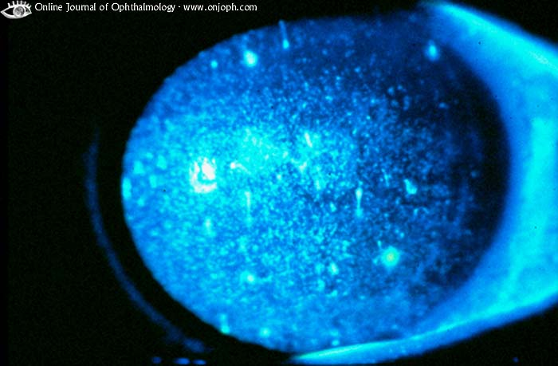
Source of picture: “Online Journal of Ophthalmology” >>

- treatment:
adenovirus conjunctivitis – resolves spontaneously in about 3 wk.
UV exposure – keratitis heals in 24 hours: short-acting cycloplegics, systemic analgesics, patching for 24 h.
contact lens overwear – antibiotic ointment, eye is not patched (because of high incidence of serious infection).

Corneal Ulcer
- local necrosis of corneal tissue.

Etiology
- Infection:
  - bacteria (most commonly Staphylococcus, Pseudomonas, Streptococcus pneumoniae).
  - fungi
  - viruses
  - Acanthamoeba see p. Eye72 >>
- Bullous keratopathy, cicatricial pemphigoid.
- Corneal trauma, corneal foreign body (incl. sleeping in contact lenses, inadequate contact lens sterilization).
- Vitamin A deficiency, protein malnutrition.
- Eyelid abnormalities (e.g. entropion, trichiasis, corneal exposure due to incomplete eyelid closure).
- Connective tissue disease (RA is most common systemic vasculitic disorder to involve ocular surface!) – see below (peripheral ulcerative keratitis).

Symptoms & Signs
- ache, foreign-body sensation, photophobia, lacrimation.
- ulcer begins as dull, grayish, circumscribed superficial opacity → necroses and suppurates to form excavated ulcer.
- considerable circumcorneal hyperemia; in long-standing cases blood vessels may grow in from limbus (corneal neovascularization).
- ulcer may spread to involve width of cornea or may penetrate deeply; pus may appear in anterior chamber (hypopyon).
- complications - iridocyclitis, corneal perforation (with iris prolapse, panophthalmitis, eye destruction).
- ulcers heal with scar tissue (opacification → decreased vision).

Bacterial Corneal Ulcer: cornea is heavily infiltrated; in center tissue has melted away and descemetocele has developed:
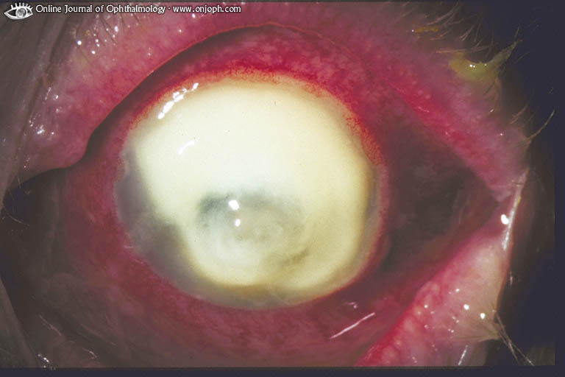
Source of picture: “Online Journal of Ophthalmology” >>

Dendritic Keratitis, Recurrence After Keratoplasty, Fluorescein: corneal transplant in eye with herpetic corneal scarring is infected by herpes:
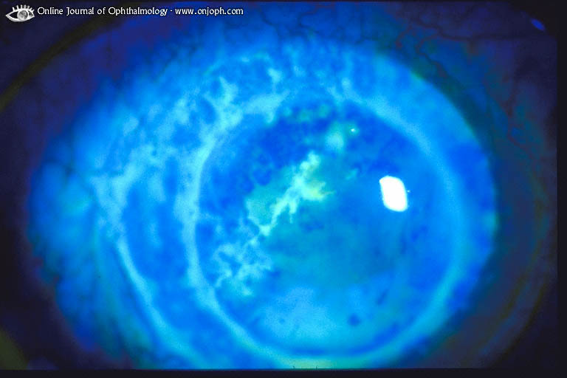
Source of picture: “Online Journal of Ophthalmology” >>

Dendritic Keratitis, areas no longer active leave superficial scar:
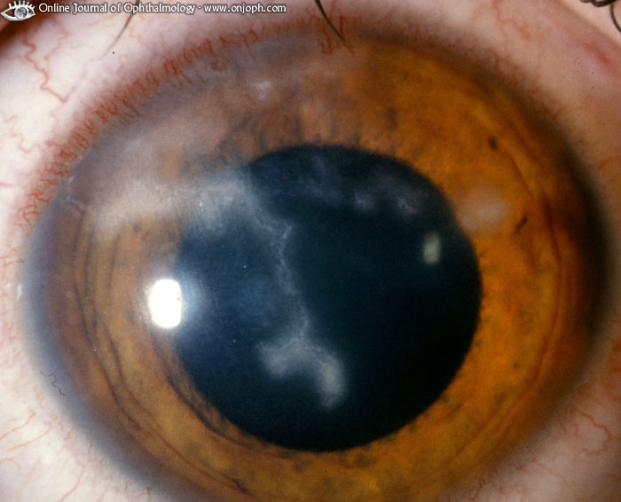
Source of picture: “Online Journal of Ophthalmology” >>

Dendritic Keratitis, fluorescein outlines lesion much better than normal slitlamp view:
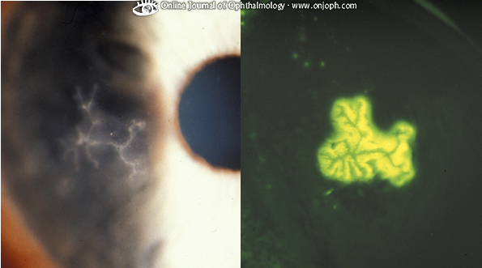
Source of picture: “Online Journal of Ophthalmology” >>

Recurrent herpetic keratouveitis, central cornea is thinned and has cleared while margin is still active; strong neovascularization:
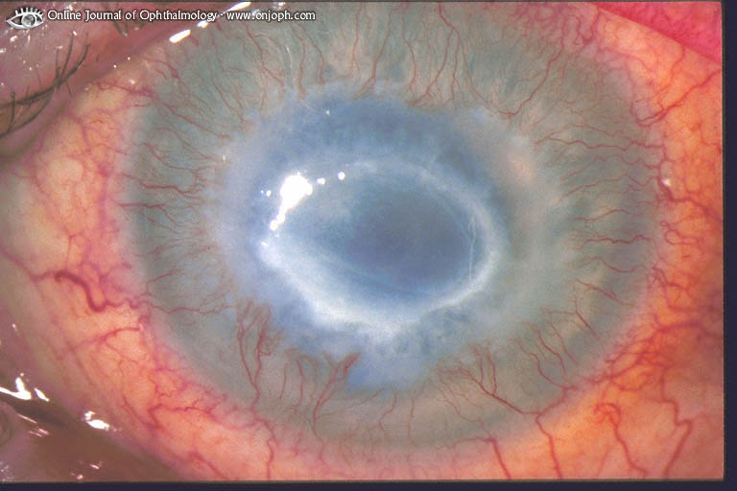
Source of picture: “Online Journal of Ophthalmology” >>

Disciform Herpetic Keratitis and Keratouveitis, Rose-bengal stain of necrotic corneal epithelium, pupil is distorted due to posterior synechiae (sign of uveitis):
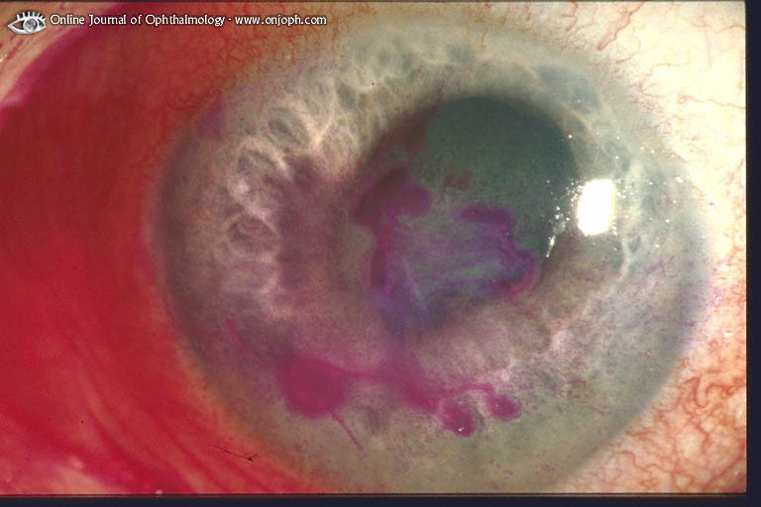
Source of picture: “Online Journal of Ophthalmology” >>

serpiginous keratitis (s. ulcus serpens) - severe, creeping, central, suppurative ulcer often due to pneumococci.

Diagnosis
- corneal epithelial defects stain green with 1% fluorescein.

Treatment
Corneal ulcers are emergencies - should be treated only by ophthalmologist!
Do not patch eye!
Drugs:
- broad-spectrum topical antibiotics (every 15 minutes; beware toxicity – esp. gentamicin – delays epithelization).
- cycloplegics
- topical / systemic immunosuppressive agents (if etiology necessitates)
N.B.B. in herpes simplex etiology (dendritic corneal ulcers) topical steroids can result in massive ameboid ulceration → blindness!
Surgical Care:
- resection of adjacent conjunctival tissue.
- perforation → lamellar or penetrating keratoplasty (cyanoacrylate glue application is frequently inadequate).

Bacterial keratitis
- presents acutely (within 24 h) - pain, photophobia, tearing, purulent discharge, reduced vision.
- whitish-yellow stromal infiltrate under epithelial defect + anterior chamber reaction + conjunctival injection → stromal and epithelial edema, hypopyon → stromal necrosis.
- firm diagnosis - positive culture (cultures often are negative!) from corneal scrapings.
- treatment - broad-spectrum topical antibiotics (e.g. cefazolin + tobramycin starting at every 15-30 minutes).
- with prompt therapy most bacterial corneal infections can be cured with little sequelae.

Pseudomonas Keratitis - acutely inflamed eye with circular infiltrate:
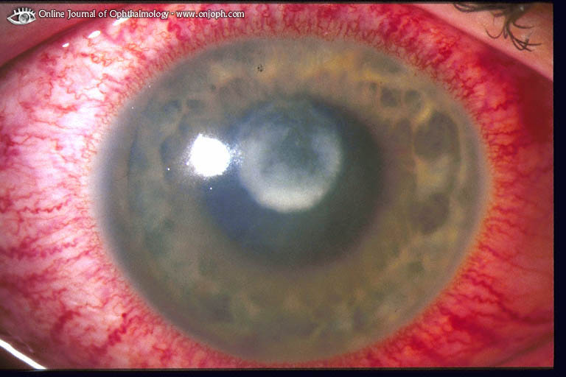
Source of picture: “Online Journal of Ophthalmology” >>

Hypopyon:
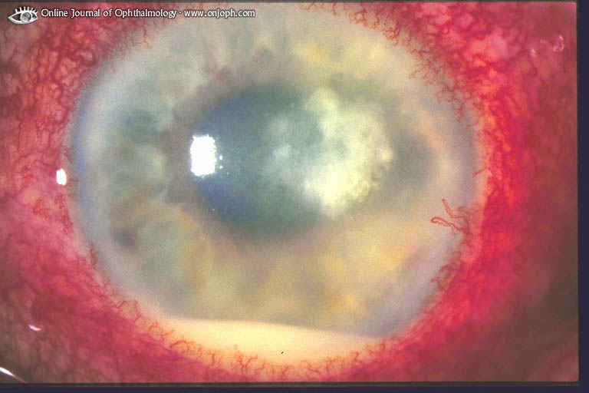
Source of picture: “Online Journal of Ophthalmology” >>

Peripheral Ulcerative Keratitis
(Marginal Keratolysis; Peripheral Rheumatoid Ulceration)
- peripheral corneal inflammation & ulceration.
- often associated with active collagen vascular diseases (e.g. RA, Wegener granulomatosis, relapsing polychondritis).
- decreased vision, photophobia, foreign-body sensation.
- in periphery of cornea - area of opacification (infiltration by WBCs and ulceration - stains green with fluorescein).

Marginal Rheumatoid Corneal Ulcer (Furrow): Peripheral cornea melting without gross inflammatory reaction is well visible in slitlamp beam:
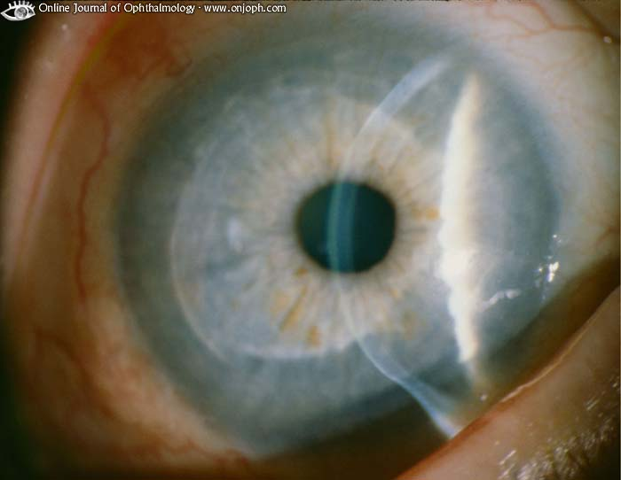
Source of picture: “Online Journal of Ophthalmology” >>

Corneal Ulcer, Rheumatic Polyarthritis: bland chronic (as indicated by vessels) corneal ulcer with beginning descemetocele; corneal tissue has melted away without much cellular infiltration:
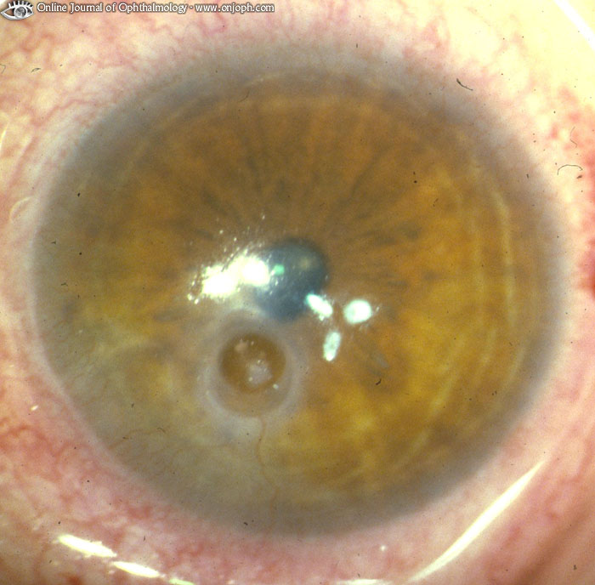
Source of picture: “Online Journal of Ophthalmology” >>

Keratoconjunctivitis Sicca (KCS)
- chronic, bilateral desiccation of conjunctiva & cornea due to:

- aqueous tear-deficient keratoconjunctivitis sicca - inadequate tear volume:
- isolated idiopathic condition (most commonly).
- Sjögren syndrome
- scarring of lacrimal ducts - cicatricial pemphigoid, Stevens-Johnson syndrome, trachoma.
- damaged lacrimal gland - graft-versus-host disease, local radiation therapy, familial dysautonomia.

- evaporative keratoconjunctivitis sicca excessive tear loss (accelerated evaporation) because of poor tear quality (e.g. mucin deficiency in avitaminosis A).

Symptoms & Signs
- itching, burning, photophobia, foreign body sensation, gritty sensation, pressure behind eye → flood of tears after severe irritation.
- patients blink at accelerated rate.
- hyperemic conjunctiva; scattered, fine, punctate loss of corneal (superficial punctate keratitis) and/or conjunctival epithelium - mainly areas between eyelids (these areas stain with fluorescein).
aqueous tear-deficient KCS - conjunctiva appears dry, lusterless with redundant folds.
evaporative KCS - abundant tears, foam at eyelid margin, often associated blepharitis and acne rosacea.
- rarely decreases vision, but eyes are so irritated that it is difficult to use them.
- symptoms can be aggravated by:
- prolonged visual efforts (reading, working on computer, driving, watching TV)
- local environments (dusty, smoky, dry environments).
- drugs (isotretinoin, tranquilizers, diuretics, antihypertensives, oral contraceptives, all anticholinergics).
- symptoms improve in high-humidity environments.

Diagnosis
- decreased tear meniscus at lower lid margin (on slit lamp examination).

Aqueous tear-deficient KCS → Schirmer test:
- standardized strips of filter paper are placed, without topical anesthesia, at junction between middle and lateral third of lower lid;
- ≤ 5 mm of paper wetting after 5 min (on two successive occasions) confirms diagnosis (norma > 15 mm).

Evaporative KCS → tear breakup test:
- instill small volume of highly concentrated fluorescein (to make tear film visible) → accelerated rate of loss of intact tear film.

Treatment
artificial tears - effective for both forms of KCS.
- more viscous artificial tears are particularly useful in evaporative KCS.
- artificial tear ointments particularly useful for nocturnal lagophthalmos.
humidifiers
- in recalcitrant cases → occlusion of nasolacrimal punctum, partial tarsorrhaphy.

Phlyctenular Keratoconjunctivitis
- discrete nodular inflammation areas (phlyctenules) of cornea / conjunctiva.
- delayed hypersensitivity reaction to unknown antigen (mycobacteria, chlamydia, Staphylococcal proteins in primary seborrheic blepharitis?).
- usually children; uncommon in USA.
- phlyctenules - crops of small yellow-gray hard 1-3 mm nodules surrounded by hyperemia on limbus, cornea, bulbar conjunctiva;
- ulcerate but heal within 1-2 weeks;
- leave no scar on conjunctiva;
- leave corneal opacity and vascularization with vision loss.
- treatment - topical corticosteroid-antibiotic combination.

Interstitial (Parenchymatous) Keratitis
- chronic, nonulcerative-nonsuppurative cellular infiltration of deep corneal layers.
- etiology:
  - leading cause - syphilis - congenital (usually as late finding in children) or acquired; immune-mediated reaction to unknown treponemal antigen; uncommon in USA.
  - Cogan's syndrome (triad – interstitial keratitis, vestibulo-auditory disease, autoimmune vasculitis - prompt referral to rheumatologist is necessary!).
  - Lyme disease, Epstein-Barr, herpes virus infection, tbc, leprosy
- photophobia, pain, lacrimation, gradual vision loss.
- lesion begins in deep corneal stroma (no primary involvement of corneal epithelium or endothelium!);
- soon entire cornea develops ground-glass appearance, obscuring iris.
- new blood vessels grow in from limbus and produce orange-red areas (salmon patches of Hutchinson); these vessels often regress, leaving behind remnants (ghost vessels);
- progressing corneal thinning may lead to perforation;
- often associated with uveitis (iritis, iridocyclitis, choroiditis).
- inflammation and neovascularization begin to subside after 1-2 mo (some corneal opacity may remain).
- treatment – topical steroids ± antibiotics / antiviral agents.
- without treatment, permanent corneal opacity is typical → corneal transplantation.

Disciform Herpetic Keratitis, stromal infiltrate and endothelial decompensation:
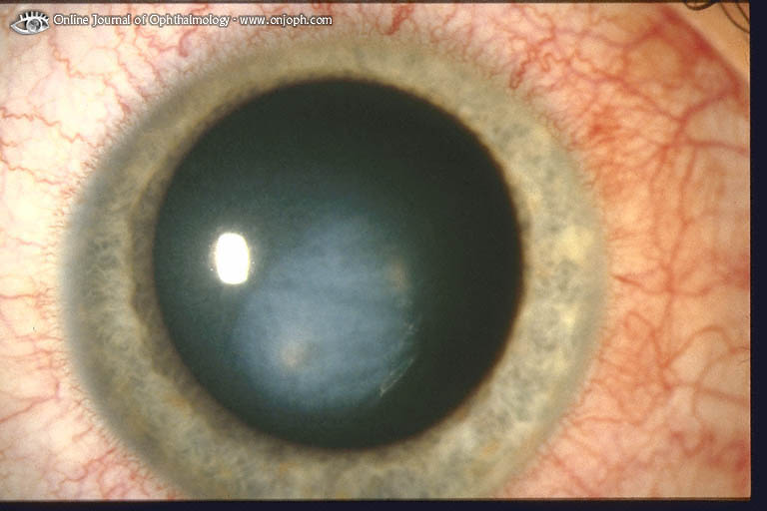
Source of picture: “Online Journal of Ophthalmology” >>

Luetic Keratitis Parenchymatosa; cloudy vascularized (ghost vessels) corneal scars indicate former inflammation, caused by connatal syphilis:
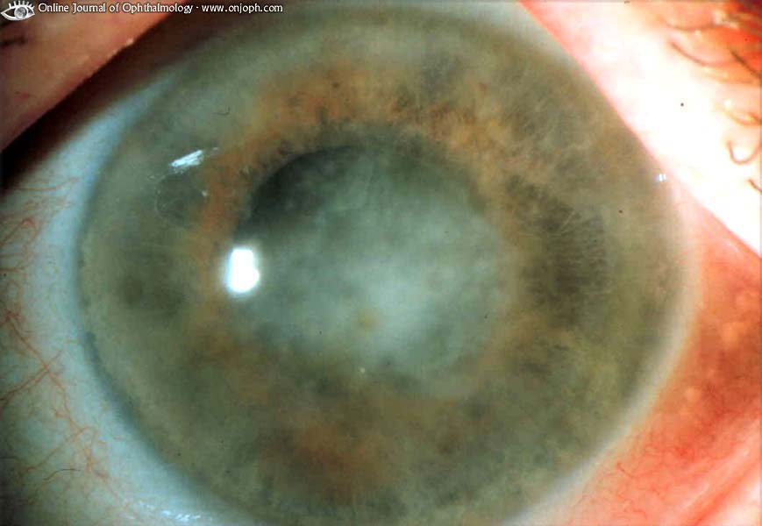
Source of picture: “Online Journal of Ophthalmology” >>

Keratomalacia (Xerotic Keratitis; Xerophthalmia)
- hazy, dry cornea that becomes denuded.
- etiology - vitamin A deficiency and protein-calorie malnutrition.
- corneal ulceration (with secondary infection) is common.
- associated findings - affected lacrimal glands (extreme eyes dryness), foamy Bitot spots on bulbar conjunctiva, night blindness.

Melting away of peripheral corneal tissue due to lack of vascular tissue (Wegener's granulomatosis, polyarthritis, polyarteritis nodosa); iris is prolapsed into corneal defect (peaked pupil):
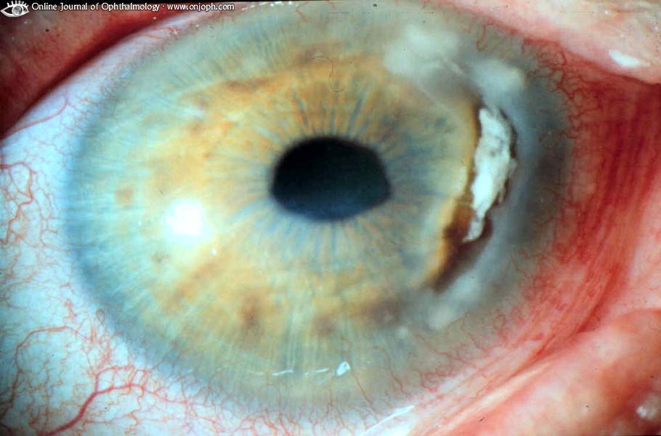
Source of picture: “Online Journal of Ophthalmology” >>

Keratoconus
- slowly progressive, noninflammatory paraxial (usually inferior to pupil) stromal thinning → corneal ectasia.

Etiology
- commonly isolated ocular condition.
- commonly recognized associations - vernal keratoconjunctivitis, retinitis pigmentosa, Leber congenital amaurosis; systemic connective tissue disorders (e.g. Ehlers-Danlos, Marfan syndromes).
- risk factors - atopic history, rigid contact lens wear, vigorous eye rubbing.

Pathology
- all corneal layers are affected.
- most notable features – thinning of corneal stroma, ruptures in Bowman layer, iron deposition in basal epithelial cells (forming Fleischer ring).
- cornea assumes cone shape → major changes in refractive power (frequent change of eyeglasses).
- advanced cases rarely progress to corneal hydrops (s. acute keratoconus) - breaks in Descemet layer lead to central stromal edema and potentially secondary severe corneal scarring.

Clinical Features
- bilateral (but usually asymmetrical), beginning at age 10-20.
- progressively decreasing vision (distortions, glare/flare, monocular diplopia or ghost images) - multiple unsatisfactory attempts in obtaining optimum spectacle correction.
- although progressive, stabilizes after some time in most patients.
visual loss:
      - primarily from irregular astigmatism and myopia
      - secondarily from corneal scarring.

Diagnosis
- irregularly astigmatic keratometry values (egg-shaped, esp. corneal inferior steepening).
- diagnosis confirmation - computer-assisted videokeratography.
- other findings - iron deposition in basal epithelial cells in (often partial) ring shape at base of conical protrusion called Fleischer ring; corneal scarrings.

Treatment
- treat any conditions that lead to eye rubbing!
- mainstay of treatment - rigid gas permeable contact lenses.
- acute treatment of corneal hydrops is palliative (hyperosmotic NaCl 2-5% drops may provide temporary relief).
- corneal transplant (penetrating keratoplasty) surgery may be necessary (indication - vision not correctable to better than 20/40 –10-20% of all patients).
    - contact lenses are often still required postgraft for optimum vision.
    - although extremely rare, KC can recur in graft.

Bullous Keratopathy
- failure of corneal endothelium → corneal edema → subepithelial fluid-filled bullae → decreased vision.
- etiology:
    - Fuchs' corneal endothelial dystrophy (bilateral, progressive corneal endothelial cell loss)
    - corneal endothelial trauma (e.g. intraocular surgery, poorly designed / malpositioned intraocular lens implant).
- some bullae rupture → foreign-body sensation, bacteria invasion → corneal ulcer.
- treatment:
- dehydrating agents (e.g. hypertonic saline)
- intraocular pressure-lowering agents
- soft contact lenses
- corneal transplantation.

Neurotrophic Keratopathy
- degenerative disease due to decreased corneal sensitivity (hypesthesia):
- cornea susceptible to injury, decreased reflex tearing → ulceration, infection.
- poor corneal healing → melting, perforation.
N.B. sensory nerves exert trophic influence on corneal epithelium - epithelial sloughing can occur without any trauma!
sympathetic neuromediators & prostaglandins further decrease epithelial cell mitosis.

- etiology – herpetic infections of cornea, CN5 palsy (e.g. surgery for trigeminal neuralgia, surgery for acoustic neuroma), topical anesthetic abuse, corneal surgery, etc.
- ectropion, lagophthalmos, thyroid ophthalmopathy hasten progression.
- Cochet-Bonnet esthesiometer can give quantitative measurement of corneal sensitivity (it consists of nylon filament, which can be extended from device to different lengths and touched to cornea until it bends or patient responds; small diameter of instrument allows accurate testing of different areas of cornea; shorter length of filament required, less sensitive cornea).

Treatment
- Topical lubrication (preservative-free artificial tears, gels, ointments)
- Topical tetracycline (anticollagenolytic - increases healing of epithelial defects)
- Surgery:
    - closure of lids (lateral tarsorrhaphy, palpebral spring, botulinum A toxin injection in levator muscle).
    - closure of persistent epithelial defect (conjunctival flap, amniotic membrane transplantation).
    - repair of deep ulceration (lamellar keratoplasty, penetrating keratoplasty, multilayer amniotic membrane transplantation, cyanoacrylate glue with soft bandage contact lens).

Corneal Transplantation (s. Penetrating Keratoplasty)
Indications
- To improve optical qualities of cornea (e.g. opaque/scarred cornea, irregular astigmatism due to keratoconus).
- To reconstruct cornea to preserve eye (e.g. perforated cornea).
- To treat disease unresponsive to medical management to preserve eye (e.g. severe, uncontrolled fungal corneal ulcer), or to alleviate pain (e.g. recurrent ruptured bullae in bullous keratopathy).

The most common indications (in descending order)
- bullous keratopathy (pseudophakic, Fuchs' endothelial dystrophy, aphakic)
- keratoconus
- repeat graft
- keratitis / postkeratitis, perforation
- corneal stromal dystrophies.

Donor Tissue Selection
- tissue matching is not necessary!
- donor's blood is tested for HIV-1, HIV-2, hepatitis B, hepatitis C.

Surgical Technique
- general or local anesthetic.
- surgeon punches out corneal button from central part of donor cornea using trephine → surgeon removes central 60-80% of host cornea using trephine and scissors → donor corneal button (trephined slightly larger than recipient bed) is sutured in place.

Postoperative Management
- topical antibiotics for several weeks.
- topical corticosteroids for several months.
- corneal astigmatism can be reduced by suture adjustment or selective suture removal.
- full visual potential may take up to 1 yr (changing refraction, slow wound healing); earlier and better vision is attained with rigid contact lens over corneal transplant.
- wear shields, glasses, sunglasses; avoid bending over completely, lifting heavy objects, straining, Valsalva maneuver.

Complications
Graft rejection is not uncommon – after > 2 weeks post operation: decreased vision, photosensitivity, ocular ache, ocular redness.
H: topically (± periocular injection, oral) corticosteroids; regraft is possible.

Repeat Keratoplasty: first large graft is clouded and vascularized, small second graft is clear:
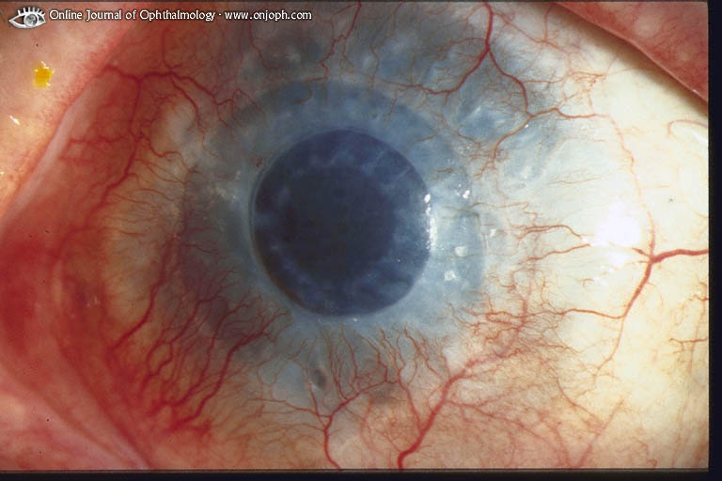
Source of picture: “Online Journal of Ophthalmology” >>

Prognosis
- current 5-year graft failure rate is ≈ 35%.
- chance of long-term transplant success:
> 90% for keratoconus, corneal scars, early bullous keratopathy, corneal stromal dystrophies;
80-90% for bullous keratopathy, inactive viral keratitis;
50% for active corneal infection;
0-50% for chemical or radiation injury.
- factors for high rate of success:
- avascularity of cornea
- anterior chamber has no lymphatic drainage.
- effectiveness of immunosuppressive drugs.

Arcus Lipoides Senilis (Gerontoxon):
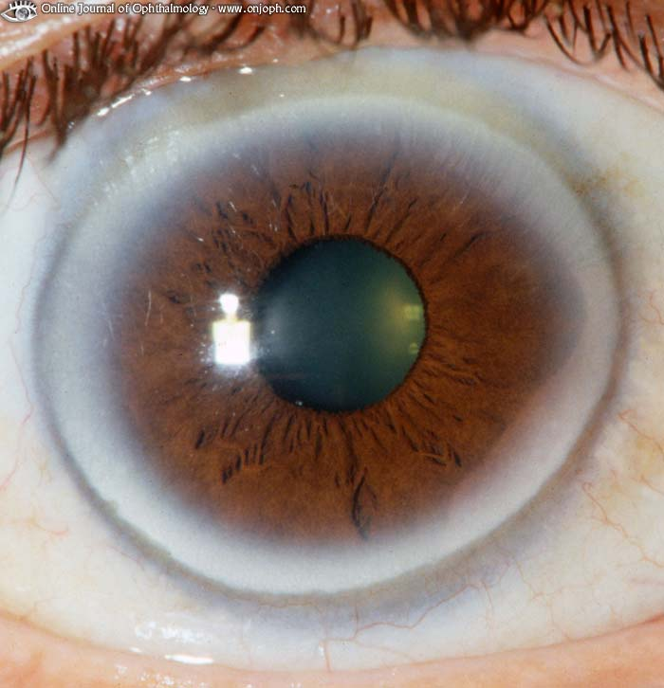
Source of picture: “Online Journal of Ophthalmology” >>

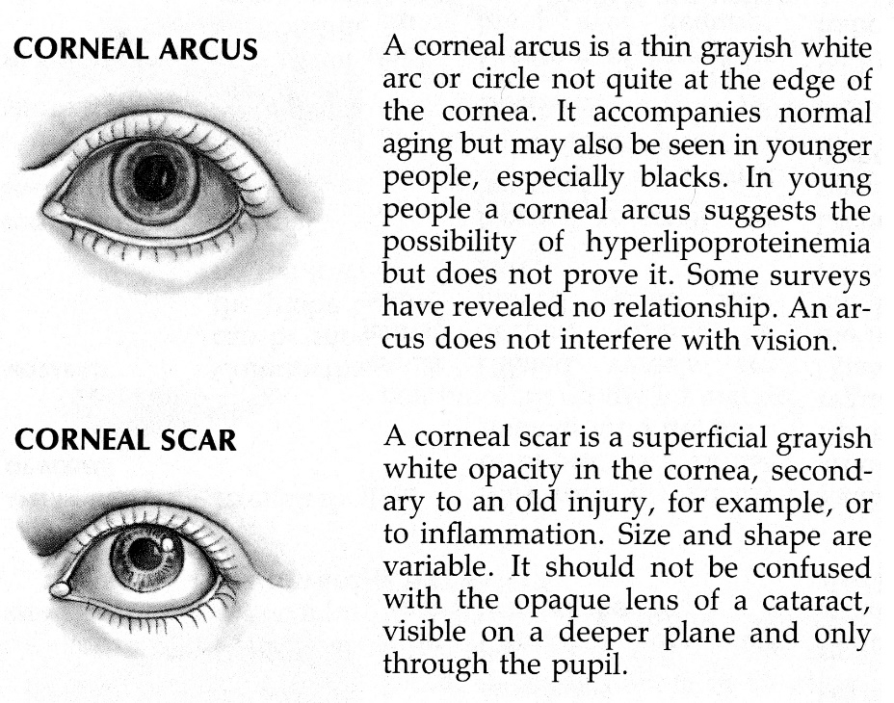

Bibliography for ch. “Ophthalmology” → follow this link >>

Viktor’s Notes℠ for the Neurosurgery Resident
Please visit website at www.NeurosurgeryResident.net

