Vitreous Disorders
Last updated: May 9, 2019
Vitreous Hemorrhage 1
Etiology 1
Treatment 1
Posterior vitreous detachment 1

Vitreous Hemorrhage
- blood extravasation within or around vitreous body.

Etiology
    - retinal neovascularization - neovascular fragile vessels (e.g. diabetic retinopathy!!!, retinal vein occlusion, retinopathy of prematurity)
    - posterior vitreous detachment with retinal vascular tear, retinal tears, ocular trauma
    - subretinal bleeding with secondary extension into vitreous.
    - Terson syndrome: SAH → acutely elevated ICP transmitted to retinal venules via optic nerve; 33% SAH patients have associated intraocular hemorrhage!!!
N.B. coagulation disorders / anticoagulant therapy does not cause vitreous hemorrhage!

Clinical features - large floaters, painless monocular visual loss.
- hemorrhage tends to absorb slowly.

Complications:
    - hemosiderosis bulbi with photoreceptor toxicity
    - glaucoma secondary to blockade of trabecular meshwork by formed ghost cells (develop from long-standing blood cells in vitreous)
    - severe floaters
    - myopic shift and amblyopia in infants.

Diagnosis - black reflex on ophthalmoscopy; blood impedes complete fundus examination (H: B-scan ultrasonography).
N.B. examine carefully to rule out possible retinal detachment!

Old Vitreous Hemorrhage; diffuse yellowish opacity through which one may get orange reflex; it consists of breakdown products of hemoglobin:
Source of picture: “Online Journal of Ophthalmology” >>

Old Vitreous Hemorrhage, Histology; hemoglobin breakdown products are seen in addition to erythrocyte ghost cells (arrow):
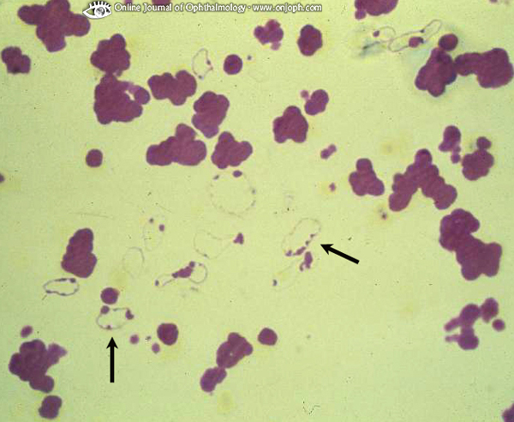
Source of picture: “Online Journal of Ophthalmology” >>

Treatment
- bed rest with head elevated 30-45° with occasional bilateral patching (to allow blood to settle inferiorly).
- treat cause (e.g. photocoagulation of new vessels).
localized bleeding → photocoagulation.
nonclearing vitreous hemorrhage → pars plana vitrectomy.

Posterior vitreous detachment
- contraction of vitreous gel → separation from retina → macroscopic opaque aggregates of vitreous fibers floating in vitreous → floaters (become less noticeable with time).
- more prevalent in highly myopic and older persons.

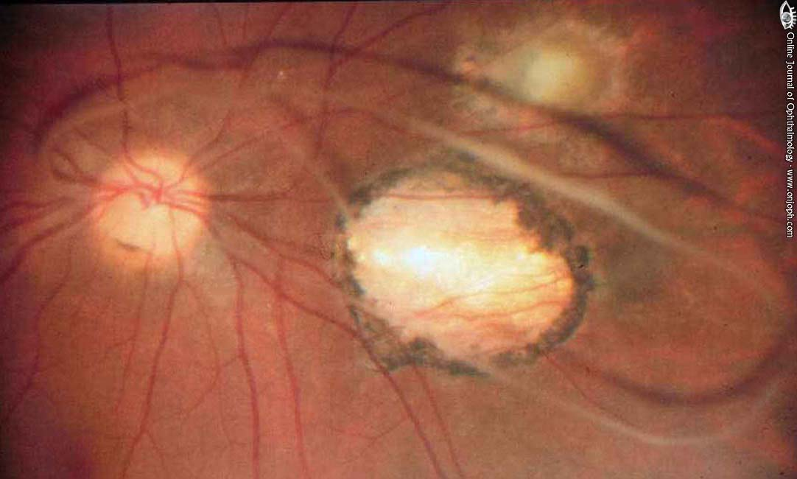

Posterior vitreous detachment without Weiss ring:
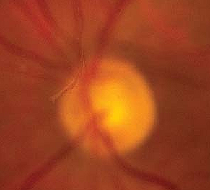

Bibliography for ch. “Ophthalmology” → follow this link >>

Viktor’s Notes℠ for the Neurosurgery Resident
Please visit website at www.NeurosurgeryResident.net

