Lacrimal Disorders
Last updated: May 9, 2019
Dacryostenosis 1
Clinical Features 1
Treatment 1
Dacryocystitis 1
Dacryoadenitis 2

Tear film provides:
- smooth and transparent refractive surface
- essential moisture
- oxygen to epithelial cells
- protective proteins (e.g. IgA, complement, lysozyme)

Health of ocular surface is entirely dependent upon quantity & quality of tear film (both can be altered by contact lenses!).
- normal eye has 6 μL tears with turnover 1.2 μL/min.

Dacryostenosis
- stricture of nasolacrimal duct.
Congenital dacryostenosis - epiphora of one eye in infant (at age > 3 wk)
Acquired dacryostenosis:
- chronic lacrimal sac infection
- severe or chronic conjunctivitis.
- deviated septum, hypertrophic rhinitis, mucosal polyps, hypertrophied inferior turbinate, fracture of facial bones.

Clinical Features
- prolonged blockage → dacryocystitis.
- pressure on lacrimal sac → copious mucus / pus reflux from punctum.

Treatment
Congenital dacryostenosis - resolves spontaneously by age 6 mo.
- milking lacrimal sac (with firm fingertip massage) + antibiotic ointment may speed resolution.
- if resolution is not spontaneous → punctum should be dilated (under brief general anesthesia) and lacrimal drainage system probed.

Acquired dacryostenosis - dilate punctum under local anesthetic → isotonic saline irrigation through nasolacrimal system with fine blunt canaliculus needle (fluorescein drop in saline makes obstruction in nose easily detectable).
- if this technique fails → lacrimal probing with increasing size.
- complete obstruction → surgical opening.

Dacryocystitis
- infection of lacrimal sac.
- usually secondary to dacryostenosis.

Acute dacryocystitis - pain, redness, edema about lacrimal sac; epiphora; conjunctivitis; blepharitis; fever; leukocytosis; abscess may form → rupture → draining fistula.
- treatment - frequent hot compresses; cephalexin / cefazolin for severe cases; incision and drainage for abscess.

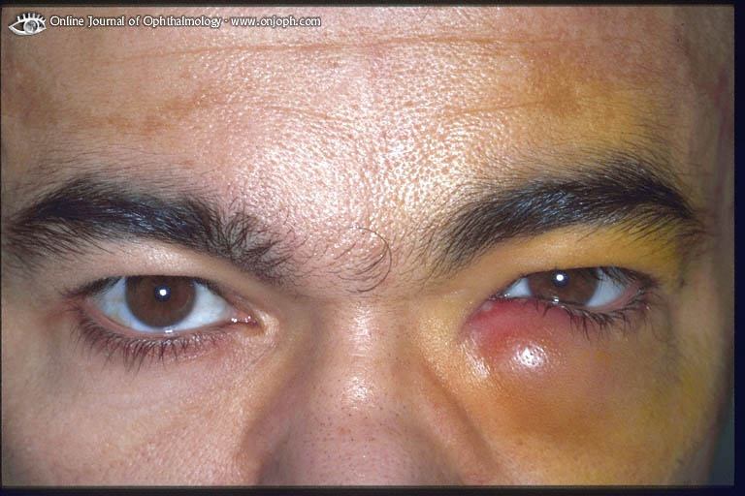
Source of picture: “Online Journal of Ophthalmology” >>

Chronic dacryocystitis - slight sac swelling and tearing may be the only symptoms.
- pus may regurgitate (through punctum) when pressure is applied.
- retained secretions may form large mucocele.
- treatment - nasolacrimal duct dilation with probe and syringing with saline(under local anesthetic); contributory nasal or sinus abnormalities should be treated.
if this treatment fails → nasolacrimal intubation, dacryocystorhinostomy, sac removal.

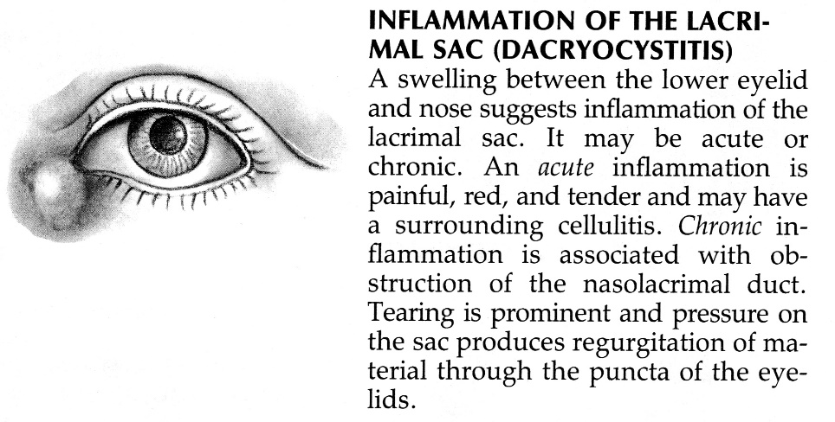

Dacryoadenitis
- pain and swelling on temporal side of upper lid (upper lid appears S-shaped), ptosis:
- etiology:
acute – viruses (mumps, influenza, measles), gonococci.
chronic – tumors, sarcoid, tbc.

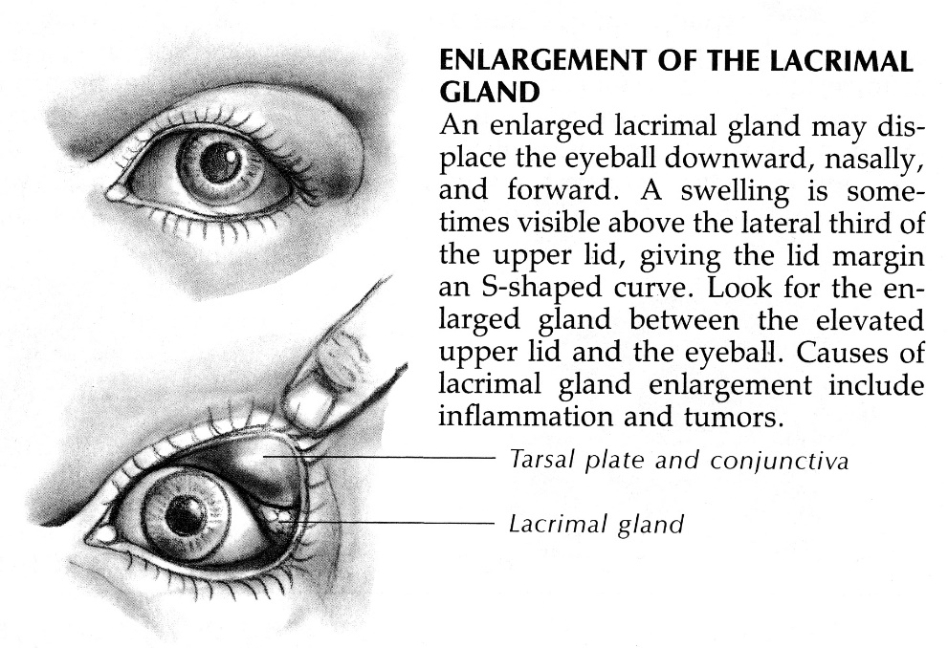

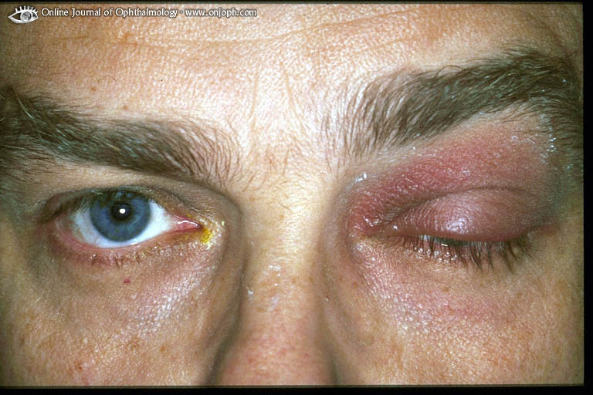
Source of picture: “Online Journal of Ophthalmology” >>

Bibliography for ch. “Ophthalmology” → follow this link >>

Viktor’s Notes℠ for the Neurosurgery Resident
Please visit website at www.NeurosurgeryResident.net

