Eye Trauma
Last updated: May 9, 2019
Hyphema 1
Classification 1
Clinical features 1
Complications 1
Treatment 2
Foreign Bodies 2
Diagnosis 3
Treatment 3
Contusions & Lacerations 3
Burns 4
Iridodialysis, Cyclodialysis 4
Clinically 4
Treatment 4
Commotio Retinae 5
Etiology 5
Clinically 5
Funduscopy 5
Treatment 5
Orbital Fractures – see p. TrH27 >>

Document legally (in any patient with upper facial trauma): vision, range of extraocular motion, location of lid and conjunctival lacerations and foreign bodies, depth of anterior chamber, anterior chamber / vitreous hemorrhage, cataract.
Ocular trauma accounts for 8-10% of all visual impairments!

Prehospital management – see p. TrH25 >>

Hyphema
- blood accumulation in anterior chamber.
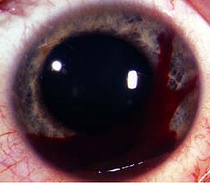

Classification
Traumatic hyphema (even small hyphema can be sign of major intraocular trauma!)
Grade 1 - occupying < 1/3 of anterior chamber

Grade 2 - filling 1/3-1/2 of anterior chamber

Grade 3 - filling > 1/2 of anterior chamber
Grade 4 - total filling.
Spontaneous hyphema - secondary to neovascularization, ocular neoplasms, vascular anomalies.

Clinical features
- < 50% hyphemas settle inferiorly to form level; 40% form definite clot adherent to iris stroma; 10% have dark clot in contact with endothelium (poor outcome and corneal staining).
- tear at anterior aspect of ciliary body is most common site of bleeding (71%).
- usual duration of uncomplicated hyphema is 5-6 days; mean duration of elevated IOP is 6 days.

Complications

Elevated IOP - may accompany hyphemas of any size (esp. with near total or total hyphemas); periods:
- hypertonia - during acute phase of hyphema (first 24 hours after injury) - trabecular plugging by erythrocytes and fibrin.
- hypotonia (≤ normal IOP) from 2nd to 6th day - due to reduced aqueous production and uveitis.
- hypertonia - recovery of ciliary body.
- normotonia - recovery of trabecular meshwork (disappearance of hyphema)

Glaucoma may result:
  - if large segments of anterior chamber angle are irreparably damaged and/or clot organization produces extensive peripheral anterior synechiae → intractable glaucoma.
  - erythrocytes lose hemoglobin and become ghost cells in vitreous cavity → circulate forward into anterior chamber with resultant trabecular blockage → delayed ghost cell glaucoma.

Secondary hemorrhage into anterior chamber (≈ 25%) usually in first 3 days.
- due to clot lysis and retraction.
- markedly worsens prognosis.

Posterior synechiae
- secondary to iritis or iridocyclitis.

Peripheral anterior synechiae
- occurs if hyphema has remained in anterior chamber for prolonged period (> 9 days).

Corneal bloodstaining
- more likely in total hyphema that remains for at least 6 days with IOP > 25 mmHg.
- clearing of corneal bloodstains may require many months.

Optic atrophy
- due to ↑ IOP.
- for black patients (with sickle cell trait), prevention of secondary hemorrhage is critical factor!

Treatment
- patching (bilateral or injured eye only).
- bed rest, elevating bed head 30-45° (→ hyphema settling in inferior anterior chamber).
- sedation in extremely apprehensive individual.
- If analgesics are required, avoid aspirin and other NSAIDs with antiplatelet effect.
- Topical medications:
- aminocaproic acid (some administer orally) - prevention of recurrent hemorrhages; clot will persist in anterior chamber for increased period – so avoid in grade 4 hyphema.
- antiglaucomatous medications - initiate therapy incrementally with brimonidine, followed by latanoprost and timolol; if IOP is still elevated, add carbonic anhydrase inhibitor.
- steroids (after 3-4th day of retained hyphema) - to decrease iridocyclitis and to prevent synechiae.
- atropine (indicated in grade 3-4 hyphemas) - to break pupillary block.
Any other topical medications lack definite evidence of advantages!!!
- Surgical evacuation – indicated in:
- grade 3-4 hyphemas persisting for > 4 days.
- microscopic corneal bloodstaining (at any time); most typical early sign of corneal bloodstaining is tiny yellowish granules in posterior third of corneal stroma - surgical treatment in this early stage may prevent gross staining, and cornea may clear in 4-6 months.
- IOP ≥ 50 mmHg for 4 days (or ≥ 35 mmHg for more than 24 hours if sickle cell trait or disease is present!)
- preferred technique is evacuation with closed vitrectomy instrumentation.
- other methodologies – paracentesis, irrigation & aspiration through small incision, clot irrigation with trabeculectomy.
- extreme care is required to avoid any contact with iris, lens, or corneal endothelium.

Foreign Bodies
Typical patient - 20-40 yrs male who does not wear protective eye gear.
- most injuries occur at work using various tools with metal striking metal – patient feels something enter eye with no obvious external changes; hence, incident usually is dismissed quickly.

Avoid pressure on globe!

Conjunctival, Corneal foreign bodies
- Apply anesthetic and fluorescein staining
- Evert individually both lids.
- Inspect with binocular lens (loupe) or slit lamp.
- Remove foreign body:
Conjunctival → moist sterile cotton applicator.
Corneal → irrigation;
if cannot be dislodged → lift out on point of sterile spud / hypodermic needle under slit-lamp magnification.
N.B. unless steel / iron foreign bodies are removed immediately, they leave rust ring on cornea (also requires removal under slit-lamp magnification):
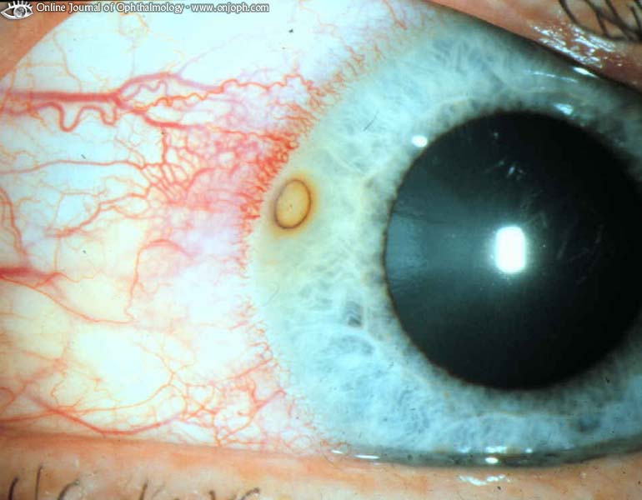
Source of picture: “Online Journal of Ophthalmology” >>

Burr removal of metallic rust ring:
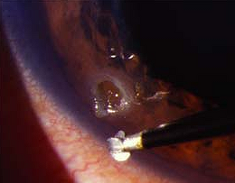

- Antibiotic ointment (bacitracin/polymyxin B or sulfacetamide sodium 10%).
  - for larger foreign bodies, treatment is as for corneal abrasion (short-acting cycloplegic + antibiotic + firm patch to keep eye closed overnight).
  - corneal epithelium regenerates within 1-3 days.
N.B. corticosteroids are contraindicated (promote growth of fungi and herpes simplex virus)!!!

Intraocular foreign bodies
Diagnosis
Slit lamp examination:
- entry sites:
in cornea - disruption in smooth surface with corneal edema surrounding perforation site.
in sclera - area of conjunctival injection; darker pigmentation indicates choroidal exposure.
- examine iris before dilatation (disruption point?) and lens after dilatation (cataract?).

Dilated fundus examination reveals foreign bodies in posterior segment.

Fine CT with 2-mm sections can localize foreign bodies as small as 0.7 mm.
X-ray - beneficial for metallic foreign bodies.
MRI - more effective in localizing nonmetallic foreign bodies.
Do not use if cannot exclude metallic objects!!!
Ultrasound is useful adjunct tool to determine if object is metallic.

Treatment
Require immediate surgical removal (delay of 24 hours increases endophthalmitis risk to 13.4%):
Inert substances - glass, stone, plastic (may be removed at later time after initial wound is closed).
Metals – oxidize (copper / iron should be removed urgently – can cause chalcosis / siderosis - toxic to retina!!!)
Organic material - ↑ risk of endophthalmitis.

- systemic and topical antimicrobials are indicated; tetanus prophylaxis.
- minimize pressure on globe even in cases of self-sealing wounds.
- surgical approach varies with object location.
- removal through original entry wound is not recommended.

Object in anterior chamber
- lens is intact - constrict pupil with miotics to reduce risk of lenticular injury.
- 20-gauge rare earth magnet may retrieve small metallic objects; nonmagnetic objects or large magnetic objects are managed best with intraocular forceps.
- damaged lens should be removed (usually via phacoemulsification); concurrent IOL insertion is not performed (because calculation of intraocular lens power may not be exact).

Object in posterior chamber
- to reduce risk of intraocular content extrusion, anterior chamber paracentesis is performed to soften eye.
  - external approach - via sclerotomy and electromagnet.
  - internal approach – via vitrectomy; very large objects sometimes are managed best through limbal incision.

Contusions & Lacerations
Lid contusions (black eye)
ice packs to inhibit swelling - during first 24 h;
hot compresses to aid absorption - next day.

Lid lacerations → repair with fine sutures in at least three layers (to prevent notching as healing progresses):
6-0 absorbable suture for deep layer (conjunctiva and tarsus) - knots tied into wound;
5-0 chromic sutures for middle layer (orbicularis oculi muscle);
6-0 nonabsorbable suture (e.g. silk) for skin.
Traumatized lids should never be opened forcibly - injury could be aggravated!
- patch eye.
- lacerations involving lid margin or loss of lid tissue should be dealt by ophthalmologist (if injury prevents tears from keeping cornea moist → artificial tears).
- lacerations near medial canthus - danger of violating lacrimal apparatus. see below

Eyebrow lacerations
- carefully explore wound - fracture may be palpated (that does not visualize on X-ray).
- minimum debridement - eyebrow is very difficult to reconstruct.
- debridement should be done parallel to hair follicles (not perpendicular to skin, as is general rule) – to minimize bald area in repaired eyebrow:
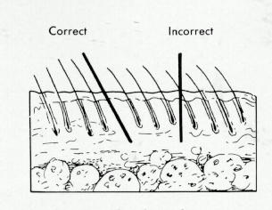
- any defect in muscle layers is approximated with deep sutures (to prevent functional defect or depressed scar).
- during wound closure, eyebrow borders should be aligned first to avoid visible step-off (for this reason eyebrow should not be shaved - would destroy landmarks for accurate closure).

Eyebrow avulsion
- can be replaced with hair-bearing tissue from postauricular area.
- keep graft < 1 cm in width to ensure its survival.
- graft pedicled on anterior branch of superficial temporal artery also may be used.

Lacrimal canaliculus laceration
- > 50% tear volume is normally evacuated through inferior canaliculus - when this pathway is interrupted it is important that it be repaired when possible.
any laceration in medial third of lower lid - suspect injury to inferior canaliculus.
- diagnosis (after hemostasis):
- place probe (e.g. small nylon or polypropylene suture) through punctum into wound.
- insufflate canaliculus with air and instill sterile saline into laceration → air will bubble through saline.
- instill fluorescein in conjunctival sac - observe dye in wound.
- treatment: Vier stainless steel rod (with swaged-on black silk) is passed through punctum into laceration site and then into medial portion of canaliculus, to align cut ends; laceration is stabilized with small chromic sutures; free end of suture of rod is tied in place to help stabilize rod and is used to retrieve it for removal; rod is left in place for 4-6 weeks.

Trauma to globe
Perforating injury – sclera partially torn.
Penetrating injury – sclera complete rupture.
- corneal laceration - irregular (“teardrop”) pupil due to iris prolapse through cornea.
- globe laceration risks sympathetic ophthalmia.
- emergency treatment:
- protective rigid shield
- analgetics
- cyclopentolate 1% + phenylephrine 2.5%
- antimicrobials (systemic / local - drops only, since ointment could penetrate lacerated globe!)
- corticosteroids are contraindicated until wounds are closed surgically.

Severe windshield injury after 7 days - iris tissue has prolapsed through corneal wound, pupil is peaked toward prolapse, marked hyperemia of conjunctiva:
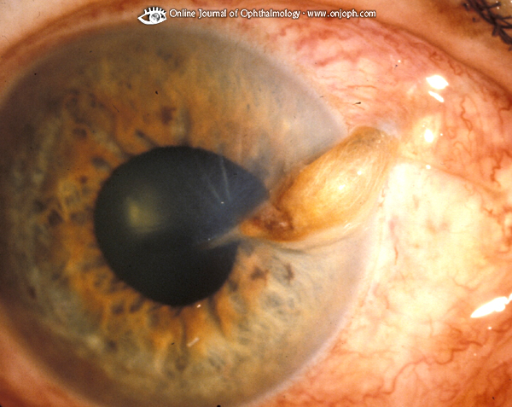
Source of picture: “Online Journal of Ophthalmology” >>

Traumatic optic neuropathy - impact injury to optic nerve (without concomitant facial fracture or penetrating wound) → instantaneous (rarely delayed) permanent visual loss
- occurs in 0.5-5% closed head injuries.
- treatment - high-dose steroids (≈ acute spinal cord injury).

Burns
Lid burns - cleanse thoroughly with sterile saline → apply petrolatum gauze or antimicrobial ointment → sterile pressure dressing held by elastic bandage around head until surface has healed.

Chemical burns of cornea / conjunctiva
Symptoms & signs – pain, hyperemic edema, eyelid burns, corneal opacification & epithelial defects, anterior chamber reaction (hazy fluid), possibly ↑ IOP.
Treatment:
  - immediate copious irrigation with water, saline, or other bland fluid; for at least 30 min; holding eyelids open [e.g. Morgan lens]; repeatedly assess pH of inferior fornix (with litmus paper) until it becomes neutral (recheck after 5-10 min).
  - anesthetize eye with 1 drop of proparacaine 0.5% (→ oral analgetics)
  - asses extent of injury (incl. visual acuity, slit lamp)
  - antibiotic ointment
  - pressure patching, artificial tears.
  - steroids are helpful.
- chemical iritis → long-acting cycloplegic (e.g. atropine 1%).
- corneal scarring, opacification is risk.

Iridodialysis, Cyclodialysis
Iridodialysis - disinsertion of iris from scleral spur; elevated IOP can result from damage to trabecular meshwork or from formation of peripheral anterior synechiae (PAS).
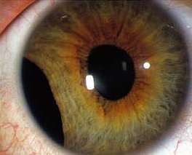

Cyclodialysis - disinsertion of ciliary body from scleral spur; increased uveoscleral outflow occurs initially resulting in hypotony (later, IOP elevation can result from closure of cyclodialysis cleft).

Clinically
- asymptomatic unless glaucoma develops.

Treatment
- sunglasses, contact lenses with artificial pupil.
- surgical correction if large iridodialysis and patient symptomatic.
- if glaucoma develops → treatment similar to primary open-angle glaucoma.
N.B. avoid miotics - may reopen cyclodialysis clefts, causing hypotony; strong mydriatics may close clefts, resulting in pressure spikes.

Commotio Retinae
Etiology
- contrecoup injury (blunt trauma to globe causes shock waves which travel posteriorly and lead to disruption of photoreceptors).

Clinically
- decreased vision or asymptomatic; history of recent ocular trauma.

Funduscopy
- confluent area of retinal whitening (visual acuity does not always correlate with degree of retinal whitening).
- whitening is intracellular edema and fragmentation of photoreceptor outer segments and intracellular edema of retinal pigment epithelium; no intercellular edema.
- when occurs in macula is called Berlin edema.
- retinal blood vessels are undisturbed in area of retinal whitening!
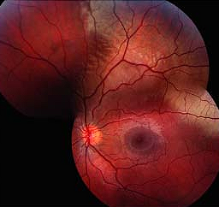

Treatment
No treatment is required - clears without therapy!

Bibliography for ch. “Ophthalmology” → follow this link >>

Viktor’s Notes℠ for the Neurosurgery Resident
Please visit website at www.NeurosurgeryResident.net

