Red Eye
Last updated: May 9, 2019
- caused by dilation of blood vessels - cardinal sign of ocular inflammation.

Diagnostic algorithm:
- fluorescein staining – detects corneal etiologies (abrasions, keratopathy, ulcers, infection).
- measure intraocular pressure - detects acute glaucoma.
- check anterior chamber - inflammatory cells suggests iritis or endophthalmitis.

for types of eye vessel dilation → see p. Eye78 >>

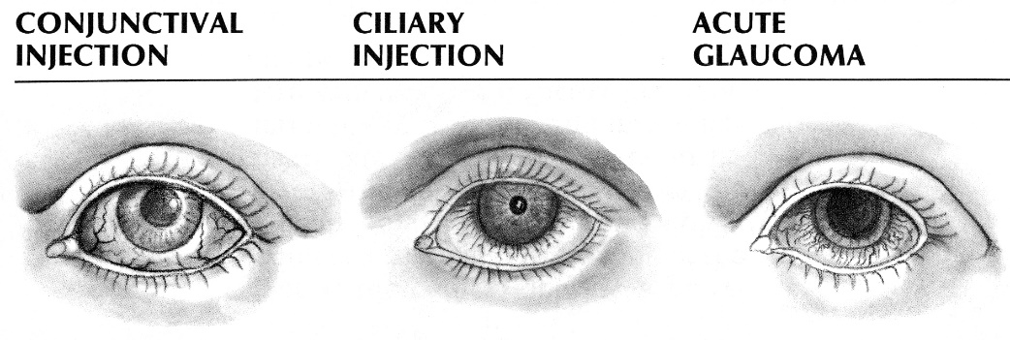

 | Acute Conjunctivitis | Acute Iritis | Acute Glaucoma | Episcleritis / Scleritis
Pain | + (burning) | ++, photophobia | ++++ (with nausea, vomiting) | + (irritation) / +++
Vision | normal | ↓ | ↓↓↓ | normal
Discharge | mucopurulent | lacrimation | lacrimation | lacrimation
Hyperemia | conjunctival diffuse (globe + eyelids) | circumcorneal | circumcorneal & conjunctival | large patch (20-100%) of bulbar conjunctiva
Cornea | normal | transparent, precipitates on posterior surface | cloudy (edema) | normal
Iris | normal | dull, swollen | congested and bulging | normal
Pupil | normal | irregular miosis, minimally reactive | mid-dilated, unreactive | normal

Primary care physicians should refrain from treating any patients with steroids without ophthalmologic consultation!

Bibliography for ch. “Ophthalmology” → follow this link >>

Viktor’s Notes℠ for the Neurosurgery Resident
Please visit website at www.NeurosurgeryResident.net

