Osteomyelitis
Last updated: June 11, 2019
Cranial Osteomyelitis 1
Etiology 1
Clinical Features 1
Diagnosis 1
Treatment 1
Vertebral Osteomyelitis (s. Infective Spondylitis) 1
Etiology 1
Clinical Features 2
Diagnosis 2
Treatment 3
Infectious Diskitis 4
Etiology 4
Clinical Features 4
Diagnosis 4
Treatment 4
General Features of osteomyelitis → see p. 1192 (2-3) >>

Cranial Osteomyelitis
Etiology
- Direct extension from paranasal sinuses, ear (e.g. malignant external otitis see p. Ear40 >>)
- Penetrating skull injury
- Infected craniotomy flap, skeletal traction
- Hematogenous

Gradenigo's syndrome – apical petrositis (osteomyelitis) involving CN5 & CN6. see p. CN5 >>

Clinical Features
- pain, tenderness, swelling, warmth at infected site.
- drainage of purulent material if open wound is present.
- if systemic symptoms are present, underlying subdural / epidural empyema is commonly present.

Diagnosis
- Plain skull film (positive > 50%)
- CT
- Technetium bone scans (helpful if skull radiographs are negative);
  - false-positive in old trauma or previous craniotomy; H: gallium scan (differentiates infection from other causes of positive technetium scan).

Treatment
- Surgical debridement (removal of infected bone)
  - adequate margin of normal bone is removed to minimize risk of recurrence.
  - after at least 1 year with no evidence of inflammation, cosmetic / protective cranioplasty may be performed.
- Antibiotics
  - MRSA is treated with 6 weeks of vancomycin; if hardware is present (e.g. cranial mesh), add rifampin.

Vertebral Osteomyelitis (s. Infective Spondylitis)
- destructive disco-vertebral lesion.
Infections of vertebrae usually involve disk space (vs. malignant lesions!)

- disseminated via small nutrient arteries, bacteria lodge beneath end-plate of vertebra (usually anteriorly) → quickly extend into adjacent disc and end-plate of opposite vertebra.
In children, because the disk is vascularized, it can be a primary site.
- complications - paraspinal extension (along spine, beneath paravertebral ligaments, etc) - paraspinal abscess, anterior epidural abscess;
  - paraspinal masses are large in indolent forms of infection (such as tuberculosis).

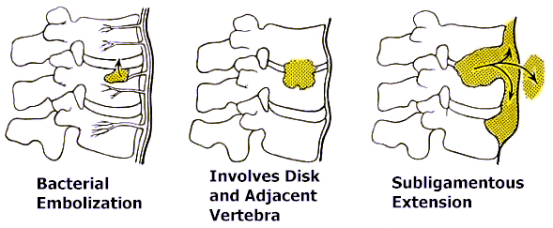

- occasionally, nondiscogenic forms (involving only vertebral bodies or neural arches) are encountered - difficult to distinguish from neoplasia, metastases!

Etiology
- hematogenous spread (rarely, direct extension*):
- Pyogenic bacteria - staphylococci are most common! (≈ 50%).
- M. tuberculosis (Pott's disease) – one of the oldest demonstrated diseases of humankind (in 1779, Percivall Pott presented the classic description of spinal tuberculosis).
- rare in West; still a significant cause of disease in developing countries.
- affects young adults.
- 80% patients have no evidence of pulmonary involvement.
- most frequent in lower thoracic ÷ upper lumbar vertebrae.
- tendency to involve multiple segments (through subligamentous paraspinal spread).
- discs frequently are spared until later in course.
*e.g. complications of discography, lumbar puncture

Most common primary sources of infection (can be identified only in 40% patients): urinary tract, skin, lungs.
  - well-recognized risk factor - IV drug use.

Clinical Features
- course tends to be subacute (patients with pyogenic spondylitis usually present while infection is still confined to one disc space):
- Deep back pain - exacerbated by motion (movement restriction by muscle spasm), may be unrelieved by rest.
- Spine tenderness over involved spine segment.
- Fever (25%).
N.B. all signs of infection may be absent!

Neurological involvement - late and inconstant feature (≈ 1% cases; but in 40% of cases caused by tuberculosis!) by:
  - intraspinal extension of infection (epidural abscess)
  - spine instability and fractures

Diagnosis
- ESR↑ (!!!), CRP↑, WBC↑ (30%)
- X-ray (changes may take weeks ÷ months to appear!):
  - progressive narrowing of disk space
  - erosion and destruction of adjacent vertebral end-plates → body collapse → wedging, subluxations, sharp kyphosis (gibbus).
  - paravertebral soft-tissue masses:
cervical spine - focal swellings of retropharyngeal soft-tissue stripe;
thoracic spine - displacement of paraspinal lines;
lumbar spine - lost psoas muscle shadow.

Radiographic changes of spinal tuberculosis on plain films:
- Lytic destruction of anterior portion of vertebral body
- Reactive sclerosis on a progressive lytic process
- Enlarged psoas shadow with or without calcification; fusiform paravertebral shadows suggest abscess formation
In contrast to pyogenic disease, calcification is common in tuberculous lesions!
- Vertebral end plates are osteoporotic.
- Intervertebral disks may be shrunk or destroyed.
- Vertebral bodies show variable degrees of destruction → collapse with anterior wedging
- Bone lesions may occur at more than one level.

- MRI (diagnostic method of choice – highly sensitive and specific! – changes are seen 2–3 weeks earlier than on plain X-rays):
- low T1 signal (high signal on T2) throughout disc and in adjacent vertebral bodies.
- thinning, fragmentation (and eventual loss) of dark line of vertebral end-plates.
- IV Gd-DTPA → diffuse enhancement in areas showing signal change.
N.B. in degenerative disk disease, changes are less uniform, disk is desiccated and bone destruction is absent, no paravertebral soft-tissue masses.
Specific MRI findings of tuberculous spondylitis:
  - thin and smooth enhancement of the abscess wall (vs. pyogenic spondylitis - thick and irregular enhancement of abscess wall)
  - well-defined paraspinal abnormal signal (vs. pyogenic spondylitis - ill-defined paraspinal abnormal signal).
- CT (less sensitive and specific; better tolerated by some patients with severe back pain): punched-out erosions of bone adjacent to involved disc (“moth-eaten” appearance), small dense sequestra, prominent sclerosis.
- Bone scan with technetium, gallium.
- CT-directed needle biopsy of affected vertebrae; open biopsy may be necessary to obtain adequate tissue for culture.

Discovertebral osteomyelitis, L4-5 (sagittal T1-MRI): diffuse low intensity throughout L4/5 vertebral bodies, and even lower signal from intervening disc space (which is barely visible because of loss of dark line of vertebral end-plates); little epidural soft-tissue thickening suggesting extraosseous extension.  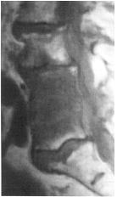 | Staphylococcal discovertebral spondylitis (axial CT): vertebral end-plate shows typical moth-eaten appearance (upper arrows) and another focus of infection is visible in inferior articular process (lower arrow):  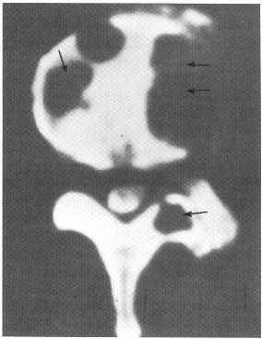  Source of picture: Ronald G. Grainger, David J. Allison “Grainger & Allison’s Diagnostic Radiology: A Textbook of Medical Imaging”, 4th ed. (2001); Churchill Livingstone, Inc.; ISBN-13: 978-0443064326 >>

Infectious spondylitis at T6-7:
A) lateral radiograph - disc space narrowing, erosion of adjacent vertebral end-plates (arrow), reactive sclerosis in inferior vertebra.
B) CT - bony destruction; note extent of associated paraspinal soft-tissue mass (arrows).
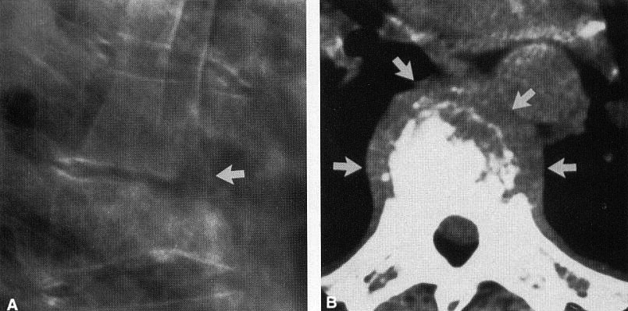

Thoracic tuberculous spondylitis:

A) paraspinal soft-tissue mass in AP radiograph; involved disc space is difficult to resolve.

B) disc space obliteration and destruction of adjacent vertebral end-plates.
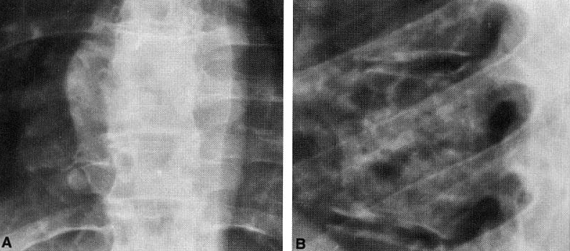

Tuberculous spondylitis with subligamentous extension (sagittal thoracic tomogram) - obliteration of disc space and destruction of adjacent vertebral end-plates in midthoracic spine; superior and inferior subligamentous extension is manifested by erosions of anterior vertebral body margins over several levels (arrows):
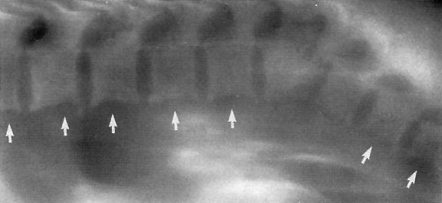

Pyogenic spondylitis:
A) lateral X-ray at L4-L5 - marked narrowing of disc space, loss of sharp vertebral end-plate margins, and mild reactive sclerosis in L4 vertebral body.
B) T1-MRI - extensive abnormal low signal within adjacent vertebral bodies and intervening disc, with loss of hypointense border at vertebral margins.
C) postcontrast T1-MRI - pronounced enhancement of involved vertebra and portions of infected disc; no epidural involvement.
D) fat-suppressed T2-MRI - edema in vertebral bodies, abnormally bright signal in infected disc - corresponding to areas of low signal intensity in postgadolinium MRI (arrowheads).
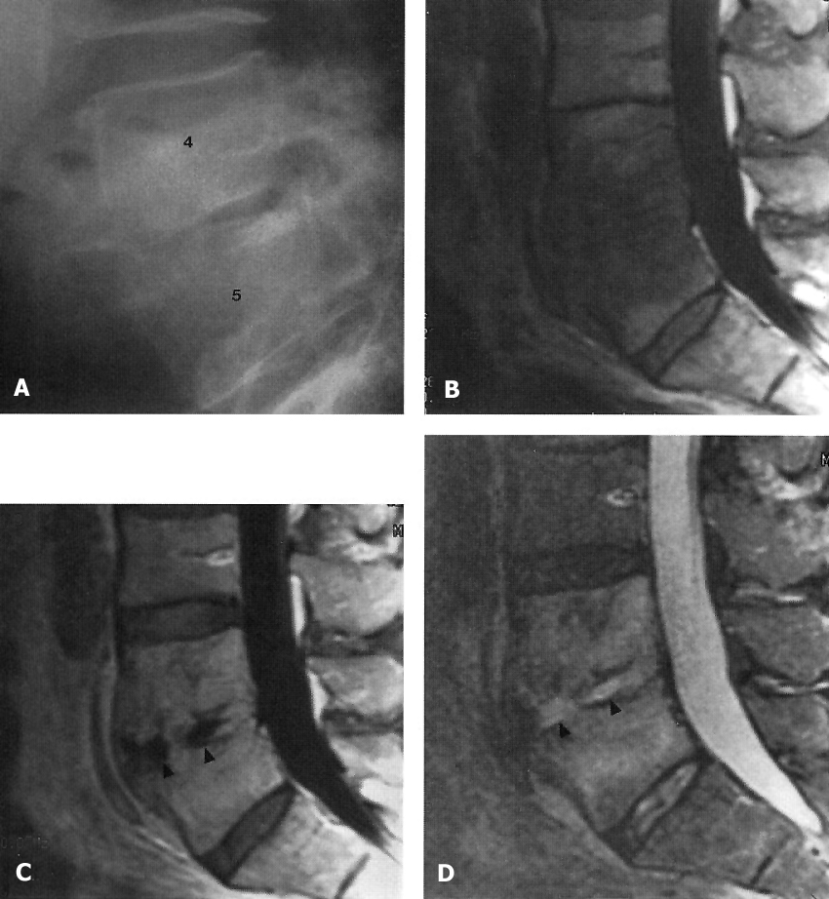

Tuberculous spondylitis in 46-year old male.
A. CT shows contact interdisk Th11-Th12 vertebral body destruction, with large and spongy sequesters, prevertebral and epidural extension (surrounds a large square).
B. CT shows paravertebral tight, with calcination abscess near the right crus of diaphragm (surrounds a small square). C. CT shows accidental findings of post- primary pulmonary tuberculosis (arrow):
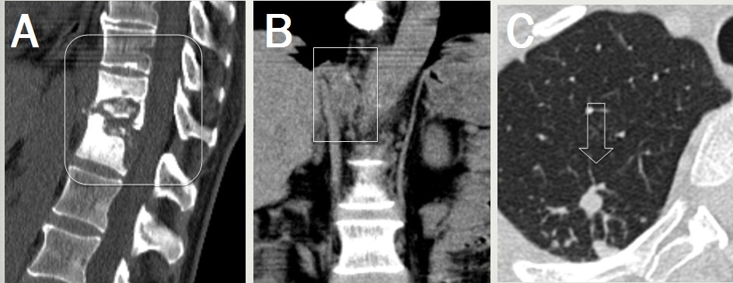

Treatment
- Infection control
  - MRSA is treated with 6 weeks of vancomycin; if hardware is present (e.g. cranial mesh), add rifampin.
- Patient comfort (bed rest, brace)
- Operative debridement (e.g. epidural extension)
- Prevention of further deformity.
  - instrumentation* up to corpectomy may be indicated.
*modern instrumentation is titanium – does not need to be isolated from site of infection.

Infectious Diskitis
Etiology
- usually iatrogenic (complication of previous surgery or needle puncture of intervertebral disks) - most often staphylococci!

Clinical Features
- severe pain, aggravated by palpation; partially relieved by recumbency.
- muscle spasm.
- fever
  - interspace infections must be observed closely – risk of extradural abscesses!

Diagnosis
Early in course:
  - X-rays and CT are normal!
  - gallium scans may be falsely positive because of recent surgery.

Later in course - destructive changes along edges of disk space, narrowing of intervertebral space.
  - CT demonstrates these changes early.

Needle biopsy of involved interspace identifies causative bacteria (cultures are often sterile → direct surgical biopsy).

Treatment
- bed rest, medication for pain and muscle spasms.
- antibiotic therapy (empirically – against staphylococci).
- no response to conservative therapy → open surgery (remove infected material from interspace).

- when infection is controlled, interspace will eventually narrow → spontaneous fusion.

Bibliography for ch. “Infections of Nervous System” → follow this link >>

Viktor’s Notes℠ for the Neurosurgery Resident
Please visit website at www.NeurosurgeryResident.net

