Encephalitis
Last updated: January 16, 2021
Viral Encephalitis 1
Etiology 1
Pathophysiology 2
Pathology 2
Clinical Features 2
Diagnosis 3
Treatment 3
Prognosis 3
Special Features of Viral Encephalitides 4
Herpes simplex encephalitis 4
Etiopathophysiology 4
Pathology 4
Clinical Features 5
Diagnosis 5
Treatment 6
Prognosis 6
VZV encephalomyelitis 6
Arbovirus encephalitides (general) 7
West Nile encephalitis 8
Clinical Features 8
Diagnosis 8
Treatment 8
Prognosis 8
Tick-borne encephalitis (TBE) 8
Epidemiology 8
Clinical Features 8
Diagnosis 9
Prognosis 9
Encephalitis Lethargica (von Economo disease) 9
Etiology 9
Pathology 9
Clinical Features 9
Balamuthia Amebic Encephalitis 10
Etiology 10
Diagnosis 10
CMV encephalitis → see p. 270 >>
HIV encephalitis → see p. 270 >>
Measles encephalitides (postinfectious, subacute sclerosing panencephalitis SSPE)
→ see p. 265 (7a) >>

Encephalitis - inflammation of brain parenchyma due to:
- direct viral invasion (primary encephalitis) – viral encephalitis see below >>
- hypersensitivity initiated by virus or other foreign protein (secondary encephalitis) – parainfectious (s. postinfectious) encephalitis, postvaccinal encephalitis. see p. Dem9 >>

Panencephalitis = leukoencephalitis (i.e. myelinoclastic) + polioencephalitis (i.e. polioclastic)

- encephalitis is almost invariably associated with meningeal inflammation (meningoencephalitis) and sometimes with simultaneous involvement of spinal cord (encephalomyelitis).

Viral Encephalitis
Incidence – 3.5-7.4 cases per 100,000 persons annually (most are mild cases).
Encephalitis is far less common than meningitis!
- children are most vulnerable.

Etiology
≈ same viruses that cause viral meningitis:
*encephalitis in immunocompromised (i.e. immunocompromised host is key risk factor)

- Herpesviruses
Neurologic disease has been associated with all herpesviruses but HHV-7

    - herpes simplex virus type 1- most common cause of sporadic encephalitis!
    - herpes simplex virus type 2 (encephalitis in neonates)
    - varicella-zoster virus*
    - Epstein-Barr virus
    - cytomegalovirus*
    - human herpesvirus type 6
    - simian herpes virus (s. B virus):
- close relative of herpes simplex viruses;
- transmission to man has been reported by contamination, typically occurring in research laboratory;
- rapidly ascending encephalomyelitis → mortality 72% and severe neurologic sequelae.

- Arboviruses - most common causes of endemic encephalitis! (outbreaks during warm weather)
  - mosquito-borne:
    - St. Louis encephalitis virus - most common epidemic viral encephalitis in USA
    - Japanese B encephalitis virus - most common viral encephalitis worldwide
    - California encephalitis group viruses (virtually all cases are caused by La Crosse strain)
    - western equine encephalitis virus
    - eastern equine encephalitis virus
    - dengue viruses
    - West Nile encephalitis virus
  - tick-borne:
    - in North America - Powassan virus, Colorado tick fever virus
    - in Europe - tick-borne encephalitis virus: European subtype (s. Western, Central European), Far-Eastern subtype (s. Russian spring-summer encephalitis)

- Enteroviruses (outbreaks during warm weather)

- Other viruses:
    - measles (i.e. subacute measles encephalitis)*
    - rubella
    - mumps
    - lymphocytic choriomeningitis virus

Nonviral causes of encephalitis:
      - Mycoplasma pneumoniae
      - Toxoplasma gondii
      - Bartonella henselae
      - Treponema pallidum
      - Borrelia burgdorferi

Causes of focal encephalitis:
- herpes simplex virus!!!
- enterovirus (esp. coxsackie A)
- California encephalitis virus
- Powassan virus
- measles (subacute measles encephalitis)
- human herpesvirus type 6
- varicella-zoster

Causes of chronic/relapsing meningoencephalitis:
- measles (postmeasles encephalomyelitis, subacute sclerosing panencephalitis)
Measles does not usually cause acute encephalitis!
- rubella (progressive rubella panencephalitis)
- enteroviruses (in agammaglobulinemic patients! – immunity against enteroviruses is humoral)

Pathophysiology
  - virus replicates outside CNS.
  - virus gains entry into CNS:
  - hematogenous spread
  - retrograde neural transmission along peripheral (rabies, HSV, VZV) or olfactory (HSV) nerves.

Pathology
  - perivascular inflammation (mononuclear cuffing that extends into parenchyma) in cortex (some cases predominantly involve basal ganglia).
  - severe vasogenic cerebral edema → ICP↑.
  - swelling, disintegration, necrosis of cortical neurons (frequently with visible inclusion bodies*) with phagocytosis of debris (neuronophagia).
*may be diagnostic (e.g. “owl-eyes” in CMV, Negri bodies in rabies)
N.B. inflammatory response affects gray matter disproportionately to white matter!
Viral encephalitis is polioclastic, vs. postinfectious encephalitis – myelinoclastic
  - necrotizing vasculitis with focal (petechial) hemorrhages of cortex and white matter.
  - meningeal inflammation is common.
  - reactive hypertrophy-hyperplasia of astrocytes and microglia – often form clusters or microglial nodules (glial “stars”).

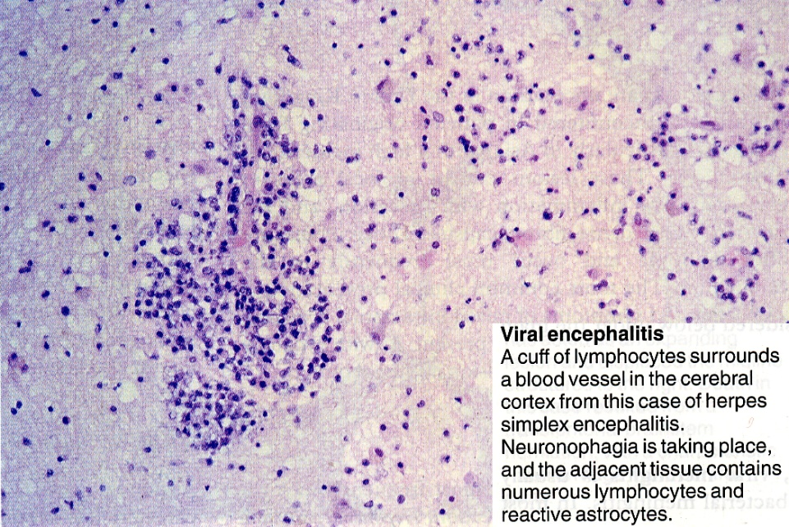
Source of picture: James C.E. Underwood “General and Systematic Pathology” (1992); Churchill Livingstone; ISBN-13: 978-0443037122 >>

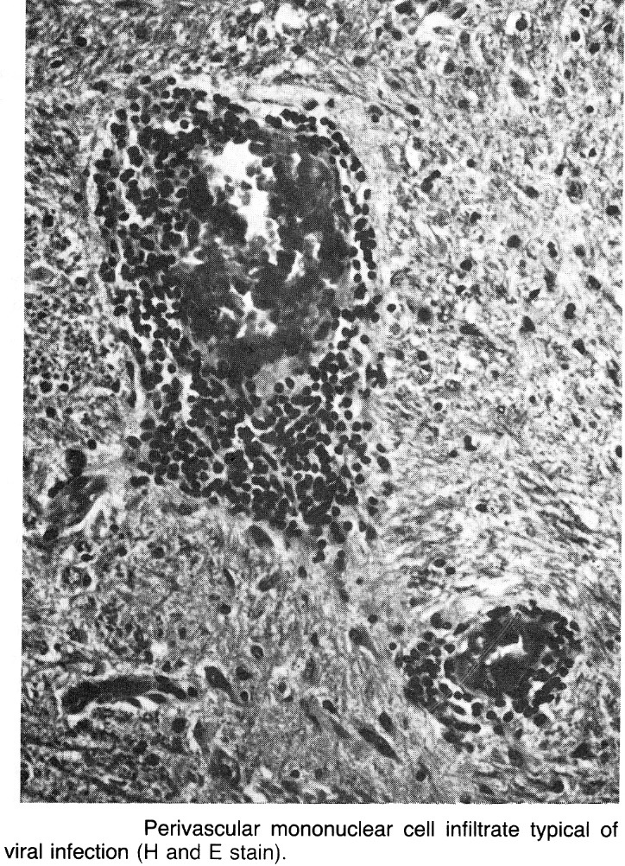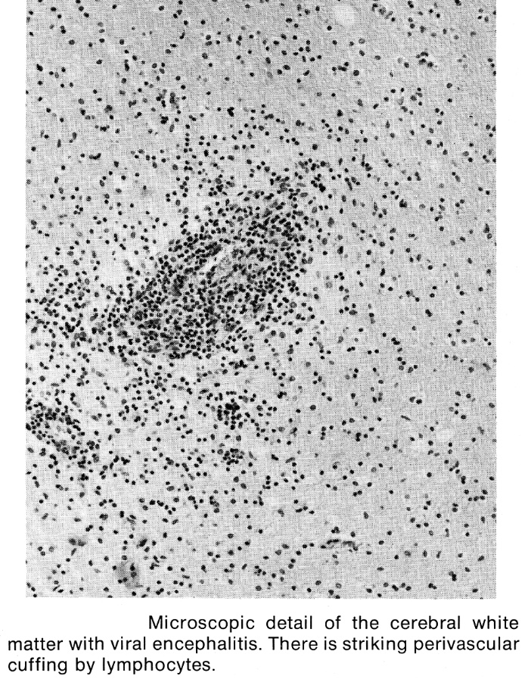

Clinical Features
- vary widely in severity!!!

- Symptoms of prodromal viral illness ± meningitis: fever, malaise, headache, vomiting, photophobia, stiff neck and back.

Dramatic diffuse and/or focal acute neuropsychological dysfunction (encephalopathy):

- Diffuse cerebral dysfunction:
- altered level of consciousness (mild lethargy ÷ deep coma); vs. viral meningitis – intact sensorium!
- mental status changes (psychiatric symptoms): delirium (confusion, disorientation), hallucinations, agitation, personality change, behavioral disorders (up to frankly psychotic state!).

- Focal neurologic signs reflecting sites of inflammation (virtually every possible type of focal neurologic disturbance):
  - focal or generalized seizures (> 50%)
  - paralysis (with hyperactive tendon reflexes, extensor plantar responses)
  - cranial nerve deficits
  - aphasia
  - ataxia
  - involuntary movements (e.g. myoclonic jerks)
  - hypothalamic-pituitary lesion → temperature dysregulation, diabetes insipidus, SIADH.

N.B. it is impossible to reliably distinguish on clinical grounds alone etiology of viral encephalitis.

Diagnosis
CSF should be examined in all patients!!! (unless contraindicated by ICP↑↑↑). see p. D40 >>
Characteristic CSF profile ≈ viral meningitis

- pressure↑
- clear (Eastern equine is only virus with cloudy CSF – due to > 1000 PMNs)
- lymphocytic pleocytosis 5-500
  - rarely, may be absent on initial LP (H: repeat LP).
  - > 1000 – Eastern equine, California encephalitis, mumps, lymphocytic choriomeningitis.
  - atypical lymphocytes – EBV.
  - large numbers of PMNs – Eastern equine, enteroviruses (esp. echovirus 9).
  - RBCs – HSV, Colorado tick fever, California encephalitis (occasionally).
- protein↑
- normal glucose; glucose ↓ - mumps, LCMV, HSV.
- CSF cultures are often disappointing (cultures are invariably negative in HSV-1 encephalitis).
- PCR - diagnostic procedure of choice!!!
- virus-specific antibodies - best results occur after 1st week of illness – useful only as retrospective diagnostic confirmation.

Role of brain biopsy has declined greatly with widespread availability of CSF PCR (but still diagnostic criterion standard for rabies).
- taken from site that appears to be significantly involved by clinical - laboratory criteria.
- tissue is:
  - cultured for virus
  - examined histopathologically & ultrastructurally (e.g. direct immunofluorescence for viral antigens).
- sensitivity > 95%, specificity > 99%.

EEG - diffuse slowing without any specific features;
- focal / lateralized EEG abnormalities is strong evidence of HSV encephalitis!

Neuroimaging – focal* or diffuse encephalitic process (low density with mass effect predominantly in white matter – i.e. vasogenic edema).
- occasional intracerebral hemorrhages within lesion.
- T2-MRI is the best.
- contrast enhancement in overlying cortex (or basal ganglia & thalami).
*HSV encephalitis

Treatment
Major diagnostic impetus is to distinguish HSV from other viruses!
HSV → urgent acyclovir (also useful in selected severe cases of EBV or VZV).
Initiating treatment before definitive diagnosis of HSV encephalitis is now common practice!
CMV: about dosages → see p. Inf1 >>
- ganciclovir.
- foscarnet.
Other viruses → supportive measures (in ICU initially):
- cardiopulmonary monitoring & support.
- ICP management (monitoring, fluid restriction, avoidance of hypotonic IV solutions, dexamethasone-mannitol-furosemide).
- fever suppression (acetaminophen, aspirin, cooling blanket, etc).
- prophylactic anticonvulsants (e.g. phenytoin, phenobarbital, lorazepam).
- prophylaxis of aspiration pneumonia, decubitus ulcers, contractures, deep venous thrombosis.
- at some centers, antibiotics are administered until diagnosis of bacterial meningitis is excluded.

  - SIADH (syndrome of inappropriate antidiuretic hormone) is frequent in children - serum [Na⁺] needs to be monitored closely. see p. 2516 >>
  - precautions in handling stool specimens in those with enteroviral infection.
  - isolate patients suspected of having measles, chickenpox, or rubella.

Prognosis
- considerable variation in incidence and severity of sequelae; e.g.:
Eastern equine (severity only after rabies!!!) – 80% survivors have severe neurologic sequelae;
Japanese B, St. Louis, enterovirus 71 – virtually universal sequelae among survivors;
Western equine – low ÷ moderate sequelae;
EBV, California, Colorado tick fever, Venezuelan equine, enteroviral* – good prognosis (sequelae are extremely rare).
*prognosis is poor in newborns (may be fatal) or in agammaglobulinemia (may become persistent, because immunity against enteroviruses is Ig-mediated!)

Most common sequelae: seizure disorders, extrapyramidal features (esp. dystonia, occasionally parkinsonism), weakness, changes in mentation, memory loss.

mortality depends to etiology (may be up to 75%*).
*100% in rabies or VZV in immunosuppressed patients

Special Features of Viral Encephalitides
Herpes simplex encephalitis
see p. 256 (1-6) >>
Etiopathophysiology
- not related to immunosuppression.
- no seasonal variation (occurs throughout year).
- case-to-case transmission does not occur.

HSV type 1 - most common cause of sporadic encephalitis! (0.2-0.4 cases per 100,000 persons annually) ≈ 10-20% of all encephalitides in USA!
- 70-75% cases are due to virus reactivation lying dormant in trigeminal ganglia (i.e. virus spreads to CNS transneuronally along CN5).
- 25-30% cases occur during primary viral infection.
  - in experimental animals, intranasal inoculation leads to viral entry via olfactory nerve → infection of olfactory bulb → temporal cortex (olfactory bulb is rarely affected in humans - olfactory nerve is less likely to be site of viral entry in humans).

HSV type 2 (encephalitis in neonates - 2-3 cases per 10,000 live births).

Pathology
Herpesviruses have tropism for temporal, orbital-frontal cortex, limbic structures and pons! (often asymmetrical but usually bilateral)
Diffuse, severe edema → intense necrosis with petechial hemorrhages (disease was once called acute necrotizing encephalitis) → multicystic encephalomalacia with regional cerebral atrophy.
N.B. may cause necrotic / cystic mass that closely resembles brain tumor.

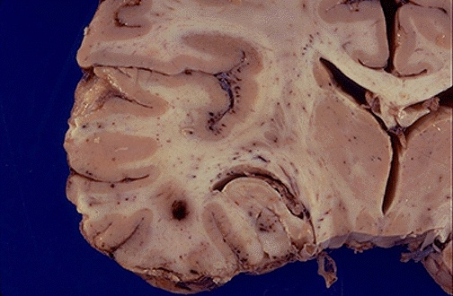
Source of picture: “WebPath - The Internet Pathology Laboratory for Medical Education” (by Edward C. Klatt, MD) >>

Blood vessel (V) surrounded by dense aggregate of lymphocytes and plasma cells (which have crossed BBB and migrated into grey matter of temporal lobe):
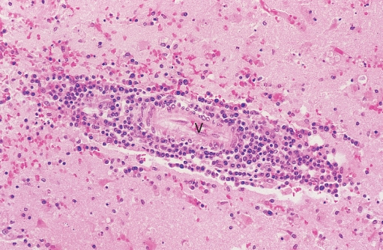

Electron microscopy - viral particles of any herpesvirus appear as arrays and scattered single particles (as shown here in nucleus of neuron):
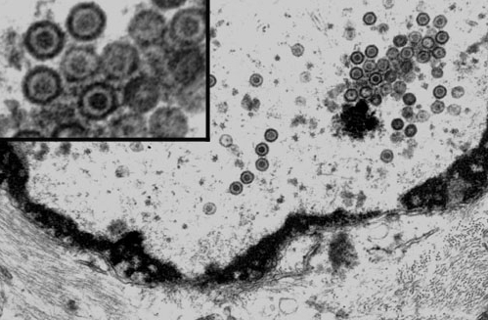

Clinical Features
- suggest involvement of inferomedial frontotemporal regions: temporal lobe seizures, olfactory / gustatory hallucinations, anosmia, bizarre behavior / personality alterations, memory disturbance.
N.B. clinical criteria alone are not reliable in differentiating HSV and non-HSV encephalitis!
enterovirus may also cause focal encephalitis, but (unlike herpes encephalitis) patients typically improve spontaneously within 1-2 days of admission.
- often high fever (104-105°F) initially.
- herpetic skin lesions are seen in only few cases.
- characteristically aggressive course; more indolent in immune-compromised persons (indicates role of immune system in destructive nature of herpes encephalitis).

Neonatal HSV encephalitis:
- encephalitis alone – begins within ≈ 2 weeks of birth.
  - HSV reaches CNS by intraneuronal routes.
  - often localized to one or both temporal lobes.
  - no skin lesions.
- encephalitis as part of disseminated disease - begins at age of 7-9 days or earlier.
  - CNS becomes infected hematogenously.
  - multiple areas of hemorrhagic necrosis throughout cerebral cortex.
  - signs of disseminated HSV infection (skin & mucosal lesions, keratoconjunctivitis, shock, jaundice, etc).

Diagnosis
- CSF = viral encephalitis + :
  - presence of RBCs and xanthochromia (hemorrhagic necrotic nature of encephalitis).
  - may be glucose↓.
  - cultures are invariably negative.
  - PCR - sensitivity (95-100%) and specificity (< 100%) exceeds brain biopsy!!! (PCR may be negative in first 24-48 hours but then becomes and remains positive for up to 2 weeks; PCR remains positive for as long as 5 days after treatment initiation).
N.B. false-positive PCR may occur – match with clinical picture!
prior to PCR availability, HSV isolation from tissue obtained at brain biopsy was considered gold standard for diagnosis!
  - intrathecal synthesis of HSV-specific antibody (can be detected within 3-10 days after onset, i.e. too late for acute diagnosis; remains positive for several days after PCR becomes negative); serum-to-CSF ratio < 20:1 suggests intrathecal production of antibodies.
N.B. blood serology is not useful!

- brain biopsy (reserved for unclear diagnoses or significant mass effect when LP is contraindicated) – encephalitic pathology with hemorrhagic necrosis; intranuclear eosinophilic Cowdry type A inclusions in both neurons and glia.

- EEG - paroxysmal features in temporal lobe (80%) as early as first few days of disease (but may take up to 2 weeks to develop) - paroxysmal lateral epileptiform discharges (PLEDs) - periodic focal spikes (once every 1-4 seconds) on background of slow or low-amplitude ("flattened") activity.
N.B. focal / lateralized EEG abnormalities is strong evidence of HSV encephalitis!

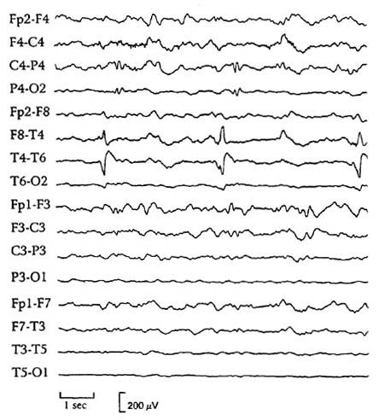

- CT (becomes positive after 1st week) - hypodense lesions, mass effect, and contrast enhancement in temporal lobes.

- T2-MRI reveals foci of increased signal intensity (in medial temporal lobes and inferior frontal gray matter extending up into insula) much earlier than CT (starting 1st or 2nd day after onset).

(A, B) T2-weighted TSE axial/coronal; (C, D) T2-weighted FLAIR axial/coronal:
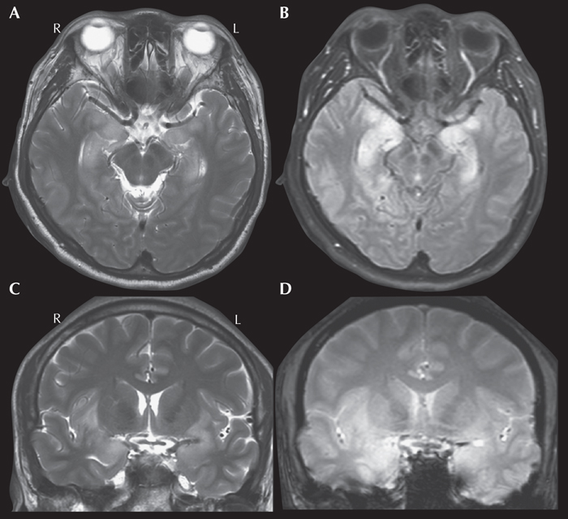

T2-MRI: swelling and signal change in antero-medial parts of left temporal lobe and minimal signal change in comparable parts of right:
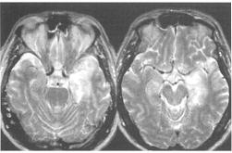

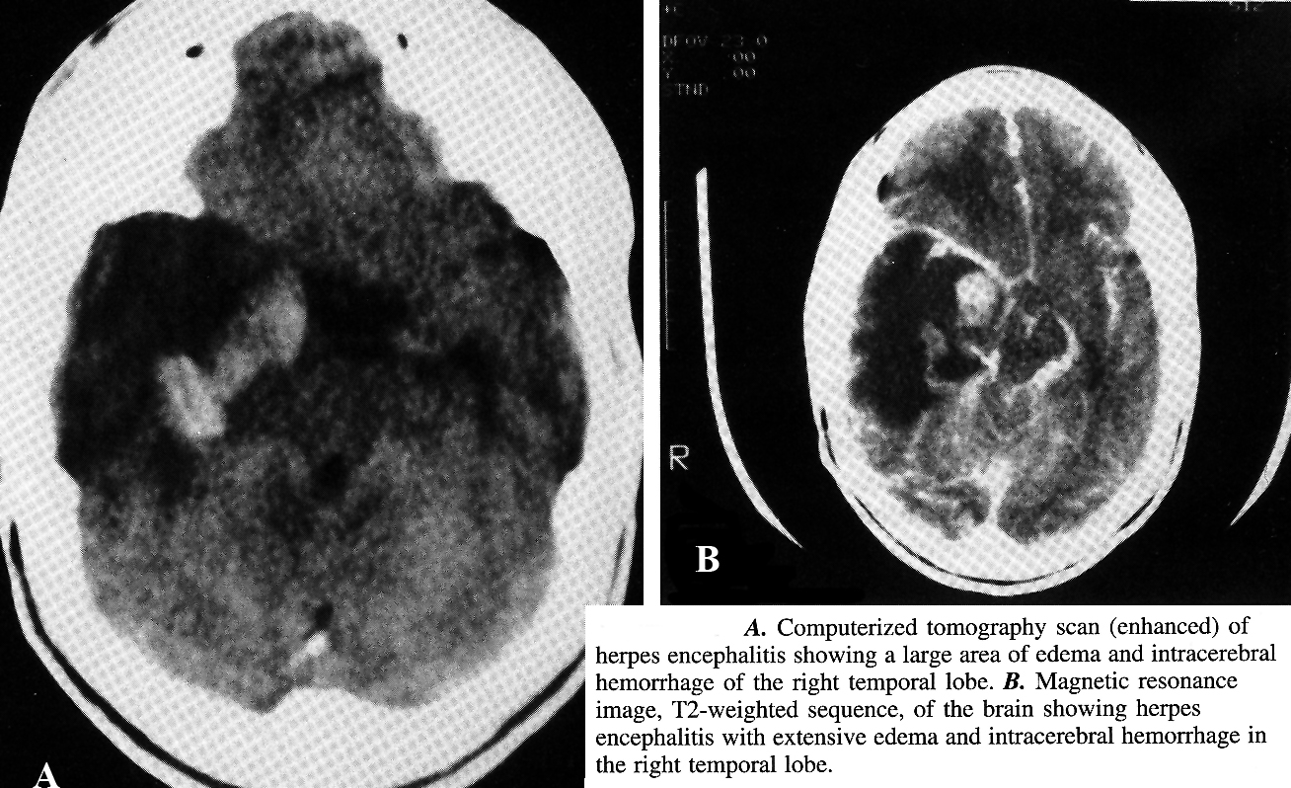

Treatment
– urgent acyclovir IVI for 14-21 days. dosages → see p. Inf1 >>
- discontinue if PCR is found negative.
- if clinical deterioration occurs over next 48-72 hours with acyclovir → brain biopsy.
- less effective and more toxic alternative – vidarabine.
- in HIV-positive patients (↑incidence of acyclovir-resistant HSV and HZV), consider foscarnet.
- some type of decompressive operation may be necessary if steroids (and other measures) are inadequate to control severe ICP elevations.

Prognosis
- of treated patients (severe neurologic impairment at initiation of therapy + older age + delayed initiation of therapy → poorer prognosis):
19-30% patients die (50-80% without acyclovir)
46% survivors - no or only minor sequelae
12% survivors - moderately impaired
42% survivors - severely impaired

VZV encephalomyelitis
Encephalitis
- rare complication of:
- varicella (chickenpox); esp. immunocompromised adults
N.B. differentiate form immunologic post-chickenpox encephalitis (most commonly as cerebellitis – acute cerebellar ataxia).
- herpes zoster oticus / ophthalmicus
  - multifocal ischemic & hemorrhagic infarctions (white matter > gray matter; concentrated at gray-white matter junction).
  - small demyelinative lesions with preservation of axons (due to small vessel vasculopathy).
  - diagnosis:
    - PCR in CSF.
    - VZV-specific intrathecal antibody response.
    - brain biopsy - Cowdry type A inclusions, VZV antigens or nucleic acids.
  - treatment – acyclovir group IV.

Thrombotic Cerebrovasculopathy (Vasculitis)
- extremely rare complication of herpes zoster ophthalmicus.
- pathogenesis - direct viral invasion of arterial walls (arteritis) via viral spread along intracranial branches of trigeminal cranial nerve.
- mean interval after rash ≈ 7 weeks → infarction (in internal carotid, anterior or middle cerebral arteries) → apoplectic hemiplegia ± other ipsilateral hemispheric deficits (aphasia, etc).
- angiography - multifocal thrombosis.

Myelitis
- herpes zoster direct invasion into spinal cord (e.g. posterior poliomyelitis, transverse myelitis, Brown-Sequard syndrome).
  - motor weakness, sensory loss and bladder dysfunction generally occur as rash resolves.

Arbovirus encephalitides (general)
- vary in epidemiology, mortality, morbidity. see p. 260 (1-2) >>
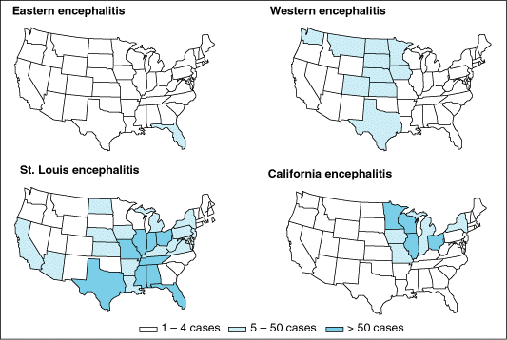

Encephalitis | Region | Animal host | Age | Mortality | Sequelae
Mosquito-borne
Eastern equine (alphavirus) | Atlantic and Gulf | birds | children, > 50 yrs | 35-75% | 80%
Japanese B  (flavivirus) | Asia |  | children | 33% (50%  in elderly) | 50%
St. Louis  (flavivirus) | All (esp. around Mississippi River) |  | > 50 yrs | 2% (20% in elderly) | 20% (elderly)
Western equine  (alphavirus) | West, midwest |  | infants,  > 50 yrs | 5–15% | low (moderate in infants)
West Nile  (flavivirus) | Africa, Asia,  Europe, USA |  | > 50 yrs | 12% (only elderly) | not  prominent
Venezuelan equine  (alphavirus) | South/Central America | horses, small mammals | children, > 50 yrs | 0.4-1% | rare
California, La Crosse  (bunyavirus) | East and north-central (i.e. geographically misnamed) | rodents, small  mammals | children | < 1% | rare, mild
Dengue fever  (flavivirus) | Tropics | mosquitoes |  | low | mild
Tick-borne
Colorado tick  fever (orbivirus) | US, Rocky  Mountains area | Small  mammals |  | low | rare
Powassan  (flavivirus) | Canada, northern  US | Birds, small  mammals |  | high | 50%
Far East  tick-borne  (flavivirus) | Former eastern  Russia |  |  | 20% | frequent
European tick-borne  (flavivirus) | Europe |  |  | 1-2% | < Far East

- mosquito / tick bite → local replication at skin site → viremia → seeding of reticuloendothelial system (incl. liver, spleen, lymph nodes) → secondary viremia → seeding of CNS (through capillary endothelial cells or through choroid plexus).
N.B. only 10% people bitten by arbovirus-infected insects develop overt encephalitis!

Unique clinical features:
- St. Louis encephalitis:
- inappropriate secretion of antidiuretic hormone (→ hyponatremia) (25-30%)
- renal involvement
- eastern equine encephalitis – early basal ganglion and thalamic involvement (see by MRI, CT); CSF pleocytosis – up to 2000 cells/mm³ (60-90% are PMNs).
- Venezuelan equine encephalitis – pharyngitis.
- dengue encephalitis – vasculopathy, thrombocytopenia, coagulopathy (majority of patients require transfusion of whole blood, fresh frozen plasma, and platelets).
- Colorado tick fever – encephalitis is almost never seen.
- West Nile encephalitis – see below >>
- tick-borne encephalitis – see below >>

Diagnosis in clinical practice:
- identifying virus-specific IgM in serum or CSF
- ≥ 4-fold increase in virus-specific IgG between acute and convalescent sera

Vaccines are available for:
- Venezuelan equine encephalitis*
- Western equine encephalitis*
- Eastern equine encephalitis*
- Japanese B encephalitis
- tick-borne encephalitis.
*vaccination on large-scale community program is not indicated because of low incidence of disease.

West Nile encephalitis
- flavivirus similar to Japanese B virus.
- endemic in Middle East, Africa, and Asia (seropositivity of children in Egypt ≈ 50%).
- birds transmit virus to humans via Culex, Aedes, and Anopheles mosquitoes.
- can be transmitted by means of organ transplant, blood transfusion!

Procleix WNV Assay (detects viral RNA) - FDA approved to screen donors of blood / organs / cells / tissues.

- documented perinatal transmission (transplacental, via breast-feeding).
- first USA outbreak in late summer 1999 (several deaths in New York);
  - by late summer 2002, West Nile virus has been identified throughout eastern and southeastern United States.
  - following bird migration, virus is extending westward.
  - now virus is found in all continental USA!!!

Clinical Features
(only 1 in 150 affected patients develop symptomatic WNE; usually asymptomatic in endemic areas).
- incubation of 1-15 days → influenza-like illness (with low grade fever and lethargy).
- non-neurologic involvement:
- multifocal chorioretinitis (most common ophthalmologic manifestation).
- hepatomegaly (10%), splenomegaly (20%).
- CNS involvement in < 15% cases:
- encephalitis (particular brainstem involvement)
- aseptic meningitis

Diagnosis
  - West Nile virus-specific IgM (ELISA in CSF or serum) detectable 10 days after infection onset; positive results must be confirmed by additional test.
  - PCR.
  - Profound and prolonged blood lymphopenia, increased serum transaminases, ESR↑.
  - Virus may be cultured from blood (within first 2 weeks), but it is not usually culturable from CSF.
  - Brain biopsy - nonspecific diffuse encephalitis.

Treatment
- supportive.

Prognosis
- excellent (except elderly or debilitated – death is possible); recovery is usually complete.

Tick-borne encephalitis (TBE)
Epidemiology
- does not occur in America.  - ticks act as both vector and reservoir.  - main hosts are small rodents (humans are accidental hosts; large animals are feeding hosts for ticks, but do not play role in maintenance of virus).  - humans are infected:  - tick bites.  - consumption of raw milk (from goats, sheep, or cows).  - vaccine is available (life-long protection). | 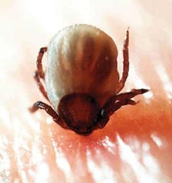
Clinical Features
Asymptomatic incubation period – 7-14 days (shorter after milk-borne exposure).  Biphasic febrile illness:  - first phase – mild flulike episode with leuko- & thrombocyto-penia lasting 2-4 days (corresponds to viremia); this phase may be clinically inapparent!  - 4-10 days of remission  - second phase occurs in only 20-30% patients – sudden high fever with leukocytosis and CNS involvement: | 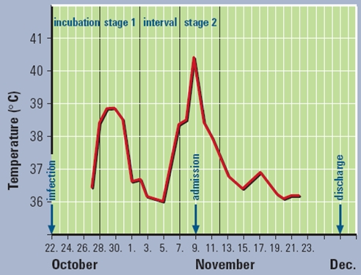

- meningitis  - encephalitis  - myelitis.  - predilection for anterior horn cells in neck → flaccid upper limb - shoulder girdle paralysis, hanging head!!!  - spread to medulla oblongata → bulbar syndrome with respiratory / circulation failure → death. | 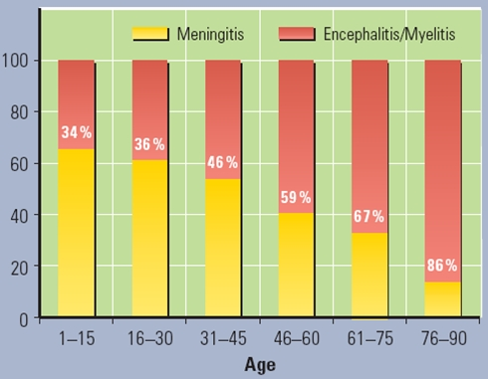
Atrophic shoulder following TBE:
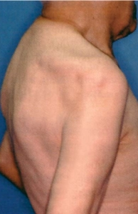

Diagnosis
– laboratory (clinical features are nonspecific):
- standard of diagnosis - TBE-specific IgM / IgG* in either serum (during first phase) or CSF (during second phase). * ≥ 4-fold rise in paired samples
- PCR - not very useful in clinical practice.
- in CSF, PMNs may predominate!

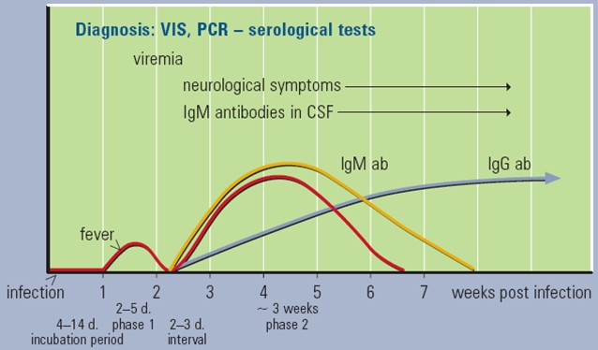

- T2-MRI - increased signal intensity in basal ganglia and thalami.

T2-MRI of 5 year girl with TBE: significant changes within both thalami and right nucleus lentiformis without enhancement by contrast medium:
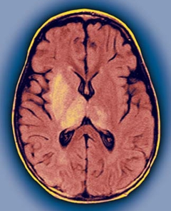

Prognosis
- mortality – 1-2% (deaths occur 5-7 days after onset of neurologic signs).
- neurologic sequelae in 35-60% patients.
- neuropsychiatric sequelae in 10-20% patients.

Encephalitis Lethargica (von Economo disease)
Etiology
– unknown (presumably viral, but proof is lacking).
- occurred in epidemic form in 1917-1928 (i.e. following influenza pandemic of 1914-1918) - spread rapidly over entire world (affected patients of all ages, both sexes evenly, all races and occupations).

Pathology
- similar to other encephalitides.

Clinical Features
- acute / subacute diffuse brain involvement:
- mild fever at onset; rise to ≥ 107 F in terminal stages (in fatal cases).
- headache
- disturbed sleep rhythm, marked lethargy*
- disorders of eye movements, esp. diplopia (75% patients!)**
- most frequent motor symptoms - all categories of basal ganglia injury.
- acute organic psychosis.
*damage to brainstem reticular formation
**damage to nuclei around aqueductus
  - acute stage lasts ≈ 4 weeks and merges gradually into postencephalitic phase with various sequelae in large percentage of recovered patients.
    - von Economo disease is basis for postencephalitic Parkinsonism. see p. Mov11 >>
    - behavior disorders and emotional instability (without intellectual impairment) were common sequelae in children.
  - mortality ≈ 25%.

Balamuthia Amebic Encephalitis
Etiology
Balamuthia mandrillaris - free-living ameba
  - ameba is present in soil - transmitted by inhalation of airborne cysts or by direct contamination of skin lesion.
  - causes encephalitis in humans (both immunocompetent and immunocompromised), horses, dogs, sheep, and nonhuman primates.
  - ≈ 150 cases reported worldwide (since recognition of disease in 1990).

Diagnosis
CSF - protein↑ (64-674 mg/dL), WBCs↑ (11-540 cells/mm3) with lymphocytic predominance; normal / low glucose (15-74 mg/dL).

Bibliography for ch. “Infections of Nervous System” → follow this link >>

Viktor’s Notes℠ for the Neurosurgery Resident
Please visit website at www.NeurosurgeryResident.net

