Extrapyramidal Movement Disorders (general)
Last updated: July 12, 2019
Pathophysiology 1
Clinical Features 2
Diagnosis 3
Treatment 4
Morphologic Correlations 4
Tremor 5
Essential tremor 6
Orthostatic tremor 7
Primary writer's tremor 7
physiologic tremor 7
dystonic tremor 8
“Rubral” tremor 8
Shuddering attacks 8
Holmes tremor 8
Hereditary chin trembling 8
Tic 9
Mannerisms 10
Chorea 10
Ballismus 10
Athetosis 11
Myoclonus 11
Asterixis 13
Dystonia 13
Tardive (s. oral-buccal-lingual) dyskinesia 14
Akathisia 15
Psychogenic movement disorders 15
Stereotypy 16
Catatonia 16
Operative (surgical) Techniques – see p. Op360 >>
Pyramidal UMN, LMN movement disorders (fasciculations, fibrillations, myokymia, spasms, cramps, tetany, contractures) → see p. Mov3 >>
Hemifacial spasm → see p. CN7 >>

Term “extrapyramidal disorders” is now replaced by more descriptive and accurate term “movement disorders”!

Pathophysiology
- most movement disorders are due to basal motor nuclei dysfunction.
- several primary movement disorders are hereditary.
- basal motor nuclei neurons vary greatly in structure, biochemistry and blood supply – different factors affect different nuclei.
- most lesions are symmetric → bilateral symptomatology;
unilateral lesion → dysmodulation of ipsilateral motor cortex → contralateral signs (due to pyramidal decussation).

All (!) motor disorders fall into two classes of deficits:
- Primary functional deficits (negative signs) – loss of function of damaged neurons.
- Secondary deficits (positive signs / release phenomena) – abnormal patterns of action when controlling input (usually inhibitory) is destroyed.

Drugs can induce / exaggerate movement disorders:
- dopamine D₂ -receptor antagonists → acute dystonic reactions, acute akathisia, drug-induced parkinsonism, neuroleptic malignant syndrome, tardive dyskinesia.
- drugs that enhance noradrenergic tone (thyroxine, epinephrine, insulin) can exaggerate physiological tremor; cocaine → chorea, tics, opsoclonus-myoclonus.
- anticonvulsants → chorea (valproate may induce hypokinesia).

Clinical Features
      - Hyperkinesias (s. dyskinesias) – involuntary movements:
pathogenesis → see Huntington disease in p. Mov20 >>
N.B. excessive voluntary movements (e.g. in attention deficit disorders, mania) are not generally considered as hyperkinesias!
        - tremor
        - athetosis
        - tic
        - ballismus
        - chorea
        - myoclonus
        - dystonia
        - tardive dyskinesia
Hyperkinesias occur spontaneously (at rest) or during specific situations:
- sudden movement (e.g. as person stands up or starts to run) induces paroxysmal kinesigenic dyskinesia.
- prolonged exercise can induce paroxysmal exertional dyskinesia.
- fatigue, stress.
- ingestion of caffeine and alcohol.
- hyperkinesias are frequently increased by action.
- hyperkinesias disappear during sleep.

      - Hypokinesias (supplementary motor cortex, corpus striatum, subst. nigra) – decreased amplitude of movement without paralysis; also includes:
- Bradykinesia – decreased speed (slowness) of movement.
- Akinesia – paucity / absence of movement.
pathogenesis → see parkinsonism in p. Mov10 >>
Fatigue is particularly prominent in hypokinesias.
Term “hypokinetic syndrome” is synonymous with “parkinsonism”.

      - Changes in muscle tone: rigidity / hypotonia see p. Mov3 >>

      - Changes in postural reflexes:
        - trouble starting & stopping gait (freezing) see p. Mov7 >>
        - pro-, latero-, retropulsion → festinating gait, fallings (pathophysiology may be related to bradykinesia and not to unique postural response deficit) see p. Mov7 >>

      - Cognitive dysfunctions (nucl. caudatus), affective (limbic) dysfunctions (nucl. accumbens).

Disorders of basal ganglia do not cause weakness or reflex changes!!!

- onset of most movement disorders is insidious; exception – hemiballismus (sudden onset related to cerebrovascular accident).

Diagnosis
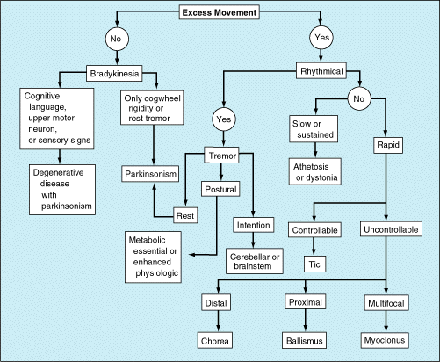

- CT, MRI:
- primary neurodegenerative movement disorders – only mild to moderate cerebral atrophy.
- particularly useful in disclosing secondary nondegenerative causes (e.g. cerebrovascular accidents, abscesses, tumors)
- EEG (must include episodes of movements) - is there cortical event that occurs simultaneously.
- EMG can guide botulinum toxin injections in most dystonic muscles.
- tremors are characterized with tremorometer (applied over agonist and antagonist muscles).

Treatment
- Neurotransmitter substitutes:
  - to replenish deficient transmitter (e.g. dopamine)
  - to block overactive circuits (e.g. anticholinergics)
Hyperkinesia (dopamine↑, Acch↑, serotonin↓, GABA↓) H: dopamine antagonists, anticholinergics.
Hypokinesia (dopamine↓, Acch↑, serotonin↑, GABA↑, prolactin↑) H: dopamine agonists, anticholinergics.
- Stereotactic destruction / inactivation – disrupts overactive circuit (reversal of secondary deficits) – surgical lesions counteract effects of original lesions.
Dystonia responds best, athetosis least!
- Neural transplantation
- Destruction of pyramidal pathways – last resort for life-threatening hyperkinesias.

support tools
Swallowing is affected by either hypokinesia or hyperkinesia (advanced diseases require feeding tubes).
Hypokinesia:
- freezing episodes can be precipitated by low-lying objects and crowded conditions - remove all unnecessary furnishings from patient's walking area.
- visual cues (like striped lines on floor) may help in prominent freezing akinesia to overcome blockage and initiate movement.
- if patient falls - wear knee, elbow, hip protective padding.
- if patient is highly immobilized – consider venous status and pulmonary emboli.

Hyperkinesia:
- protective clothing if patient bumps himself from flinging movements.
- avoid braces & splints – movements still persist → braced extremity or trunk will be injured.
- hyperkinetic patients may be hypermetabolic - attention to weight & nutrition.

Morphologic Correlations
- globus pallidus lesions → trunk muscles unable to maintain postural support (e.g. head bends forward so that chin touches chest; body bends at waist);
      - motor cortex is deprived of information it needs to automatically control trunk muscles (globus pallidus is major outflow tract of basal ganglia).
      - no muscular weakness, no deficit of voluntary control - patient can stand upright when requested to do so.
- striatum lesions:
- chorea
- athetosis
- dystonia
- nucl. subthalamicus lesions → ballismus.
- substantia nigra (pars compacta) lesions → Parkinson disease.

Tremor
- regular (rhythmic) oscillatory movements caused by alternate contractions of opposing muscles; most prominent in hands & forearms.
Tremor types are determined by observing patient:
- at rest (with patient sitting or lying in repose) – resting tremor.
- with posture-holding (with arms extending in front of body) – postural tremor (incl. essential tremor).
- with action (such as writing or pouring water from cup) – action tremor (incl. essential tremor).
- with intention maneuvers (such as finger-to-nose maneuver) – intention tremor.

- Resting (static) tremor – most prominent in relaxed limbs.  - 3-7 Hz, coarse (amplitude larger than in physiologic tremor).  - “pill-rolling” in hand, pronation / supination in forearm.  - may affect other body parts (incl. jaw, face, tongue), but never affects neck or head itself! voice is also spared!  - disappears with voluntary limb movement, also during sleep.  - aggravated with excitement, agitation.  - etiopathology – substantia nigra lesion in parkinsonism syndrome. |  |  | 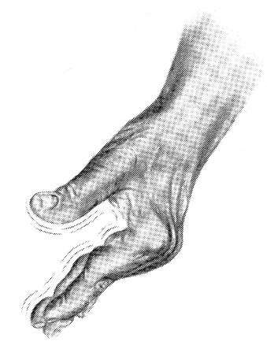
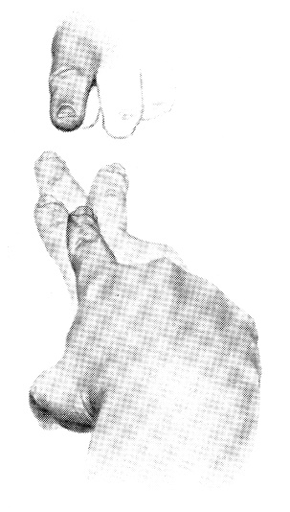 | - Intention tremor – most prominent during voluntary limb movement, gets worse as target is neared (in severe cases target may never be attained).  - greatest when patients use visual cues to guide movement.  - 1.5-7 Hz; absent at rest or during maintained posture.  - proximal > distal.  - pathology – abnormality of cerebellum or its outflow pathways (dentate nucleus, superior cerebellar peduncle, contralateral red nucleus).  - titubation – coarse head & trunk tremor (of cerebellar origin) in upright position.  - no effective treatment exists!  - physical measures (e.g. weighting affected limbs or teaching patients to brace proximal limb during activity) are useful.
- Action / postural tremor – appears when limb is involved in activity or actively maintaining posture.  - fine, rapid.  - may be asymmetrical.  - absent at rest. |  | 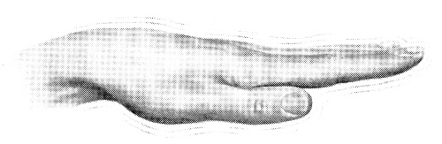
  - tremor is seen through trajectory movement but patient's finger stabilizes at endpoint (either examiner's finger or patient's nose).
  - may have associated head tremor, vocal tremor.
  - may be temporarily helped by alcohol ingestion (diagnostic maneuver!).
  - made worse by phenothiazines.
  - H: propranolol (drug of choice), primidone, diazepam, alprazolam, small alcohol doses.
Source of tremor pictures: Barbara Bates “A Guide to Physical Examination”, 3rd ed. (1983); J.B. Lippincott Company; ISBN-13: 978-0397543991 >>

Tremors that are highly dependent on posture: orthostatic tremor, primary writer's tremor.

Scales
Clinical Rating Scale for Tremor (CRST)
Quality of Life in Essential Tremor Questionnaire

Essential tremor
Epidemiology, Genetics
- most frequent hyperkinetic movement disorder! (age-adjusted prevalence 2-5%)
- autosomal dominant in 50% - can use term familial (benign hereditary) tremor
- may affect any age group (bimodal distribution of onset – peak in adolescence and second peak in 4-5th decade).
- no specific structural abnormality has been noted in brain (some evidence implicates brain stem circuits involving inferior olive).

Clinical Features
- 7-12 Hz (faster than resting tremor); frequency tends to decrease with increasing amplitude and patient age.
- alternating or synchronous (!) contractions of agonist and antagonist muscles.
- first affects hands;
- most prominent in outstretched position (postural) – hand flexion-extension at wrists or adduction-abduction of fingers.
- also during action.
- may be asymmetric.
- major impact on fine motor skills (e.g. large, irregular, tremulous handwriting).
- intensified by any factor that intensifies physiologic tremor.
- later may involve head, neck, and voice (→ wavering voice).
- frequent combination with dystonia or parkinsonism.

Prognosis
- lifelong illness that does not affect the lifespan.
- steadily progressive with age (occasionally is incorrectly called senile tremor), sometimes suddenly takes exponential course
some clinical studies indicate that essential tremor may be slowly progressive neurodegenerative disorder – with progressive cognitive deficits and increased risk of dementia

Treatment
propranolol, primidone, topiramate, gabapentin, zonisamide
Level A, established as effective (Class 1 evidence) – propranolol (up to 160-180 mg/d), primidone – both can reduce tremor by 60% in 50% of patients.
Level B, probably effective - alprazolam, atenolol, gabapentin, sotalol, topiramate
Level C, possibly effective - nadolol, nimodipine, clonazepam, botulinum toxin A
Level U, insufficient evidence - Gamma knife (targets as for DBS)
Probably do not reduce limb tremor in essential tremor and should not be considered - levetiracetam, 3,4-diaminopyridine.
Possibly has no effect in treating limb tremor in essential tremor and may not be considered – flunarizine.
Insufficient evidence to support or refute - pregabalin, zonisamide, clozapine.

FDA approved: Deep Brain Stimulation, RF or FUS: see p. Op360 >>
- magnicellular part of VIM [ventralis intermedius] nucleus of thalamus - standard target: DBS reduces tremor 80% in 80% of patients; FUS reduces tremor by 50% at 3 months and 40% at 12 months postop.
- caudal zona incerta (cZi) - alternative target

Orthostatic tremor
- patient can walk with only mild discomfort, but when asked to stand in place for several seconds → hard cramping calves & thighs that shake uncontrollably.
- considered to be variant of ET, but does not respond to usual drugs;
clonazepam is effective.

Primary writer's tremor
– only during writing.
- may respond to ET medications, but often improve more with anticholinergics.
- most effective measures - changing to large, fat pen (requires different muscles for holding), switching to typing.

physiologic tremor
- ≈ 9-11 Hz (adults), 6-8 Hz (children).
- exaggerated in noradrenergic tone↑ (cold, effort, fear, anxiety*, β-adrenomimetics, caffeine, hyperthyroidism, pheochromocytoma), fatigue, alcohol withdrawal, glucocorticoids.
* some people cannot sign their name in public

dystonic tremor
– observed in dystonia - result of patient's own compensatory movement to overcome dystonia (therefore tremor is maximized in position that opposes natural dystonic contraction).

“Rubral” tremor
= resting tremor + intention tremor + postural tremor.
  - pathology – structural disease in red nucleus or pathways connecting it with cerebellar and thalamic nuclei.
  - treatment is frustrating (no reliable pharmacological success has been reported); because patients are not weak and overshoot their targets, stabilization with wrist weights can reduce amplitude and disability.

Shuddering attacks
- sudden flexion of head and trunk and shuddering (shivering) movements (if ice-cold water is poured down back of unsuspecting individual).
- onset at 4-6 mo; may persist to 6-7 yr of age.
- up to 100 attacks/day followed by several symptom-free weeks.
- may be childhood precursor of essential tremor.

Holmes tremor
Definition (Consensus Statement of the Movement Disorder Society on Tremor from 1998): rest and intention tremor with sometimes irregular amplitude, however, a postural tremor is also present in many patients.

- first described in 1904 by Gordon Holmes as a 3–4 Hz flexor-extension oscillation, present at rest and exacerbated with posture and additionally intensified with action.
- slow frequency tremor, usually less than 4.5 Hz.
- it is a symptomatic (secondary) tremor - imaging studies are usually abnormal, although in some cases no lesion can be demonstrated.
- tremor commonly develops between 1 and 24 months after a CNS insult (delayed onset might be due to neuronal plastic changes).
- it is assumed that a double lesion is required to develop HT, including the dopaminergic nigrostriatal system and the cerebello-thalamo-cortical or dentate-rubro-olivary pathways.
- treatment:
- pharmacologic treatment is usually unsuccessful, although levodopa treatment has provided benefit in some cases.
- VIM DBS has good results.

Hereditary chin trembling
- 3 Hz (may be confused with epilepsy).
- precipitated by stress, anger, frustration.
- autosomal dominant inheritance.
- neurologic examination, EEG are normal.

Tic
- brief, repetitive (but nonrhythmic!), stereotyped, coordinated movements occurring at irregular intervals (burst for brief moments from background of normal motor activity).  - involve face, neck, shoulders (motor tics), vocal apparatus (vocal tics) more than other body parts (e.g. repetitive winking, grimacing, shoulder shrugging).  - exact pathophysiologic mechanism unknown (dopaminergic hyperactivity in striatum?)  - can be controlled by antidopaminergic agents. | 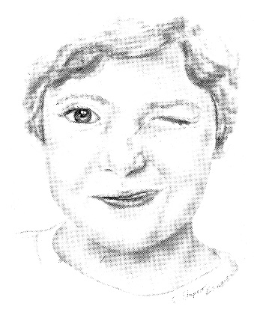
Source of picture: Barbara Bates “A Guide to Physical Examination”, 3rd ed. (1983); J.B. Lippincott Company; ISBN-13: 978-0397543991 >>
- etiology:
- primary tic disorder - no specific morphologic changes in brain; wide clinical spectrum (transient tics of childhood ÷ Gilles de la Tourette syndrome). see p. Mov22 >>
- secondary tics - hypoxic head injury, head trauma, viral encephalitis, CO intoxication, Huntington's disease, neuroacanthocytosis, startle disorders, cocaine abuse, opiate withdrawal, stimulant medications.

- premonitory feelings precede 80% tics.
e.g. burning feeling in eye before eye blink, tension or crick in neck that is relieved by stretching of neck or jerking of head, feeling of tightness or constriction relieved by arm or leg extension, nasal stuffiness before sniff, dry or sore throat before throat clearing or grunting, itching before rotatory movement of scapula.
- ≈ 93% of tics are perceived by patients to be irresistibly but purposefully executed (intentional component is useful feature in differentiating tics from other hyperkinetic movement disorders)
- tics usually are intermittent, but may persist during all stages of sleep (vs. other hyperkinetic movement disorders).
- tics can be suppressed voluntarily (e.g. in public) for various periods of time (but inner tension builds up and is only relieved by increased burst of more tics);
Tics may not be seen in doctor's office, even though they may be disabling at school or home!
N.B. chorea, ballismus, myoclonus cannot be voluntarily suppressed!
- tics can involve ocular muscles! - very few other dyskinesias involve ocular movements:
  - opsoclonus (dancing eyes) - form of myoclonus;
  - ocular myoclonus (rhythmical 2 Hz vertical oscillations) accompanied by palatal myoclonus;
  - oculogyric spasms (sustained deviation of eyes, thus dystonia).

Simple motor tics may be impossible to distinguish from myoclonic or choreic jerk.
Complex motor tics may be impossible to distinguish from compulsions - coordinated patterns of sequential movements; e.g. touching nose, touching other people, head shaking with shoulder shrugging, kicking of legs, obscene gesturing (copropraxia).

Simple vocal tics - throat-clearing sounds, grunts, etc.
Complex vocal tics - verbalizations and utterance of obscenities (coprolalia), repetitions of one's own sounds (palilalia) or sounds of others (echolalia).

Mannerisms
- frequently encountered personalized physiologic tics (analogous to excessive clearing of throat).
- may persist after repeated performances of motor habits and have therefore been called ”habit spasms”.

Chorea
- clonic hyperkinesis – involuntary rapid, jerky, multiple, random (unpredictable)* movements that flow from one body part to another – generally distal limb & facial muscles** – looks like restlessness / fidgeting:
*vs. tics – stereotypic movements
** proximal and axial muscles can also be involved
- muscles hypotonic!  - occur at rest (disappear during sleep) or interrupt normal coordinated movements (volitional activity may become difficult).  - inability to maintain sustained contraction (motor impersistence) – results in:  - dropping of objects.  - inability to keep tongue protruded  - inability to keep fist in sustained tight grip; hand grip contracts and relaxes (milkmaid sign). | 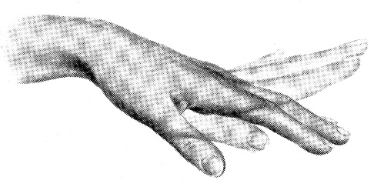  Source of picture: Barbara Bates “A Guide to Physical Examination”, 3rd ed. (1983); J.B. Lippincott Company; ISBN-13: 978-0397543991 >>
- speech is explosive and inarticulate.
- stuttering / dancing gait see p. Mov7 >>
- patellar reflexes are "hung up" or “pendular”.
- choreic movements cannot be suppressed, and patient can often hide some of movements by incorporating them into semipurposeful movements (known as parakinesia).
- pathology – striatum (caudate) lesion → GABAergic deficiency.
- etiology: see p. Mov20 >>
  - Huntington disease (prototypic chorea!)
  - Sydenham chorea (with rheumatic fever) – spontaneous full recovery.
  - chorea gravidarum (often in patients with history of rheumatic fever) - begins during 1st trimester, resolves spontaneously by / after delivery; H: barbiturates (other drugs may harm fetus).
  - Wilson disease
  - excess dopamine-agonist therapy, etc
- treatment – dopamine antagonists.

Ballismus
- wild flinging, violent, jerking movements of proximal appendicular muscles (“violent chorea, involving large muscle groups”)
N.B. most severe hyperkinesis! (death may result from exhaustion)
- cannot be suppressed voluntarily!
- mostly unilateral (hemiballism) – contralateral nucl. subthalamicus lesion (e.g. hemorrhagic stroke in arterial hypertension – sudden onset!).
- rarely bilateral (biballism); e.g. overdosage of levodopa.
- normally, nucl. subthalamicus indirectly inhibits motor cortex;
nucl. subthalamicus (releases Glu) excites thalamus; thalamus (releases GABA) inhibits motor cortex.
- normally, nucl. subthalamicus inhibits centers that issue motor commands for body balance;
ballismus movements appear to be like those performed when individual is thrown off balance.
- disorder usually subsides spontaneously within several weeks.
- treatment – dopamine antagonists (e.g. haloperidol) - block "overactive" D receptors in striatum.
for prolonged disabling hemiballism - contralateral thalamotomy or pallidotomy.

Athetosis
- tonic hyperkinesis (form of dystonia) - slow, twisting-writhing, large amplitude movements (flexion / extension, pronation / supination) of distal appendicular muscles (fingers and hands, sometimes toes and feet).

- often associated with spasticity!  - if athetosis is not present at rest, it can be brought out by having patient carry out voluntary motor activity elsewhere on body (phenomenon is known as overflow).  - etiology - early life brain damage:  - corpus striatum myelinization disorders (status marmoratus)  - cerebral palsy (injury to basal ganglia in neonatal period). | 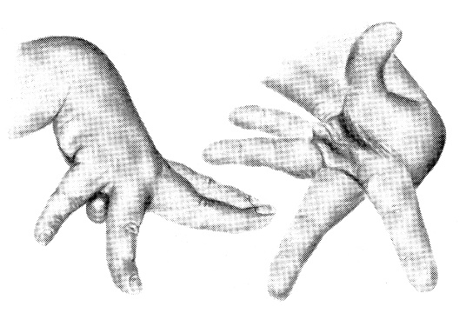  Source of picture: Barbara Bates “A Guide to Physical Examination”, 3rd ed. (1983); J.B. Lippincott Company; ISBN-13: 978-0397543991 >>
- in infants, movement speed can be very slow causing sustained contractions, abnormal posturing (athetosis blends with dystonia).
- in adults, movement speed can be faster (athetosis blends with chorea → choreoathetosis).
- differential - profound proprioceptive loss - outstretched limbs (with eyes closed) may demonstrate pseudoathetosis.

Involuntary movements of distal limbs (chorea, athetosis) often go together – due to dopaminergic hyperactivity.

- athetosis usually does not respond to pharmacologic therapy!

Myoclonus
- sudden, brief, rapid, unpredictable (shocklike) jerks of limbs or trunk (single muscle ÷ entire body).  - caused by muscular contractions (positive myoclonus) or inhibitions (negative myoclonus).  - jerks are more sudden than in chorea.  - cannot be suppressed voluntarily! | 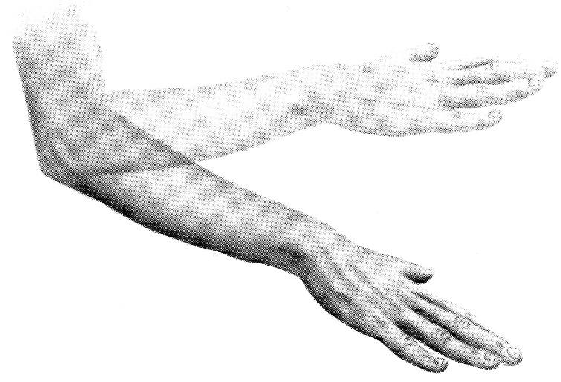  Source of picture: Barbara Bates “A Guide to Physical Examination”, 3rd ed. (1983); J.B. Lippincott Company; ISBN-13: 978-0397543991 >>
Etiology N.B. myoclonus is exceptional movement disorder - it is not basal ganglia disorder!!!
    - physiological myoclonus:
      - normal person falling asleep (nocturnal myoclonus, s. hypnic jerks).
      - hiccup (singultus) - myoclonus of diaphragmatic muscles.
    - essential myoclonus – heredodegenerative. see p. Mov22 >>
    - epileptic myoclonus
    - symptomatic myoclonus - variety cortical, brain stem, cerebellum, spinal cord disorders (Creutzfeldt-Jakob disease!, posthypoxic or metabolic encephalopathies, etc.):

Frequency:
  - single irregular jerks
  - rhythmical oscillatory jerks (e.g. palatal / ocular 2 Hz myoclonus, polyminimyoclonus).

Triggering & extent:
- anatomic extent: focal, segmental, or generalized.
- amplitude ranges: mild contractions that do not move joint ÷ gross contractions that move limbs, head, or trunk.
- myoclonic jerks can appear:
- with body at rest
- when affected body part is in voluntary activity - action myoclonus (more disabling).
- jerks can often be triggered by sudden stimuli (stimulus sensitive, s. reflex myoclonus) - sound, light, visual threat, movement.
  - cortical reflex myoclonus (usually focal myoclonus) is triggered by active or passive movements of affected body part;
  - reticular reflex myoclonus is segmental or generalized - spreads along body away from source in timed-related sequential fashion.
- jerks occurring in different body parts are often synchronized - feature specific for myoclonus!
fact that rhythmical myoclonic jerks of one body part are synchronized with contractions elsewhere is strong argument for myoclonus (vs. tremor).
- myoclonus has relationship to seizures - both are result of hyperexcitable neurons.
- oculopalatal myoclonus persists during sleep!
general rule - all movement disorders except myoclonus* disappear during sleep.
*also some tics?
Myoclonus can cause falls:
Positive myoclonus throws patient off balance.
Negative myoclonus (esp. sudden inhibitions of thigh muscles when patient is standing / walking).

Symptomatic treatment
      - anticonvulsants (clonazepam!!! – drug of choice, valproate, levetiracetam).
      - 5-HTrp (serotonin precursor; must be used with carbidopa).

Asterixis
- most common form of negative myoclonus – nonrhythmic, brisk, wide amplitude flapping movements of hands.

- ask patient hold arms forward, with hands cocked up and fingers spread for 1-2 minutes → extended wrist and fingers flex suddenly and briefly (sudden loss of antigravity muscle tone [EMG silence] – negative myoclonus) → return to original position.  - etiology – various metabolic encephalopathies: liver failure, renal failure, pulmonary insufficiency → cerebral hypoxic / metabolic derangement. | 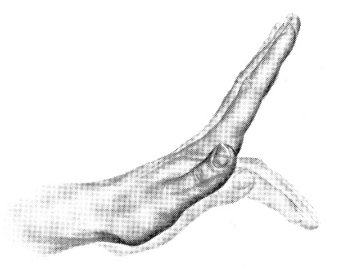
Source of picture: Barbara Bates “A Guide to Physical Examination”, 3rd ed. (1983); J.B. Lippincott Company; ISBN-13: 978-0397543991 >>

Dystonia
- long sustained twisting movements of axial muscles (i.e. ≈ athetosis but involve large areas) → grotesque twisted postures.  - agonist and antagonist muscles contract simultaneously.  - if patient attempts to oppose them → rhythmic interruptions (dystonic tremor).  - spasms lessen in intensity with "sensory tricks" or "gestes antagonistes" (e.g. gentle counterpressure by hand against chin in patient with torticollis may enable to maintain primary or normal head position). | 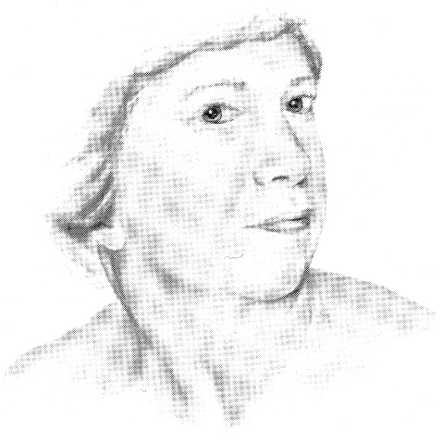
Source of picture: Barbara Bates “A Guide to Physical Examination”, 3rd ed. (1983); J.B. Lippincott Company; ISBN-13: 978-0397543991 >>

- etiology: striatum (putamen) dysfunction see p. Mov21 >>
- primary dystonia (s. dystonia musculorum deformans, torsion dystonia)
- neuroleptics (phenothiazines) – acute dystonia of head (incl. eyes, tongue) & neck.
see p. Psy9 >>
- various neurodegenerative disorders
- kernicterus (dystonia + hearing loss)
- perinatal cerebral injury, encephalitis, strokes, tumors, trauma
Unilateral dystonia (hemidystonia) - lesion in contralateral striatum (particularly putamen).
- can be painful (particularly drug-induced forms).
- treatment:
- anticholinergics (trihexyphenidyl, benztropine, diphenhydramine)
- dopamine-depleting drugs (reserpine)
- local injection of botulinum A toxin q 3-6 months.

Speed of movement varies widely:
- very brief (less than second) - dystonic spasms or myoclonic dystonia;
H: diphenhydramine or benztropine i/v.
- several seconds - dystonic movements.
- minutes to hours - dystonic postures (if present for weeks or longer, postures could lead to permanent fixed contractures - torticollis, scoliosis, tortipelvis, etc).
Marked body distortion of such degree is rarely seen in any other diseases!

According to extent:
- single body part - focal dystonia (e.g. spasmodic torticollis, blepharospasm, writer's cramp, spastic dysphonia, Meige syndrome)
- two or more contiguous regions - segmental dystonia
- generalized dystonia (e.g. primary dystonia)

During disorder progression:
- task-specific dystonia - occurring only during specific activity (such as writing);
- action dystonia - occurring only when affected body part is carrying out any voluntary action;
- overflow dystonia - occurring when other body parts are voluntarily moving;
- continual dystonia (dystonia at rest) - occurring even when body is at rest;
- fixed postures

Tardive (s. oral-buccal-lingual) dyskinesia
- repetitive stereotypic rapid bizarre choreoathetoid movements of lower facial muscles & tongue: grimacing, lip pursing, tongue protrusions, opening-closing mouth, jaw deviations - resembles continual chewing movements.  - it is stereotypy!  - patient may not be aware of dyskinesia. | 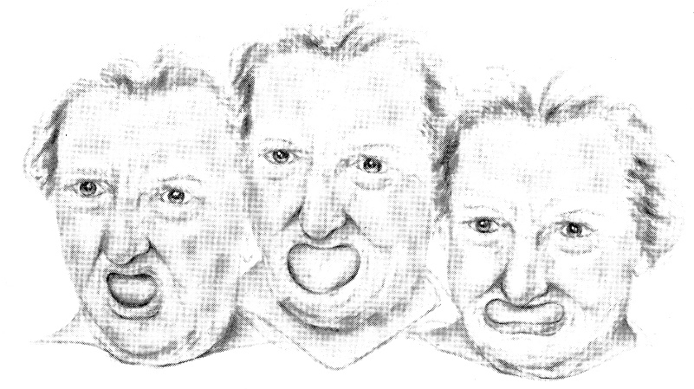  Source of picture: Barbara Bates “A Guide to Physical Examination”, 3rd ed. (1983); J.B. Lippincott Company; ISBN-13: 978-0397543991 >>
- trunk may show repetitive flexion and extension (“body-rocking”).
- hands may flex and extend (e.g. “piano-playing” fingers).
- when patient stands, legs repetitively move (“marching-in-place”).
- when patient walks, arms swing more than normal and stride may be lengthened.

Etiology:
- neuroleptics – late (tardive) side effect! – due to chronic [6 months may be enough!] blockade of dopamine receptors – develop hypersensitivity. see p. Psy9 >>
N.B. dyskinesia may remain or even worsen after drug withdrawal! see p. Mov25 >>
N.B. metoclopramide for ≥ 12 weeks causes TD in 20% patients!
- longstanding psychoses*
- elderly edentulous persons*
*cause oral dyskinesias that are not tardive dyskinesia per se

Treatment:
- Dopamine-depleting drugs (e.g. reserpine).
- Cholinergics (e.g. deanol).
- Stop / reduce neuroleptic therapy.
- Noradrenergic antagonists (propranolol, clonidine)
- GABA agonists (clonazepam, diazepam, valproate, baclofen)
- Botulinum toxin injections
- Vitamin E, buspirone, calcium channel blockers.

Akathisia
[Greek – “unable to sit still”] - compulsion to stereotypically move extremities (usually legs) - inability to remain in sitting posture, with motor restlessness and feeling of muscular quivering in response to internal restless feelings.
Akathisia = stereotypy + sensory component
- patients describe vague but intense discomfort (e.g. burning or pain) in their body that is relieved by movement.
- can be transiently suppressed by patient if he is asked to do so.
- particularly affects lower extremities ("restless legs") and often is worse at night, causing insomnia.
- typical akathisic patient: when sitting, strokes scalp, crosses-uncrosses legs, rocks trunk, squirms in chair, gets out of chair often to pace back and forth, even makes noises such as moaning.
N.B. akathisic movements are complex stereotypic movements.

Etiology
- side effect of D₂-blockers (e.g. neuroleptics):
  - when drug therapy is initiated; usually within first few months (acute akathisia);
H: withdraw medication, propranolol, amantadine, clonidine, anticholinergics, vit. E, benzodiazepines (for akathisia associated with extreme anxiety)
  - after chronic treatment (tardive akathisia); may be associated with tardive dyskinesia (may be difficult to differentiate between two); worsens on sudden drug discontinuation;
H: increase dose of offending drug (will mask movement disorder).

- akathisic movements can also be reaction to stress, anxiety, boredom, or impatience - physiologic akathisia.

Psychogenic movement disorders
- can present as any type of hyperkinesia, hypokinesia and gait disorders.
- most are continual (or paroxysmal nonkinesigenic without family history).
- frequent distractibility, inconsistency of signs, abrupt (strokelike) onset.

Stereotypy
- constant involuntary repetition of certain meaningless (purposeless) coordinated, patterned gestures or movements (repeat themselves continually and identically) - seemingly purposeful and ritualistic.
- simple (e.g. chewing movement, foot tapping, body rocking) or complex (e.g. complicated rituals, sitting down and arising from chair).
- can be volitionally suppressed.
- if there is long periods of minutes between movements, it may be difficult to distinguish from motor tics, compulsions, gestures, and mannerisms.
tics are acts that are impelling but not impossible to resist;
stereotypies, although illogical, are without irresistible urge.
- etiology:
- behavioral disorders, schizophrenia, mental retardation, autism, Rett syndrome, Angelman syndrome, Asperger syndrome
- classic tardive dyskinesia
- normal children
- no consistent neurochemical abnormalities are found.
- therapy is empirical - neuroleptics, dopamine-depleting drugs.

Catatonia
- extreme psychomotor disturbance – either markedly retarded motor activity (maintaining rigid postures and resisting efforts to be moved, akinetic mutism, "waxy flexibility") or markedly agitated motor activity (purposeless and unstimulated motor activity, bizarre posturing, echolalia, echopraxia).
- patients appear awake with eyes open, blink spontaneously and do not appear distressed.
- etiology:
- schizophrenia (catatonic stupor, catatonic excitement, catatonic posturing). see p. Psy11 >>
- mood disorders
- toxic psychosis
- generalized and focal cerebral insults (e.g. neoplasms, head trauma, cerebrovascular disease, encephalitis).
- general medical conditions (hypercalcemia, hepatic encephalopathy, homocystinuria, thiamine deficiency, diabetic ketoacidosis).
- it is not known whether specific CNS structures must be affected to produce catatonia.
- treatment - stabilization / correction of underlying cause is definitive treatment.
- neuroleptics or restraints may be indicated to prevent injury from disorganized behavior.
- upon recovery, patients have some memory of events that occurred during catatonic stupor.

Bibliography for ch. “Movement disorders, Ataxias” → follow this link >>

Viktor’s Notes℠ for the Neurosurgery Resident
Please visit website at www.NeurosurgeryResident.net

