Cerebellar Disorders
Last updated: April 17, 2019
Clinical Features 1
Lesion localization guide 2
Clinical Syndromes 2
General Management 3

Cerebellum functions to coordinate willed movements and postures – unless patient can make voluntary muscular contractions, cerebellum cannot be tested clinically!

Cerebellum cannot be tested:
- in coma, during sleep
- in paralysis

Clinical Features
Cerebellar lesions do not affect:
- mental status (cognition, memory, consciousness, etc)
- sensory status
- autonomic functions
- muscle strength

In cerebellar disorders vision has no effect on clinical signs! N.B. exceptions exist!
vs. vestibular, proprioceptive disorders
Romberg sign might be present or absent, depending on site of cerebellar lesion!

I. Ataxia (s. incoordination) see p. D1 >>
- inability to coordinate muscle activity during voluntary movement.
[Greek – a (negative article) + taxi (order)]
      - disordered coordination of antagonist muscles; esp. difficulty of simultaneous movement in several joints → decomposition of complex movement into series of single muscle actions = asynergia.
Cerebellum functions to ensure coordination [synergia]
      - term “ataxia” has replaced term “asynergia”.
      - no difference between ataxia from lesions of cerebellar peduncles and ataxia from damage to cerebellum itself!

- Dysmetria – disturbance of trajectory during active movement (due to inability to control distance, direction, speed, power):
hypermetria – limb overshoots target (past-pointing).
hypometria – limb stops before reaching target.
Bradyteleokinesia – terminal slowing before reaching target.
Signe de la prehension – patients open fingers excessively wide in anticipation of object and close their fingers with undue force grasping object.

- Inability to perform rapidly alternating movements (e.g. forearm pronation-supination) - movements are rapid but irregular (dysdiadochokinesia); due to inability to rapidly stop movement, it may seem slow (bradydiadochokinesia):

- Dysarthria – ataxia of bulbar muscles – slurred (articulatory impreciseness), slow speech, increased variability of pitch and loudness, sing-song quality, increased separation of syllables (scanning speech).
- hemispherical disorders (esp. left superior paramedian) are associated with dysarthria more frequently than are vermal lesions.

- Gait ataxia – truncal ataxia of walking - unsteady walking with tendency to fall and compensatory wide-based stance (“drunken sailor” gait) → see p. Mov7 >>
- gait deviates and falls to side of lesion.
- may be so severe that patient cannot walk (abasia).

- Postural ataxia - truncal ataxia of stance & sitting.
- stance usually is on broad base, with feet several inches apart.
- patient may be unable to sit or stand without support (astasia).

- Limb ataxia – ataxia of extremities (more marked in upper limbs than in lower limbs, in complex movements than in simple movements, in fast movements than in slow movements, and when change of direction is required):
- upper extremities:  finger-to-finger  finger-to-nose  past-pointing (target is overshot, affected forefinger deviates almost constantly outward).  writing labored and slow, letters irregular in size and enlarged (megalographia).  - lower extremities – heel-to-shin. | 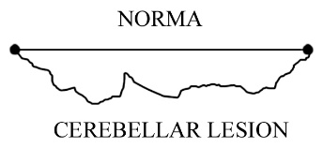

- Ocular ataxia – ataxia of extraocular muscles (esp. in midline cerebellar lesions – see oculomotor syndromes [below]):
- gaze-evoked nystagmus - horizontal, large amplitude, slow phase toward primary eye position;
may be associated with slow- and fast-phase reversal on return to primary position (rebound nystagmus) - specific for cerebellar lesions!
- abnormal smooth pursuit (catch-up saccades in attempt to keep moving target near fovea - saccadic pursuit)
- impairment of fixation saccades (ocular dysmetria).
- Gegenrucken - square wave jerks (inappropriate saccades disrupting fixation) which are immediately followed by corrective saccade.
- inability to suppress vestibulo-ocular reflex (VOR) by fixation, abnormalities of optokinetic nystagmus.

- Delay in movement initiation, inability to stop ongoing movement
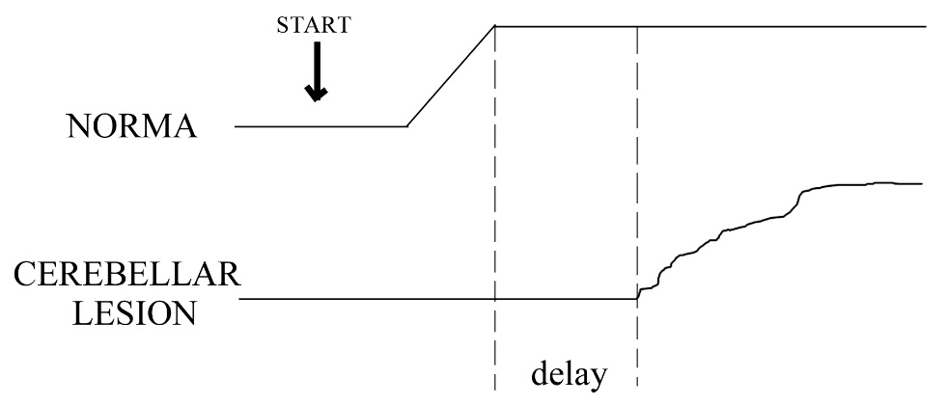 | - movement is hard to stop on fly → Stewart-Holmes sign [s. rebound phenomenon], dysdiadochokinesia.

II. Muscle hypotonia
- hypotonia, hyporeflexia, asthenia can be seen only in acute lesions; disappear within few days or weeks.
  - less brisk pendular tendon reflexes (e.g. lower leg swinging back and forth several times after knee tendon is tapped).
  - swinging of affected limbs in rapid passive movements.
- patients with chronic lesions usually have normal muscle tone and normal tendon reflexes!

III. Tremor
- limb tremor:
  - intention (s. kinetic) tremor see p. Mov3 >>
  - static tremor develops if patient attempts to maintain limb in fixed position - position can be sustained steadily for several seconds, but then limbs develop rhythmical oscillation generated at proximal limb muscles.
- rhythmic trunk tremor can evolve into severe titubation.

Lesion localization guide
  - Lesions produce disturbances in ipsilateral limbs – because of crossed superior cerebellar peduncle + decussatio tr. pyramidalis, decussatio tr. rubrospinalis. see p. A88 >>
  - Due to somatotopic organization different body regions are affected.
  - Lesions of superior peduncles (main cerebellar outflow) and deep nuclei leave especially severe, generalized, and irreversible deficits.
  - If only cerebellar cortex is affected, deficits become milder with time.
  - Lesions of midline structures → disturbances of stance, gait, ocular movements;
lesions of hemispheres → disturbances of limb movements.
N.B. gait ataxias result from lesions in all divisions (flocculonodular, anterior, posterior lobes); ataxia of voluntary movements results exclusively from lesions of lateral parts of posterior lobe!
  - Nystagmus may be present in both – midline and hemispheric lesions.

Clinical Syndromes
Vestibulocerebellum (caudal vermis syndrome, s. flocculonodular syndrome)
- truncal ataxia:
- ataxic gait;
- omnidirectional postural tremor of head and trunk (< 1 Hz) not enhanced by eye closure (absent Romberg sign!!!);
- patients frequently fall already during sitting (astasia)!
Patient moves normally when lying down!
- fine coordinated movements of all limbs are preserved!
- dysarthria
- ocular symptoms – nystagmus, saccadic slow pursuit, inability to suppress vestibulo-ocular reflex

- most commonly due to tumor (classically – medulloblastoma), hemorrhage.
- motion sickness is impossible to elicit.

Spinocerebellum (rostral vermis syndrome, s. anterior lobe syndrome)
- severe ataxic stance & gait (not improved when patient is physically supported, i.e. gravity eliminated), anteroposterior body sway (3 Hz)* provoked by eye closure (present Romberg sign!!!), abnormal heel-to-shin test.
*patients rarely fall because body tremor is opposite in phase in head, trunk, and legs - minimal shift of center of gravity.
- other activities intact; upper extremities spared!
- dysarthria, dysmetric saccades.

- most commonly due to chronic alcoholism - affects spinocerebellar part of anterior lobe (“leg region”).

Cerebrocerebellum (cerebellar hemisphere syndrome)
- unilateral (most commonly due to tumor, stroke) – ipsilateral limbs ataxia, tremor, hypotonia (leads to gait deviation*, past-pointing); shoulder on side of lesion stands lower; there is accompanying scoliosis.
*can be demonstrated by asking to walk around chair - as patients rotate toward affected side, they fall into chair; rotating toward normal side, they move away from chair in spiral.

Pancerebellar syndrome
- bilateral hemispheres + vermis - due to neurodegenerative diseases, acute alcoholic intoxication.
- truncal and bilateral limb ataxia, dysarthria, oculomotor disturbances, etc.

Cerebellar Oculomotor syndromes

- midline cerebellar structures:
  - dorsal vermis & underlying fastigial vermis - saccadic dysmetria, mild deficits of smooth pursuit.
  - flocculus & paraflocculus - impaired smooth pursuit; gaze-evoked, rebound, downbeat nystagmus; impaired optokinetic nystagmus; disability to adjust gain of VOR.
  - nodulus - prolongation of vestibular responses, periodic alternating nystagmus (spontaneous horizontal nystagmus that changes direction every few minutes).

Cerebellovascular syndromes
All cerebellar arteries supply cerebellar as well as brain stem structures - vascular disorders damage cerebellum and brain stem together!

Affected artery | Cerebellar Signs/Symptoms | Associated Findings
POSTERIOR INFERIOR  CEREBELLAR ARTERY (PICA) - inferior hemispheres (up to primary fissure), inferior vermis, deep nuclei, inferior peduncle, lateral medulla oblongata, choroid plexus of 4th ventricle. | Ipsilateral limb ataxia | Nausea, vomiting
 | Kinetic tremor | Ipsilateral Horner's syndrome, impaired facial pain and temperature sensation
 | Dysarthria
 | Nystagmus | Contralateral impaired body pain and temperature sensation
 | Gait ataxia
ANTERIOR INFERIOR  CEREBELLAR ARTERY (AICA) - flocculus and adjacent inferior and anterior cerebellum, inferior & middle peduncles, CN 7-9, 12 nuclei, inner ear. | Ipsilateral limb ataxia | Nausea, vomiting
 | Nystagmus | Vertigo
 | Dysarthria | Ipsilateral Horner's syndrome, deafness, facial paralysis, impaired facial pain and temperature sensation
 |  | Contralateral impaired body pain and temperature sensation
SUPERIOR CEREBELLAR  ARTERY (SCA) - superior hemispheres, major parts of vermis, all deep nuclei, all peduncles, pons. | Ipsilateral limb ataxia | Nausea, vomiting
 | Dysarthria | Ipsilateral Horner's syndrome
 |  | Partial deafness
 |  | Contralateral loss of facial and body pain and temperature sensation
 |  | Contralateral hemifacial weakness

Paroxysmal Ataxia
- Infancy ÷ early childhood (usually with mental retardation) - metabolic disorder (e.g. urea cycle deficiencies, aminoacidurias, disorders of pyruvate and lactate metabolism).
- Adults:
  - drug ingestion
  - MS
  - vertebrobasilar TIA
  - foramen magnum compression
  - intermittent obstruction of ventricular system
  - inherited periodic ataxia.

General Management
- pharmacotherapy - only few ataxias can be treated effectively (e.g. episodic ataxias – acetazolamide).
- physical therapy - most important treatment (e.g. dyssynergia might be reduced by placing additional weight on ataxic limb to increase inertia).
- avoid drugs associated with cerebellar dysfunction (lithium, phenytoin).

Bibliography for ch. “Movement disorders, Ataxias” → follow this link >>

Viktor’s Notes℠ for the Neurosurgery Resident
Please visit website at www.NeurosurgeryResident.net

