Oligodendrogliomas
Last updated: December 22, 2020
Epidemiology 1
Classification 1
Genetics, Molecular Markers 1
Location 1
Pathology 1
Clinical Features 3
Diagnosis 3
Treatment 4
Prognosis 5

Most "benign" of gliomas! - never grade IV

Epidemiology
- 4-19% of all intracranial tumors.
- 2-25% of all gliomas (only 6% in children).
- most commonly - young and middle-aged adults (median age 25-50 yrs).

Classification
- Oligodendroglioma (WHO grade II) ≈ 80%; median survival 6-10 yrs.
- Anaplastic (malignant) oligodendroglioma (WHO grade III) ≈ 15-20%; median survival 2.2-4 yrs.

N.B. there is no grade IV oligodendroglioma.

Genetics, Molecular Markers
- definitive diagnosis (a must mutations!) - IDH1/2 mutation + 1p19q co-deletion (assay by FISH)
N.B. most of low grade oligodendrogliomas are positive for IDH1 R132H mutation with intact ATRX nuclear staining.
- if histology looks like oligo, but IDH-wild type – call astrocytoma!
N.B. deletions of both 1p36 and 19q13 = greater response to chemotherapy.
N.B. it has to be deletion of both (co-deletion!)

- ATRX remains present (vs. astrocytoma).

Location
- single lesion in cerebral hemispheres (white matter):
frontal > parietal, temporal > occipital lobe (3:2:2:1 ratio).
- rarely, in cerebellum, brain stem, spinal cord.
- 10% tumors disseminate through CSF.

Pathology
Low-grade oligodendroglioma (grade 2)
- grossly well demarcated (but generally infiltrative); 20% are cystic.
- very cellular - monotonous side-by-side collection of homogeneous, compact, rounded cells with distinct borders and clear cytoplasm surrounding dark uniform central nucleus ("fried egg" appearance). No conspicuous fibrillary background!
- may infiltrate diffusely into cortex around normal neuronal elements (without causing loss of function) → may extend to leptomeninges.
- neoplastic cells may tightly surround neurons (perineuronal satellitosis).
- within tumor, branching blood vessels (delicate network of anastomosing capillaries) are highly characteristic - divide cells into discrete clusters - “chicken-wire” capillary pattern.
- microcalcification may be extensive.
- many oligodendrogliomas have some component of astrocytoma within them;
  - it is difficult to distinguish neoplastic astrocytes from reactive astrocytes.
  - some tumors are truly mixed oligoastrocytomas (both cell types arise from common precursor - oligodendrocyte type-2 astrocyte, s. O2A cell); minimum proportion of astrocyte is 10-25%.

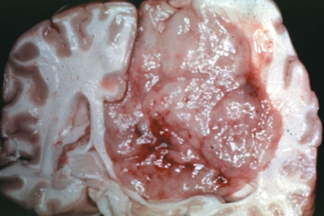

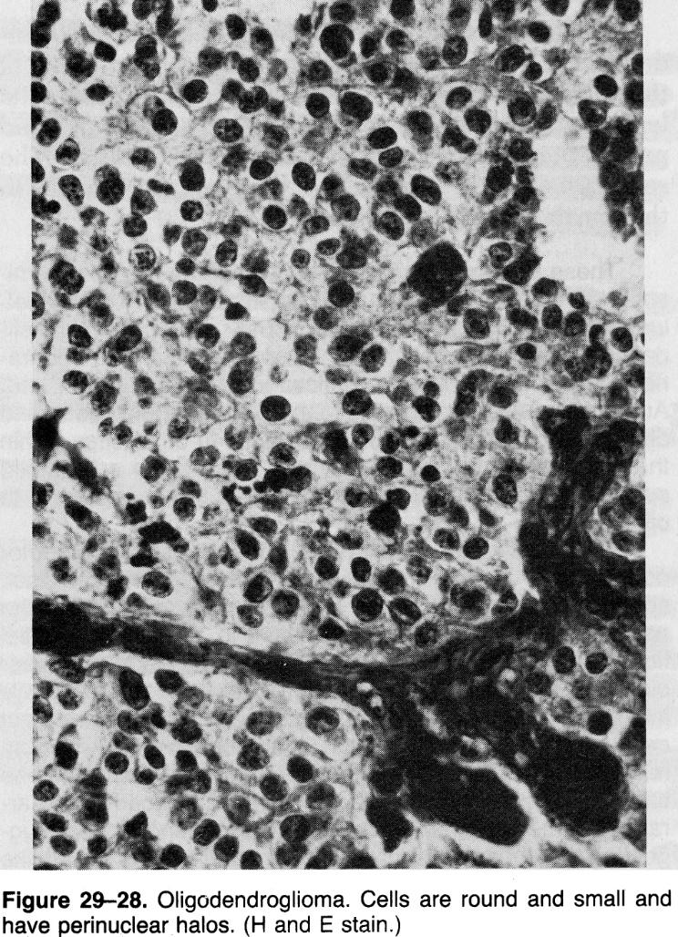

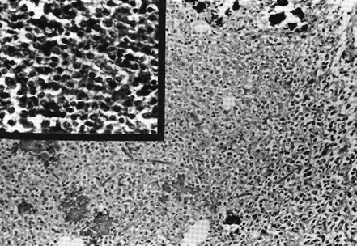

Classic “fried egg” appearance with perinuclear halos and “chicken-wire” capillary pattern:
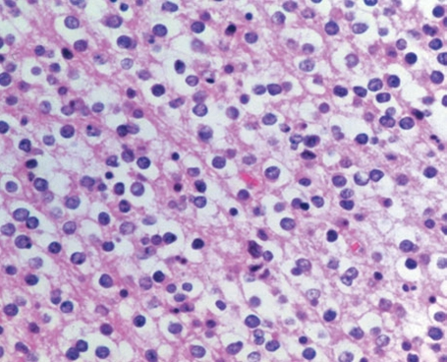

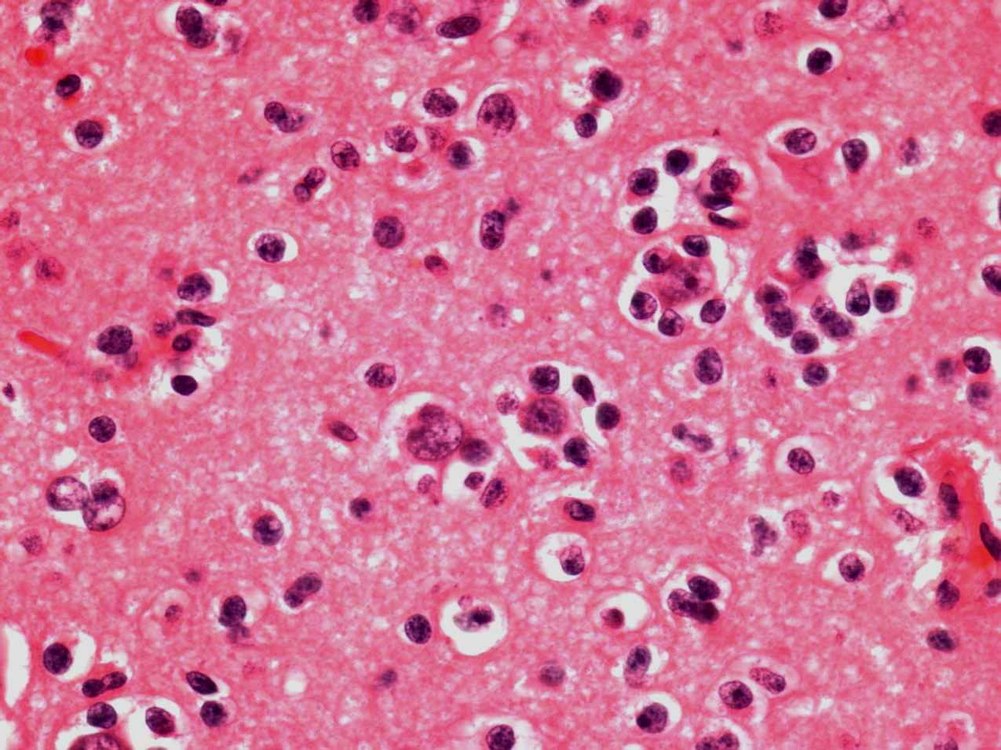
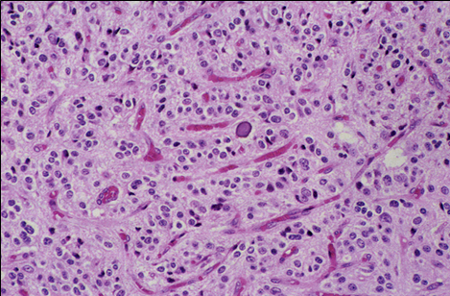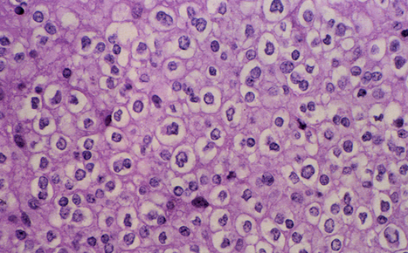

Anaplastic (malignant) oligodendroglioma (grade 3) - increased cellularity, nuclear pleomorphism, endothelial proliferation, mitotic activity, and necrosis.
- may progress to glioblastoma multiforme.
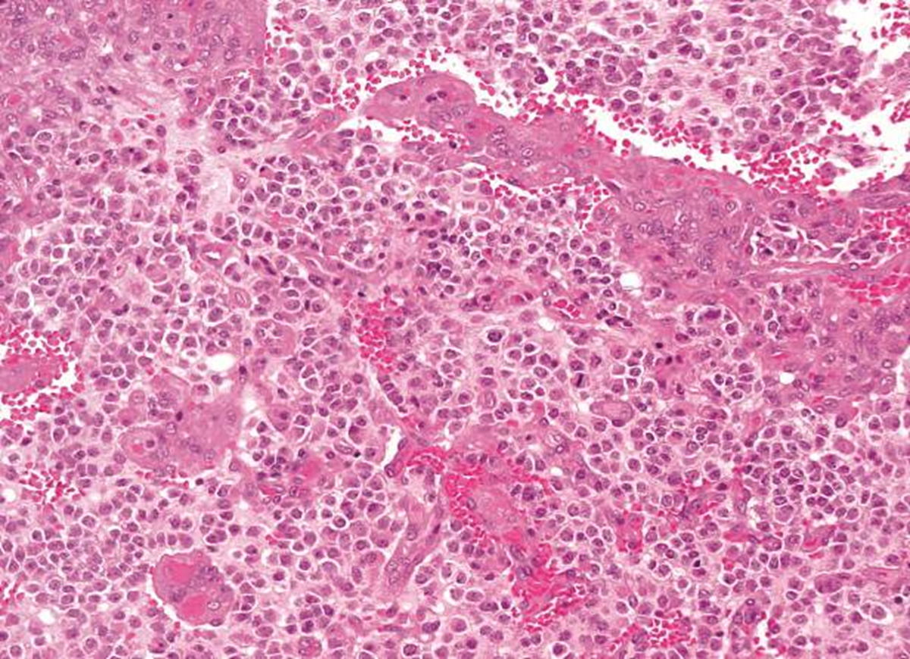

Clinical Features
- duration of symptoms before diagnosis averages 7-11 years!
- most common (50%) presenting symptom is seizure!; 80% patients have seizures at some time.
Seizures are more common with oligodendrogliomas than other gliomas!
- focal cerebral dysfunction, rarely ICP↑.

Diagnosis
- CT - invisible (unless calcified*). *calcification fleck on CT may be first clue to neoplasm
- MRI: low-grade tumors - generally do not enhance (FLAIR is positive), while anaplastic oligodendroglioma does enhance; intratumoral calcification is common (≈ 90%).
- definite diagnosis – biopsy (almost always possible).

Differentiate intraventricular oligodendroglioma from central neurocytoma and dysembryoplastic neuroepithelial tumor – do not need chemotherapy and radiotherapy!

A. Noncontrast CT - calcified mass in left temporal lobe (arrows); mild mass effect but little edema.
B. MR-T2 - heterogeneous mass with hypointense signal (black arrows) surrounded by higher signal zone (white arrows), consistent with calcified temporal lobe mass.
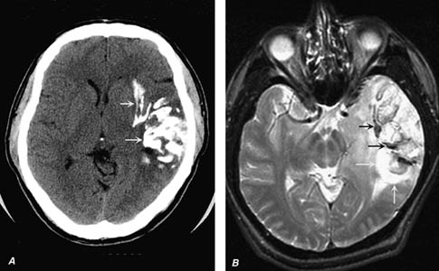

T2-MRI - highly demarcated white signal; does not enhance:
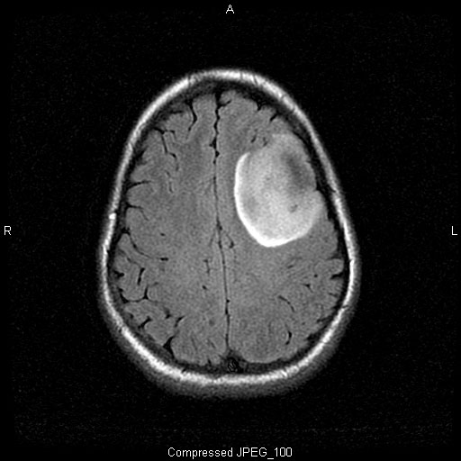

Anaplastic oligodendroglioma:
A. T1-MRI - minimal heterogeneous contrast enhancement; central area of low signal intensity indicates necrosis (arrow).
B. Spin density - better delineates extent of vasogenic edema and vascular structures within and adjacent to neoplasm (arrows).
C. T2-MRI - large portions of left temporal lobe are involved by neoplastic process.
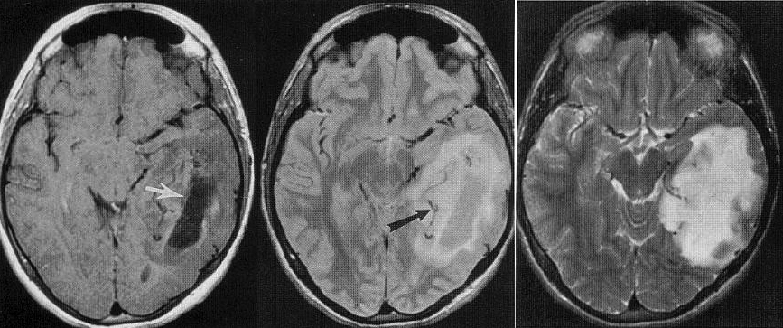

Spontaneous hemorrhage into mixed oligodendroglioma:
A. Noncontrast CT - spheroid hematoma in mass with calcification located in left parietal lobe surrounded by zone of decreased attenuation.
B. Contrast CT - enhancing tumor and relationship of hematoma.
C. Noncontrast T1-MRI - hemorrhage in tumor and surrounding edema.
D. Noncontrast T2-MRI - edema and reaction to oligodendroglioma with acute hemorrhage.
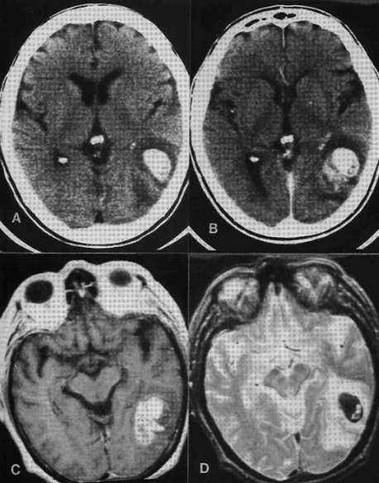

Treatment
No intervention ÷ aggressive multimodal treatment
Grade II guidelines - see p. Onc10 >>
Algorithm - see p. Onc10 >>
- anticonvulsive therapy is recommended once oligodendroglioma is diagnosed.
- some small asymptomatic (except for controlled seizures) tumors can be observed.
- surgery - mainstay of treatment (resection is usually subtotal because of infiltrative nature of tumor - surgical cure remains unlikely!);
total gross resection → observation for recurrence; recurrence → radiotherapy.
incomplete removal → radiotherapy.
anaplastic oligodendroglioma (regardless of resection extent) → radiotherapy.
- use 2-3 cm margin for 54-60 Gy radiotherapy (children – 50 Gy).
- chemotherapy - favorable response (most chemosensitive of gliomas)!!! (esp. in combined loss of 1p/19q):
    - for recurrences
    - adjuvant for anaplastic oligodendroglioma
standard - PCV = procarbazine + lomustine (CCNU) + vincristine
for relapses also may be tried - temozolomide

Ino Y, et al. Clin Cancer Res. 2001;7:839-845

LITT
Insular oligo
Staged Laser Interstitial Thermal Therapy (LITT) Treatments to Left Insular Low-Grade Glioma. Daniel M Hafez et al. Neurosurgery, Volume 86, Issue 3, March 2020, Pages E337–E342
- left-sided insular oligodendroglioma treated in two stages (3 months apart - due to large 5 cm size – to prevent severe edema and seizures) with no permanent clinical deficit (temporary mild difficulty with word repetition) → chemoradiation → near resolution of the tumor at 2 yrs:

Language localization using rs-fMRI:
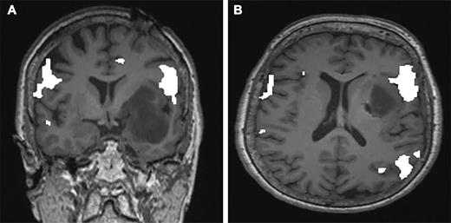

A-B. Stage 1
C-D. Stage 2
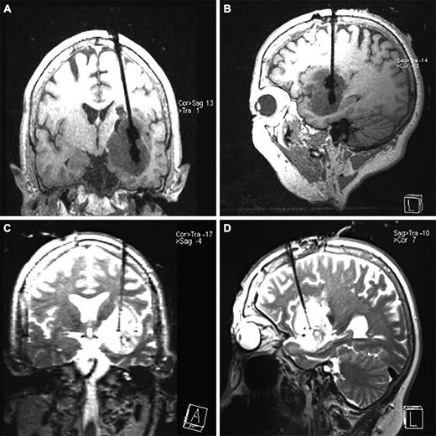

Prognosis
- prognosis is much better than for astrocytomas!
N.B. late progression of disease is common (5-year survival time used to indicate "cure" in other cancers is not relevant for oligodendrogliomas)
- indolent course - patients may survive for many years.
- combined loss (co-deletion) of 1p/19q is significant predictor of longer survival in anaplastic oligodendroglioma.
- prognosis is worse for mixed tumors (oligoastrocytomas).

Bibliography for ch. “Neuro-Oncology” → follow this link >>

Viktor’s Notes℠ for the Neurosurgery Resident
Please visit website at www.NeurosurgeryResident.net

