Choroid Plexus Tumors
Last updated: April 12, 2019
Choroid Plexus Papilloma 1
Etiology 1
Location 1
Pathology 1
Clinical Features 1
Diagnosis 1
Treatment 3
Choroid Plexus Carcinoma (s. Anaplastic Choroid Plexus Papilloma) 3
Pathology 3
Diagnosis 4
Treatment 4

Papilloma (grade I) : Carcinoma (grade III) = 5 : 1
Practically, only in kids

Choroid Plexus Papilloma
- rare benign neoplasm of cuboidal neuroepithelial cells lining papillae of choroid plexus.
- < 1% of brain tumors, but 3% of childhood intracranial neoplasms (esp. younger groups: 4-6% in children < 2 years and 10-20% in infants).
- male-to-female ratio = 2.8 : 1

Etiology
- have been associated with von Hippel-Lindau syndrome, Li-Fraumeni syndrome, Aicardi syndrome.
- one etiologic theory - presence of simian vacuolating virus No. 40 (SV40)–related viral DNA; SV40 is oncogenic virus with ability to inactivate both Rb and p53 proteins.

Location
- corresponds to normal choroid plexus locations:
  - 60% - lateral ventricles (most common location for children) - lining of body, trigone, inferior horn
  - foramen of Monro
  - roof of 3rd ventricle
  - 30% - posterior portion of roof of 4th ventricle → cerebellopontine angle (most common location for adults)

Most common in lateral ventricles of children!

Pathology
- fill ventricles and compress walls.
- often pedunculated, giving it some mobility.
- slow growing, does not invade brain parenchyma (often reach size of 60-70 g before are diagnosed).
- histologically differentiating normal choroid plexus from papilloma can be very difficult.
- normal choroid plexus epithelium tends to have more "hobnail" shape on ventricular side, whereas papilloma epithelium is more flattened.
- occasionally may spread via CSF.

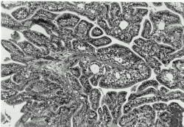
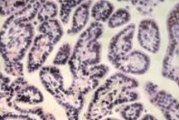

Clinical Features
- intracranial hypertension:
    - hydrocephalus:
      - increased CSF secretion by tumor cells (up to 4 times of normal)
      - obstructed CSF flow.
      - damage to CSF resorptive bed from recurrent hemorrhages (basilar arachnoiditis).
    - later – mass effect.

- tumors in 4th ventricle frequently produce cerebellar / cerebellopontine angle findings.

Diagnosis
Imaging - lobulated, ‘cauliflower-like’ hypodense ÷ slightly hyperdense mass with cystic areas, located within or near ventricular system.
N.B. papilloma is within choroid plexus and thus outside BBB - contrast enhancement is marked!
- edema, invasion into surrounding parenchyma.
- punctate calcifications (20% tumors);
vs. global calcification throughout mass - more indicative of carcinoma!
- heterogeneous MRI signal intensity – reflects high vascularity, calcifications, hemorrhages.
- determination of tumor stalk location is crucial – dictates surgical approach!

T1-MRI postgadolinium - lobulated, strongly enhancing tumour in trigone of left lateral ventricle:
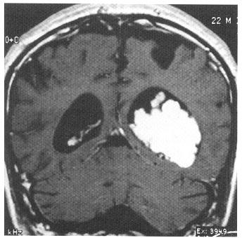

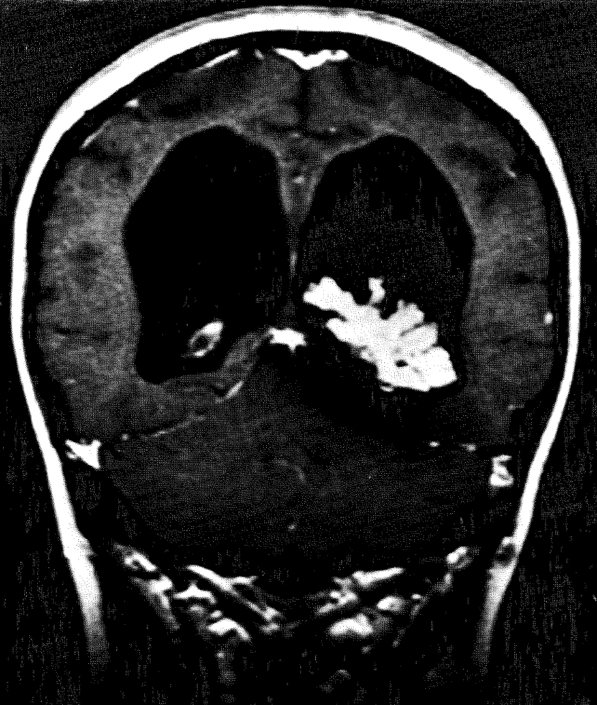

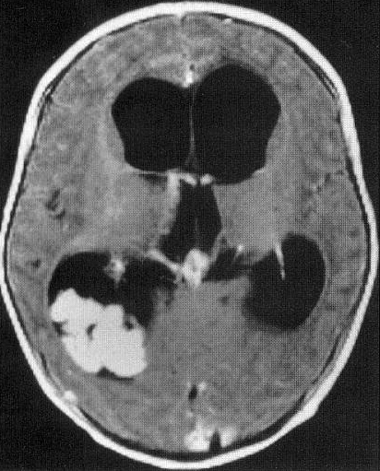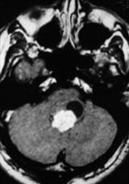

MRI – 3rd ventricular ch. plexus papilloma extending into lateral ventricles:
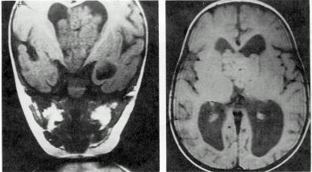

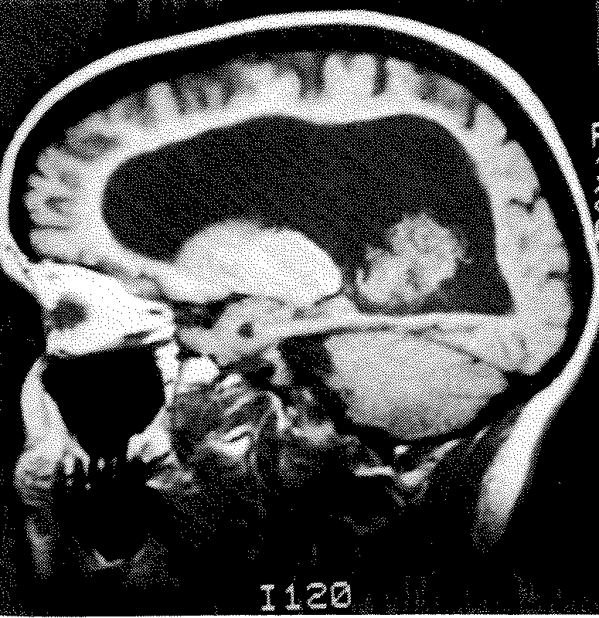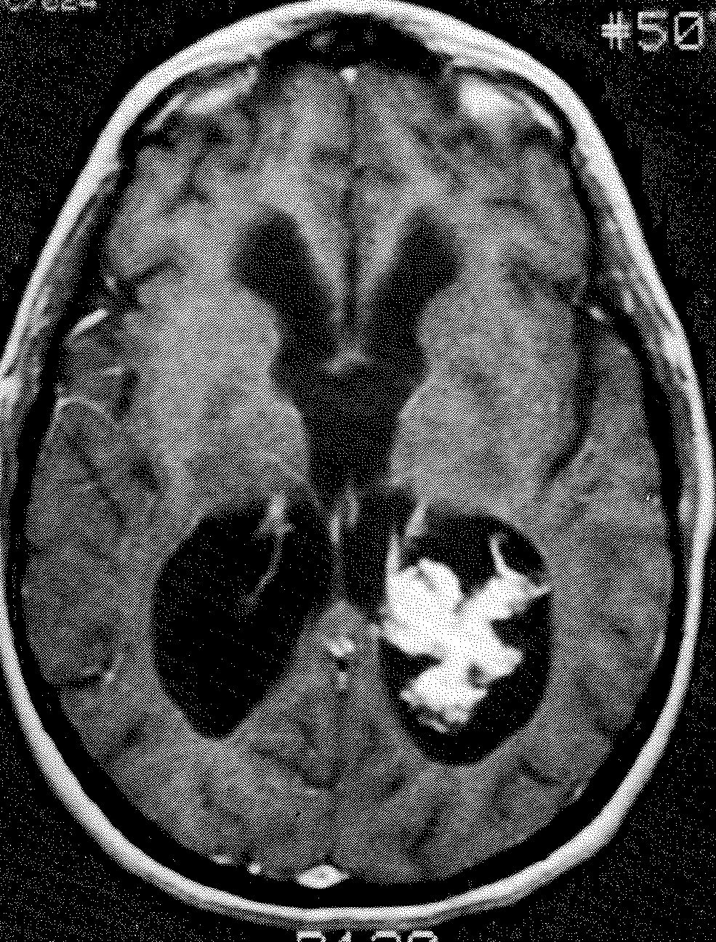

CSF - protein↑, xanthochromia.

Can be extremely vascular! (blood supply derived from choroidal arteries) - angiography is sometimes indicated before surgery.

Treatment
Persistently increased ICP is not compatible with life - watchful waiting is inappropriate!

Surgical removal of mass! (many intraventricular lesions can be totally resected through endoscope)
High incidence of surgical cure! (gross total resection nearly always effects cure)
- normalize excessive CSF pressure prior to surgery - repeated lumbar punctures or ventricular shunt (in older patient).
Intraventricular tumors outside posterior fossa are more easily removed if ventricles are large - preoperative shunts are usually not inserted in otherwise stable patients.
- hydrocephalus may not resolve with surgery (derangement of reabsorption mechanisms or blockage at other sites in ventricular system); H: shunting (required in up to 60% patients postoperatively!).
Treatment of hydrocephalus must be considered both before and after any surgery!
- subtotally resected papillomas require additional therapy:
      - reoperation
      - (intraventricular) chemotherapy
      - (craniospinal) irradiation.

Choroid Plexus Carcinoma (s. Anaplastic Choroid Plexus Papilloma)
- extremely rare malignant tumor of choroid plexus.
- usually found in children.
- significantly longer survival is noted in cases associated with +9p and -10q.

Pathology
- anaplastic features: nuclear pleomorphism and hyperchromasia, mitotic activity↑, tumor giant cells, tumor necrosis, frank invasion of brain parenchyma.
- extremely vascular.
- in adults, must be differentiated from much more common metastatic carcinoma.
- 44% cases disseminate along CSF pathways (diffuse and aggressive leptomeningeal spread).

Papillary character (partially retained in left side) has been lost on right side; note pseudostratified epithelium forming irregular glandular structures on left and diffuse epithelial growth on right:
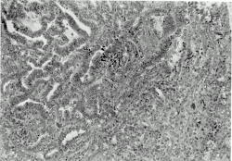
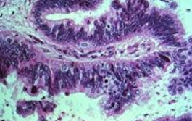

Diagnosis
Imaging - more heterogeneous than papilloma; global calcification; areas of necrosis.
- craniospinal MRI and CSF cytology - any evidence of seeding?

Treatment
Surgical removal of mass!
- resection may be facilitated by preoperative chemotherapy (iphosphamide, carboplatin, VP-16).
- adjuvant chemotherapy and radiotherapy have been demonstrated to increase survival;
- carboplatin and etoposide are commonly used.
- in documented leptomeningeal seeding, use craniospinal irradiation.

Bibliography for ch. “Neuro-Oncology” → follow this link >>

Viktor’s Notes℠ for the Neurosurgery Resident
Please visit website at www.NeurosurgeryResident.net

