Neuroblastic Tumors
Last updated: April 12, 2019
Neuroblastoma 1
Epidemiology 1
Genetics 1
Pathology 1
Location 2
Clinical Features 3
Fetal neuroblastoma 3
Diagnosis 3
Laboratory tests 4
Imaging 4
Biopsy 5
Diagnostic Criteria 5
Staging 5
International Neuroblastoma Staging System (INSS) 5
Evans staging system 5
Shimada histopathologic classification 5
Joshi histopathologic classification 6
Differential 6
Treatment 6
Surgery 6
Chemotherapy 7
Other Medical Treatments 7
Radiotherapy 7
Cooperative group Risk-Related treatment strategies 7
Low-risk group 7
Intermediate-risk group 7
High-risk group 7
Response to treatment 7
Prognosis 8
Ganglioneuroma (s. Ganglioma) 9
Atypical teratoid/rhabdoid tumour (WHO grade IV) 9

Tumors of primordial (embryonal) neural crest cells (pluripotent sympathetic cells - ultimately populate sympathetic chain and adrenal medulla):
- Pheochromocytoma – if in adrenals
- Sympathoblastomas (s. neurocristopathies) - spectrum of maturation and dedifferentiation:
  - ganglioneuroma - benign, composed entirely of well-differentiated ganglia cells.
  - ganglioneuroblastoma - moderately differentiated: contains ≥ 50% mature cells (if < 50%, some investigators use term maturing neuroblastoma).
  - neuroblastoma - malignant, consists predominantly of postganglionic sympathetic undifferentiated neuroblasts.
    - neuroblastomas may show spontaneous or induced differentiation to ganglioneuroblastoma or ganglioneuroma.

Neuroblastoma
- highly undifferentiated embryonal malignancy arising from postganglionic sympathetic neuroblasts.

- first described by Virchow in 1864.

Epidemiology
Typically occurs in infants & young children:
- most common malignancy during infancy! (30-50% of all neoplastic cases in neonates)
- 7.8-10% of childhood cancers - 4th most common malignancy of childhood (after leukemias, CNS tumors, lymphomas); 15% of deaths from cancer in pediatric population!
- most common intra-abdominal malignancy of infancy.
- most common extracranial solid tumor in children < 5 yrs.
- prevalence ≈ 1 case per 7-10,000 live births.
- incidence 0.1-1 case per 8000-10,000 children (8.0-8.7 per million per year in children < 15 yrs).
- Japan has highest incidence! (result of neonatal screening - detected tumors that normally would have not been discovered and would have regressed spontaneously; → neonatal screening has been abandoned in Japan since it was shown not to significantly improve mortality or morbidity!!!).
- age at diagnosis: 36-40% children < 1 year, 35% children 1-2 years, 25% children > 2 years (95-97% are diagnosed by age 10 yrs).
Median age at diagnosis - 22 months.
Rare after age 10 years!
Have been diagnosed in utero (at 19 weeks' gestational age)
- male-to-female ratio = 1.2-1.3 : 1

Genetics
- 1-2% cases are familial (median age at diagnosis – only 9 months); associated with number of disorders (Hirschsprung disease, fetal alcohol syndrome, DiGeorge syndrome, neurofibromatosis type 1, Beckwith-Wiedemann syndrome).
- 20% cases are inherited through autosomal dominant pattern.
- 1p deletion is found in 70-80% neuroblastomas.
- N-myc oncogene amplification (occurs in 20-25% cases; located on distal 2p, linked to 1p deletion and 17q gain) = aggressive behavior (high metastatic potential).
Oncogene amplifications cytogenetically are seen as double-minute chromatin bodies or as homogeneously staining regions.

Pathology
- some neuroblastomas weight > 1 kg.
- neural malignant poorly differentiated small, blue, round cell tumor (uniform cells resemble primitive neuroblasts - dense hyperchromatic nuclei and scant cytoplasm).
Small, blue, round cell tumors of childhood:
  - neuroblastoma
  - primitive neuroectodermal tumors (incl. medulloblastoma)
  - non-Hodgkin lymphoma
  - Ewing sarcoma
  - undifferentiated soft tissue sarcoma (rhabdomyosarcoma).
- diagnostic Homer-Wright rosettes (observed in 15-50% patients); also present in PNETs (incl. medulloblastoma) see p. Onc18 >>!!!!
- electron microscopy can be useful - ultrastructural features (e.g. neurofilaments, neurotubules, synaptic vessels, dense core granules) are diagnostic for neuroblastoma!
- maintenance of dedifferentiated state involves failure in ligand-receptor pathways; one of most studied and most popular pathways is nerve growth factor (NGF) and its receptor (NGFR).
- spontaneous regression of microscopic clusters of neuroblastoma cells (neuroblastoma in situ) is common!!!
Documented spontaneous rate of resolution!!! (surgical capsule can be violated, leaving residual tumor, and good outcome still might be achieved)
½ neuroblastomas that reach size that would be detectable by screening actually regress without specific therapy, whereas equivalent number are detected clinically

Location
- anywhere along sympathetic nervous system (during 5th week of embryogenesis, primitive sympathetic neuroblasts invaginate → migrate along entire sympathetic chain from neural crest to site where adrenal anlage eventuates):
60-70% in abdominal retroperitoneum (35-40% adrenal medulla, 25-30% paraspinal ganglia)
15-20% posterior mediastinum (sympathetic trunk, aortic body)
5% pelvic (organ of Zuckerkandl)
3-5% cervical (carotid body)
2% intracranial (e.g. olfactory bulb & olfactory mucosa - so called esthesioneuroblastomas)
1% primary tumor cannot be found.
- infants - more frequently thoracic and cervical tumors; older children - abdominal tumors.
- locations of metastases: bone* (60%), regional lymph nodes (35-45%), orbit (20%), liver (15%), intracranial areas (14%), lung (10%), skin.
*often metaphyseal and symmetrical

Neuroblastoma of right adrenal in neonate - neoplasm (white arrow) is displacing liver to left:
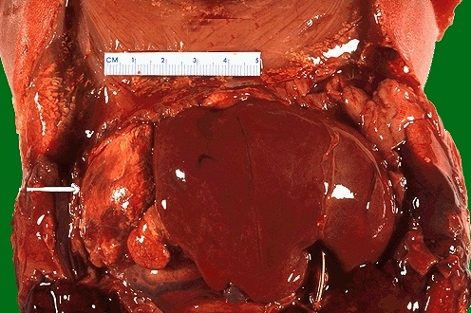
Source of picture: “WebPath - The Internet Pathology Laboratory for Medical Education” (by Edward C. Klatt, MD) >>

Neuroblastoma (one of "small round blue cell" tumors) - areas of necrosis and calcification:
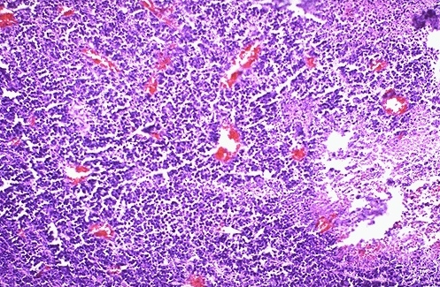
Source of picture: “WebPath - The Internet Pathology Laboratory for Medical Education” (by Edward C. Klatt, MD) >>

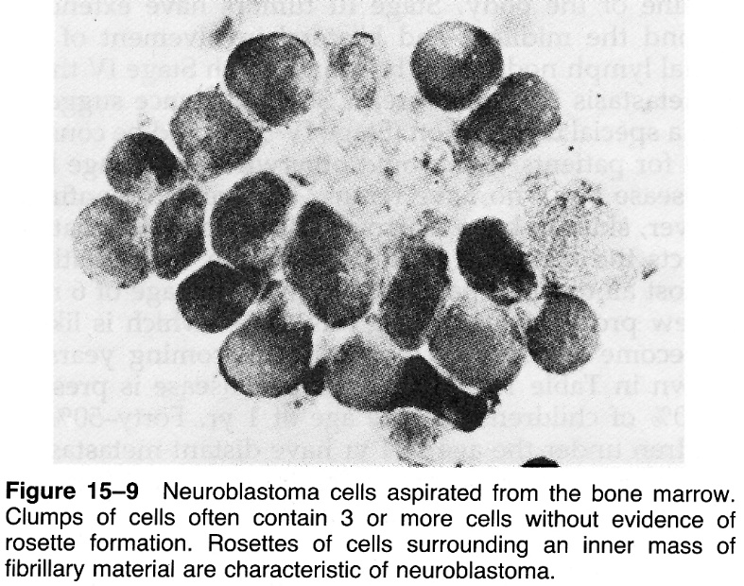

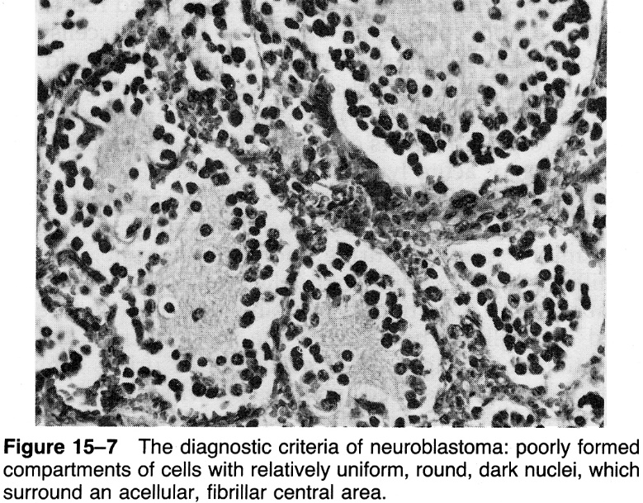

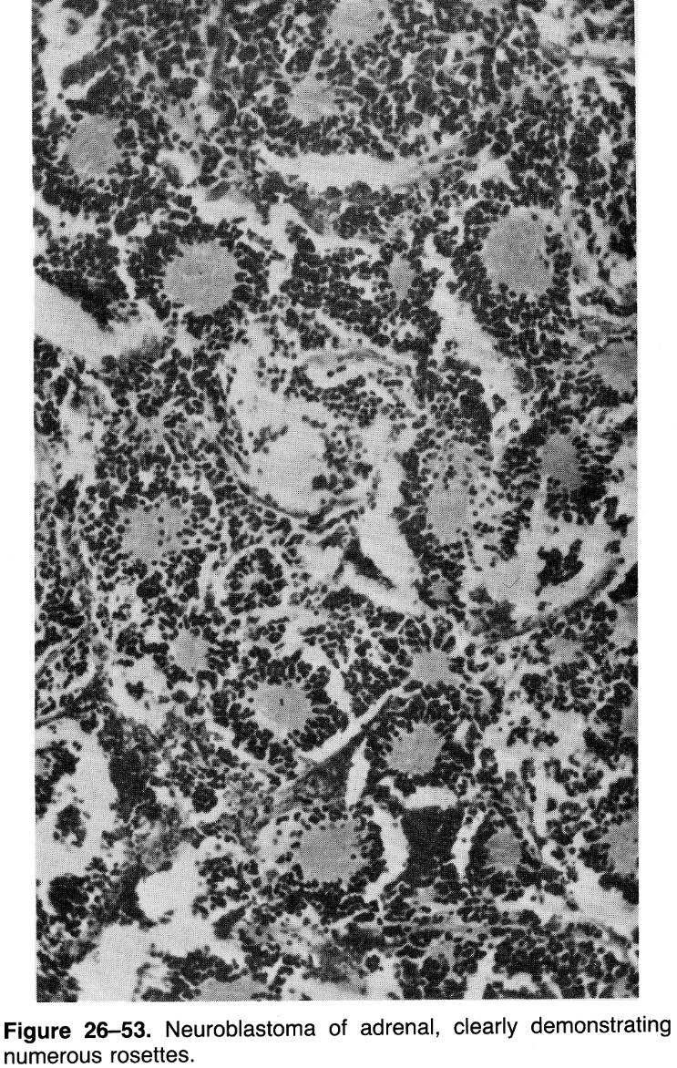

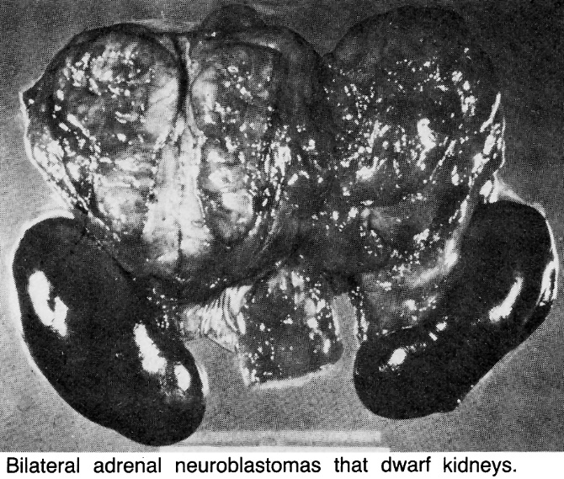

Clinical Features
- children with localized disease are asymptomatic.
- children with disseminated disease are generally sick.

Great mimicker - myriad clinical presentations related to:
    - Site of primary tumor
      - 45-54% patients have palpable fixed, large, nontender, irregular, firm abdominal tumor that crosses midline*
*vs. Wilms' tumor - smooth mobile flank mass that does not cross midline
      - adrenal tumor → abdominal complaints (abdominal pain, anorexia, emesis, weight loss).
      - organ of Zuckerkandl tumor → bladder and bowel compression.
      - neuroblastoma in paraspinal ganglia may invade through neural foramina (“dumbbell” tumor) → spinal cord compression (7-15% patients).
H: emergency chemotherapy (laminectomy reserved for patients who do not respond!)
      - cervical region or high thoracic tumor → compression of sympathetic ganglia (e.g. Horner syndrome) or superior vena cava syndrome.
      - posterior mediastinum neuroblastoma may be asymptomatic (or mild airway obstruction, chronic cough).

    - Metastatic disease – present in 50-66% patients.
      - constitutional symptoms - general malaise, anorexia, failure to thrive, weight loss, anemia, irritability, fever.
      - Hutchinson syndrome - widespread metastasis to bone: bone pain → limping and pathologic fractures (can simulate osteomyelitis).
      - bone marrow metastases → bone marrow failure.
      - Pepper syndrome (occurs only in infants) - overwhelming metastatic neuroblastoma of liver → intra-abdominal pressure↑ → respiratory compromise; associated with stage 4S; spontaneous regression (few infants may die of massive hepatomegaly, respiratory failure, and overwhelming sepsis).
      - “blueberry muffin” babies - infants with random subcutaneous metastases - nontender, bluish subcutaneous nodules; when provoked, nodules become intensely red and subsequently blanch for several minutes thereafter (secondary response to release of vasoconstrictive tumor by-products).
      - rarely, metastases to orbits → periorbital ecchymosis (“raccoon eyes”)*, proptosis.
*can mimic child abuse

    - Metabolically active by-products
      - 89-95% neuroblastomas (esp. differentiated tumors with good prognosis) produce catecholamines, but patients rarely have symptoms related to catecholamine secretion.
N.B. hypertension (≈ 10% patients) is caused by renal artery or vein compression, not catecholamine excess!
      - 7% neuroblastomas (esp. differentiated tumors with good prognosis) secrete VIP → paraneoplastic Verner-Morrison syndrome: intractable secretory diarrhea; resolves with complete tumor removal.

2-4% patients have opsoclonus - myoclonus paraneoplastic syndrome, s. myoclonic encephalopathy (antineural antibodies against tumor that cross-react with neural cells in cerebellum or elsewhere in brain): opsoclonus, myoclonus, truncal ataxia.
- indicator of good long-term prognosis for survival.
- neurology can progress and be devastating despite successful treatment of tumor!!!

Fetal neuroblastoma
- can be detected on obstetric ultrasound as early as 19 weeks.
- typically adrenal gland (90%).
- placental metastases → fetal hydrops.
- catecholamine secretion → preeclampsia.

Diagnosis
N.B. neonatal screening has no benefit on mortality and morbidity!!!

Laboratory tests
- ESR↑
- Liver function tests (liver metastases)
- CBC (bone marrow metastases)
- Metabolic catecholamine by-products↑
      - in urine (90-95%): homovanillic acid (HVA)↑, vanillylmandelic acid (VMA)↑; low VMA-to-HVA ratio is poor prognosis (poorly differentiated tumor - lost final enzymatic pathway that converts HVA to VMA).
Screening - LaBrosse VMA spot test (highly inaccurate).
Confirmation - high-performance liquid chromatography on 24-hour urine.
  - levels must be > 3.0 SD above mean for age.
  - normalizing urinary VMA and HVA excretion to milligrams of creatinine in sample makes timed collection unnecessary, and avoids most false-negatives.
      - serum: dopamine or norepinephrine↑.
  - tumor cells lack enzyme that converts norepinephrine to epinephrine (but norepinephrine does not reach detectable serum levels - 1) catabolized within tumor; 2) tyrosine hydrolase is subject to negative feedback loop by norepinephrine).
- Tumor markers: neuron-specific enolase (NSE)*, ferritin, lactic dehydrogenase (LDH), chromogranin A, neuropeptide Y.
*elevated in 96% metastatic neuroblastomas.

Imaging
These imagings are necessary for all infants and children with abdominal mass!

Plain radiographs:
      - abdomen – flank mass, finely stippled calcifications (30%).
      - chest – posterior mediastinal mass, splaying of ribs and rib erosion, pleural effusions and pleural nodules.
      - long bones – irregular lucencies or lytic lesions in metaphysis or submetaphyseal bone; tumor infarction → sclerotic lesions; periosteal reaction is common.
      - skull – widening of cranial sutures secondary to dural metastasis; classic hair-on-end appearance (albeit unusual in neuroblastoma) can be seen.
      - spine – widening of neuroforamina, vertebral body scalloping, erosion of pedicles, scoliosis.
Sonogram (small tumors have been detected on prenatal ultrasound!) - inhomogeneous mass with focal brightly echogenic areas (calcifications).
Excretory urograms (were widely used in past) - adrenal neuroblastomas typically displace ipsilateral kidney laterally and downward → classic “drooping-lily” sign.
CT / MRI - tumor extent, regional lymph nodes, vessel invasion, distant metastatic disease;
      - CT - stippled calcifications (80-90%), lobulated heterogeneous appearance on contrast-enhanced CT (areas of low attenuation - necrosis and hemorrhage).
      - MRI: neuroblastomas are hypointense on T1 and hyperintense on T2; inhomogeneous enhancement.
      - spinal MRI – determining cord compression (alternative – CT myelography).
      - head CT – only if clinically indicated; enhancing dural metastases can simulate meningitis.
Scintigraphy:
      - metaiodobenzylguanidine (MIBG) - sensitive and specific compound taken up by catecholaminergic cells.
      - ¹¹¹In pentetreotide (somatostatin analog) is as sensitive as MIBG.
      - if MIBG scintigraphy negative* → bone scintigraphy using ⁹⁹Tc diphosphonate and skeletal bone survey.
      - I¹²³ iobenguane - structure similar to norepinephrine - taken up by norepinephrine transporter in adrenergic nerve terminals and stored in presynaptic storage vesicles in adrenergically innervated tissues (adrenal medulla, salivary glands, heart, liver, spleen and lungs as well as tumors derived from neural crest).
*30% neuroblastomas may not take up MIBG (though 90-95% secrete catecholamines); 50% recurrent neuroblastomas do not take up MIBG even if they took up MIBG before therapy

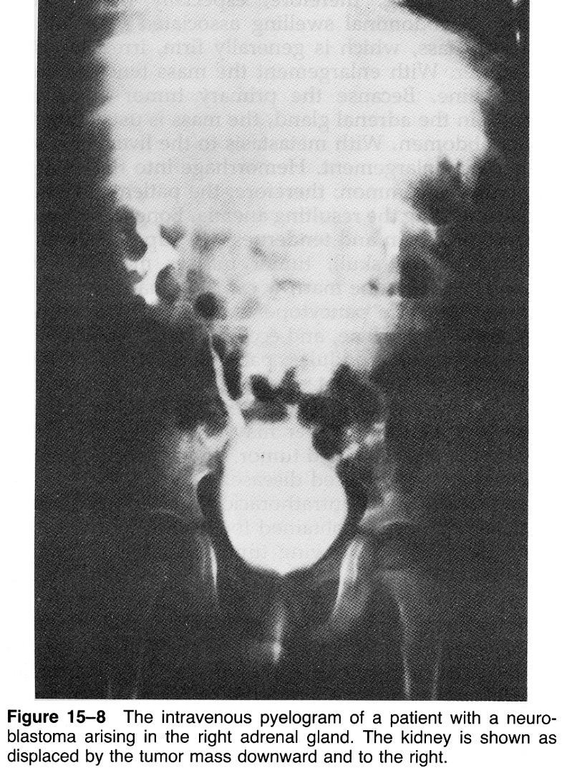

Esthesioneuroblastoma (MRI) in ethmoid sinus with intradural extension (arrow):
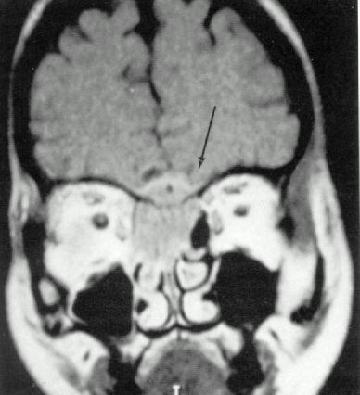

Biopsy
- sine qua non of diagnostic evaluation:
- H & E stain
- immunohistochemistries - neuroblastoma stains with monoclonal Ab recognizing neurofilaments, synaptophysin, and neuron-specific enolase (NSE).
- biologic studies of tumor tissue sample assign risk category (particularly important in nonmetastatic disease); e.g. test N-myc oncogene copy number + chromosome studies.
- electron microscopy - dense core, membrane-bound neurosecretory granules, microfilaments, parallel arrays of microtubules within neuropil.

Option is to sample bone marrow (frequent metastatic site) - 2 aspirates and 2 biopsies* (1 from each posterior iliac crest); only single study positive for tumor is required to document bone marrow involvement, but all four studies are required if findings are negative.
*might become obsolete because immunocytology of aspirates may offer single best source of diagnostic information

Diagnostic Criteria
- require histopathologic diagnosis:
- unequivocal pathologic diagnosis made from tumor tissue by light microscopy ± immunohistology, electron microscopy, or urine / serum catecholamines↑.
- bone marrow (aspirate or trephine biopsy) contains unequivocal tumor cells (e.g. syncytia or immunocytologically positive clumps of cells) + urine (or serum) catecholamines↑.
- genetic features characteristic of neuroblastoma (1p deletion, N-myc amplification) support diagnosis.

Staging
Extent of disease | Infants | Older children
localized tumors | 39-40% | 19-20%
regional lymph node spread | 18% | 13%
disseminated disease | 7-25% | 68-80%

International Neuroblastoma Staging System (INSS)
Stage 1 - complete gross excision (with or without microscopic residual disease); ipsilateral and contralateral lymph nodes are microscopically negative (nodes attached to and removed with primary tumor may test positive).
Stage 2A - incomplete gross excision; ipsilateral and contralateral lymph nodes are microscopically negative.
Stage 2B - complete or incomplete gross excision; ipsilateral nonadherent lymph nodes are positive; contralateral lymph nodes test negative microscopically.
Stage 3 - tumor crosses midline: midline is defined as vertebral column
- unresectable unilateral tumor infiltrating* across midline (with or without regional lymph node involvement).
- localized unilateral tumor with positive contralateral regional lymph node.
- midline tumor with bilateral extension by infiltration* (unresectable) or by lymph node involvement.
*vs. pedunculated tumor that hangs over midline
Stage 4 - distant metastases to distant lymph nodes, bone, bone marrow, liver, skin, and/or other organs (except as defined for stage 4S).
Stage 4S (limited to infants < 1 yr!) - localized primary tumor (as defined for stages 1-2B), with dissemination limited to skin, liver, and/or bone marrow.
      - marrow involvement should be minimal (i.e. < 10% of total nucleated cells identified as malignant by bone biopsy or by bone marrow aspirate); more extensive bone marrow involvement or cortical bone involvement is stage 4.
      - MIBG scan (if performed) should be negative for disease in bone marrow.
      - significantly better prognosis (than with stage 4); spontaneous regression is common; 5-yr survival ≈ 70-75%.

Evans staging system
Stage 1 - tumor confined to organ of origin.
Stage 2 - tumor extends beyond organ of origin but does not cross midline; ipsilateral regional lymph nodes may be involved.
Stage 3 - tumor extends beyond midline.
Stage 4 - distant metastases
Stage 4s - localized tumor in infants that does not cross midline, with metastatic disease confined to liver, skin, and bone marrow (no evidence of cortical bone involvement!).

Shimada histopathologic classification
- age
- presence or absence of Schwannian stromal development (stroma-rich, stroma-poor)
- nodular pattern
- degree of neuroblast differentiation
- mitosis-karyorrhexis index (MKI) - index of cellular proliferation (number of karyorrhectic cells per number of cells scanned)

Favorable histology group:
- any age, stroma-rich tumors without nodular pattern
- age < 18 months, stroma-poor tumors, MKI < 200/5000.
- age < 60 months, stroma-poor tumors, MKI < 100/5000, well-differentiated neuroblasts.

Unfavorable histology group:
- any age, stroma-rich tumors, nodular pattern.
- any age, stroma-poor tumors, MKI > 200/5000.
- age > 18 months, stroma-poor tumors, undifferentiated neuroblasts, MKI > 100/5000.
- age > 18 months, stroma-poor tumors, differentiated neuroblasts, MKI 100-200/5000.
- age > 60 months, stroma-poor tumors, differentiated neuroblasts, MKI < 100/5000.

Joshi histopathologic classification
Joshi et al attempted to simplify Shimada classification using presence of calcification and mitotic rate:
Good prognosis (grade 1) - low mitotic rate (≤ 10 mitoses/10 high-power fields) and calcification.
Intermediate prognosis (grade 2) - low mitotic rate or calcification.
Poor prognosis (grade 3) - high mitotic rate and no calcification.

Criteria for Risk Assignment:
INSS Stage | Age  (years) | MYCN Status | Shimada Histology | DNA Ploidy | Risk Group
1 | 0-21 | Any | Any | Any | Low
2A/2B | < 1  ≥ 1-21  ≥ 1-21  ≥ 1-21 | Any  Nonamplified  Amplified  Amplified | Any  Any  Favorable  Unfavorable | Any  -  -  - | Low  Low  Low  High
3 | < 1  < 1  ≥ 1-21  ≥ 1-21  ≥ 1-21 | Nonamplified  Amplified  Nonamplified  Nonamplified  Amplified | Any  Any  Favorable  Unfavorable  Any | Any | Intermediate  High  Intermediate  High  High
4 | < 1  < 1  ≥ 1-21 | Nonamplified  Amplified  Any | Any | Any | Intermediate  High  High
4S | < 1 | Nonamplified  Nonamplified  Nonamplified  Amplified | Favorable  Any  Unfavorable  Any | >1  =1  Any  Any | Low  Intermediate  Intermediate  High
Low = survival > 90%
Intermediate = survival 30-50%.
High = survival < 20%.

Feature | Type 1 | Type 2 | Type 3
MYCN gene | Normal | Normal | Amplified
Karyotype/ploidy | Hyperdiploid or Triploid | Near-diploid or Near-tetraploid | Near-diploid or Near-tetraploid
1p loss of heterozygosity | - | ± | +
TRK-A expression | High | Variable (low) | Low or absent
Age | Usually ≤ 1 yr | Usually > 1 yr | Usually 1-5 yr
INSS stage | Usually 1, 2, 4S | Usually 3, 4 | Usually 3, 4
3-y survival | ≈ 95% | 25-50% | ≈ 5%

Differential
- lymphoma / leukemia
- hepatoblastoma
- rhabdomyosarcoma
- Ewing's sarcoma
- renal cell carcinoma
- Wilms tumor (nephroblastoma)
- adrenal hemorrhage

Stains | Neuroblastoma | Lymphoma | Ewing's  sarcoma | Rhabdomyosarcoma | Primitive  neuroectodermal tumor
Neurofilament | + | - | ± | - | -
Synaptophysin | + | - | - | - | -
Neuron-specific enolase (NSE) | + | - | -* | -* | +
β₂-microglobulin | - | - | - | - | +
Leukocyte common antigen (T-200 protein) | - | + | - | - | -
Vimentin | - | ± | + | + | +
Myoglobin | - | - | - | + | -
Myosin | - | - | - | + | -
Actin | - | - | - | + | -
Desmin | - | - | - | + | -
*extraosseous Ewing's sarcoma, variants of Ewing's sarcoma and rhabdomyosarcoma stain for NSE.

Treatment
Surgery
- manages only low-stages (stages 1-2).
Surgery is contraindicated for high-stage neuroblastoma!
- preoperatively - general bowel preparation and 3rd-generation cephalosporin.
- neuroblastoma does not require specific anesthetic protocol (vs. pheochromocytoma).
- incision - midline transperitoneal;
alternatives - upper transverse abdominal incision, chevron incision.
- neuroblastoma invades tunica adventitia of large blood vessels (but rarely invades into lumen) - obtain distal and proximal control of major blood vessels (most common surgical complication is vascular injury!)
- if renal hilum is involved → nephrectomy.
- if tumor cannot be removed primarily → wedge biopsy for histopathology, immunohistochemistry, and genetic studies.
Avoidance of surgical risk is particularly important in infants who have substantially better survival!
Complications are lower for delayed or second-look procedures, after tumor shrinkage by chemotherapy.
- to complete protocol, regional lymph nodes are evaluated + liver biopsy.
- send tumor for biologic studies.
- postoperatively - if residual disease is present → second-look surgery (chemotherapy has no advantage).

Chemotherapy
Multiple-agent chemotherapy is backbone of multimodality treatment (routine for advanced stages).
Common chemotherapeutic agents:
- cisplatin, carboplatin*
- doxorubicin*
- cyclophosphamide*, ifosfamide
- epipodophyllotoxins (teniposide and etoposide*)
- topotecan
*most active drugs against neuroblastoma

- most active drug pairs (combining non-cell cycle-specific agents with cell cycle-dependent drugs): cyclophosphamide + doxorubicin; cisplatin + teniposide.
- high-dose ifosfamide, carboplatin and etoposide (HD-ICE) is effective treatment for refractory or relapsed neuroblastoma - retrospective study from Memorial Sloan-Kettering Cancer Center.
- large number of nonproliferating tumor cells – poor chemosensitivity!
- may result in ↓size of primary tumor and metastases, occasional bone marrow sterilization, rare transformation of neuroblastoma into benign ganglioneuroma.
- emergency chemotherapy is first choice for spinal cord compression!
- autologous bone marrow transplant or peripheral blood stem cell rescue allow high-dose treatment.

dinutuximab (Unituxin, United Therapeutics Corporation) - FDA approved in combination with granulocyte-macrophage colony-stimulating factor (GM-CSF), interleukin-2 (IL-2), and 13-cis-retinoic acid (RA), for pediatric patients with high-risk neuroblastoma who achieve at least partial response to prior first-line multiagent, multimodality therapy.

Other Medical Treatments
- symptomatic treatments:
          - ACTH - fairly efficacious (some patients are resistant).
          - Plasmapheresis & IVIG

Supplemental nutrition often is required during therapy!

Opsoclonus-Myoclonus syndrome – may be treated:
- ACTH or corticosteroids.
- IVIG.
- multimodal chemotherapy.

Radiotherapy
- limited yet well-defined role; indicated for:
            - regional lymph node metastases with sequential cyclophosphamide
            - stage 4 infants with Pepper syndrome (to control respiratory compromise)
            - total-body irradiation (TBI) with autologous bone marrow transplantation (ABMT).
- in vitro neuroblastoma is radiosensitive, but clinical trials have been inconsistent and inconclusive.

Cooperative group Risk-Related treatment strategies
Low-risk group
- surgical excision alone (even residual microscopic disease does not affect survival significantly) → observation.
- recurrent disease → chemotherapy; radiation is reserved for those who fail to chemotherapy.

Intermediate-risk group
- surgery, chemotherapy (adjuvant or neoadjuvant).
- second-look surgery post-chemotherapy is used to attempt complete resection.
- residual disease postchemotherapy and surgery → radiotherapy.

High-risk group
- surgery, multiagent chemotherapy (adjuvant or neoadjuvant) ± radiation therapy (e.g. for residual disease) → consolidation with high-dose chemotherapy (with peripheral blood stem cell rescue).
- risk of relapse after consolidation may be decreased with 13-cis-retinoic acid (induces neuroblast differentiation an death).

Response to treatment
- evaluations are recommended:
- at end of induction (usually 3-4 months)
- at end of treatment (usually 8-12 months)
- before and after surgical procedures
- before bone marrow transplantation
- as indicated clinically.

Response | Primary | Metastases | Markers
complete response | No tumor | No tumor (chest, abdomen, liver, bone, bone marrow, nodes, etc.) | HVA/VMA normal
very good partial response | Reduction > 90% but < 100% improved | No tumor (as above except bone); no new bone lesions | HVA/VMA decreased > 90%
partial response | Reduction 50-90% | No new lesions; 50-90% reduction measurable sites; 0-1 bone marrow samples with tumor; no new bone lesions | HVA/VMA decreased 50-90%
mixed response | No new lesions; > 50% reduction of any measurable lesion (primary or metastases) with < 50% reduction in any other; < 25% increase in any existing lesion*
no response | No new lesions; < 50% reduction but < 25% increase in any existing lesion*
progressive disease | Any new lesion; increase of any measurable lesion by > 25%; previous negative marrow positive for tumor
*quantitative assessment does not apply to marrow disease
- complete response in metastatic sites and partial response in primary tumor are considered partial response overall.

Prognosis
Most recurrences occur during first 2 years following treatment.
Overall 5-year survival rate - 55% (83% for infants, 40% for children > 5 yrs)

Age is most significant prognosticator – infants (< 1 yr) have better prognosis compared with older children:
      - 40% infants have localized neuroblastoma (vs. only 20% children > 1 yr).
      - only 7-25% infants have disseminated neuroblastoma (vs. 68-80% children > 1 yr).
      - several reports have described adults with neuroblastoma - course of disease is more indolent than in children!

Prognosis of disseminated neuroblastoma:
infants - favorable outcomes with combined chemotherapy and surgery.
children > 1 year - very poor survival despite intensive multimodal therapy.

Other prognosis indicators:
- stage at diagnosis; survival :
stage 1 – 90%
stage 2 – 80%
stage 3 – 60%
stage 4 – 10%
stage 4S – 70-75%
- tumor N-myc amplification (> 10 copies) - poor prognosis (except for infants)
- tumor 1p deletion - poor prognosis
- serum neuron-specific enolase (NSE)↑ (> 100 ng/mL) - poor prognosis
- serum ferritin↑ (> 142 ng/mL) - poor prognosis*.
- serum LDH↑ (> 1500 μg/mL) - poor prognosis*.
- hyperdiploid tumor DNA (DNA index > 1) (only for infants) - favorable prognosis (good response to cyclophosphamide and doxorubicin)
*marker of rapid tumor growth or large tumor burden

- worst location of primary tumor - adrenal gland.
- worst location of metastases - bones.

Ganglioneuroma (s. Ganglioma)
- composed of mature (fully differentiated) ganglion cells, Schwann cells, and neuritic processes (neuropil) - completely benign counterpart of neuroblastoma.
N.B. histopathologic features may vary within single tumor - multiple sections (particularly from regions with different gross appearance) should be examined!

- usually occurs in adults.
- if occurs in CNS, it is called gangliocytoma (s. central ganglioneuroma);
if in CNS and glial component is also present – ganglioglioma. see p. Onc22 >>

Atypical teratoid/rhabdoid tumour (WHO grade IV)
AT/RT + Bilateral renal malignant rhabdoid tumors
“Nasty CP angle tumor in kids”
“CP angle tumor in ≤ 3 yo kid is AT/RT until proven otherwise”
- age < 3 yrs
- inactivation of INI1/hSNF5 gene (22q) in 100% cases (SMARC mutation).
- Ki-67/MIB-1 labelling indices > 50%, focally up to 100%
- rhabdoid cells - vesicular chromatin, prominent nucleoli, eosinophilic globular cytoplasmic inclusions displacing nucleus:
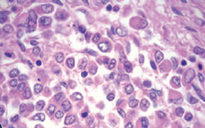
Rhabdoid = rod-shaped
- can stain for anything (muscle markers, etc).
- 4 : 3 = supratentorial : infratentorial

Bibliography for ch. “Neuro-Oncology” → follow this link >>

Viktor’s Notes℠ for the Neurosurgery Resident
Please visit website at www.NeurosurgeryResident.net

